Supplementary Information

Abbreviations

ACE2, angiotensin-converting enzyme 2; AcOH, acetic acid; Alloc, allyloxycarbonyl; Arg, arginine; Asp, asparagine; CAS + IMD, casirivimab and imdevimab; CC₅₀, median cytotoxicity concentrations; CI, combination index; ClAc-L-Phe, N-chloroacetyl-L-tyrosine; ClAc, chloroacetyl; ClAcOH, chloroacetic acid; CPE, cytopathic effects; Cryo-EM, Cryo-electron microscopy; Cys, cysteine; D-PBS (–), Dulbecco’s phosphate-buffered saline; DIC, N,N'-diisopropylcarbodiimide; DIPEA, N, N-diisopropylethylamine; DMEM, Dulbecco's modified eagle medium; DMF, N, N-dimethylformamide; DMSO, dimethyl sulfoxide; DODT, 3,6-dioxa-1,8-octanedithiol; DTT, dithiothreitol; EC₅₀, median effective concentrations; EC₉₀, 90% effective concentration; EDTA, 2,2',2'',2'''-(Ethane-1,2-diyldinitrilo)tetraacetic acid; Et3N, triethylamine; F4CON, Fmoc-Phe(4-carbamoyl)-OH; F4COO, Fmoc-Phe(4-carboxyl)-OH; FBS, fetal bovine serum; Fmoc-Glu-OtBu, Fmoc-L-glutamic Acid 1-tert-Butyl Ester; Fmoc, 9-fluorenylmethyloxycarbonyl; Glu, glutamic Acid; Gly, glycine; h, hour; HATU, 1-[bis(dimethylamino)methylene]-1H-1,2,3-triazolo[4,5-b]pyridinium 3-oxide hexafluorophosphate; HEPES, 2-[4-(2-hydroxyethyl)piperazin-1-yl]ethanesulfonic acid; HOSu, N-hydroxysuccinimide; HPLC, high-performance liquid chromatography; HRMS, high resolution mass spectrometer; HRP, horseradish peroxidase; IL-6, interleukin-6; Ile, isoleucine; KEC16, Lys(palmitoyl-Glu-OtBu); LC–MS/MS, liquid chromatography-tandem mass spectrometry; LLOD, lower limit of detection; Lys, lysine; MeA, N-methyl alanine; MeCN, acetonitrile; MEM, minimum essential medium; min, minute; MTBE, methyl tert-butyl ether; NaCl, sodium chloride; NH4HCO3, ammonium hydrogen carbonate; NHC, Beta-D-N4-hydroxycytidine; NMP, N-methyl-2-pyrrolidone; NTD, N-terminal domain; Oxyma, ethyl (hydroxyimino)cyanoacetate; PA-EC₉₀, protein-adjusted EC₉₀; PCR, polymerase chain reaction; PD, pharmacodynamics; Pd(PPh3)4, tetrakis triphenylphosphine; Phe, phenylalanine; PhSiH3, Phenylsilane; PK, pharmacokinetics; PKPD, pharmacokinetic-pharmacodynamic; RBD, receptor-binding domain; RG, reverse genetics; RT-qPCR, real-time reverse transcriptase-polymerase chain reaction; rt, room temperature; SD1, subdomain 1; SPPS, solid phase peptide synthesis; TA, thioanisole; tBu, tertiary butyl; TCID₅₀, 50% tissue culture infective dose; TFA, trifluoroacetic acid; THF, tetrahydrofuran; TIPS, triisopropyl silane; Trp, tryptophan; Tyr, tyrosine; UV, ultraviolet; VeroE6/TMPRSS2, Transmembrane serine protease 2-expressing Vero E6

Materials and Methods

Materials
DMEM, D-PBS (–), MEM, and penicillin-streptomycin were purchased from Thermo Fisher Scientific (Waltham, MA, USA). Remdesivir was purchased from MedChemExpress (Monmouth Junction, NJ, USA). REGN10933 (casirivimab) and REGN10987 (imdevimab) were purchased from Cell Sciences (Newburyport, MA, USA). Nirmatrelvir was purchased from ChemScene (Monmouth Junction, NJ, USA). NHC was purchased from eNovation Chemicals LLC (Bridgewater, NJ, USA). The CellTiter-Glo® 2.0 Cell Viability Assay Kit was purchased from Promega (Madison, WI, USA). Sensor chips, glycine buffer, HBS-P buffer, and 50 mM NaOH were purchased from Cytiba (Marlborough, MA, USA). EDTA and NaCl were obtained from Nakalai Tesque (Kyoto, Japan). Methanol, acetonitrile, and formic acid were purchased from Kanto Chemical Co., Inc (Tokyo, Japan). FBS, CP-100356 monohydrochloride, and all other chemicals were purchased from Sigma-Aldrich (St. Louis, MO, United States).

Cells and viruses
VeroE6/TMPRSS2 cells¹ were purchased from the Japanese Collection of Research Bioresources Cell Bank (Osaka, Japan) and maintained in DMEM containing 10% heat-inactivated FBS and 1% penicillin-streptomycin. SARS-CoV-2 clinical isolates were obtained from the National Institute of Infectious Diseases, Japan. The SARS-CoV-2 MA-P10 strain (mouse-adapted hCoV-19/Japan/TY/WK-521/2020)² was prepared according to previous reports^{3–5}. The viruses were propagated in VeroE6/TMPRSS2 cells, and the resulting viral stocks were stored at −80 °C. Viral titers were determined in VeroE6/TMPRSS2 cells using TCID₅₀ assays.

PDPS selection
Thioether-macrocyclic peptide libraries were constructed using the flexible in vitro translation system, with ClAc-L-Phe as an initiator⁶. The mRNA libraries were prepared as previously reported⁷. The mRNA library corresponding for the thioether-macrocyclic peptide library was designed to contain an AUG initiator codon for ClAc-L-Phe incorporation. The initiator codon was followed by 8–12 NNU random codons (N = G, C, A, or U) encoding random proteinogenic or non-proteinogenic amino acids, and then a fixed downstream UGC codon encoding Cys. After in vitro translation, a thioether bond formed spontaneously between the N-terminal ClAc group of the initiator L-Phe residue and the sulfhydryl group of a downstream Cys residue. In the first round of selection, the initial cyclic peptide library was formed by combining puromycin and the mRNA library (200 pmol) in a 100 μL scale flexible in vitro translation system, in the presence of 30 μM of ClAc-L-Phe-tRNA^{fMet}CAU. The translation was performed at 37 °C for 30 min. After the addition of 10 μL of 100 mM EDTA (pH 7.5) solution, the reaction was incubated at 37 °C for 30 min to facilitate cyclization. The library was then reverse-transcribed at 42 °C for 30 min using the M-MLV reverse transcriptase (Promega). Desalting was performed on pre-washed Sephadex G-25 columns (Bio-Rad). The desalted solution of peptide-mRNA/cDNA complexes was combined with a solution of biotinylated S1 containing the K417N, E484K, and N501Y mutations (mS1-bio) (ACROBiosystems, Newark, DE, USA) and rotated at 23 °C for 1 h in selection buffer (25 mM HEPES pH 7.5, 150 mM NaCl and 0.05% Tween 20). The final concentration of mS1-bio was 250 nM. Positive selection of S1-bio was performed using Dynabeads M-280 streptavidin magnetic beads (Thermo Fisher Scientific), with rotation at 4 °C for 20 min. The selected peptide-mRNA/cDNAs complexes were dissociated from the beads by incubating in 1 ×PCR reaction buffer heated to 95 °C for 5 min. The amount of eluted cDNA was qualified using the StepOnePlus™ (Thermo Fisher Scientific) RT-qPCR system. The selected cDNA was amplified by PCR, purified, and used in the next selection round. In each subsequent round of selection, cDNA from the previous round and a puromycin linker were applied to a 5-μL-scale reprogrammed in vitro translation system and incubated at 37 °C for 30 min. After adding 1 μL of 100 mM EDTA (pH 7.5), the reaction mixture was incubated at 37 °C for 30 min. The peptide-mRNA/cDNA complexes were then reverse transcribed and desalting on pre-washed Sephadex G-25 columns. Negative selection of desalted peptide-mRNA/cDNA complex was performed in the absence of the target protein using Dynabeads M280 streptavidin magnetic beads and rotation at 4 °C for 10 min in selection buffer. This process was repeated three times by adding the supernatant to fresh beads. The supernatant from the final round of negative selection was then added to a solution of biotinylated RBD containing the K417N, E484K, and N501Y mutations (mRBD-bio) (ACROBiosystems) and rotated at 23 °C for 1 h in selection buffer. The final concentration of mRBD-bio was 250 nM. As described in the first round of selection, the cDNA was quantified using RT-qPCR and then amplified by PCR. Subsequent rounds of selection were then performed. mS1-bio was used in the third, fourth (final concentration = 250 nM), and sixth (final concentration = 10 nM) rounds; mRBD-bio (final concentration = 250 nM) was used in the fifth round, and biotinylated wildtype S1 domain (WTS1-bio; final concentration = 10 nM; ACROBiosysmtems) was used in the seventh round. The recovered cDNA was then identified by Miseq sequencing (Illumina, San Diego, CA, USA).

Synthesis of S-880008
S-880008
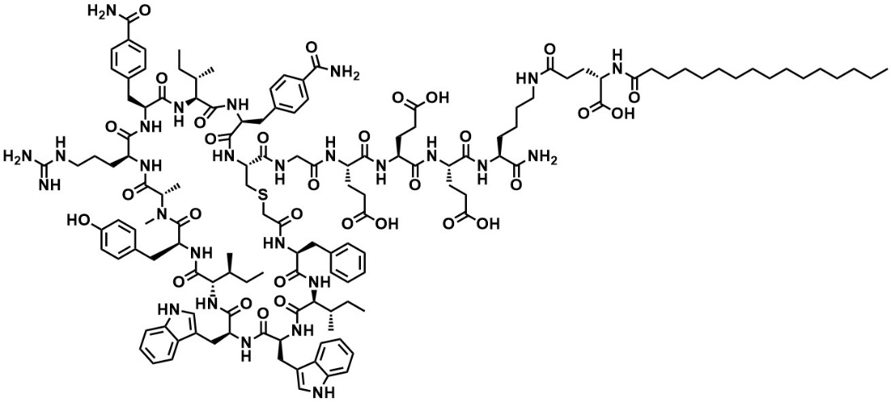
Procedure for Fmoc-based solid phase peptide synthesis (SPPS)
The linear peptide sequence of S-880008 or S-880008 analog was synthesized according to a standard Fmoc-based SPPS protocol. Fmoc-amino acids and other starting materials were commercially available and used without further purification. Fmoc-Sieber resin (27 mmol, 36.0 g), swelled in DMF, was treated with Alloc-Lys(Fmoc)-OH (2.1 eq.), DIC (2.1 eq.), and Oxyma (2.1 eq.) dissolved in DMF. The contents were agitated at 55 °C for 1.5 h, then drained and the resin was washed with DMF. Deprotection of Fmoc was conducted by treatment with 20% piperidine in DMF for 2 x 10 min at 25 °C and the resin was washed with DMF. Next, the resin was treated with Fmoc-Glu-OtBu (3 eq.), DIC (3 eq.), and Oxyma (3 eq.) dissolved in DMF, and agitated at 55 °C for 2 h followed by the Fmoc deprotection by 20 % piperidine in the same manner as the previous step. Furthermore, the resin was treated with palmitic acid (4.2 eq.), DIC (4.2 eq.), and Oxyma (4.2 eq.) dissolved in DMF, and agitated at 25 °C for 1.5 h. After DMF washing, the Alloc deprotection was conducted by treatment with Pd(PPh₃)₄ (0.25 eq.), PhSiH₃ (5 eq.), and piperidine (20 eq.) in THF under flowing nitrogen to afford a Lys(palmitoyl-Glu-OtBu) bound resin. The detailed conditions of the following peptide elongation steps were shown in the below table.

 |  | amino acid  (eq.) | DIC  (eq.) | Oxyma  (eq.) | temp.  (°C) | time  (min)
1 | Glu | 3 | 3 | 3 | 55 | 30
2 | Glu | 3 | 3 | 3 | 55 | 30
3 | Glu | 3 | 3 | 3 | 55 | 30
4 | Gly | 3 | 3 | 3 | 55 | 30
5 | Cys | 3 | 3 | 3 | 30 | 60
6 | F4CON | 2.2 | 2.2 | 2.2 | 55 | 30
7 | Ile | 3 | 3 | 3 | 55 | 30
8 | F4CON | 2.2 | 2.2 | 2.2 | 55 | 30
9 | Arg | 3 | 3 | 3 | 55 | 30
10 | MeA | 3 | 3 | 3 | 55 | 30
11 | Tyr | 3 | 3 | 3 | 55 | 30
12 | Ile | 3 | 3 | 3 | 55 | 60
13 | Trp | 3 | 3 | 3 | 55 | 30
14 | Trp | 3 | 3 | 3 | 55 | 30
15 | Ile | 3 | 3 | 3 | 55 | 60
16 | Phe | 3 | 3 | 3 | 55 | 30

Fmoc deprotection of each step was conducted by treatment with 20 % piperidine in DMF for 1 x 5 min and 1 x 10 min at 25 °C. Finally, the resin was treated with ClAcOH (5 eq.), DIC (5 eq.), and HOSu (5 eq.) dissolved in DMF, and agitated at 25 °C for 1 h to afford the target linear peptide bound resin (114.0 g).

Cleavage from resin
To the above resin was added a solution of TFA/TIPS/H₂O/DTT/TA (87.5/2.5/2.5/5/2.5, v/v/v/v) and agitated at 25°C. The released linear peptide was precipitated with MTBE/heptane (1/1, v/v), washed with MTBE/heptane, and dried in vacuo to obtain a crude linear peptide.

Cyclization and purification
To a solution of crude linear peptide (30 g) in MeCN/H₂O (3/1, v/v, 1200 mL) was added Et₃N (45 mL) in MeCN/H₂O (1/1, v/v, 780 mL). After reaction for 18 h, the reaction mixture was directly purified by a YMC-Triart Prep C18-S (100 x 250 mm, 10 μm) HPLC column eluting with a solvent gradient of A:B, where A = 0.5% NH₄HCO₃ in H₂O and B = MeCN (72 min Gradient: 25–43 B%, detection: 220 nm) at a flow rate of 600 mL/min, and the collected pure fractions were lyophilized to obtain cyclic peptide containing salts. Furthermore, the obtained cyclic peptide (22 g) was purified by a YMC-Triart Prep C18-S (100 x 250 mm, 10 μm) HPLC column eluting with 1% MeCN in H₂O for 15 min followed by eluting with a solvent gradient of A:B, where A = 0.5% AcOH in H₂O and B = MeCN (15 min gradient: 10–70 B%, detection: 220 nm) at a flow rate of 600 mL/min for desalting, and the collected pure fractions were lyophilized to afford pure S-880008 [18.5 g, UV (220 nm) purity = 98.7%, total yield = 30.9%].

HPLC analysis
S-800008 purity was analyzed using a SHIMADZU Nexera HPLC system coupled to a Waters ACQUITY-UPLC BEH C18 HPLC column (2.1 mm x 150 mm, 1.7 mm) eluted with a solvent gradient of A:B, where A = 0.1% TFA in H₂O and B = 0.08% TFA in MeCN (19 min gradient: 35–63.5 B%, detection: 220 nm, temperature: 60°C) at a flow rate of 0.4 mL/min. With S-880008 analytical, UV purity (peak areas) = 92.2% (Retention time = 7.66 min)

Peak areas of S-880008 on the chromatograms obtained from the sample solution and the standard solution were determined by the automatic integration method. The content of S-880008 free base in weight was calculated by the following equation.

Content as S-880008 free base (%) in weight = (WS× C ×AT)/(WT ×AS)

WS: Sampling amount of the standard substance for the standard solution (mg)
WT: Sampling amount of the test substance for the sample solution (mg)
C: Content as S-880008 free base in weight in the standard substance (%)
AS: Peak area of S-880008 from the standard solution
AT: Peak area of S-880008 from the sample solution

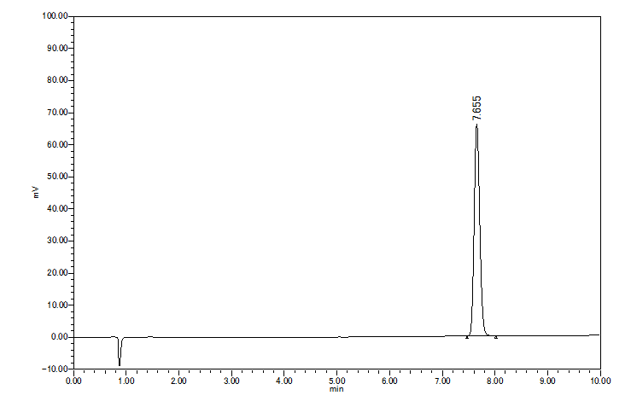

HRMS analysis
Chromatographic separation was performed on a YMC-Triart C18 column (2.1 mm × 50 mm; 3 μm, YMC Co., Ltd) and reversed phase using a gradient elution of mobile phase A (H₂O/formic acid = 1000/1) and mobile phase B (acetonitrile/formic acid = 1000/1) at a flow rate of 0.75 mL/min. High resolution mass spectrum (HRMS) was obtained using a Q Exactive Plus Orbitrap mass spectrometer (Thermo Fisher Scientific).
With S-880008 Analytical, HRMS calcd for [C137H191N27O31S] [M+2H]²⁺ 1372.7055, found 1372.7042.

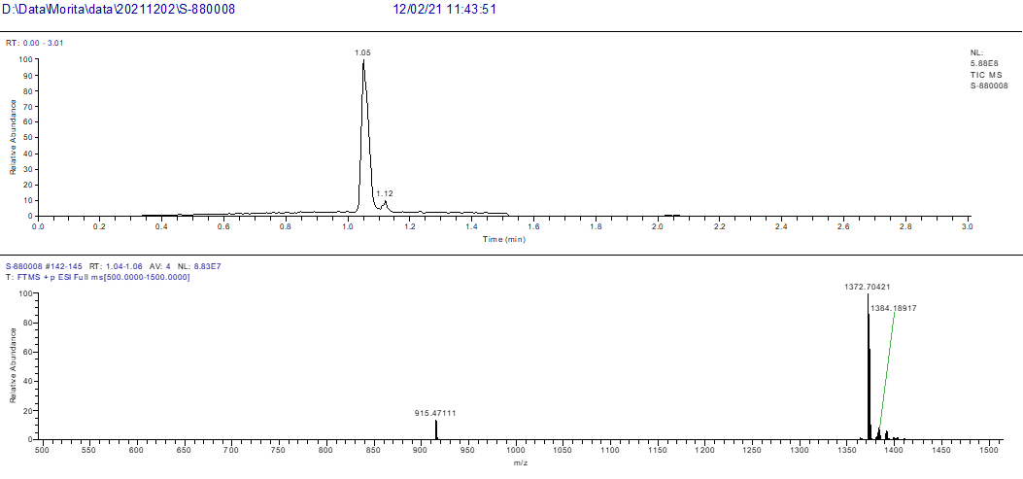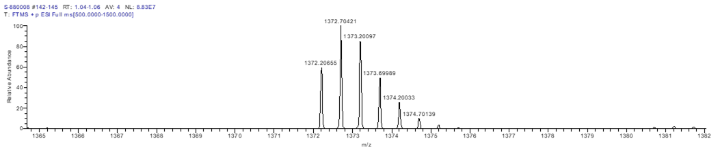

Synthesis of S-880008 analog
Procedure for Fmoc-based solid phase peptide synthesis (SPPS)
Synthetic Method S-A
SPPS was performed with Syro I, a fully automated parallel peptide synthesizer. Rink-amide resin or KEC16 bound Rink amide resin was swelled in DMF for 30 min. The resin was drained and treated with 20% piperizine in DMF (24 mL/mmol) to deprotect Fmoc before subjected to SPPS. The resin was drained and treated with a pre-mixed solution of Fmoc-protected amino acid (4 equiv.), HATU (4 equiv.) dissolved in DMF (16 mL/mmol) and DIPEA (8 equiv.) dissolved in NMP (8 mL/mmol). The contents were gently agitated for 20 min at 75℃. After drained, the resin was washed with DMF for four times. For amino acids next to N-methyl amino acids or aromatic amino acids, or Arg, double coupling was carried out. For Cys, single coupling was carried out for 40min at rt. Deprotection of Fmoc was conducted by treatment with 20% piperidine in DMF (24 mL/mmol) at rt for 1 x 3 min and 1 x12 min followed by coupling of the next amino acid. The coupling and deprotection protocol were repeated to afford the elongated linear peptide. After elongation with amino acids, to the resulting peptide-bound resin was added pre-mixed chloroacetic acid (4 equiv.), HATU (4 equiv.) dissolved in DMF (16 mL/mmol) and DIPEA (4 equiv.) dissolved in NMP (4 mL/mmol). The mixture was agitated for 40 min at rt. After drained, the protected linear peptide was obtained.

Synthetic Method S-B
SPPS was performed with Liberty PRIME, a fully automated parallel peptide synthesizer. KEC16 bound Rink amide resin was treated with 20% piperidine in DMF (24 mL/mmol) to deprotect Fmoc before subjected to SPPS. The resin was drained and treated with a solution of Fmoc protected amino acid (5 equiv.), DIC (10 equiv.), Oxyma (5 equiv.) dissolved in DMF (40 mL/mmol). The contents were gently agitated for 1 min at 105℃. For amino acids next to N-methyl amino acids and Ile, double coupling was carried out. For Arg, double coupling was carried out for 10 min at 60℃. Deprotection of Fmoc was conducted by treatment with 20% piperidine in DMF (24 mL/mmol) for 1 min at 90℃. After drained, the resin was washed with DMF followed by coupling of the next amino acid. The coupling and deprotection protocol were repeated to afford the elongated linear peptide. After elongation with amino acids, to the resulting peptide-bound resin was added a solution of chloroacetic acid (5 equiv.), DIC (10 equiv.), Oxyma (5 equiv.) dissolved in DMF (40 mL/mmol). The mixture was agitated at rt for 30 min. After drained, the protected linear peptide was obtained.

Synthetic Method S-C
SPPS was performed with Liberty Blue, a fully automated parallel peptide synthesizer. Rink-amide resin or KEC16 bound Rink amide resin was treated with 20% piperidine in DMF (24 mL/mmol) to deprotect Fmoc before subjected to SPPS. The resin was drained and treated with a solution of Fmoc protected amino acid (5 equiv.), DIC (10 equiv.), Oxyma (5 equiv.) dissolved in DMF (40 mL/mmol). The contents were gently agitated for 2-4 min at 90℃. For amino acids next to N-methyl amino acids and Ile, double coupling was carried out. For Arg, double coupling was carried out for 10 min at 60℃. Deprotection of Fmoc was conducted by treatment with 20% piperidine in DMF (24 mL/mmol) for 1 min at 90℃. After drained, the resin was washed with DMF followed by coupling of the next amino acid. The coupling and deprotection protocol were repeated to afford the elongated linear peptide. After elongation with amino acids, to the resulting peptide-bound resin was added a solution of chloroacetic acid (5 equiv.), DIC (10 equiv.), Oxyma (5 equiv.) dissolved in DMF (40 mL/mmol). The mixture was agitated at rt for 30 min. After drained, the protected linear peptide was obtained.

Cleavage from resin and cyclization
The protected linear peptide was added TFA/TIPS/DODT/H2O (92.5/2.5/2.5/2.5, 80 mL/mmol) and the resulting mixture was shaken for 1.5 h at rt. The released linear peptide was precipitated with cold MTBE/n-hexane (1:1, 800 mL/mmol), washed with MTBE/n-hexane (1:1, 800 mL/mmol) twice, and dried in vacuo to give the linear peptide. To a solution of the linear peptide in DMSO (200 mL/mmol) was added Et3N (10 equiv.). After stirring for 2 h, the reaction mixture was evaporated by Genevac HT-4 evaporator to afford the cyclic peptide.

Purifiation
Peptides were purified using a Waters SQD2 system connected to Phenomenex Kinetex C18 (5 μm, 100 Å, 30 mm x 150 mm) or Phenomenex Gemini-NX C18 AXIA (5 μm, 110 Å, 30 mm x 100 mm) or Phenomenex Kinetex EVO C18 column (5 μm, 100 Å, 30 mm x 150 mm), reversed phase HPLC column eluting with a solvent gradient A:B, where A = 0.1% TFA in water and B = 0.1% TFA in acetonitrile at a flow rate of 15 mL/min.

HRMS analysis
Chromatographic separation was performed on a Waters ACQUITY UPLC BEH C18 column (2.1 mm× 50 mm; 1.7 μm, Waters Co., Ltd) and reversed phase using a gradient elution of mobile phase A (H₂O/formic acid = 1000/1) and mobile phase B (acetonitrile/formic acid = 1000/1) at a flow rate of 0.8 mL/min. High resolution mass spectrum (HRMS) was obtained using a Waters Xevo G2 TOF (ESI).

Compound 1

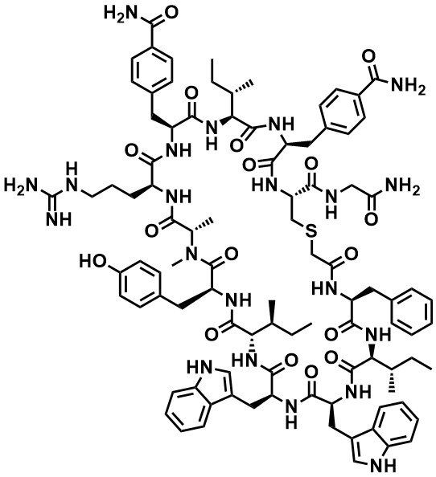

Compound 1 was synthesized by Synthetic Method S-B with Rink-amide resin (0.1 mmol, 145 mg). The obtained linear peptide was cleaved from resin and cyclized, then purified using Purification Method. The obtained pure fractions were combined and evaporated, then lyophilized to give 62 mg (y. 33%) of compound 1 as a white solid. With Analytical, UV purity (220 nm) = 100% (Retention time = 1.46 min): HRMS calcd for [C95H121N21O17S] [M+H]⁺ 1861.9082, found 1861.9363.

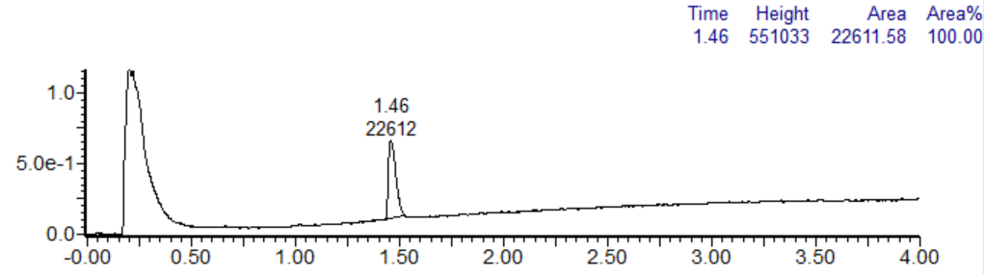
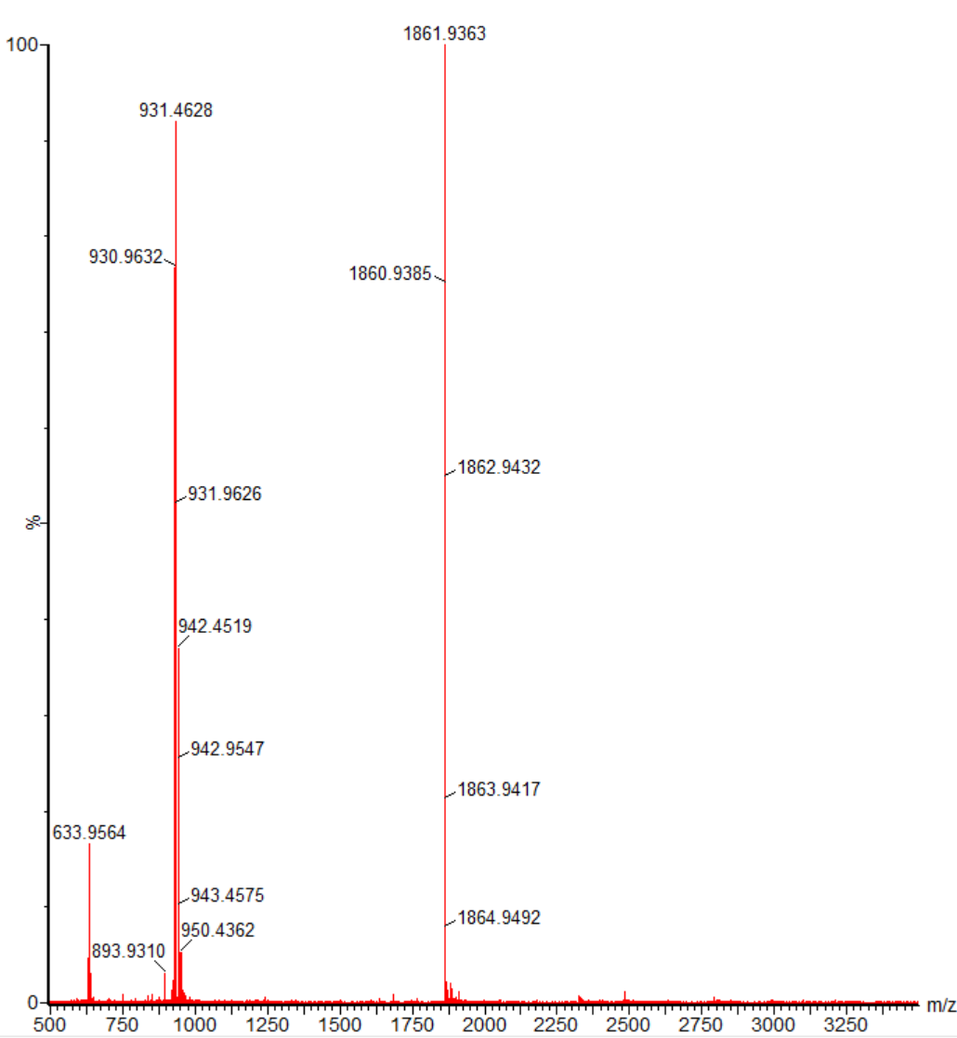

Compound 2

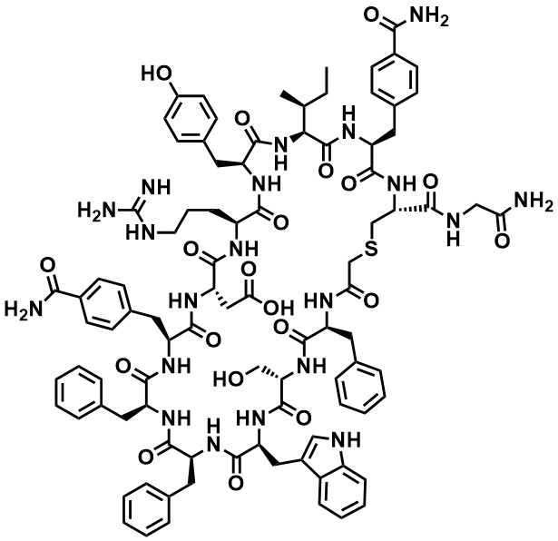

Compound 2 was synthesized by Synthetic Method S-A with Rink-amide resin (0.05 mmol, 73 mg). The obtained linear peptide was cleaved from resin and cyclized, then purified using Purification Method. The obtained pure fractions were combined and evaporated, then lyophilized to give 7.1 mg (y. 15%) of compound 2 as a white solid. With Analytical, UV purity (220 nm) = 100% (Retention time = 1.46 min): HRMS calcd for [C93H110N20O20S] [M+H]⁺ 1860.8038, found 1860.8413.
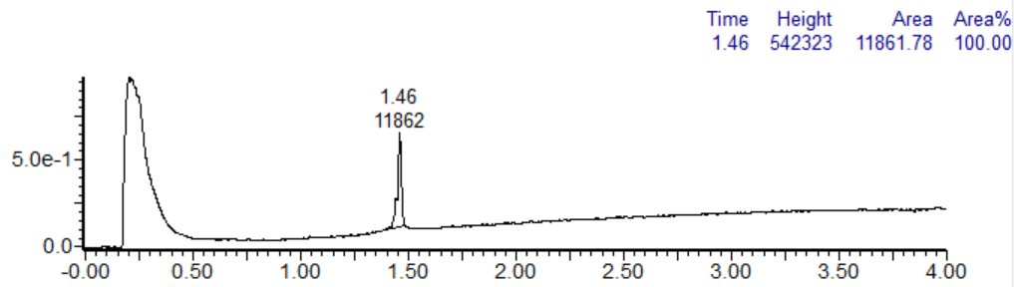
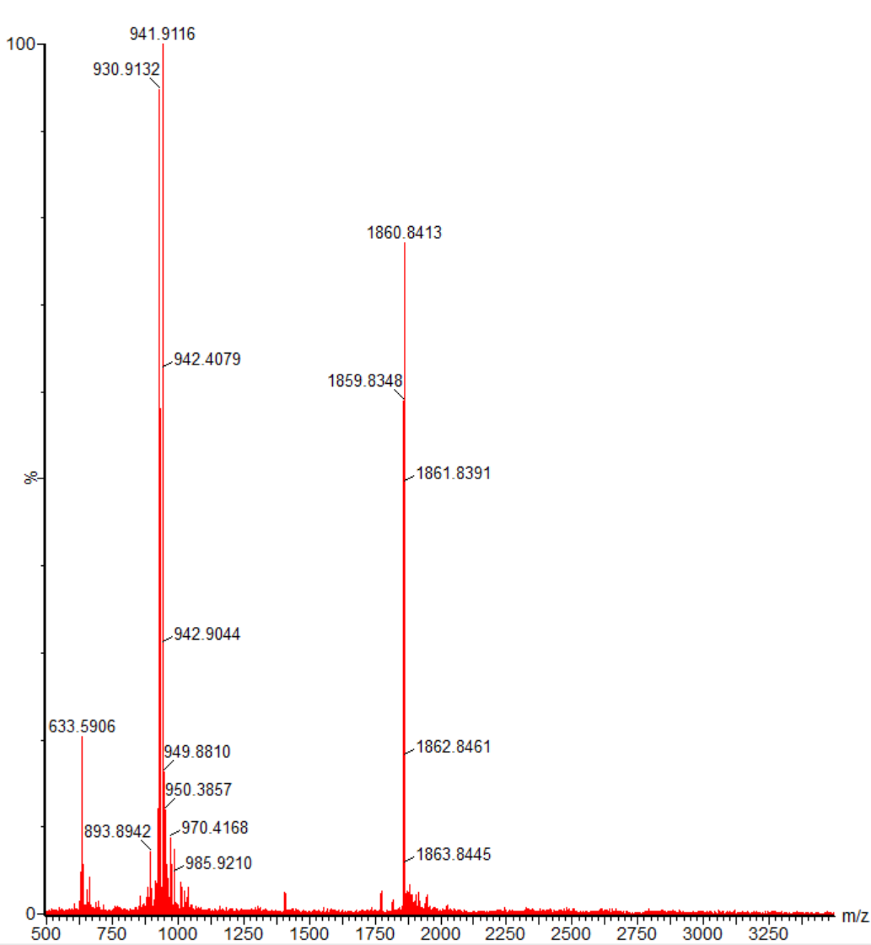

Compound 3

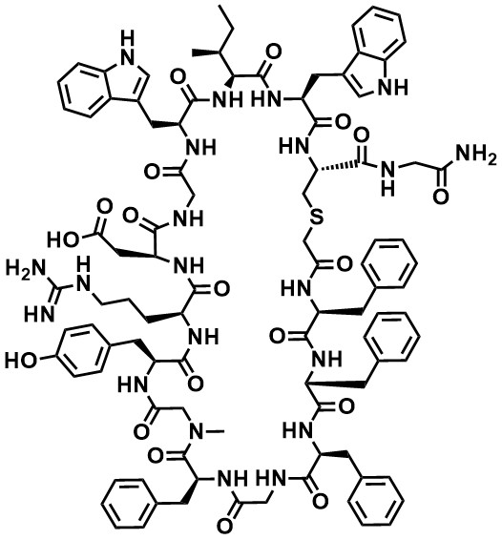
Compound 3 was synthesized by Synthetic Method S-A with Rink-amide resin (0.05 mmol, 73 mg). The obtained linear peptide was cleaved from resin and cyclized, then purified using Purification Method. The obtained pure fractions were combined and evaporated, then lyophilized to give 7.4 mg (y. 16%) of compound 3 as a white solid. With Analytical, UV purity (220 nm) = 100% (Retention time = 1.68 min): HRMS calcd for [C97H115N21O19S] [M+H]⁺ 1911.8511, found 1911.8844.
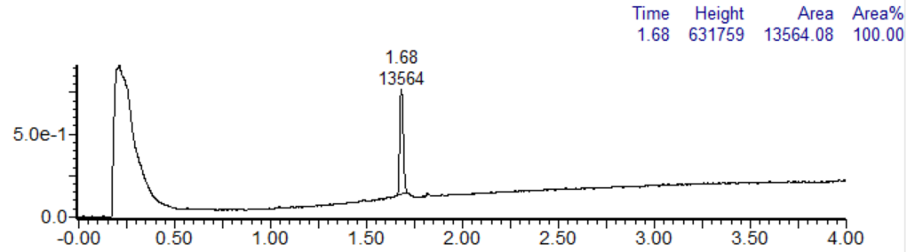

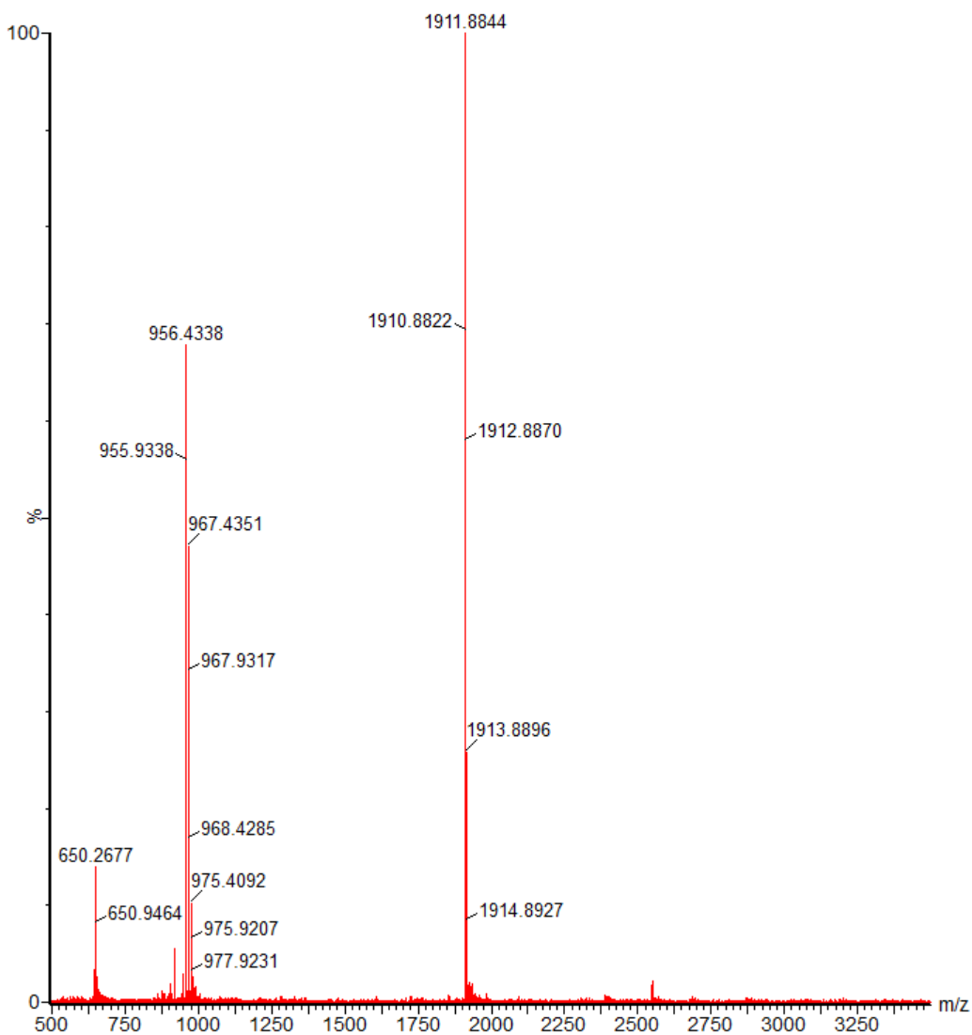

Compound 4

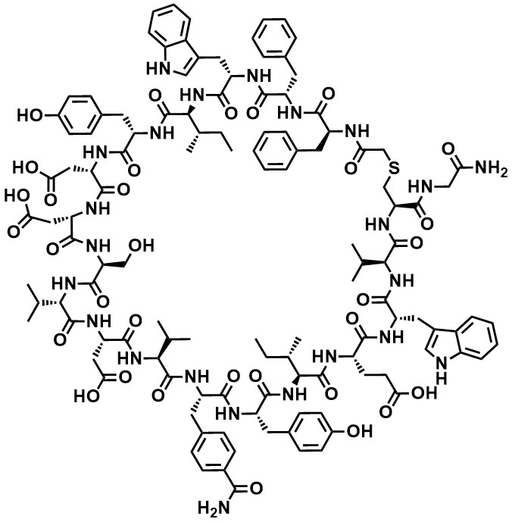
Compound 4 was synthesized by Synthetic Method S-A with Rink-amide resin (0.05 mmol, 73 mg). The obtained linear peptide was cleaved from resin and cyclized, then purified using Purification Method. The obtained pure fractions were combined and evaporated, then lyophilized to give 6.8 mg (y. 11%) of compound 4 as a white solid. With Analytical, UV purity (220 nm) = 100% (Retention time = 1.71 min): HRMS calcd for [C122H153N23O32S] [M+2H]²⁺ 1243.5482, found 1243.5648.
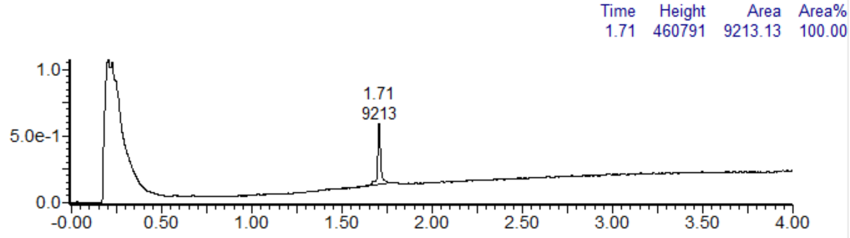
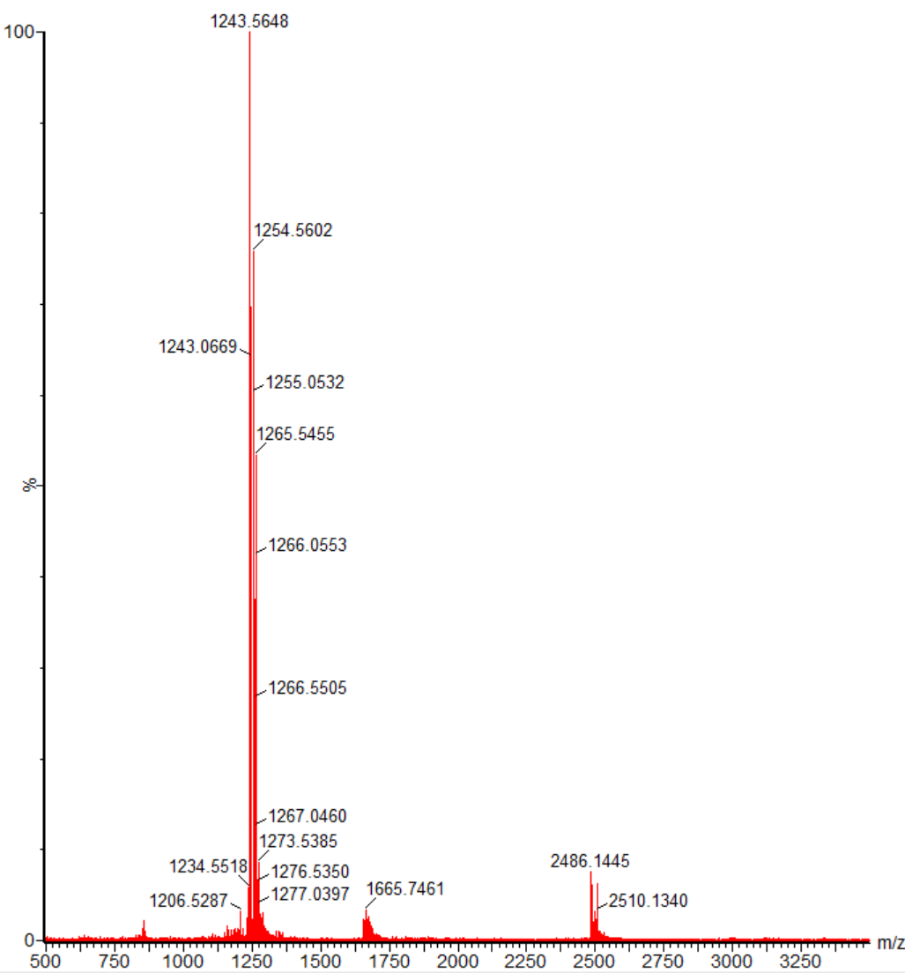

Compound 5

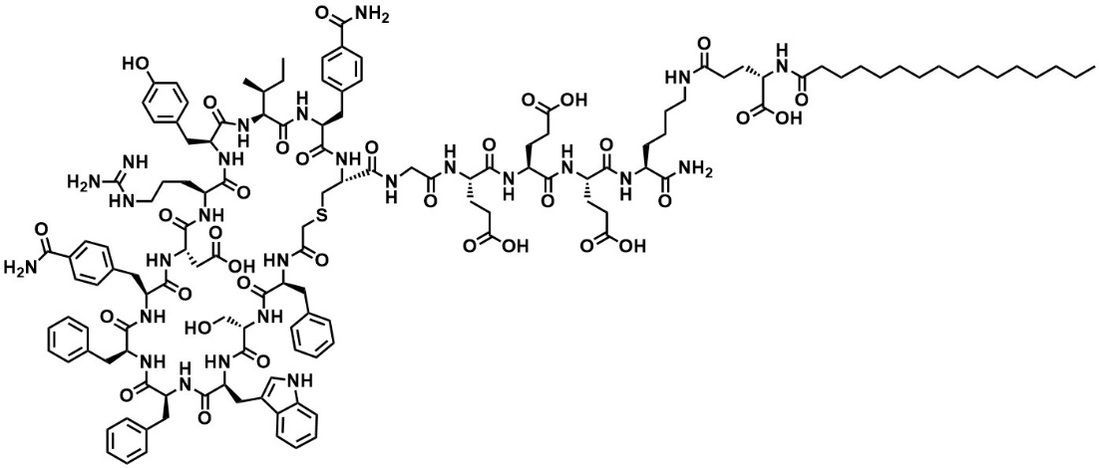

Compound 5 was synthesized by Synthetic Method S-A with Rink-amide resin (0.05 mmol, 73 mg). KEC16 bound Rink amide resin was synthesized using Fmoc-Lys(palmitoyl-Glu-OtBu)-OH (CEM corporation). The obtained linear peptide was cleaved from resin and cyclized, then purified using Purification Method. The obtained pure fractions were combined and evaporated, then lyophilized to give 13 mg (y. 19%) of compound 5 as a white solid. With Analytical, UV purity (220 nm) = 100% (Retention time = 2.23 min): HRMS calcd for [C135H180N26O34S] [M+2H]²⁺ 1372.1533, found 1372.1741.
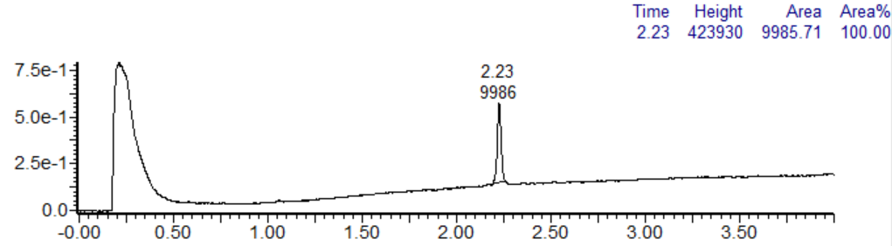

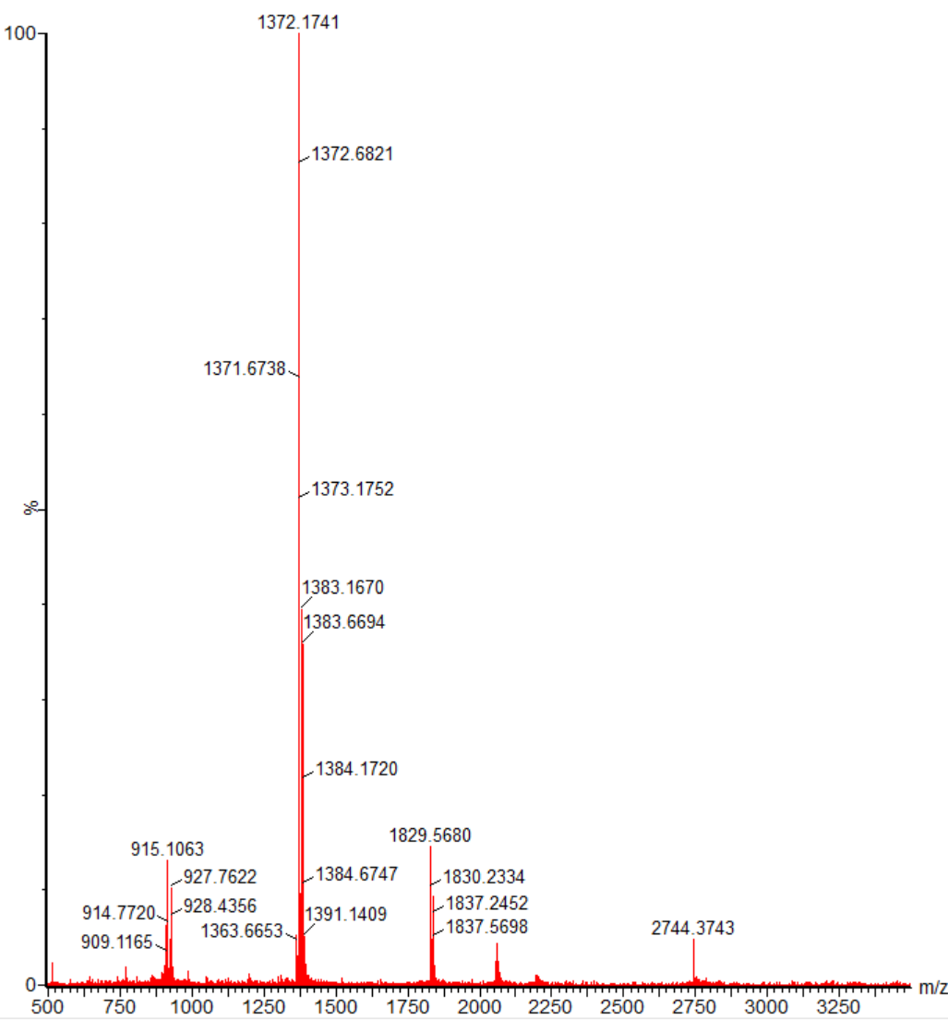

Compound 6

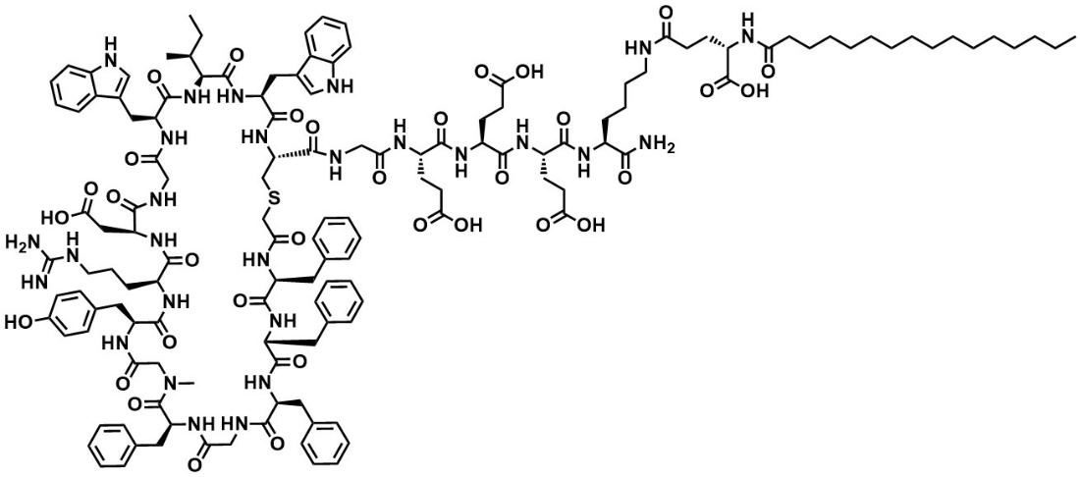

Compound 6 was synthesized by Synthetic Method S-A with Rink-amide resin (0.05 mmol, 73 mg). KEC16 bound Rink amide resin was synthesized using Fmoc-Lys(palmitoyl-Glu-OtBu)-OH (CEM corporation). The obtained linear peptide was cleaved from resin and cyclized, then purified using Purification Method. The obtained pure fractions were combined and evaporated, then lyophilized to give 13 mg (y. 19%) of compound 6 as a white solid. With Analytical, UV purity (220 nm) = 100% (Retention time = 2.34 min): HRMS calcd for [C139H185N27O33S] [M+2H]²⁺ 1397.677, found 1397.6986.
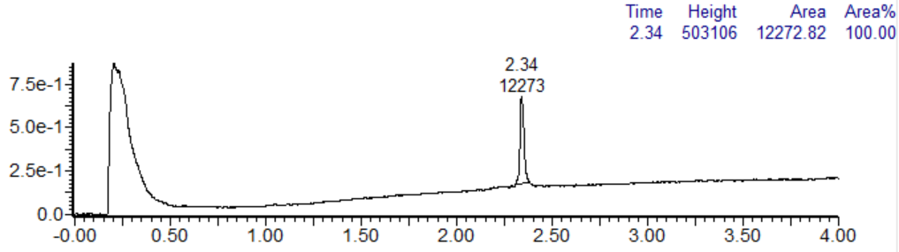

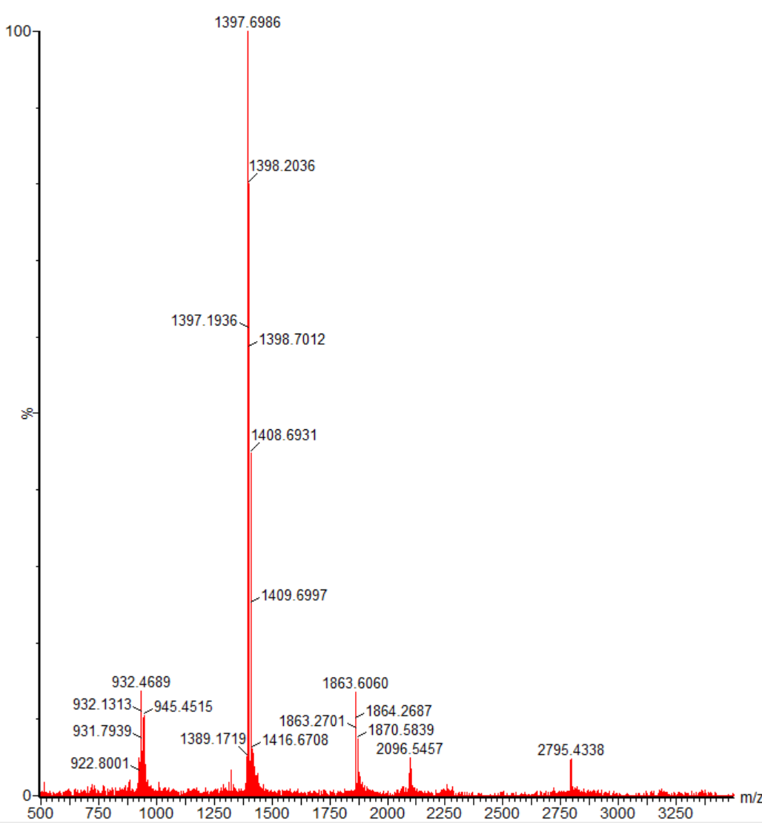

Compound 7

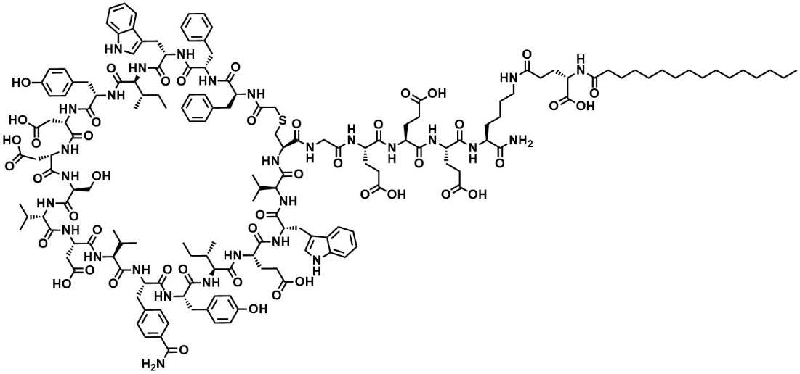

Compound 7 was synthesized by Synthetic Method S-A with Rink-amide resin (0.05 mmol, 73 mg). KEC16 bound Rink amide resin was synthesized using Fmoc-Lys(palmitoyl-Glu-OtBu)-OH (CEM corporation). The obtained linear peptide was cleaved from resin and cyclized, then purified using Purification Method. The obtained pure fractions were combined and evaporated, then lyophilized to give 6.0 mg (y. 7.1%) of compound 7 as a white solid. With Analytical, UV purity (220 nm) = 100% (Retention time = 2.52 min): HRMS calcd for [C164H223N29O46S] [M+2H]²⁺ 1684.7957, found 1684.8301.
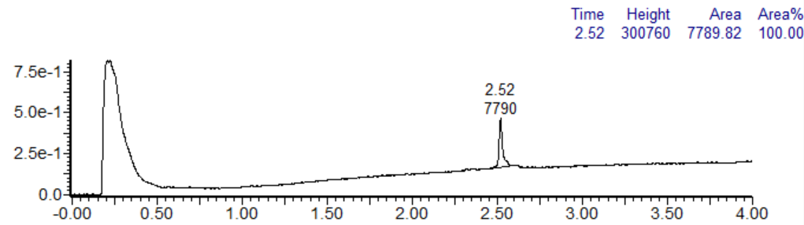

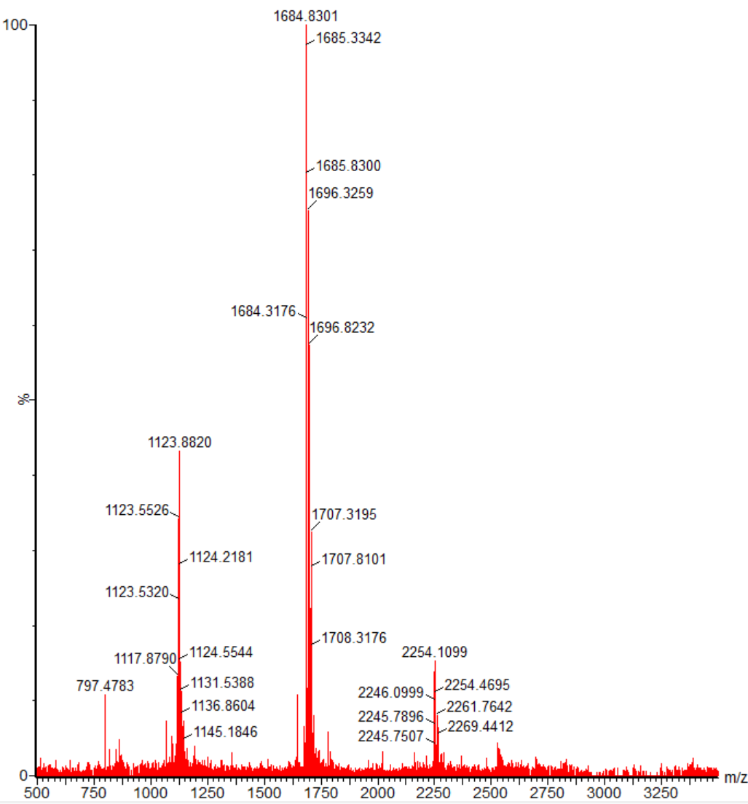

Compound 8

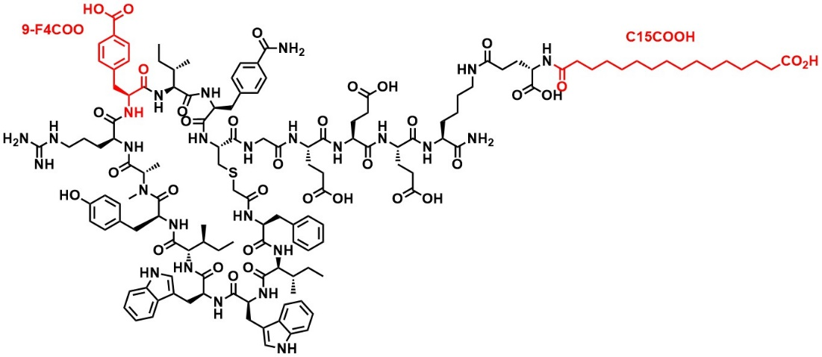

Compound 8 was synthesized by Synthetic Method S-C with Rink-amide resin (0.1 mmol). KEC15COOH bound Rink amide resin was synthesized by same methods of KEC16 bound Rink amide resin, using 16-(tert-Butoxy)-16-oxohexadecanoic acid instead of palmitic acid. The obtained linear peptide was cleaved from resin and cyclized, then purified using Purification Method. The obtained pure fractions were combined and evaporated, then lyophilized to give 20 mg (y. 7%) of compound 8 as a white solid. With Analytical, UV purity (220 nm) = 98% (Retention time = 1.71 min): HRMS calcd for [C137H188N26O34S] [M+2H]²⁺ 1388.1846, found 1388.1804.
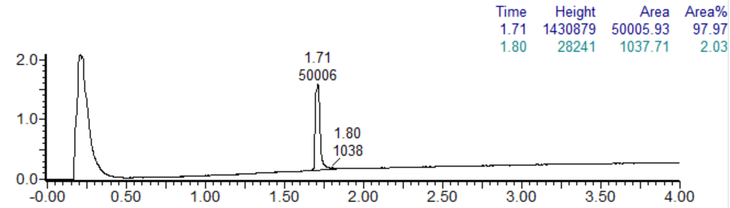

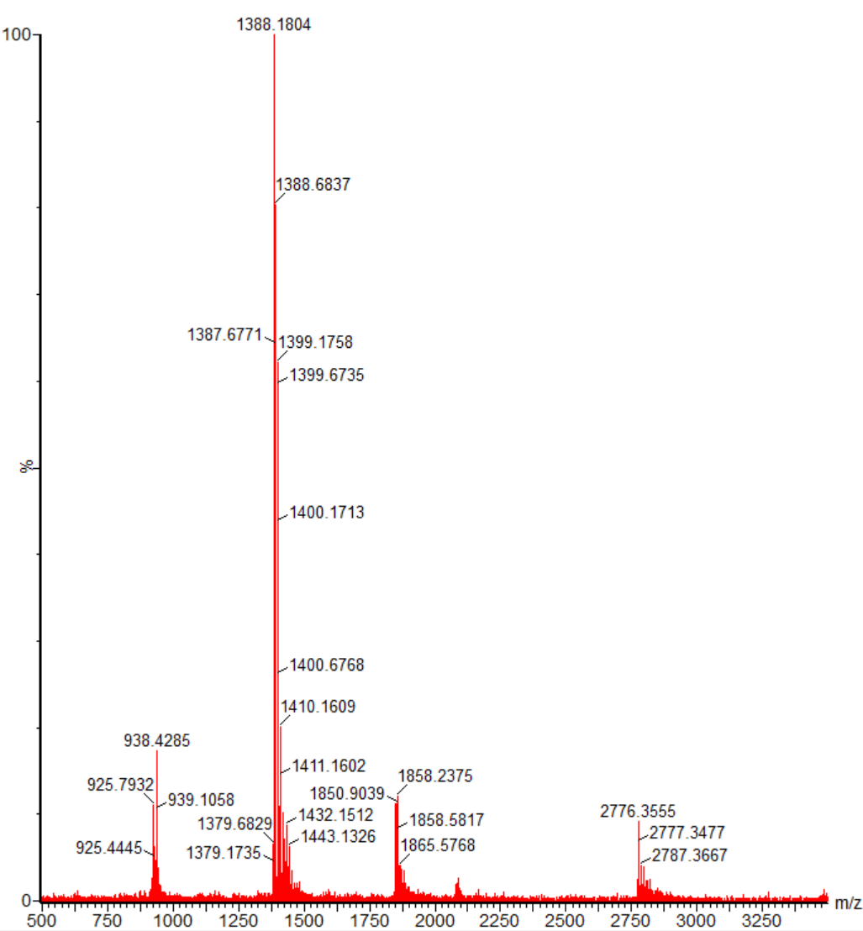

Compound 9

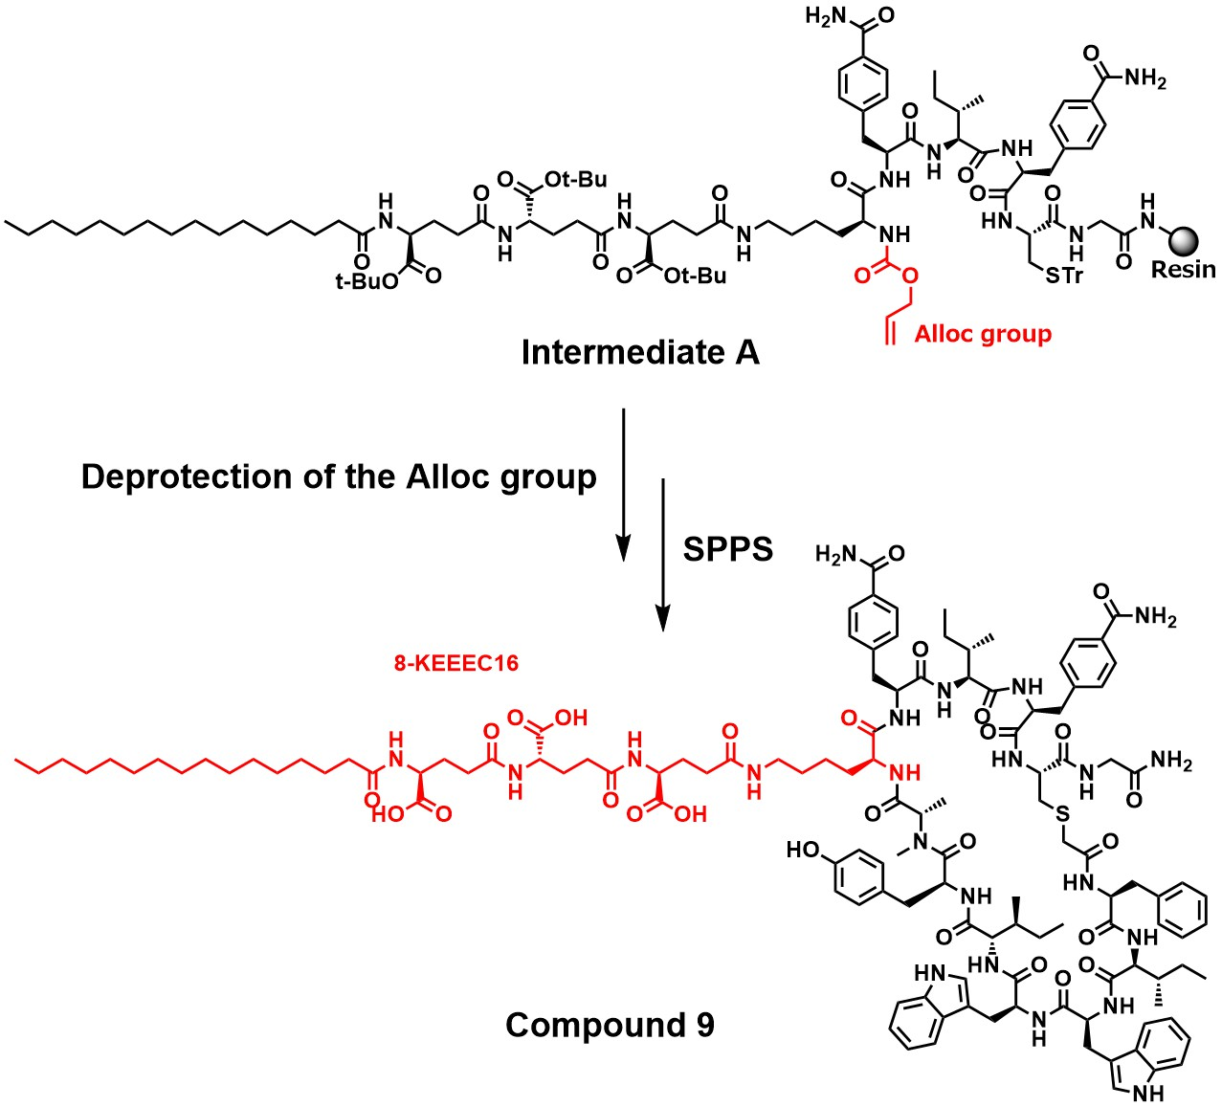
Compound 9 was synthesized by Synthetic Method S-C with Rink-amide resin (0.25 mmol, 365 mg). The obtained intermediate A was deprotected the Alloc group by treatment with Pd(PPh₃)₄ (0.3 eq.), PhSiH₃ (5 eq.) in DCM and followed by SPPS. The obtained linear peptide was cleaved from resin and cyclized, then purified using Purification Method. The obtained pure fractions were combined and evaporated, then lyophilized to give 64 mg (y. 10%) of compound 1 as a white solid. With Analytical, UV purity (220 nm) = 93% (Retention time = 2.61 min): HRMS calcd for [C126H172N22O27S] [M+2H]²⁺ 1230.1337, found 1230.1329.
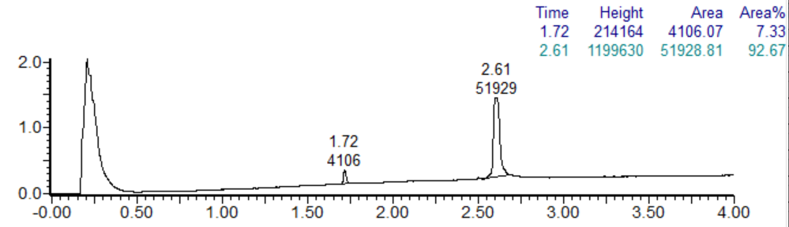
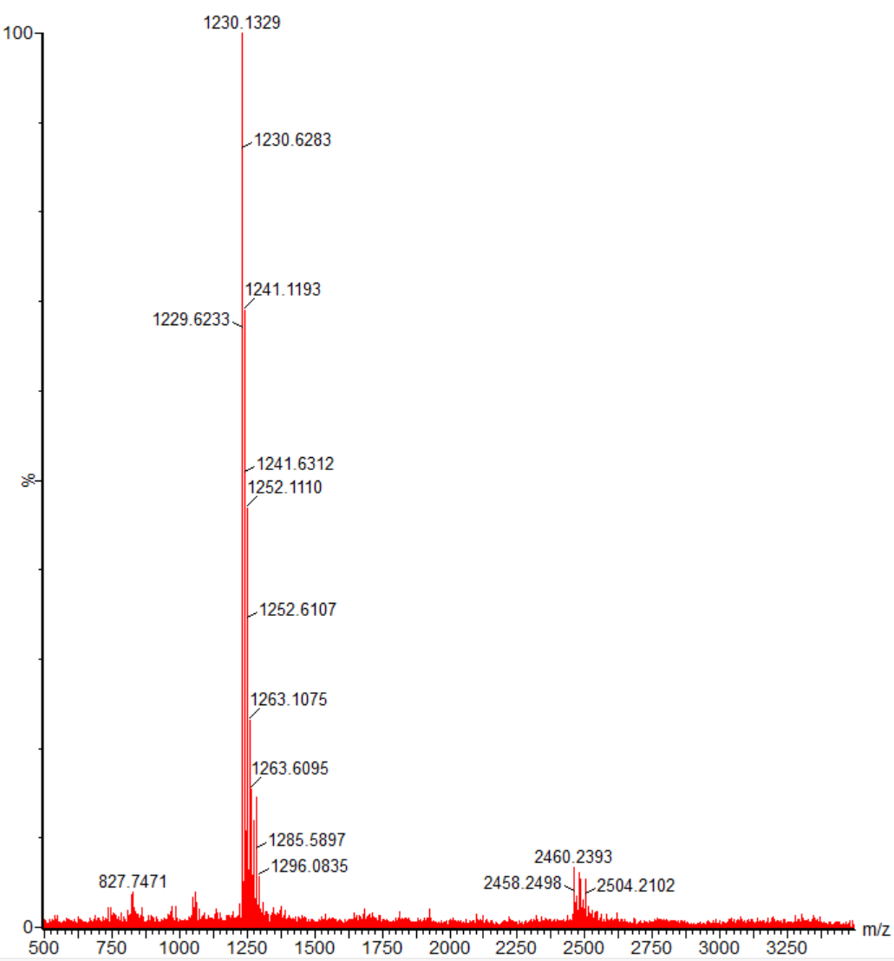

Compound 10

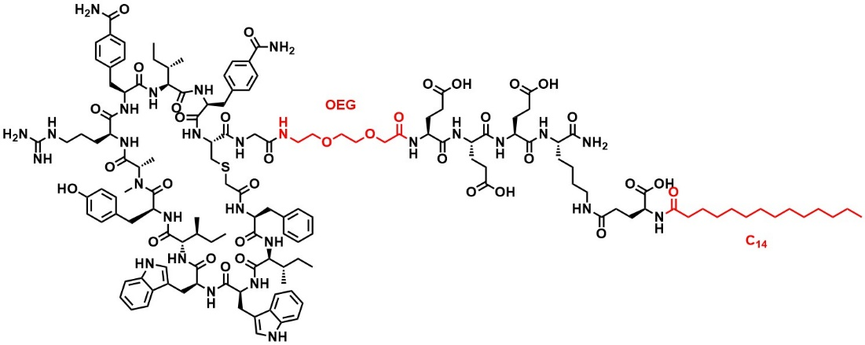
Compound 10 was synthesized by Synthetic Method S-C with Rink-amide resin (0.1 mmol, 247 mg). KEC14 bound Rink amide resin was synthesized by same methods of KEC16 bound Rink amide resin, using myristic acid instead of palmitic acid. The obtained linear peptide was cleaved from resin and cyclized, then purified using Purification Method. The obtained pure fractions were combined and evaporated, then lyophilized to give 30 mg (y. 10%) of compound 10 as a white solid. With Analytical, UV purity (220 nm) = 92% (Retention time = 1.93 min): HRMS calcd for [C141H198N28O34S] [M+2H]²⁺ 1431.2268, found 1431.2219.
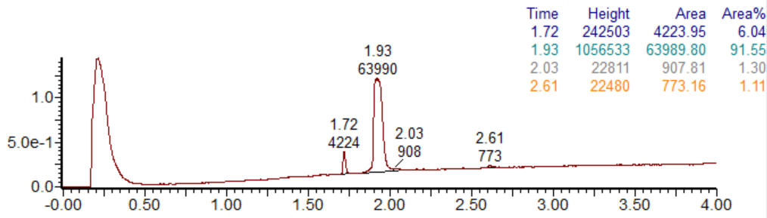

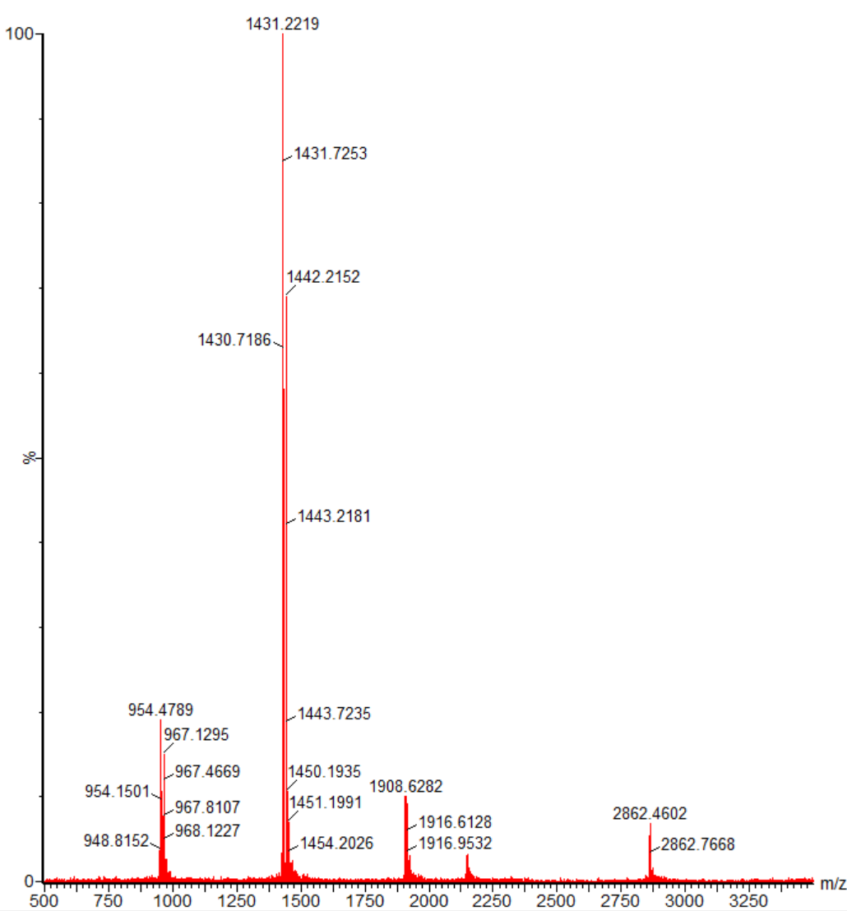

Compound 11

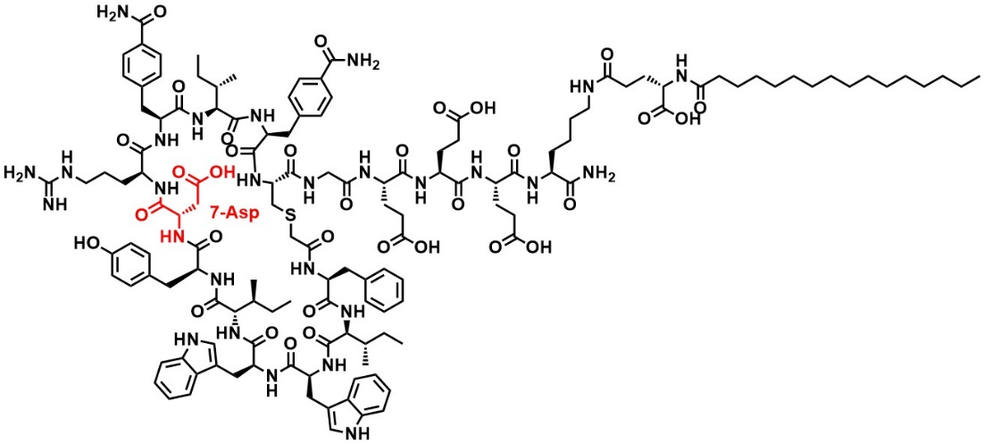

Compound 11 was synthesized by Synthetic Method S-B with KEC16 bound Rink-amide resin (0.05 mmol, 88 mg). The obtained linear peptide was cleaved from resin and cyclized, then purified using Purification Method. The obtained pure fractions were combined and evaporated, then lyophilized to give 12 mg (y. 8.3%) of compound 11 as a white solid. With Analytical, UV purity (220 nm) = 93% (Retention time = 2.15 min): HRMS calcd for [C137H189N27O33S] [M+2H]²⁺ 1387.6926, found 1387.1892.
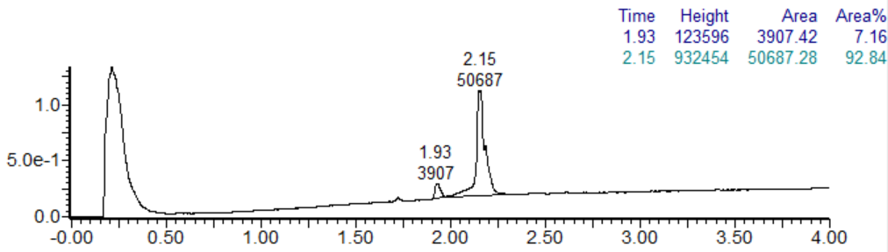

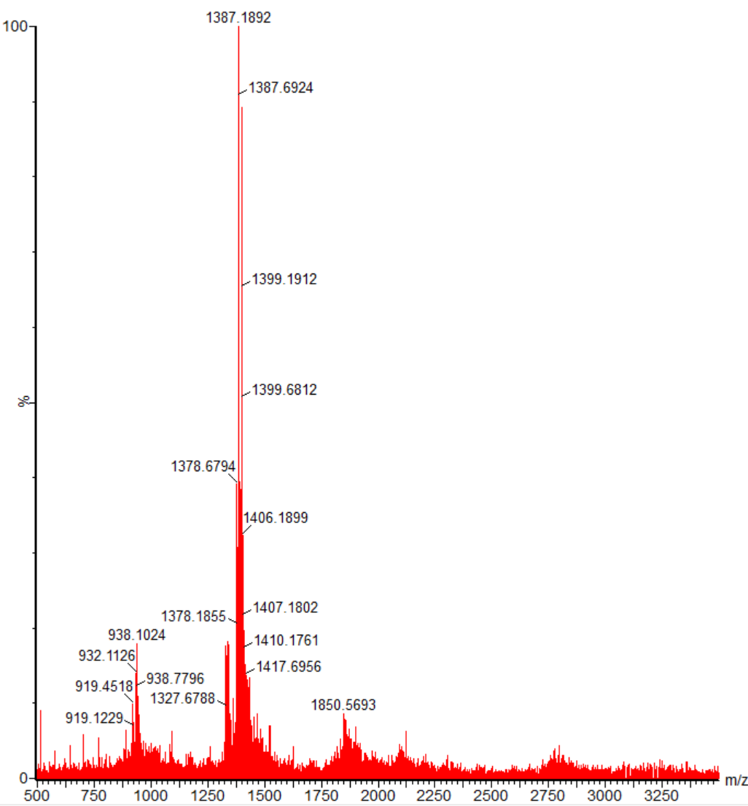

Compound 12

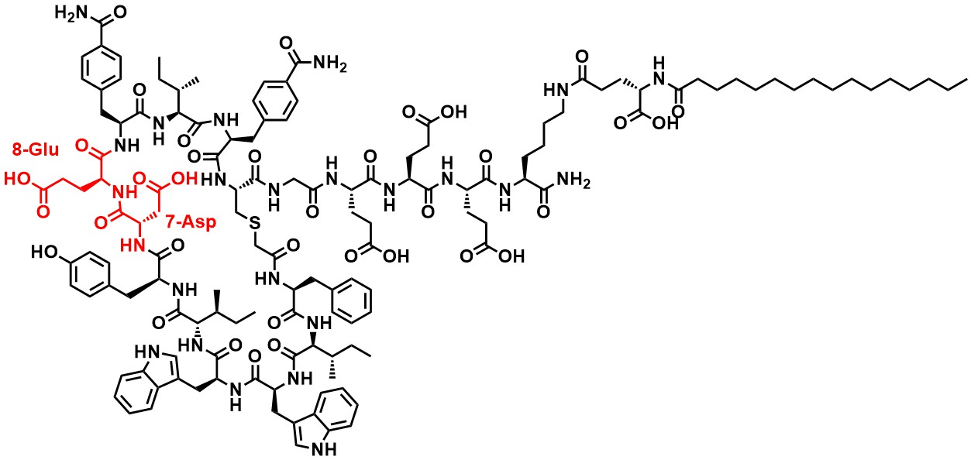
Compound 12 was synthesized by Synthetic Method S-B with KEC16 bound Rink-amide resin (0.05 mmol, 88 mg). The obtained linear peptide was cleaved from resin and cyclized, then purified using Purification Method. The obtained pure fractions were combined and evaporated, then lyophilized to give 18 mg (y. 13%) of compound 12 as a white solid. With Analytical, UV purity (220 nm) = 86% (Retention time = 2.59 min): HRMS calcd for [C136H184N24O35S] [M+2H]²⁺ 1374.1634, found 1374.1613.
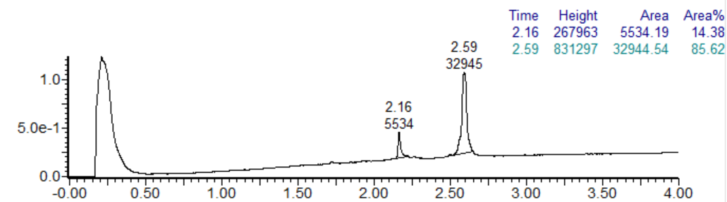
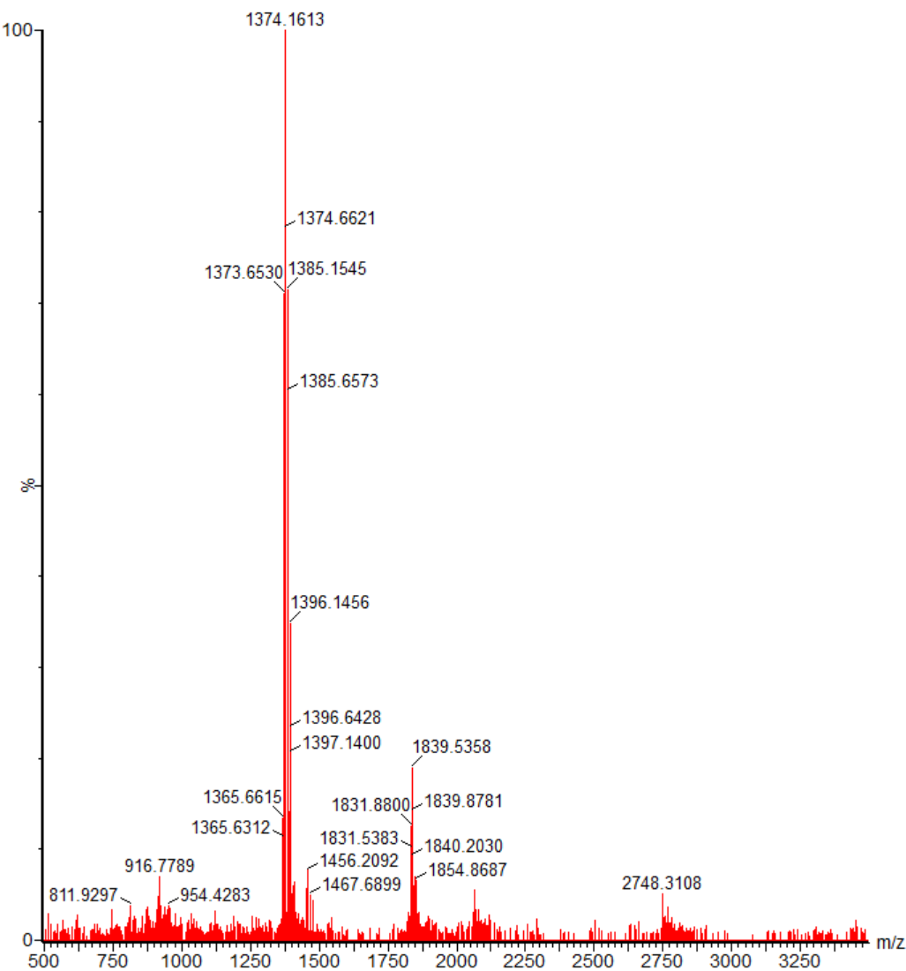

Compound 13

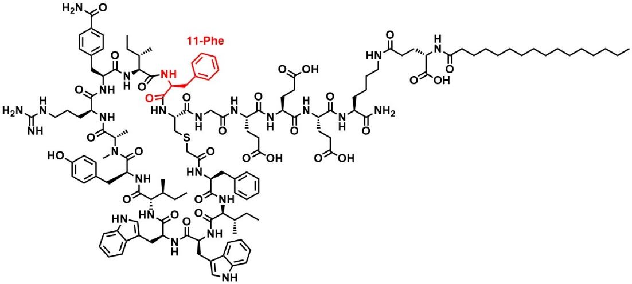
Compound 13 was synthesized by Synthetic Method S-A with KEC16 bound Rink-amide resin (0.05 mmol, 88 mg). The obtained linear peptide was cleaved from resin and cyclized, then purified using Purification Method. The obtained pure fractions were combined and evaporated, then lyophilized to give 14 mg (y. 10%) of compound 13 as a white solid. With Analytical, UV purity (220 nm) = 100% (Retention time = 2.28 min): HRMS calcd for [C136H190N26O30S] [M+2H]²⁺ 1351.2026, found 1351.2227.
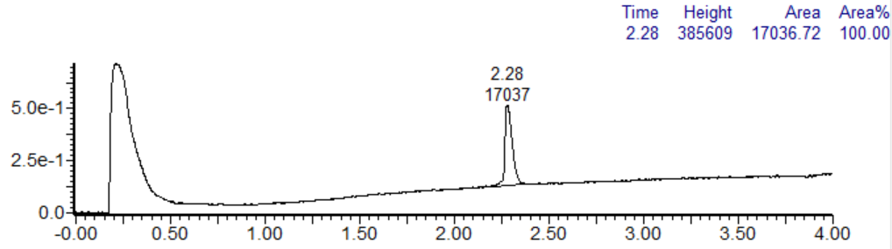
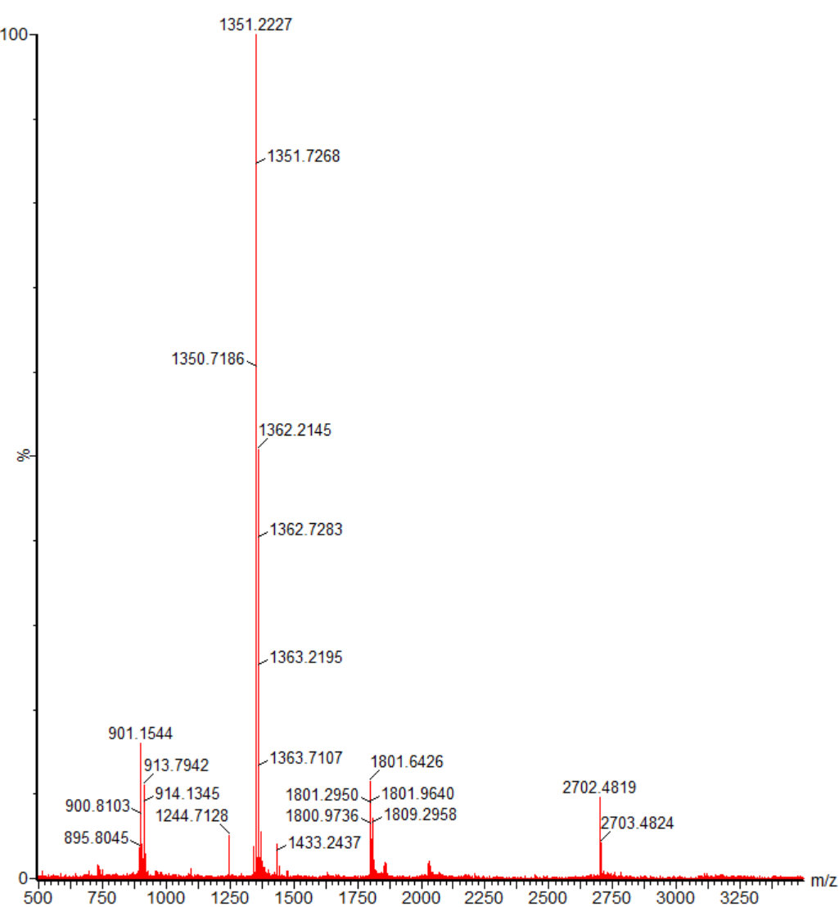

Compound 14

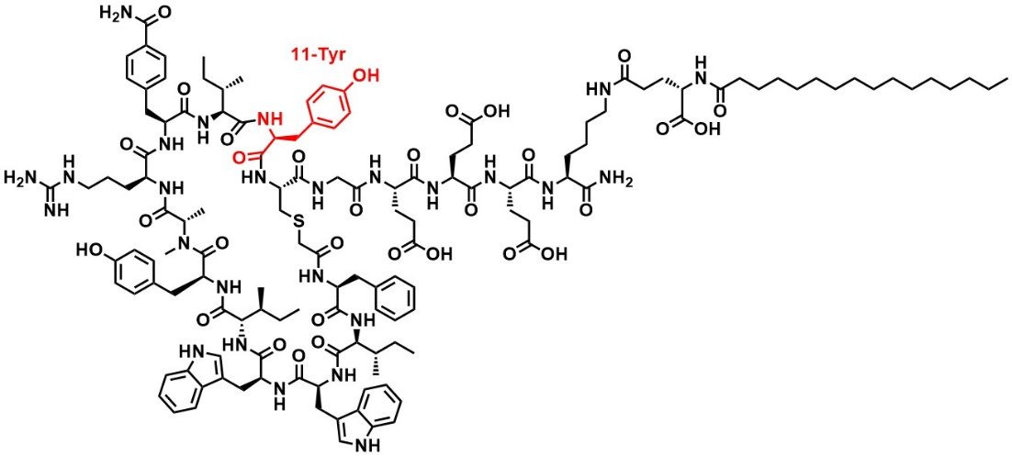
Compound 14 was synthesized by Synthetic Method S-A with KEC16 bound Rink-amide resin (0.05 mmol, 88 mg). The obtained linear peptide was cleaved from resin and cyclized, then purified using Purification Method. The obtained pure fractions were combined and evaporated, then lyophilized to give 12 mg (y. 17%) of compound 14 as a white solid. With Analytical, UV purity (220 nm) = 100% (Retention time = 2.24 min): HRMS calcd for [C136H190N26O31S] [M+2H]²⁺ 1359.2, found 1359.2172.
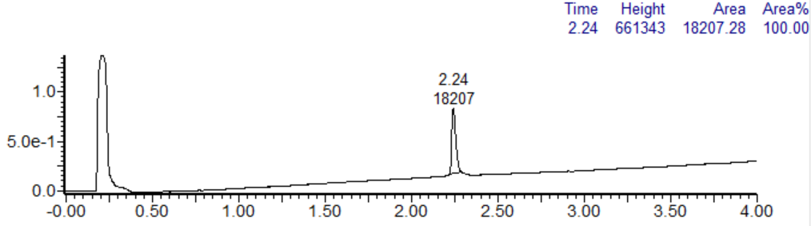
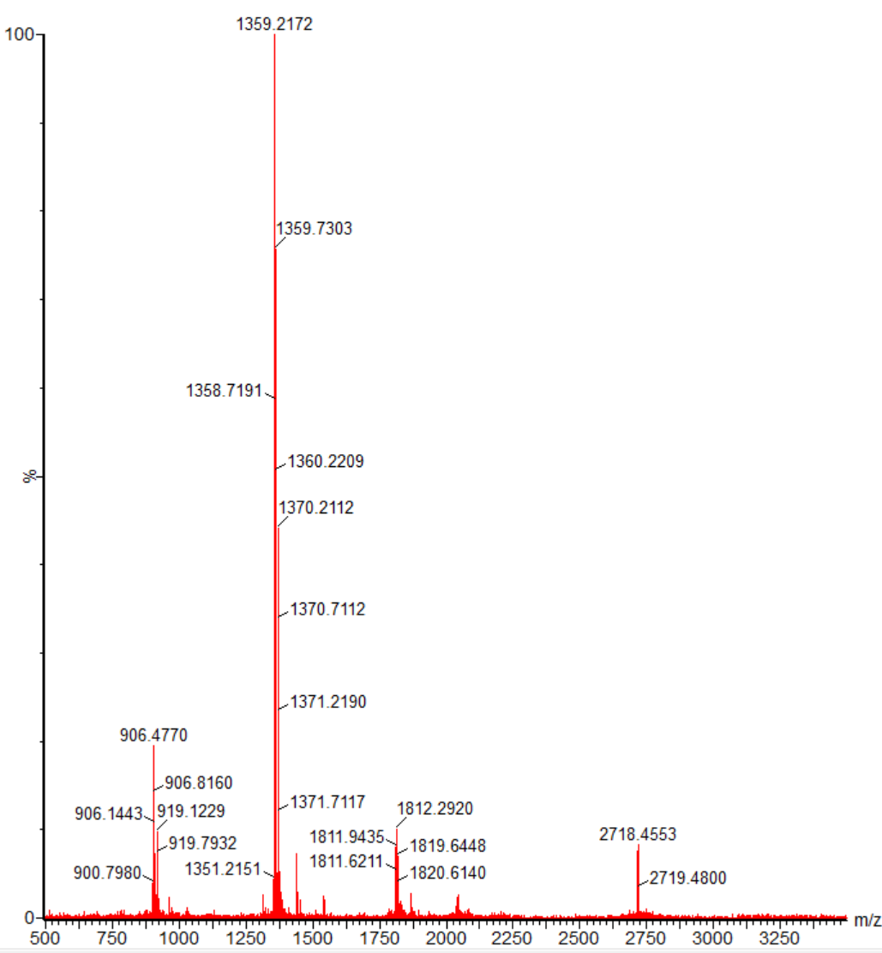

Compound 15

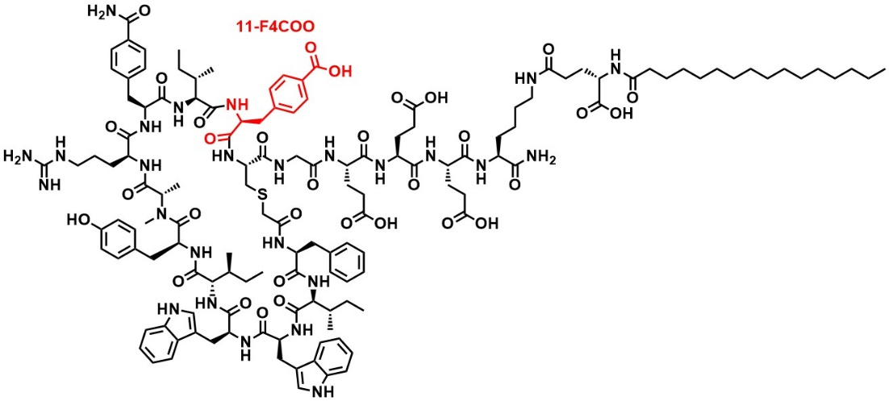
Compound 15 was synthesized by Synthetic Method S-A with KEC16 bound Rink-amide resin (0.05 mmol, 88 mg). The obtained linear peptide was cleaved from resin and cyclized, then purified using Purification Method. The obtained pure fractions were combined and evaporated, then lyophilized to give 11 mg (y. 16%) of compound 15 as a white solid. With Analytical, UV purity (220 nm) = 100% (Retention time = 2.23 min): HRMS calcd for [C137H190N26O32S] [M+2H]²⁺ 1373.1975, found 1373.2206.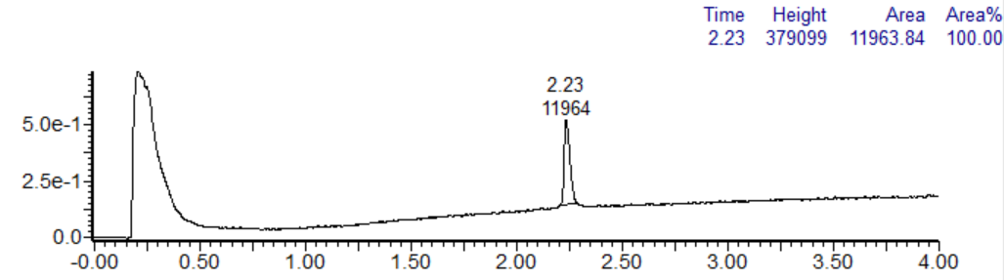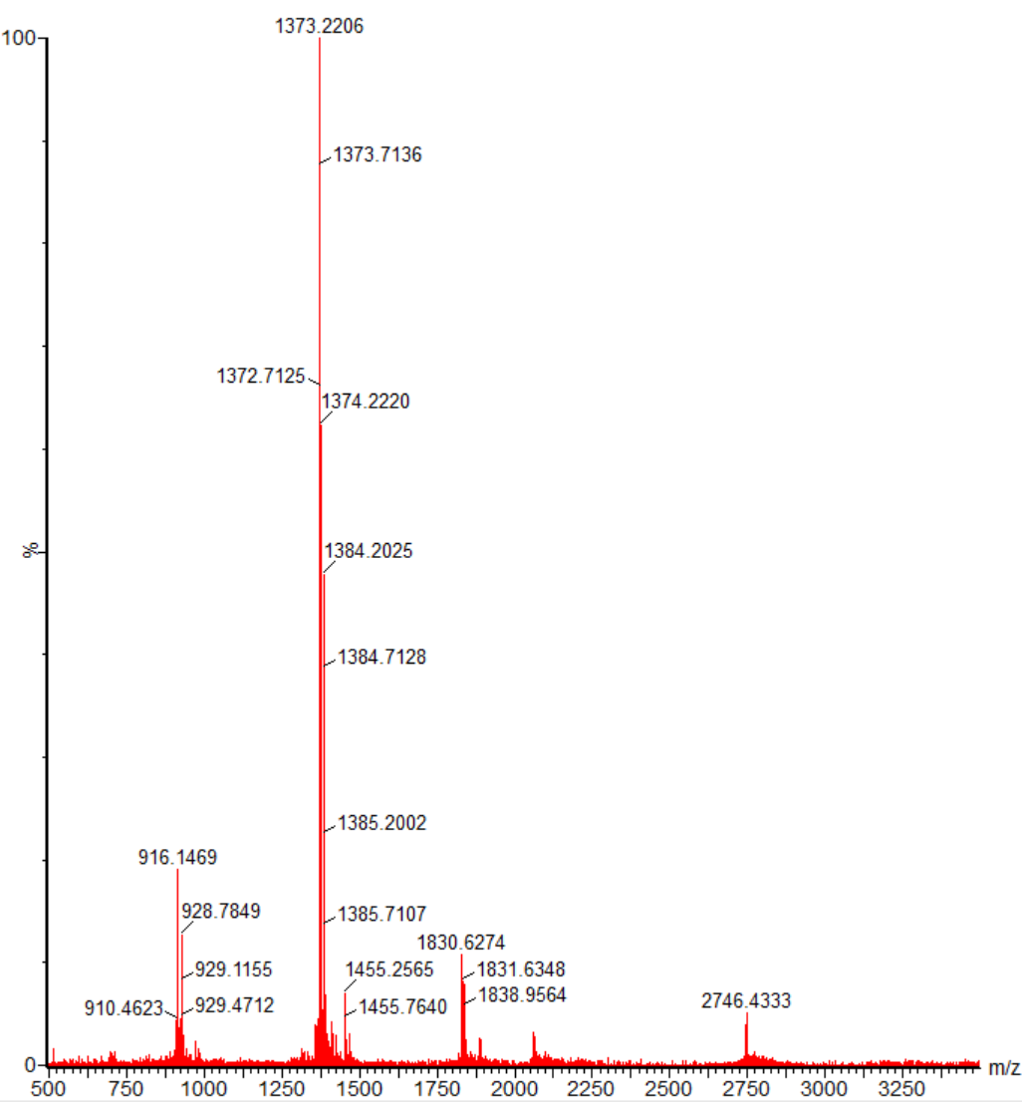

In vitro evaluation of antiviral activity and cytotoxicity
The antiviral activities and cytotoxicities of the candidate compounds were evaluated as previously described^{8,9} with minor modifications. Briefly, serially diluted compounds and each SARS-CoV-2 strain (at 300−3000 TCID₅₀/well) were added into wells of a 96-well plate and the plates were incubated for 1 h at room temperature (rt). Next, VeroE6/TMPRSS2 cells (1.5 × 10⁴ cells/well) suspended in MEM supplemented with heat-inactivated 2% FBS and 1% penicillin-streptomycin (viral assay medium) were seeded into each well and cultured for 3−4 days at 37 °C, 5% CO₂. Cell viability was evaluated using a CellTiter-Glo® 2.0 Cell Viability Assay. The EC₅₀ were determined by plotting the concentration of each compound versus the level of inhibition and fitting the data using a four-parameter logistical fit model (Model 205, XL fit). The CC₅₀ were evaluated in the same manner as antiviral activity but using uninfected cells.

Quantification of intracellular viral RNA by RT-qPCR
VeroE6/TMPRSS2 cells were seeded into 96-well plates (2.3 × 10⁴ cells/well) containing viral assay medium at 1 day prior to infection. To calculate the EC₉₀ against the hCoV-19/Japan/TY38-873/2021 (BA.1) and hCoV-19/Japan/TY40-385/2022 (BA.2) strains, compounds diluted with DMSO and viral assay medium were incubated with viral solution for 1 h at rt. After removing the cell culture medium, the mixture of compound and virus was added to the cells and incubated at 37 °C, 5% CO₂ for 24 h (BA.1: 3000 TCID₅₀/well, BA.2: 1000 TCID₅₀/well). To determine the EC₉₀ and PA-EC₉₀ values of each compound against hCoV-19/Japan/TY/WK-521/2020 (WT), the compounds were diluted in DMSO or D-PBS (–) and added to MEM containing 0%, 3.13%, 6.25%, 12.5%, or 25.0% human or mouse sera. After a 1-h incubation at rt, the viral solution containing human or mouse serum was added to the solution containing each antiviral compound and incubated for 1 h. After the removal of cell culture medium, this preincubated preparation was added to the cells and incubated at 37 °C, 5% CO₂ for 24 h (WT: 1000 TCID₅₀/well). Intracellular viral RNA was then extracted using the Direct-zol-96 RNA kit (ZYMO RESEARCH, Irvine, CA, USA) according to the manufacturer’s protocol. Viral RNA was qualified by RT-qPCR using the EXPRESS One-Step SuperScript qRT-PCR universal kit (Thermo Fisher Scientific) and PCR primer pairs targeting the N gene as previously described¹⁰.
The concentration of S-880008 or remdesivir required to cause a 10-fold reduction in viral RNA copy number relative to the viral control (i.e., in the absence of the antiviral compound) (EC₉₀) was calculated using the following formula:
EC₉₀ = 10[log10(x) + (log10(X) – log10(x)) × (y + 1) / (y − Y)]
In the formula, X is the lowest concentration required to achieve a > 1 log₁₀ copies/mL reduction in viral RNA compared with the viral control, x is the highest concentration required to achieve a ≤ 1 log₁₀ copies/mL reduction in viral RNA compared with the viral control, and Y and y represent the mean reduction in viral RNA copy number relative to the viral control at X and x, respectively.
To calculate the PA-EC₉₀ of 100% human or mouse serum, the EC₉₀ value at each concentration of human or mouse serum was extrapolated using linear regression.
The potency shift (PS) was calculated using the following formula:
PS = PA-EC₉₀ / EC₉₀ (0% serum)

Surface plasmon resonance (SPR)
All SPR experiments were carried out at 298K using the Biacore T200 system (Cytiba) with a Series S NTA sensor chip. Prior to ligand immobilization, the sensor chip was washed with 350 mM EDTA (10 μL/min for 1 min) and treated with 500 nM NiCl₂ (5 μL/min for 1 min) to saturate a surface with nickel. In the immobilization step, the spike proteins of the WT or BA.2 strain were diluted to a concentration of 50 ng/mL with running buffer (HBS-P buffer: 10 mM HEPES pH 7.4, 150 mM NaCl, 0.05% v/v Tween 20) and then loaded at a flow rate of 10 μL/min using “Manual run” mode. This achieved an immobilization level of between 700 and 900 resonance units (RU). The binding affinity of S-880008 for the spike protein was analyzed using the single cycle kinetic method at a flow rate of 100 μL/min in HBS-P buffer containing 1% DMSO. Increasing concentrations (12.3–1,000 nM) of S-880008 were injected consecutively, with an injection time of 180 s (per analyte) and a dissociation time of 1,800 s. After the dissociation step, the chip was regenerated with 500 mM EDTA, 5 M GuSCN in 5 mM TCEP, 1 mg/mL pepsin in 10 mM Glycine buffer (pH 2.1), and 50 mM NaOH in 1 M NaCl. Assays were performed in triplicate and each sensorgram was analyzed in 1:1 binding mode using the Biacore T200 evaluation Software (Cytiva).

Cryo-electron microscopy (Cryo-EM)
Sample preparation and data collection
To prepare the complexes of spike protein and antiviral compound required for Cryo-EM, the SARS-CoV-2 WT spike protein bearing six proline substitution (residues 817, 892, 899, 942, 986, and 987) and GSAS (Gly-Ser-Ala-Ser) at the furin cleavage site (residues 682−685), including the T4 fold of the trimerization domain, a histidine tag, and a Strep-tag, was expressed and purified using a previously reported procedure¹¹. The spike protein solution was incubated at 37 °C for 1 h before use. The purified compounds were dissolved in D-PBS (–) and sonicated for 10 min. Solutions of antiviral compound and spike protein (final concentration = 1.2 μM) were then mixed together. The following concentration of S-880008 were initially investigated: 1, 5, 10, 50, 100, and 200 μM; however, aggregates were observed on the Cryo-EM grid at concentrations ≥ 50 μM. Therefore, all subsequent complexes evaluated by Cryo-EM contained 10 μM compound and 1.2 μM spike protein in D-PBS (–). The mixtures were incubated at 18 °C for 1 h, before being applied to a Quantifoil R1.2/1.3 Cu 300 mesh grid, a R1.2/1.3 Cu 300 mesh with a 2-nm carbon layer grid, or a R2.0/2.0 Cu 300 mesh grid (Quantifoil Micro Tools GmbH, Großlöbichau, Germany). Each grid was freshly glow-discharged for 60 s at 10 mA using a PIB-10 (Vacuum Device, Ibaraki, Japan). The samples were plunged into liquid ethane and processed using a Vitrobot Mark IV system (Thermo Fisher Scientific) with the following settings: temperature, 18 °C; humidity, 100%; blotting time, 5 s; and blotting force, 5.
Micrographs were acquired using the Krios G4 cryo-transmission electron microscope (Thermo Fisher Scientific), which was operated at 300 kV with a K3 direct electron detector (Gatan) at a nominal magnification of 130,000 × (0.67 per physical pixel). A GIF-Biocontinuum energy filter (Gatan, Pleasanton, CA, USA) with a 20-eV slit width was used during the procedure. Each micrograph was acquired using a total exposure of 1.5 s and a total dose of 53.5 or 57.5 e/Å² over 50 frames. All micrographs were generated using EPU software (Thermo Fisher Scientific). The parameters of interest and data collection details are summarized in Extended Data Table 6.

Cryo-EM image processing
All datasets were processed using RELION 3.1 software¹². The movie frames obtained for the S-880008 complex were aligned and dose-weighted. The CTFFIND4¹³ program was then used to estimate the CTF of the aligned images, and those with a CTF max resolution score of < 5.5 Å were selected for further analysis. Auto-picking, based on a Laplacian-of-Gaussian filter and 2D classification (K = 100, T = 2), was performed for 41,490 particles to generate the 2D templates suitable for reference-based picking. Subsequently 849,174 particles picked with 2D reference were subjected to 2D classification. A 3D initial model was then generated using the particles assigned to the SARS-CoV-2-spike-protein-like class. 3D classification (K = 4, T = 4) was performed against the initial 3D model to remove junk particles. 81,884 particles belonging to optimal 3D class were re-extracted without binning (0.67 Å per pixel). These particles were used in the final 3D reconstruction with C3 symmetry to generate a map with a resolution of 3.02 Å after CTF refinement and Bayesian polishing. As the density of S-88008 was identified in the pockets formed at the RBD/SD1/NTD interface, the aligned particles were symmetry-expanded using the C3 symmetry operation. The UCSF Chimera program¹⁴ was then used to create a soft mask for the RBD/SD1/NTD/S-880008 complex. Focus 3D classification without alignment (K = 4, T = 16) was performed after signal subtraction. Using classes that distinctly showed the density of S-888008, a local map was generated through 3D refinement. The workflow of S-880008 Cryo-EM data processing is shown in Supplementary Fig. 1.
RELION 3.1 was used to align and dose-weigh the movie frames generated from spike complexes containing compounds 8−12. The same 2D templates as used for S-880008 were used to pick particles from the micrographs. 3D (K = 6, T = 4) and 2D (K = 200, T = 2) classification was used to remove junk particles from those that were selected. 3D classification (K = 4, T = 8) was then repeated to select best class for 3D refinement. If the complex only existed in a RBD 3-up state (compounds 8, 9, and 10), it was processed in the same way as the S-880008 complex, yielding a global map (C3 symmetry) and a local map focusing on the ligand. If the complex contained several RBD conformations (compounds 11 and 12), however, the particles were first aligned by 3D refinement, before 3D classification focusing on the RBD without alignment was performed to separate each RBD orientation state. Finally, each state was refined to obtain a map. The workflow of Cryo-EM data processing for compounds 8−12 is shown in Supplementary Fig. 2, 3.
The reported resolutions are based on the gold-standard Fourier shell correlation curve (FSC) threshold of 0.143. Local resolutions were calculated using RELION 3.1¹⁵. The data processing figures and final reconstructed maps were prepared using Chimera (version 1.15)¹⁴ and Chimera X (version 1.1)¹⁶.

Cryo-EM model building and analysis
The SARS-CoV-2 spike protein (PDB:7K4N)¹⁷ was fitted to a map of the S-880008 complex using the UCSF Chimera program. Molecular restraints were created by eLBOW¹⁸ after processing in Phenix (version 1.19)¹⁹. Iterative rounds of manual fitting in Coot (version 0.9.6)²⁰ and real-space refinement in Phenix were performed to improve the non-ideal rotamers, bond angles, and Ramachandran outliers. The final model was validated using MolProbity²¹. The other ligand complexes were fitted and refined in the same way as the S-880008 complex, using the structure of S-880008 complex as the initial model. The surface, cartoon, and stick representations of the structural models presented in the figures were prepared using PyMOL (version 2.3.3) (http://pymol.sourceforge.net).

Time of addition assay
A time of addition assay was performed according to our previous report²² with minor modifications. VeroE6/TMPRSS2 cells were seeded into 96-well plates (1.5 × 10⁴ cells/well) at 1 day prior to viral infection. SARS-CoV-2 (WT: 1 × 10⁴ TCID₅₀/mL) was incubated for 1 h at rt in the presence or absence of serially diluted antiviral compounds. After removing the cell culture medium, 100 μL of the SARS-CoV-2 (WT: 1 × 10³ TCID₅₀/well), either alone or in combination with various serially diluted antiviral compounds, was added to the wells. After a 1-h incubation at 37 °C, 5% CO₂, the supernatants were removed, and 100 μL of viral assay medium, with or without the serially diluted antiviral compounds was added to the wells. After a final 6-h incubation at 37 °C, 5% CO₂, the viral RNA was quantified by RT-qPCR and EC₉₀ was calculated as described earlier.

Protein-protein interaction ELISA
A 1 μg/mL solution of spike protein (ACROBiosystems) was used to coat 384-well assay plates (Thermo Fisher Scientific) overnight at 4 ℃. After removing the coating solution, the plates were washed three times with D-PBS (–) containing 0.05% Tween 20 (PBS-T) and then blocked with 1% BSA in PBS-T at rt. After removing the supernatant, the plates were washed three times with PBS-T. S-880008 was three-fold serially diluted in PBS-T to a final concentration range of 1.27 nM to 25 μM, before being added to the wells. A three-fold serially diluted (in PBS-T) neutralizing antibody cocktail of CAS + IMD (final concentration range of 0.51 nM to 10 μM) was then added to each plate as a positive control. Each plate also included the high (ACE2 plus PBS-T) and low (PBS-T alone) control wells. All plates were then incubated for 1 h at rt. After incubation completion, 100 ng/mL biotinylated human ACE2 protein (ACROBiosystems) and 100 ng/mL HRP-conjugated streptavidin (Thermo Fisher Scientific), which were prepared in PBS-T containing 0.1% BSA, were added to the samples, the positive control, and the high control. 100 ng/mL HRP-conjugated streptavidin was also added to the low control wells. All the plates were then incubated again for 1 h at rt. After incubation completion, the plates were washed three times with PBS-T. Finally, the TMB-ELISA Substrate Solution (Thermo Fisher Scientific) was added to the wells and the plates were incubated at rt for 5 min. The color reaction was stopped by the addition of sulfuric acid. Absorbance at 450 nm was measured using a microplate reader.

Cell fusion assay
Preparation of cells and plasmids
VeroE6/TMPRSS2/GFP cells and VeroE6/TMPRSS2/mCherry cells were established by lentiviral transduction. These cells were maintained in DMEM supplemented with 10% FBS and 1% penicillin-streptomycin. The pCMV-Myc-C-Spro (WT) and pCMV-Myc-C-Spro (δ) plasmids were generated by cloning the base sequence of the spike protein derived from hCoV-19/Japan/TY/WK-521/2020 strain (WT) and hCoV-19/Japan/TY11-927-P1/2021 strain (δ), respectively, into the pCMV-Myc-C vector (Takara Bio Inc., Shiga, Japan).

Cell fusion inhibition assay
pCMV-Myc-C-Spro (WT) or pCMV-Myc-C-Spro (δ) plasmid was incubated at rt for ≥ 15 min with the Opti-MEM® I (Thermo Fisher Scientific) and TransIT®-LT1 (Takara Bio Inc.) reagents. These mixtures were then diluted in assay medium (MEM supplemented with 2% FBS and 1% penicillin-streptomycin) and dispensed into a 96-well plate at 0.1 μg of plasmid per well. pCMV-Myc-C was used as a negative control. The VeroE6/TMPRSS2/GFP cells and VeroE6/TMPRSS2/mCherry cells were mixed at a 1:1 cell ratio, before being seeded into the 96-well plate (3 × 10⁴ cells/well) and incubated at 37 °C, 5% CO₂ for 6 h. After incubation completion, the culture fluid was removed and 200 μL of S-880008, remdesivir, or CAS + IMD (diluted to appropriate concentrations with assay medium) was added into the 96-well plate. The 96-well plate was then incubated at 37 °C, 5% CO₂ for a further 42 h (WT) or 26 h (δ). At 48 h (WT) or 32 h (δ) after plasmid transfection, images of GFP and mCherry fluorescence were captured on a BZ-X800 fluorescence microscope (Keyence, Osaka, Japan). Finally, the size of the area of GFP and mCherry colocalization was measured in the images using BZ-X800 analysis software (Keyence).

S-880008-resistant viruses
Isolation of SARS-CoV-2 with low susceptibility to S-880008
VeroE6/TMPRSS2 cells (cultured in T-75 flasks, Corning Inc., Corning, NY, U.S.) were infected with each SARS-CoV-2 strain (WT, α, δ, and BA.2: 75,000 TCID₅₀) for 2 days at 37 °C, 5% CO₂. These SARS-CoV-2-infected cells were used for the isolation of S-880008-resistant virus. First, 250 μL/well of viral assay medium (with or without S-880008), 500 μL/well of fresh, uninfected VeroE6/TMPRSS2 cells (4 × 10⁵ cells/mL), and 250 μL/well of SARS-CoV-2-infected VeroE6/TMPRSS2 cells were added to each well of a 24-well plate. The plates were then incubated for 3 days at 37 °C, 5% CO₂. After incubation completion, 100 μL/well of SARS-CoV-2-infected VeroE6/TMPRSS2 cells and 400 μL/well of viral assay medium (with or without S-880008) was mixed in new 24-well plates, and the plates were incubated for 1 h at rt. Next, 250 μL/well of fresh VeroE6/TMPRSS2 cells (2 × 10⁵ cells) and 250 μL/well of viral assay medium (with or without S-880008) was added to the 24-well plates, and the plates were incubated for 3 days at 37 °C, 5% CO₂. This process was repeated five times. After five passages (when CPE of viral infection were observed), the cell culture medium was collected for viral mRNA extraction. The extracted viral RNA was genotyped using the iSeq 100 sequencing system (Illumina) according to manufacturer’s protocol. The criteria for the selection of characteristic amino acid substitutions for the preparation of S-880008-resistant viruses by reverse genetics (RG) were: 1) A given amino acid substitution was present in several SARS-CoV-2 strains, and 2) If several base codons encoded the same amino acid, the base codons found in multiple samples at a frequency > 50% were selected.

Preparation of S-880008-resistant SARS-CoV-2 variants using RG
The RG approach yielded 11 viruses, which comprised one WT virus and 10 viruses containing each of the 10 characteristic amino acid substitution in the spike region. Viruses harboring the F562C or L984F mutations failed to grow. The remaining eight viruses, however, exhibited CPE in VeroE6/TMPRSS2 cells and had sufficiently high viral titers to be used in cell-based, antiviral activity evaluation assays.

Assessing the antiviral activity of S-880008-resistant viruses
The antiviral activities of the candidate compounds against the S-880008-resistant viruses were evaluated as described earlier. Briefly, serially diluted compounds and each RG-generated virus (at 1,000 TCID₅₀/well) were added to wells of 96-well plates and incubated for 1 h at rt. After incubation completion, the VeroE6/TMPRSS2 cells (1.5 × 10⁴ cells/well) were added to each well and cultured for 3 days at 37 °C, 5% CO₂.

Evaluating the antiviral efficacy of S-880008 in combination with other antiviral agents in vitro
VeroE6/TMPRSS2 cells were suspended in viral assay medium and seeded into 96-well plates (1.5 × 10⁴ cells/well) at 1 day prior to infection. The combination of S-880008 with remdesivir or nirmatrelvir was tested in the first set of assays. Two-fold serial dilutions (in viral assay medium) of S-880008, remdesivir, or nirmatrelvir were prepared. After removing the cell culture medium, S-880008 was added to each row, while remdesivir or nirmatrelvir were added to each lane, of the 96-well plate. SARS-CoV-2 (WT: 1,000 TCID₅₀/well) was then added to the plates and the cells were cultured for 3 days at 37 °C, 5% CO₂. The next set of assays tested the combination of S-880008 with CAS + IMD. Again, 2-fold serial dilution of S-880008 and CAS + IMD were established in viral assay medium; however, this time they were added to each row and lane of new 96-well plates that did not contain cells. SARS-CoV-2 was added to the plates containing S-880008 and CAS + IMD and incubated for 1 h at rt. Next, the cell culture medium was removed from the wells containing cells that were seeded at 1 day prior to infection. The cells were then incubated with the virus (1,000 TCID₅₀/well) + compound mixture for 3 days at 37 °C, 5% CO₂. After incubation completion, the inhibitory effects of the antiviral compound combinations were evaluated using a CellTiter-Glo® 2.0 Cell Viability Assay kit.
Data was analyzed according as previously described²⁴. Briefly, the EC₅₀ of each compound alone was first calculated using XLfit (version 5.3.1.3) software (fit model: 205; ID Business Solutions). The combination index (CI) values for each condition involving two compounds (compound A and compound B) were then calculated using the following formula:
CI = (D_{A/A + B})/D_{A} + (D_{B/A + B})/D_{B} + (D_{A/A + B} × D_{B/A + B})/(D_{A} × D_{B})
In the formula, D_{A} and D_{B} are the EC₅₀ values of compounds A and B alone, respectively. D_{A/A + B} is the concentration of compound A that achieved a 50% inhibition in combination with compound B at the closest ratio of each EC₅₀ value. D_{B/A + B} is the concentration of compound B that achieved 50% inhibition in combination with compound A at the closest ratio of each EC₅₀ value. The combination effects were defined based on the CI value: synergy, CI ≤ 0.8; additive effect, 0.8 < CI < 1.2; and antagonism, CI ≥ 1.2.

In vivo mouse experiments
Ethics statement
Animal experiments were authorized by the Shionogi Pharmaceutical Research Centre Institute Director (Shionogi & Co., Ltd., Toyonaka, Japan) based on the report produced by the Institutional Animal Care and Use Committee (approval number: S21043D) and performed in accordance with the guidelines set out by this committee. The facilities where the animal experiments were conducted are certified by the Association for Assessment and Accreditation of Laboratory Animal Care International.

Animals
Female BALB/cAJcl mice were purchased from CLEA Japan, Inc (Tokyo, Japan). All mice were maintained in a controlled environment of 20–26 °C, 30%–70% relative humidity, and a 12 h light/dark cycle. Animals were housed at a density of five mice per cage and were maintained on a standard chow diet of CE-2 (CLEA Japan, Inc.) with water available ad libitum. Mice experiencing a >20% drop in body weight, which constitutes a humane endpoint, were euthanized.

Non-lethal mouse model
Five-week-old mice were intranasally inoculated with 50 μL (100 TCID₅₀/mouse) of SARS-CoV-2 MA-P10 diluted in D-PBS (–) under anesthesia. The mice were then treated intranasally with S-880008 (0.01, 0.1, or 1 mg/kg/dose once daily, or 0.005, 0.05, or 0.5 mg/kg/dose twice a day) at 1 day post-infection (dpi). D-PBS (vehicle) was intranasally administered once or twice daily at 1 dpi as a negative control. NHC (150 mg/kg/dose, dissolved in saline [Otsuka Pharmaceutical Factory, Inc., Tokushima, Japan]) was orally administered twice a day for 5 consecutive days from 1 to 5 dpi as a positive control. The dosing volume was 2.5 mL/kg/dose (S-880008 and vehicle) or 10 mL/kg/dose (NHC). Mice (n = 5/group) were euthanized at 1, 2, 4, or 9 dpi and their lung tissues were harvested. The lung samples were homogenized in 2 mL of D-PBS (–). The homogenates were then centrifuged at 3,000 rpm for 5 min at 4 °C and the supernatants were filtered through 0.45-μm filters. Lung homogenate aliquots were stored at −80°C until use. Viral assay medium (75 μL) was added to wells of a 96-well plate. VeroE6/TMPRSS2 cells were suspended in viral assay medium to 1.5 × 10⁵ cells/mL and added to the plates at 100 μL/well. 10-fold serial dilution of lung homogenates were prepared in viral assay medium, and 25 μL of each diluted sample was added to the wells. The plates were incubated for 4 days at 37°C, 5% CO₂. After incubation completion, the extent of virus-induced CPE was quantified using a microscope. Viral titer was expressed as log₁₀ TCID₅₀/mL, and the LLOD was defined as 1.80 log₁₀ TCID₅₀/mL. If no CPE was observed at the lowest dilution of compound, the LLOD was imputed as the viral titer.
For the pharmacokinetic analysis, approximately 0.1 mL of blood was collected from the posterior maxillary vein using a heparinized capillary (in the absence of anesthesia) at 24 h after S-880008 treatment (2 dpi). Plasma was obtained by centrifuging the blood at 12,000 rpm for 3 min at 4 °C. The plasma or the lung homogenates (30 μL, both collected at 2 dpi) were each mixed with 120 μL methanol and the mixtures were incubated for 2 min at rt. The samples were then centrifuged (12,000 rpm for 3 min at 4 °C) and 100 μL of the supernatant was removed and stored at −80°C until the determination of S-880008 concentration.

Lethal mouse model
Retired breeder female BALB/c mice (10–12-months-old) were used to establish the lethal model of SARS-CoV-2 MA-P10 infection. S-880008 and NHC were administered in the same way as outlined in the “Non-lethal mouse model” section. The survival rates and body weight changes were monitored throughout the 14-day post-infection period (n = 5/group). Viral titers in the lungs of mice at 4 dpi (n = 2–3/group) were determined in Vero E6/TMPRSS2 cells. IL-6 levels in the lungs of mice at 4 dpi (n = 2–5/group) were measured as previously reported¹⁰. Whole lung weights of infected and uninfected mice in the S-880008 and NHC treatment groups (n = 5–6) at 4 dpi were measured. Whole lung weight as a proportion of body weight was also calculated.

Pharmacokinetic-pharmacodynamic (PKPD) analysis
Bioanalytical assessments
The concentrations of S-880008 in plasma and lung homogenate samples were determined by LC–MS/MS using a SCIEX TQ6500Plus mass spectrometer (AB SCIEX, Framingham, MA, USA). A structural analog of S-880008 was used as an internal standard (IS). Equal volumes (75 μL) of supernatant and 0.4 ng/mL IS (reconstituted in methanol) were mixed. A 10-μL aliquot of assay solution was then injected into the HPLC system and separated on a reversed-phase column (YMC-Triart C18 column, 2.1 mm × 50 mm; 3 μm, YMC Co., Ltd., Kyoto, Japan) using an elution gradient of mobile phase A (H₂O/formic acid = 1,000/1) and mobile phase B (acetonitrile/formic acid = 1,000/1) at a flow rate of 0.75 mL/min. Mass spectrometry was performed in the positive electrospray ionization mode, using multiple reaction monitoring with m/z transitions of 1372.8 → 451.2 for S-880008 and 1365.6 → 437.1 for IS. Good linearity was achieved over the 1.5–5,000 ng/mL concentration range of the plasma and lung homogenate samples.

PKPD analysis
The concentration of S-880008 in the plasma and lung homogenate samples was used as a PK parameter in the PKPD analysis. The PD data and the PKPD parameters of the various antiviral compounds were analyzed using a nonlinear regression model, generated by XLfit (version 5.3.1.3; ID Business Solutions)²⁵. These data were fitted to the four-parameter logistic equation (model 604) y = A – B exp (– C x^{D}), where y was the difference in log₁₀ TCID₅₀/mL between each dosing group and the vehicle group; A was the maximum y (locked at 5.17), which was the viral titer reduction observed in individuals showing maximal response; B was range of y values (locked at 5.17), which ranged from 0 (minimum value) to 5.17 (maximum value as A); C was the scaling factor; D was the EC₅₀ (i.e., the value of a PKPD parameter that produced a 50% maximum effect); and x was the value of each PKPD parameter (C_{plasma} or C_{lung}). In the PKPD analysis, a lower limit of quantification value was substituted in when the plasma and lung concentrations were below the lower limit of quantification.

Statistical analysis
The log-rank test was used to compare the post-infection survival lengths of the S-880008-, NHC-, and vehicle-treated groups. Dunnett’s multiple-comparison test was used to compare the viral titers and IL-6 levels in the lung tissues, we all as the lung weights of mice in the S-880008- or NHC-treated groups and the vehicle-treated group at each time point. The log-rank test and Dunnett’s multiple-comparison test were conducted using SAS version 9.2 for Windows (SAS Institute, Cary, NC, USA) and Prism version 9.5.1 for Windows (GraphPad Software, Boston, MA, USA), respectively. P-values < 0.05 were considered as a measure of statistical significance.

Supplementary References
1. Matsuyama, S. et al. Enhanced isolation of SARS-CoV-2 by TMPRSS2- expressing cells. Proc. Natl. Acad. Sci. U. S. A. 117, 7001–7003 (2020).
2. Uemura, K. et al. 2-Thiouridine is a broad-spectrum antiviral nucleoside analogue against positive-strand RNA viruses. bioRxiv (2022) doi:10.1101/2022.12.14.520006.
3. Dinnon, K. H. et al. A mouse-adapted model of SARS-CoV-2 to test COVID-19 countermeasures. Nature 586, 560–566 (2020).
4. Leist, S. R. et al. A Mouse-Adapted SARS-CoV-2 Induces Acute Lung Injury and Mortality in Standard Laboratory Mice. Cell 183, 1070–1085.e12 (2020).
5. Gu, H. et al. Adaptation of SARS-CoV-2 in BALB/c mice for testing vaccine efficacy. Science (80-. ). 369, 1603–1607 (2020).
6. Goto, Y., Katoh, T. & Suga, H. Flexizymes for genetic code reprogramming. Nat. Protoc. 6, 779–790 (2011).
7. Ishizawa, T., Kawakami, T., Reid, P. C. & Murakami, H. TRAP display: A high-speed selection method for the generation of functional polypeptides. J. Am. Chem. Soc. 135, 5433–5440 (2013).
8. Unoh, Y. et al. Discovery of S-217622, a Noncovalent Oral SARS-CoV-2 3CL Protease Inhibitor Clinical Candidate for Treating COVID-19. J. Med. Chem. (2022) doi:10.1021/acs.jmedchem.2c00117.
9. Kawashima, S. et al. Ensitrelvir is effective against SARS-CoV-2 3CL protease mutants circulating globally. Biochem. Biophys. Res. Commun. 645, 132–136 (2023).
10. Nobori, H. et al. Efficacy of ensitrelvir against SARS-CoV-2 in a delayed-treatment mouse model. J. Antimicrob. Chemother. 77, 2984–2991 (2022).
11. Onodera, T. et al. A SARS-CoV-2 antibody broadly neutralizes SARS-related coronaviruses and variants by coordinated recognition of a virus-vulnerable site. Immunity 54, 2385–2398.e10 (2021).
12. Zivanov, J. et al. New tools for automated high-resolution cryo-EM structure determination in RELION-3. Elife 7, 1–22 (2018).
13. Rohou, A. & Grigorieff, N. CTFFIND4: Fast and accurate defocus estimation from electron micrographs. J. Struct. Biol. 192, 216–221 (2015).
14. Pettersen, E. F. et al. UCSF Chimera - A visualization system for exploratory research and analysis. J. Comput. Chem. 25, 1605–1612 (2004).
15. Kucukelbir, A., Sigworth, F. J. & Tagare, H. D. Quantifying the local resolution of cryo-EM density maps. Nat. Methods 11, 63–65 (2014).
16. Goddard, T. D. et al. UCSF ChimeraX: Meeting modern challenges in visualization and analysis. Protein Sci. 27, 14–25 (2018).
17. Tortorici, M. A. et al. Ultrapotent human antibodies protect against SARS-CoV-2 challenge via multiple mechanisms. Science (80-. ). 370, 950–957 (2020).
18. Moriarty, N. W., Grosse-Kunstleve, R. W. & Adams, P. D. Electronic ligand builder and optimization workbench (eLBOW): A tool for ligand coordinate and restraint generation. Acta Crystallogr. Sect. D Biol. Crystallogr. 65, 1074–1080 (2009).
19. Liebschner, D. et al. Macromolecular structure determination using X-rays, neutrons and electrons: Recent developments in Phenix. Acta Crystallogr. Sect. D Struct. Biol. 75, 861–877 (2019).
20. Emsley, P., Lohkamp, B., Scott, W. G. & Cowtan, K. Features and development of Coot. Acta Crystallogr. Sect. D Biol. Crystallogr. 66, 486–501 (2010).
21. Williams, C. J. et al. MolProbity: More and better reference data for improved all-atom structure validation. Protein Sci. 27, 293–315 (2018).
22. Sasaki, M. et al. S-217622, a SARS-CoV-2 main protease inhibitor, decreases viral load and ameliorates COVID-19 severity in hamsters. Sci. Transl. Med. 15, eabq4064 (2023).
23. Torii, S. et al. Establishment of a reverse genetics system for SARS-CoV-2 using circular polymerase extension reaction. Cell Rep. 35, 109014 (2021).
24. Chou, T. & Talalay, P. Quantitative Dose-Effect Relationships : the Combined Effects of Multiple. Adv Enzym. Regul 22, 27–55 (1984).
25. Ando, Y. et al. Pharmacokinetic and pharmacodynamic analysis of baloxavir marboxil, a novel cap-dependent endonuclease inhibitor, in a murine model of influenza virus infection. J. Antimicrob. Chemother. 76, 189–198 (2021).

Supplementary Figures
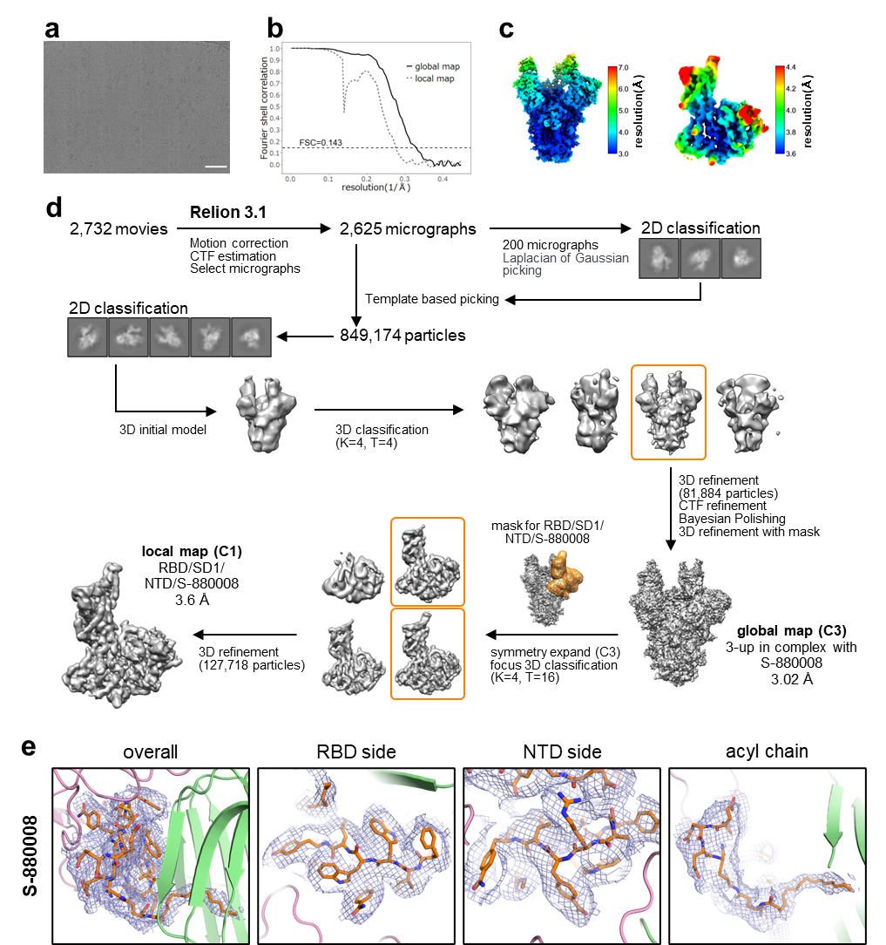
Supplementary Fig. 1 The Cryo-EM data processing strategy used to characterize the SARS-CoV-2 spike trimer in complex with S-880008.
a. Representative micrograph. Scale bar = 50 nm. b. Resolution assessment of S-880008 complex maps with the Gold-standard Fourier shell correlation (FSC) curve threshold set to 0.143. c. Local resolution heat map. d. Cryo-EM data processing flowchart. e. Map-model fitting of S-880008.

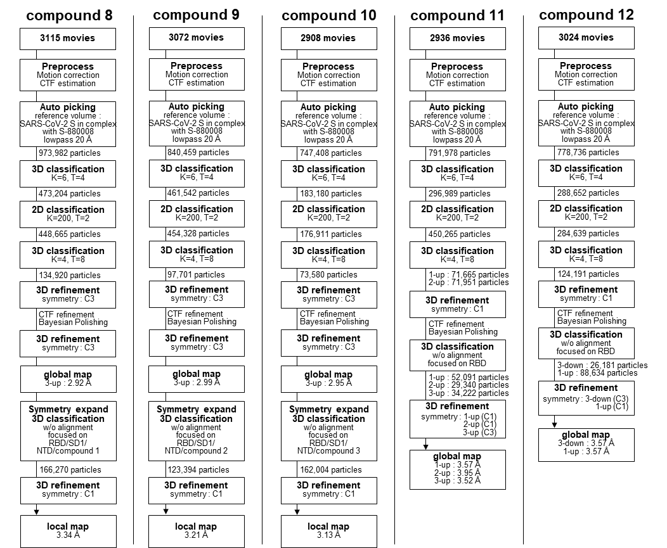
Supplementary Fig. 2 Cryo-EM data processing flowcharts for SARS-CoV-2 spike trimer in complex with each antiviral compound.

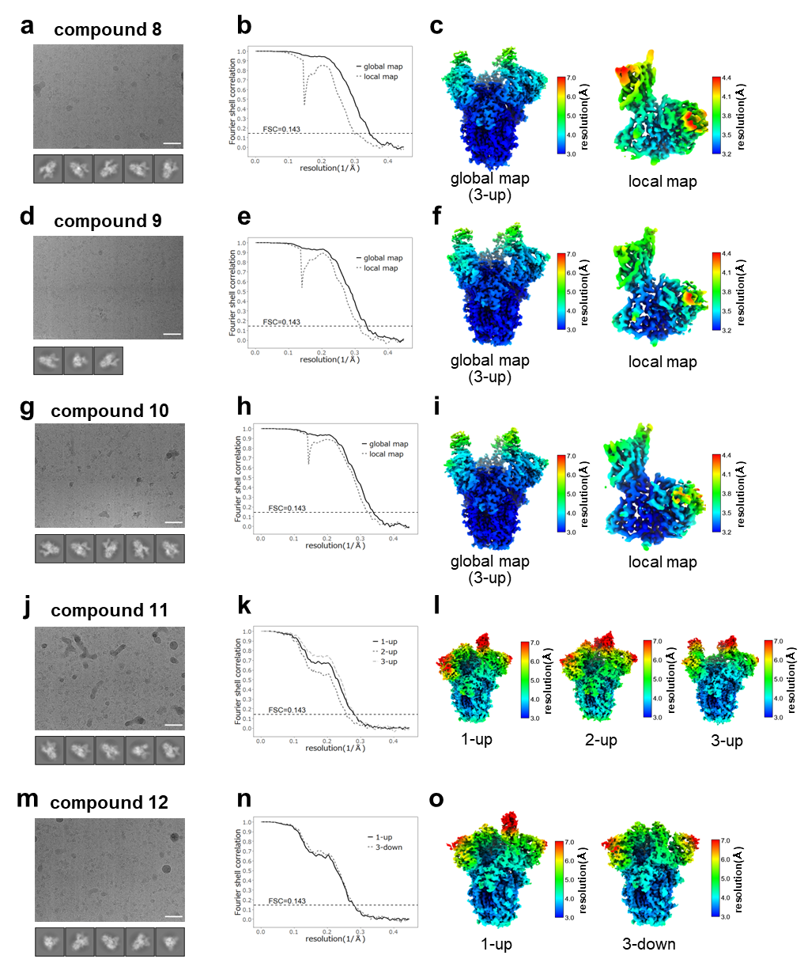
Supplementary Fig. 3 Cryo-EM data obtained for each antiviral compound in complex with the SARS-CoV-2 spike trimer.
a, d, g, j, m. Representative micrographs. Scale bar = 50 nm. b, e, h, k, n. Representative 2D class images. c, f, i, l, o. Resolution assessment of maps with a Gold-standard Fourier shell correlation (FSC) curve threshold of 0.143.

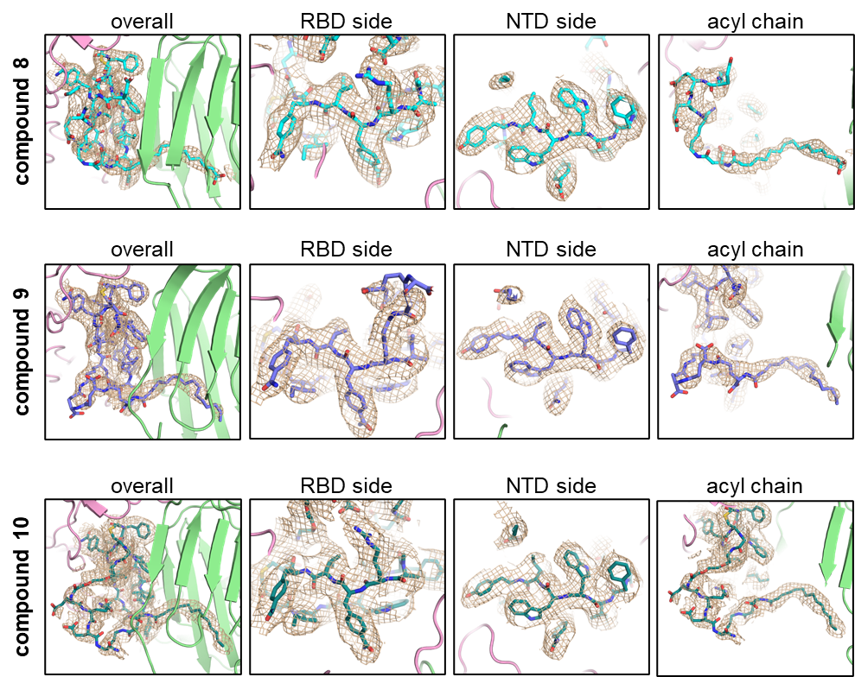
Supplementary Fig. 4 Map-model fitting of compound 8, 9, and 10.

