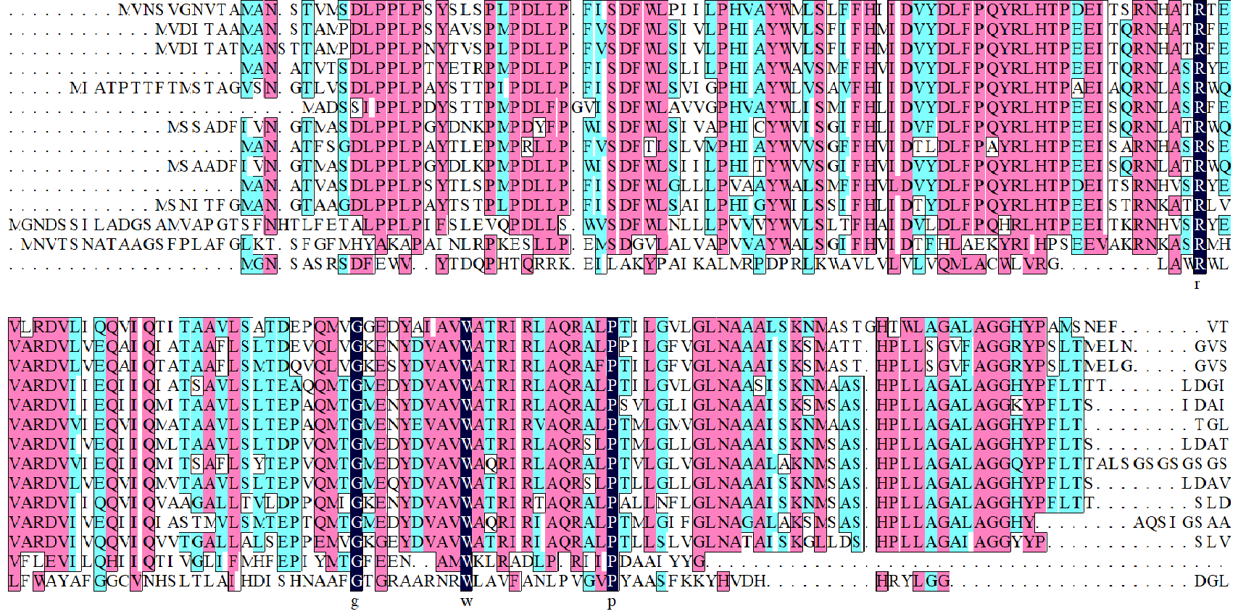
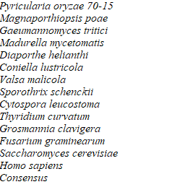
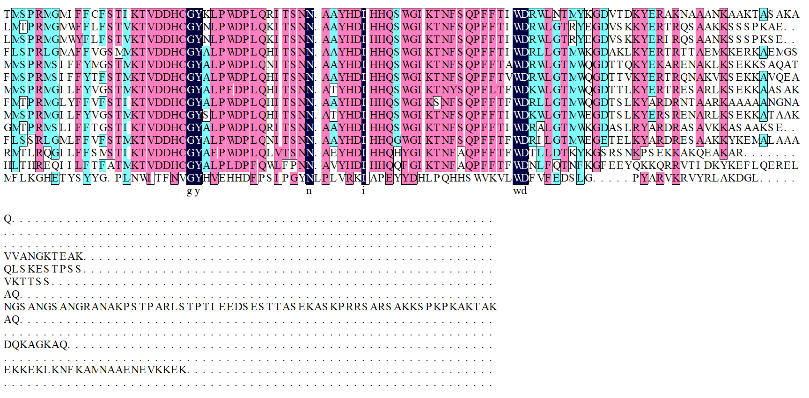

FigureS1| Sequence alignment of MoSur2 protein with several filamentous fungi and Homo sapiens using DNAMAN

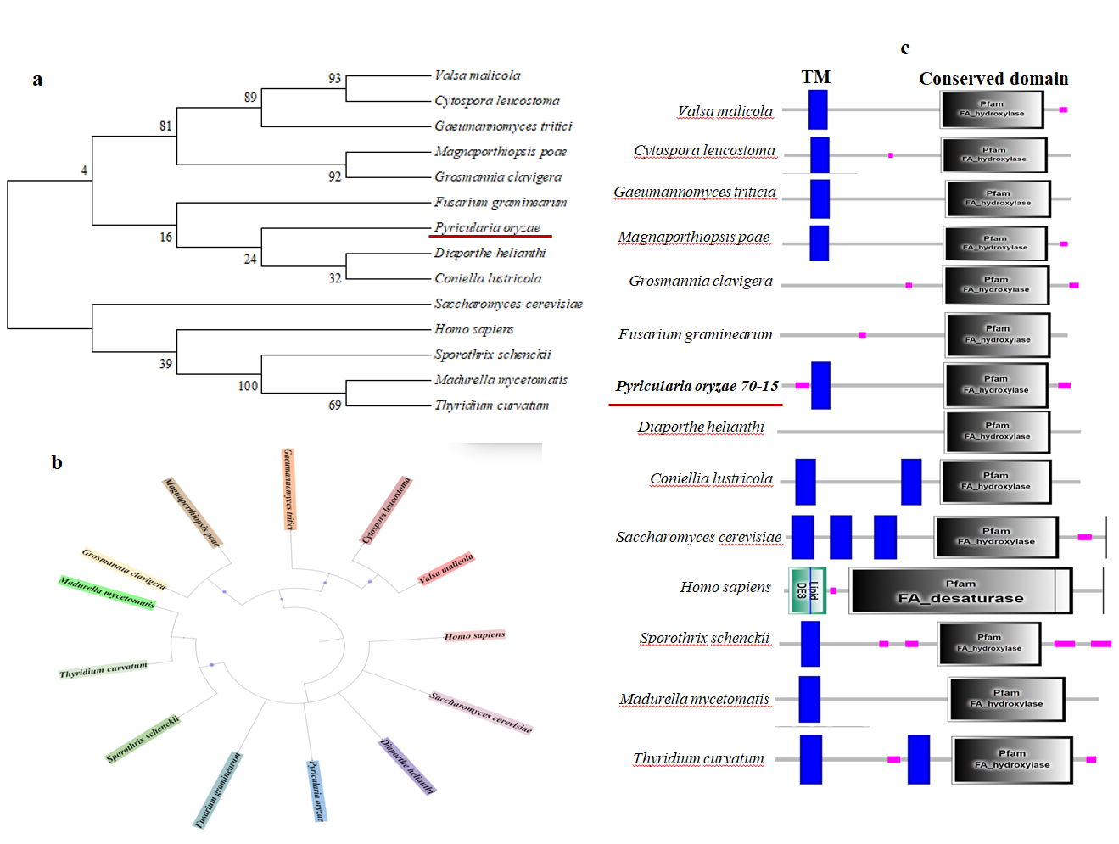
FigureS2| phylogenetic tree was constructed among different fungi and H. sapiens which have conserved Sur2 protein using MEGA software. (b) Circular phylogenetic tree of Sur2 protein was constructed by iTOL software. (c) FA_Hyrdoxylase enzymatic domain containing conserved proteins was observed using STRING database in various fungi including model organism S. cerevisiae, present study organism M. oryzae, and H. sapiens.

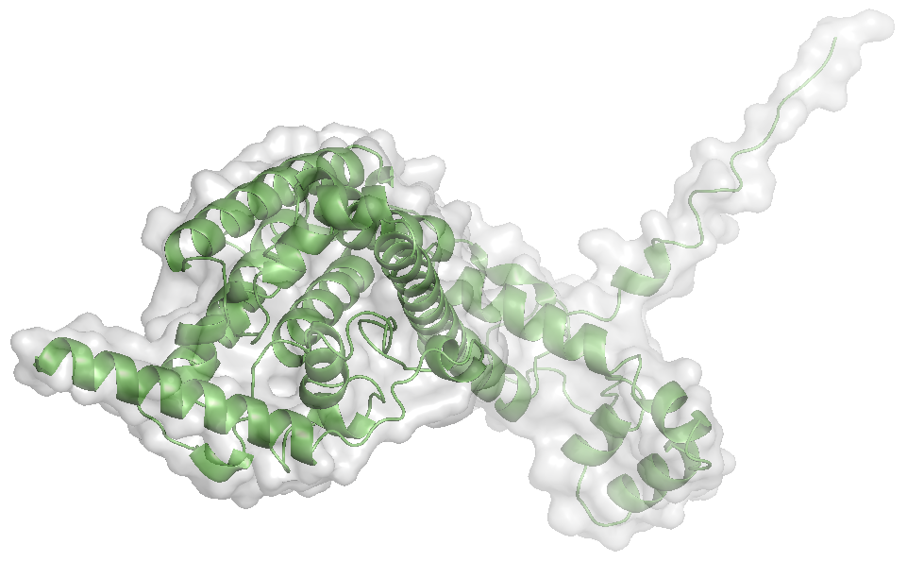
a
Sur2
-N
C-

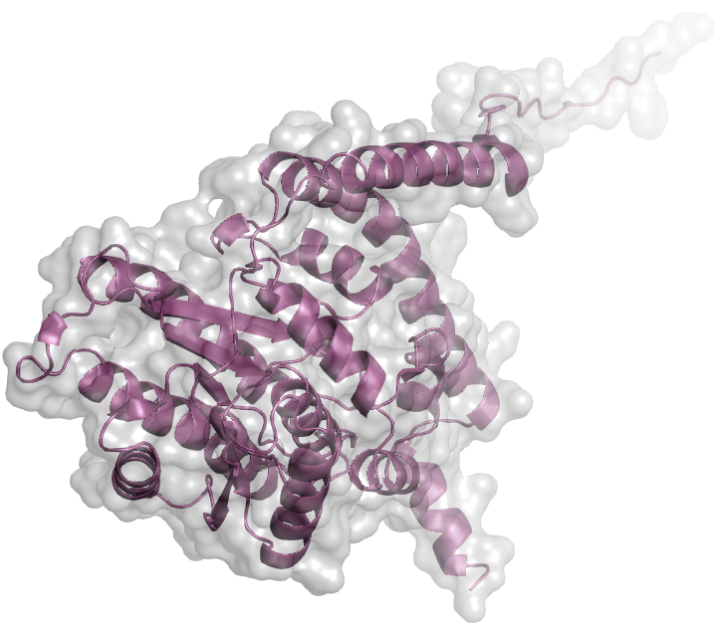
Tsc10
b
-C
-N
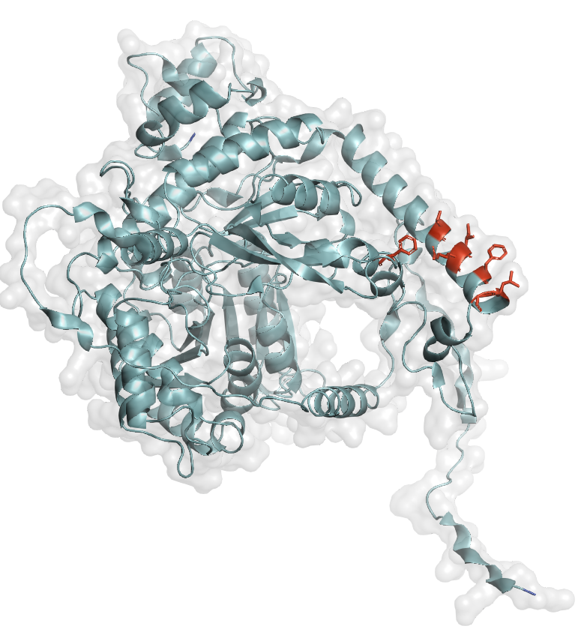
Spt2
-N
-C
c

FigureS3| 3D structure of MoSur2, MoTsc10 and MoSpt2 was constructed using Alphafold3

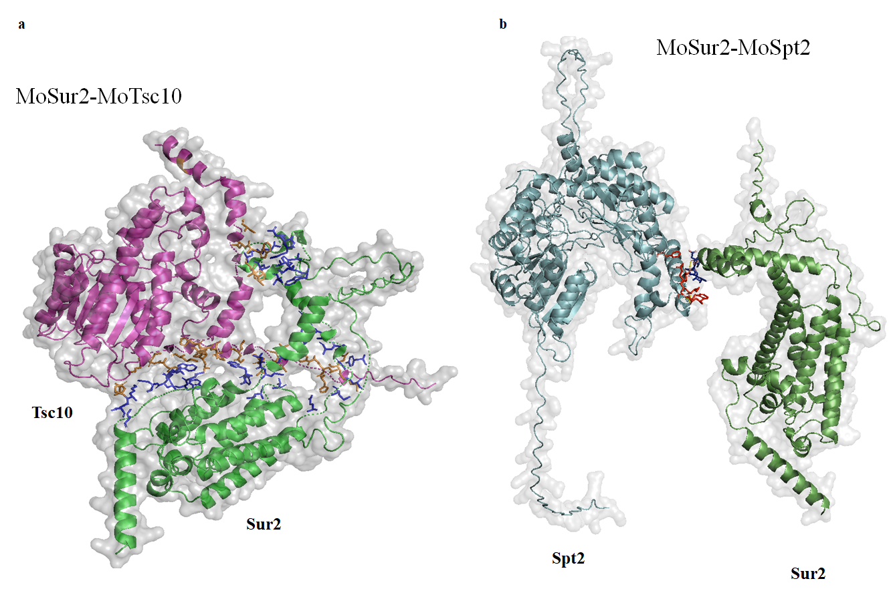
FigureS4| Predicted 3D interaction models of MoSur2-MoTsc10 and MoSur2-MoSpt2 were generated using Alphafold3 and visualized by PyMol. Interacting sequences were shown in red and blue color

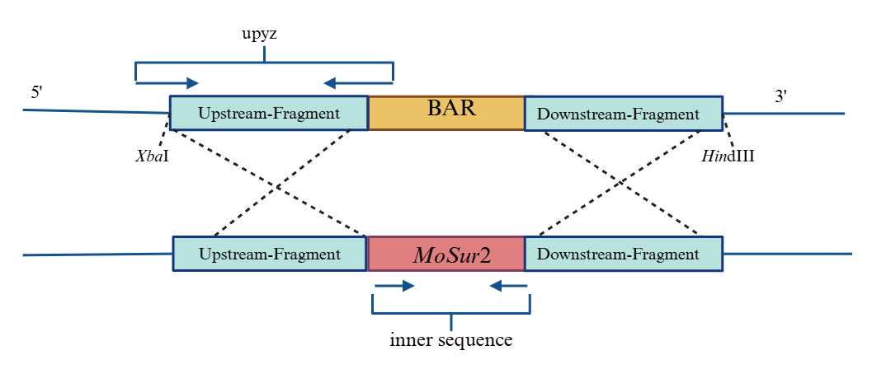
a

b
Marker
Guy11
∆Mosur2
2.4 kbp
Recombinational DNA
Guy11
∆Mosur2
Target gene
Tubulin
Marker
1.0 kbp
0.5 kbp

FigureS5| Confirmation of knockout mutant by PCR. (a) The deletion strategy of mutant preparation is shown with upstream and downstream sequences and restriction enzymes. (b) PCR test of the null mutants, the recombination fragment were amplified in positive strains but not in the wild-type strain.

