SUPPLEMENTAL MATERIALS
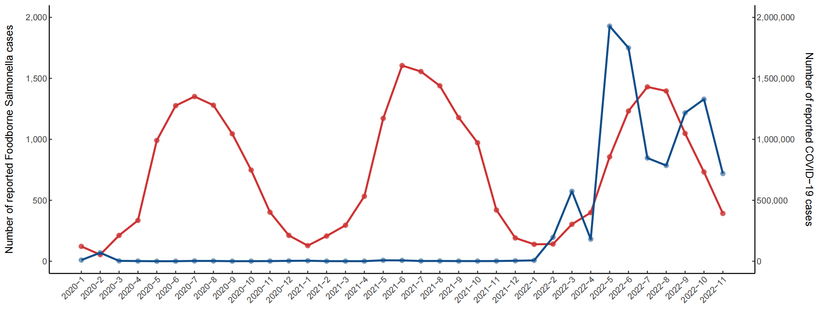
Figure S1. Correlation between number of reported NTS and number of reported covid-19 cases in China, 2013–2022.

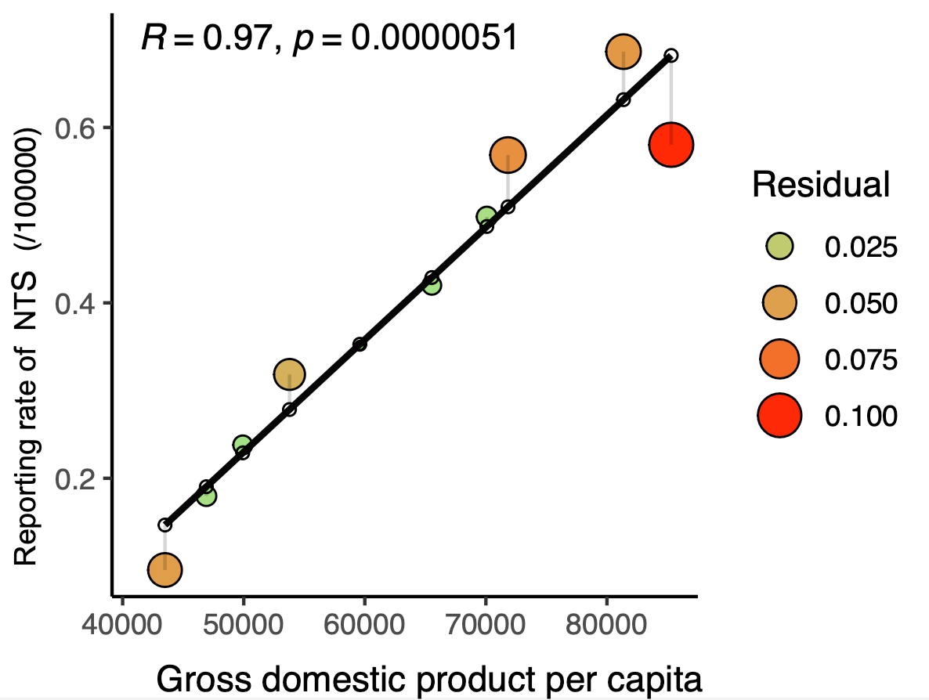
Figure S2. Correlation between reporting rate of NTS and GDP in China, 2013–2022.

