Supplementary Information for “Genome-wide mapping of complement system proteins for islet autoimmunity in the DAISY and TEDDY children”
Xiaowei Hu, Bobbie-Jo M Webb-Robertson, Hemang M Parikh, Ernesto S Nakayasu, Suna Onengut-Gumuscu, Wei-Min Chen, Ashley Frazer-Abel, Thomas O Metz, Stephen S Rich, Marian J Rewers, Ani Manichaikul

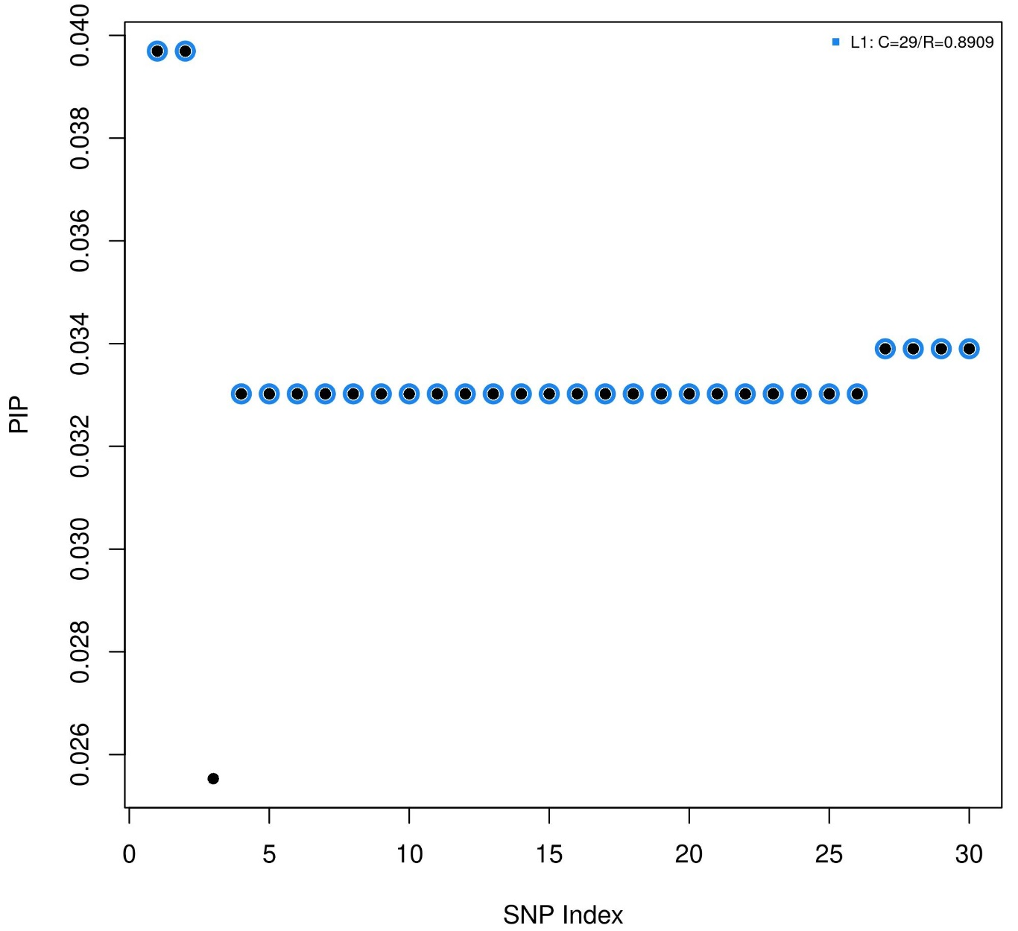
Supplementary Figure 1: Fine-mapping of C8A FDR-significant (FDR<0.1) cis-pQTLs identified in DAISY pooled analysis by SRM platform. SRM, selected reaction monitoring mass spectrometry assay; PIP, posterior inclusion probability for fine mapping.

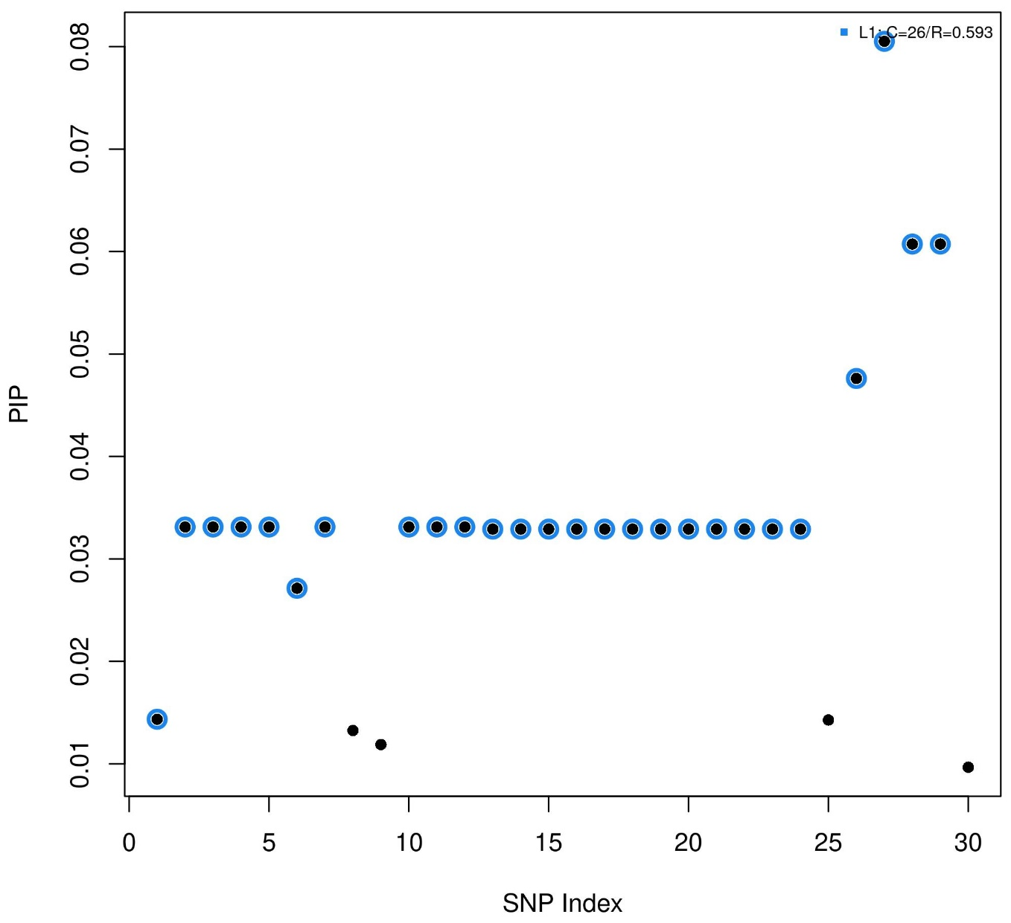
Supplementary Figure 2: Fine-mapping of CFB FDR-significant (FDR<0.1) cis-pQTLs identified in DAISY pooled analysis by SRM platform. SRM, selected reaction monitoring mass spectrometry assay; PIP, posterior inclusion probability for fine mapping.

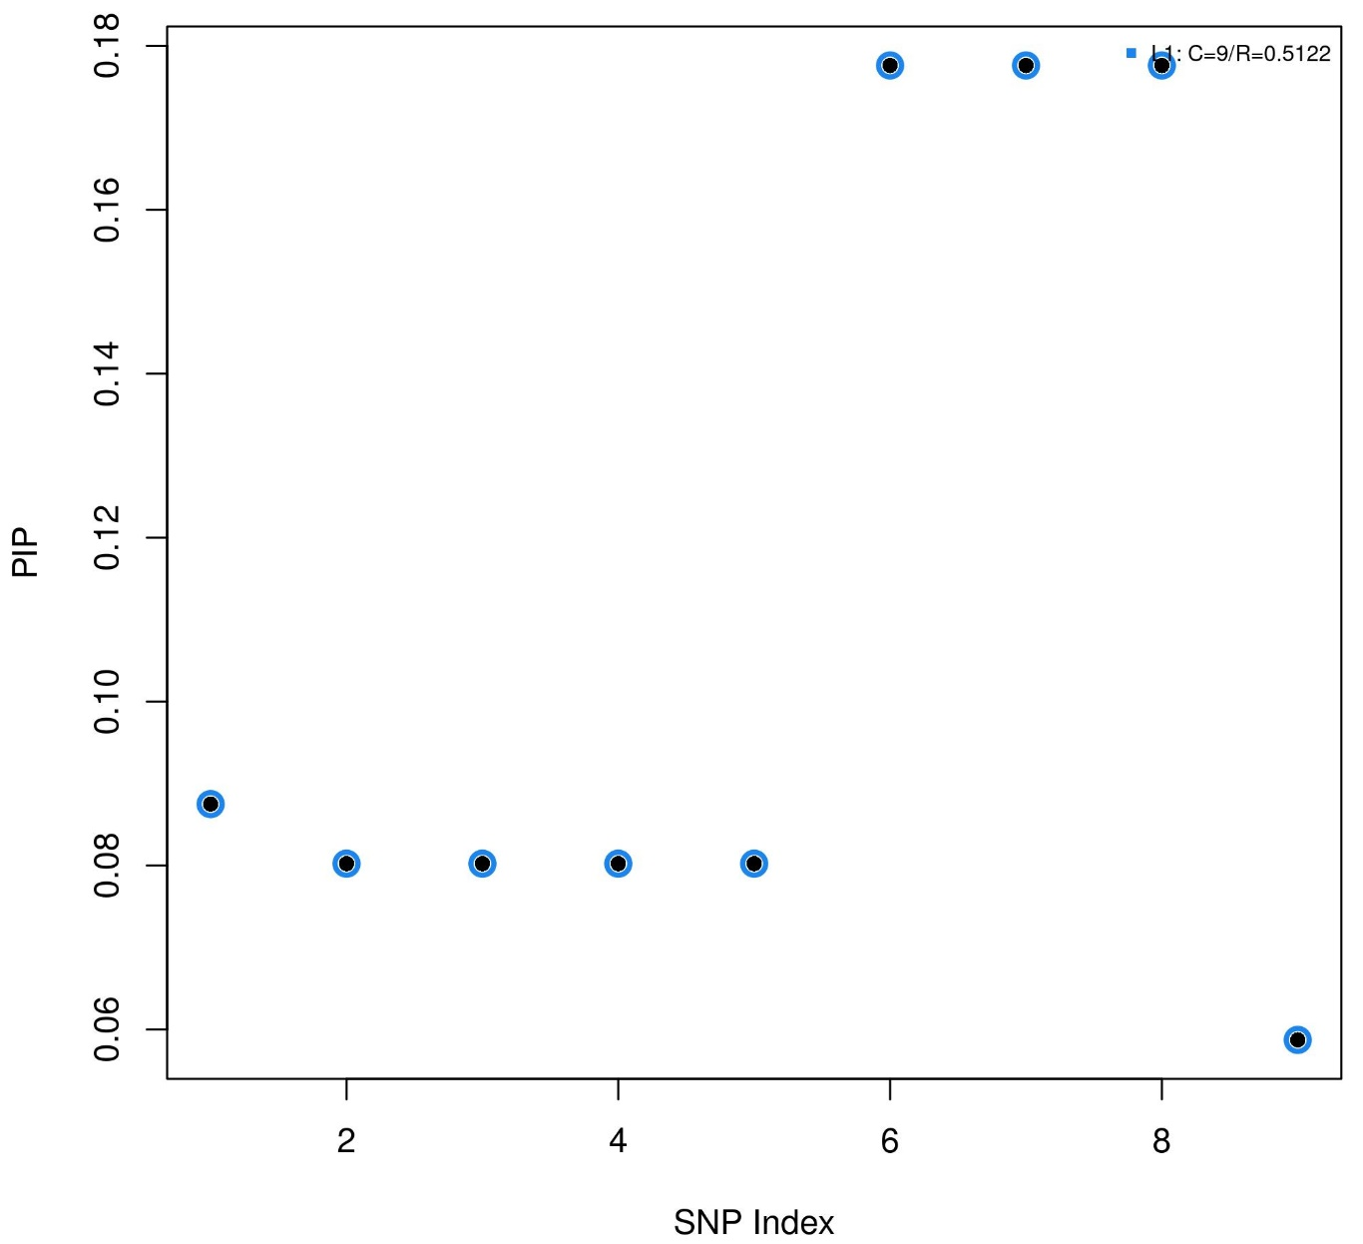
Supplementary Figure 3: Fine-mapping of C4B FDR-significant (FDR<0.1) cis-pQTLs identified in DAISY pooled analysis by SRM platform. SRM, selected reaction monitoring mass spectrometry assay; PIP, posterior inclusion probability for fine mapping.

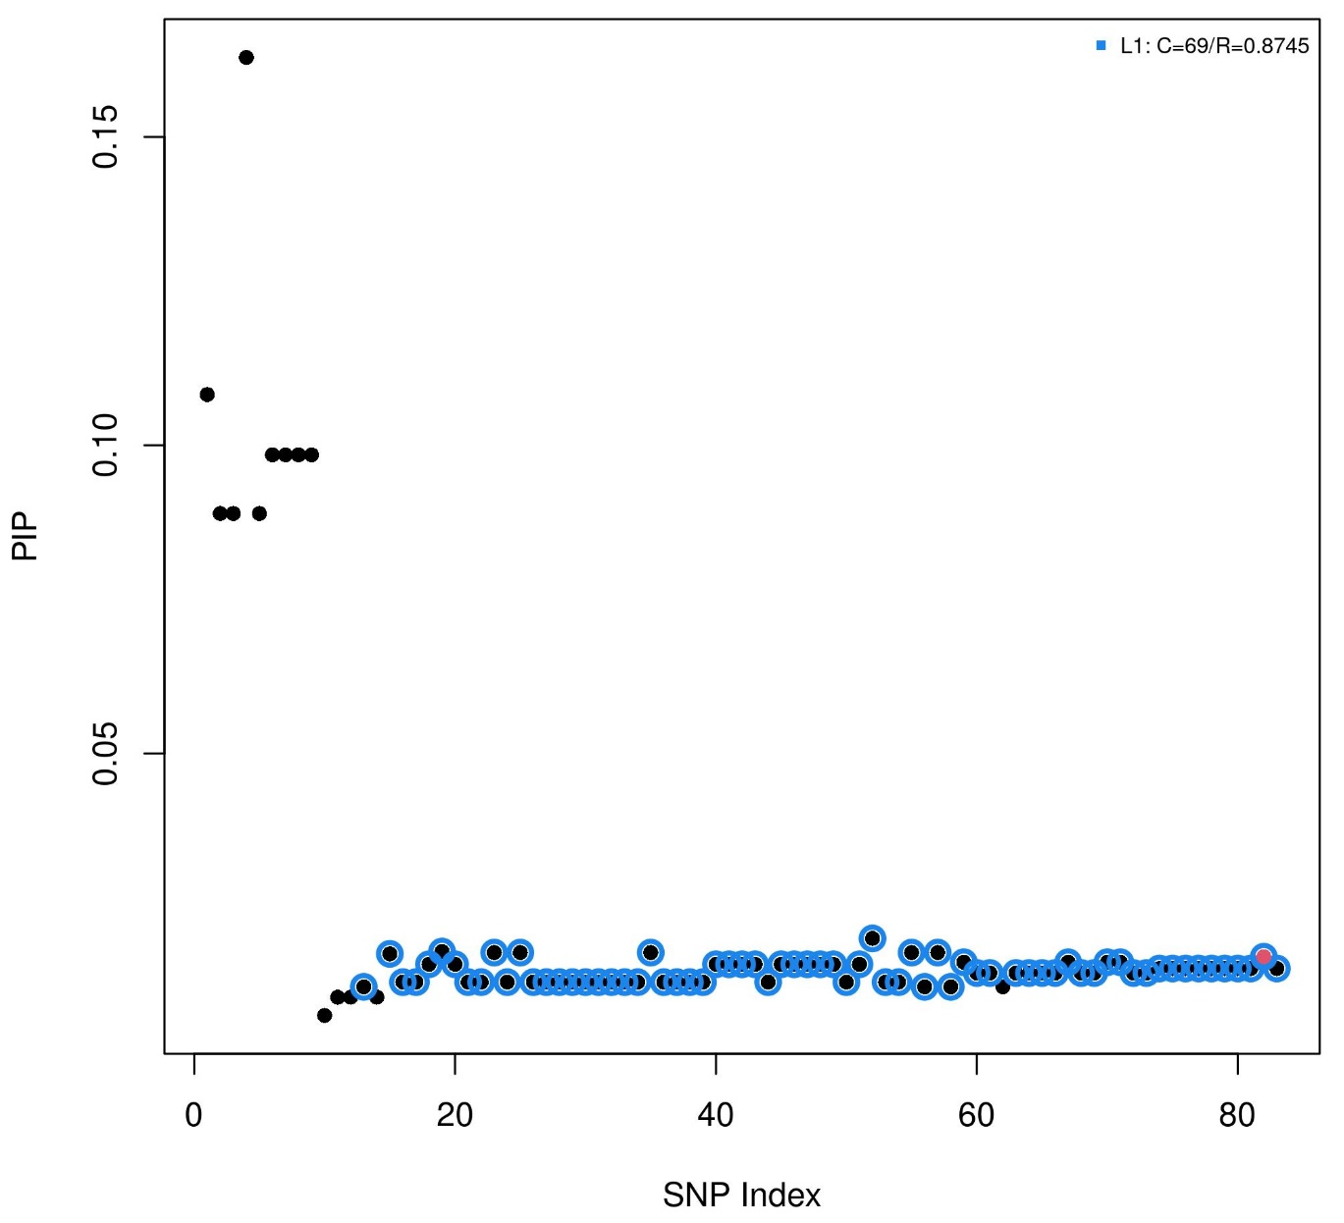
Supplementary Figure 4: Fine-mapping of CFH FDR-significant (FDR<0.1) cis-pQTLs identified in DAISY pooled analysis by Exsera platform. PIP, posterior inclusion probability for fine mapping.

A)
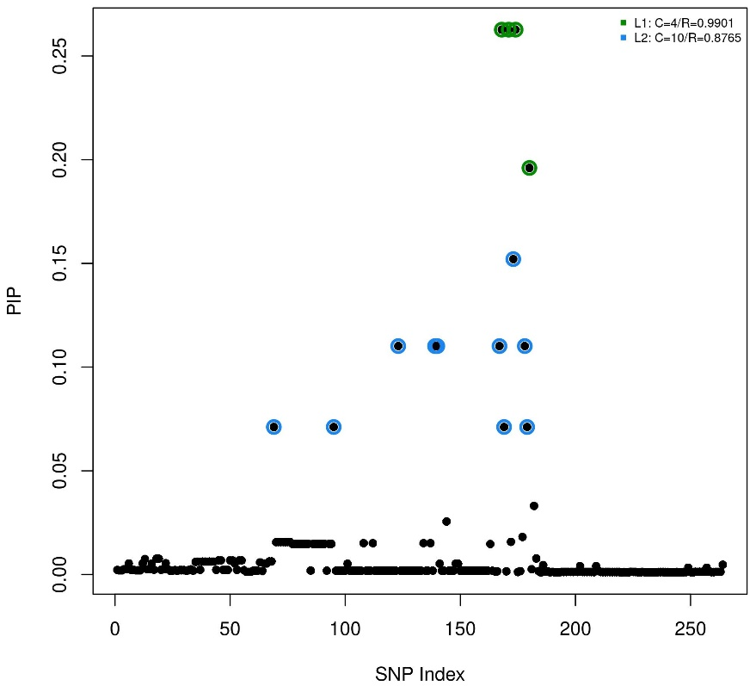
B)
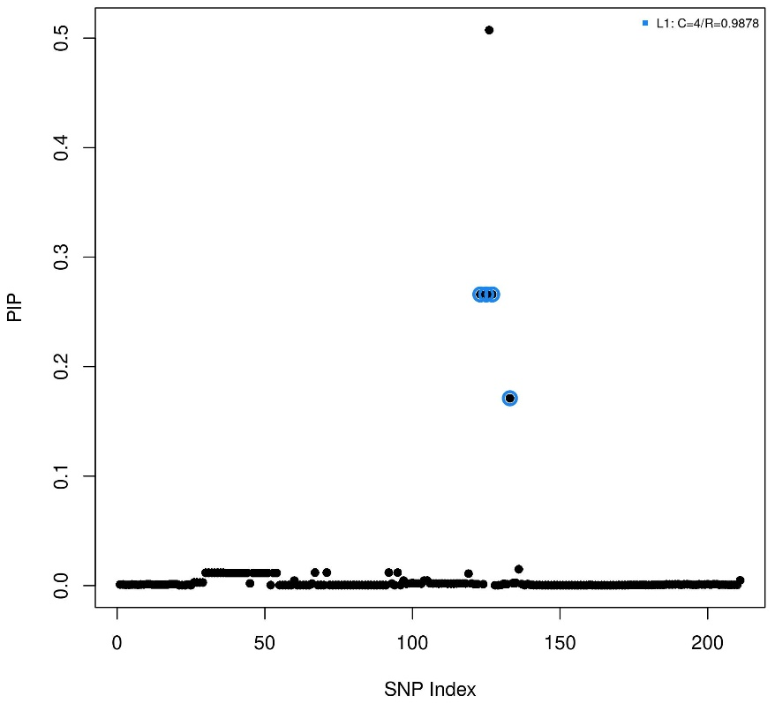
Supplementary Figure 5: Fine-mapping of MBL2 FDR-significant (FDR<0.1) cis-pQTLs identified in DAISY analysis by Exsera platform. A) Pooled analysis; B) Case-stratified analysis. PIP, posterior inclusion probability for fine mapping.
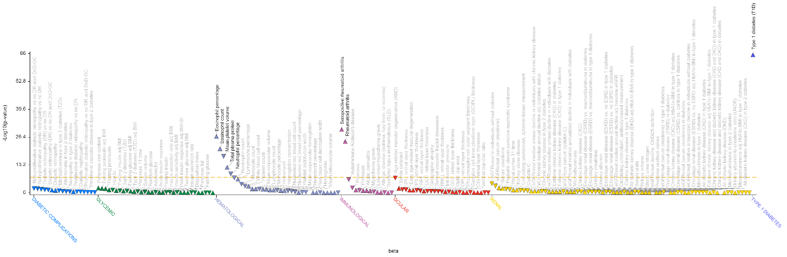
Supplementary Figure 6: PheWAS look-up of CFB top replicated cis-pQTL rs150978802 on T1D Knowledge Portal (https://t1d.hugeamp.org).

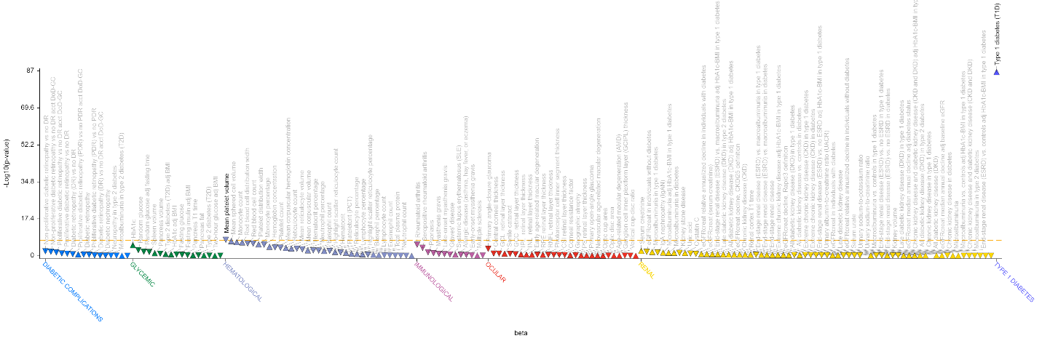
Supplementary Figure 7: PheWAS look-up of C4A top replicated cis-pQTL rs9263822 on T1D Knowledge Portal (https://t1d.hugeamp.org).

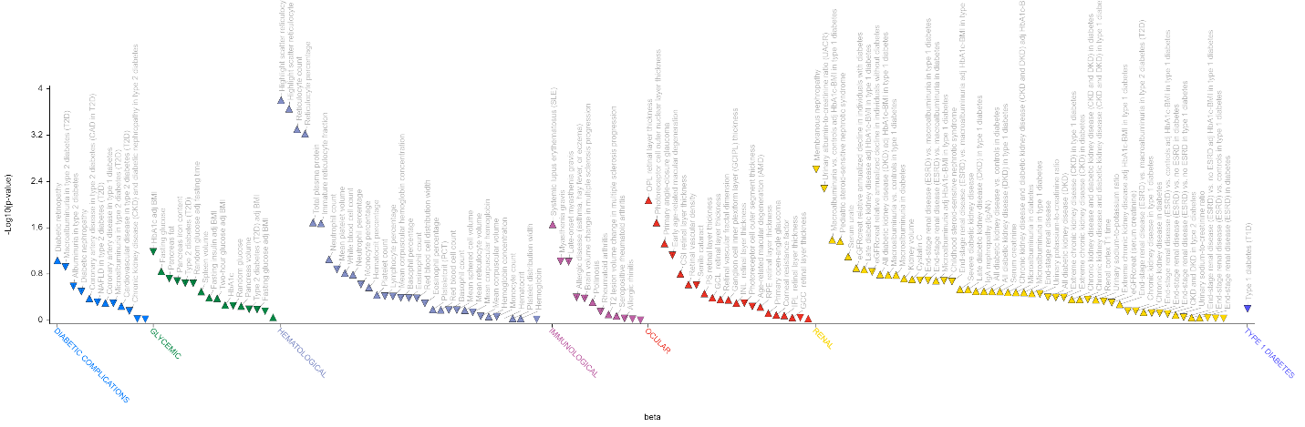
Supplementary Figure 8: PheWAS look-up of C8A top replicated cis-pQTL rs856928 on T1D Knowledge Portal (https://t1d.hugeamp.org).
A)
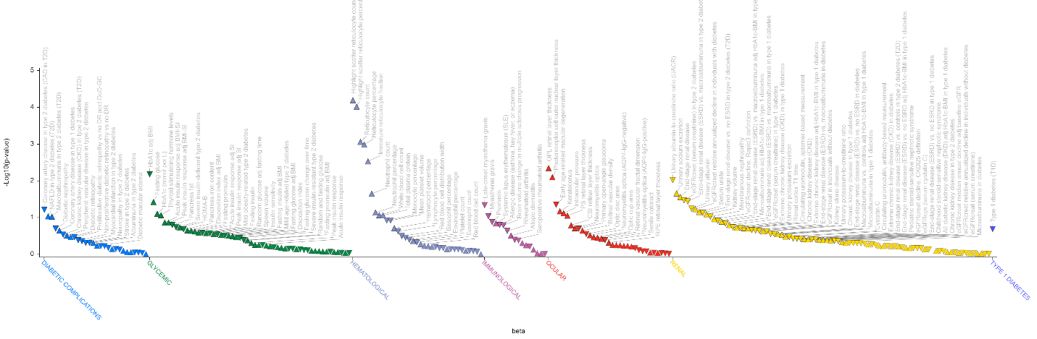
B)

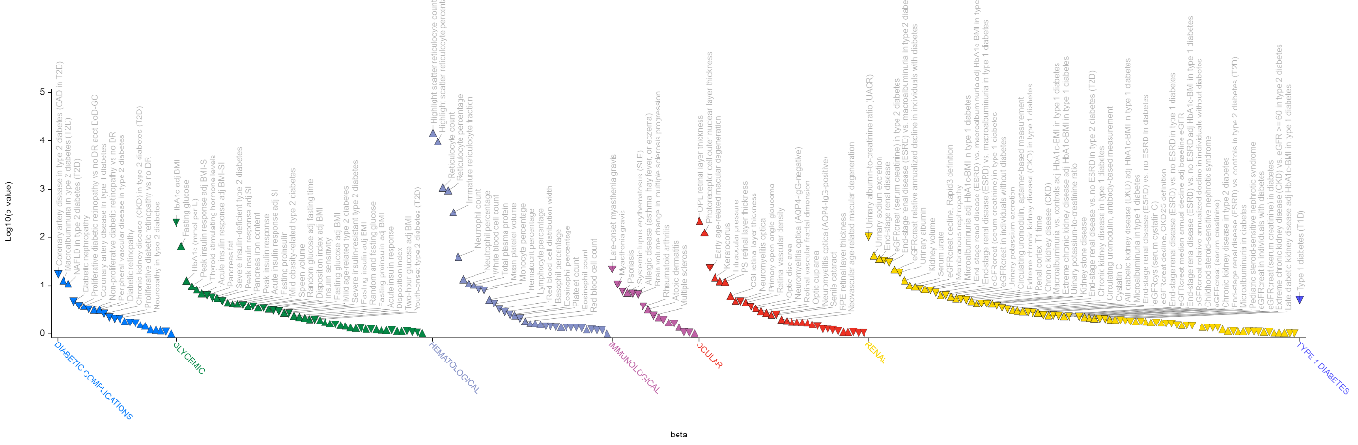
Supplementary Figure 9: PheWAS look-up of C8B replicated cis-pQTLs on T1D Knowledge Portal (https://t1d.hugeamp.org). A) rs607268; B) rs676705.
A)
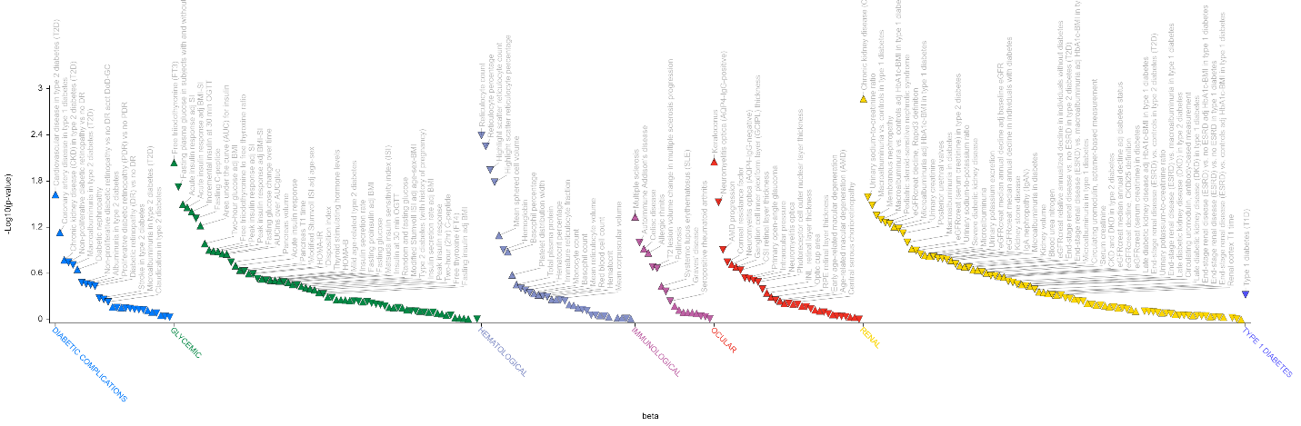B)
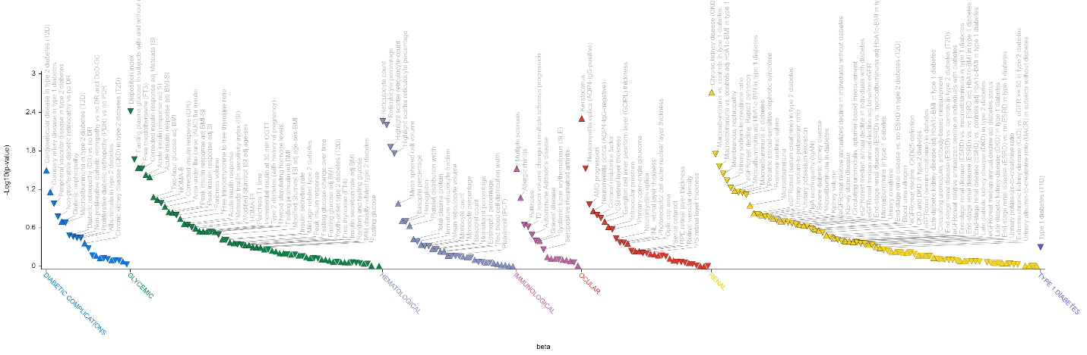
Supplementary Figure 10: PheWAS look-up of MBL2 replicated cis-pQTLs on T1D Knowledge Portal (https://t1d.hugeamp.org). A) rs1800450; B) rs1031101.

A)
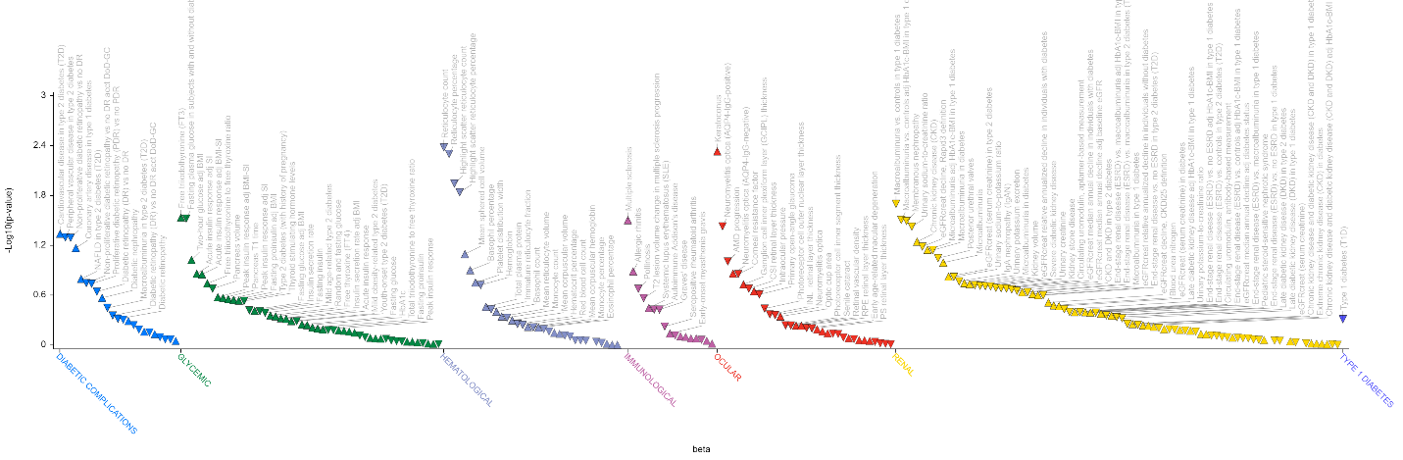B)
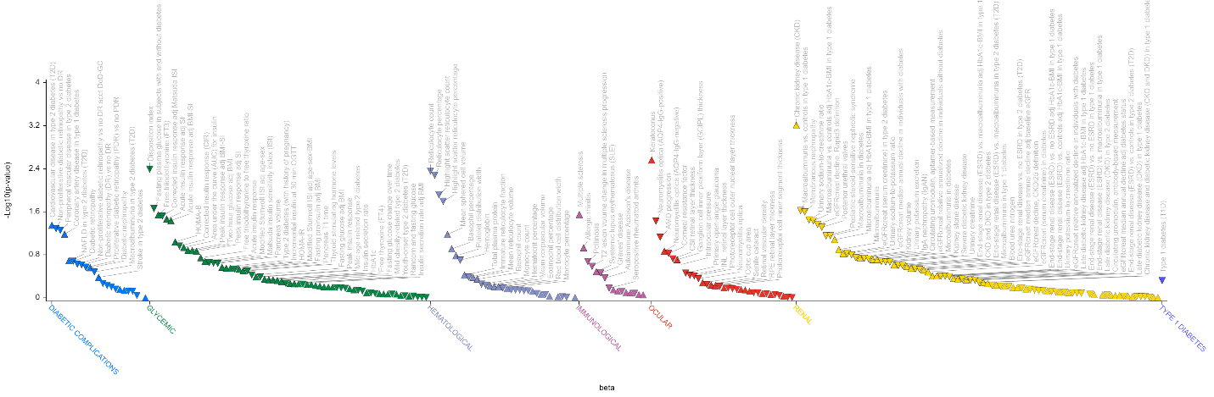
Supplementary Figure 11: PheWAS look-up of MBL2 replicated cis-pQTLs on T1D Knowledge Portal (https://t1d.hugeamp.org). A) rs11003128; B) rs11003131.

