A Practical and Prescriptive Framework for Appropriate Implementation and Review of Artificial Intelligence (FAIR-AI) in Healthcare

Supplementary Information

Supplementary Figure 1. Strength of validation
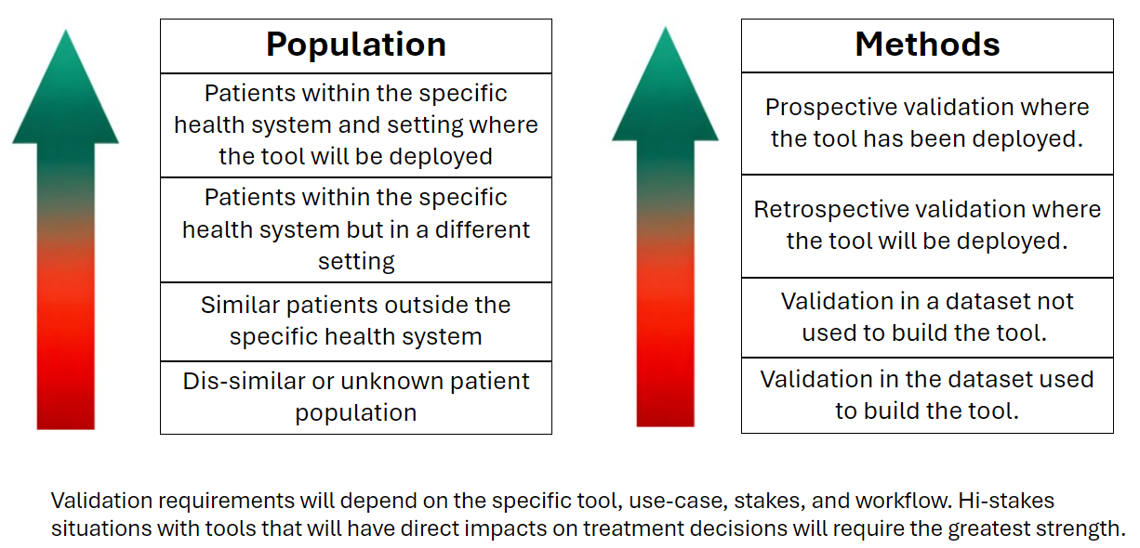

Supplementary Table 1. Examples – Guiding principles and Ethics Statement
Ethics Statement
Our evaluation processes are designed to promote the responsible and ethical use of artificial intelligence (AI) in our healthcare system, ensuring that all AI tools we evaluate align with the highest standards of fairness, accountability, transparency, and responsibility. We are committed to ensuring that the deployment of AI respects the dignity, rights, and well-being of all individuals impacted by its use.
Guiding principles
- Equitable and ethical | It is our collective responsibility to identify and mitigate potential bias, injustice, and harm from the use of AI solutions.
- Valid and reliable | AI solutions will be internally evaluated before implementation and periodically while in production to ensure continued valid and consistent results within the specified scope of use. The extent of the evaluation is commensurate with the type of AI and the potential risk and/or benefit.
- Transparent | Detailed, understandable explanations of performance and impact will be available for stakeholders. End users will be made aware when they are interacting with an AI model instead of a human. Levels of explanations and awareness are commensurate with the type of AI and the potential risk and/or benefit.
- Impactful | AI solutions will be selectively applied to defined organizational problems with attention to the workflows that support implementation and adoption.

Supplementary Box 1. Example – FAIR-AI Summary Statement
FAIR-AI Review Summary

FAIR-AI review for [solution name] was completed on [Month dd, yyyy] (ID#[id num]; developed by [vendor]).

[This review was escalated to [organization name]’s AI Governance (AIG) committee and] The AI application has been categorized as MODERATE RISK based on the Framework for Appropriate Implementation & Review of AI (FAIR-AI). This determination only applies to the AI review of the intended use case. Additional enterprise approvals may be required prior to implementation.

Brief Description of AI Application
- What is the solution?
- What type of AI/model does it use?
- What output does it produce?
- How often does it produce results or what triggers a result?

Intended Use Case
- Who will be using it?
- How will it be used?
- What is the desired outcome or benefit from incorporating this tool?

Risk Determination
The following FAIR-AI criteria were identified as risks during review, leading to a Moderate risk determination
- [Identified FAIR-AI Risk Category: Describe risk]
- [Add a bullet for each risk criteria that triggered moderate risk. The risk criteria listed should correspond to language in the FAIR-AI screening. Describe why it was triggered and what specific risk or negative outcome we are exposed to as a result.]

Other Considerations
[OPTIONAL SECTION. Add bullets for any other considerations or recommendations.]
[If this was escalated to AIG, describe why it was escalated and why it was lowered to Moderate]
Safe AI Monitoring
Once implemented, AI solutions may develop inaccuracies or bias over time due to changes in data, workflow, or use. To mitigate that risk, the business owner acknowledges the following Safe AI responsibilities for Moderate Risk AI Solutions.

Complete the Safe AI Attestation form every <#> months from implementation.
In partnership with Enterprise Data Science, create a Safe AI Metric plan (including metric, methodology, frequency, and next due date) for each identified risk and provide updates during the Safe AI Attestation, as required.
Notify Enterprise Data Science of any changes to the AI solution or its use case.

