SUPPLEMENTARY
Lithium-ion Battery Waste as a Robust Oxygen Evolution Reaction Electrocatalyst for Seawater Splitting

Magdalena Warczak ^{1*}, Katarzyna Belka ¹, Weronika Urbańska ², Monika Michalska ³, Njemuwa Nwaji ⁴, Magdalena Osial ⁴
¹ Bydgoszcz University of Science and Technology, Faculty of Chemical Technology and Engineering, Seminaryjna 3 Street, 85-326 Bydgoszcz, Poland; magdalena.warczak@pbs.edu.pl
² Wrocław University of Science and Technology, Faculty of Environmental Engineering, Wybrzeże Wyspiańskiego 27 Street, 50-370 Wrocław, Poland
³ VSB-Technical University of Ostrava, Faculty of Materials Science and Technology, Department of Chemistry and Physico-Chemical Processes, 17. listopadu 2172/15, 708 00, Ostrava-Poruba, Czech Republic
⁴ Institute of Fundamental Technological Research, Polish Academy of Sciences, Department of the Theory of Continuous Media and Nanostructures, Pawińskiego 5B Street, 02-106 Warsaw, Poland
E-mail: magdalena.warczak@pbs.edu.pl (corresponding author)
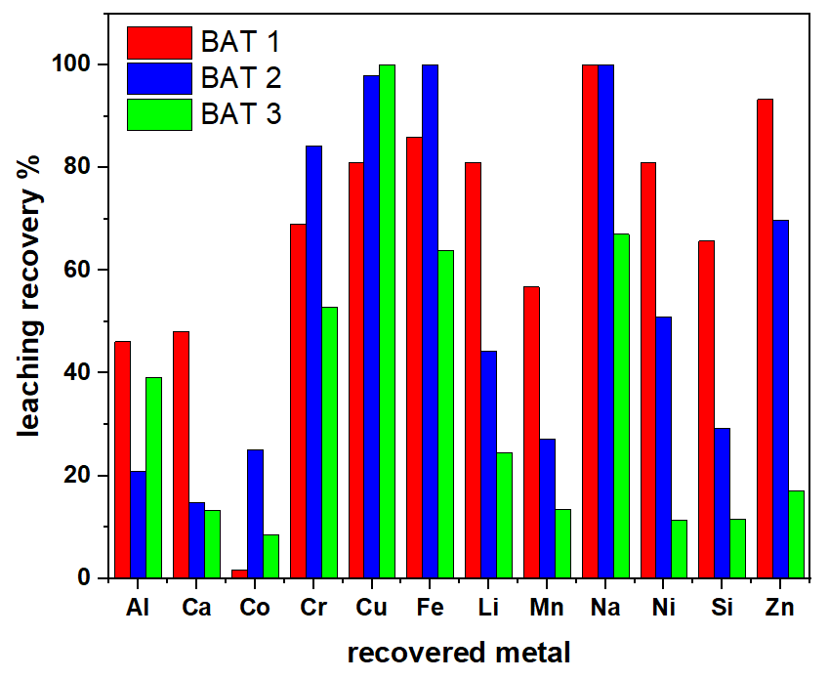
Figure S1. ICP-MS recovery rate of metals for BAT 1-3.
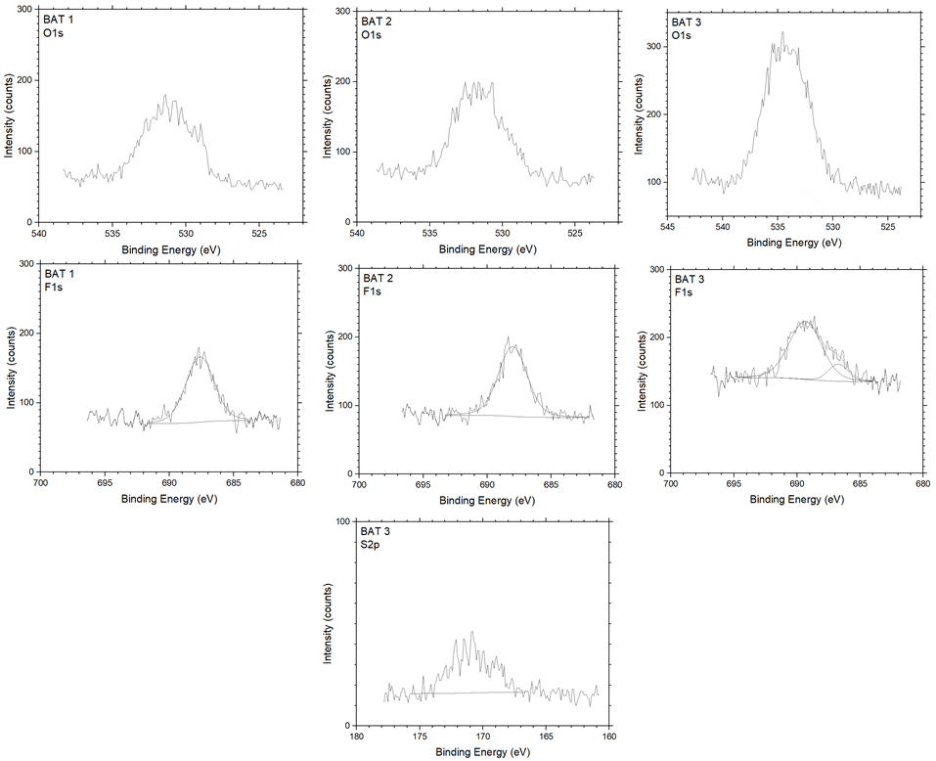
Figure S2. High-resolution O 1s, F 1s XPS spectra for BAT 1-3 and S 2s spectrum for BAT 3.
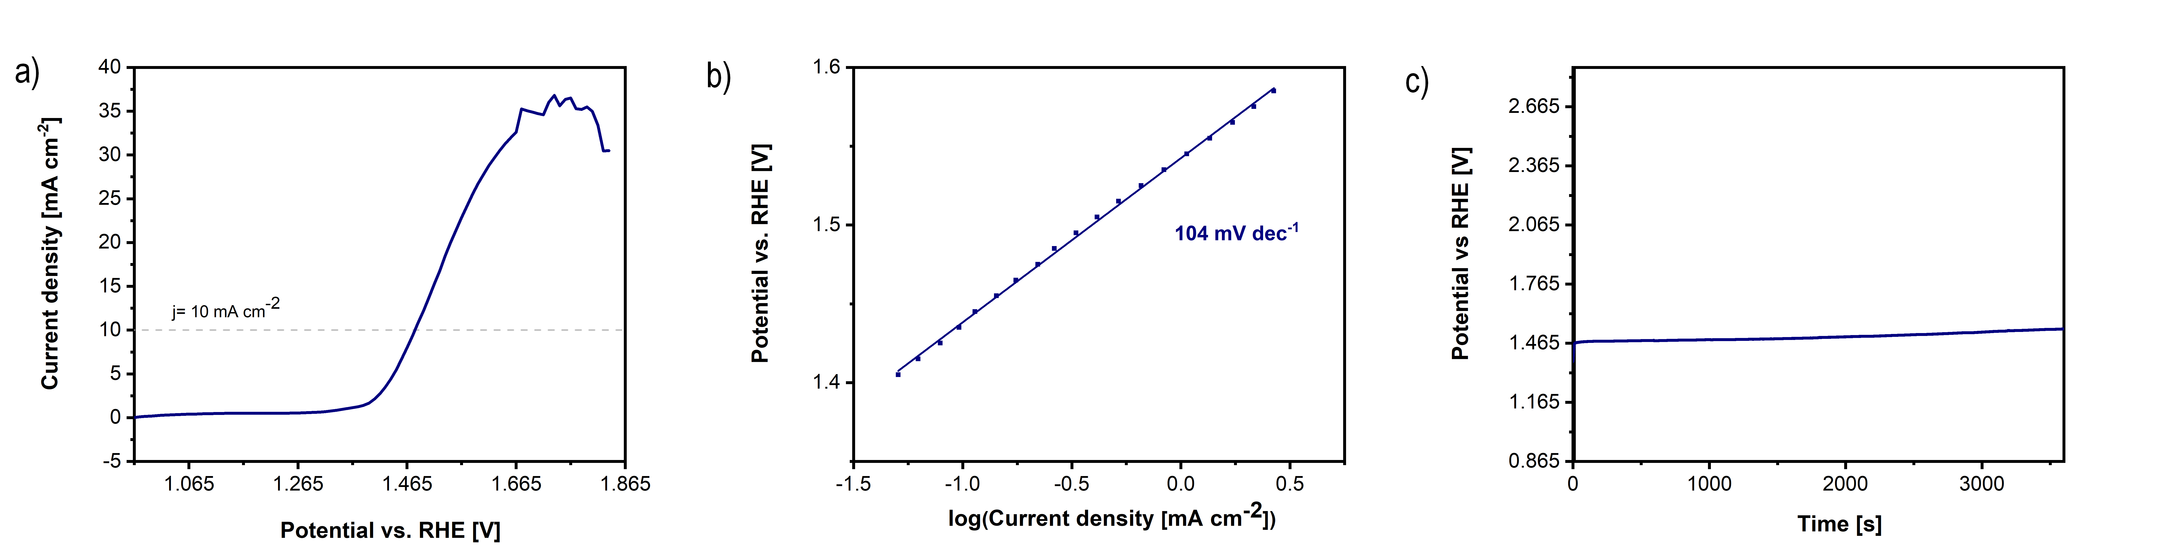
Figure S3. The electrochemical OER performance of benchmark RuO₂ (a) LSV curves; (b) Tafel plots; (c) CP curves recorded in 0.1 M KOH at 10 mA cm⁻².

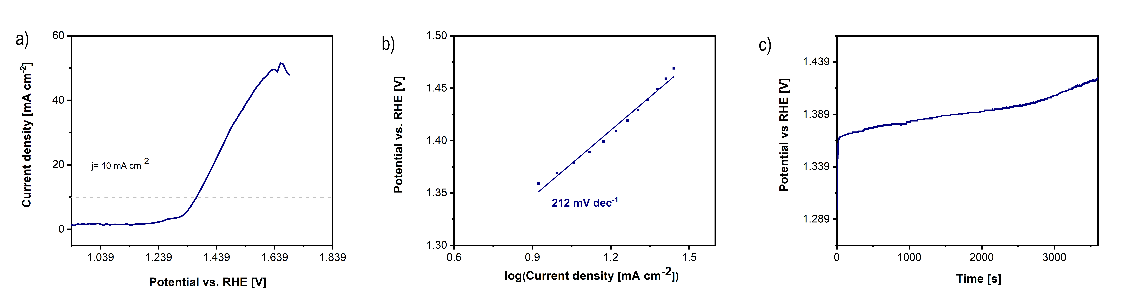

Figure S4. The electrochemical OER performance of benchmark RuO₂ (a) LSV curves; (b) Tafel plots; (c) CP curves recorded in 1 M KOH + 1 M NaCl (1:1 vol.) at 10 mA cm⁻².

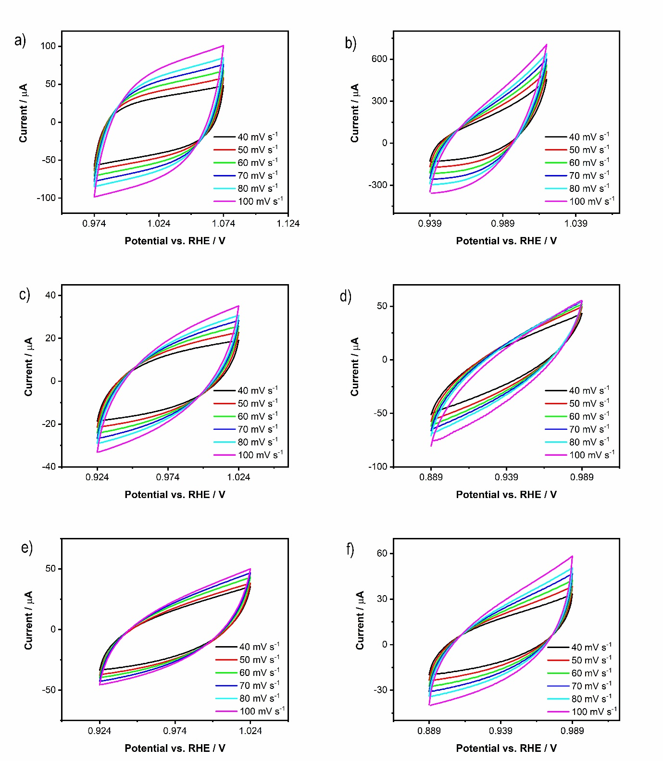
Figure S5. Cyclic voltammograms of GC electrodes modified by various battery waste: BAT 1 (a,b), BAT 2 (c,d) and BAT 3 (e,f) recorded in 0.1 M KOH (left columns) and in 1 M KOH + 1 M NaCl (1:1 vol) (right columns) at various scan rates.

