Figure1D
β-actin
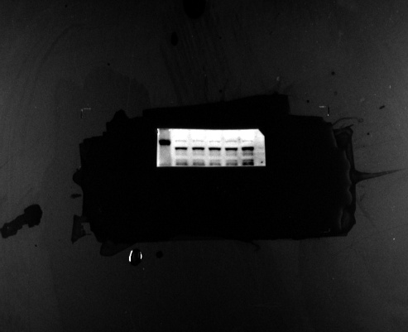
HECW1
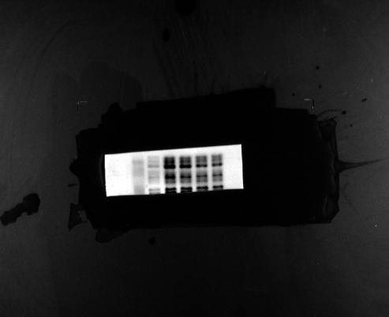
Figure 5B
AGS-HECW1
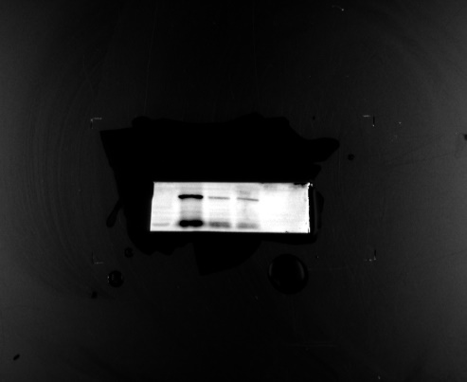
AGS-β-actin
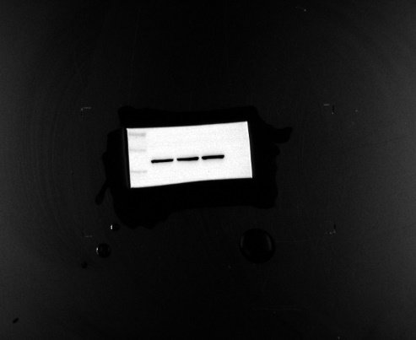
MKN-45-HECW1
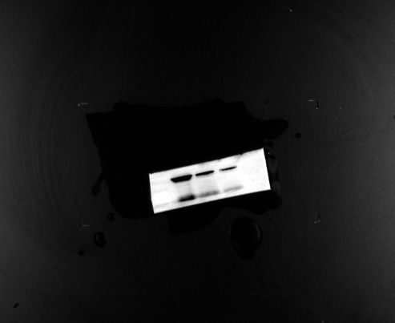
MKN-45-β-actin
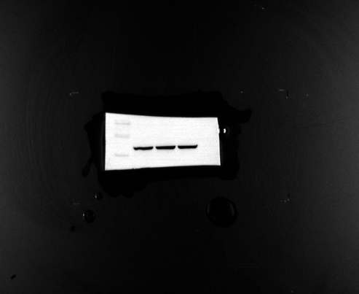
Figure 6D
MKN-45-YAP
MKN-45-p-YAP
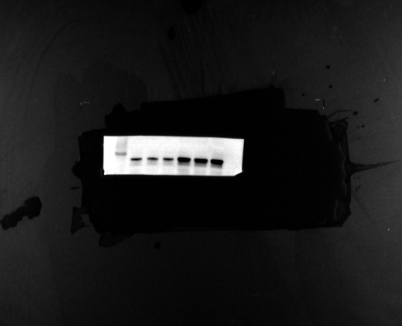
MKN-45-β-actin
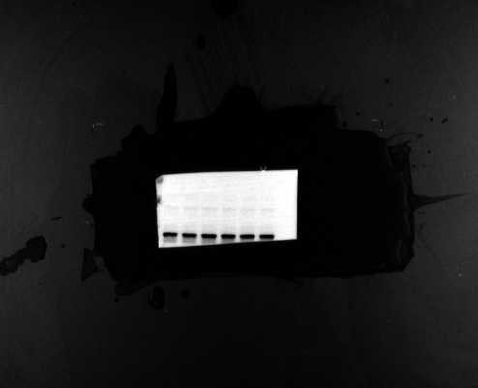
AGS-YAP
AGS-p-YAP
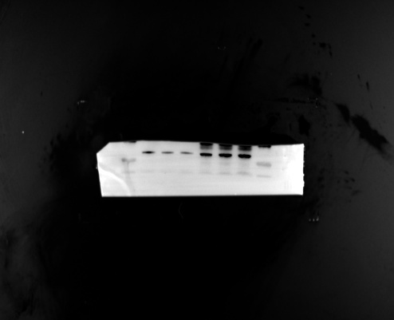
AGS-β-actin
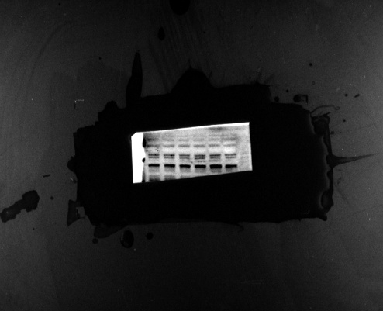
Figure 7A
MKN-45-YAP
MKN-45-p-YAP
MKN-45-β-actin
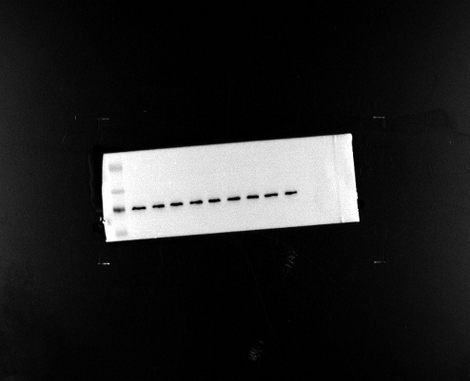
AGS-YAP
AGS-p-YAP
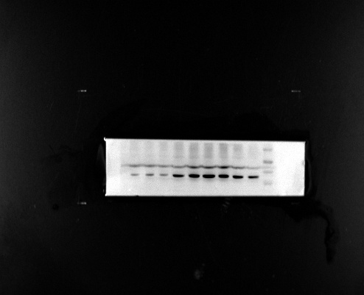
AGS-β-actin
