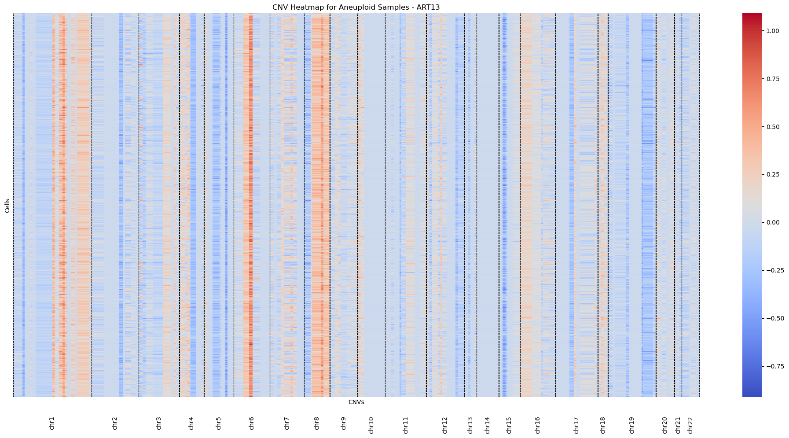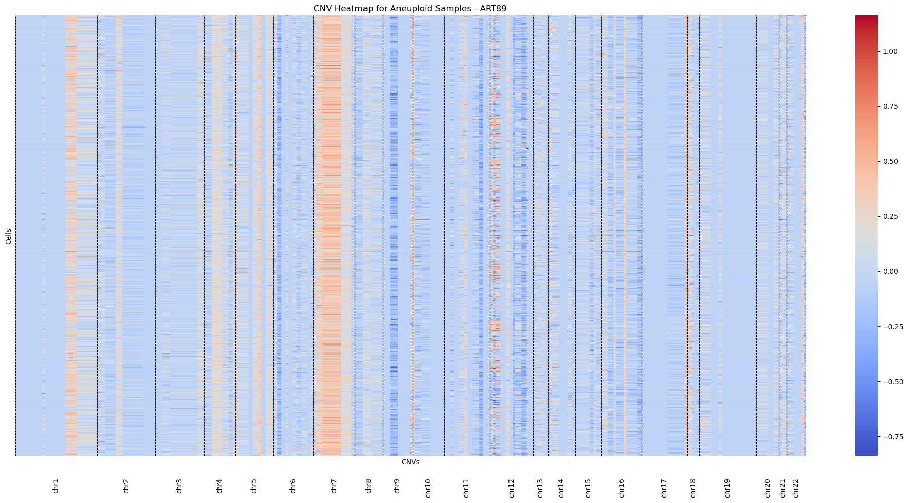
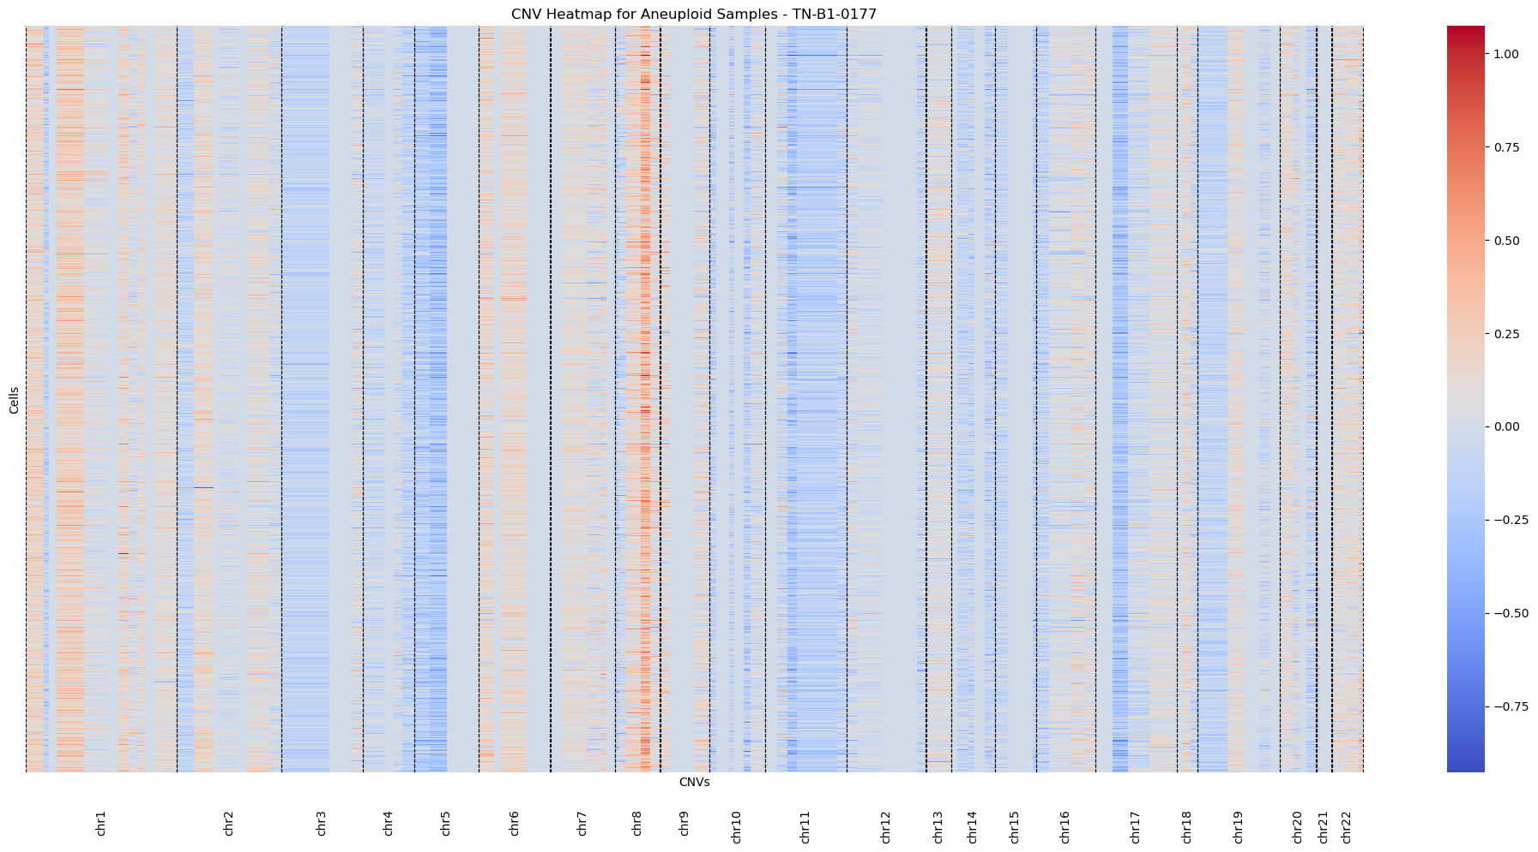
Supplementary Fig. 1: Classification of Single Cells from 21 TNBC Patients: The heatmaps visualizes copy number variations (CNVs) across chromosomes for 3 different donors. Each column represents a genomic region within a specific chromosome.

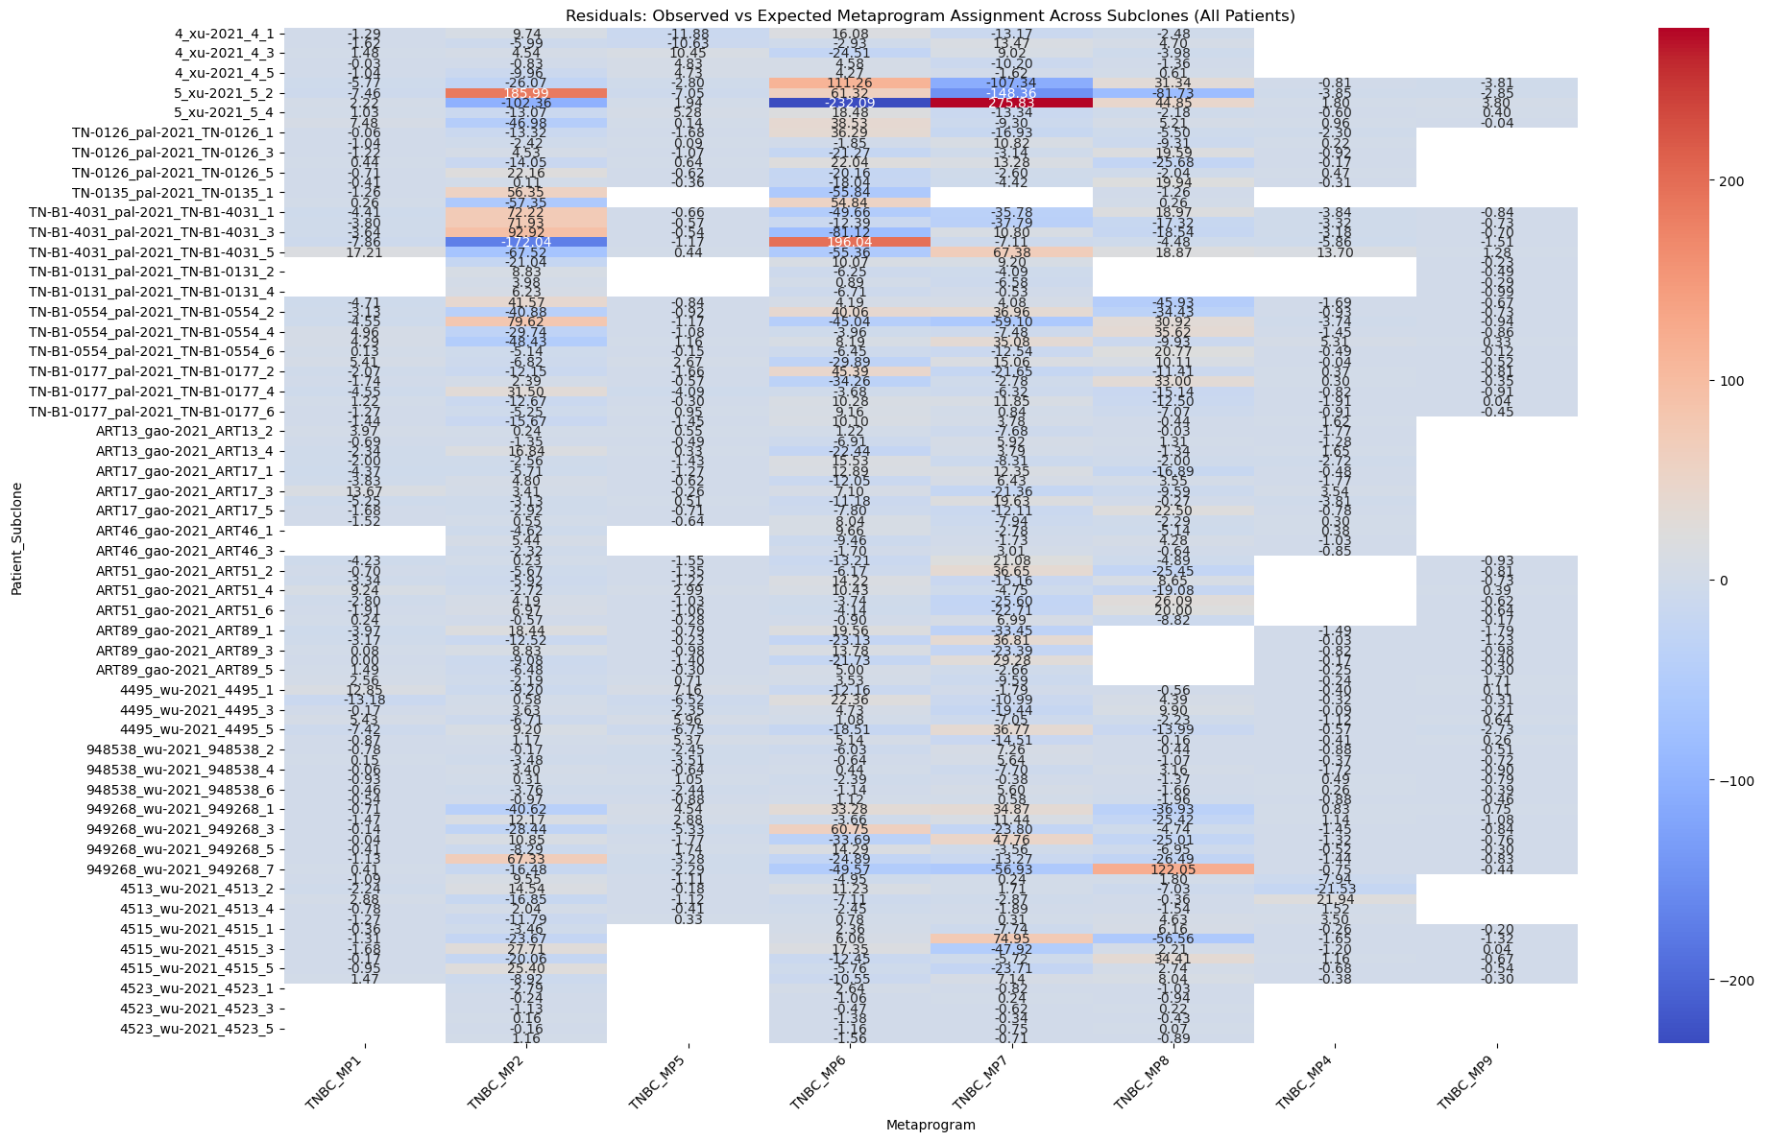Supplementary Fig. 2: Heatmap of residuals from chi-squared testing of metaprogram (MP) assignments across subclones in patients. Each row represents the residuals calculated for a specific patient's subclones, showing the difference between observed and expected MP assignments. Positive residuals indicate MPs over-represented in a given subclone, while negative residuals reflect under-represented MPs.
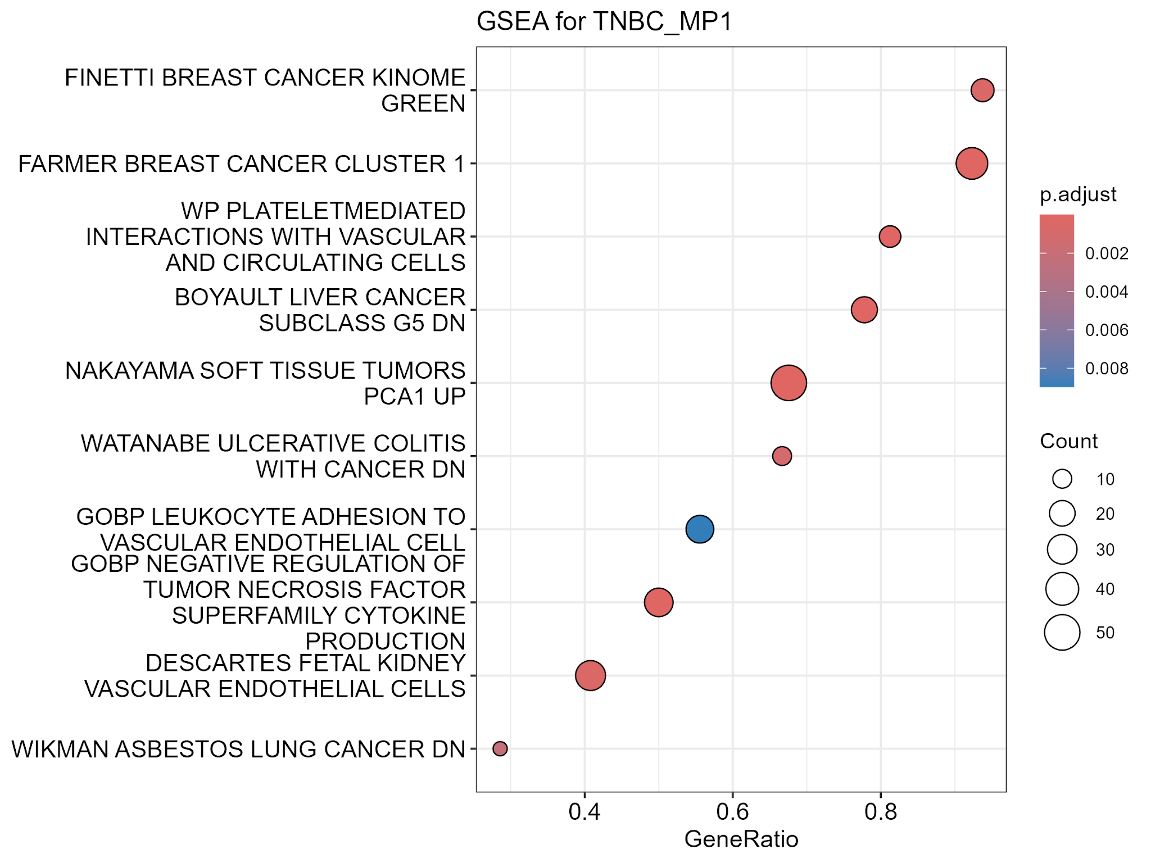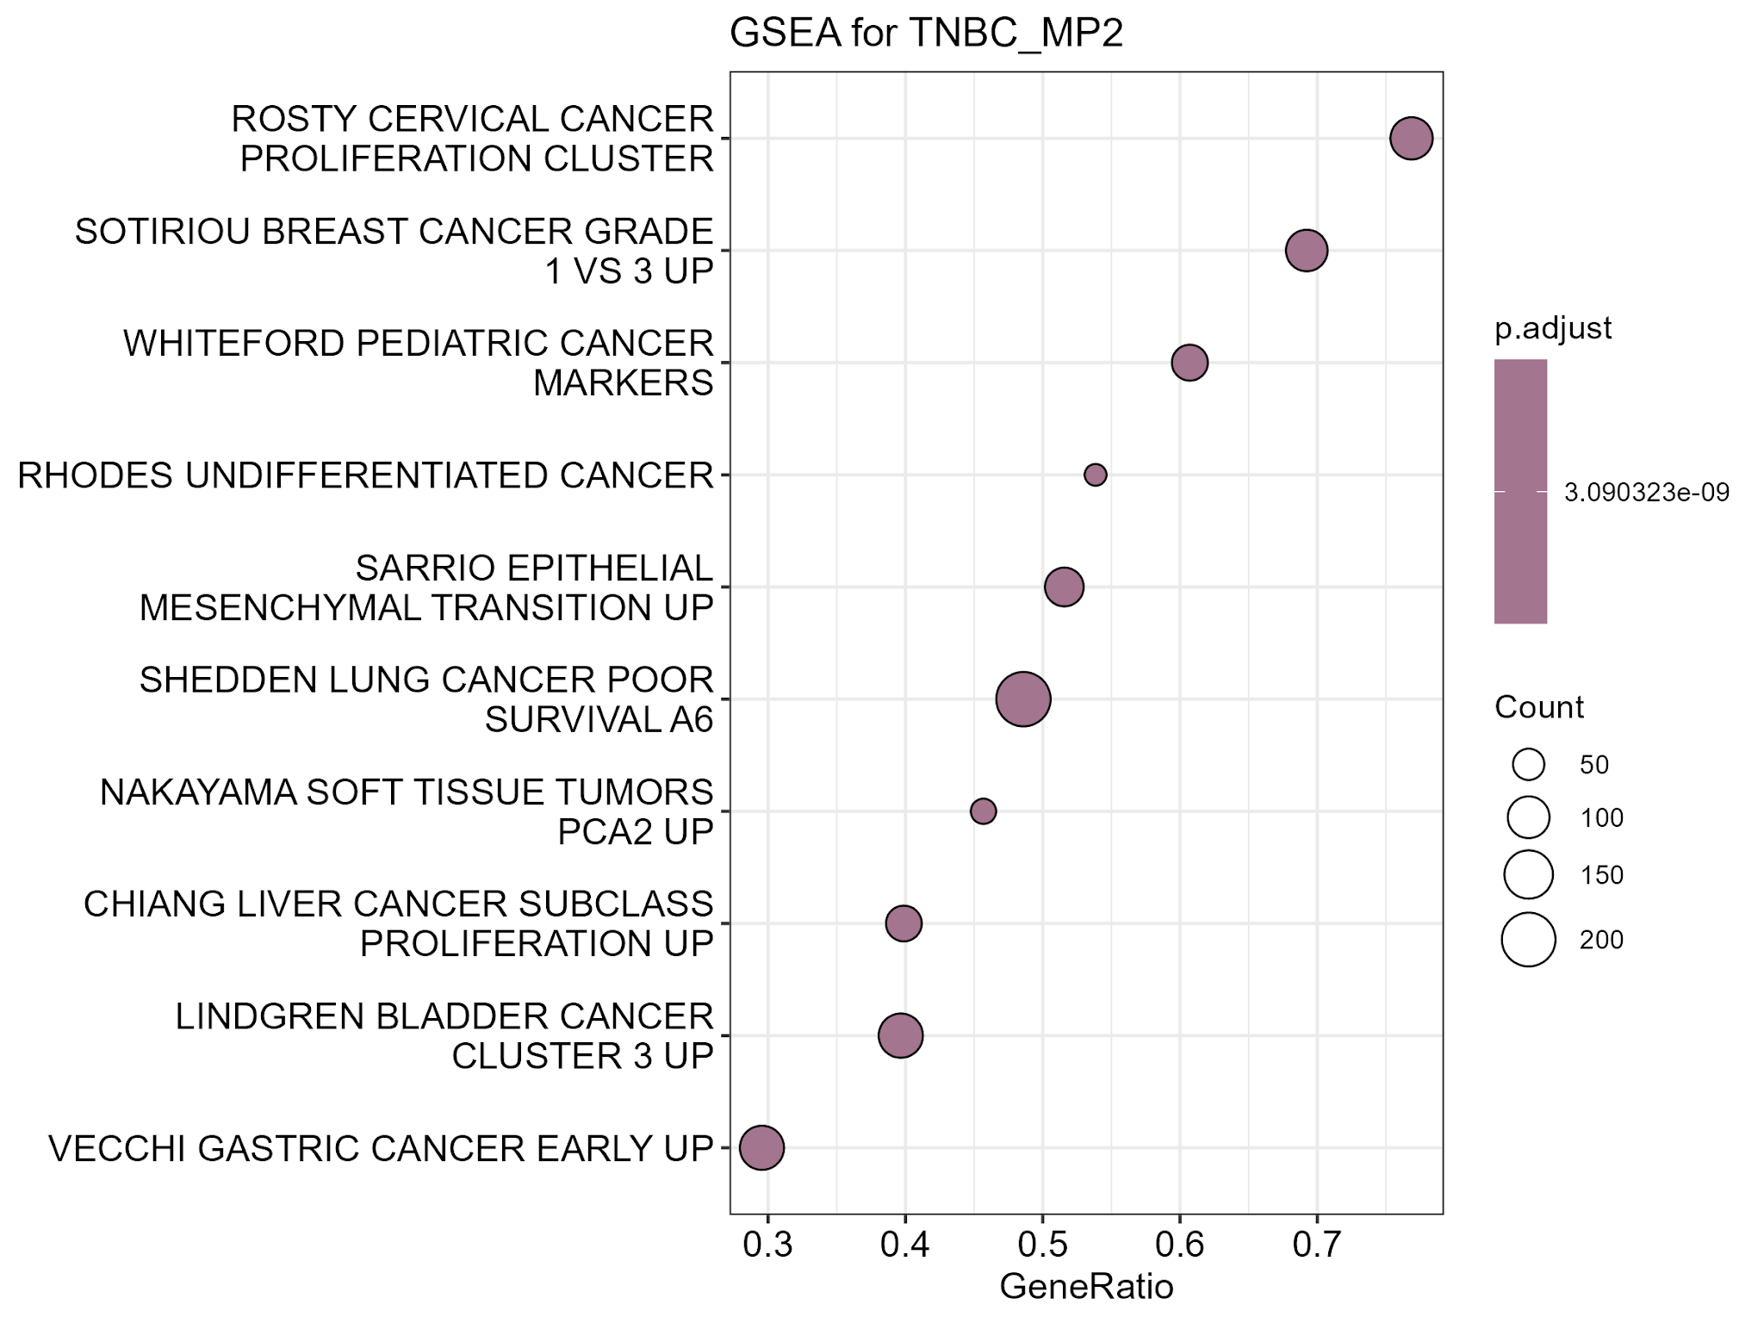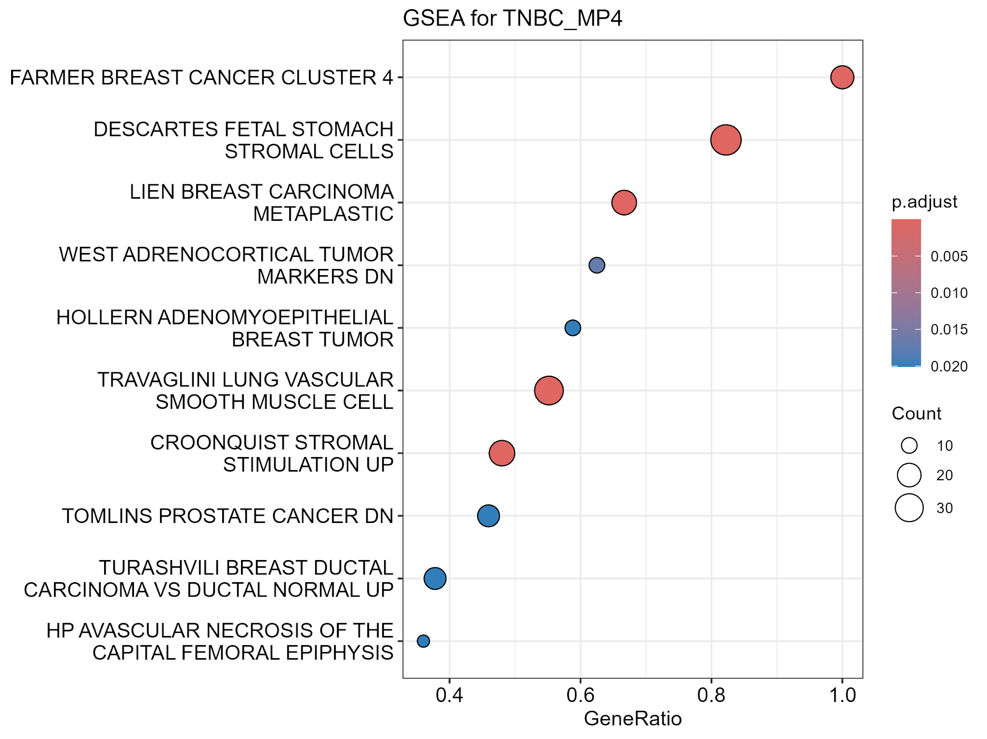

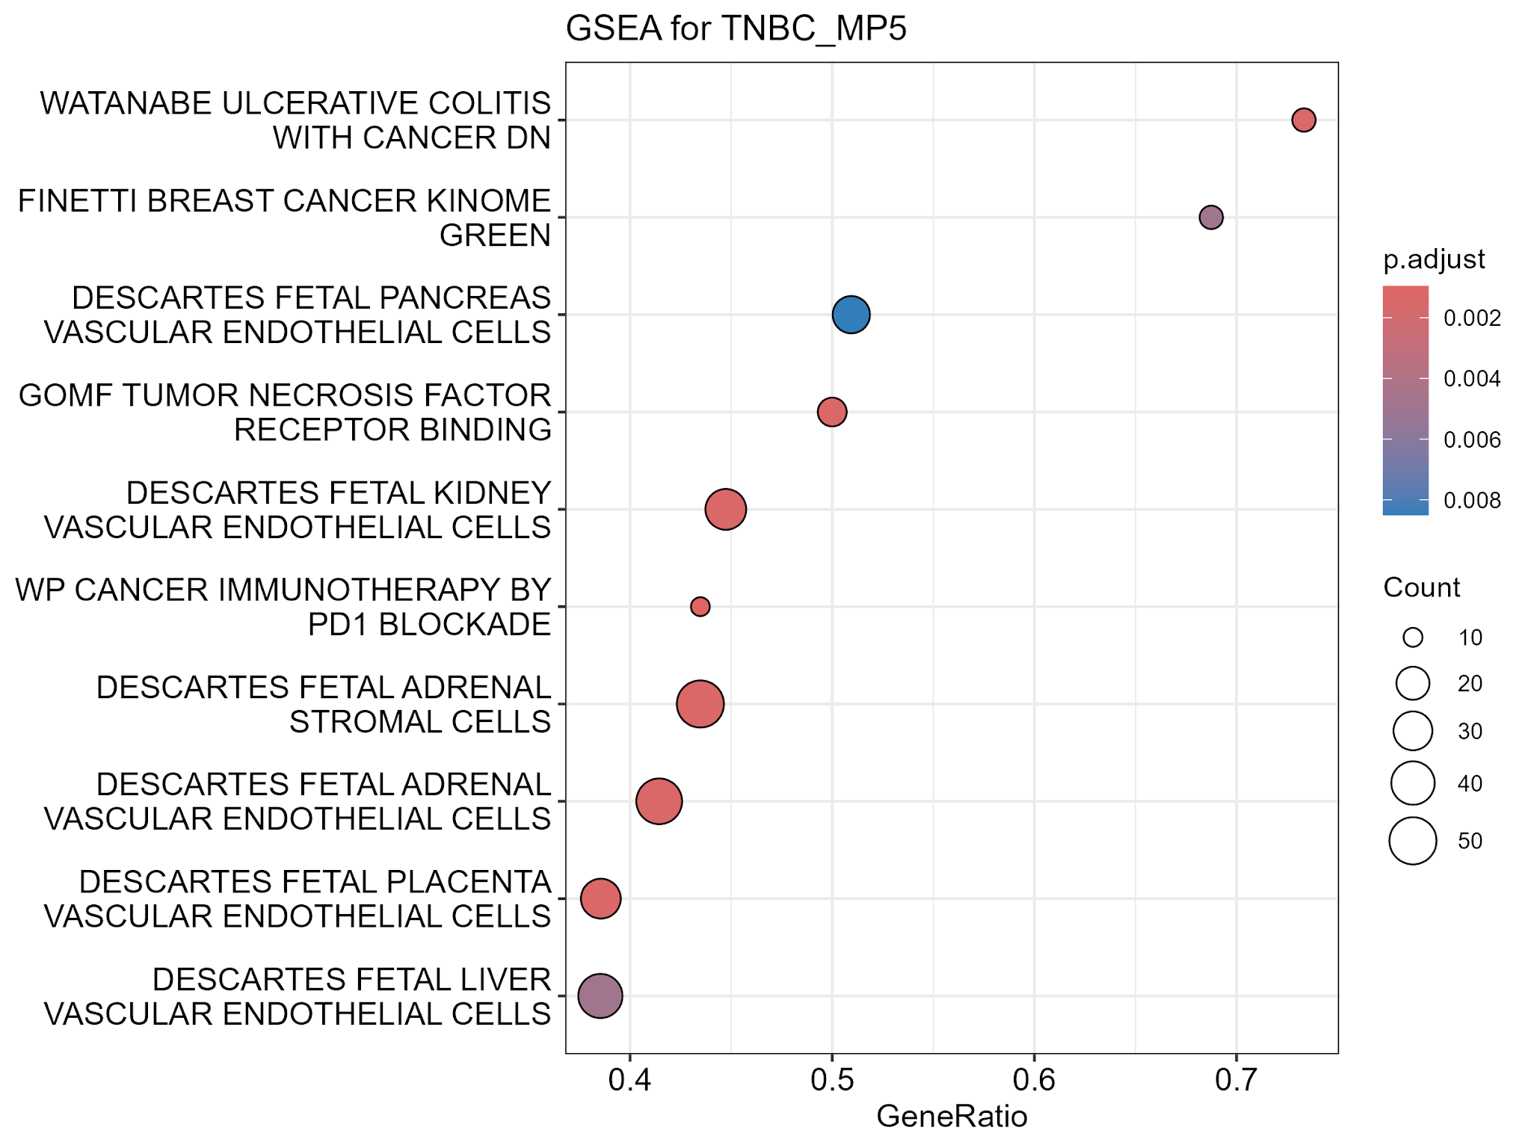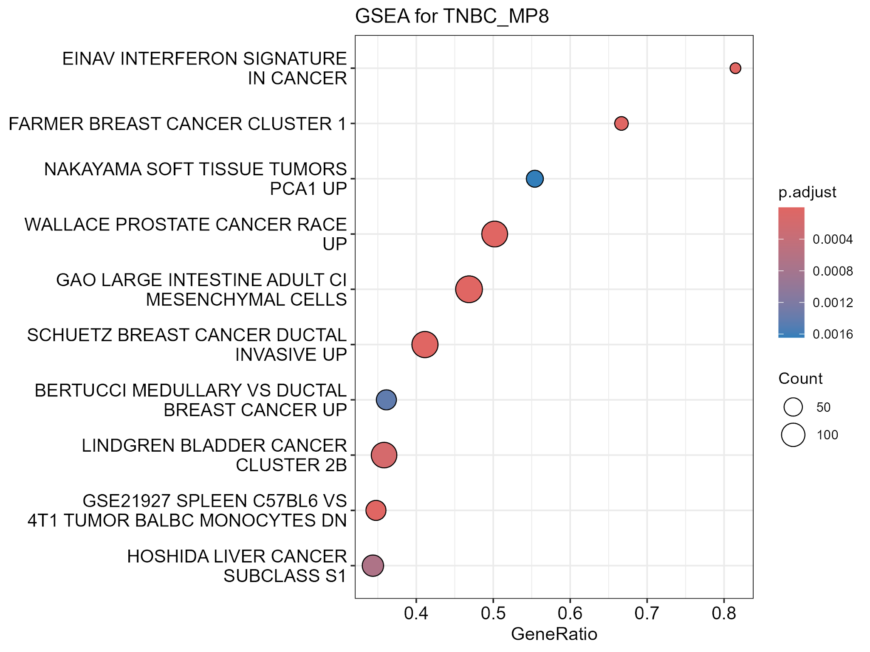
Supplementary Fig. 3: GSEA results for TNBC metaprograms TNBC_MP1, 2, 3, 4, 5, and 8. Each plot displays the top enriched pathways with positive GeneRatios and lowest adjusted p-values .The analysis included pathways related to breast cancer, angiogenesis, epithelial-mesenchymal transition (EMT), vascular processes, and other tumor-associated functions. The pathways are plotted on the x-axis by their GeneRatio, indicating the extent of enrichment, while the size of the points reflects pathway significance.

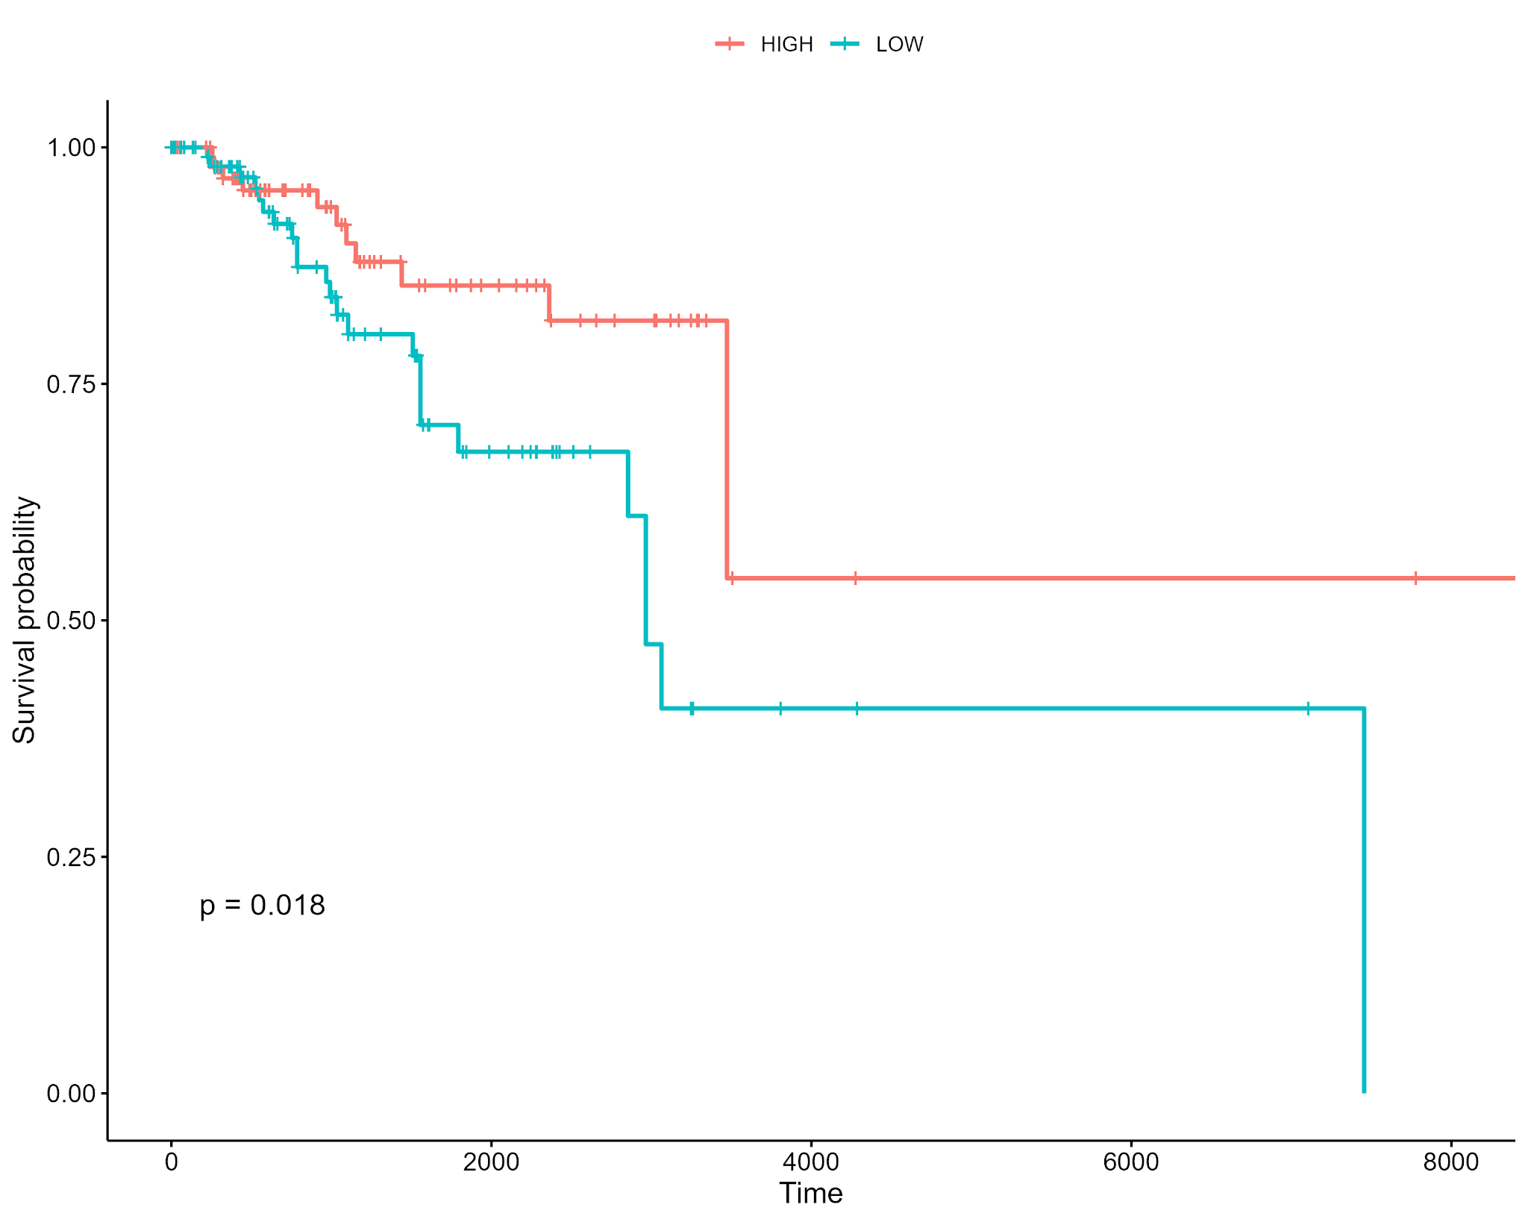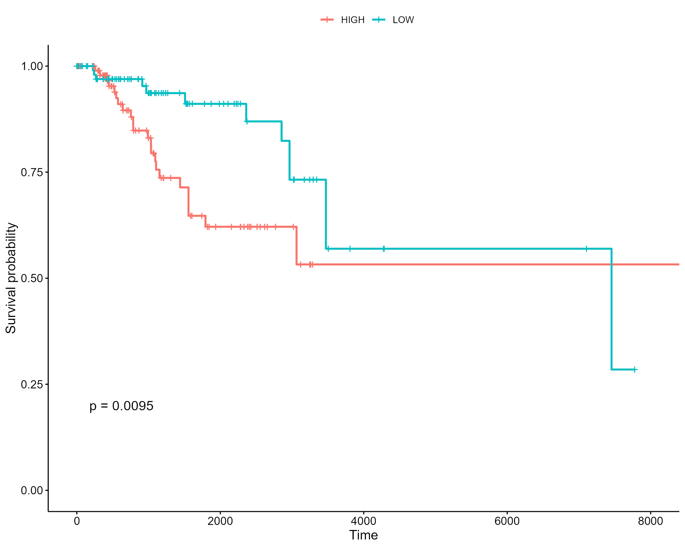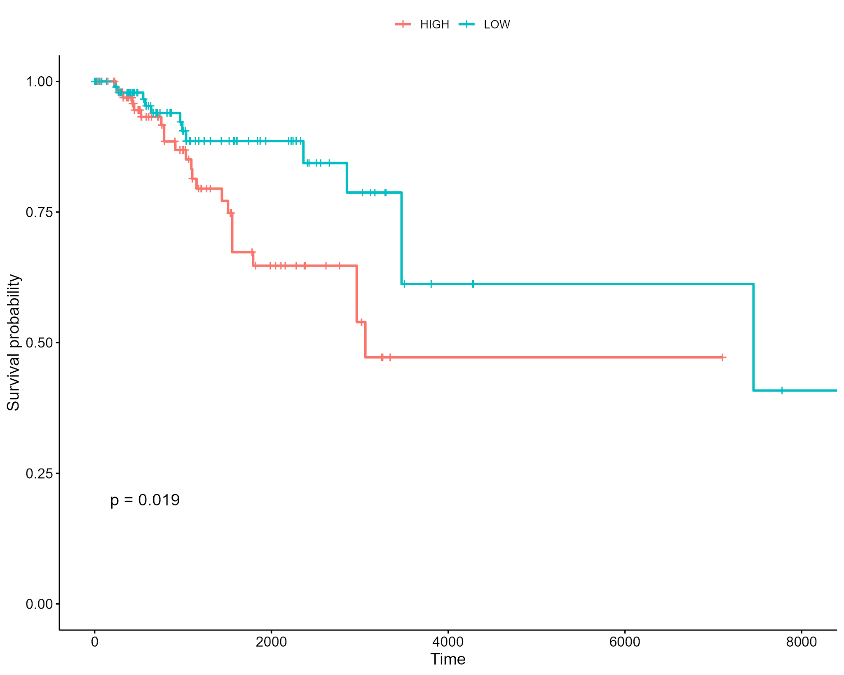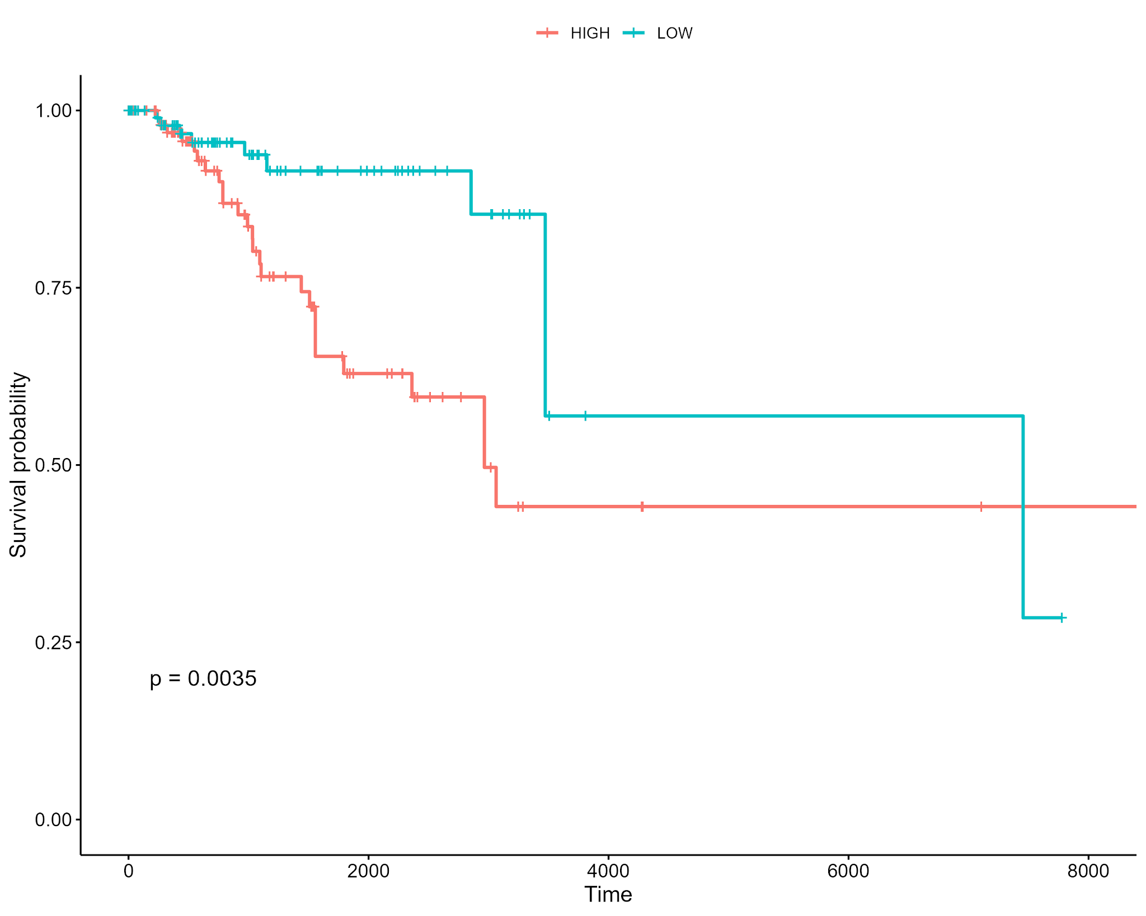
NC8
NC9
NC2
NC2
NC6

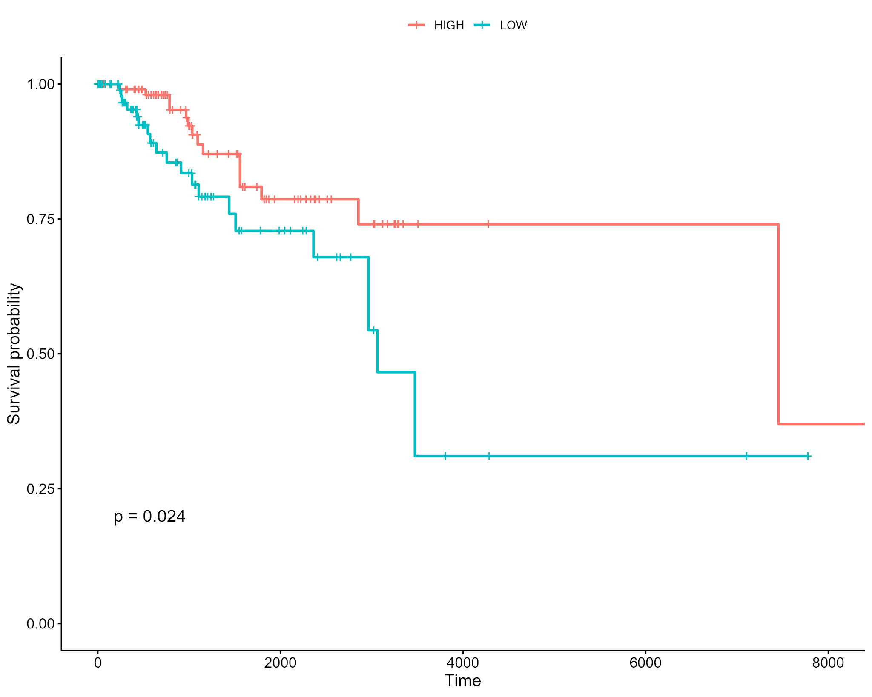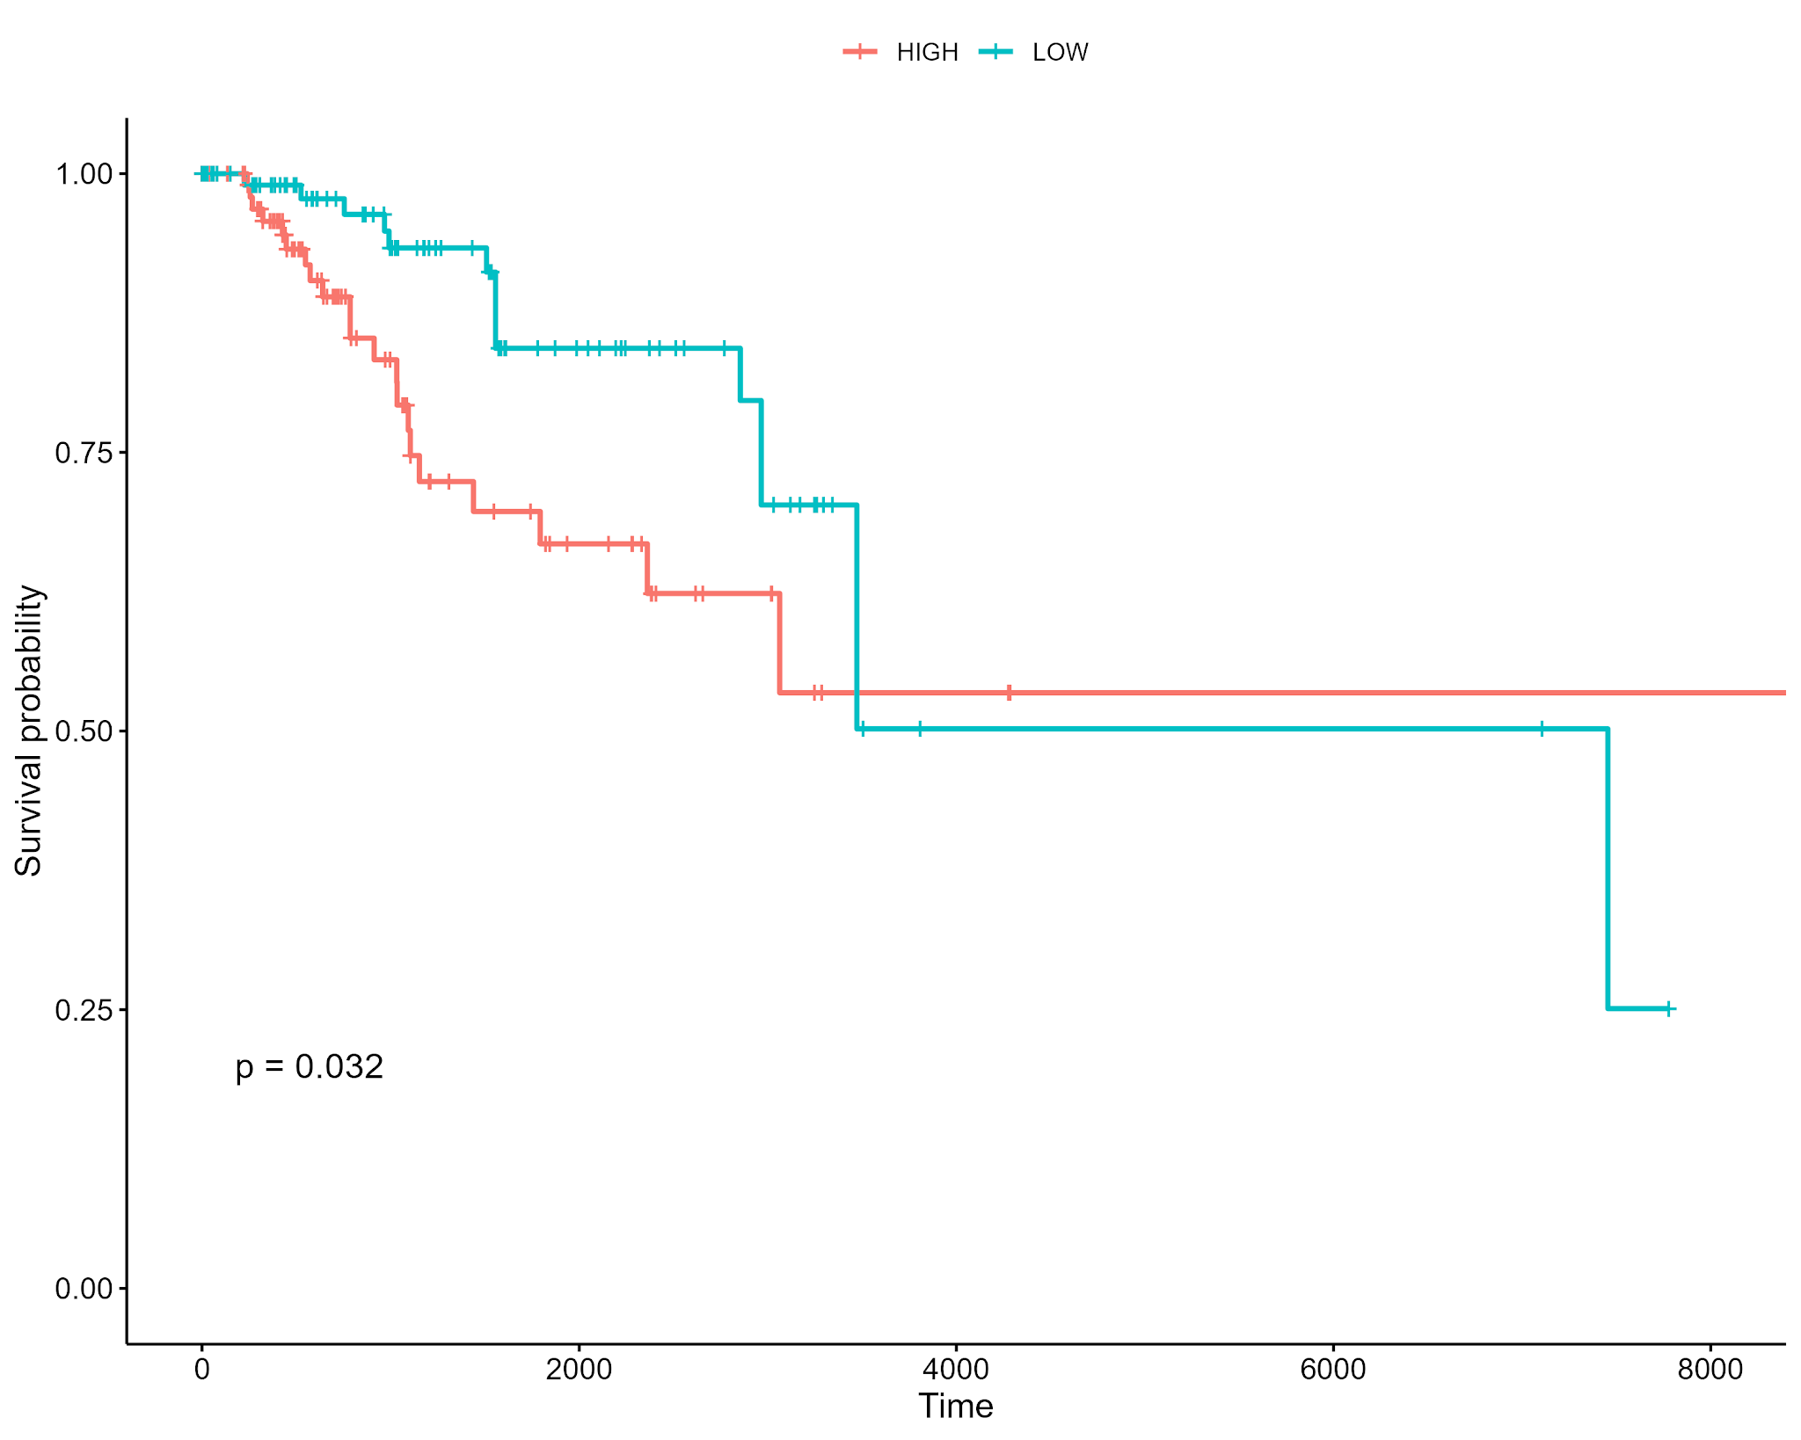
NC10
NC11
Supplementary Fig. 4: Kaplan-Meier Survival Plots for Nonmalignant TNBC programs NC2, 6, 8, 9, 10, and 11 Kaplan-Meier survival plots for patients with TNBC classified based on module expression levels of various MPs from the nonmalignant cells from TNBC patients. Each plot compares the survival probabilities of patients with high and low expression levels of specific metaprograms.

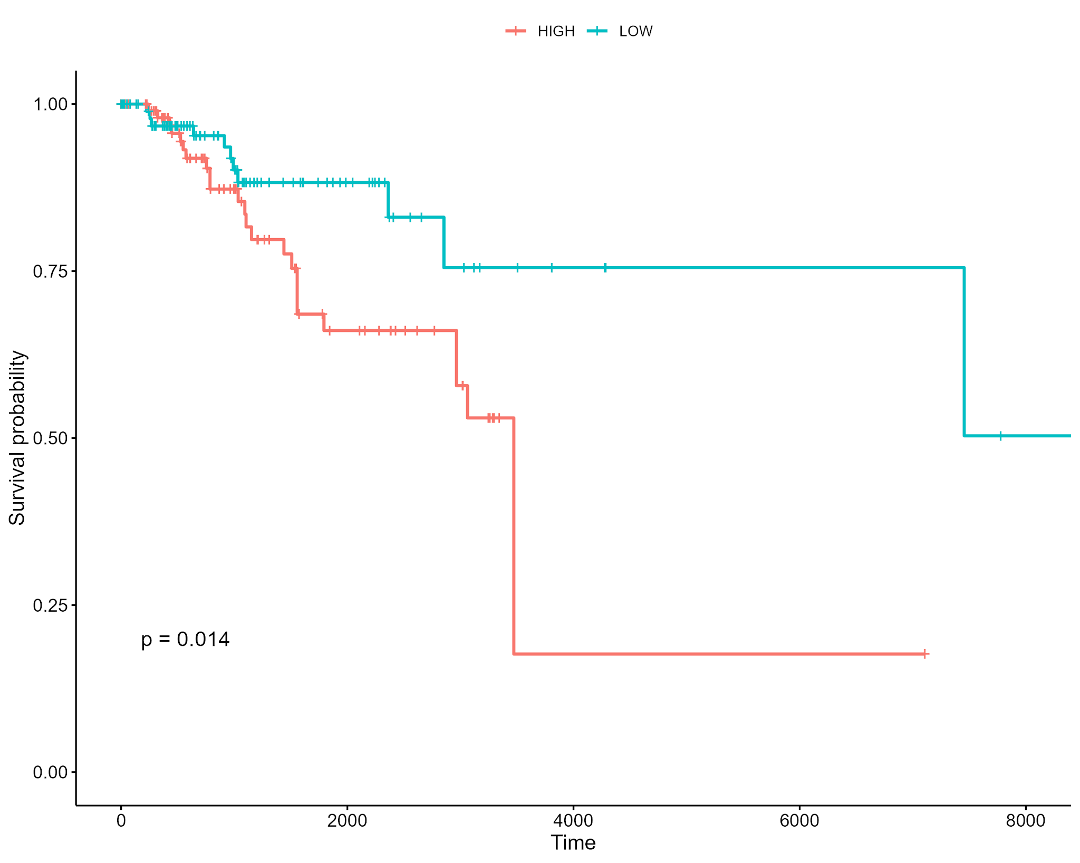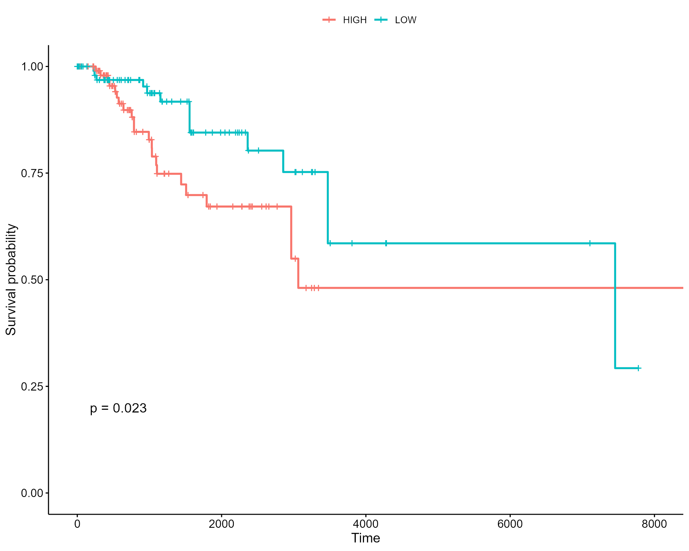
Reed2024_MP1
Reed2024_MP3

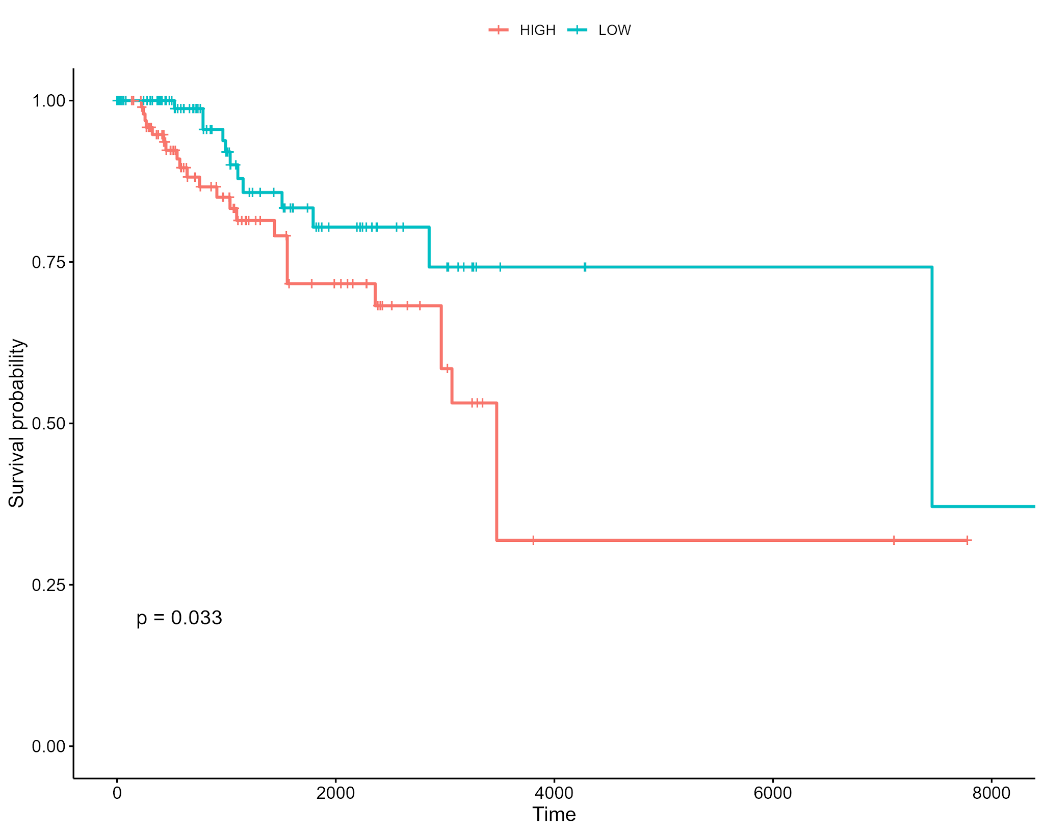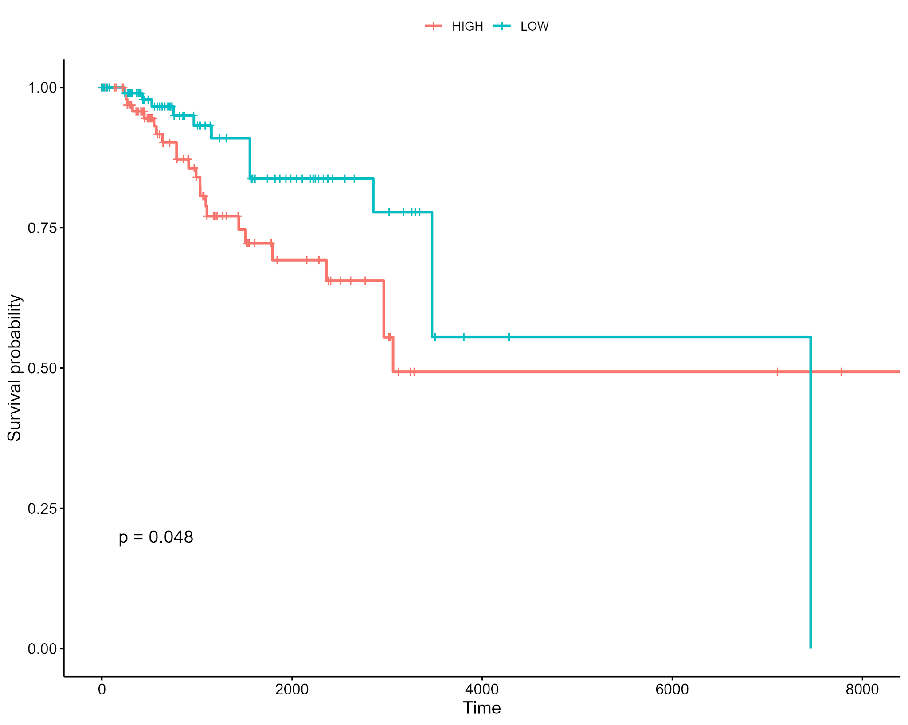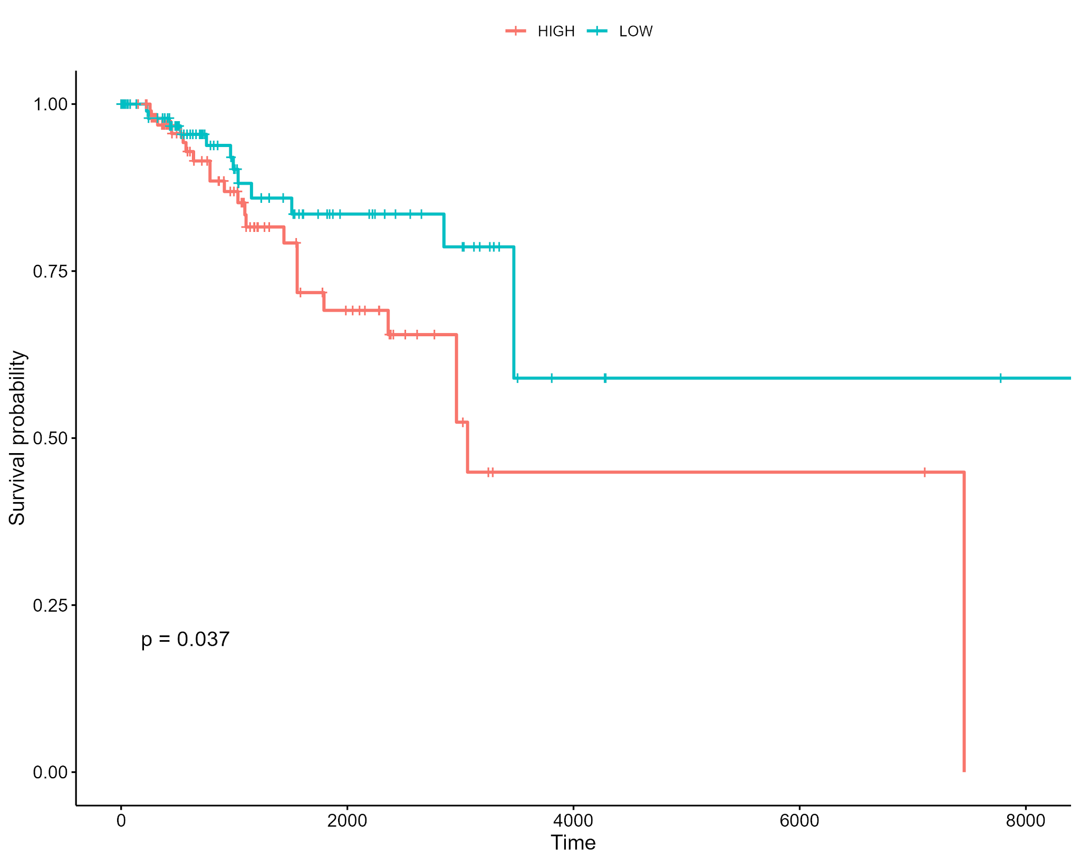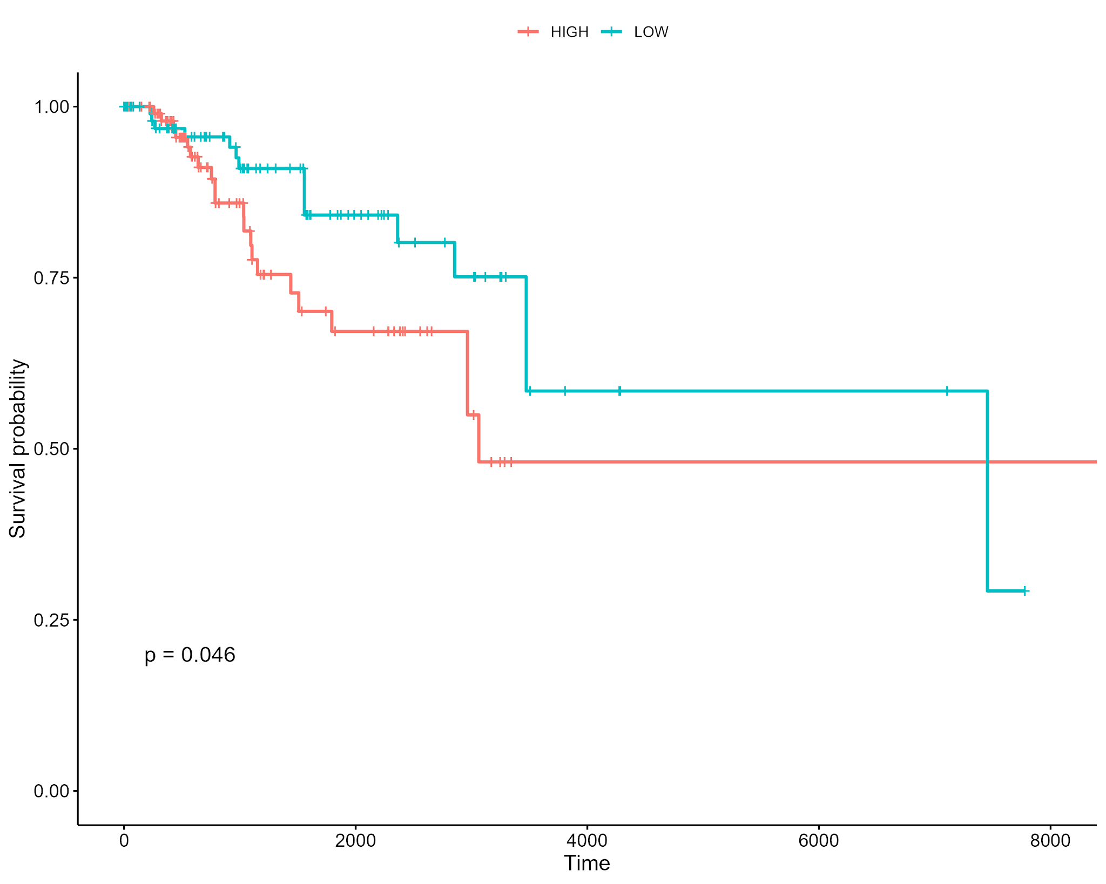Supplementary Fig. 5: Kaplan-Meier Survival Plots for Significant Non Cancerous, Nonmalignant Normal Breast MPs 1, 3, 7, 9, 22, 31. Kaplan-Meier survival plots for patients with TNBC classified based on module expression levels of various MPs from Reed et al., 2024. Each plot compares the survival probabilities of patients with high and low expression levels of specific metaprograms.
Reed2024_MP7
Reed2024_MP9
Reed2024_MP22
Reed2024_MP31

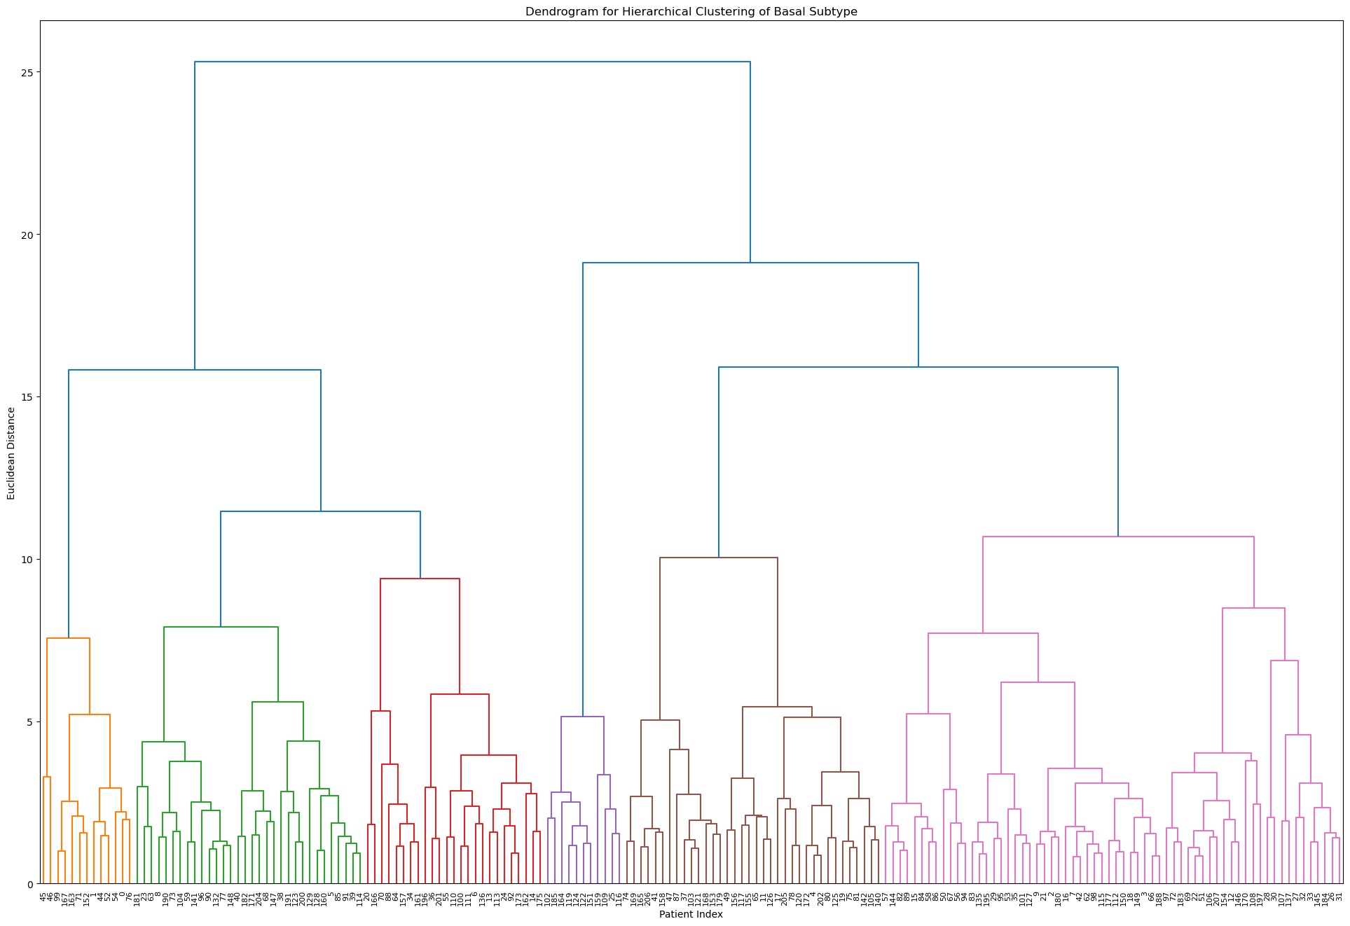
Supplementary Fig. 6: Stratification of Patients via MP Scores Compared to PAM50 based on MP Scores. Hierarchical clustering with a cutoff of 11 revealed multiple clusters of patients based on their combined MP scores.

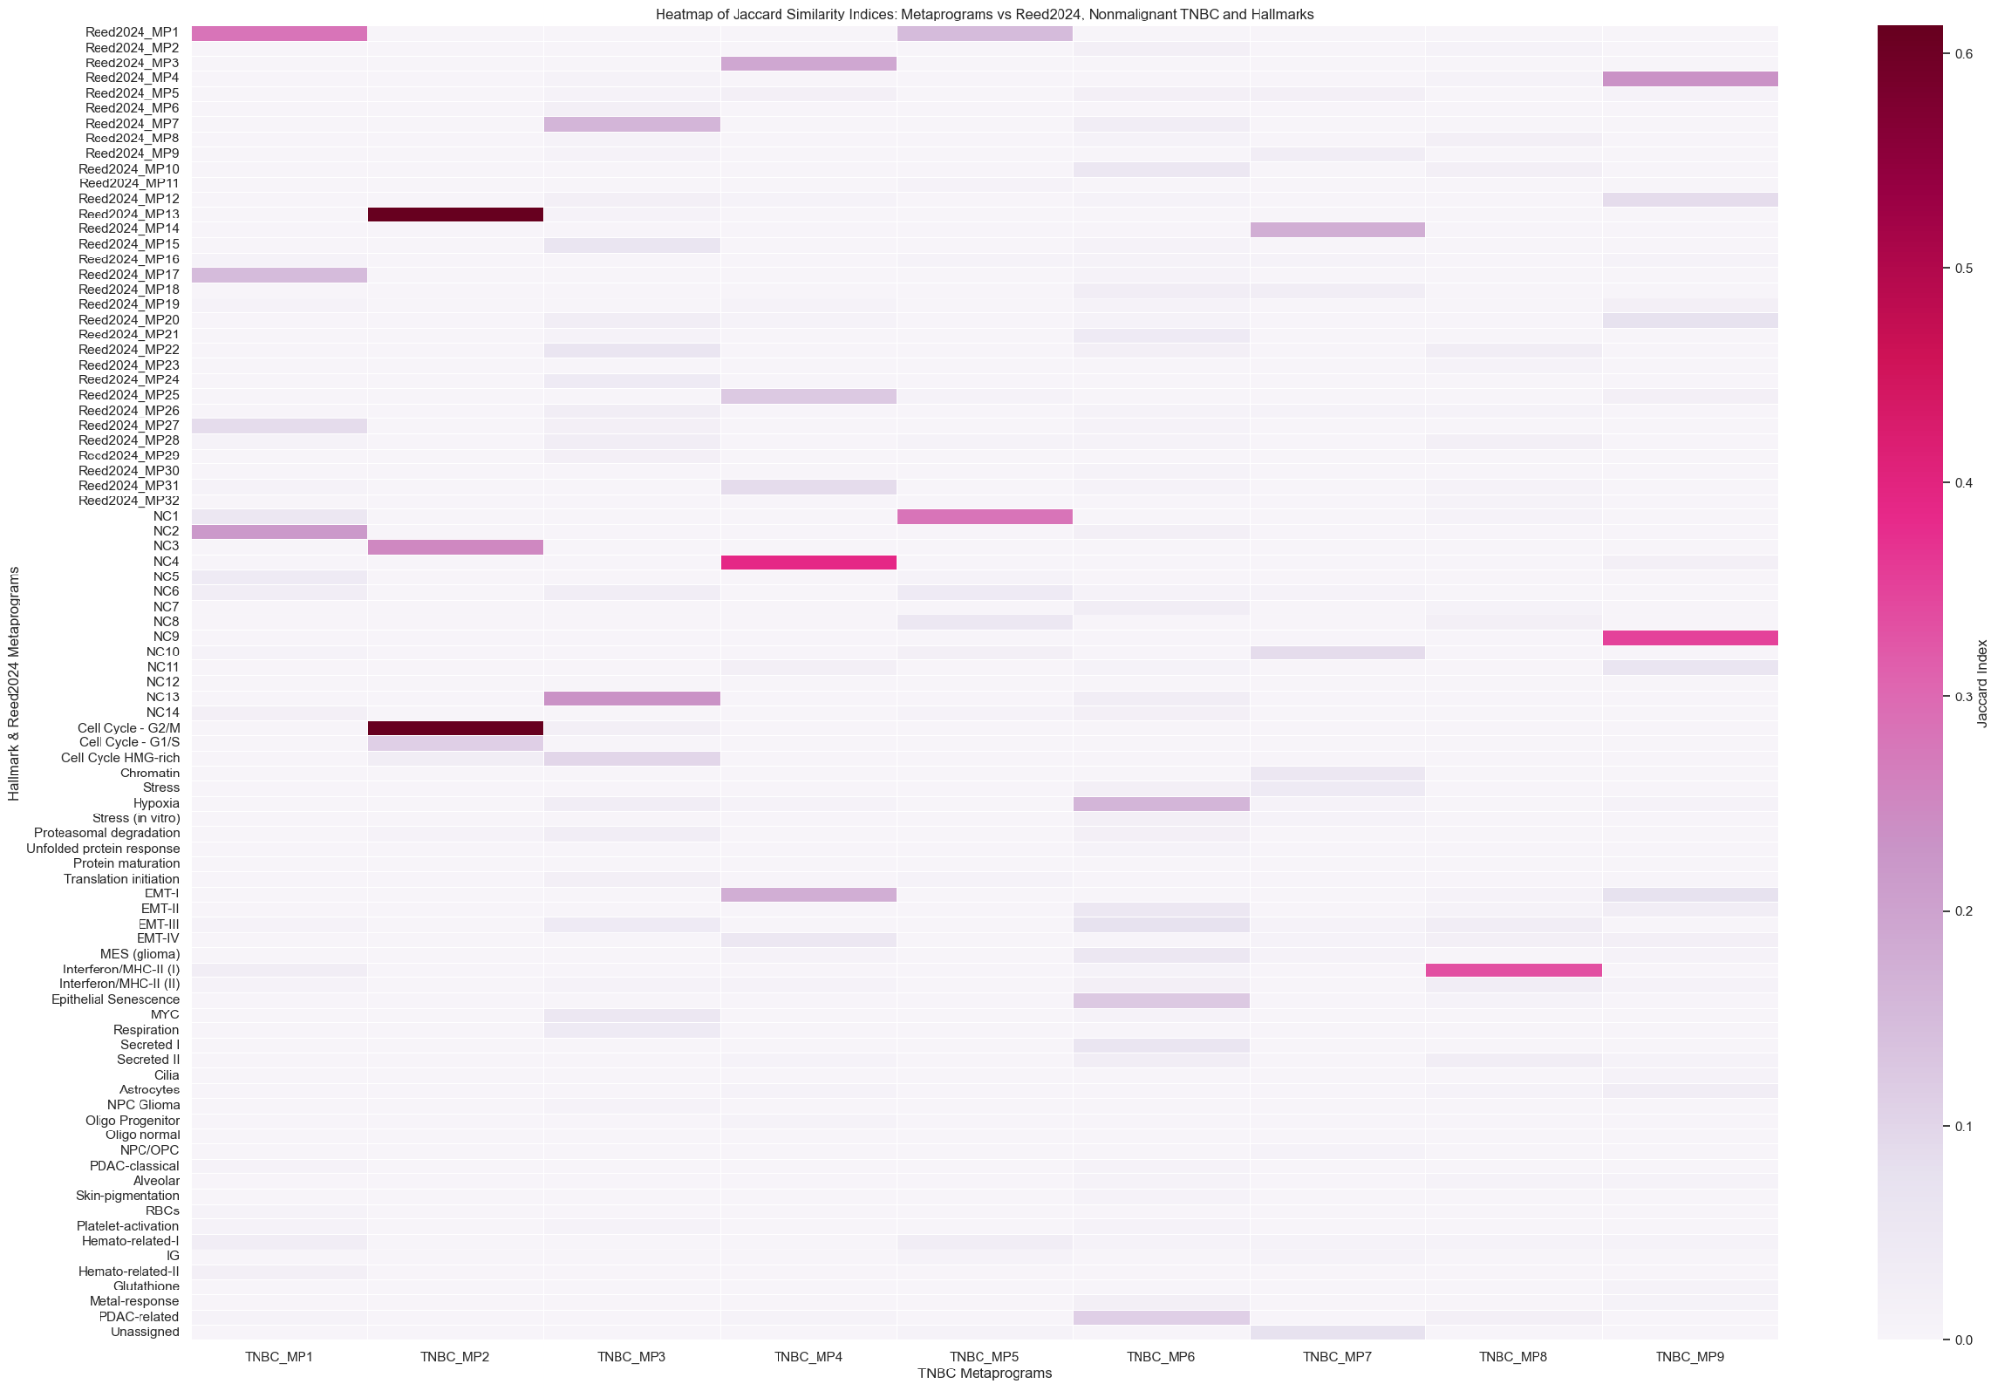Supplementary Fig. 7: Heatmap of Jaccard Similarity Indices: Malignant TNBC Metaprograms vs. Nonmalignant TNBC, Reed2024, and Hallmark Metaprograms. The heatmap displays the Jaccard similarity indices between TNBC metaprograms derived from malignant cells (C1-C9) and clusters from nonmalignant TNBC cells (NC1-NC14), Reed2024 clusters derived from noncancerous breast tissue, and hallmark gene sets. The color scale ranges from light pink (low similarity) to dark purple (high similarity), with the Jaccard index values indicating the extent of overlap between the gene sets of the compared clusters.

