Supplementary Results 1: Sample Specific MP correlations
To examine the stability and variability of MP relationships across samples in this updated TNBC dataset, we analyzed individual donor correlation matrices and compared them to an aggregated correlation matrix for all samples. This approach allows us to identify consistent and variable interactions among MPs across the tumor microenvironment in TNBC.

General Observations Across Samples
Stable Correlations Across Samples
- TNBC_MP1 and TNBC_MP5 continue to show a positive correlation across nearly all donors, underscoring their shared role in immune modulation within the tumor microenvironment. This consistency suggests a fundamental immune-modulatory axis that is preserved across different tumor environments.
- Similarly, TNBC_MP4 and TNBC_MP9 display stable positive correlations across donors, likely reflecting coordinated ECM remodeling and angiogenesis processes. This recurring pattern implies a tightly linked relationship between ECM organization and vascular development that is essential for TNBC progression.
Variable Correlations Across Samples
- TNBC_MP2 and TNBC_MP7 exhibit considerable variability in their correlation across samples. While some samples display weak or neutral correlations, others show more distinct relationships, highlighting the context-dependent nature of cell cycle progression (TNBC_MP2) and luminal-like states (TNBC_MP7). This variability could be influenced by specific tumor characteristics or microenvironmental factors.
- TNBC_MP6 also demonstrates differential correlation patterns with other MPs across samples. As TNBC_MP6 is associated with EMT and hypoxia, this variability may indicate that the hypoxia response is sensitive to the unique metabolic or proliferative states of individual tumors.

Unique Patterns in Specific Donor Samples
- Donor ART17: In this sample, a moderate positive correlation between TNBC_MP4 and TNBC_MP9 suggests synchronized ECM remodeling and angiogenesis activities, potentially indicative of an invasive phenotype.
- Donor TN-0126: Here, TNBC_MP6 (MES-like, EMT/hypoxia) shows a stronger association with TNBC_MP7 (Luminal-like) than in other samples, possibly reflecting heightened EMT and transcriptional reprogramming, which could contribute to more aggressive tumor behavior in this specific tumor context.

Sample-Specific and Cross-Sample Comparisons
Stable Relationships:
- MPs such as TNBC_MP1 and TNBC_MP5 maintain robust positive correlations across most samples, indicating a strong immune-related interaction that may be a consistent feature of the TNBC microenvironment.
- TNBC_MP4 and TNBC_MP9 also maintain a stable positive correlation, underscoring a foundational role for ECM remodeling and angiogenesis across the dataset. This suggests that these processes are not only central to tumor progression but also widely shared across individual tumors.
Variable Relationships:
- TNBC_MP2 (cell cycle) and TNBC_MP3 (metabolic activity) display variable correlation patterns across samples, suggesting that these interactions are highly dependent on the tumor’s unique proliferative and metabolic demands.
- The correlations of TNBC_MP6 with other MPs, particularly TNBC_MP4 and TNBC_MP7, also vary across donors, highlighting that EMT and hypoxia may play more specialized roles in different tumor environments.

Interpretation and Implications
- Core MP Interactions: The consistent positive correlations between MPs such as TNBC_MP1 and TNBC_MP5 or TNBC_MP4 and TNBC_MP9 suggest stable interactions central to TNBC biology. These may represent essential features of the immune response and vascular development within TNBC tumors and could be potential therapeutic targets.
- Context-Dependent MP Relationships: The variable interactions observed with TNBC_MP2, TNBC_MP3, and TNBC_MP6 across samples indicate that these MPs respond dynamically to tumor-specific factors, such as hypoxia levels, metabolic demands, and proliferative state. These relationships may reflect the tumor's adaptive responses to its microenvironment, potentially linked to differences in aggressiveness or treatment resistance.
- Sample-Specific Correlation Patterns: Unique correlation patterns in individual samples, such as those in ART17 and TN-0126, could reflect specific tumor phenotypes. These observations suggest that further study of these sample-specific features may help identify subtypes within TNBC with distinct clinical characteristics.
This analysis of MP correlations underscores the complex and context-dependent nature of the TNBC tumor microenvironment, with certain features that are both stable across samples and specific to individual tumors. Further examination of these MP relationships may reveal new insights into TNBC biology and therapeutic opportunities.

The following heatmaps illustrate the correlation between MPs across all malignant cells in the each individual patient. The correlation matrix displays the relationships between the expression patterns of the nine metaprograms (TNBC_MP1-9) across malignant cells. The correlation values range from -1 to 1, where positive values (closer to 1) indicate a positive correlation, and negative values (closer to -1) indicate a negative correlation.
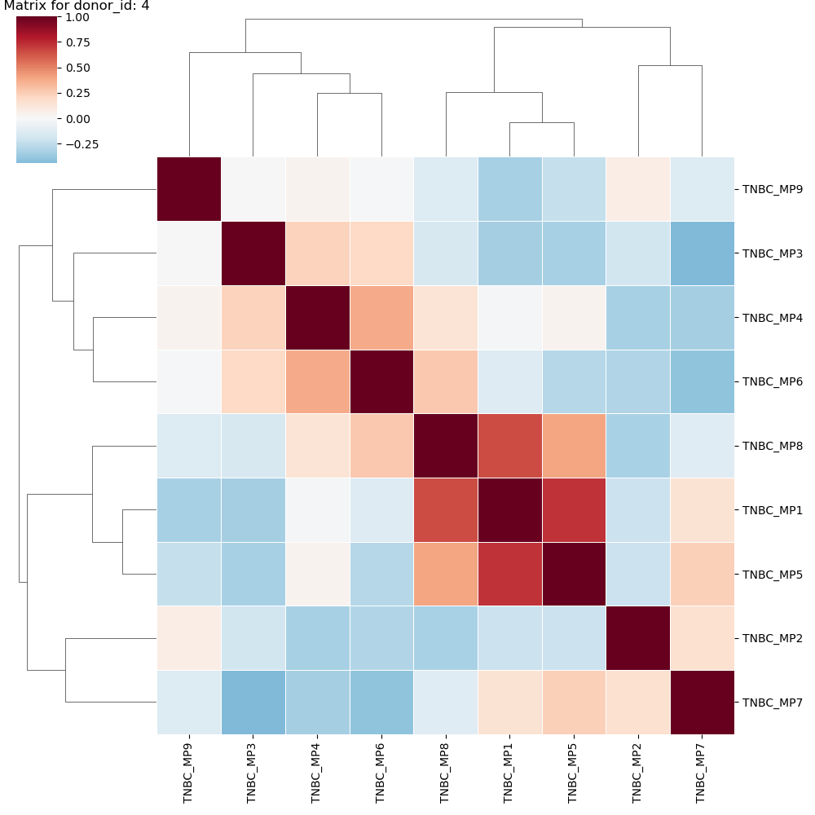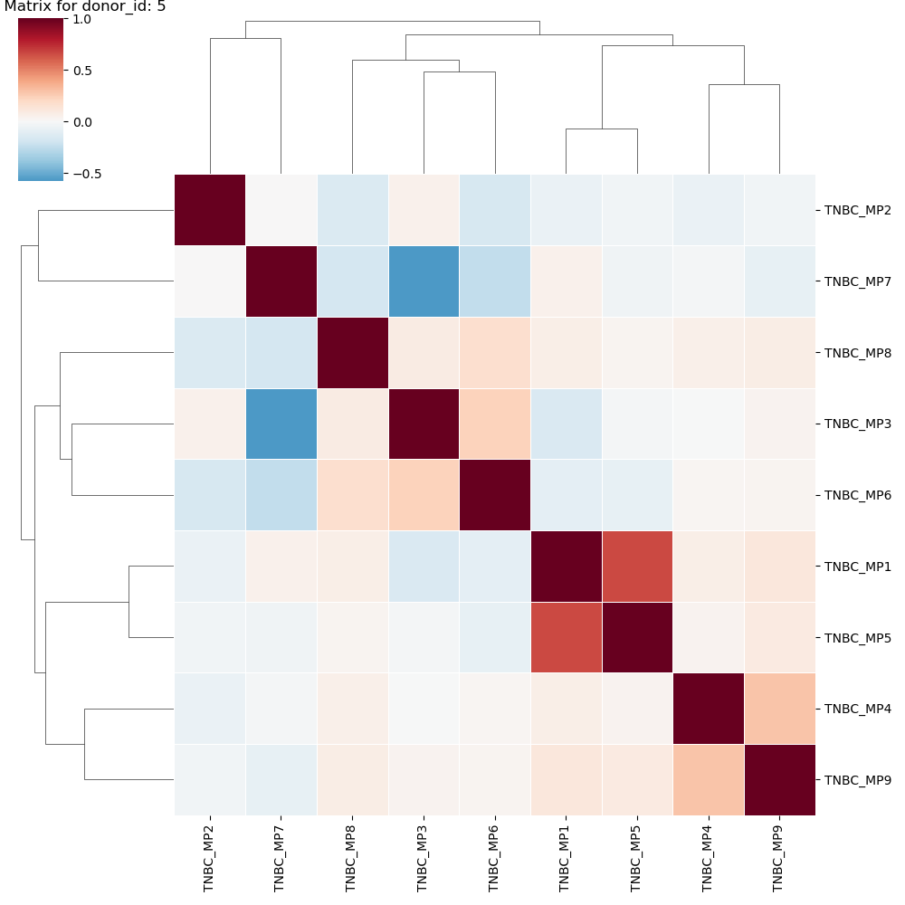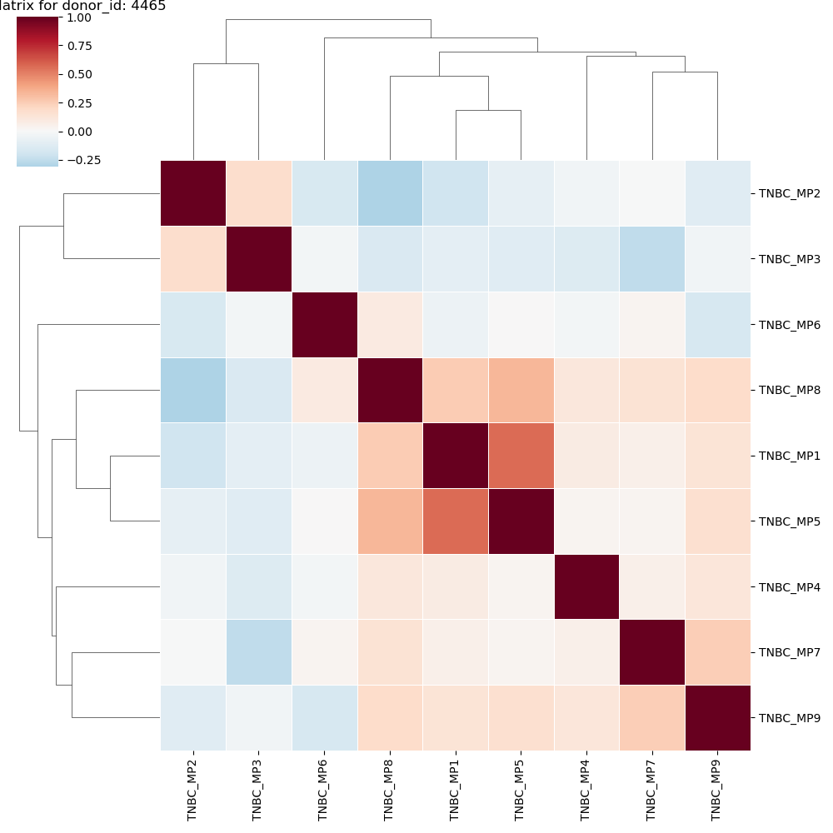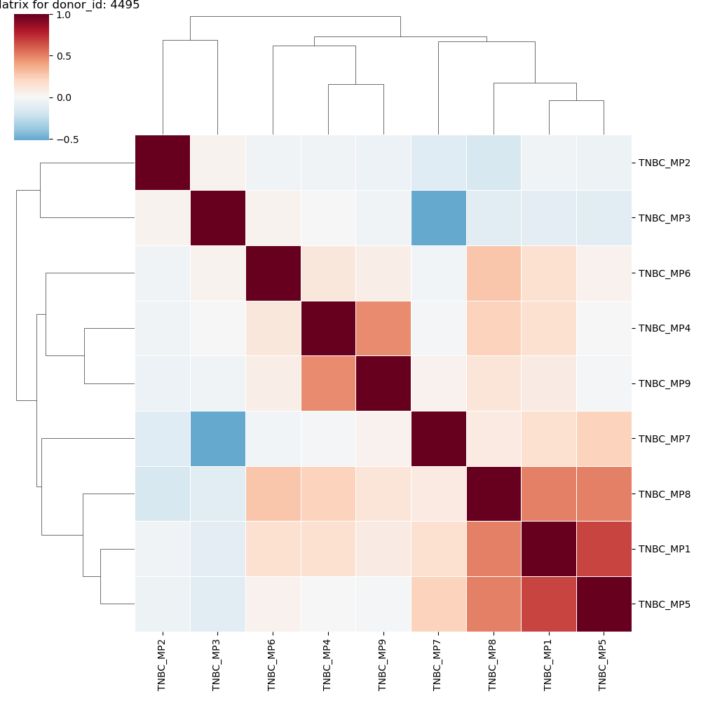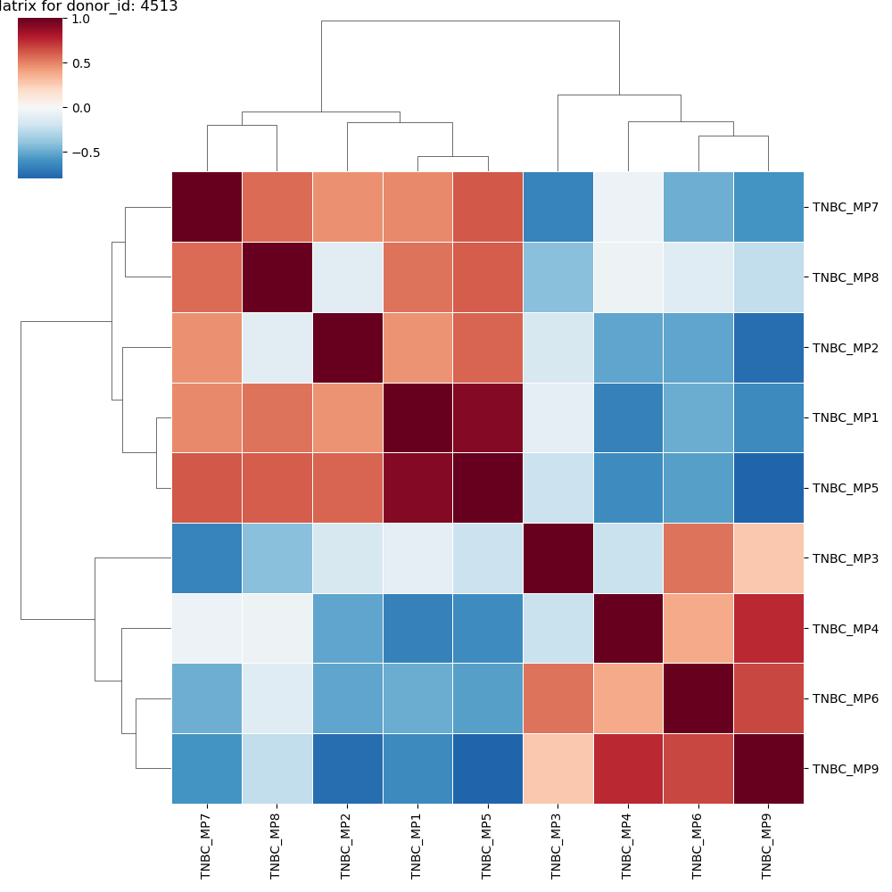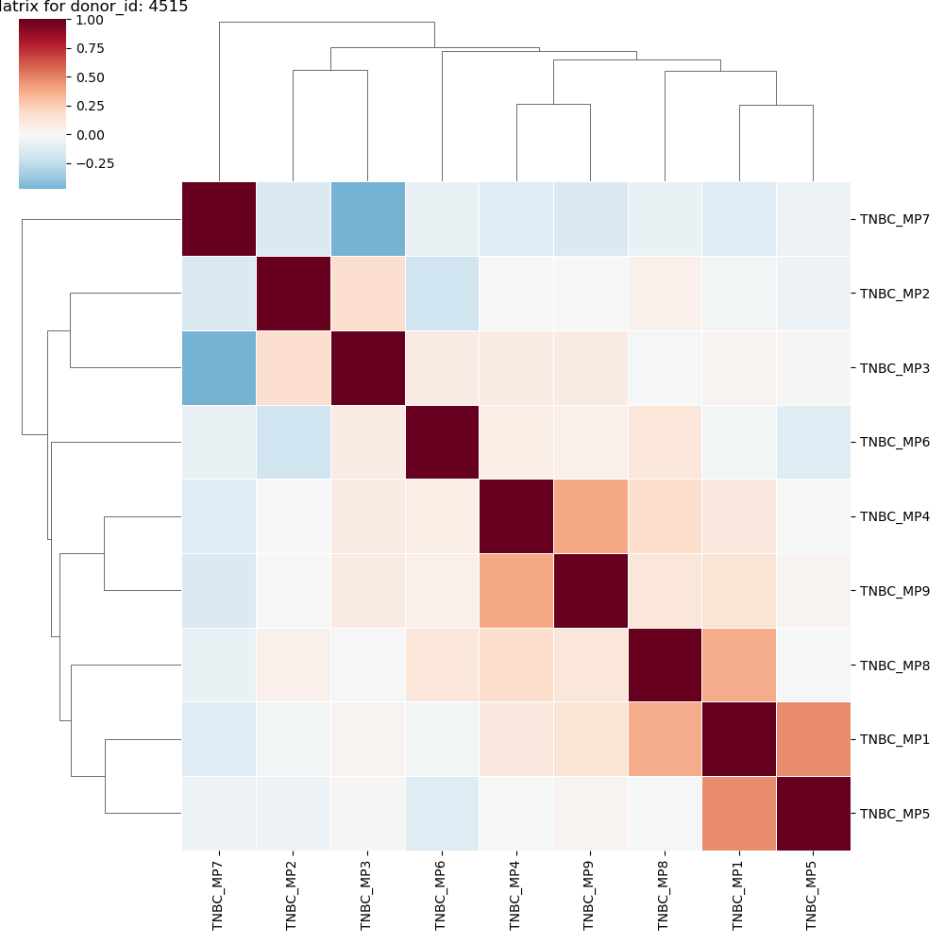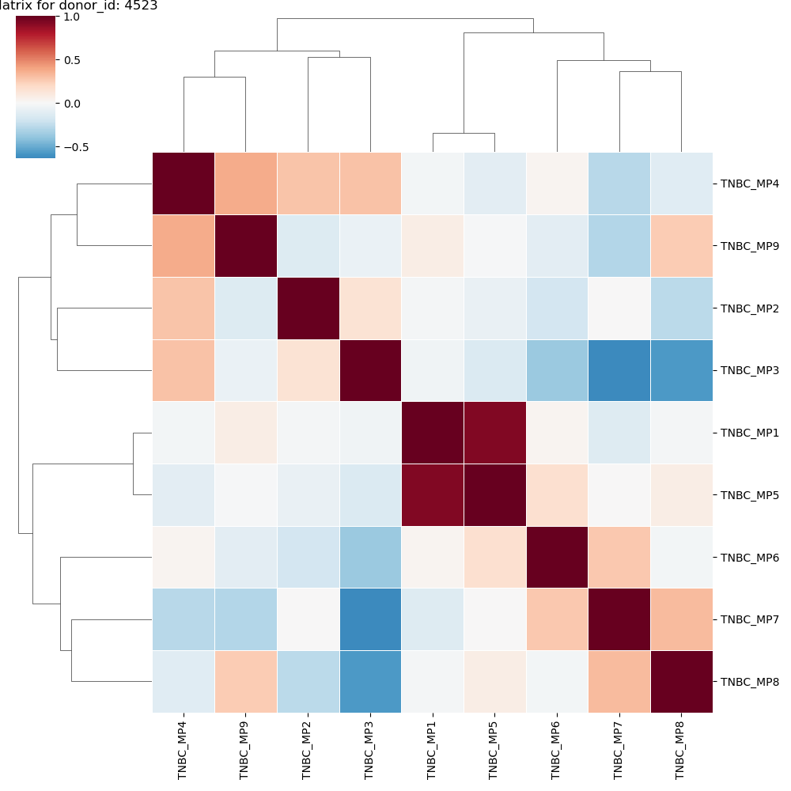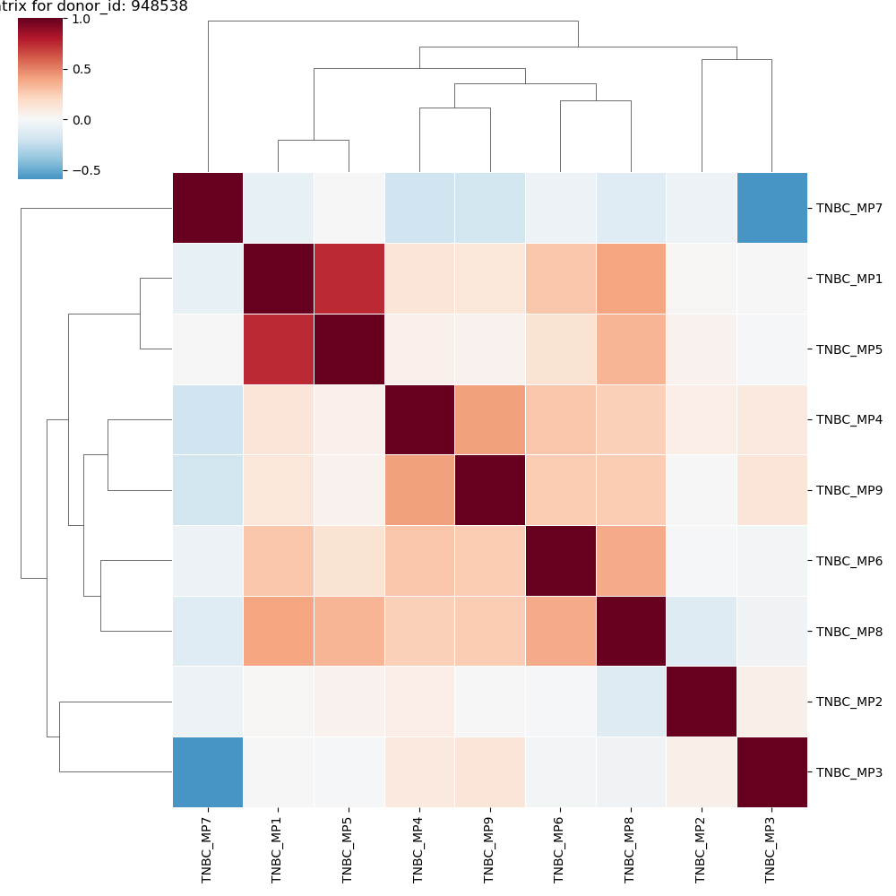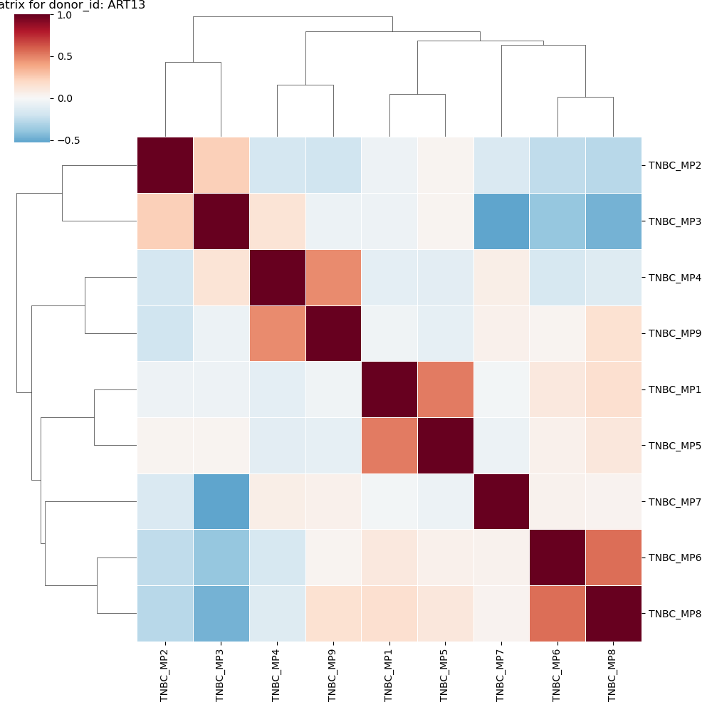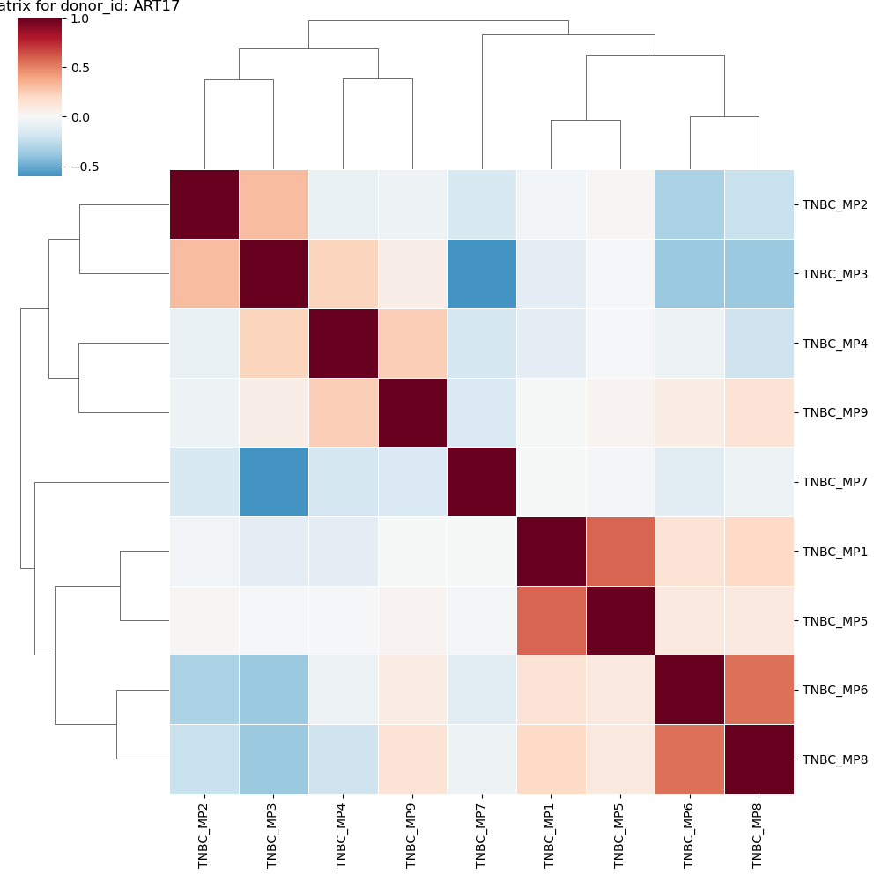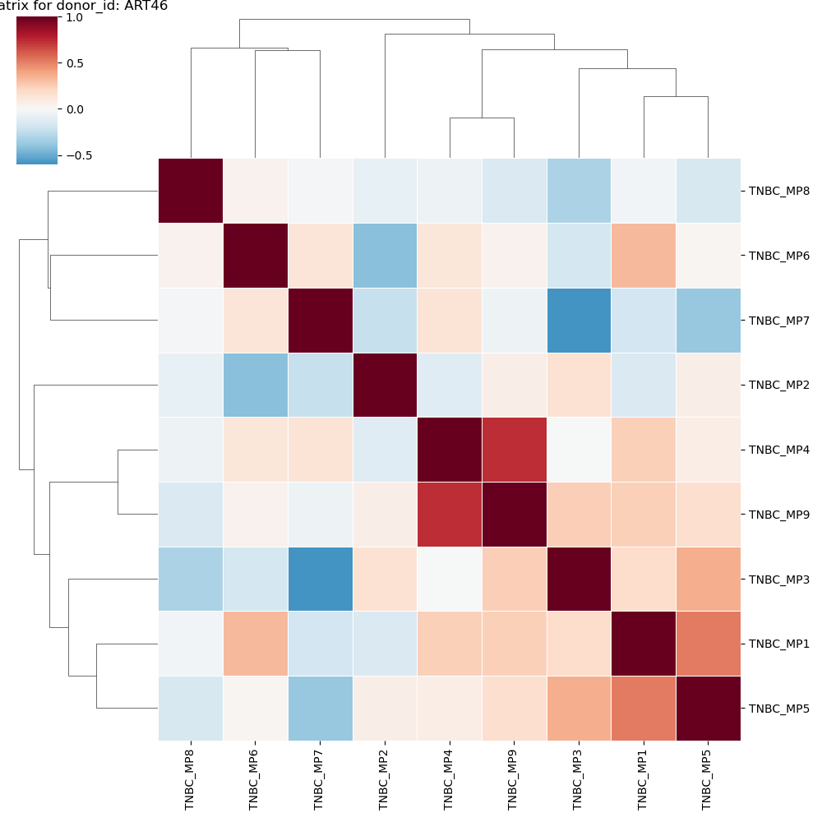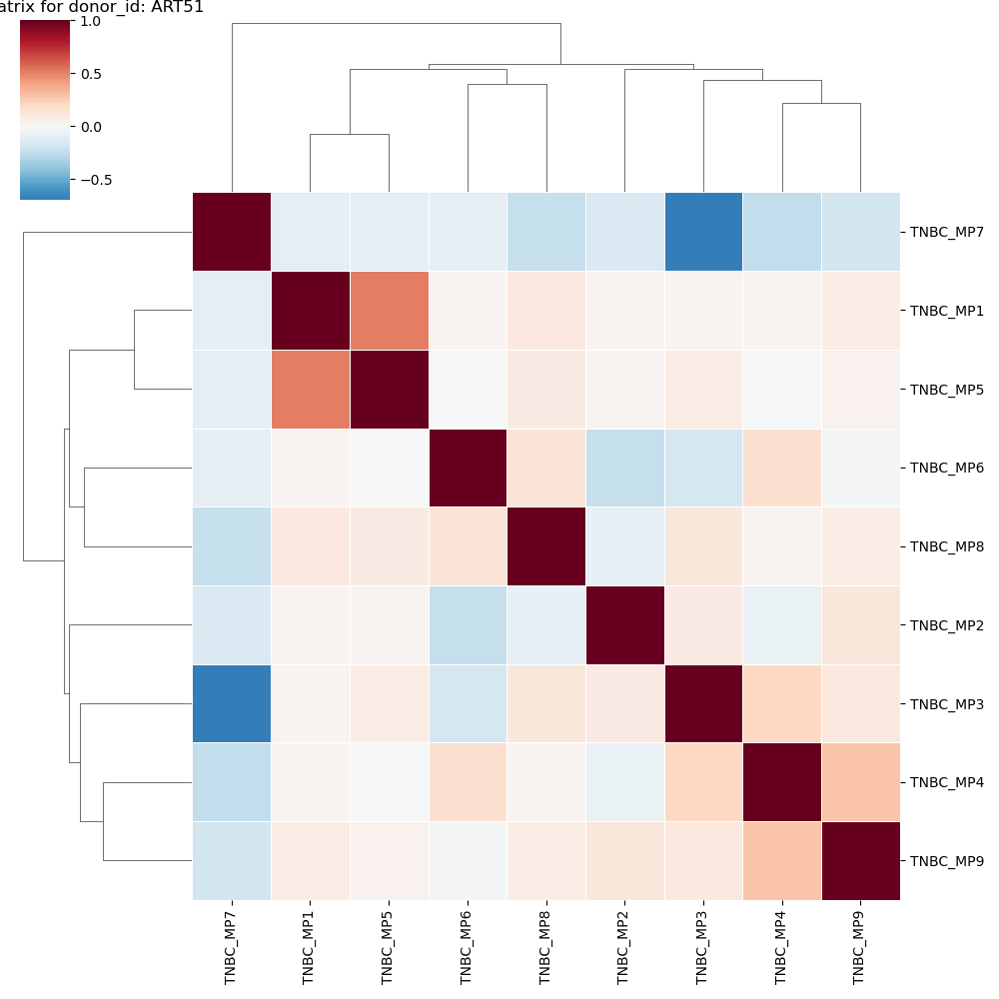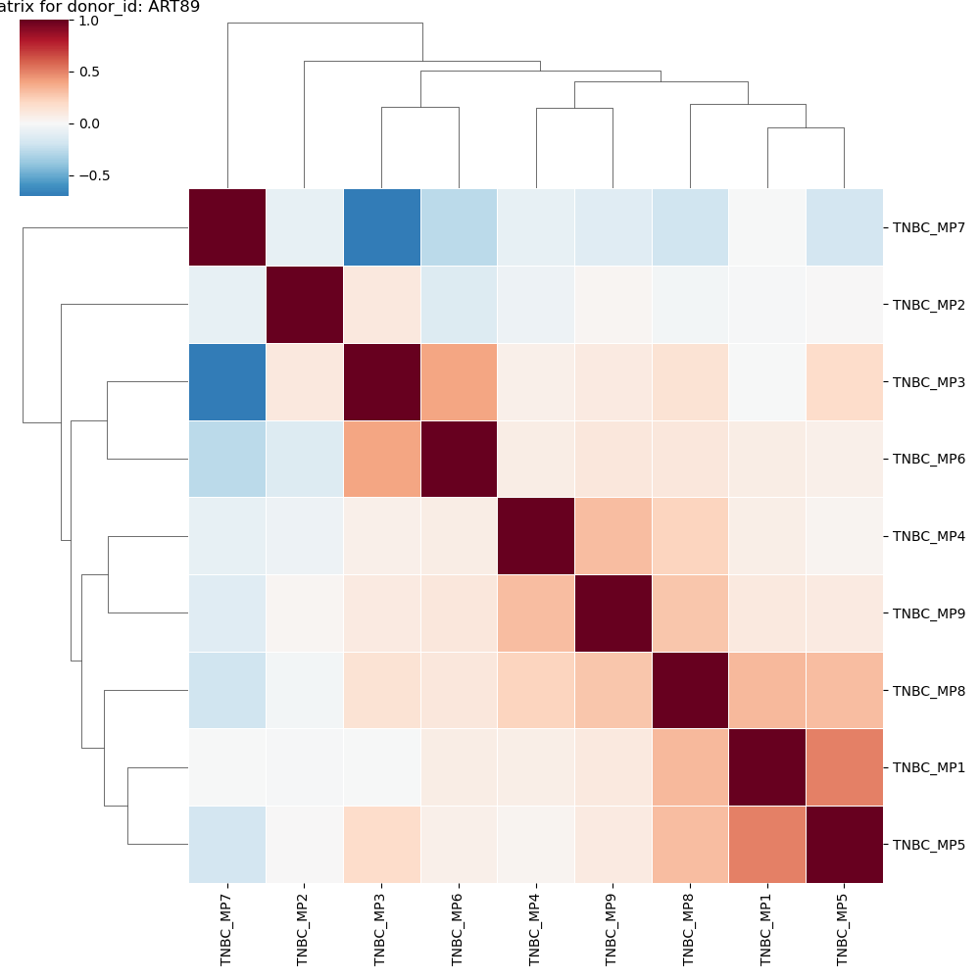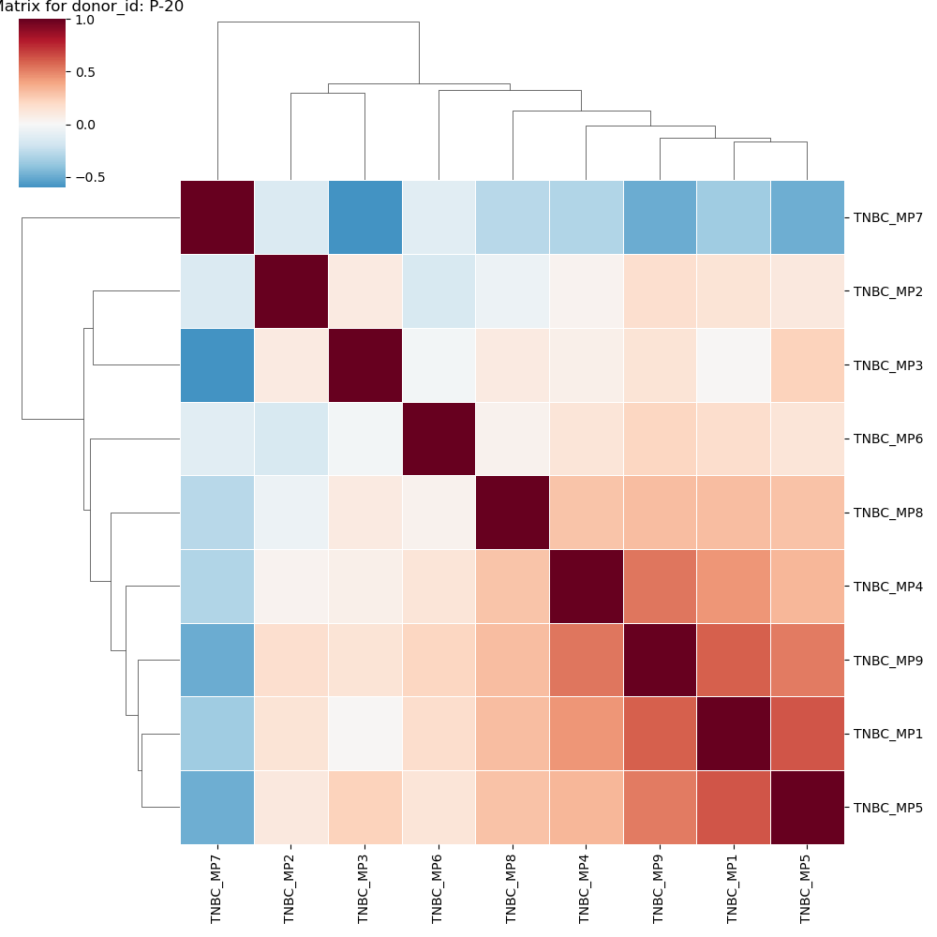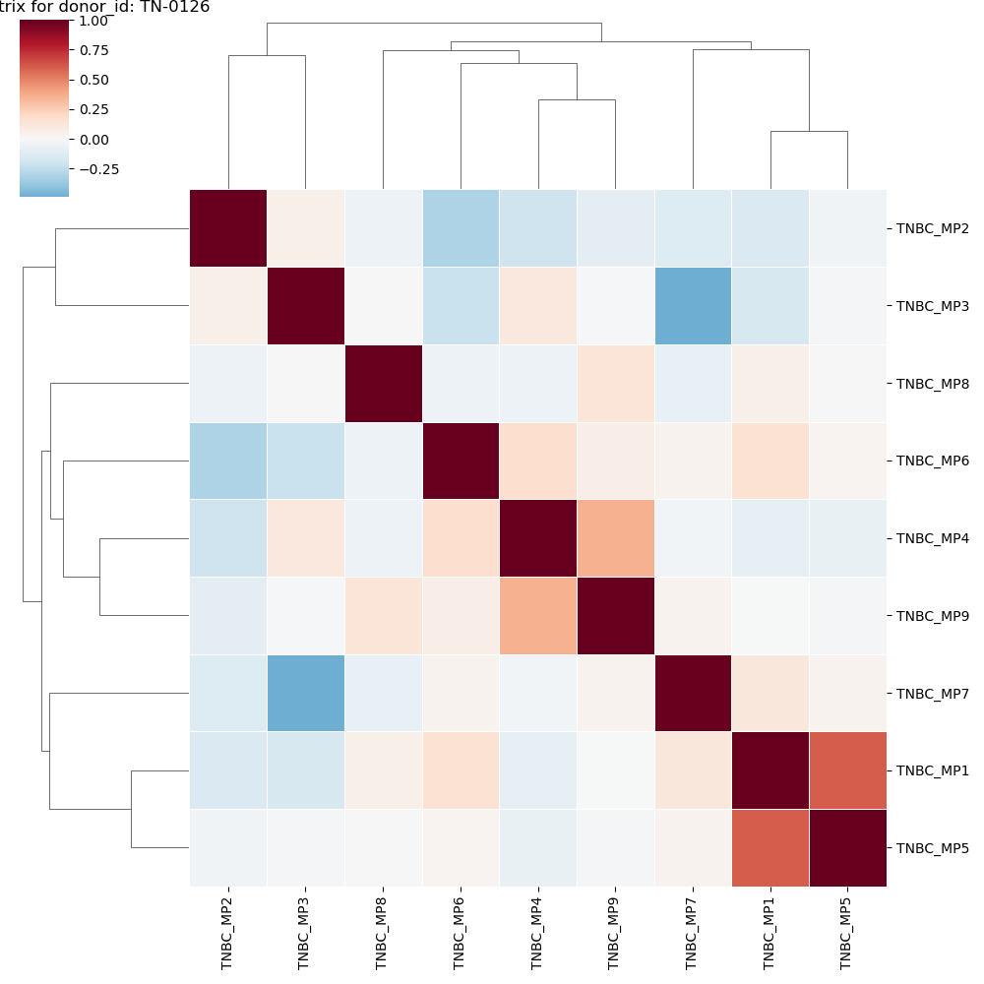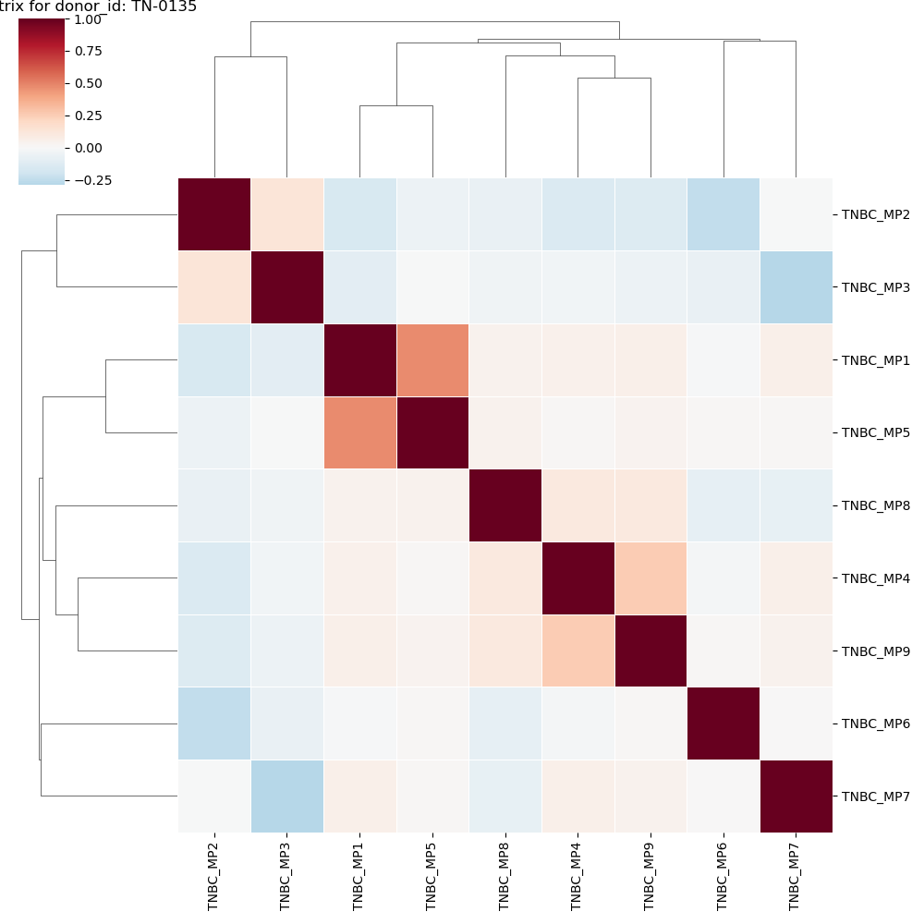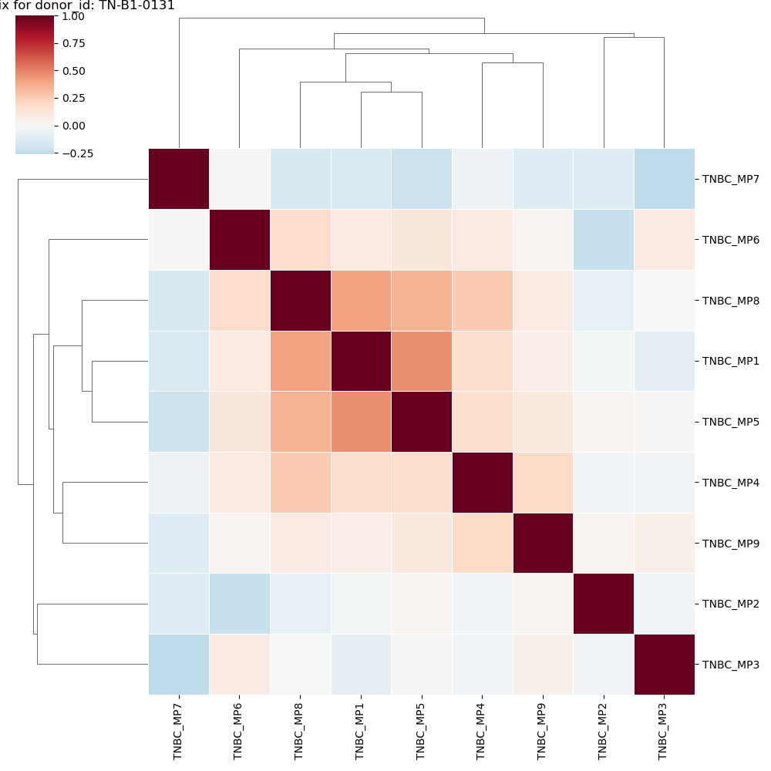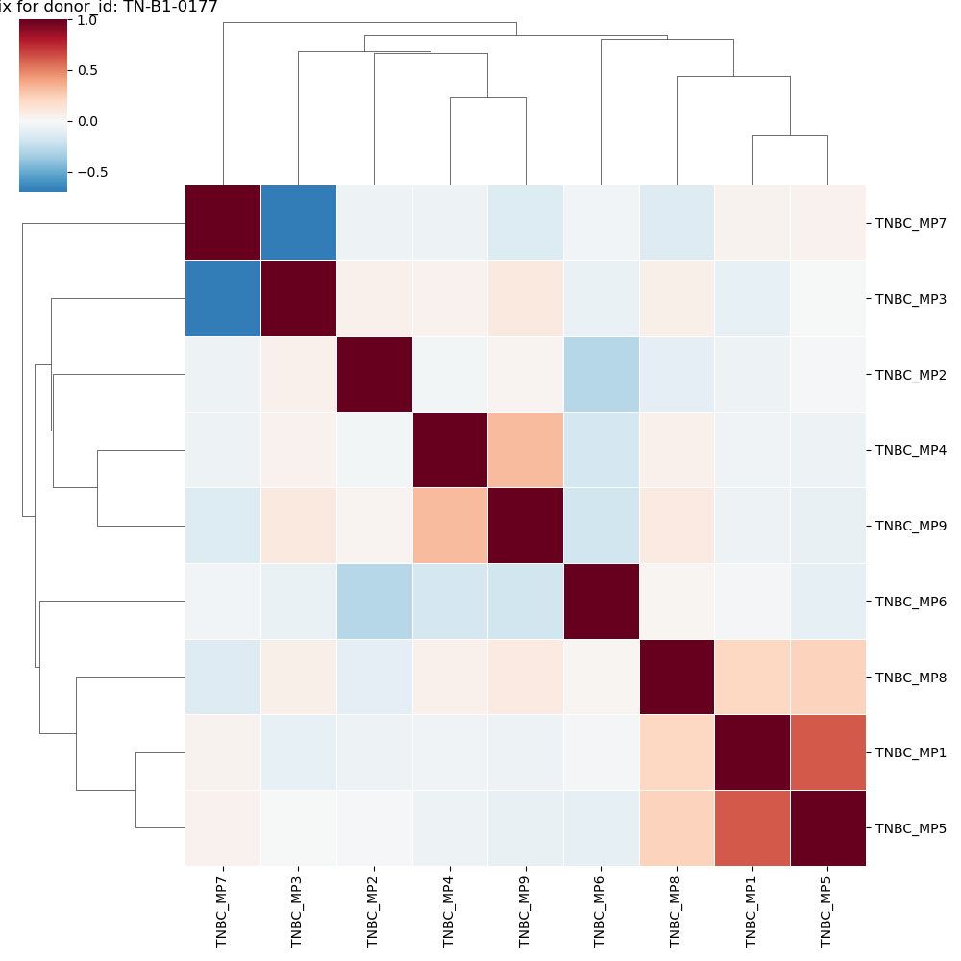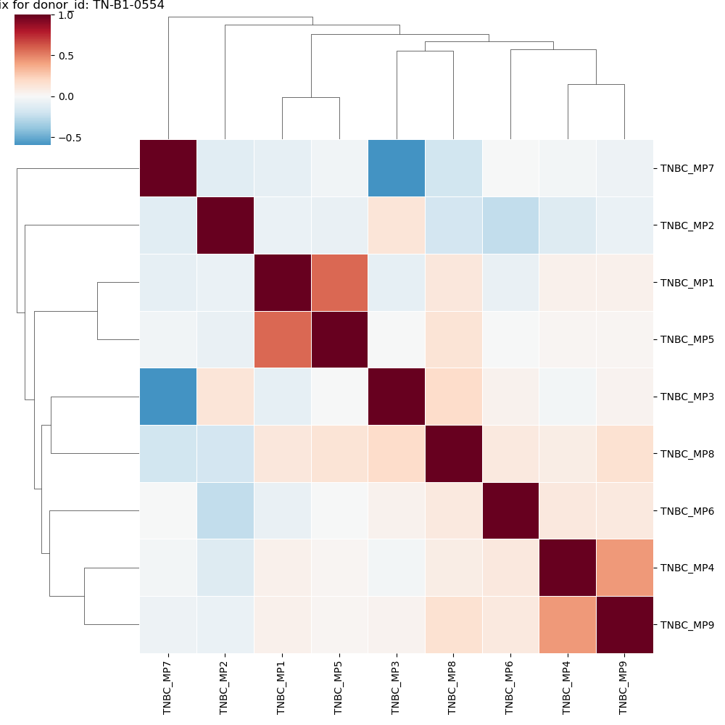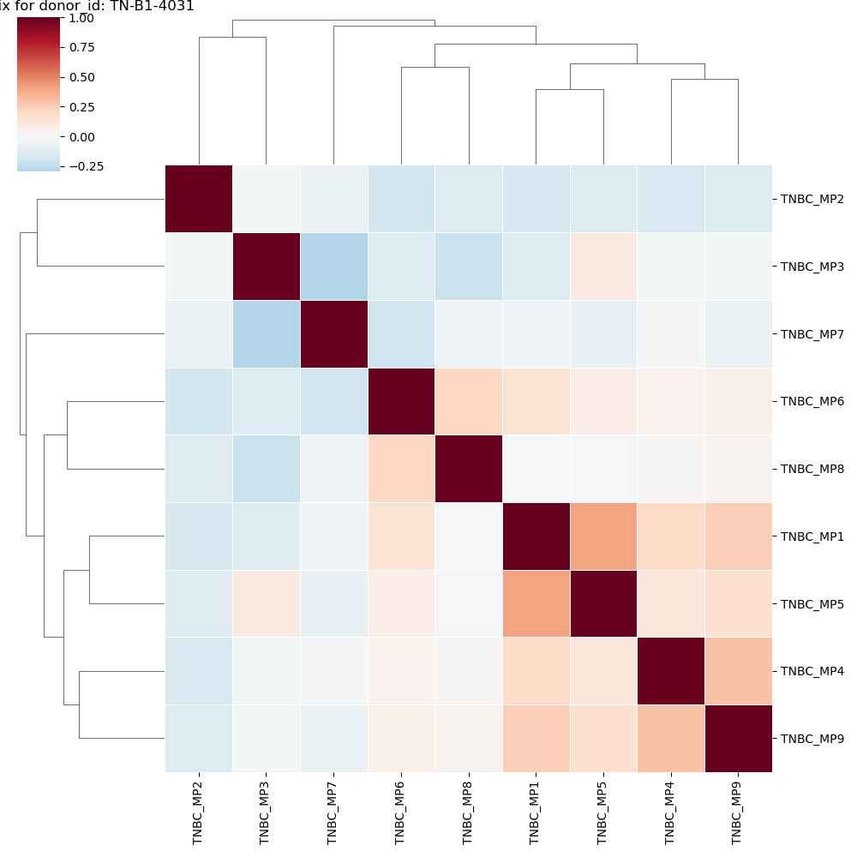

Supplementary Results 2: Comparison with Other Metaprograms
Overlaps within Metaprograms:
TNBC_MP1 overlaps with TNBC_MP5 with 9 genes:
Genes: PTPRC,CD37,LCP2,ALOX5AP,SAMSN1,CD52,CD53,SRGN,HCST

Overlaps between Metaprograms and Hallmarks:
TNBC_MP2 overlaps with Cell Cycle - G2/M with 38 genes:
Genes: KIF2C,UBE2T,CDCA8,BIRC5,MAD2L1,NUSAP1,ZWINT,CDCA3,CCNA2,NUF2,PLK1,CENPW,HMGB2,CCNB2,TOP2A,CDK1,UBE2C,CDC20,TPX2,DLGAP5,CENPA,KPNA2,MKI67,KIF23,SMC4,DEPDC1,GTSE1,CCNB1,AURKB,CDKN3,PBK,AURKA,CENPF,HMMR,ASPM,PRC1,PTTG1,CENPE

TNBC_MP2 overlaps with Cell Cycle - G1/S with 10 genes:
Genes: UBE2T,TK1,RAD51AP1,MAD2L1,ZWINT,CDK1,RRM2,TYMS,MYBL2,HMGB2

TNBC_MP3 overlaps with Cell Cycle HMG-rich with 9 genes:
Genes: RAN,SLC25A5,SUMO2,STMN1,TUBB,YBX1,TUBA1B,NME1,SNRPE

TNBC_MP4 overlaps with EMT-I with 15 genes:
Genes: COL6A1,COL1A1,TAGLN,POSTN,LUM,COL3A1,MMP2,ACTA2,COL1A2,DCN,CTSK,CXCL12,COL6A3,SPARC,RARRES2

TNBC_MP4 overlaps with EMT-IV with 5 genes:
Genes: ASPN,THBS2,DCN,SERPINF1,SPARC

TNBC_MP6 overlaps with Hypoxia with 14 genes:
Genes: ERO1A,HK2,CA9,IGFBP3,EGLN3,VEGFA,LDHA,SLC2A1,PGK1,ADM,NDRG1,SLC16A3,NDUFA4L2,S100A10

TNBC_MP6 overlaps with EMT-III with 7 genes:
Genes: EMP1,S100P,TNFRSF12A,PHLDA2,ANXA3,ANXA1,S100A10

TNBC_MP6 overlaps with Epithelial Senescence with 11 genes:
Genes: S100P,IGFBP3,KRT17,KRT6A,S100A9,GPRC5A,MAL2,KRT16,S100A8,KRT6B,ANXA1

TNBC_MP6 overlaps with Secreted I with 6 genes:
Genes: EMP1,PIM1,TNFRSF12A,PHLDA2,PLAUR,ANXA1

TNBC_MP6 overlaps with PDAC-related with 10 genes:
Genes: ISG20,EMP1,KRT17,TNFRSF12A,KLK7,SLC2A1,PLAUR,KRT16,SLC16A3,ANXA1

TNBC_MP8 overlaps with Interferon/MHC-II (I) with 25 genes:
Genes: PARP9,IFIT1,PSMB9,TNFSF10,MX1,TYMP,IFI44,ISG15,PARP14,UBE2L6,IFIT2,IFIT3,IFITM1,SAA1,IFI35,TAP1,IFI6,GBP1,BST2,IFITM3,STAT1,PLSCR1,IFI27,OAS1,IFI44L

TNBC_MP9 overlaps with EMT-I with 7 genes:
Genes: A2M,SPARCL1,COL4A2,IGFBP7,COL4A1,SPARC,CAV1

Overlaps between Metaprograms and Reed2024:
TNBC_MP1 overlaps with Reed2024_Cluster 1 with 22 genes:
Genes: TYROBP,SPI1,C1QB,CD52,LILRB4,HLA-DPB1,CD37,HLA-DQA1,CYTIP,LAPTM5,CD86,HLA-DPA1,SRGN,RGS1,C1QC,ALOX5AP,FCER1G,PTPRC,C1QA,CD48,SAMSN1,CD53

TNBC_MP1 overlaps with Reed2024_Cluster 17 with 13 genes:
Genes: TYROBP,SPI1,CSF1R,C1QC,C1QA,C1QB,C3AR1,CYBB,LAPTM5,LILRB4,APOC1,MS4A6A,FCER1G

TNBC_MP1 overlaps with Reed2024_Cluster 27 with 8 genes:
Genes: HLA-DQA1,RNASE6,MS4A6A,CD86,MNDA,HLA-DPB1,HLA-DPA1,LYZ

TNBC_MP2 overlaps with Reed2024_Cluster 13 with 38 genes:
Genes: UBE2T,CDCA8,BIRC5,ZWINT,NUSAP1,MAD2L1,CDCA3,CCNA2,SPC25,NUF2,FOXM1,PLK1,HMGB2,CCNB2,TOP2A,CDK1,UBE2C,CDC20,TPX2,DLGAP5,CENPA,MKI67,RRM2,KIF23,DEPDC1,MND1,GTSE1,TYMS,CCNB1,AURKB,NDC80,CDKN3,TK1,CENPF,HJURP,HMMR,ASPM,PTTG1

TNBC_MP3 overlaps with Reed2024_Cluster 7 with 14 genes:
Genes: ENO1,S100A11,NPM1,RAN,PFN1,PPIA,PRDX1,PSMB1,YBX1,TXN,CHCHD2,NME1,SNRPE,S100A10

TNBC_MP3 overlaps with Reed2024_Cluster 22 with 6 genes:
Genes: ENO1,S100A11,GSTP1,TUBB,NME1,GAPDH

TNBC_MP4 overlaps with Reed2024_Cluster 3 with 16 genes:
Genes: COL6A1,COL1A1,LUM,MFAP4,MMP2,DPT,THBS2,COL1A2,DCN,SERPINF1,CTSK,PRRX1,AEBP1,COL6A3,SFRP2,RARRES2

TNBC_MP4 overlaps with Reed2024_Cluster 25 with 11 genes:
Genes: COL1A1,COL5A1,POSTN,COL15A1,COL3A1,COL5A2,COL1A2,WNT2,COL14A1,COL6A3,SPARC

TNBC_MP4 overlaps with Reed2024_Cluster 31 with 8 genes:
Genes: MFAP4,ASPN,SFRP4,DCN,SERPINF1,CTSK,AEBP1,RARRES2

TNBC_MP5 overlaps with Reed2024_Cluster 1 with 13 genes:
Genes: PTPRC,CD37,LCP1,ALOX5AP,CD2,CST7,SAMSN1,CD52,CD3E,CD3D,CD7,CD53,SRGN

TNBC_MP6 overlaps with Reed2024_Cluster 10 with 5 genes:
Genes: SDC4,RARRES1,S100A9,S100A8,CSTB

TNBC_MP9 overlaps with Reed2024_Cluster 4 with 19 genes:
Genes: CYYR1,FLT1,CLEC14A,ECSCR,PLVAP,SOX17,VWF,AQP1,GNG11,ANGPT2,SPARCL1,MYCT1,S1PR1,EMCN,CLDN5,RAMP2,CALCRL,ESAM,CD93

TNBC_MP9 overlaps with Reed2024_Cluster 12 with 8 genes:
Genes: GNG11,CLDN5,ECSCR,RAMP2,RHOJ,IGFBP7,CAV1,FLT4

TNBC_MP9 overlaps with Reed2024_Cluster 20 with 7 genes:
Genes: ANGPT2,GNG11,CALCRL,PLVAP,ESAM,AFAP1L1,SPARC

Overlaps between Metaprograms and Nonmalignant TNBC:
TNBC_MP1 overlaps with NC1 with 5 genes:
Genes: PTPRC,HCST,CCL4,CD52,S100A4

TNBC_MP1 overlaps with NC2 with 18 genes:
Genes: TYROBP,SPI1,CSF1R,C1QC,IGSF6,C1QB,C1QA,CYBB,MS4A6A,FPR3,LILRB4,FGL2,MNDA,AIF1,LST1,APOC1,LYZ,FCER1G

TNBC_MP2 overlaps with NC3 with 20 genes:
Genes: KIF2C,BIRC5,CDCA3,CCNA2,SPC25,CCNB2,TOP2A,CDK1,UBE2C,CDC20,TPX2,DLGAP5,MKI67,RRM2,GTSE1,TYMS,AURKB,TK1,HJURP,ASPM

TNBC_MP3 overlaps with NC13 with 19 genes:
Genes: PFN1,STMN1,GSTP1,SNRPD2,NME1,SNRPE,S100A10,DSTN,UQCRH,PRDX1,GAPDH,S100A11,MDH2,MARCKSL1,YBX1,PEBP1,RAN,UQCRB,PPIA

TNBC_MP4 overlaps with NC4 with 28 genes:
Genes: COL5A1,POSTN,COL3A1,SERPINF1,PRRX1,COL6A3,THY1,COL6A1,FAP,FBN1,ASPN,CTSK,CXCL12,LUM,DPT,THBS2,AEBP1,RARRES2,SPARC,SFRP2,COL1A1,MXRA8,MMP2,COL5A2,COL1A2,DCN,COL12A1,SULF1

TNBC_MP5 overlaps with NC1 with 22 genes:
Genes: CD52,IL2RB,GNLY,KLRD1,HCST,CST7,GZMB,CD2,GZMM,CD3E,LCK,APOBEC3G,GZMH,KLRB1,CD3D,GZMA,PTPRC,CTSW,CD247,CCL5,CD7,CD3G

TNBC_MP5 overlaps with NC8 with 5 genes:
Genes: LTB,CD2,CD3E,CD27,CD3D

TNBC_MP7 overlaps with NC10 with 8 genes:
Genes: MDM4,PCSK7,NKTR,DDX17,SMG1,MACF1,OGT,NPIPB5

TNBC_MP9 overlaps with NC9 with 26 genes:
Genes: ARHGEF15,APLNR,CYYR1,FLT1,ADGRF5,CLEC14A,PLVAP,AFAP1L1,ADGRL4,SOX17,VWF,AQP1,FLT4,GNG11,CD34,MYCT1,KDR,EMCN,ROBO4,CLDN5,RAMP2,CALCRL,ESAM,PCDH17,TIE1,RAMP3

TNBC_MP9 overlaps with NC11 with 6 genes:
Genes: MCAM,SPARCL1,COL4A2,IGFBP7,COL4A1,CAV1

