Cluster locality name | Latitude | Longitude
Gurmha (GMA) cluster | 25.08836111 | 86.33027778
Sohdihwa (SOH) cluster | 25.06958 | 86.39754
Sohdihwa (SOH) site | 25.0692 | 86.39692
Chormara Camp (CMA) cluster | 25.10855 | 86.36961
Parsatari cluster 1 | 25.12009 | 86.3713
Parsatari cluster 2 | 25.12007 | 86.37133
Parsatari cluster 3 | 25.1201 | 86.37134
Bhorbhandari | 25.11723333 | 86.36235
Jahbha | 25.115913 | 86.355752
Table 1 Location of clusters and sites
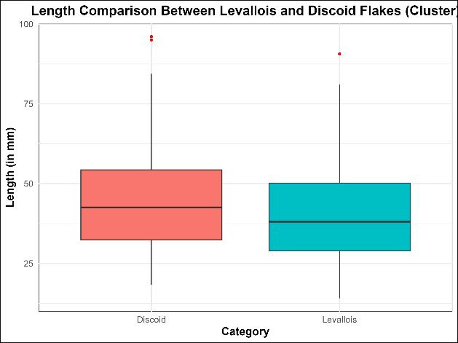

Fig. 1 Boxplot depicting t-test analysis of Levallois and discoid flake length

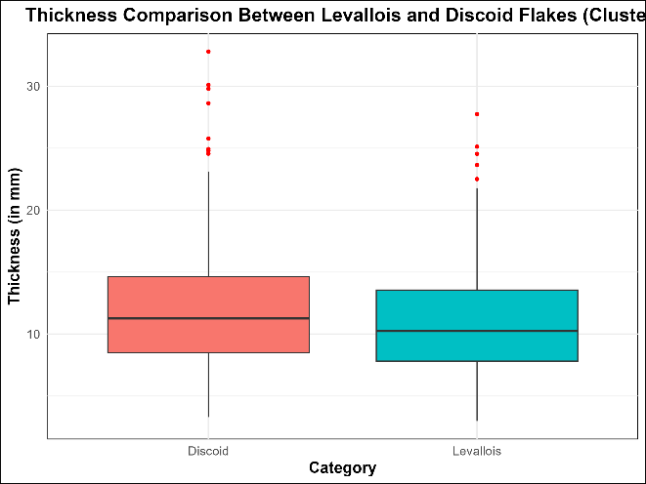

Fig. 2 Boxplot depicting t-test analysis of Levallois and discoid flake width

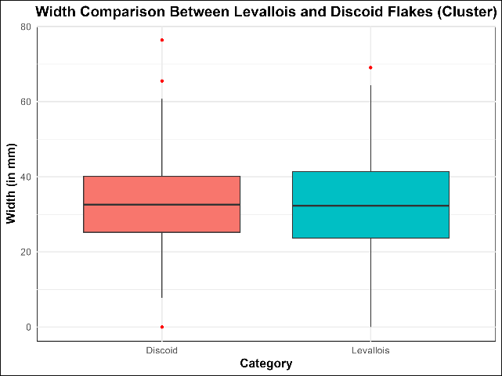

Fig. 3 Boxplot depicting t-test analysis of Levallois and discoid flake thickness

