Supplementary information for

Monthly-Resolved Cave Proxy Evidence for Northward Gulf Stream Migration During the Little Ice Age

Edward C. G. Forman^{1,*}, James U. L. Baldini¹, Robert A. Jamieson², Franziska A. Lechleitner³, Izabela W. Walczak⁴, Dan C. Nita^{5,6}, Struan R. Smith⁷, David A. Richards⁵, Lisa M. Baldini⁸, Cameron McIntyre⁹, Wolfgang Müller¹⁰

¹Department of Earth Sciences, University of Durham, Durham DH1 3LE, United Kingdom.
²Earth Surface Science Institute, School of Earth and Environment, University of Leeds, Leeds LS2 9JT, United Kingdom.
³Department of Chemistry, Biochemistry and Pharmaceutical Sciences, and Oeschger Centre for Climate Change Research, University of Bern, 3012 Bern, Switzerland.
⁴Durham Centre for Academic Development, University of Durham, Durham DH1 1TA, United Kingdom.
⁵School of Geographical Sciences, University of Bristol, Bristol BS8 1SS, United Kingdom.
⁶Institute for Research, Development and Innovation in Applied Natural Sciences, Babes-Bolyai University, Cluj-Napoca 400084, Romania.
⁷Natural History Museum, Bermuda Aquarium Museum and Zoo, Bermuda.
⁸School of Health & Life Sciences, Teesside University, Middlesbrough TS1 3BX, United Kingdom.
⁹Laboratory of Ion Beam Physics, ETH Zürich, 8093 Zürich, Switzerland; Current address: AMS Laboratory, Scottish Universities Environmental Research Centre (SUERC), East Kildbride G75 0GF, United Kingdom.
¹⁰Institute of Geosciences, Goethe University Frankfurt, 60438 Frankfurt am Main, Germany.

*Corresponding author:
Edward C. G. Forman
Email: ecgforman@gmail.com
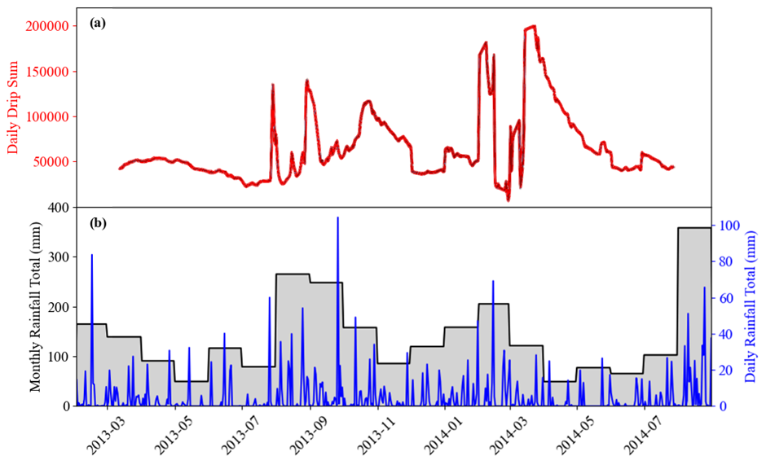

Figure S1. Stalagmite’s drip rate response to rainfall. a Daily drip sum (red) recorded by a Stalagmate Plus Mk2b automated drip logger above BER-SWI-13⁴⁹. b Daily (blue) and monthly (grey bars) rainfall sums observed at Bermuda International Airport²⁹.
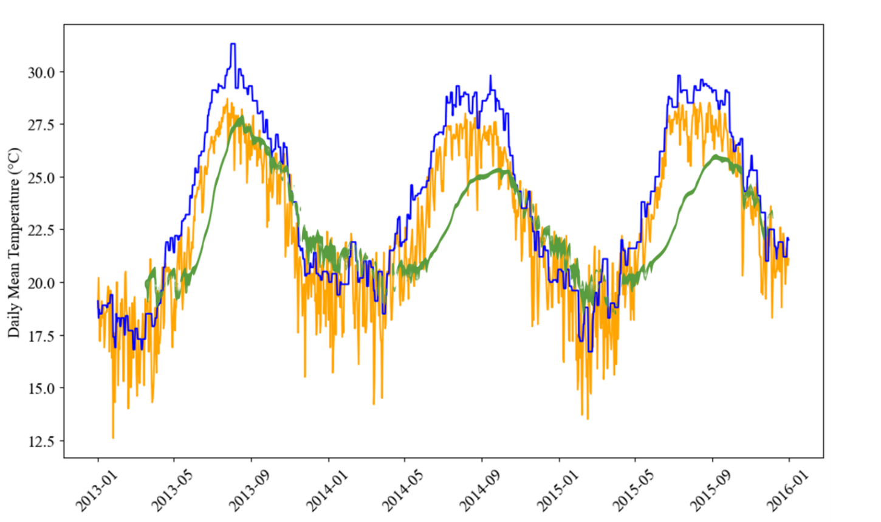

Figure S2. Site climatology during the cave monitoring period. Daily SSTs (blue) and outside temperature (orange) observed at Bermuda International Airport²⁹. Cave temperature (green) recorded by a Tinytag Plus 2 - TGP-4500 logger located by the cave pool⁴⁹.
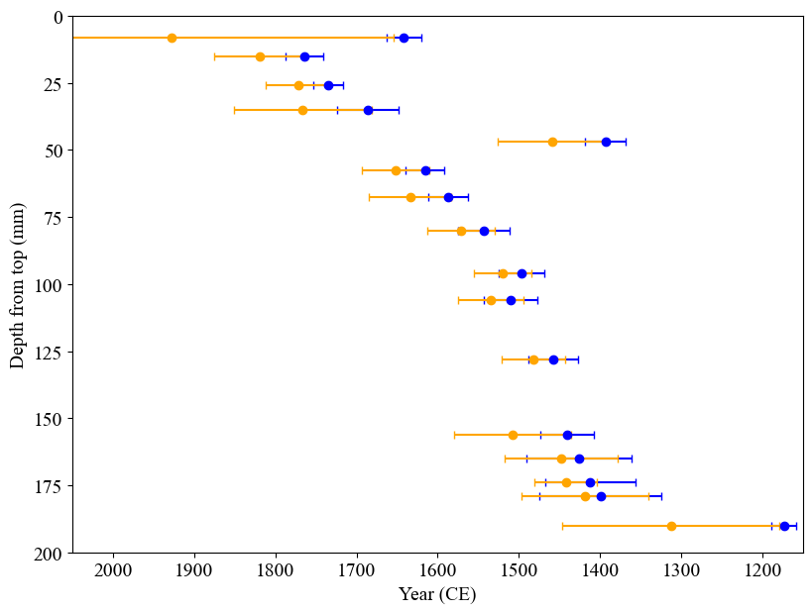

Figure S3. Comparison of different initial Th estimates. (²³⁸U/²³²Th)_{initial} of 0.8 ± 0.4 (blue) and of 5 ± 2.5 (orange). Note that the uncertainties (2se) are expanded after correction for initial Th.
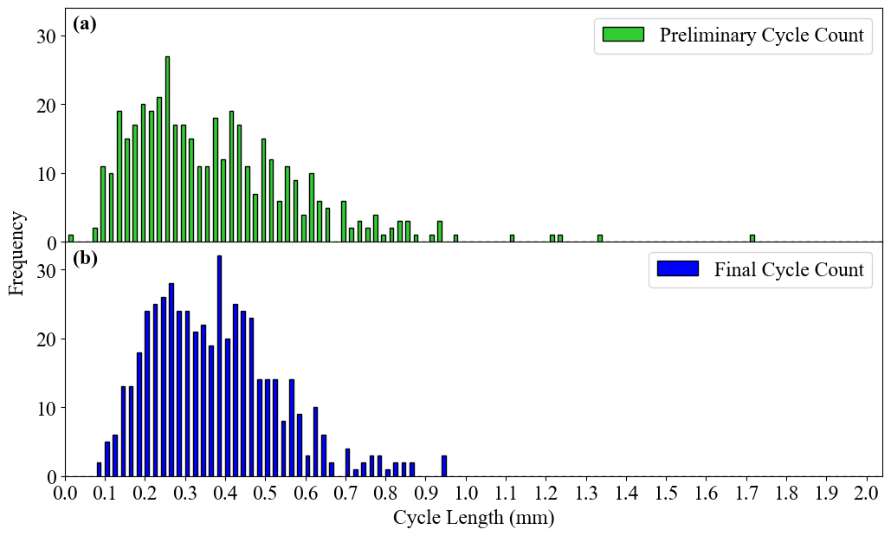

Figure S4. Distribution of annual cycle length for both cycle counts. a preliminary cycle count – mean = 372.5 μm yr⁻¹; range = 1710.9 μm yr⁻¹. b final cycle count – mean = 359.7 μm yr⁻¹; range = 865.8 μm yr⁻¹.
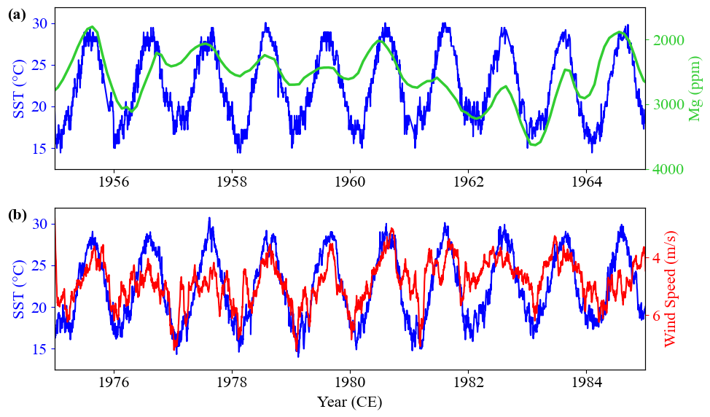

Figure S5. Example of annual cyclicity of Mg concentrations, wind speed, and sea surface temperature (SST). Mg cyclicity (green) shown against observational SST data (a, blue) which in turn is plotted against observational wind speed data (b, red)²⁹. Mg cyclicity is not directly compared to wind speed variability due to potential anthropogenic impacts on the Mg record post-1970 and wind speed observations beginning in 1975. Note that the Mg and wind speed axes are inverted.

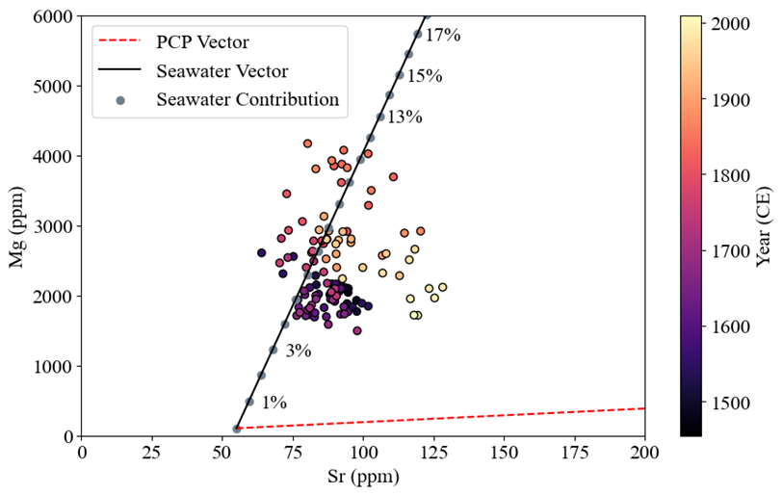

Figure S6. 5-year binned mean LA-ICPMS-derived Sr and Mg values for BER-SWI-13 shown against a modelled PCP (dashed red line) and seawater vector (solid black line). The PCP vector was constructed using bedrock concentrations from Rouse⁷⁵ and partition coefficients given in Huang and Fairchild⁷⁶. The modelled seawater vector represents different amounts of marine aerosol contribution to the dripwater and thus resultant calcite¹⁶. 0% marine aerosol contribution is defined as the Mg and Sr concentrations expected in dripwater exclusively from the dissolution of the surrounding bedrock. The percentages (denoted by the grey points on the seawater vector in increments of 1%) represent the addition of a given amount of seawater into the dripwater, where elemental concentrations of seawater are derived from global averages⁷⁷.
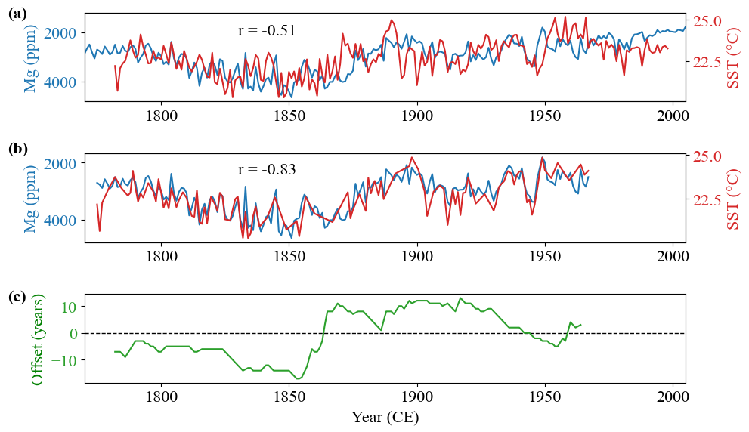

Figure S7. DTW results. a The original coralline SST record (red; 20) against the annual magnesium record (blue). b The coralline SST record after warping (red) against the annual magnesium record (blue). DTW was performed on the data pre-1967 as to not be influenced by localised anthropogenic changes in the Mg record. c The temporal offset applied to each year during the warping process.
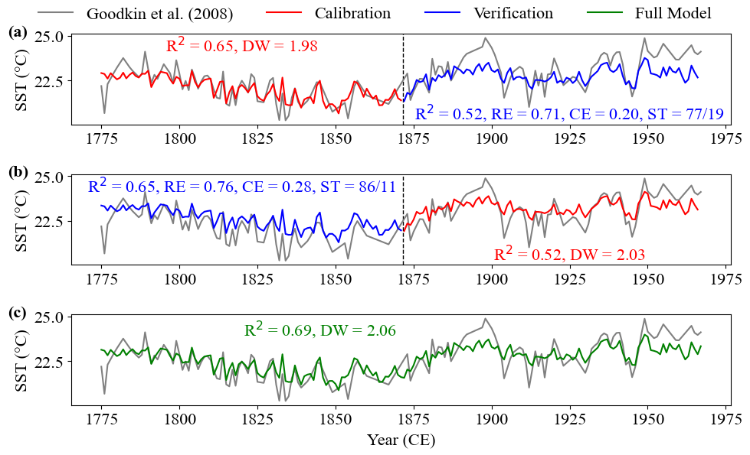

Figure S8. Split-period testing of the Cochrane-Orcutt regression model. a The forward results. b The reverse results. c The full model results. DW - Durbin-Watson statistic; RE - reduction of error statistic; CE - coefficient of efficiency statistic; ST - signs test.
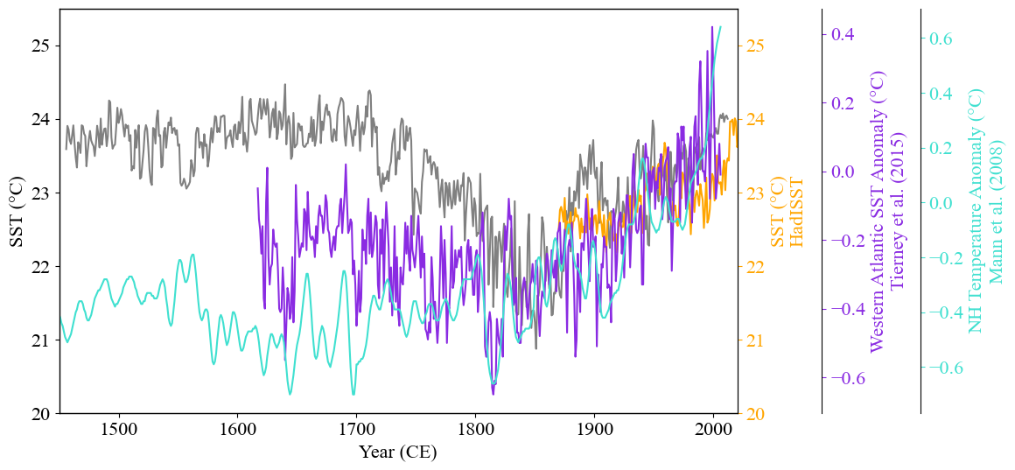

Figure S9. Comparison of stalagmite-derived record to previously published reconstructions. A reanalysis record for Bermuda (orange,³⁰), a proxy reconstruction for the Western Atlantic ocean using records South of Bermuda (purple,⁷⁸), and a Northern Hemisphere proxy temperature anomaly reconstruction (cyan,⁴⁸).

Table S1. Uranium-series chronological data. (separate file)

Table S2. Radiocarbon chronological data. (separate file)

Table S3. The monthly and annual stalagmite-derived SST record. (separate file)

