Supplement table 1
H. pylori infection rate between Parkinson’s disease patients and outpatients population in the rural and urban area
Area | Rural |  |  | Urban
Characteristics | PD | Outpatients population | P value | PD | Outpatients population | P value
H.P positive (DOB≥4), n (%) | 53(30.8) | 1512(41.7) | 0.005 | 37(25.9) | 6080(32.4) | 0.096
H.P positive (DOB≥8), n (%) | 38(22.1) | 1303(35.9) | <0.001 | 33(23.1) | 4857(25.9) | 0.443
n (%) indicates the number of constituents (n) and the composition ratio (%).

A
B
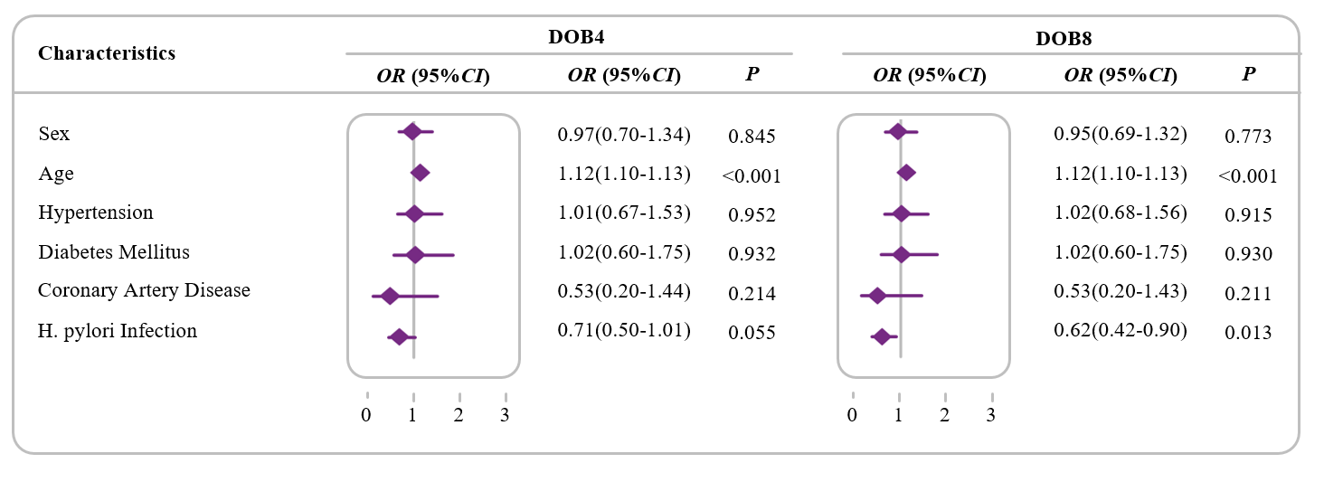
Supplement Fig 1. Comparison of H. pylori infection rates in PD patients with outpatients population for confounding factors by multivariate logistic regression analysis in rural and urban, respectively. A. Comparison of H. pylori infection rates in PD patients with outpatients population. B. Association of H. pylori infection and PD by a multivariate logistic regression analysis in rural area. Odds ratio (ORs) was adjusted for the sex (male=1, female =0), age (years), Hypertension (Yes=1, No=0), Diabetes Mellitus (Yes=1, No=0), Coronary Artery Disease (Yes=1, No=0),, H. pylori infection (Positive=1, Negative=0). **p < 0.01. ***p < 0.001.

Supplement table 2
The H. pylori infection rate between Parkinson’s disease patients and outpatients population in the different age
Age | ＜65 |  |  | ≥65
Characteristics | PD | Outpatients population | P value | PD | Outpatients population | P value
H.P positive (DOB≥4), n (%) | 38(25.2) | 6849(34.1) | 0.021 | 52(31.7) | 743(32.2) | 0.901
H.P positive (DOB≥8), n (%) | 29(19.2) | 5581(27.8) | 0.019 | 42(25.6) | 579(25.1) | 0.879
n (%) indicates the number of constituents (n) and the composition ratio (%).

