Appendix A. Location of the 96 plots in Long Point, ON established in 2017 (A) and an illustration of what plots (B). Each plot consisted of one phytometer (one individual plant of each species) grown either with or without above-ground competition from P. australis, or one of the three resident species. The location of 2016 plots were nearly identical to the 2017 layout. Inset maps illustrate the location of the plots in Long Point, with a polygon indicating the area from which the environmental measures were taken from unmanipulated areas of each target species, and the location of the study in the Great Lakes region.

Appendix B. Phytometer height over the 2016 field season. Not collected (NC) indicates when a phytometer had died or was consumed. If above-ground tissue was still present, then it was measured and collected at the end of the growing season. Occasionally phytometers did not possess a whole, entire leaf for carbon assimilation measurements.
D | Phytometer | Neighbours | Competition | 18-May-16 | 03-Jun-16 | 12-Jun-16 | 22-Jun-16 | 02-Jul-16 | 12-Jul-16
PCC1CU | Phragmites | Calamagrostis | No | 63 | 160 | 183 | 216 | 230 | 248
PCC2CU | Phragmites | Calamagrostis | No | 41 | 98 | 110 | 126 | 129 | 145
PCC1 | Phragmites | Calamagrostis | Yes | 60 | 128 | 155 | 173 | 183 | 188
PCC2 | Phragmites | Calamagrostis | Yes | 42 | 100 | 124 | 141 | 149 | 160
PCC3CU | Phragmites | Calamagrostis | No | 52 | 127 | 145 | 166 | 180 | 194
CAP1CU | Carex | Phragmites | No | 61 | 92 | 91 | 100 | 101 | 98
CAP1 | Carex | Phragmites | Yes | 61 | 92 | 97 | 97 | 97 | 97
CAP2CU | Carex | Phragmites | No | 71 | 80 | 86 | 91 | 89 | 90
CAP2 | Carex | Phragmites | Yes | 70 | 91 | 93 | 95 | 93 | 93
CAP3CU | Carex | Phragmites | No | 70 | 106 | 107 | 103 | 112 | 110
CAP3 | Carex | Phragmites | Yes | 70 | 99 | 105 | 105 | 104 | 103
CAP4CU | Carex | Phragmites | No | 64 | 105 | 114 | 111 | 111 | NC
CAP4 | Carex | Phragmites | Yes | 61 | 105 | 112 | 113 | 113 | 114
CAP5CU | Carex | Phragmites | No | 83 | 90 | 94 | 94 | 95 | 90
CAP5 | Carex | Phragmites | Yes | 82 | 100 | 104 | 106 | 107 | 100
PCC3 | Phragmites | Calamagrostis | Yes | 52 | 138 | 153 | 167 | 174 | 192
PCC4CU | Phragmites | Calamagrostis | No | 75 | 190 | 222 | 243 | 261 | 279
PCC4 | Phragmites | Calamagrostis | Yes | 78 | 191 | 214 | 245 | 258 | 272
PCC5CU | Phragmites | Calamagrostis | No | 63 | 174 | 202 | 230 | 249 | 264
PCC5 | Phragmites | Calamagrostis | Yes | 64 | 160 | 185 | 212 | 231 | 243
PCC6CU | Phragmites | Calamagrostis | No | 69 | 122 | 132 | 146 | 156 | 166
PCC6 | Phragmites | Calamagrostis | Yes | 65 | 159 | 178 | 209 | 220 | 223
CCP1CU | Calamagrostis | Phragmites | No | 66 | 106 | 114 | 120 | 123 | 124
CCP1 | Calamagrostis | Phragmites | Yes | 67 | 93 | 98 | 109 | 114 | 114
CCP2CU | Calamagrostis | Phragmites | No | 65 | 83 | 90 | NC | NC | NC
CCP2 | Calamagrostis | Phragmites | Yes | 79 | 113 | 119 | 131 | 134 | 137
CCP3CU | Calamagrostis | Phragmites | No | 67 | 108 | 129 | 139 | NC | NC
CCP3 | Calamagrostis | Phragmites | Yes | 61 | 89 | 97 | 101 | 101 | 103
CCP4CU | Calamagrostis | Phragmites | No | 58 | 77 | 82 | 85 | 79 | NC
CAP6CU | Carex | Phragmites | No | 59 | 85 | 96 | 108 | 108 | 112
CAP6 | Carex | Phragmites | Yes | 63 | 105 | 100 | 100 | 101 | 100
CAP7CU | Carex | Phragmites | No | 62 | 78 | 102 | 111 | 106 | 109
CAP7 | Carex | Phragmites | Yes | 63 | 103 | 114 | 120 | 119 | 119
CAP8CU | Carex | Phragmites | No | 53 | 83 | 82 | 89 | 85 | 84
CAP8 | Carex | Phragmites | Yes | 51 | 81 | 86 | 86 | 86 | 86
CAP9CU | Carex | Phragmites | No | 71 | 96 | 98 | 99 | 100 | 102
CAP9 | Carex | Phragmites | Yes | 73 | 109 | 110 | 113 | 111 | 111
CAP10CU | Carex | Phragmites | No | 80 | 88 | 100 | 104 | 100 | 105
CAP10 | Carex | Phragmites | Yes | 79 | 93 | 99 | 99 | 100 | 100
PCA1CU | Phragmites | Carex | No | 86 | 149 | 171 | 194 | 208 | 223
PCA1 | Phragmites | Carex | Yes | 85 | 116 | 130 | 142 | 154 | 164
PCA2CU | Phragmites | Carex | No | 80 | 122 | 131 | 148 | NC | NC
PCA2 | Phragmites | Carex | Yes | 80 | 169 | 197 | 227 | 246 | 255
PCA3CU | Phragmites | Carex | No | 69 | 140 | 155 | 175 | 194 | 215
PCA3 | Phragmites | Carex | Yes | 68 | 109 | 123 | 137 | 145 | 160
PCA4CU | Phragmites | Carex | No | 83 | 130 | 141 | 154 | 176 | 191
PCA4 | Phragmites | Carex | Yes | 85 | 133 | 148 | 164 | 175 | 182
PCA5CU | Phragmites | Carex | No | 83 | 108 | NC | NC | NC | NC
PCA5 | Phragmites | Carex | Yes | 84 | 150 | 163 | 179 | 188 | 201
PCA6CU | Phragmites | Carex | No | 81 | 120 | 133 | 143 | 148 | 161
PCA6 | Phragmites | Carex | Yes | 83 | 146 | 159 | 175 | 189 | 197
CAP11CU | Carex | Phragmites | No | 87 | 91 | 97 | 97 | 97 | 97
CAP11 | Carex | Phragmites | Yes | 84 | 88 | 91 | 92 | 92 | 89
CAP12CU | Carex | Phragmites | No | 88 | 88 | 98 | 98 | 103 | 103
CAP12 | Carex | Phragmites | Yes | 89 | 103 | 108 | 97 | 95 | 108
CCP4 | Calamagrostis | Phragmites | Yes | 86 | 116 | 141 | 174 | 190 | 191
CCP5CU | Calamagrostis | Phragmites | No | 82 | 109 | 139 | 137 | NC | NC
CCP5 | Calamagrostis | Phragmites | Yes | 83 | 121 | 133 | 161 | 169 | 171
CCP6CU | Calamagrostis | Phragmites | No | 55 | 78 | 88 | 94 | 100 | 101
CCP6 | Calamagrostis | Phragmites | Yes | 57 | 78 | 83 | 89 | 94 | 97
CCP7CU | Calamagrostis | Phragmites | No | 55 | 61 | 68 | 74 | 78 | 80
CCP7 | Calamagrostis | Phragmites | Yes | 56 | 79 | 78 | 80 | 82 | 83
CCP8CU | Calamagrostis | Phragmites | No | 45 | 75 | 79 | 83 | 85 | 85
CCP8 | Calamagrostis | Phragmites | Yes | 43 | 74 | 79 | 87 | 90 | 90
CCP9CU | Calamagrostis | Phragmites | No | 62 | 89 | 91 | 95 | 100 | 103
CCP9 | Calamagrostis | Phragmites | Yes | 63 | 78 | 81 | 89 | 94 | 98
CCP10CU | Calamagrostis | Phragmites | No | 57 | 92 | 87 | 110 | 110 | 121
CCP10 | Calamagrostis | Phragmites | Yes | 58 | 78 | 79 | 80 | 81 | 84
CCP11CU | Calamagrostis | Phragmites | No | 55 | 64 | 64 | 65 | 66 | 66
CCP11 | Calamagrostis | Phragmites | Yes | 53 | 54 | 74 | 57 | 59 | 63
CCP12CU | Calamagrostis | Phragmites | No | 68 | 94 | 101 | 109 | 110 | NC
TYP1CU | Typha | Phragmites | No | 85 | 152 | 167 | 185 | 194 | 199
TYP1 | Typha | Phragmites | Yes | 86 | 154 | 180 | 215 | 228 | 239
TYP2CU | Typha | Phragmites | No | 78 | 140 | 174 | 200 | 213 | 217
TYP2 | Typha | Phragmites | Yes | 82 | 168 | 193 | 229 | 232 | 245
TYP3CU | Typha | Phragmites | No | 88 | 153 | 170 | 188 | 198 | 205
TYP3 | Typha | Phragmites | Yes | 85 | 133 | 133 | 133 | 136 | 137
TYP4CU | Typha | Phragmites | No | 92 | 170 | 187 | 227 | 227 | 248
TYP4 | Typha | Phragmites | Yes | 94 | 176 | 200 | 221 | 237 | 259
TYP5CU | Typha | Phragmites | No | 98 | 180 | 197 | 229 | 246 | 258
TYP5 | Typha | Phragmites | Yes | 99 | 194 | 208 | 233 | 250 | 272
TYP6CU | Typha | Phragmites | No | 98 | 185 | 200 | 211 | 242 | 256
TYP6 | Typha | Phragmites | Yes | 97 | 172 | 194 | 200 | 235 | 270
PTY1CU | Phragmites | Typha | No | 81 | 147 | 158 | 174 | 196 | 213
PTY1 | Phragmites | Typha | Yes | 83 | 139 | 168 | 186 | 198 | 217
PTY2CU | Phragmites | Typha | No | 93 | 147 | 155 | 169 | 193 | 203
PTY2 | Phragmites | Typha | Yes | 92 | 170 | 180 | 211 | 221 | 238
PTY3CU | Phragmites | Typha | No | 85 | 108 | 124 | 141 | 157 | NC
PTY3 | Phragmites | Typha | Yes | 90 | 156 | 157 | 181 | 202 | 223
PTY4CU | Phragmites | Typha | No | 98 | 181 | 198 | 212 | 231 | 249
PTY4 | Phragmites | Typha | Yes | 95 | 165 | 180 | 196 | 218 | 234
PTY5CU | Phragmites | Typha | No | 87 | 178 | 198 | 221 | 247 | 263
PTY5 | Phragmites | Typha | Yes | 99 | 181 | 192 | 222 | 243 | 262
PTY6CU | Phragmites | Typha | No | 112 | 174 | 192 | 213 | 228 | 242
PTY6 | Phragmites | Typha | Yes | 117 | 209 | 228 | 259 | 278 | 298
Appendix C. Phytometer height over the 2017 field season. Not collected (NC) indicates when a phytometer had died or was consumed. If above-ground tissue was still present, it was measured and collected at the end of the growing season. Occasionally phytometers did not possess a whole, entire leaf for carbon assimilation measurements.
ID | Phytometer | Neighbour | Competition | 10-May-17 | 27-May-17 | 07-Jun-17 | 16-Jun-17 | 28-Jun-17
CAP1 | Carex | Phragmites | Yes | 34 | 82 | 75 | 132 | 140
CAP10 | Carex | Phragmites | Yes | 76 | 117 | 127 | 150 | 210
CAP10CU | Carex | Phragmites | No | 77 | 108 | 104 | 142 | 150
CAP11 | Carex | Phragmites | Yes | 79 | 98 | 120 | 141 | 160
CAP11CU | Carex | Phragmites | No | 80 | 100 | 63 | 60 | 61
CAP12 | Carex | Phragmites | Yes | 71 | 91 | 104 | 103 | 118
CAP12CU | Carex | Phragmites | No | 66 | 82 | 91 | 95 | 120
CAP1CU | Carex | Phragmites | No | 35 | 75 | 70 | 131 | 130
CAP2 | Carex | Phragmites | Yes | 55 | 90 | 97 | 116 | 140
CAP2CU | Carex | Phragmites | No | 57 | 91 | 96 | 127 | 127
CAP3 | Carex | Phragmites | Yes | 63 | 105 | 86 | 123 | 125
CAP3CU | Carex | Phragmites | No | 61 | 75 | 82 | 115 | 135
CAP4 | Carex | Phragmites | Yes | 55 | 92 | 81 | 146 | 156
CAP4CU | Carex | Phragmites | No | 52 | 70 | 80 | 141 | 143
CAP5 | Carex | Phragmites | Yes | 72 | 118 | 89 | 144 | 153
CAP5CU | Carex | Phragmites | No | 75 | 89 | 90 | 141 | 158
CAP6 | Carex | Phragmites | Yes | 80 | 114 | 100 | 154 | 163
CAP6CU | Carex | Phragmites | No | 81 | 95 | 103 | 142 | 145
CAP7 | Carex | Phragmites | Yes | 53 | 90 | 104 | 131 | 135
CAP7CU | Carex | Phragmites | No | 51 | 71 | 95 | 155 | 140
CAP8 | Carex | Phragmites | Yes | 66 | 96 | 93 | 134 | 138
CAP8CU | Carex | Phragmites | No | 63 | 76 | 80 | 130 | 131
CAP9 | Carex | Phragmites | Yes | 67 | 108 | 103 | 140 | 160
CAP9CU | Carex | Phragmites | No | 68 | 92 | 92 | 143 | 150
CCP1 | Calamagrostis | Phragmites | Yes | 61 | 79 | 80 | 88 | 88
CCP10 | Calamagrostis | Phragmites | Yes | 70 | 83 | 76 | 85 | 88
CCP10CU | Calamagrostis | Phragmites | No | 70 | 85 | 93 | 101 | 110
CCP11 | Calamagrostis | Phragmites | Yes | 79 | 97 | 106 | 112 | 120
CCP11CU | Calamagrostis | Phragmites | No | 80 | 100 | 104 | 111 | 111
CCP12 | Calamagrostis | Phragmites | Yes | 75 | 101 | 115 | 118 | 118
CCP12CU | Calamagrostis | Phragmites | No | 74 | 103 | 118 | 121 | 125
CCP1CU | Calamagrostis | Phragmites | No | 63 | 67 | 74 | 93 | 100
CCP2 | Calamagrostis | Phragmites | Yes | 67 | 81 | 93 | 110 | 145
CCP2CU | Calamagrostis | Phragmites | No | 67 | 87 | 95 | 98 | 110
CCP3 | Calamagrostis | Phragmites | Yes | 67 | 95 | 105 | 95 | 95
CCP3CU | Calamagrostis | Phragmites | No | 68 | 82 | 87 | 94 | 96
CCP4 | Calamagrostis | Phragmites | Yes | 70 | 90 | 99 | 110 | 118
CCP4CU | Calamagrostis | Phragmites | No | 71 | 93 | 91 | 202 | 115
CCP5 | Calamagrostis | Phragmites | Yes | 71 | 99 | 110 | 120 | 124
CCP5CU | Calamagrostis | Phragmites | No | 70 | 90 | 89 | 94 | 95
CCP6 | Calamagrostis | Phragmites | Yes | 65 | 104 | 74 | 98 | 100
CCP6CU | Calamagrostis | Phragmites | No | 64 | 86 | 91 | 99 | 105
CCP7 | Calamagrostis | Phragmites | Yes | 64 | 84 | 91 | 105 | 112
CCP7CU | Calamagrostis | Phragmites | No | 65 | 86 | 94 | 109 | 110
CCP8 | Calamagrostis | Phragmites | Yes | 62 | 86 | 96 | 90 | 90
CCP8CU | Calamagrostis | Phragmites | No | 59 | 96 | 107 | 124 | 130
CCP9 | Calamagrostis | Phragmites | Yes | 79 | 107 | 112 | 118 | 135
CCP9CU | Calamagrostis | Phragmites | No | 79 | 81 | 94 | 100 | 103
PCA1 | Phragmites | Carex | Yes | 56 | 136 | 158 | 193 | 225
PCA1CU | Phragmites | Carex | No | 54 | 107 | 120 | 130 | 148
PCA2 | Phragmites | Carex | Yes | 53 | 89 | 112 | 142 | 170
PCA2CU | Phragmites | Carex | No | 50 | 110 | 116 | 144 | 165
PCA3 | Phragmites | Carex | Yes | 77 | 108 | 131 | 160 | 173
PCA3CU | Phragmites | Carex | No | 76 | 129 | 149 | 174 | 175
PCA4 | Phragmites | Carex | Yes | 85 | 159 | 200 | 210 | 220
PCA4CU | Phragmites | Carex | No | 87 | 130 | 144 | 147 | 147
PCA5 | Phragmites | Carex | Yes | 68 | 113 | 135 | 152 | 180
PCA5CU | Phragmites | Carex | No | 70 | 137 | 154 | 187 | 188
PCA6 | Phragmites | Carex | Yes | 58 | 117 | 134 | 159 | 162
PCA6CU | Phragmites | Carex | No | 60 | 106 | 112 | 134 | 135
PCC1 | Phragmites | Calamagrostis | Yes | 52 | 137 | 167 | 210 | 210
PCC1CU | Phragmites | Calamagrostis | No | 49 | 108 | 125 | 147 | 150
PCC2 | Phragmites | Calamagrostis | Yes | 51 | 126 | 163 | 205 | 219
PCC2CU | Phragmites | Calamagrostis | No | 54 | 140 | 180 | 217 | 240
PCC3 | Phragmites | Calamagrostis | Yes | 51 | 132 | 165 | 199 | 215
PCC3CU | Phragmites | Calamagrostis | No | 50 | 79 | 100 | 124 | 230
PCC4 | Phragmites | Calamagrostis | Yes | 59 | 155 | 207 | 260 | 292
PCC4CU | Phragmites | Calamagrostis | No | 57 | 136 | 176 | 210 | 220
PCC5 | Phragmites | Calamagrostis | Yes | 54 | 106 | 115 | 164 | 170
PCC5CU | Phragmites | Calamagrostis | No | 55 | 113 | 150 | 174 | 185
PCC6 | Phragmites | Calamagrostis | Yes | 76 | 118 | 121 | 122 | 125
PCC6CU | Phragmites | Calamagrostis | No | 78 | 129 | 148 | 166 | 180
PTY1 | Phragmites | Typha | Yes | 63 | 118 | 153 | 190 | 204
PTY1CU | Phragmites | Typha | No | 64 | 133 | 165 | 194 | 209
PTY2 | Phragmites | Typha | Yes | 58 | 133 | 171 | 220 | 236
PTY2CU | Phragmites | Typha | No | 56 | 129 | 165 | 170 | 210
PTY3 | Phragmites | Typha | Yes | 71 | 151 | 183 | 216 | 244
PTY3CU | Phragmites | Typha | No | 70 | 134 | 156 | 196 | 222
PTY4 | Phragmites | Typha | Yes | 80 | 161 | 163 | 235 | 268
PTY4CU | Phragmites | Typha | No | 84 | 163 | 198 | 233 | 264
PTY5 | Phragmites | Typha | Yes | 77 | 132 | 163 | 189 | 211
PTY5CU | Phragmites | Typha | No | 75 | 144 | NC | NC | NC
PTY6 | Phragmites | Typha | Yes | 86 | 156 | 201 | 222 | 244
PTY6CU | Phragmites | Typha | No | 88 | 146 | 175 | 220 | 238
TYP1 | Typha | Phragmites | Yes | 85 | 182 | 223 | 252 | 252
TYP1CU | Typha | Phragmites | No | 84 | 153 | 194 | 230 | 248
TYP2 | Typha | Phragmites | Yes | 76 | 150 | 200 | 255 | 263
TYP2CU | Typha | Phragmites | No | 74 | 158 | 102 | 244 | 270
TYP3 | Typha | Phragmites | Yes | 84 | 170 | 207 | 252 | 288
TYP3CU | Typha | Phragmites | No | 82 | 167 | 192 | 229 | 268
TYP4 | Typha | Phragmites | Yes | 87 | 173 | 118 | 267 | 284
TYP4CU | Typha | Phragmites | No | 89 | 174 | 217 | 247 | 274
TYP5 | Typha | Phragmites | Yes | 76 | 179 | 218 | 276 | 302
TYP5CU | Typha | Phragmites | No | 76 | 144 | 186 | 210 | 244
TYP6 | Typha | Phragmites | Yes | 70 | 162 | 187 | 249 | 288
TYP6CU | Typha | Phragmites | No | 72 | 157 | 190 | 245 | 270

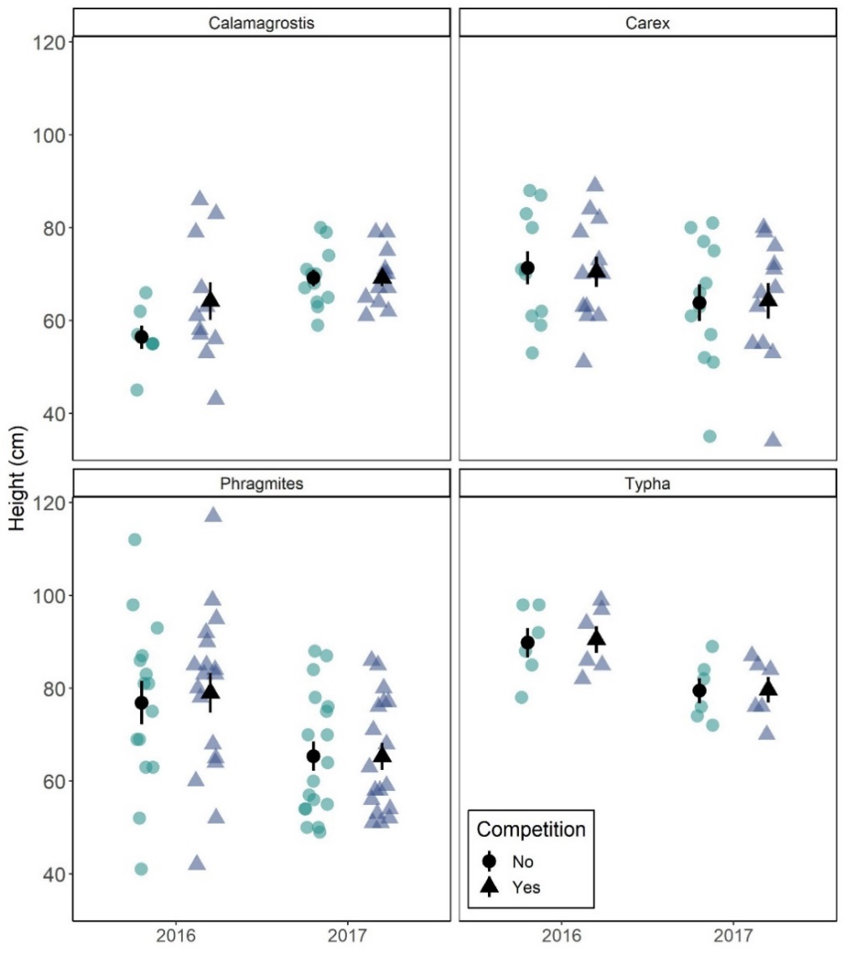
Appendix D. Height of phytometers at establishment in 2016 (n = 96) and 2017 (n = 96). Phytometers were paired by height to account for natural variation among plants in the field.

Appendix E. Photosynthetic water use efficiency (mmol CO₂ mol⁻¹ H₂0) at varying levels of photosynthetically active radiation (µmol s⁻¹ m⁻² ) for resident plant species (A) and P. australis phytometers (B) growing with or without above-ground competition. Error bars represent standard error.

Appendix F. Comparisons of above-ground biomass production when resident species (A) or P. australis (B) grew with or without competition, using the relative competition index approach to standardize among species (see main text for formula). Values above 0 indicate a reduction in the amount of above-ground biomass when growing with competition, while values below 0 indicate an increase in above-ground biomass when growing with competition. Data includes phytometers from 2016 and 2017, collected over the course of one growing season (May - July) in Long Point, ON.

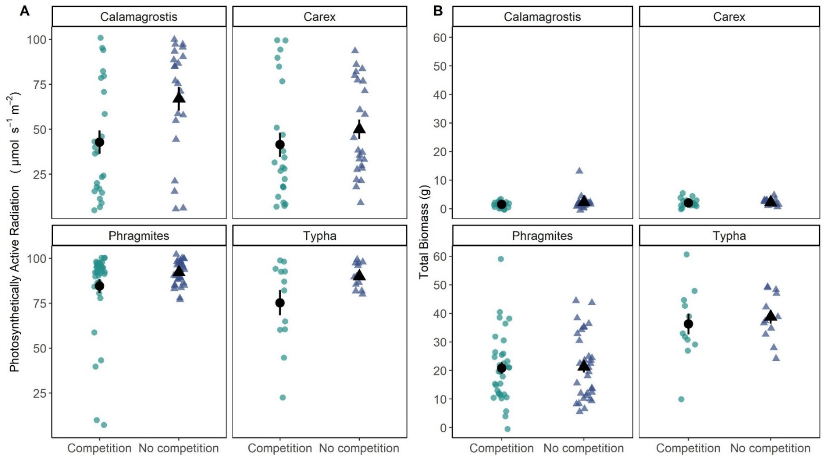
Appendix G. The percent of photosynthetically active radiation reaching the top of each phytometer growing with or without competition (A) and the total aboveground biomass produced by each species growing with or without competition (B). Large symbols represent the average and error bars represent standard error.

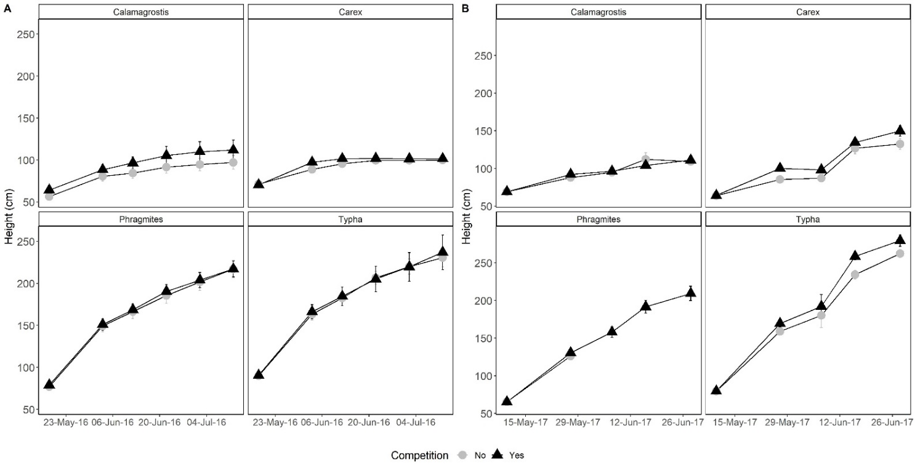
Appendix H. The growth of phytometers over the 2016 (A) and 2017 (B) growing seasons. Resident species represent remnant emergent marsh (Typha spp.), sedge meadow (Carex aquatilis) and meadow marsh (Calamagrostis canadensis) growing with or without above-ground competition from P. australis, while invasive P. australis grew with or without above-ground competition from resident species. Error bars represent standard error.
Appendix I. Eigenvalue and variance explained by the first three axes of our PCA, and the eigenvector values of all environmental variables included in the analysis.
 | PC1 | PC2
Eigenvalue | 9.720 | 1.286
Proportion explained | 0.648 | 0.086
Soil moisture (%) | 0.34293 | -0.63565
Copper (Cu) | 0.753489 | 0.879554
Iron (Fe) | 1.313269 | 0.168952
Manganese (Mn) | 0.877403 | -0.80537
Phosphorus (P) | 1.310303 | 0.045938
Magnesium (Mg) | 1.32475 | 0.231848
Potassium (K) | 1.28684 | 0.154487
Zinc (Zn) | 1.256093 | 0.059001
Carbon (C) | 1.277762 | -0.07677
Total Nitrogen (TN) | 1.228042 | -0.02341
Sodium (Na) | 1.144614 | -0.1705
Calcium (Ca) | 1.312584 | -0.21473
Sulphur (S) | 1.365828 | 0.052466
Incident light (%) | -0.15694 | -0.71027
Soil pH | -1.1525 | 0.155776

Appendix J. The scree plot assessing inertia of the environmental variable PCA. Axes PC1 and PC2 were selected for further analyses.

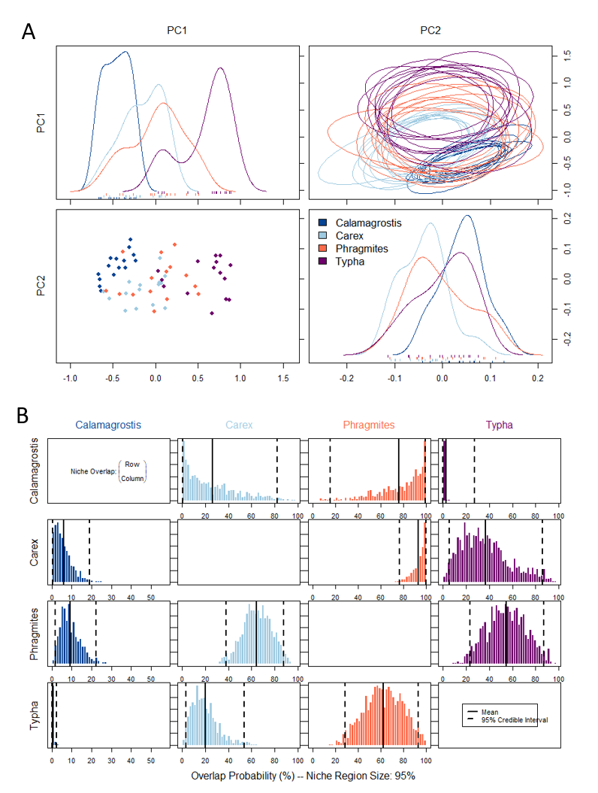
Appendix K. Projections of the 95% niche regions for each plant species based on weighted PCA axis scores (A); quadrats include one-dimensional density plots and 10 randomly drawn ellipticals per species which represent the two-dimensional niche region (A). Posterior distribution of the probabilistic niche overlap metric (%) for specified 95% niche region of all four plant species. Plots show the overlap probability of species A (row) onto the niche of species B (column). The posterior means and 95% credible intervals are displayed in black.

