Supporting Information

Anchored Anions, Mobile Cations: Charge Storage in MOF-based Supercapacitors Studied with operando Small Angle X-ray Scattering

Malina Seyffertitz¹, Chloe J. Balhatchet², Max V. Rauscher¹, Sebastian Stock¹, Gerhard Fritz-Popovski¹, Thomas Leiner³, David Holec³, Heinz Amenitsch^{4,5}, Alexander C. Forse², Oskar Paris¹*
1 Chair of Physics, Montanuniversität Leoben, Austria
2 Yusuf Hamied Department of Chemistry, University of Cambridge, United Kingdom
3 Chair of Physical Metallurgy, Montanuniversität Leoben, Austria
4 Institute of Inorganic Chemistry, Graz University of Technology, Austria
5 ELETTRA Sincrotrone Trieste, Italy

*oskar.paris@unileoben.ac.at
Figure S1: WAXS pattern from the dry Ni₃(HITP)₂ MOF with all in-plane reflections (hk0) up to reflection (10 10 0) indicated by vertical lines. Mixed reflections (hkl) and stacking reflexion (00l) are not shown.

a)
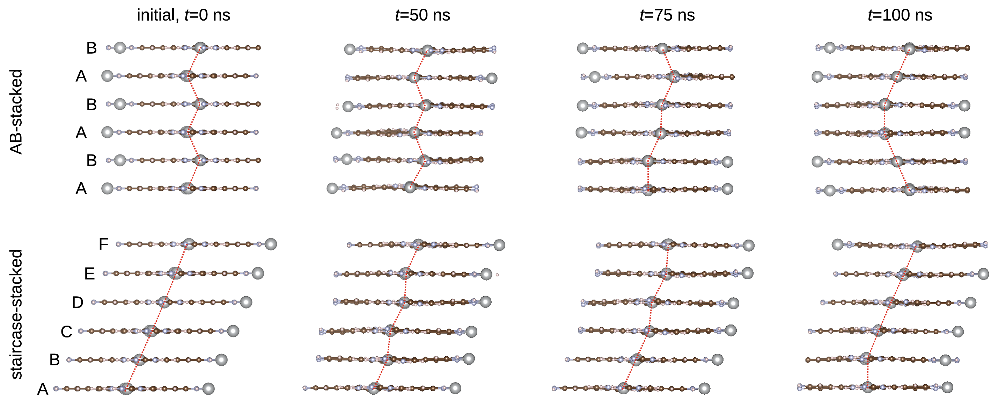

b)
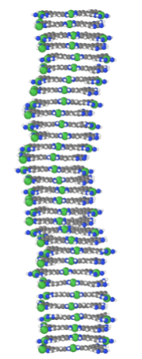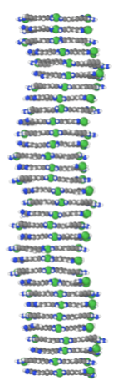
Figure S2: a) Snapshots from molecular dynamics simulations of 6 layers of Ni₃(HITP)₂ MOF, performed using the Matlantis framework. The image rows show relaxed structures starting from an AB-stacked configuration (upper) and a staircase-stacked configuration (bottom) at the start of simulation, and after 50 ns, 75 ns and 100 ns. In both cases, the layers remain mobile and shift around their centre. The atoms are coloured according to the species: C (brown), H (purple), N (blue), and Ni (grey, large atoms). The Ni positions are connected by red dotted lines as a guide-for-the-eye to visualise the stacking. b) Snapshots from molecular dynamics simulations of 32 layers of Ni₃(HITP)₂ MOF, performed using the Matlantis framework. The images show relaxed structures starting from an AB-stacked configuration (left) and a stacked configuration (right). In both cases, the layers remain mobile and shift around their centre. b) Snapshots of the system with 32 layers resembling the experimental turbostratic structures. Here, the atoms are coloured according to the species: C (grey), H (white), N (blue), and Ni (green)

Supplementary Note SN1:
For the molecular dynamics simulations, we used a universal PFP potential (v.5.0.0) from Preferred Computational Chemistry (PFCC), which describes interactions between 72 different elements of the periodic table and is made accessible by a platform called MatlantisTM ^{1,2}. The temperature during the MD simulation was set to 300 K using a NVT Berendsen Integrator³ and a timestep of 1 fs. Simulations lasted for 100,000 timesteps and subsequent energy minimizations were performed using a BFGS algorithm⁴. Figure S2 shows snapshots of molecular dynamics (MD) simulations of 6 layers of Ni₃(HITP)₂ MOF, starting from two different initial stackings. The upper row's initial configuration is composed of...ABAB…-stacked layers, while on the staring configuration in the lower row contains layers shifted always with respect to the previous layer to get a staircase layer configuration (…ABCD…). The MD simulations at 300 K show that the individual layers of the MOF can shift a certain margin with respect to the neighbouring layers, which indicates a weak binding between the individual layers. We took the structural snapshots every 5 ns, starting from 50 ns (i.e. 11 snapshots) from both MD runs and structurally relaxed them. The average energy difference between the two different configurations in a dry state is very small, only 21 meV for 450 atoms, forming the 6-layer models (about 10⁻⁵ of the total potential energy of the system). We have performed similar simulations with even larger systems up to 32 layers, yielding qualitatively the same conclusions. The larger systems, however, possess more degrees of freedom (with respect to the periodic boundary conditions applied), hence resulting in configurations resembling the experimental turbostratic structures where the central -Ni-Ni- chain is almost perpendicular to the MOF layers and exhibits small random in-plane displacements around a common vertical axis, as shown in Figure S2 b).

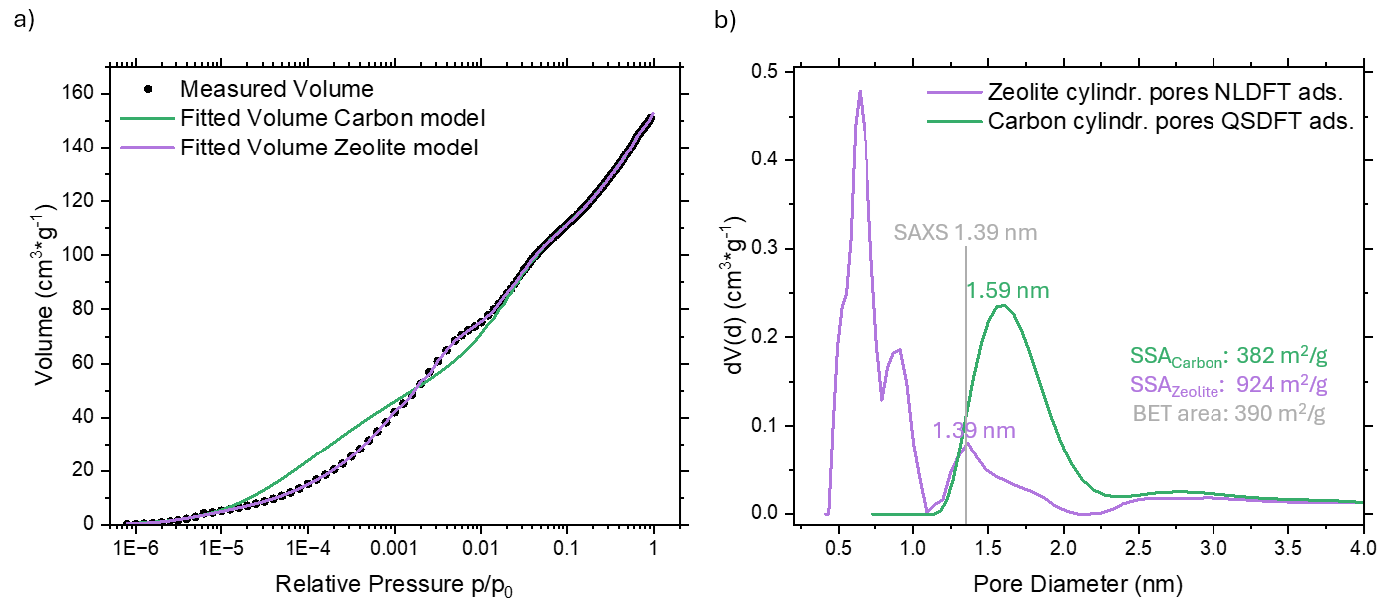
Figure S3: a) Fitting comparison of Ar@87K gas sorption analysis and the Zeolite NLDFT kernel for cylindrical pores on the adsorption branch (purple) and the Carbon QSDFT kernel for cylindrical pores on the adsorption branch and b) the derived pore size distributions. The pore size obtained from SAXS is added for reference.
Supplementary Note SN2:
Gas Sorption Analysis was performed with an Autosorb IQ-XR-XR-AG (Anton Paar, Graz, Austria) device. A comparison of the fitting results from the two gas sorption kernels (Zeolite non-local density functional theory (NLDFT) and Carbon quenched solid density functional theory (QSDFT), both on the adsorption branch) reveals that, while the zeolite kernel accurately reproduces the experimental data, the carbon kernel shows significant discrepancies. Furthermore, the pore size obtained using the carbon kernel is incompatible with the pore size determined by SAXS. These observations suggest that, for this specific MOF (Ni₃(HITP)₂), the use of a zeolite kernel for Ar@87K gas sorption analysis might be more appropriate.

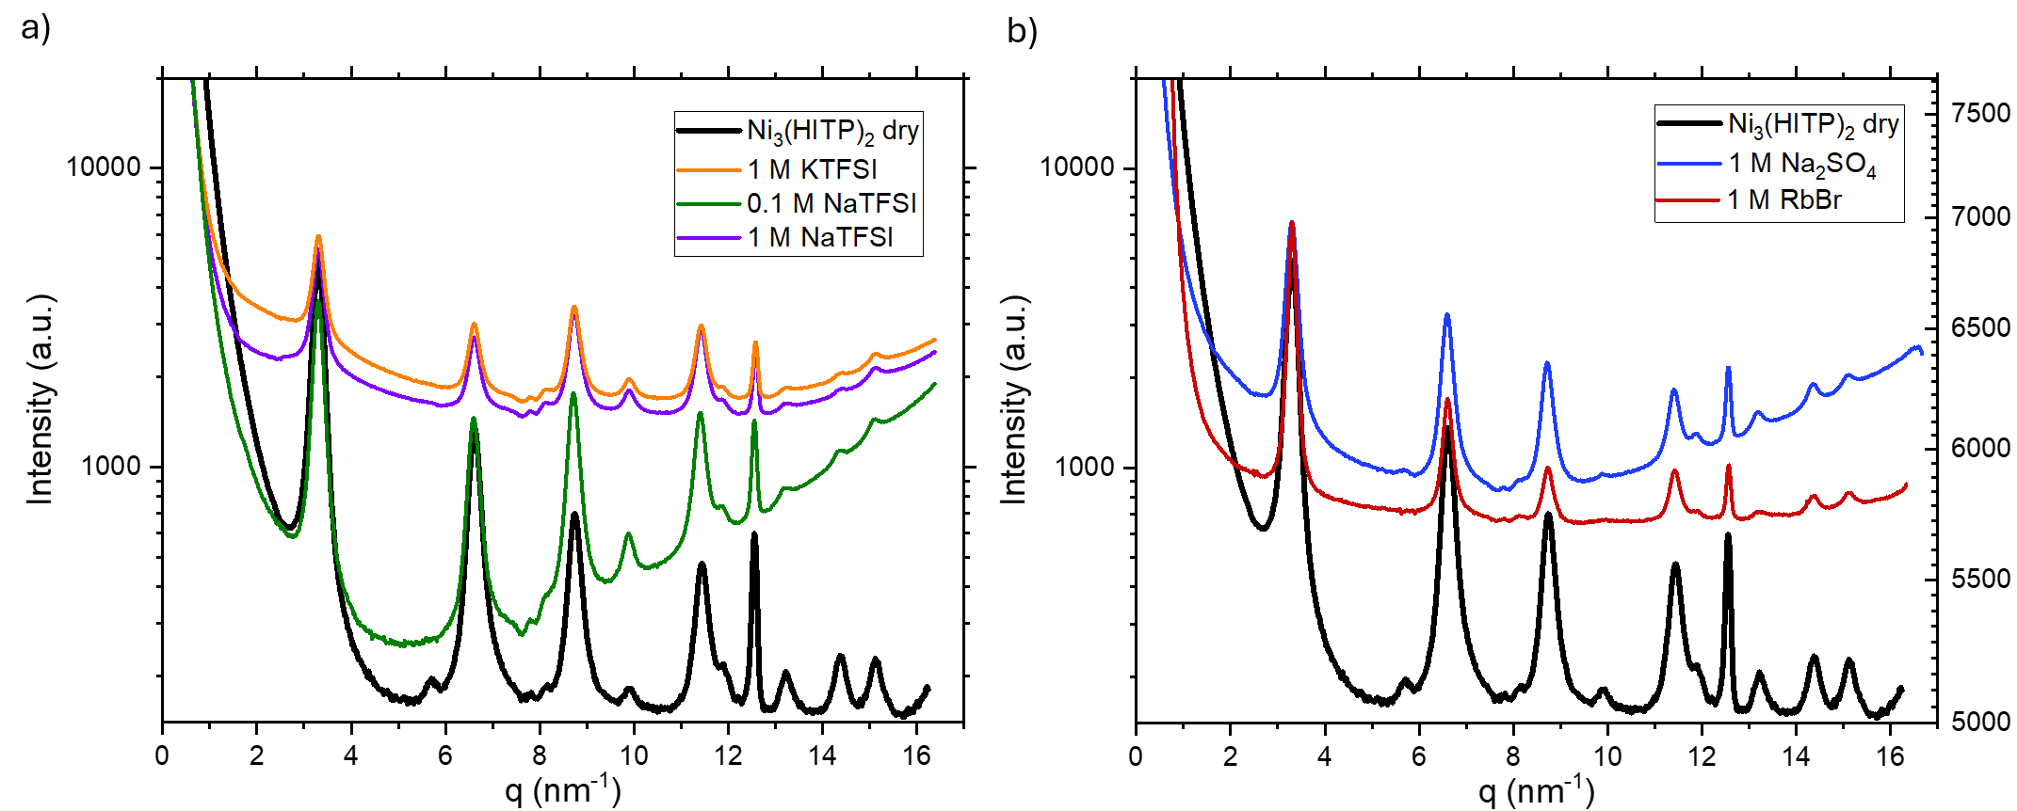
Figure S4: SAXS signal obtained for Ni₃(HITP)₂ wetted with aqueous a) 1 M KTFSI, 0.1 M NaTFSI, NaTFSI showing changes in the formfactor evident by i.e. the inversion of peak intensity ratios of the 200 and 210 peaks at about 6.6 nm⁻¹ and 8.9 nm⁻¹ respectively and b) 1 M Na₂SO₄ and 1 M RbBr showing no signs of a changed form factor. The SAXS measurements were conducted at 16 keV, which is above the adsorption edge for Rb⁺ and Br⁻, thus causing a strong background fluorescence signal. The 1 M RbBr measurement is therefore plotted on a secondary y-axis on the right.

Table ST1: Electron density (ρ_{el})⁵, electron number, linear absorption coefficient (μ) at 16.4 keV⁶ and molecular volume (V_{mol}) and -mass (m_{mol})^{7,8}.
 | ρ_{el} | Electron number | μ (16.4 keV) | V_{molecular} | m_{molecular}
 | e⁻/Å³ | - | 1/cm | Å³ | 10⁻²⁵ g
Ni₃(HITP)₂ | 0.781
H₂O | 0.335
1 M NaTFSI (aq.) | 0.393
1 M Na⁺ in H₂O | 0.342
Na⁺ ion | 2.784 | 10 | 36.75 | 3.6 | 3.8
TFSI⁻ ion | 0.760 | 136 | 11.20 | 179.0 | 46.5

Supplementary Note SN3:
The electron density of a multicomponent system ρ_{mix} can be calculated by summing the individual electron densities ρ_{i}, weighted by their respective volume fraction w_{i}:
$$ρ_{mix}= \sum_{i}{w_{i}*ρ_{i}}$$
Since the difference between the electron density of the TFSI⁻ rich layer (ρ_{TFSI-rich}) and the rest of the pore (ρ_{pore}) is caused by additional TFSI⁻ ions, we can rewrite the equation above as:
$${ρ_{TFSI-rich}-ρ}_{pore}= {Δw}_{TFSI}*ρ_{TFSI}$$
With Δw_{TFSI} representing the change in volume fraction of TFSI⁻ between the TFSI-rich surface layer and the pore, and ρ denoting the electron densities of the TFSI-rich surface layer, the pore and TFSI⁻ ions, respectively. Based on the molecular volume of TFSI⁻ (Ref.⁸), as shown in Supplementary Table ST1, a 10% volume fraction of TFSI⁻ corresponds to approximately a 1 M concentration.

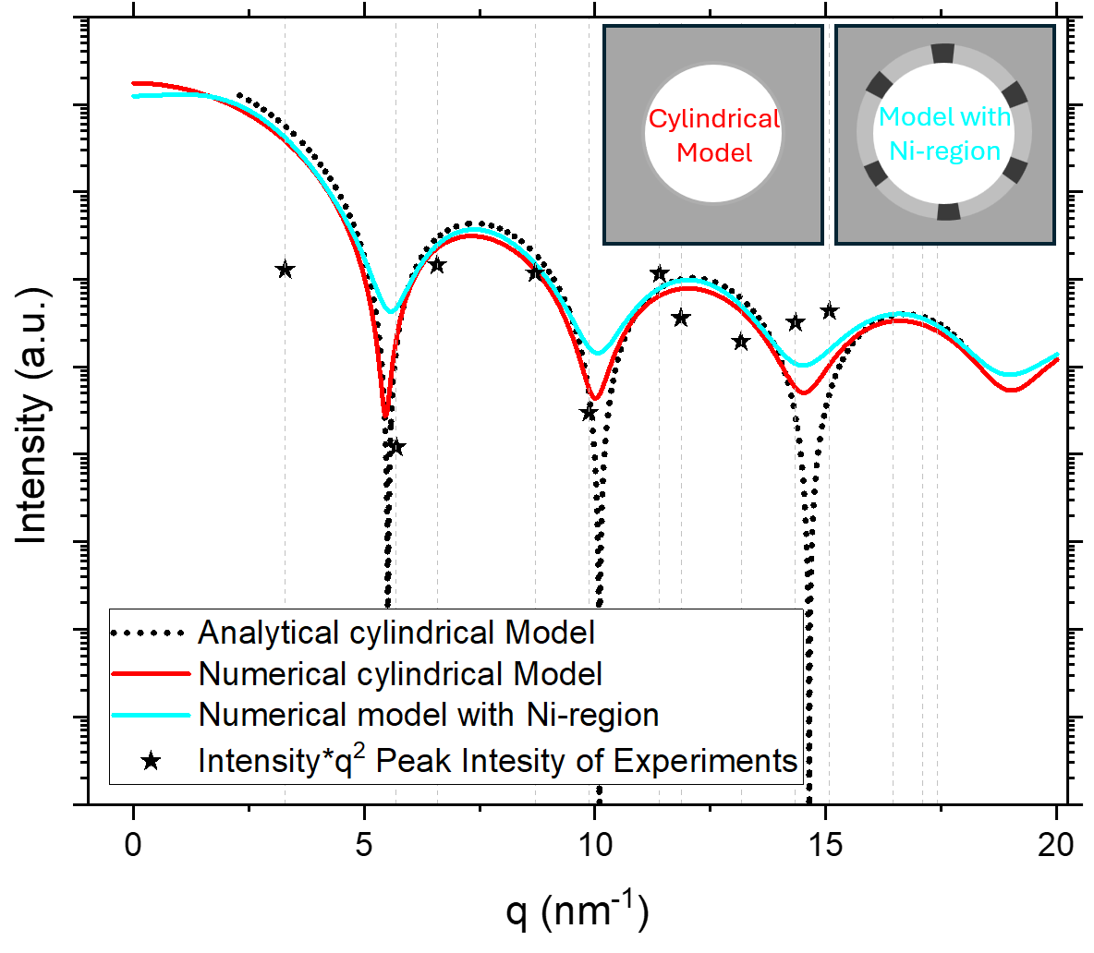
Figure S5: Comparison of analytical form factor models with numerical models taking radially varying electron density of the MOF (i.e. higher electron density for Ni) into account. The Ni regions formed circular segment rings spanning 10° at six positions around the circumference, contributing 80% of the average MOF electron density, while the non-Ni regions accounted for the remaining 20%. The inner diameter is 1.4 nm, the outer one 1.8 nm.

Supplementary Note SN4:
In this approach, the form factor was numerically computed to account for cylinders with not only a radially varying electron density distribution but also azimuthally varying electron density contributions around the circumference, as illustrated in Figure S5 in the model with Ni-regions. The form factor of the cross-section of the cylinders was determined using a Monte Carlo method^{9,10}. This calculation was done in a two-step approach. First the cross-section pair distance distribution function $p_{c}(r)$ was simulated. This function was then transformed numerically into reciprocal space resulting in the form factor of the cross-section of the cylinder.
A two-dimensional square bounding box with side length $a = 4$ nm was defined and $N_{P}={10}^{7}$ pseudo-random points were generated within this box. For each point $i$, the difference in scattering length density, $Δϱ_{i}$ relative to the scattering length density outside the cylinder, was determined. This was done by a set of conditions that linked the coordinates with the scattering length density at the given point. The inserts in Figure S5 show sketches of the corresponding parts within the bounding box having various electron densities. Then, an iteration over all possible pairs of points $i$ and $j$ (where $i≠j$) was conducted, and the distances $r_{ij}$ between these points as well as the products $ϱ_{ij}^{2}=Δϱ_{i}⋅Δϱ_{j}$ were calculated.
The $p_{c}(r)$ function was approximated by a histogram. The distance scale $r$ was divided into $N_{B}={10}^{4}$ bins with each bin having a width $Δr=\sqrt{2}⋅a/N_{B}$. Therefore, bin number $k$ corresponded to the distance range from $r_{k}=(k-1)⋅Δr$ up to $k⋅Δr$ with $1≤k≤N_{B}$. This results in a maximum distance, which is equal to the length of the diagonal of the bounding box. The height $p_{c,k}$ of each bin is proportional to the sum of all values $ϱ_{ij}^{2}$ for which $r_{ij}$ falls within the range of the corresponding bin. Including some normalisations, one consequently obtains the approximation
$$p_{c}\left(r_{k}\right)≈p_{c,k}=\frac{N_{B} a^{3}}{ \sqrt{8}π N_{P} \left(N_{P}-1\right) }⋅\left(\sum_{r_{k}≤r_{ij}<r_{k}+Δr}{ϱ_{ij}^{2}}\right)$$
The calculation was repeated 100 times to obtain an averaged histogram, along with estimates of the uncertainties associated with the heights of the individual bins.
Since the pair distance distribution function only describes pairs of scattering centres, while individual centres also contribute as a constant background to the scattering signal, it was necessary to compute an additional parameter $b$:
$$b=\frac{N_{B} a^{3}}{ \sqrt{8}π N_{P} \left(N_{P}-1\right) }\sum_{i=1}^{N_{P}}{Δρ_{i}^{2}}$$
This parameter was also determined for all the 100 repetitions of the Monte Carlo simulation.
The form factor of the cross-section $P_{c}(q)$ was then computed via numerical transformation of the histogram, expressed as:
$$P_{c}\left(q\right)≈2π \left(b+\sum_{k=1}^{N_{B}}{p_{c,k}} J_{0}\left(q r_{k}\right) Δr\right)$$
where $J_{0}$ represents the zeroth-order Bessel function. The limits of uncertainty of $P_{c}(q)$ were estimated by error propagation.

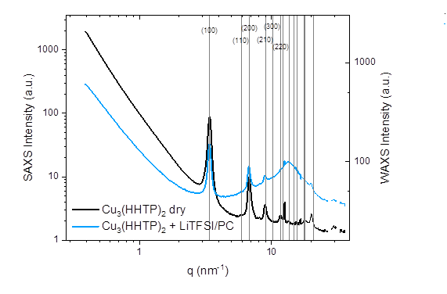
Figure S6: SAXS and WAXS signal of Cu₃(HHTP)₂ in the dry and wetted state using LiTFSI in propylene carbonate. Due to the large solvent molecules, the bulk liquid structure factor peak is strongly shifted to small q as compared to water, allowing to qualitatively compare only the first three in-plane reflections of the MOF

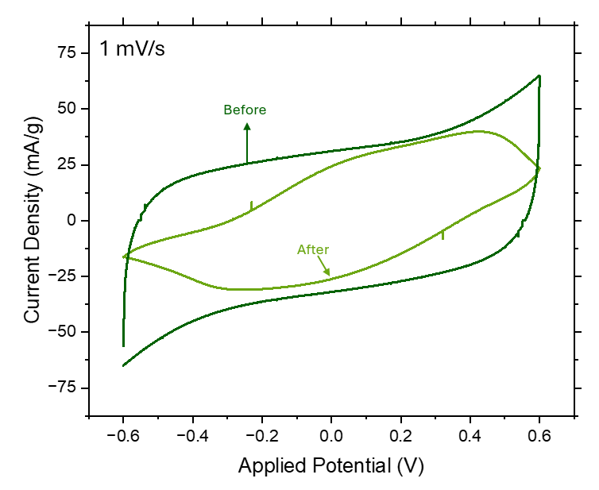
Figure S7: Cyclic voltammogram for Ni₃(HITP)₂ and 1 M NaTFSI before and after applying the voltage sequence presented in this paper between ±0.6 V.

Figure S8: SAXS transmission signal during varying applied potential for Ni₃(HITP)₂ using 1 M NaTFSI (aq.).

Supplementary Note SN5:
The transmission signal τ generally follows Beer-Lamberts Law:
$$τ=e^{-μ\left(E\right)*d}$$
Where µ(E) being the energy dependent linear absorption coefficient and d the sample thickness. In a multicomponent system the combined linear absorption coefficient can again be written as the sum of linear absorption coefficients of each component, weighted by their contribution to the irradiated sample thickness, i.e. their volume fraction when using an x-ray beam of constant diameter. As seen in Table ST1, the linear absorption coefficient of sodium might be large, however the small ion size renders them almost invisible in the x-ray transmission. In a 1 M aqueous NaTFSI solution, Na⁺ makes up only 0.22 % of the volume, while TFSI⁻ accounts for roughly 10.8 % and water about 88.9 %. Therefore, sodium contributes only 3 % to the combined linear attenuation coefficient, whereas TFSI and water make up 47 % and 50 % respectively. Changing the TFSI⁻ concentration from 1 M to 2 M increases the linear attenuation coefficient by 41 %, while a change from 1 M to 2 M Na⁺ concentration increases the linear absorption coefficient by only 3 %. More detailed information on how to determine ion concentration changes from x-ray transmission can be found in i.e. Ref.^{11,12}

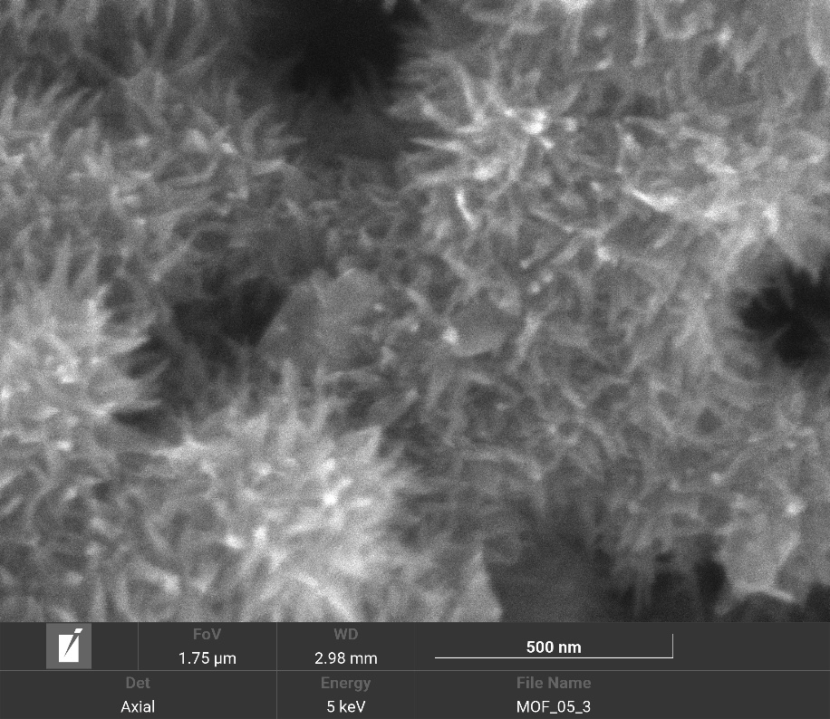
Figure S9: SEM image of Ni₃(HITP)₂ MOF using the axial backscatter electron detector at an energy of 5 keV.

Supplementary Note SN6:
The ratio of pore surface area to outer surface area was estimated based on geometric considerations. As shown in the micrograph above, the MOF consists of grains with coral-like needle particles with an approximate diameter d_{particle} ≈ 30 nm, resulting in approximate a cross-sectional of such a needle-shaped particle of A_{particle} = (d_{particle}/2)²*π. From scattering data, it is known that the structure contains cylindrical pore channels with a diameter of d_{pore} = 1.4 nm arranged hexagonally with an average distance of a = 2.2 nm between pore centres. The cross-sectional area of a single pore is A_{pore} = (d_{pore}/2)²*π. In hexagonal packing, the "effective area" per pore is A_{pore, effective} = (a/2)²*π. The packing efficiency of a hexagonal arrangement is π/sqrt(12). Using this, the number of pore channels within one particle can be estimated as: n = A_{particle} * π/sqrt(12)/ A_{pore, effective} = π/sqrt(12)*d_{particle}²/a² ≈ 75. The combined surface area (mantle area) of all pore channels in one needle-shaped particle is: M_{pores} = n*d_{pore}*π*l where l is the length of the pore channels. The outer mantle area of a single needle-shaped particle is M_{particle} = d_{particle}*π*l with l again being the length of the pore channels or the particle. The ratio of pore surface area to particle surface area is therefore: n*d_{particle}*π*l/(n*d_{pore}*π*l) ≈ sqrt(12)/π*a²/(d_{particle}*d_{pore}) ≈ 12 %. This ratio is a rough geometric estimation and represents the upper limit of the pore-to-particle surface area share. It assumes all particles are as small as 30 nm in diameter, which, as evident from the micrograph, is clearly not the case. Larger particle sizes would result in an even greater share of in-pore surface area and the 12 % obtained here only refer to the pore area within the needle shaped extensions of the much larger MOF particles.

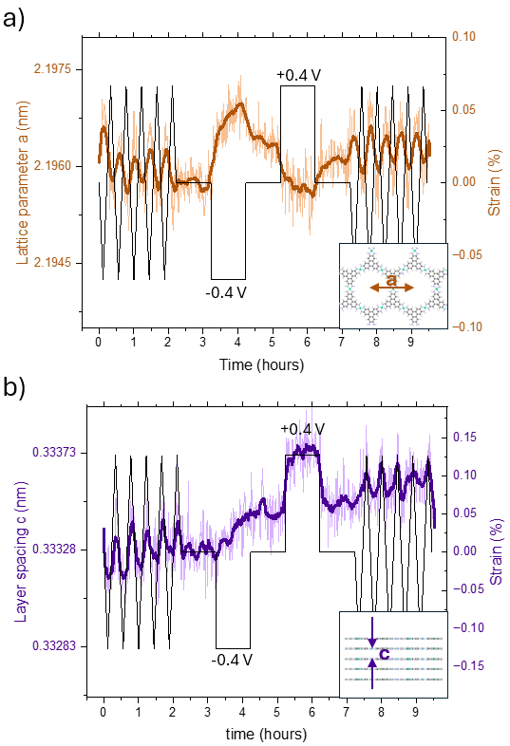
Figure S10: Evolution of the a) lattice parameter a and b) layer spacing c as a function of applied potential for the counter electrode to the electrode depicted in Figure 4 of the main manuscript. The light colour line in the background shows the measured data, while the thicker darker line represents the smoothed moving point average over 8 data points.

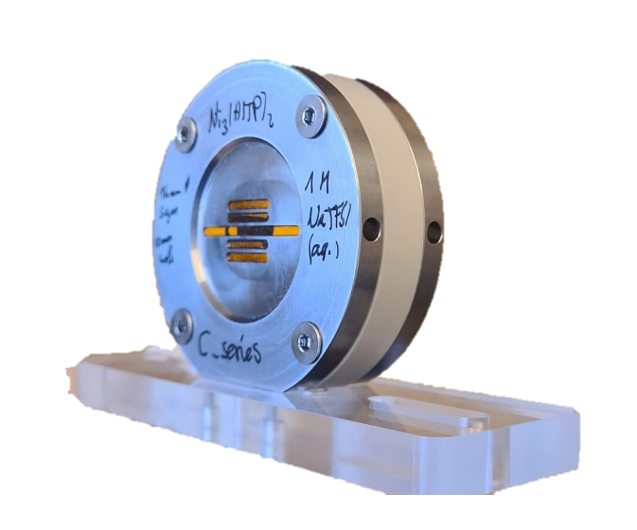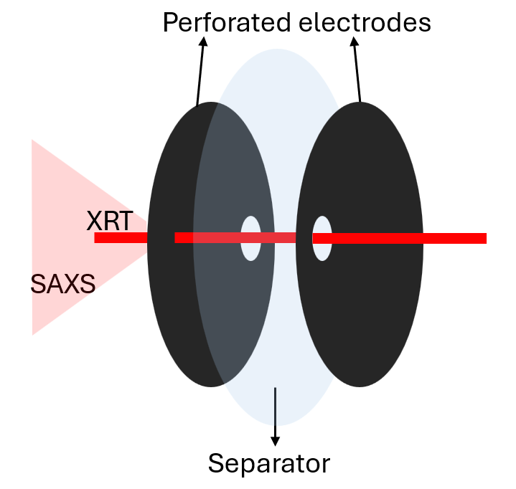
Figure S11: Left: In-situ SAXS and XRD cell featuring Kapton windows for scanning of the electrode. Right: Perforated Electrode geometry allowing to irradiate each electrode individually for the collection of SAXS/XRT signal. Not depicted is the additionally added Pt foil as a current collector.

1. Takamoto, S., Okanohara, D., Li, Q. J. & Li, J. Towards universal neural network interatomic potential. Journal of Materiomics 9, 447–454 (2023).
2. Takamoto, S. et al. Towards universal neural network potential for material discovery applicable to arbitrary combination of 45 elements. Nature Communications 2022 13:1 13, 1–11 (2022).
3. Berendsen, H. J. C., Postma, J. P. M., Van Gunsteren, W. F., Dinola, A. & Haak, J. R. Molecular dynamics with coupling to an external bath. J Chem Phys 81, 3684–3690 (1984).
4. Fletcher, R. Practical Methods of Optimization. (Wiley, 2000). doi:10.1002/9781118723203.
5. CRC Handbook of Chemistry and Physics. (CRC Press, 2014). doi:10.1201/b17118.
6. Chantler, C.T. et al. X-Ray Form Factor, Attenuation and Scattering Tables (version 2.1). X-Ray Form Factor, Attenuation and Scattering Tables (version 2.1). [Online] http://physics.nist.gov/ffast (2005) doi:https://dx.doi.org/10.18434/T4HS32.
7. Nightingale, E. R. Phenomenological theory of ion solvation. Effective radii of hydrated ions. Journal of Physical Chemistry 63, 1381–1387 (1959).
8. Chugh, M. et al. A combinatorial study of electrochemical anion intercalation into graphite. Mater Res Express 8, (2021).
9. Stöckel, P. et al. The Core Subunit Structure in RNA Polymerase Holoenzyme Determined by Neutron Small‐Angle Scattering. Eur J Biochem 112, 411–417 (1980).
10. Fritz, G. & Bergmann, A. Interpretation of small-angle scattering data of inhomogeneous ellipsoids. urn:issn:0021-8898 37, 815–822 (2004).
11. Prehal, C., Koczwara, C., Amenitsch, H., Presser, V. & Paris, O. Salt concentration and charging velocity determine ion charge storage mechanism in nanoporous supercapacitors. Nat Commun 9, 4145 (2018).
12. Seyffertitz, M. et al. Are SAXS and SANS suitable to extract information on the role of water for electric-double-layer formation at the carbon–aqueous-electrolyte interface? Faraday Discuss 249, 363–380 (2024).

