Supplementary Information
Photo Ionic gelatin power source by Ion-gradient and photo redox pairs synchronization

Supplementary Note 1. Theoretical background and synergistic mechanism derivation of design for photo responsive micro power source

In brief, the mechanisms of the photo responsive micro power source can be described in three parts.

1.1 Part 1
Polyoxometallic acid (ammonium molybdate) is a common photochromic material. This material can undergo Mo (VI) - Mo (V) photo redox process under ultraviolet light (Wavelength: 365nm) excitation, (S1). The active Mo (VI) involved in this process generates an unstable blue charged complex (${{[MO}_{14}O_{46}]}^{10-}$), which is reductive and can be oxidized by an oxidizing agent to return to its initial charged state (such as oxygen). [1-3] Therefore, ammonium molybdate with photochemical activity can change the charged particle gradient of the surrounding environment.
$2{{[MO}_{7}O_{24}]}^{6-}+MeOH\underset{→}{hv}{{[MO}_{14}O_{46}]}^{10-}+2{OH}^{-}$ (S1)

1.2 Part 2
Gelatin is a kind of translucent, high molecular weight polypeptide, usually derived from animal skin. It has low cost, well biocompatibility and biodegradability, and has been widely used in biology, medicine and other fields. There are abundant hydroxyl, carboxyl and amino groups in the molecular chain of gelatin, which makes it very easy to couple charged particles and functionalize. [4,5] On the other hand, the non-covalent hydrogen bond in gelatin breaks reversibly at temperatures of about 40°C, so at the right temperature, hydrogels using gelatin as a skeleton can achieve the conversion between liquid and colloidal. [6] Therefore, we chose gelatin as the skeleton substrate. On the one hand, in the negative hydrogel droplet, it is coupled with the octahedral configuration of molybdic acid and ions, and the larger molybdic acid and ions are fixed, so that they will not move, [1, 6-8] which ensures the effective change of charged particle gradient in the negative hydrogel droplet. On the other hand, the conversion between liquid and colloid ensures that the micropower supply can be assembled and constructed in any shape.

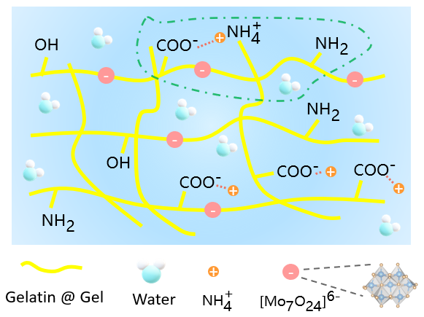
Schematic S1| Chemical chain coupling diagram of ammonium molybdate and gelatin.

1.3 Part 3
Symbol definition of optical response micro power supply:
The principle of photo responsive micro power is based on hydrogel droplets that can change the gradient of charged particles. When the light is excited, the gradient of charged particles in the negative hydrogel droplet will accumulate. Due to the effect of concentration diffusion, the changed charged particles in the negative hydrogel droplet will flow to the positive hydrogel droplet. This process will release the chemical energy and potential energy in the gradient of charged particles, and generate electromotive force between the electrode Bridges. In fact, this process can be explained by the entropy transferred by the diffusion of charged particles caused by light excitation. Since the carrier that forms the current is the charged particle in the environment, this mechanism is different from the photoelectric effect (photon-generated carrier) in the traditional sense. We define the light-induced diffusion power as the ratio of the electric field gradient to the intensity of the light field, which can be written as:
$S_{td}=-\frac{\frac{dV}{dx}}{\frac{dI}{dx}}=-\frac{V\left(I_{open}\right)-V(I_{0})}{I_{open}-I_{0}}$ (S2)
In general, the light field intensity is 0 mw/cm⁻² when it is not excited. When photoexcited, the micro power supply is uniformly covered under the light field and the positive material does not participate in any photochemical process. Therefore, the photoinduced diffusion power of the micro power supply can be written as:
$S_{td}=\frac{V\left(I_{open}\right)-V_{0}}{I_{open}}$ (S3)
Where, $S_{td}$is the photoinduced diffusion power; $V\left(I_{open}\right)$ is the open circuit potential when the light field is opened; Light intensity$I_{open}=\frac{P}{A}$, P is the ultraviolet light power, A is the device area. In simple terms, when the hydrogel droplet with photochemical reaction is defined as negative, the open circuit potential V_{OC} symbol is positive.
On the other hand, since only negative hydrogel droplets can undergo photochemical processes (as shown by the spectral data of negative and positive materials), the REDOX environment of the two electrodes before and after illumination is different, and the electrode potential at the interface of the two electrodes will change. Therefore, the final photo response potential includes not only the diffusion of charged particles caused by photo stimulated REDOX, but also the standard potential contribution of REDOX to the electrode. This will be explained further in subsequent derivations.
Because the general test environment is carried out at room temperature, the effect of temperature on the standard potential can be ignored here, so there are:
$E|_{T}=E|_{T_{0}}-\frac{dE}{dT}∙∆（T-T_{0}）=E|_{T_{0}}$ (S4)
That is, when the temperature is constant, the electrode potential changes can be approximated to be caused by REDOX pairs. Where, $E|_{T} and E|_{T_{0}}$ represent the standard potential at the two temperatures, and the change rate of electrode potential to temperature is the temperature coefficient $α_{R}=\frac{dE}{dT}$.
Therefore, to sum up, the final voltage potential change of the micro-power supply should be determined by the diffusion of charged particles caused by light induction and the REDOX potential change of the electrode. The mechanism is the change of charged particle gradient (C (OH⁻)) and electrode potential caused by REDOX pairs changes（${{[MO}_{7}O_{24}]}^{6-}$ and ${{[MO}_{14}O_{46}]}^{10-}$）which be from photoexcitation of the negative hydrogel. Therefore, the open circuit potential output is defined as:
$∆E_{t}=∆E_{r}+∆E_{c}=\left(E_{r}-E_{r0}\right)+(E_{c}-E_{c0})$ (S5)
Where $E_{r}$represents the potential contribution under the action of entropy of charged particles; $E_{c}$represents the standard potential contribution to the electrode under REDOX action. The synergistic action of $E_{r }and E_{c}$ together constitutes the open circuit output potential $E_{t}$of the micro-power supply, which will be explained by step-by-step derivation.
- Potential contribution under the action of entropy of charged particles
Under light induction, the photochemical processes of negative hydrogel droplets such as (S1). Based on the Debye-Huckel equation [9], there is an exponential relationship between the activity coefficient of electrolyte and the reciprocal size, because the gelatin support coupling effect with ${{[MO}_{7}O_{24}]}^{6-}$ / ${{[MO}_{14}O_{46}]}^{10-}$ and the size are much larger than OH—. So, the contribution of ${{[MO}_{7}O_{24}]}^{6-}$ / ${{[MO}_{14}O_{46}]}^{10-}$ can be ignoring. According to the Nernst-Planck equation and the Goldman-Hodgkin-Katz current equation [10-11], the flux of ions S in an electric field is given by $J_{S}$ (mol m⁻² s⁻¹), where:
$J_{S}=-D_{S}\left(∇C_{S}+\frac{FZ_{S}}{RT}C_{S}∇φ\right)$ (S6)
Where $D_{S}$ (m² s⁻¹) is the diffusion coefficient of S in it’s medium; $C_{S}$ (mol m⁻³) is molar concentration of ion S; $F$ (C mol⁻¹) is Faraday's constant; $Z_{S}$ is the charge of S; $R$ (J mol⁻¹ K⁻¹) is gas constant; $T$ (K) is the temperature and $φ$ (V) is the electric potential. The ion flux in current form, according to assumptions based on the Goldman-Hodgkin-Katz current equation [10-11], is given by:
$I_{S}=P_{S}VF^{2}Z_{S}^{2}\frac{C_{S_{in}}-C_{S_{out}}e^{-VF\frac{Z_{S}}{RT}}}{RT\left(1-e^{-VF\frac{Z_{S}}{RT}}\right)}$ (S7)
Where $I_{S}$ (A m⁻²) is the current density caused by the change of ion S, $P_{S}$ (m s⁻¹) is the permeability of ion S, $V$ (V) is the resulting electric potential, $F$ (C mol⁻¹) is Faraday's constant; $Z_{S}$ is the charge of S, $C_{S_{in}}$ and $C_{S_{out}}$ (mol m⁻³) is the ion (S) concentration inside and outside the electrode when the photo responsive micropower supply has an output, $R$ (J mol⁻¹ K⁻¹) is gas constant, $T$ (K) is the temperature. Here, since it is mentioned earlier that it can be approximated as only OH— at work, the above formula can be written as:
$I_{S}=\frac{VF^{2}P_{{OH}^{-}}}{RT\left(1-e^{\frac{VF}{RT}}\right)}\left[C_{S_{in}}-C_{S_{out}}e^{\frac{VF}{RT}}\right]=\frac{VF^{2}P_{{OH}^{-}}}{RT\left(1-e^{\frac{VF}{RT}}\right)}\left[C_{{OH}^{-}in }-C_{{OH}^{-}out}e^{\frac{VF}{RT}}\right]$ (S8)
Previously, we discussed the relationship between ion flux and the ideal electromotive force, and the voltage generation can be modeled according to the internal resistance, because the positive material is light stable, it accounts for a large proportion of the internal resistance. When the micro power supply is open, the external resistance is much greater than the internal resistance (R_{meter} $→∞≫R$_{source}), therefore, the micro power supply at this time will enter a state where the output voltage (V_{OC}) is high and the current I_{S}→0, so we have:
$V_{OC}|_{Er}=\frac{RT}{F}Ln\frac{C_{{OH}^{-}in}}{C_{{OH}^{-}out}}=V_{meter}$ (S9)
When short circuited，R_{meter}$→0≪R$_{source}，therefore，$V_{meter}=0$. The current output can be written as:
$I_{meter}=I_{SC}=\frac{V_{OC}}{R_{source}}$ (S10)
Schematic S2| Equivalent circuit diagram of electrical measurement connection electrode and measuring instrument of optical response micro power supply.
So, to sum up, we can know that for positive droplet materials, the additional ion concentration will hinder and neutralize the diffusion of OH— (negative droplet material), which will lead to decrease in the open circuit potential. As a design trade-off, we only use the charged particles in Type A gelatin to balance the effect of ammonium ions in the negative material, i.e.no additional ions are introduced into the positive material unless otherwise stated. The above expression (S9) shows the potential change caused by ion diffusion in the simplified case, but it cannot determine the rule under light condition. In the following, we will further analyze the rule of potential change caused by light induced ion diffusion when light on and off. To facilitate analysis, the photochemical equilibrium constant (K) in the photoinduced negative material is introduced:
$K=\frac{C{{[MO}_{14}O_{46}]}^{10-}∙C^{2}{OH}^{-}}{C^{2}{{[MO}_{7}O_{24}]}^{6-}}$ (S11)
Where, C is the concentration or activity of reactants and photochemical products.
When temperature and pressure are constant, the free energy changes as follows:
$∆G=∆G^{0}+RT∙LnK$ (S12)
Where, $∆G^{0}$ and $R$ are respectively express the Gibbs free energy change and the gas constant under the standard. In electrochemistry, a potential on a cell electrode is defined as a reduction in the Gibbs free energy per unit of Coulomb charge transfer, can be written by:
$∆G=-ZFE=-Z_{OH- }∙F∙ E$ (S13)
Where, Z is the number of electrons transferred by the reaction and F is Faraday's constant. Here we temporarily do not discuss the effect of REDOX on the electrode interface potential, only consider the potential change caused by OH— diffusion, so it can be written as:
$E_{r}=E^{0}-\frac{RT}{ZF}∙LnK$ (S14)
Therefore, the change in potential due to a change in the gradient of charged particles can be written as:
${∆E}_{r}=-\frac{RT}{ZF}∙Ln∆K$ (S15)
Since there is no change in $∆K$ involved in the positive material, the open circuit potential change under light is:
${∆V}_{r}={∆E}_{r}|_{positive}-{∆E}_{r}|_{negative}=\frac{RT}{ZF}∙Ln∆K=\frac{RT}{ZF}∙Ln\frac{∆C{{[MO}_{14}O_{46}]}^{10-}∙{∆C}^{2}{OH}^{-}}{∆C^{2}{{[MO}_{7}O_{24}]}^{6-}}$ (S16)
Since the previously mentioned contribution is small of ${{[MO}_{7}O_{24}]}^{6-}$ / ${{[MO}_{14}O_{46}]}^{10-}$, therefore, the above expression can be approximated by mathematical methods:
${∆V}_{r}=\frac{RT}{F}∙Ln∆C{(OH}^{-})$ (S17)
Therefore, in the light state, the potential change limitation caused by the change of the gradient of charged particles induced by light induction is as follows:
$V_{r}|_{limit}=\frac{RT}{F}∙Ln∆C{(OH}^{-})=-\frac{RT}{F}∙LnC{(OH}^{-})|_{produce }$ (S18)
When the light is removed, referring to the previous formula (S9), we assume that the OH— in the negative material when the light field is removed is $C{(OH}^{-})|_{I }$, which can be seen as a constant, so the potential is:
$V_{r}=\frac{RT}{F}∙Ln∆C{(OH}^{-})=\frac{RT}{F}∙[LnC{(OH}^{-})|_{I }-LnC{(OH}^{-})|_{out }]=\frac{RT}{F}∙Ln\frac{C{(OH}^{-})|_{I }}{C{(OH}^{-})|_{out }}$ (S19)
Therefore, to sum up, under ideal conditions, the theoretical analysis of potential changes caused by diffusion is consistent with the experimental results. In fact, for the effect of diffusion, we should also consider the interaction between ion equilibrium and the effect of photochemical equilibrium, but this will only affect the relationship between potential and time, but the overall trend is unchanged.
- Electrode potential contribution under REDOX action
However, when REDOX reactions are involved in the system, the effect of diffusion cannot simply be considered. The REDOX reaction at the electrode interface $（{{[MO}_{7}O_{24}]}^{6-}$ / ${{[MO}_{14}O_{46}]}^{10-}）$ will affect the REDOX potential of the electrons in the electrode, in which case we need to consider the effect of REDOX reaction.
𝑂 + 𝑛𝑒 ⇋ 𝑅 (S20)
where O is the oxidized species, 𝑅 is the reduced species. In the samples, O is ${{[MO}_{7}O_{24}]}^{6-}$ and R is ${{[MO}_{14}O_{46}]}^{10-}$. At the equilibrium, the net change in electrochemical potential should be zero at both the and electrode. Therefore, the changes in the electrochemical potential are:
$\left\{\begin{aligned}\tilde{μ}O + n\tilde{μ}e = \tilde{μ}R Negative material electrode \\ 0 Positive material electrode \end{aligned}\right.$ (S21)
Where the electrochemical potential of the substances O and R is${\tilde{ μ}}_{i}= μ_{i}+q_{i}V$ (𝑖 = 𝑂, 𝑅), including chemical potential part $μ_{i}$ and electrostatic potential part $q_{i}V$. The $q_{i}$ is the charge of substance i, and V is the electrostatic potential in the electrolyte. The electrochemical potential per mole of electrons is$\tilde{μ}e = E_{F}-FV_{e}$, $E_{F}$is the Fermi level of the electrode, $V_{e}$is the electrostatic potential in the electrode, and F is the Faraday constant. Since the Fermi level in a metal electrode can be considered a constant, the electrochemical potential difference between the positive and negative materials is the electrode voltage difference caused by the photoexcited REDOX process:
$n∆\tilde{μ_{e}}=∆\tilde{μ_{R}}-∆\tilde{μ_{O}}=\left(∆μ_{R}-∆μ_{O}\right)+q_{R}∆V-q_{O}∆V=\left(\frac{∂μ_{R}}{∂I}-\frac{∂μ_{O}}{∂I}\right)∆I+\left(q_{R}-q_{O}\right)∆V$
$=-\left(S_{R}{-S}_{O}\right)∆I+(-n∙F)∙(-S_{td}∙∆I)$ (S22)
Where the $S_{td}=-\frac{∆V}{∆I}$, $S_{i}=-\frac{∂μ_{i}}{∂I}$ (𝑖 = 𝑂, 𝑅), since charge is conserved, for every mole of reaction, $q_{R}-q_{O}=-nF$. Therefore, the total power of the photoinduced voltage potential is:
$S=\frac{∆\tilde{μ_{e}}}{nF∆I}=-\frac{{∆V}_{e}}{∆I}=-\frac{S_{R}{-S}_{O}}{nF}+S_{td}$ (S23)
Here, we define the light response coefficient $α_{I}=\frac{S_{R}{-S}_{O}}{nF}$; define the change in entropy of the REDOX reaction as $∆S_{C}=S_{R}{-S}_{O}$. Therefore, the total photoinduced voltage potential power can be simplified as:
$S=S_{r}+S_{c}=S_{td}-α_{I}$ (S24)
So, combined with 1) and 2), the total voltage can be expressed as:
$E=（S_{td}-α_{I}）∙∆I=(-\frac{S_{R}{-S}_{O}}{nF}+S_{td})∙∆I$ (S25)
Where, the $∆I$ is the light intensity of a constant light field, and according to the previous definition $S_{td}=$ $V_{r}$.
It can be seen that with the progress of the photochemical reaction, the voltage growth power is gradually reduced, and the initial state has the highest growth power under light excitation, that is, the voltage growth is the fastest. Under constant light, as the photochemical process is fully reacted, $α_{I}$can then be regarded as a fixed value, and the open circuit potential will remain constant and not increase. This is consistent with the rule of open circuit potential under continuous illumination in the experiment.
Therefore, the power of the photoinduced voltage can be written as:
$S=\left\{\begin{aligned}-\frac{S_{R}{-S}_{O}}{nF}+S_{td},light on \\ -\frac{S_{O}{-S}_{R}}{nF}+S_{td}, light off\end{aligned}\right.$ (S26)
Where,
$S_{td}=\left\{\begin{aligned}-\frac{RT}{FI}∙LnC{(OH}^{-})|_{produce } , light on \\ \frac{RT}{FI}∙Ln\frac{C{(OH}^{-})|_{I }}{C{(OH}^{-})|_{out }} , light off \end{aligned}\right.$ (S27)
Therefore, in summary, it is proved that the photoinduced voltage power of the micro-power supply is the result of the synergistic contribution of two different mechanisms (Photoinduced charged particles diffusion and Electrode potential change is caused by REDOX pairs which because photochemical processes ${{[MO}_{7}O_{24}]}^{6-}$ / ${{[MO}_{14}O_{46}]}^{10-}$).

Supplementary Note 2. Methods and mechanisms of photo responsive micropower to regulate cell activity and gene expression
Bioelectricity is an indispensable part of the living system, in which the endogenous electric field plays a vital role in cell proliferation, differentiation, communication and transport. As a kind of non-drug physical stimulation, external field electrical stimulation can regulate the endogenous electric field of cells or living systems, enhance the expression of specific genes in cells, and improve cell behavior, such as proliferation and differentiation, and has been widely used in biomedicine. Because of these effects, electrical stimulation shows great potential in areas such as tissue repair, nerve stimulation, and bone regeneration. In recent years, various power systems have been designed as field sources, such as piezoelectric, photoelectric, ionized hydrogel batteries. [12-15] In short, there are many encouraging examples, but our work solves the problem of the fabrication of any optoelectronic device and demonstrates that the output power can be cell-regulated and manipulated on demand. Importantly, our proposed power generation mechanism based on the synergistic effect of photoinduced diffusion and REDOX pairs solves the outstanding problem of the ultra-short life of photogenerated charge carriers in the field of inorganic photonics. To further confirm, we used a commercial PV system with the same power as the extended network (N=6).

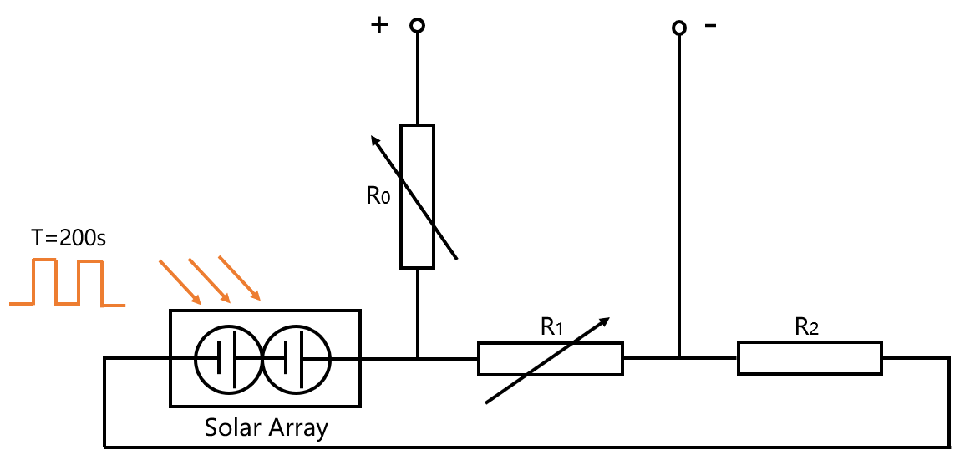
Schematic S3| a commercial photovoltaic system used in a control cell proliferation experiment.

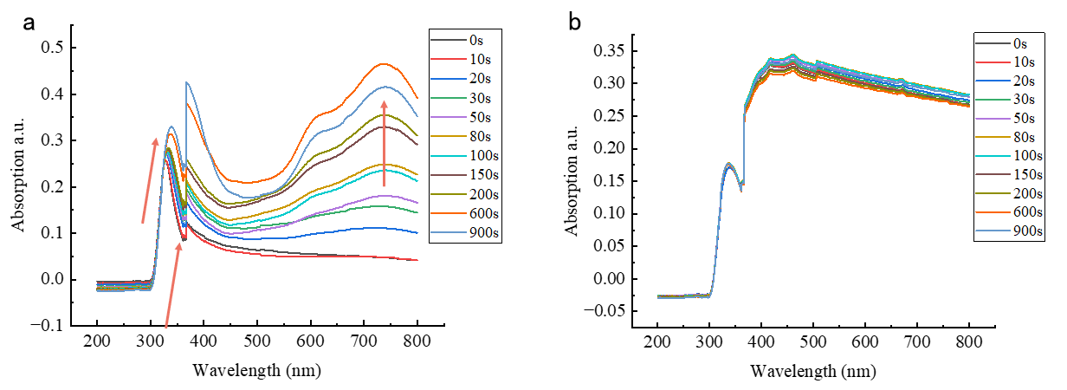
Supplementary Fig. 1| The photoactivity and photostability of different hydrogel droplets were proved by absorption spectra. a, Absorption spectra of negative hydrogel droplets at different photo excitation times. b, Absorption spectra of positive hydrogel droplets at different photo excitation times.

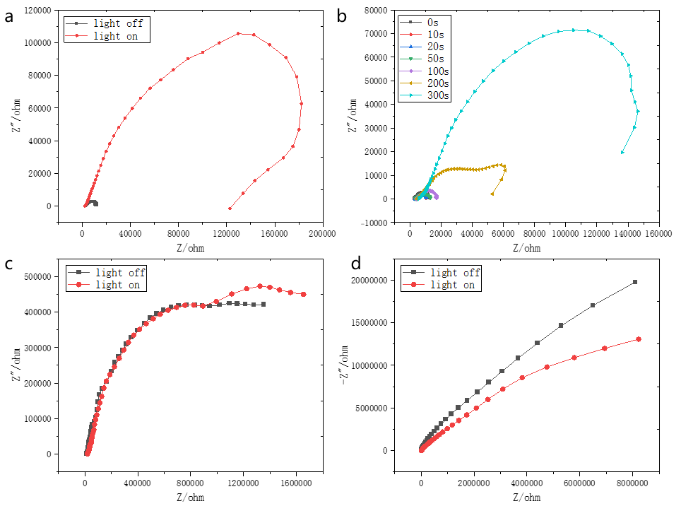
Supplementary Fig. 2| Impedance spectra of different hydrogel droplets and micropower sources. a-b, Impedance spectra of negative hydrogel droplets before and after photoexcitation (VS. 100S) and at different excitation times. c, Impedance spectra of positive hydrogel droplet before and after excitation (VS. 100S) . d, Optical response impedance spectra before and after optical excitation (VS. 100S) of a micropower supply.

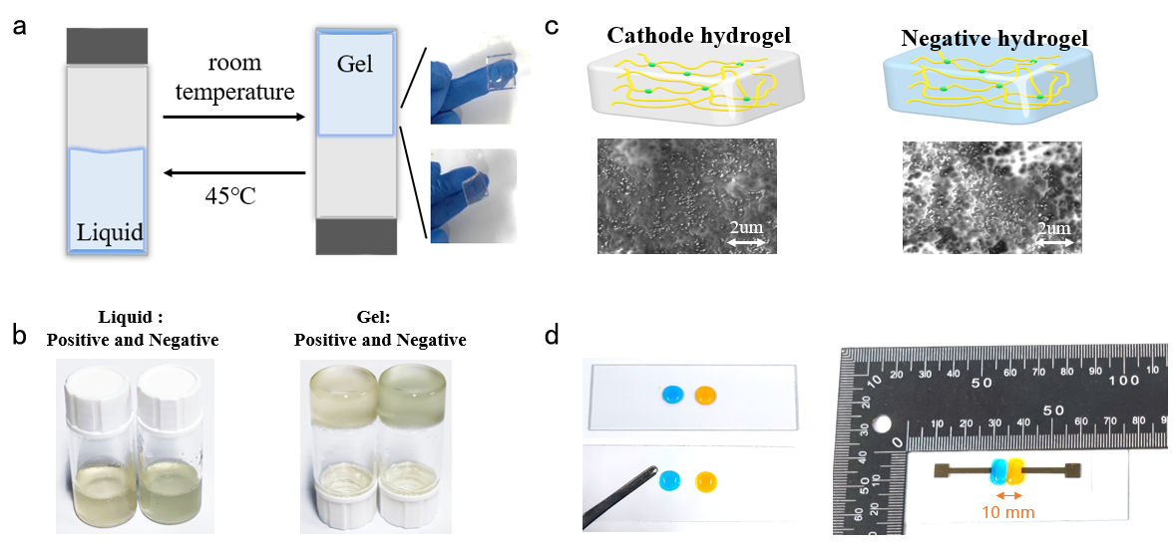
Supplementary Fig. 3| Micro power for flexibility and photos. a-b, Flexible droplet ink can achieve reversible conversion of hydrogel and droplet between room temperature to 45℃. c, SEM drying images of positive and negative hydrogel films. d, Micropower source prepared by p-gel droplets (blue) and n-gel droplets (orange). The hydrogel materials dyed with food coloring are only used for conceptual photography and non-testing purposes.

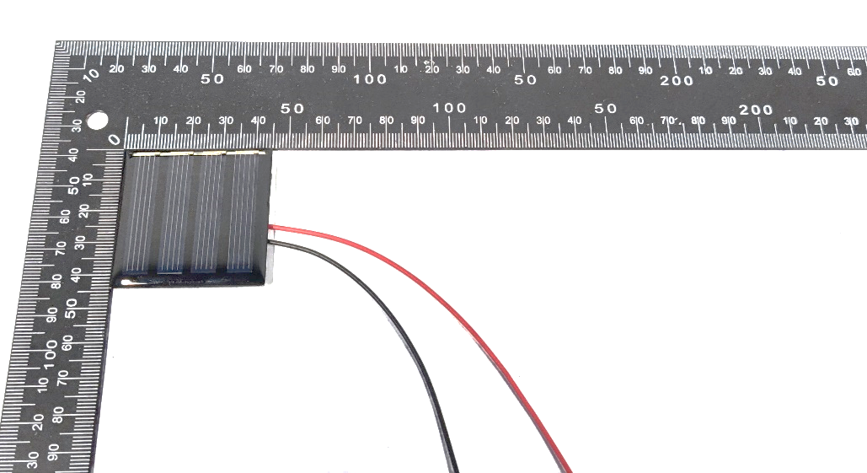
Supplementary Fig. 4| Commercial Si-based photovoltaics for testing (Tao Time Club, Polycrystalline, 4 cells connected in series).

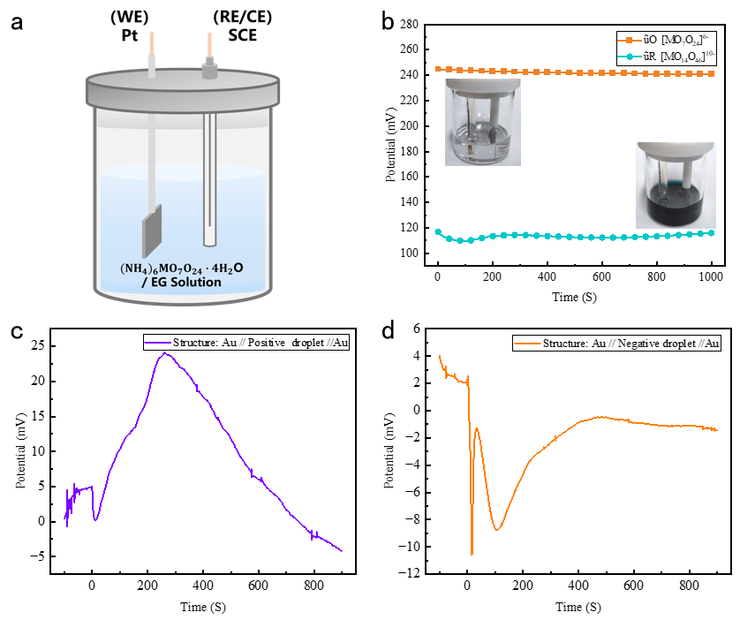
Supplementary Fig. 5| Practical measurement of REDOX contribution to potential. a, Measurement method and device diagram. b, Potential contribution of a REDOX pair. Inset: measurement photograph. c-d, Gelatin matrix contribution in positive (c) and negative droplets (d) with at 0 s start photoexcitation.

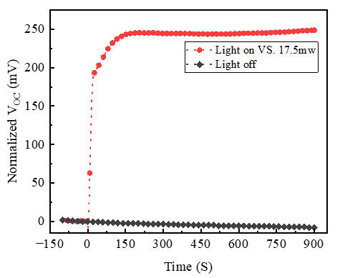
Supplementary Fig. 6| Comparison of open circuit potential with dark state of micro power supply under continuous illumination.

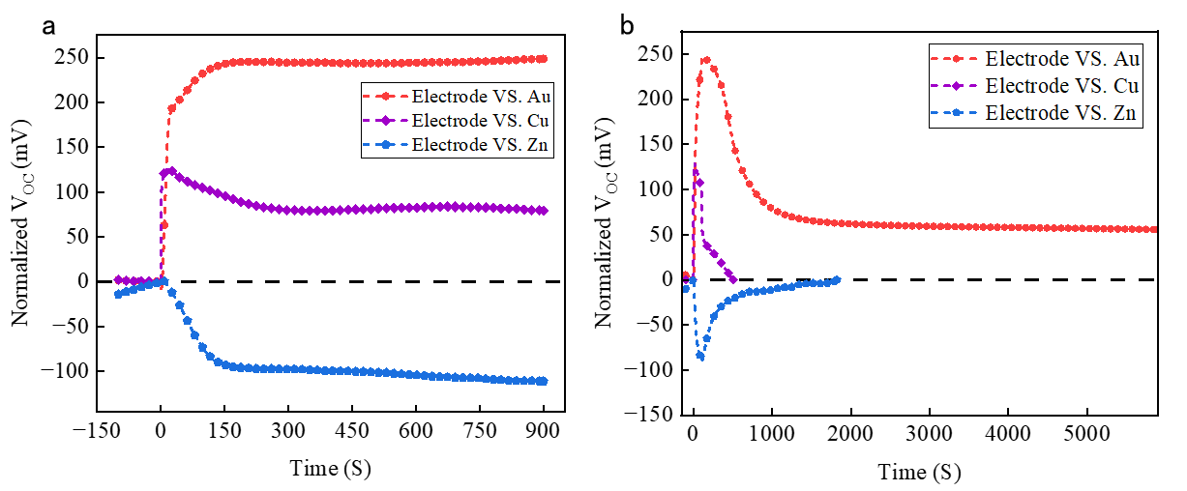
VS. 100S
Supplementary Fig. 7 | Output characteristics using different electrodes. a, V_{OC} Properties of different electrodes under continuous light excitation. b, Attenuation characteristics of different electrodes after 100S of light excitation.
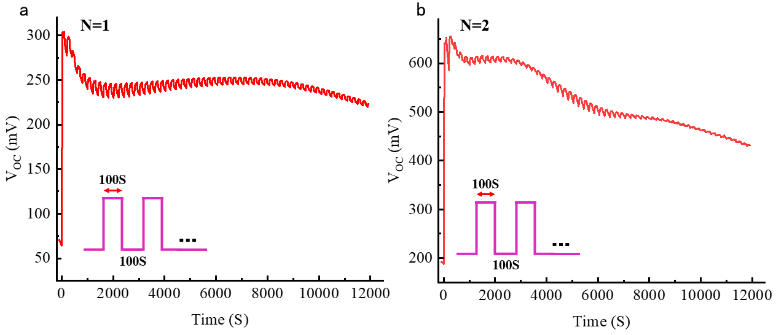
c d
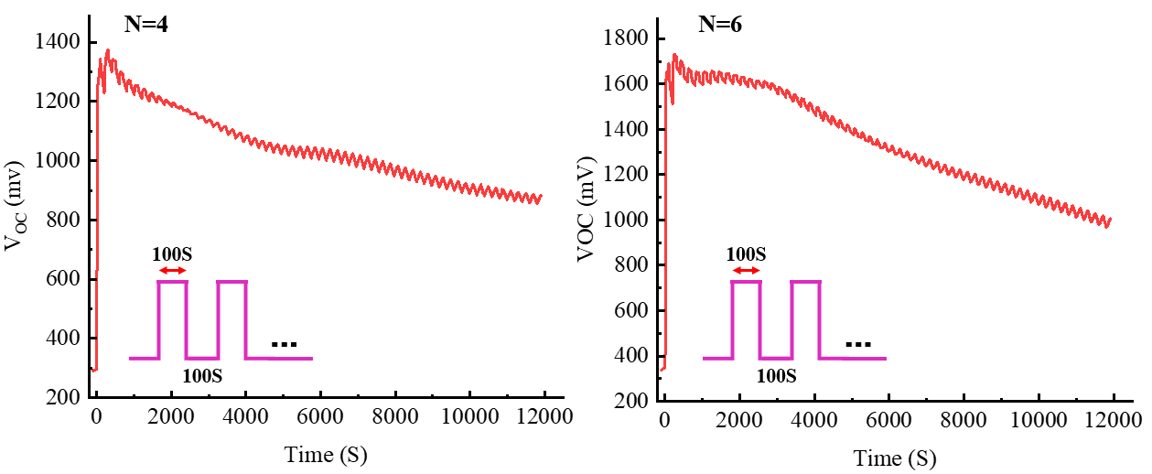
Supplementary Fig. 8 | Micro power output characteristics of T=200S, cell number of N=1 show in (a), N=2show in (b), N=4 show in (c) and N=6 show in (d).

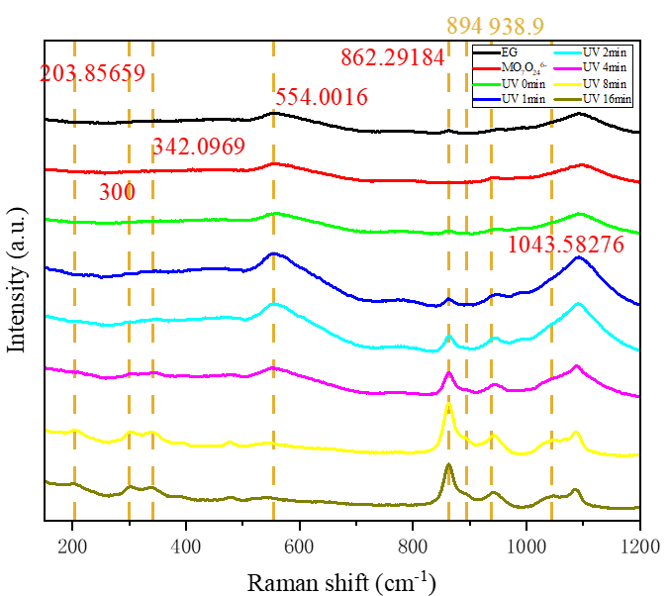
Supplementary Fig. 9 | The Raman spectra of negative droplets demonstrate the photochemical process.

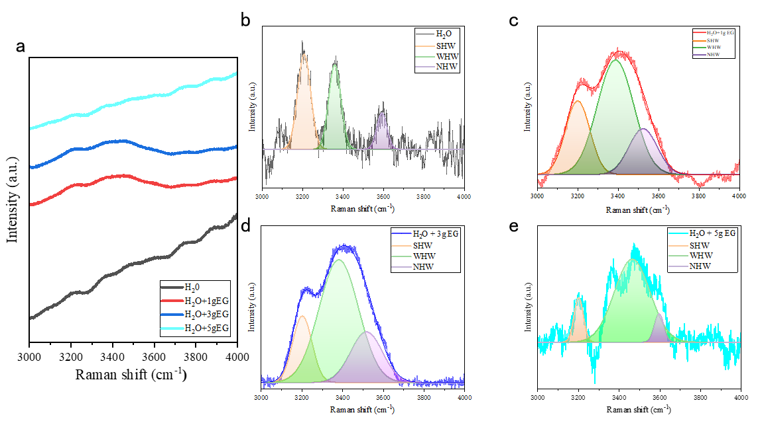
Supplementary Fig. 10 | a, The influence of different amounts of EG on the hydrogen bond of water molecules. b-e, show the normalized graph of each ratio.

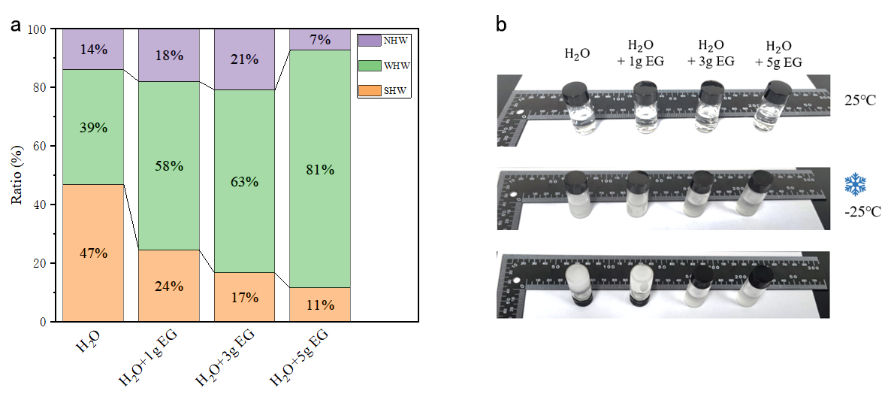
Supplementary Fig. 11 | a, Statistics of various hydrogen bonds of water molecules. b, Physical picture of resistance to freezing at low temperature.
Supplementary Fig. 12 | Our work is compared with the properties of existing ion power supplies.

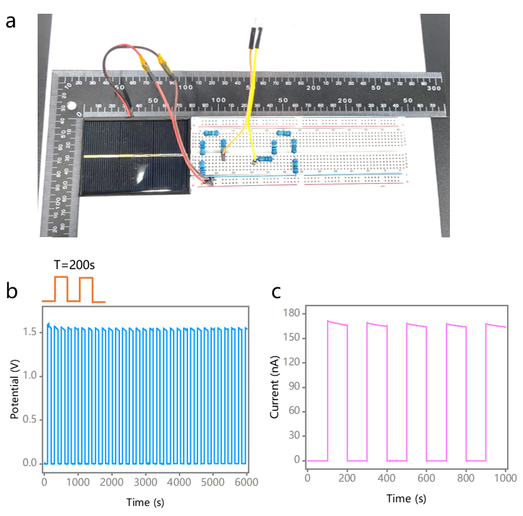
Supplementary Fig. 13 | a, Photo of a commercial photovoltaic device for cell stimulation experiments. b-c, Voltage output and current output of the device under periodic light field (T=200 s) show in (b) and (c).

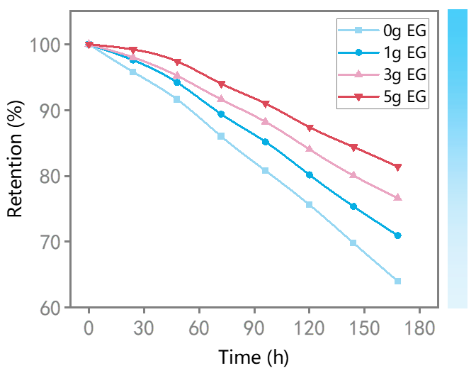
Supplementary Fig. 14 | The water retention rate of hydrogel under adding the different mass EG.

Supplementary Note 3. Definition of output lifetimes and comparison calculation with commercial solar cell
Supplementary Fig. 15 | After light off, analysis of experimental results and model fitting results. Number of N=1, 2, 4, 6, as show in a-d. Fitting model: $V\left(t\right)=(V_{0}-a_{1}){×e}^{(-\frac{t}{c_{1}})}{ + a_{1}×e}^{(-{\left(\frac{t}{c_{2}}\right)}^{2})}$, where are respectively represented ion diffusion action and PR action. We defined the PR contribution index of $a_{1}$, ion lifetime of $c_{1}$ and half wave width in Gaussian model: $2\sqrt{\ln\left(2\right)} ×c_{2}$represents PR change extent.

Table. 1: The parameters fitting results.

 | $V_{0}$/mV | $a_{1}$/mV | $c_{1}$/s | $c_{2}$/s
N=1 | 253.10 | 170.20 | 11550 | 482.60
N=2 | 537.14 | 316.50 | 3134.0 | 402.40
N=4 | 955.48 | 445.10 | 4404.0 | 622.10
N=6 | 1433.2 | 611.20 | 3801.0 | 373.90

a b
Supplementary Fig. 16 | a, Comparison of open circuit potential output (V_{OC}) between our micropower and traditional silicon-based solar cells (Tao Time Club, Polycrystalline). b, After the light off, analysis of experimental results and model fitting results Vs. Si solar cell. Fitting model: $V\left(t\right)=A_{1}{×e}^{(-\frac{t}{t_{1}})}$, where $t_{1}$are described the carrier lifetime.

Table. 2: The parameters fitting results.

 | $A_{1}$/mV | $t_{1}$/s
Si solar cell | 521.28 | 0.06

According to Supplementary Fig15 and Fig.16, the output lifetime of PI-HPS can be described as
${lifetime}_{PI-HPS}$=$c_{1}+2\sqrt{\ln\left(2\right)} ×c_{2}$ （28）
Where the ion lifetime of $c_{1}$ and half wave width in Gaussian model: $2\sqrt{\ln\left(2\right)} ×c_{2}$represents PR change extent.
The commercial solar cell output lifetime is described using the $t_{1}$, the time required potential to decay to 1/e of the starting value. So, we can calculate the output lifetime multiple:
n=$\frac{c_{1}+2\sqrt{\ln\left(2\right)} ×c_{2} }{t_{1}}$ (29)

Reference
- Toshihiro, Y. Photo- and Electrochromism of Polyoxometalates and Related Materials. Chem. Rev. 98, 307−325 (1998).
- Wang, Y. et al. Programmable photo-responsive self-healing hydrogels for optical information coding and encryption. European Polymer Journal 166 (2022).
- Guan, L. et al. Highly transparent and stretchable hydrogels with rapidly responsive photochromic performance for UV-irradiated optical display devices. Reactive and Functional Polymers 138, 88-95 (2019).
- Wang, J. et al. Ultrasoft gelatin aerogels for oil contaminant removal. Journal of Materials Chemistry A 4, 9381-9389 (2016).
- Jiang, J. et al. A multifunctional gelatin-based aerogel with superior pollutants adsorption, oil/water separation and photocatalytic properties. Chemical Engineering Journal 358, 1539-1551 (2019).
- Rizwan, K. et al. Recent advancements in engineered biopolymeric-nanohybrids: A greener approach for adsorptive-remediation of noxious metals from aqueous matrices. Environmental Research 215 (2022).
- He, Z. & Yuan, W. Adhesive, Stretchable, and Transparent Organohydrogels for Antifreezing, Antidrying, and Sensitive Ionic Skins. ACS Applied Materials & Interfaces 13, 1474-1485 (2021).
- Cheng, G. H. et al. Giant thermopower of ionic gelatin near room temperature. Science 368 (2020).
- P. Debye, E. Hückel, The theory of electrolytes. I. Lowering of freezing point and related phenomena. Physikalische Zeitschrift 24, 185-206 (1923).
- Xu, J., Sigworth, F. J. & LaVan, D. A. Synthetic protocells to mimic and test cell function. Adv. Mater. 22, 120-127 (2010).
- Schroeder, T. B. H. et al. An electric-eel-inspired soft power source from stacked hydrogels. Nature 552, 214-218 (2017).
- Kapat, K. et al. Piezoelectric Nano‐Biomaterials for Biomedicine and Tissue Regeneration. Advanced Functional Materials 30 (2020).
- Li, L. et al. Design and Applications of Photoresponsive Hydrogels. Advanced Materials 31 (2019).
- Zhang, X. et al. Biomedical Applications of Electrets: Recent Advance and Future Perspectives. Journal of Functional Biomaterials 14 (2023).
- Song, E. et al. Materials for flexible bioelectronic systems as chronic neural interfaces. Nature Materials 19, 590-603 (2020).

