Supplementary
Table S1 Selected shade tree species in the phenological trait groups of EV: evergreen, BD: brevi-deciduous and D: deciduous. The phenological differences are hypothesized to result in different root and water use characteristics. The selection also considered the canopy position (height) of shade trees in a multi-strata cocoa agroforestry system (LC= Lower canopy trees i.e. not more than 10 m height and UC= upper canopy or emergent trees)

Scientific name | Family name | Functional group
- Ricinodendron heudelotii | Euphorbiaceae | CD_DD
- Milicia excelsa | Moraceae | BD_DD
- Ficus capensis | Moraceae | BD_BD
- Spathodea campanulata | Bignoniaceae | BD_AD
- Sterculia tragacantha | Sterculiaceae | CD_DD
- Perseas americana | Fabaceae | EV_LC
- Albizia ferruginea | Fabaceae | CD_DD
- Antiaris toxicaria | Moraceae | BD_DD
- Terminalia superba | Combretaceae | BD_DD
- Terminalia ivorensis | Combretaceae | BD_AD
- Alstonia boonei | Apocynaceae | EV_UC
- Morinda lucida | Rubiaceae | EV_LC
- Pycnanthus angolensis | Myristicaceae | EV_UC

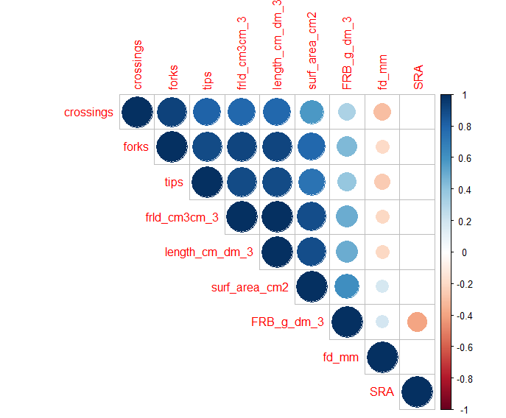
Figure S1 Correlation among fine root traits with fine root length density (FRLD) significantly correlated with other traits (total root length, surface area, biomass) estimated from WinRhizo analysis

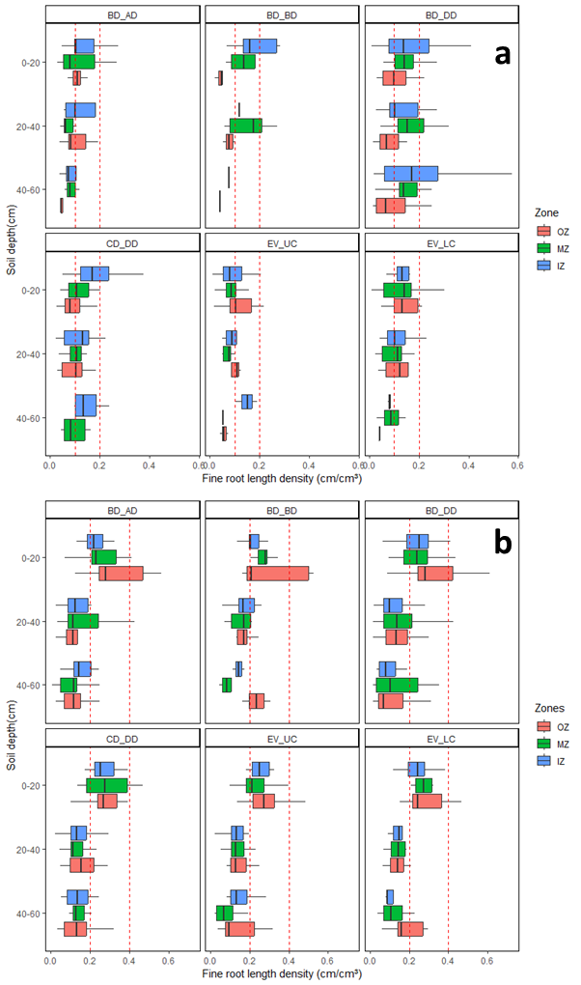
Figure S2. Vertical and horizontal fine root length density distribution of shade trees (a) and cocoa plants (b) tree roots distributions among functional groups

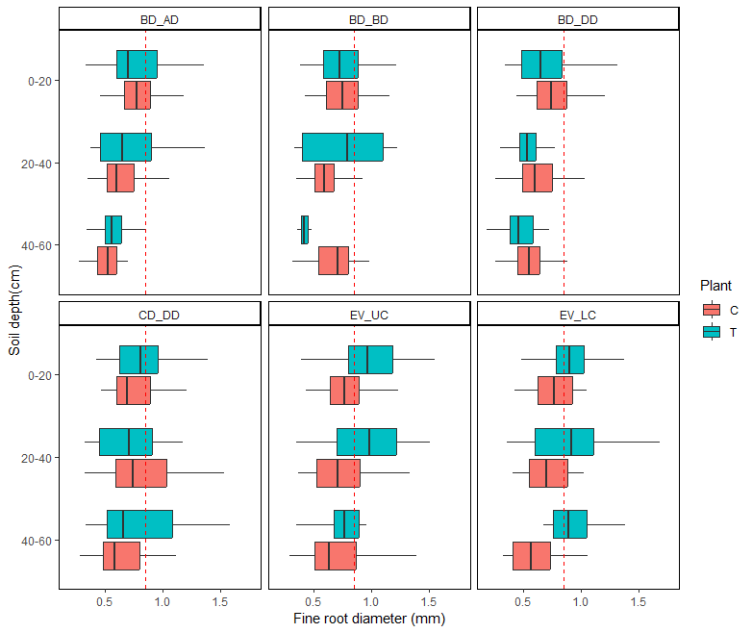
Figure S3. Vertical distribution of shade (T) and cocoa (C) tree fine roots diameter distributions among functional groups

