Supplementary information

Water-Limited Serpentinization Drives Low-Temperature Abiotic Hydrocarbons Production in Ultramafic Environments

Hugo Dutoit^{1,*}, Laurent Truche^{1,*}, Frédéric Victor Donzé¹, Christophe Monnin²

¹ ISTerre, USMB, UGE, CNRS, IRD, Université Grenoble Alpes, Grenoble, France
² GET, CNRS, IRD, UPS, CNES, Toulouse University, Toulouse, France
* Corresponding authors: hugo.dutoit@univ-grenoble-alpes.fr, laurent.truche@univ-grenoble-alpes.fr

Included in this document:
- 1 (one) Supplementary text (206 words);
- 1 (one) Method (1335 words);
- 1 (one) Supplementary references;
- 12 (twelve) Display elements (6 figures and 6 tables)

Mechanisms of Fischer Tropsch reactions
The Sabatier reaction is one of many Fischer-Tropsch-type (FTT) reactions, and several other transformations can occur in these processes. Fischer Tropsch synthesis involves surface polymerization, where reactants (hydrogen and a carbon source) are adsorbed onto a catalyst surface, forming monomer units —typically methylene groups (-[CH₂]-)— which then polymerize. This process leads to the formation of various hydrocarbons, such as alkanes (nCO + (2n + 1)H₂ → H(CH₂)nH + nH₂O), alkenes (nCO + 2nH₂ → (CH₂)_{n} + nH₂O), alcohols (nCO + 2nH₂ → H(CH₂)nOH + (n-1)H₂O), carbonyls (nCO + (2n – 1)H₂ → (CH₂)nO + (n – 1)H₂O), or even graphite through the Boudouard reaction (2 CO ↔ CO₂ + C). The main polymerization mechanisms proposed—such as the carbide mechanism, CO insertion, and hydroxycarbene mechanism—operate through the triad: initiation, propagation, and chain termination and differ in how they generate the monomer units and in the surface reaction pathways conducing to hydrocarbons. While a detailed exploration of these mechanisms is beyond the scope of this study, comprehensive discussions can be found in Rommens and Saeys (2023), Mahmoudi et al. (2017), Krylova (2014), and Rofer-DePoorter (1981). It is important to note that according to these mechanisms, methane may act as an intermediate in the formation of longer carbon-chain molecules.

Material and Methods

Reactor design

Batch reactors (Parr®) made of stainless steel 316L were used for all the experiments. A preliminary blank experiment (see below) confirmed that the reactor material does not catalyze the reaction. The reactors have an internal volume of 300 mL and are equipped with pressure and temperature sensors and connectors fitted with two valves. One valve is terminated by a septum to enable periodic on-line sampling of reaction gas to monitor reaction progress. In the few cases where water was added to the reactor, sampling was carried out using a 15 mL transfer syringe directly connected at the reactor valve. The body and head of the reactors were sealed by Teflon® gaskets. The reactors were carefully cleaned prior any use.

Blank experiments
A blank experiment was conducted at 250°C in stainless steel batch reactors without rock samples, using only H₂ and CO₂ (2 bar of each gas). This initial control was essential to verify that the reactor did not catalyze the reaction. After one month, the pressure remains unchanged, no formation of CH₄ or CO was observed, and the concentrations of the reactants remained also unchanged. Subsequently, experiments were conducted with rock samples, but using only one reactant at a time (either only CO₂, or only H₂). Similar to the initial control, no decrease in the reactant concentration was observed and no products were formed except for the Bulqizë harzburgite that returned small amounts of CH₄ when exposed to H₂.

Sample Characterization

We used samples of chromitites from Chamrousse ophiolite (French Alps) and fresh samples of chromitite and harzburgite from the deep underground chromite mine of Bulqizë in Albania. The modal mineralogical composition of these samples was deduced by using X-ray diffraction (see Supplementary Table S1). Both chromitites have respectively a Cr-spinel content of 58.5 ± 0.7 wt% and 55.3 ± 0.5 wt%; however, Bulqizë chromite is richer in Mg than the Chamrousse chromite. They differ in the rest of their composition with 4.6 ± 0.3 wt% magnetite, 12.3 ± 0.41 wt% lizardite, 9.2 ± 0.3 wt% chrysotile, 11.2 ± 0.30 wt% forsterite, 7 ± 0.2 wt% brucite, and < 1 wt% of quartz for the Bulqizë chromitite and 9.1 ± 0.4 wt% lizardite, 31.6 ± 0.8 wt% saponite, and < 1 wt% of quartz for Chamrousse chromitite. The harzburgite is poor in chromite (2.3 ± 0.1 wt%) and is mostly composed of forsterite (76.4 ± 0.3 wt%) and enstatite (12.7 ± 0.2 wt%) with minor chrysotile (2.7 ± 0.2 wt%), augite (3.4 ± 0.16 wt%), talc (1.6 ± 0.11 wt%), and < 1 wt% quartz and brucite.

Experimental Procedure

Samples were manually ground and sieved in order to obtain at least 290 to 360 g of crushed rock, 40% of which was between 315 and 100 µm and 60% between 1 mm and 315 µm. We further sonicated the grains in Milli-Q® water to remove fine particles and dried them in a glove box under Ar atmosphere (O₂ < 1 ppm) at room temperature. The reactors were filled with ~300 g of the sieved samples. Prior to heating, the reactors were flushed four to five times with 40 bars of Ar, which also enables checking for any leakage of the experimental set-up. Then, the reactors were heated at 200°C with 5 bars of Ar until they reached the desired temperature. To ensure that samples are outgassed and water-free, we applied a primary vacuum overnight at 200°C inside the reactor. Finally, we added 2 bars of CO₂ and 2 bars of H₂. For some experiments, 20 mL of degassed Milli-Q® water (conductivity 18.2 M Ω.cm) was added over the course of the reaction. Water was introduced by mean of a pressurized (with 50 bars of Ar) Swagelok® cylinder (40 mL total volume).

Reacted samples were stored in an Ar glove box immediately after quenching the experiments. Prior to opening the reactor, the volume of the headspace was estimated by injecting a known volume (V_{cylindre}) and pressure (P_{cylindre}) of helium into the reactor via a Swagelok stainless steel cylinder. The resulting pressure (P_{reactor}) enables the calculation of the volume of the headspace (V_{reactor}) as follows:

$$\begin{aligned}V_{reactor}=\frac{P_{cylinder}×V_{cylinder}}{P_{reactor}}-V_{cylinder} \#\left(4\right)\end{aligned}$$

The amount of CO₂ and H₂ consumed and the amount of CH₄ and CO produced are calculated at each time step according to the ideal gas law, knowing the partial pressure of each gas (see gas analysis below), the headspace volume of the reactor and the temperature. The carbon mass balance is then calculated, assuming CH₄ and CO as the only products. Consequently, the carbon (atomic C) selectivity (Y_{C(CH4+CO)}) represents the proportion of carbon from CO₂ that contributes to the formation of both methane and carbon monoxide (Eq. 5). Similarly, the hydrogen (atomic H) selectivity (Y_{H(CH4)}) is calculated by considering CH₄ as the sole product of H₂ consumption (Eq. 6):

$$\begin{aligned}Y_{C\left({CH}_{4}+CO\right)}=\frac{{CH}_{4\left(prod.\right)}+ {CO}_{\left(prod.\right)}}{{CO}_{2\left(cons.\right)}}×100\#(5)\end{aligned}$$

$$\begin{aligned}Y_{{H(CH}_{4})}=\frac{{CH}_{4\left(prod.\right)}}{2 H_{2\left(prod.\right)}}×100\#(6)\end{aligned}$$

Gas analysis

Headspace was sampled with a gas-tight syringe directly at the reactor output valve through a septum, and 175 µL of the gas was injected and analyzed using a Perkin Elmer® CLARUS 500 Gas Chromatograph (GC) equipped with a thermal conductivity detector (TCD) calibrated for He, H₂, O₂, N₂, CO, CH₄ and CO₂. The GC is equipped with a 2-meter-long column (RESTEK® Shin Carbon ST 80/100) through which argon served as the carrier gas. Because of the vapor pressure, experiments with water were sampled using an intermediate syringe fitted with a 3-way valve, with one way closed by a septum. About 2 mL of gas was sampled from the reactor. The intermediate syringe allows for water vapor to condensate. A gas-tight syringe is further used to transfer 175 µL of gas from the 3-way valve syringe to the GC. During all the experiments, pressure was monitored using a Keller® numerical pressure sensor.

At the completion of the experiments, a quick scan of the headspace was performed using a quadrupole mass spectrometer (QMS) miniRUEDI (Gasometrix®) from m/z ratio of 1 to 85. The QMS is equipped with both a Faraday cup (F detector) and an electron multiplier detector (M detector), has a detection limit in the parts per million by volume (ppmv) range, and requires very low gas flux (approximately 6 mL/hour for the miniRUEDI). As the species of interest were expected to be present in low amounts, we only used the M detector with an integration time of 12 seconds per [m/z] ratio.

Petrographic and mineralogical analysis

SEM-EDS. Representative grains were selected before and after the reaction and a detailed petrographic study was carried out using a Tescan Vega 3® scanning electron microscope (SEM) equipped with an energy dispersive X-ray spectrometer (EDS) for morphological, textural and semi-quantitative chemical analysis. The grains were gold film coated and examined in both secondary and backscattered electron modes. The accelerating voltage was set between 14 and 18 kV depending on the sample to get the best contrast and resolution. EDS analyses acquisition time was adjusted for every analysis in order to get a good statistic (at least 300 000 photons in total).

XRD. Rock samples were characterized by X-ray diffraction, before and after reaction, using a Bruker® D8 diffractometer using Co Ka radiation (λ = 1.78901 Å) generated at 40 kV and 40 mA. Diffractograms were collected from 10–90° 2θ.

BET. The specific areas of the rock powders were obtained using the BET method on a Belsorp-Max® apparatus using nitrogen as the adsorbent for Chamrousse and Bulqizë chromitites and krypton for the Bulqizë harzburgite, because of the low specific surface area of this latter sample.

Raman. Raman spectra were acquired on the reacted samples with a LABRAM Soleil from Horiba® and a 532 nm DPSS laser operating at 0.63 mW to avoid damaging graphite and minimize fluorescence. The laser beam was focused using an Olympus x100 objective and a 500 µm diameter for the confocal aperture resulting in a probe spot of ~1 µm. The grating (1800 grooves per nm), focal distance (800 mm) and the slit width (100 µm) of the spectrometer give a spectral resolution of 0.5 cm⁻¹. High-quality spectra were obtained with an acquisition time of 60 s per spectral window and 5 accumulations. The Raman spectra were processed using the Labspec software.

Supplementary references
Krylova, A. Y. (2014). Products of the Fischer-Tropsch synthesis (a review). Solid Fuel Chemistry, 48, 22-35, https://doi.org/10.3103/S0361521914010030
Mahmoudi, H., Mahmoudi, M., Doustdar, O., Jahangiri, H., Tsolakis, A., Gu, S., & LechWyszynski, M. (2017). A review of Fischer Tropsch synthesis process, mechanism, surface chemistry and catalyst formulation. Biofuels Engineering, 2(1), 11-31, https://doi.org/10.1515/bfuel-2017-0002
Rofer-DePoorter, C. K. (1981). A comprehensive mechanism for the Fischer-Tropsch synthesis. Chemical Reviews, 81(5), 447-474.
Rommens, K. T., & Saeys, M. (2023). Molecular views on Fischer–Tropsch synthesis. Chemical Reviews, 123(9), 5798-5858, https://doi.org/10.1021/acs.chemrev.2c00508

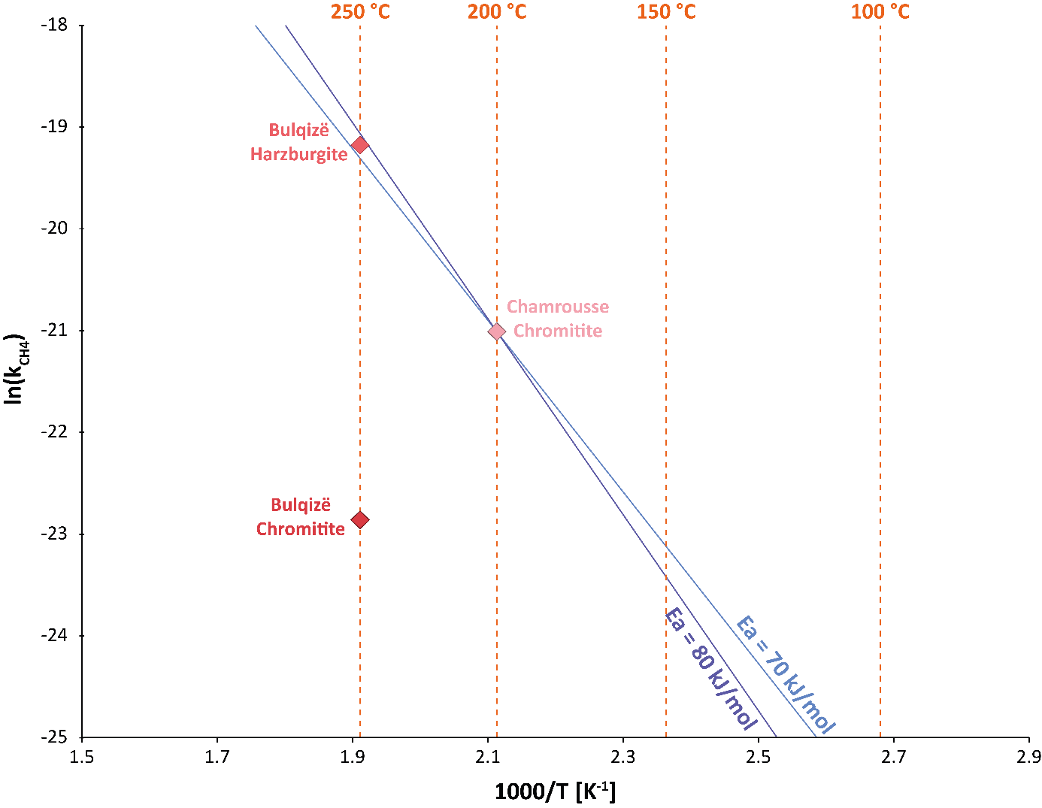
Supplementary Figure S1 : Arrhenius plot of the inverse of reaction temperature (1000/T with T in Kelvin) against the natural logarithm of CH₄ production rate (with k, the zero-order reaction rate in mol/m²/h) for the three experiments carried out in this study. The two lines show the production rate of CH₄ as a function of temperature with the Chamrousse chromitite acting as a catalyst, using our measurement at 200°C as a pivotal reference and relevant activation energies (Ea) for FTT reactions of either 80 and 70 kJ/mol.
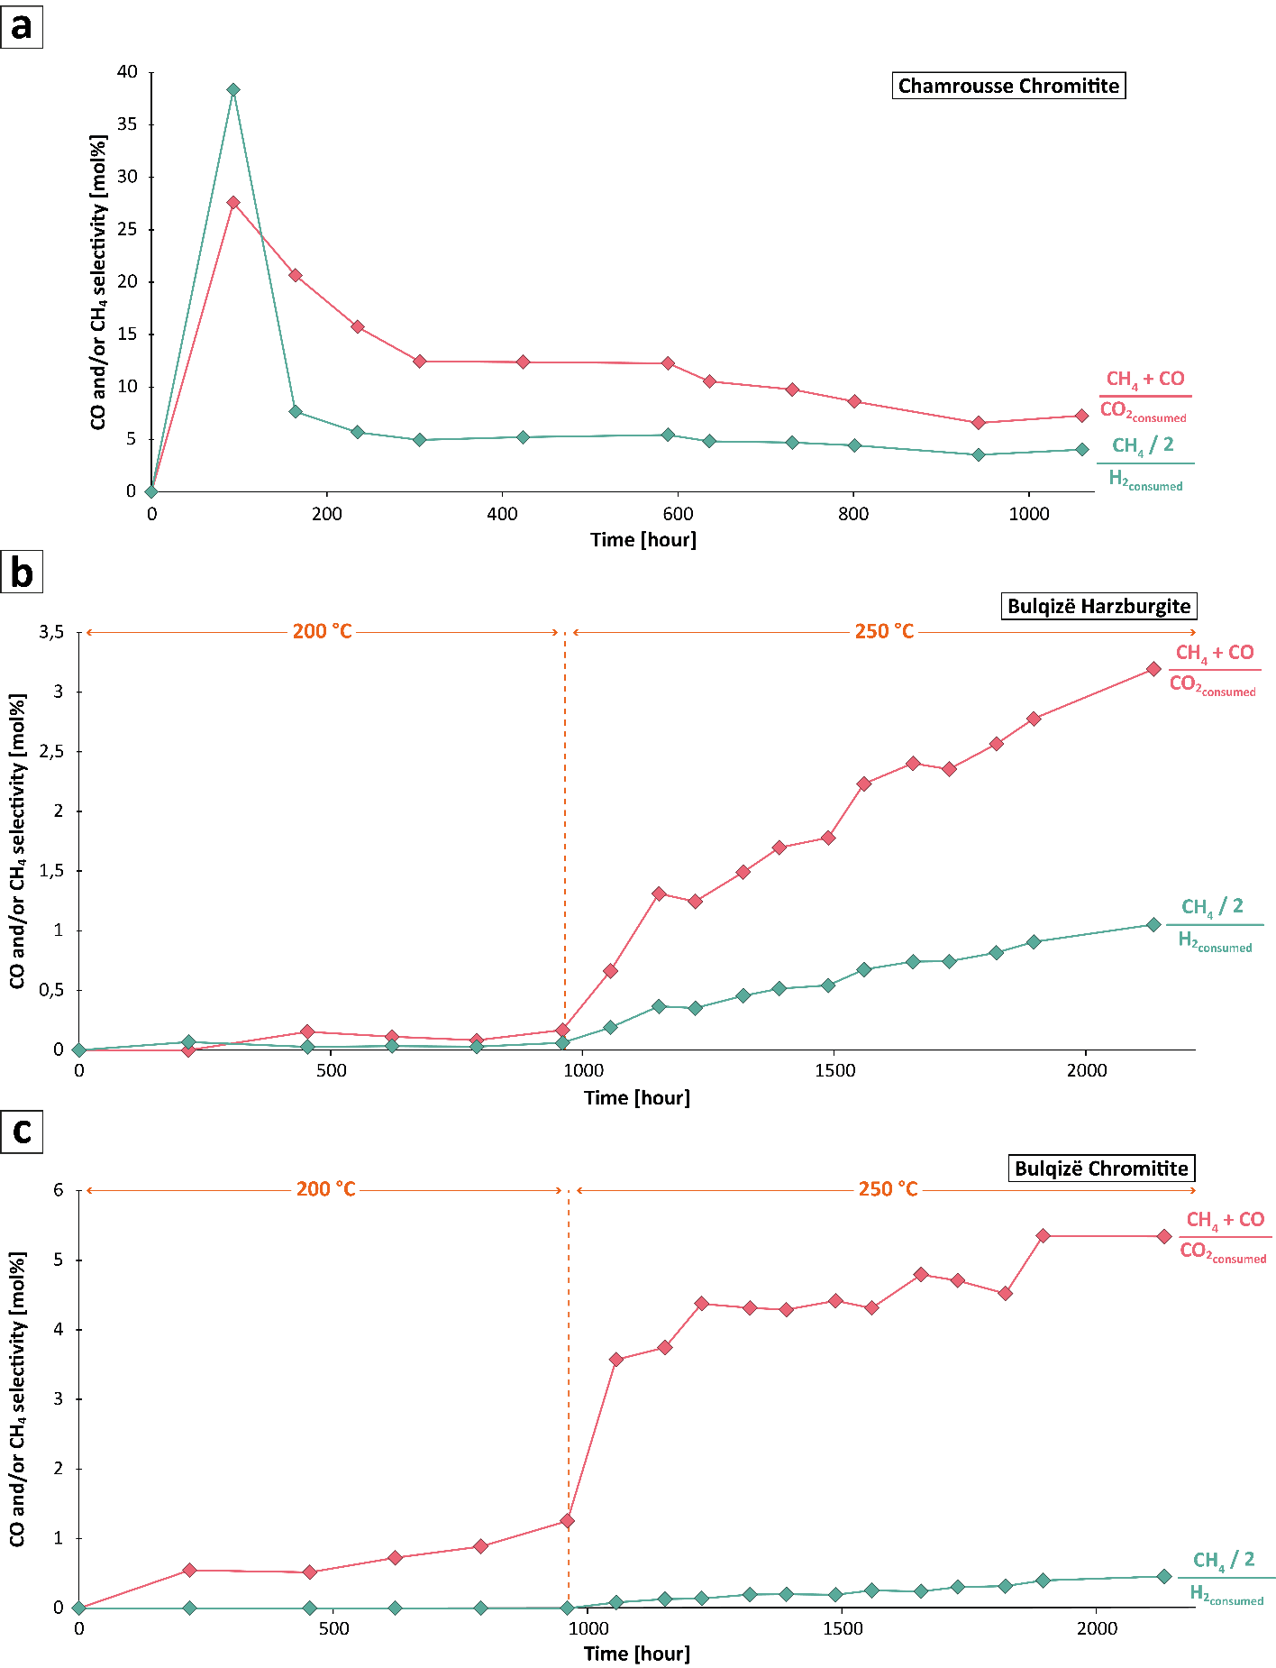
Supplementary Figure S2 : CH₄ and CO selectivity over time for (a) Chamrousse chromitite, (b) the Bulqizë harzburgite, and (c) the Bulqizë chromitite experiments (calculated according to Equation 5 and 6, see Methods).
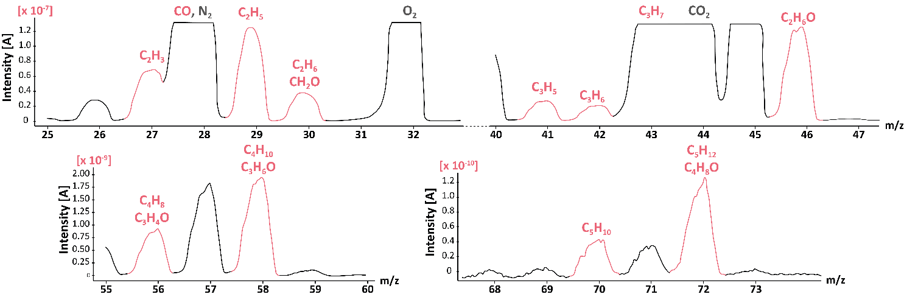

Supplementary Figure S3 : QMS scan of headspace gas at the completion of the Chamrousse chromitite experiment from m/z ratio 25 to 73 (see Methods). Several gaseous hydrocarbons compounds highlighted in red can be identified. The presence of O₂ and N₂ is due to the introduction of a small amount of air during gas transfer.

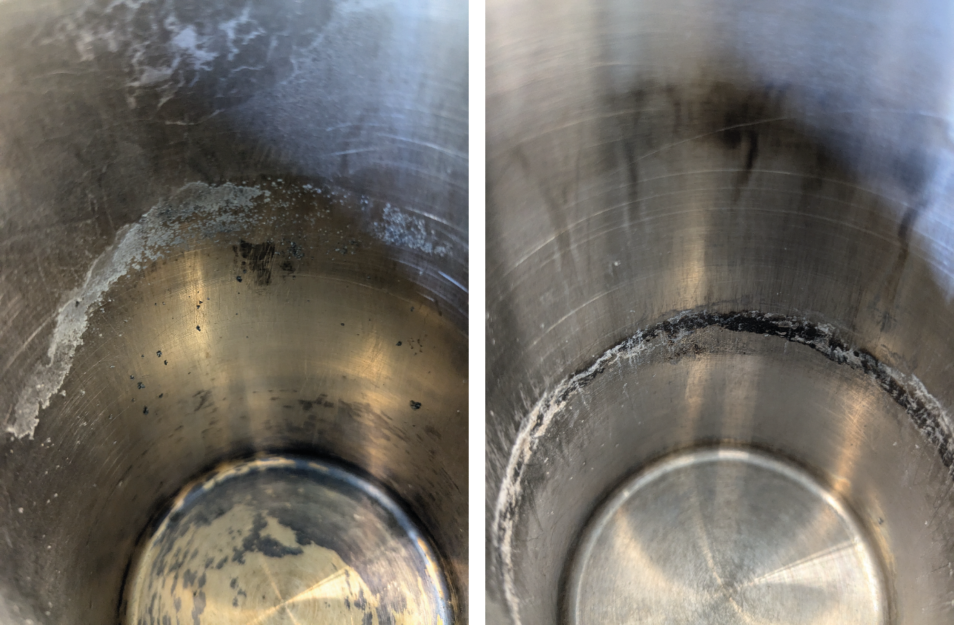
Supplementary Figure S4 : Photos of the reactor vessel after the reaction with Bulqizë harzburgite (left panel) and Bulqizë chromitite (right panel). Black and white grains are glued to the walls and a thick ring of black matter appeared at the height of rock samples.

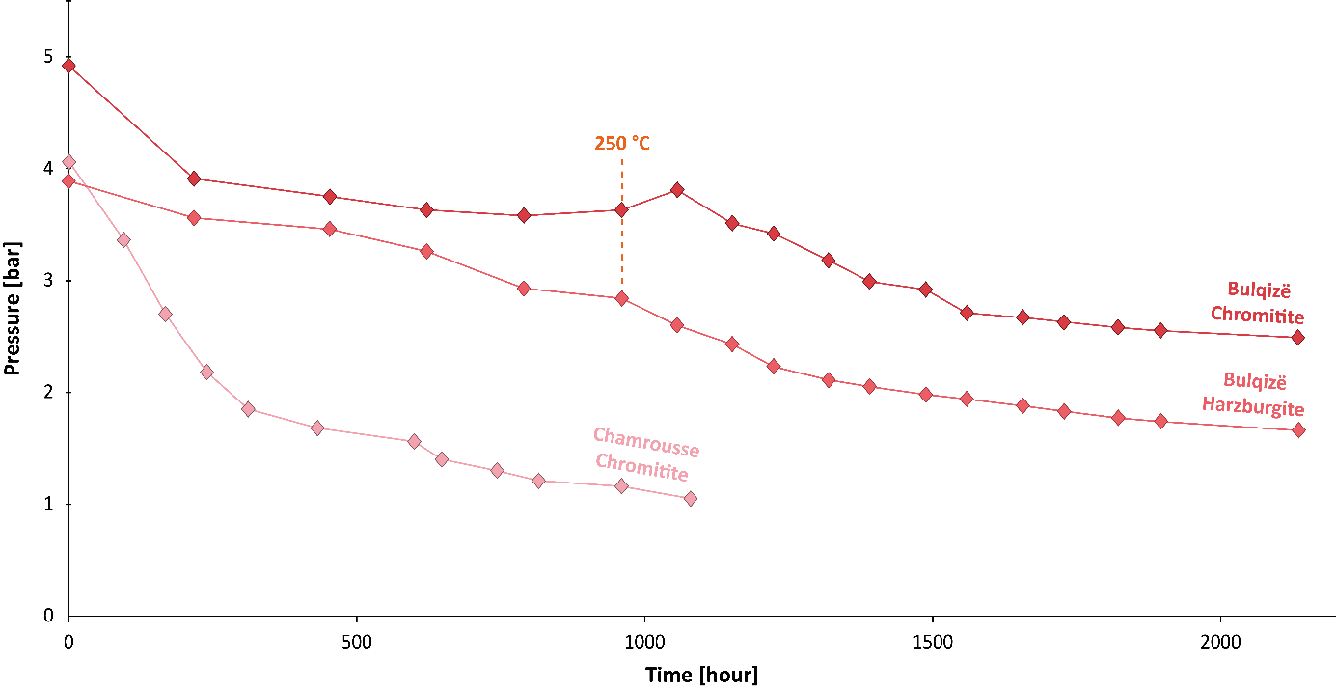
Supplementary Figure S5 : Pressure loss over time of the three experiments (Bulqizë chromitite, harzburgite and Chamrousse chromitite).

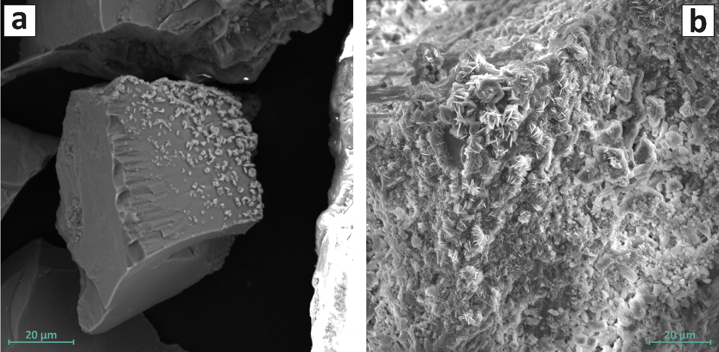
Supplementary Figure S6 : SEM images (secondary electron mode) of secondary formation of serpentine at the surface of (a) a chromite grain from the Bulqizë chromitite and (b) a olivine grain from the Bulqizë harzburgite after their reaction with H₂ and CO₂ at 200-250 °C. As the total pressure was always below the vapor saturation pressure, these observations imply that serpentine may form in the presence of water vapor.

 | Bulqizë Harzburgite | Bulqizë Chromitite | Chamrousse Chromitite
Forsterite | 76.4 | 11.2 | 0
Enstatite | 12.7 | 0 | 0
Augite | 3.4 | 0 | 0
Chromite | 2.3 | 55.3 | 58.5
Lizardite | 0 | 12.3 | 9.1
Chrysotile | 2.7 | 9.2 | 0
Saponite | 0 | 0 | 31.6
Talc | 1.6 | 0 | 0
Brucite | 0.4 | 7.0 | 0
Magnetite | 0 | 4.6 | 0
Quartz | 0.6 | 0.6 | 0.83
Mg# chromite  100×(Mg/(Mg+Fe²⁺)) | 46 | 69 | 50
Cr# chromite  100×(Cr/(Cr+Al+Fe³⁺)) | 74 | 79 | 75
Supplementary Table S1 : Modal mineralogical composition (wt%) of Bulqizë and Chamrousse rock samples as deduced from X-Ray diffraction analysis. Mg# and Cr# refer to the relative abundance of Mg to Fe²⁺, or Cr to Al³⁺ and Fe³⁺ in chromite, as deduced from microprobe analysis. Mg# and Cr# from Bulqizë samples are from Xiong et al., 2015.

Δt | P | H₂ | CO | CH₄ | CO₂ | Y_{C(CH4+CO)} | Y_{H(CH4)}
hour | bar | µmol/m² |  |  |  | mol%
0 | 2.13 | 2.91 | 0.00 | 0.00 | 4.57 | 0.00 | 0.00
96 | 3.36 | 2.80 | 0.22 | 0.08 | 3.48 | 27.60 | 38.38
168 | 2.70 | 2.08 | 0.21 | 0.13 | 2.94 | 20.67 | 7.67
240 | 2.18 | 1.55 | 0.17 | 0.15 | 2.48 | 15.75 | 5.70
312 | 1.85 | 1.22 | 0.13 | 0.17 | 2.14 | 12.46 | 4.98
432 | 1.68 | 0.99 | 0.11 | 0.20 | 2.03 | 12.40 | 5.24
600 | 1.56 | 0.75 | 0.11 | 0.23 | 1.76 | 12.28 | 5.45
648 | 1.40 | 0.63 | 0.10 | 0.22 | 1.57 | 10.55 | 4.84
744 | 1.30 | 0.53 | 0.08 | 0.22 | 1.45 | 9.77 | 4.72
816 | 1.21 | 0.46 | 0.06 | 0.22 | 1.36 | 8.64 | 4.45
960 | 1.16 | 0.30 | 0.04 | 0.19 | 1.11 | 6.59 | 3.55
1080 | 1.05 | 0.29 | 0.03 | 0.21 | 1.18 | 7.28 | 4.05
Supplementary Table S2 : Measured amounts of H₂, CO₂, CO and CH₄ (expressed in µmol/m²) over time for the reaction with the Chamrousse chromitite at 200°C. Selectivities (noted YC and YH) with respect to C- (CH₄ and CO) and H-bearing (CH₄) products are also provided. Selectivities are calculated according to Equation 5 and 6.

Δt | P | H₂ | CO | CH₄ [x10] | CO₂ | Y_{C(CH4+CO)} | Y_{H(CH4)}
hour | bar | µmol/m² |  |  |  | mol%
0 | 4.92 | 25.87 | 0.00 | 0.00 | 39.36 | 0.00 | 0.00
217.5 | 3.91 | 23.64 | 0.05 | 0.00 | 29.64 | 0.55 | 0.00
453.8 | 3.75 | 21.12 | 0.07 | 0.00 | 26.18 | 0.51 | 0.00
621.8 | 3.63 | 20.23 | 0.10 | 0.00 | 25.36 | 0.72 | 0.00
790.3 | 3.58 | 20.05 | 0.13 | 0.00 | 25.18 | 0.89 | 0.00
960.3 | 3.63 | 19.27 | 0.18 | 0.00 | 24.93 | 1.25 | 0.00
1056.3 | 3.81 | 19.05 | 0.48 | 0.11 | 25.73 | 3.57 | 0.08
1152.3 | 3.51 | 18.11 | 0.60 | 0.20 | 22.92 | 3.74 | 0.13
1224.3 | 3.42 | 17.01 | 0.69 | 0.25 | 22.94 | 4.37 | 0.14
1319.3 | 3.18 | 16.37 | 0.78 | 0.37 | 20.44 | 4.31 | 0.20
1390.8 | 2.99 | 14.88 | 0.81 | 0.44 | 19.45 | 4.29 | 0.20
1487.8 | 2.92 | 14.59 | 0.91 | 0.44 | 17.85 | 4.42 | 0.19
1558.8 | 2.71 | 13.42 | 0.89 | 0.63 | 17.28 | 4.31 | 0.25
1655.8 | 2.67 | 12.39 | 0.99 | 0.65 | 17.41 | 4.79 | 0.24
1727.8 | 2.63 | 12.10 | 1.00 | 0.84 | 16.43 | 4.71 | 0.30
1821.8 | 2.58 | 11.28 | 0.98 | 0.93 | 15.59 | 4.52 | 0.32
1895.8 | 2.55 | 11.87 | 1.11 | 1.11 | 16.55 | 5.35 | 0.40
2134.2 | 2.49 | 10.66 | 1.14 | 1.39 | 15.47 | 5.34 | 0.46
Supplementary Table S3: Measured amounts of H₂, CO₂, CO and CH₄ (expressed in µmol/m²) over time for the reaction with the Bulqizë chromitite at 200°C to 250°C (after the double line). Selectivities (noted YC and YH) with respect to C- (CH₄ and CO) and H-bearing (CH₄) products are also provided. Selectivities are calculated according to Equation 5 and 6.

Δt | P | H₂ | CO | CH₄ | CO₂ | Y_{C(CH4+CO)} | Y_{H(CH4)}
hour | bar | µmol/m² |  |  |  | mol%
0.00 | 3.89 | 431.66 | 0.00 | 0.19 | 380.93 | 0.00 | 0.00
217.50 | 3.56 | 374.20 | 0.00 | 0.08 | 385.62 | -1.67 | 0.07
453.80 | 3.46 | 341.02 | 0.00 | 0.05 | 348.18 | 0.15 | 0.03
621.80 | 3.26 | 319.64 | 0.00 | 0.08 | 312.83 | 0.11 | 0.03
790.30 | 2.93 | 297.08 | 0.00 | 0.08 | 287.29 | 0.08 | 0.03
960.30 | 2.84 | 292.53 | 0.00 | 0.17 | 279.68 | 0.17 | 0.06
1056.05 | 2.60 | 263.77 | 0.23 | 0.64 | 249.71 | 0.66 | 0.19
1152.05 | 2.43 | 252.71 | 0.50 | 1.31 | 242.43 | 1.31 | 0.37
1224.05 | 2.23 | 222.92 | 0.54 | 1.47 | 219.52 | 1.25 | 0.35
1319.55 | 2.11 | 214.13 | 0.62 | 1.98 | 206.57 | 1.49 | 0.46
1391.05 | 2.05 | 205.17 | 0.71 | 2.34 | 201.67 | 1.70 | 0.52
1488.55 | 1.98 | 202.39 | 0.76 | 2.49 | 198.79 | 1.78 | 0.54
1559.55 | 1.94 | 194.00 | 1.00 | 3.21 | 192.28 | 2.23 | 0.68
1656.55 | 1.88 | 185.28 | 1.01 | 3.66 | 186.64 | 2.40 | 0.74
1728.55 | 1.83 | 172.15 | 1.09 | 3.86 | 170.86 | 2.36 | 0.74
1822.55 | 1.77 | 171.52 | 1.14 | 4.25 | 170.91 | 2.57 | 0.82
1896.55 | 1.74 | 168.43 | 1.12 | 4.77 | 168.77 | 2.78 | 0.91
2134.95 | 1.66 | 160.42 | 1.27 | 5.71 | 162.65 | 3.19 | 1.05
Supplementary Table S4: Measured concentrations of H₂, CO₂, CO and CH₄ (expressed in µmol/m²) over time for the reaction with the Bulqizë harzburgite at 200°C and 250°C (after the double line). Selectivities (noted YC and YH) with respect to C- (CH₄ and CO) and H-bearing (CH₄) products are also provided. Selectivities are calculated according to Equation 5 and 6.

 | CH₄ production rate (measured) | ln(k_{CH4})  (measured) | ln(k_{CH4})  for Ea = 80 kJ/mol |  | ln(k_{CH4})  for Ea = 70 kJ/mol
 | mol/m²/h |  | 150°C | 100°C | 150°C | 100°C
Chamrousse chromitite (200°C) | 7.51E-10 | -21.01 | -23.41 | -26.46 | -23.11 | -25.78
Bulqize chromitite (250°C) | 1.18E-10 | -22.86 | -25.26 | -28.31 | -24.95 | -27.63
Bulqize Harzburgite (250°C) | 4.70E-09 | -19.18 | -21.58 | -24.62 | -21.28 | -23.94
Supplementary Table S5 : Measured zero-order reaction rate of methane production (in mol/m²/h) for the three experiments at 200-250°C, and the extrapolated rates at 150 and 100°C assuming an activation energy of 80 and 70 kJ/mol. Ln(k_{CH4}) stands for the natural logarithm of CH₄ production rate (with k the zero-order reaction rate in mol/m²/h).

Chamrousse chromitite | 200 °C | 250 °C |  | 150 °C | 100 °C
 | Measured |  | Ea = 80 kJ/mol
Consumption rate (mol/m²/h) | 7.32E-09 | 5.12E-08 |  | 6.62E-10 | 3.15E-11
ln(k_{H2}) | -18.73 | -16.79 |  | -21.14 | -24.18
Bulqizë chromitite | 200 °C | 250 °C |  | 150 °C | 100 °C
 | Measured |  |  | Ea = 80 kJ/mol
Consumption rate (mol/m²/h) | 5.89E-09 | 1.02E-08 |  | 5.32E-10 | 2.53E-11
ln(k_{H2}) | -18.95 | -18.41 |  | -21.35 | -24.40
Bulqizë harzburgite | 200 °C | 250 °C |  | 150 °C | 100 °C
 | Measured |  |  | Ea = 80 kJ/mol
Consumption rate (mol/m²/h) | 1.10E-07 | 1.36E-07 |  | 9.94E-09 | 4.72E-10
ln(k_{H2}) | -16.02 | -15.81 |  | -18.43 | -21.47
Olivine (McCollom, 2016) | 200 °C | 230 °C |  | 270 °C | 300 °C
Production rate (mol/m²/h) | 8.33E-11 | 2.50E-09 |  | 8.33E-09 | 7.29E-08
ln(k_{H2}) | -23.21 | -19.81 |  | -18.60 | -16.43

Supplementary table S6 : Measured zero-order reaction rate of H₂ consumption and production (in mol/m²/h) for the three experiments at 200-250°C. and the extrapolated rates at 150 and 100°C assuming an activation energy of 80 kJ/mol. Ln(k_{H2}) stands for the natural logarithm of H₂ production/consumption rate (with k the zero-order reaction rate in mol/m²/h. The H₂ production rates by olivine serpenitinization were experimentally measured by McCollom et al. (2016) at temperature ranging from 200 to 300°C.

