Supporting Information
Supporting Information

Highly Efficient and Long-acting Split-and-Mix Proteolysis Targeting Chimera Based on Self-assembled Polylactic acid

Mei-miao Zhan^{2, #}, Hailing Chen^{1, #}, Meiling He¹, Chunli Song¹, Zijun Jiao¹, Na Liu¹, Zhihong Liu², Zhanfeng Hou¹, Ying Chen², Zhibo Song³, Yun Xing¹, Zigang Li*^{1,2,4} and Feng Yin*^{2,4}

1, State Key Laboratory of Chemical Oncogenomics, School of Chemical Biology and Biotechnology, Peking University Shenzhen Graduate School, Shenzhen 518055, China
2, Pingshan Translational Medicine Center, Shenzhen Bay Laboratory, Shenzhen 518118, China
3, School of Advanced Material, Peking University Shenzhen Graduate School, Shenzhen 518055, China
4, Frontiers Medical Center, Tianfu Jincheng Laboratory, Chengdu 610212, Sichuan, China.

*Corresponding authors
E-mail addresses: lizg@pkusz.edu.cn; lizg@szbl.ac.cn (Zigang Li), yinfeng@pkusz.edu.cn (Feng yin)

#These authors contributed equally to this work.

Experimental section

Reagents and materials
PLA-PEG-NHS, PLA-PEG-Cy3, PLA-PEG-Cy5, Cy3-NHS or Cy3-NH2, Cy5-NHS or Cy5-NH2 were purchased from Yusi Pharmaceutical Technology Co., Ltd (Chongqing, China). MG132, MLN7243 proteasome inhibitor, JQ1 analogue, Palbocilib analogue, Tamoxifen analogue, Thalidomide analogue, VHL (von Hippel-Lindau) ligand, Polyvinyl alcohol (PVA, 87.5 mol% hydrolyzed) and other HPLC-grade solvents are all commercially available. Dulbecco’s Modified Eagle Medium (DMEM), RPMI Medium 1640, 0.25% Trypsin-EDTA (1×), penicillin-streptomycin (PS) and fetal bovine serum (FBS) were purchased from Thermo Fisher Scientific (Shanghai, China). HCT116, T47D, Hela and MCF-7 cell lines were purchased from ATCC. The anti-HA antibody, anti-BRD4 antibody, anti-GAPDH antibody, anti-CDK4 antibody, anti-ERα antibody, anti-tubulin antibody, anti-mouse IgG, and anti-rabbit IgG were purchased from CST (Shanghai, China) or Abcam (Shanghai, China). RIPA lysis buffer, Tris-Base, glycine, SDS, and 4% paraformaldehyde were purchased from Beijing Solarbio Science & Technology Co., Ltd (Beijing, China). Dialysis membranes MD44(3500D) and YA1069(100-500D) were purchased from Beijing Solarbio Science & Technology Co., Ltd (Beijing, China).

PLA-PEG-ligand synthesis and purification

The coupling of PLA-PEG with diverse ligands is depicted in Figure S3. Specifically, PLA-PEG-NHS was dissolved in DMSO, and subsequently, each ligand bearing amino reaction groups was added in a ratio equivalent to 1.2 times the amount of PLA-PEG-NHS, utilizing DIPEA as the catalyst. Once the reaction progressed for 12 hours, the entire reaction system was carefully transferred to a dialysis bag with a molecular weight cutoff of 1000 Da. The dialysis process was then conducted for a duration of three to four days, during which it was crucial to ensure that the dialysate (Deionized water) was replaced every 30 minutes during the initial few hours and then at a reduced frequency over the subsequent hours. After the dialysis process, the liquid contained within the dialysis bag was subjected to freeze-drying to yield the desired PLA-PEG-Ligand product. This final product was subsequently characterized using Nuclear Magnetic Resonance (NMR) spectroscopy for analysis.

UV Spectral Analysis
In order to quantify different PLA-PEG-Ligand relatively accurately, the functional ligand content was calculated in this paper except animal experiments (Measured by the total weight of PLA-PEG-Ligand). That is, before each assembly, the corresponding small molecule ligand is used as the standard sample, and the standard curve is constructed by the UV-visible absorption spectrometer (Nanodrop 2000C, Thermo Fisher Scientific Inc.). The maximum absorption wavelengths of different small molecular ligands in the case of acetonitrile as solvent are: ERα Ligand:335nm; VHL Ligand: 310nm; CRBN Ligand: 420nm; BRD4 Ligand: 334nm; CDK4 Ligand: 362nm. These data are also obtained by Nanodrop full spectrum scanning. Then, at the corresponding maximum absorption wavelength, the absorption value of the corresponding PLA-PEG-Ligand is detected, and the absorption value is brought into the above standard curve to obtain the corresponding functional ligand content.

Characterization of PLA-PEG nanoparticles
PLA-PEG nanoparticles size (PDI) and zeta potential were measured by dynamic light scattering (DLS) via a Nano ZS Zetasizer (Malvern Instruments, UK) at the 0.5 mg/mL concentration. The morphology of PLA-PEG nanoparticles was observed by SEM (ZEISS SUPRA® 5) or TEM (Commercial).
To test the stability of the PLA-PEG nanoparticles in the physiological environment, the PLA-PEG nanoparticles was dispersed in PBS or FBS or trypsin and proteases cocktail and stored at room temperature. After different hours, the PLA-PEG nanoparticles were measured by Nano ZS Zetasizer (Malvern Instruments, UK) or SEM (ZEISS SUPRA® 5).

Cell Viability by CCK8 Assay
To explore the cytotoxicity of the PLA-PEG nanoparticles in vitro, Different cell lines were seeded into the 96-well cell culture plates for 24 h. Then, the cells were treated with 100 μL of different concentrations of PLA-PEG nanoparticles (or molecule group) for 48 h. The cell viability was then assessed by CCK-8 assay (Cell Counting Kit-8) (Biosharp, BS350B), in brief, 10 μL of CCK8 was added to each well and incubated at 37 °C for 0.5-2.0 h. The absorbance was measured at 450 nm by a microplate reader (BioTek, USA).

Cellular Uptake Assay
To investigate the cellular uptake ability of the PLA-PEG nanoparticles, HCT116 cells were seeded into the 12-well cell culture plates and incubated with Cy3, Cy5, or Cy3-Cy5 labeled PLA-PEG (or nanoparticles) for 4 hours. Then cells were collected and washed with PBS, and the intracellular fluorescence intensity was analyzed by flow cytometry (ThermoFisher Attune NxT, USA).

Lysosomal escape capability of NPs in HCT116 cells^{[1]}
To explore the lysosomal escape ability of as-fabricated NPs, HCT116 cells were incubated with PLA-PEG-Cy3_Cy5 NPs and staining by the LysoTracker™ Green DND-26 (1mM, 0.2 μL) at different time points and DAPI at 37°C, and using CLSM imaging to localize the NPs’ distribution, as well as their lysosomal escape capability.

Confocal Microscopy Imaging
To investigate the visualization distribution and cellular uptake ability of the PLA-PEG nanoparticles in cells, HCT116 cells were seeded into coverslips which were placed in the 24-well cell culture plates. The next day, HCT116 cells were incubated with Cy3, Cy5, or Cy3-Cy5 labeled PLA-PEG (or nanoparticles) for different hours. The details are as follows: the duration of the cell membrane penetration test spans four hours, whereas the stability test (FRET) encompasses various durations, as detailed in the manuscript. Then, the culture medium was removed and washed with PBS three times, and the cells were fixed with 4% formaldehyde at room temperature for 10 min, then washed with PBS and mounted on slides with a DAPI-containing mounting medium. Finally, samples were imaged using a confocal laser scanning microscope (Zeiss, LSM980, Germany). The FRET channel is characterized by an excitation wavelength of 543 nm, with an emission wavelength spanning the range of 643 nm to 756 nm.

Western Blot and Immunoprecipitation
Cell lines were seeded into the 12-well cell culture plates for 24 h and then incubated with different formulations. First, to obtain the cell lysate protein, the cells were washed with PBS and then lysed by RIPA lysis buffer (Solarbio, R0100), encompassing protease inhibitor cocktail (1:100) (MedChemExpress, HY-K0010) on the ice. Then cells were centrifuged at 12000 g at 4 ℃ for 15 min. The protein lysate was collected and the concentrations were tested by bicinchoninic acid (BCA) protein assay kit (Elabscience, E-BC-K318-M). Next, the protein samples were denatured at 100 ℃ and separated by the 10%–12% SDS-PAGE gel, then transferred onto a polyvinylidene fluoride (PVDF) membrane by a wet transfer cell (Bio-Rad, USA). After that, the PVDF membrane was blocked with 5% skim milk at room temperature for 1 h and incubated with a specific primary antibody overnight at 4 °C. After being washed, the PVDF membrane was incubated with the secondary antibody at room temperature for 1 h. Finally, the PVDF membrane was stained with ECL Western blotting detection reagents and imaged by BioRad ChemiDoc XRS System. All image data were analyzed with the Image LabTM Software. Primary antibodies included BRD4 (1:1000; Abcam, ab128874), ERα (1:1000; CST, #8644), CDK4 (1:1000; CST, #12790), β-Tubulin (1:1000; CST, #15115) and GAPDH (1:5000; CST, #97166). For immunoprecipitation, cells were seeded into 6-well cell culture plates for 24 h. Then the cells were transfected with pcDNA3.1-HA-ubiquitin for 48 h and treated with the degradation group (with or without 10 μM MG132 or MLN7243 (MedChemExpress, HY-13259) or 50 μM Pomalidomide) for 8 hours or 24 hours. Subsequently, total cell protein was obtained and determined according to the steps above. Finally, the protein lysate was preincubated with anti-HA rabbit antibody (1 μg) at 4 °C overnight and 30 μL Protein G Sepharose (Cytiva, Shanghai, China) was added for 2 hours at 4 °C. The precipitates were washed with PMSF-containing PBS and analyzed by western blotting.

In Vivo Xenograft Assay
All in vivo experimental procedures were approved by the Peking University Shenzhen Graduate School Animal Care and Use Committee and performed according to the national and international guidelines for the humane treatment of animals. Balb/C nude mice (19-20 g, 5-6 weeks old) were purchased from Jiangsu Xishan Biotechnology Co., Ltd. Animal Center (Jiangsu, China). All animal experiments were performed in accordance with the guidelines of the Institutional Animal Care and Use Committee of Shenzhen Glorybay Biotech Co., Ltd. Balb/C nude mice were used to evaluate the antitumor performance of the PLA-PEG nanoparticles in vivo. The 6-week-old female Balb/C nude mice were injected with 100 μL of HCT116 cell suspensions (2 × 10⁶/100 μL, resuspended in PBS). When the tumor volume reached about 50-100 mm³, the mice were randomly divided into 7 groups (n = 5) and were injected with different drugs. The tumor-bearing mice were administered by intraperitoneal injection or intravenous injection. The mice's tumor volume and body weight were recorded every 3 days, and tumor volume was calculated by equation V (mm³) = (a × b × b) (a and b represent the longest dimension and the shortest dimension of the tumor tissues). At the end of the treatment, mice's tumors and major organs (heart, liver, spleen, lung, kidney, and brain) were collected. The weight and the microscopic images of the tumors were collected, and organs were fixed with 4% paraformaldehyde (Biosharp, BL539A) for hematoxylin-eosin (HE) staining.

Supplementary Figures
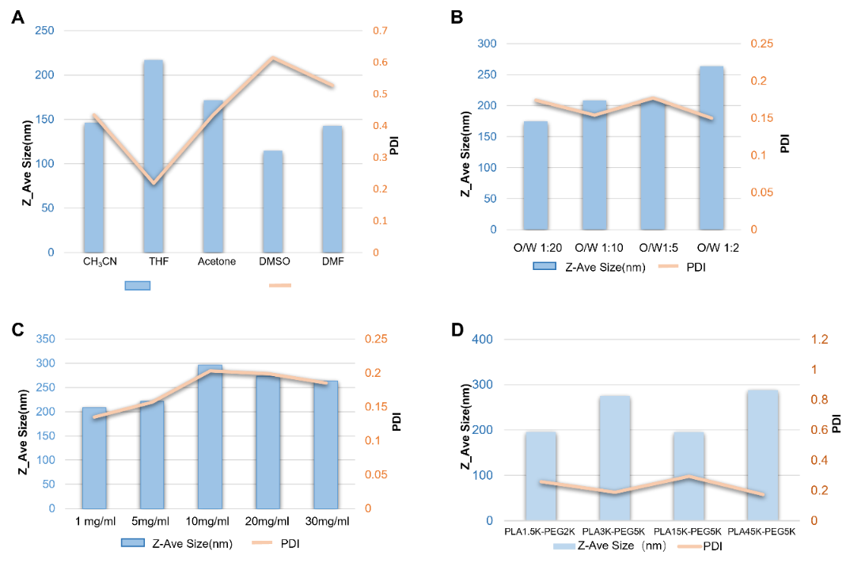
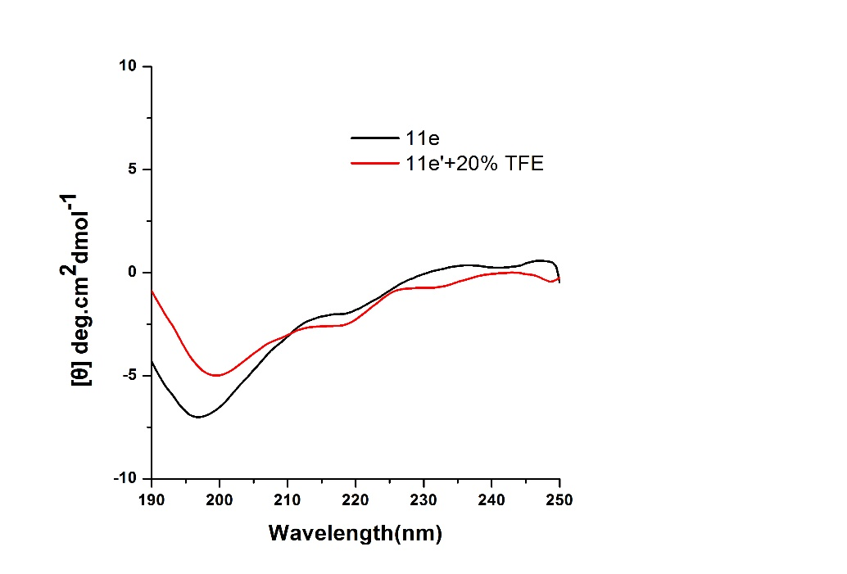
Figure S1. Particle size and PDI of PLA-PEG nanoparticles under different conditions. A) Different organic solvents. In this case, the initial concentration of the polymer is 15mg/ml, and the oil-water ratio is 1:10; B) Different oil-water ratio. In this case, the initial concentration of the polymer is 15mg/ml, and the organic solvent is THF; C) Different polymer concentration. In this case, the oil-water ratio is 1:20, and the organic solvent is THF; D) Different block proportions of PLA-PEG. In this case, the initial concentration of the polymer is 15mg/ml, the oil-water ratio is 1:20, and the organic solvent is THF.

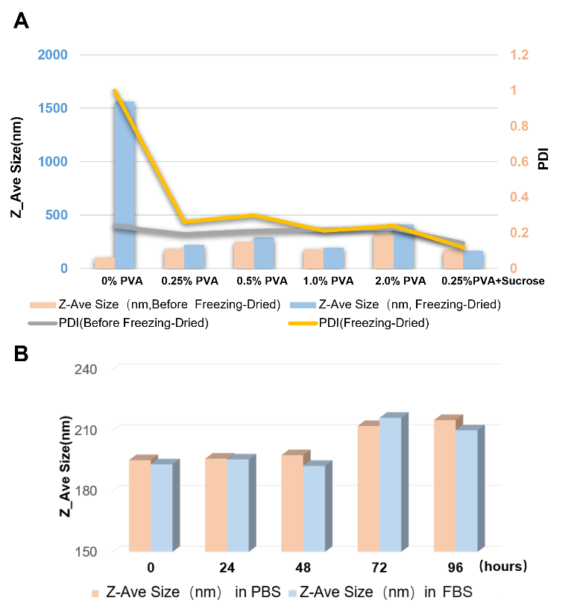
Figure S2. A) The influence of different concentrations of PVA (W/V%) on nanoparticles and the changes of particle size and PDI of PLA3K-PEG5K nanoparticles after lyophilization. In this case, the initial concentration of the polymer is 15mg/ml, the oil-water ratio is 1:20, and the organic solvent is THF; B) The stability of PLA-PEG nanoparticles in PBS and FBS at room temperature. In this case, the initial concentration of the polymer is 15mg/ml, the oil-water ratio is 1:20, the organic solvent is THF and 0.25% PVA+1.5% sucrose if need lyophilization.

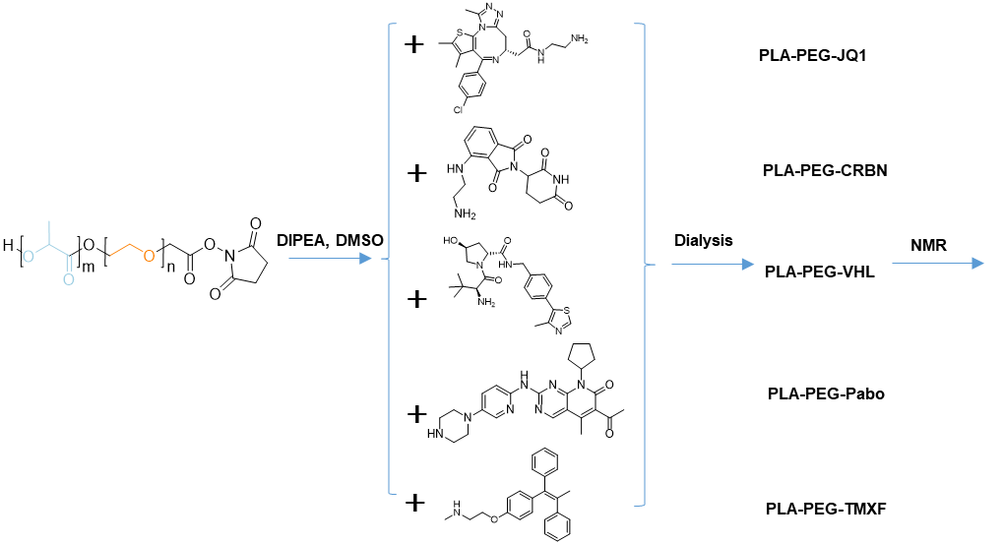
Figure S3. Synthesis strategies of different PLA-PEG-Ligand.
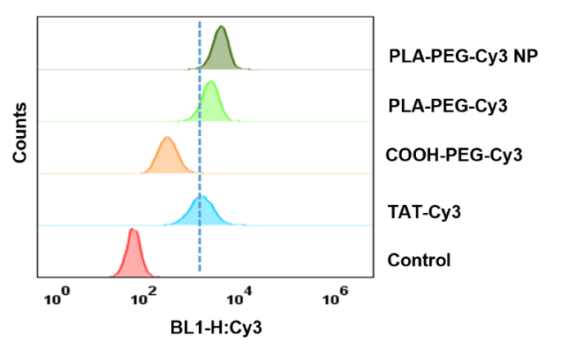
Figure S4. Cell membrane penetration of PLA-PEG nanoparticles measured via flow cytometry. PLA-PEG-Cy3 NP represents nanoparticles with Cy3 dye; PLA-PEG-Cy3 refers to the compound before assembly; COOH-PEG-Cy3 means polyethylene glycol coupled with Cy3 dye; TAT-Cy3 represents TAT transmembrane peptide coupled with Cy3 dye. TAT sequence is: YGRKKRRQRRR. The concentration of each compound is 5 μM. The cell line was HCT116.

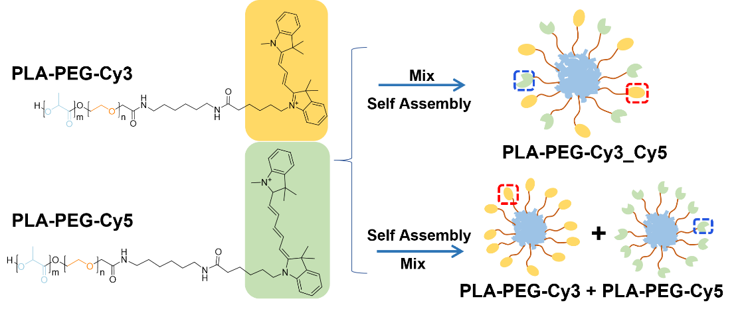
Figure S5. Assembly diagram of nanoparticles containing different dyes.

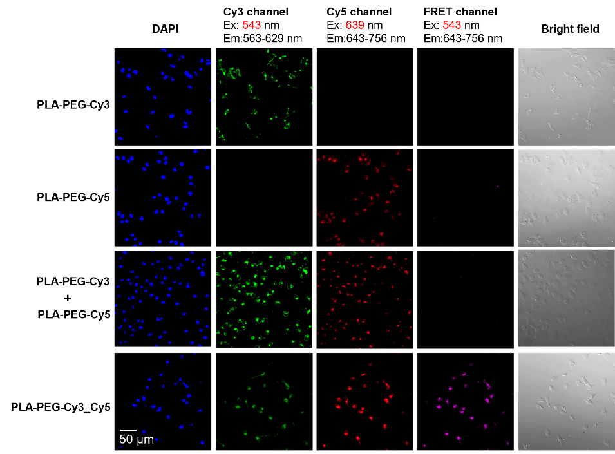
Figure S6. CLSM images with scale bar of 50 μm in different fluorescence channels of different drugs treated cells (24h). PLA-PEG-Cy3_Cy5 refers to the co-assembled nanoparticles by mixing PLA-PEG-Cy3 and PLA-PEG-Cy5 coupled with Cy3 and Cy5 dyes, respectively. PLA-PEG-Cy3+ PLA-PEG-Cy5 refers to mixing PLA-PEG-Cy3 nanoparticles and PLA-PEG-Cy5 nanoparticles. FRET refers to a fluorescence energy resonance transfer. The excitation wavelength of FRET channel is 543 nm and the detection wavelength range is 643-756 nm.

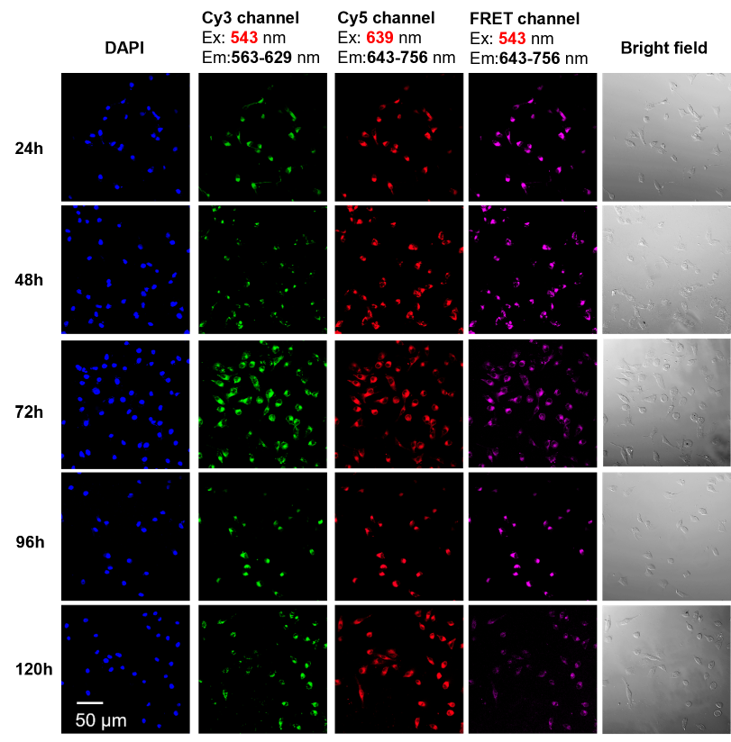
Figure S7. CLSM images with scale bar of 50μm in different fluorescence channels of PLA-PEG-Cy3_Cy5 treated cells at different time points. PLA-PEG-Cy3_Cy5 refers to the co-assembled nanoparticles by mixing PLA-PEG-Cy3 and PLA-PEG-Cy5 coupled with Cy3 and Cy5 dyes, respectively; FRET refers to a fluorescence energy resonance transfer. The excitation wavelength of FRET channel is 543 nm and the detection wavelength range is 643-756 nm.
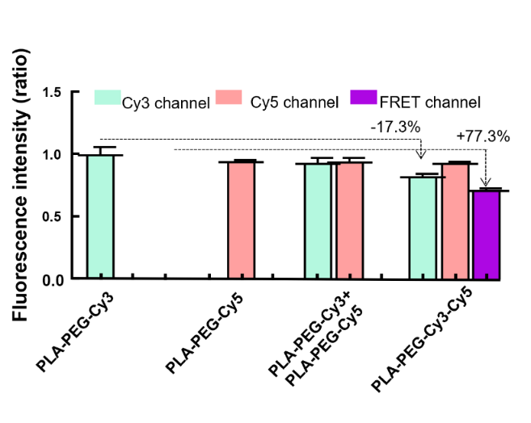
Figure S8. Fluorescence intensity values of different groups in Figure S6.

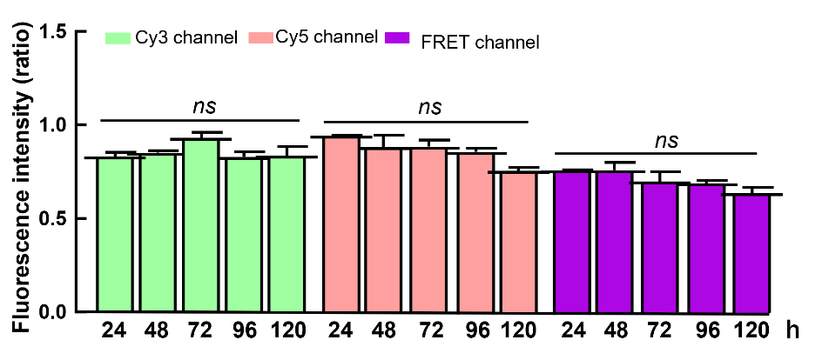
Figure S9. Fluorescence intensity values of different channels in Figure S7.
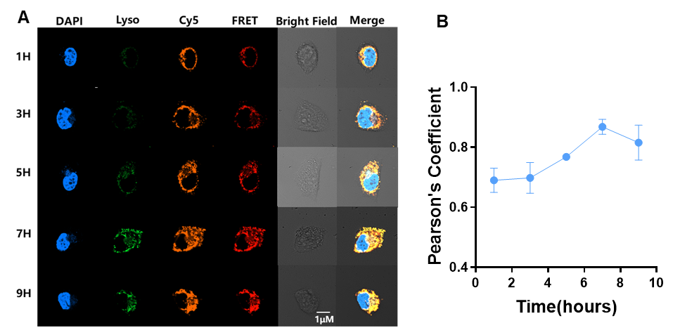
Figure S10. (A) Colocalization observation by CLSM of the PLA-PEG-Cy3_Cy5 (yellow for Cy5 Signal and red for RFET signal) and LysoTracker (green) in HCT116 cells. Scale bars = 1 μm. (B) Evolution with time of the Pearson’s correlation coefficients between the signals from the FRET and LysoTracker. The excitation wavelength of FRET channel is 543 nm and the detection wavelength range is 643-756 nm.

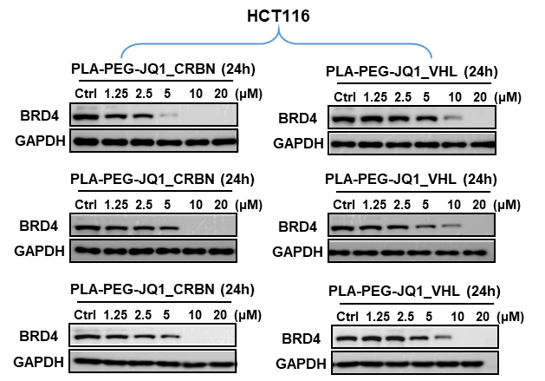
Figure S11. Concentration gradient west blot repeats of BRD4 degradation by PLA-PEG-JQ1_CRBN or PLA-PEG-JQ1_VHL in HCT116 cell lines for 24 hours.

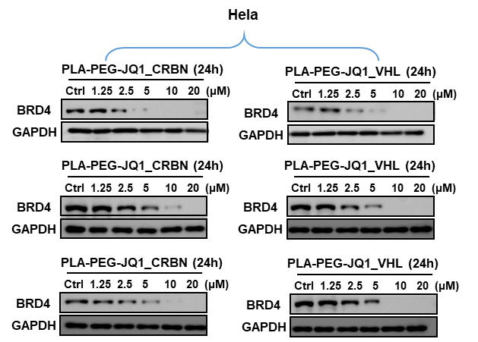
Figure S12. Concentration gradient west blot repeats of BRD4 degradation by PLA-PEG-JQ1_CRBN or PLA-PEG-JQ1_VHL in Hela cell lines for 24 hours.

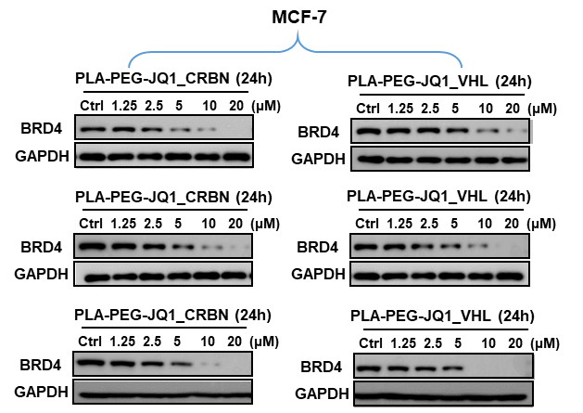
Figure S13. Concentration gradient west blot repeats of BRD4 degradation by PLA-PEG-JQ1_CRBN or PLA-PEG-JQ1_VHL in MCF-7 cell lines for 24 hours.

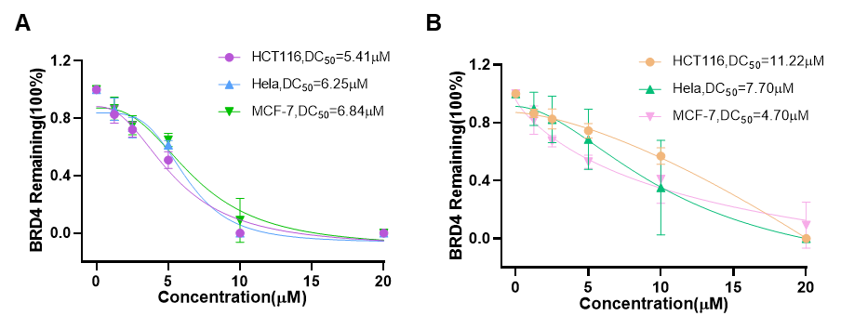
Figure S14. The BRD4 degradation curve (DC₅₀) of PLA-PEG-JQ1_CRBN (A) or PLA-PEG-JQ1_VHL (B) in HCT116, Hela, and MCF-7 cell lines.

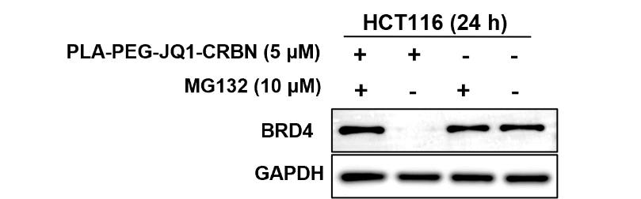
Figure S15. The situation of significant increase in the target protein content after the use of MG132 for 24 hours.
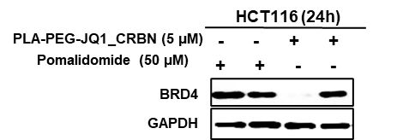
Figure S16. The situation of significant increase in the target protein content after the use of Pomalidomide for 24 hours.

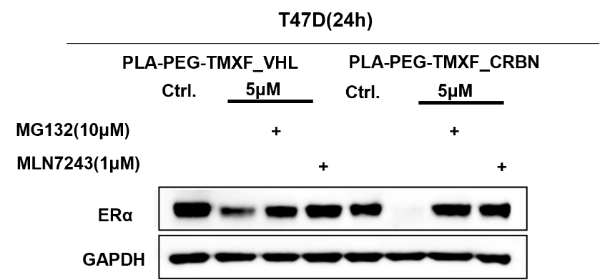
Figure S17. Results of ERα degradation by PLA-PEG-TMXF-VHL and PLA-PEG-TMXF_CRBN through ubiquitin-proteasome pathway, where MG132 (10 μM) and MLN7243 (1 μM) are proteasome inhibitors and the reaction time is 24 hours.

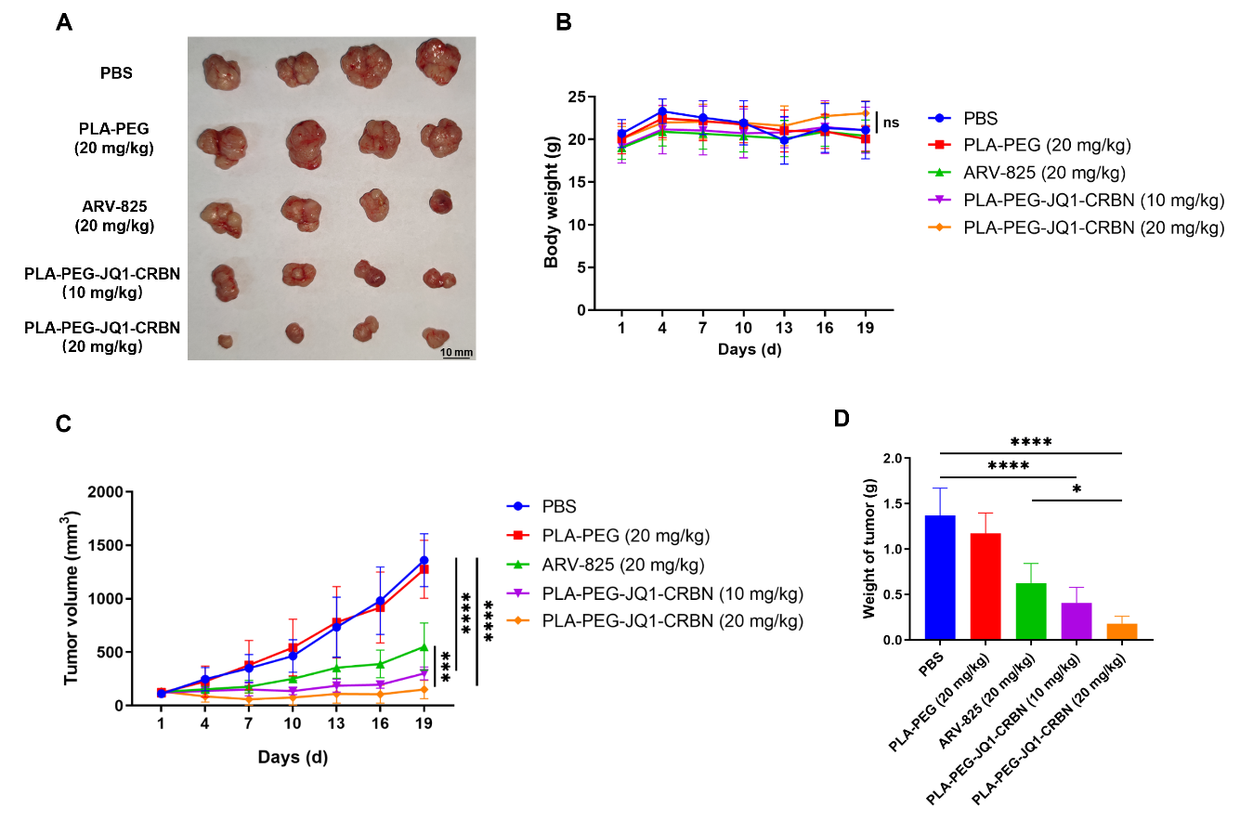
Figure S18. The administration plan for Balb/c mice. The CDX model was constructed using HCT116 cell lines, and the drugs were intraperitoneally injected into the mice every day. A) The images of tumor tissue at the end point of the experiment with scale bar 10mm; B) Body weight changes of mice throughout treatment. NS refers to no significance; C) Average tumor growth curves of each group throughout treatment; D) Weight statistics of tumor tissue at the end point of the experiment. Data are analyzed by GraphPad Prism 8 (*p < 0.05, **p < 0.01, ***p < 0.001, ****p < 0.0001).

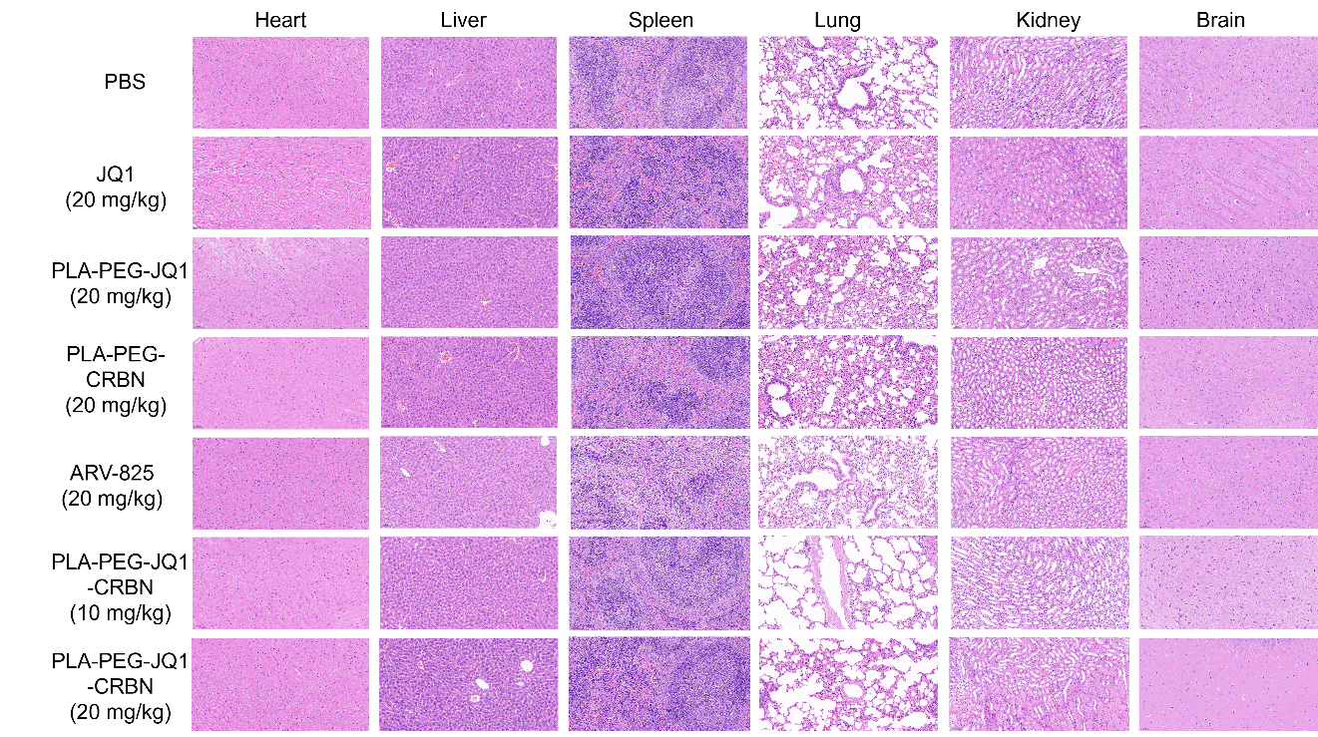
Figure S19. Hematoxylin-eosin staining (HE) sections of the Heart, Liver, Spleen, Lung, Kidney, and Brain after treatment with different drugs.
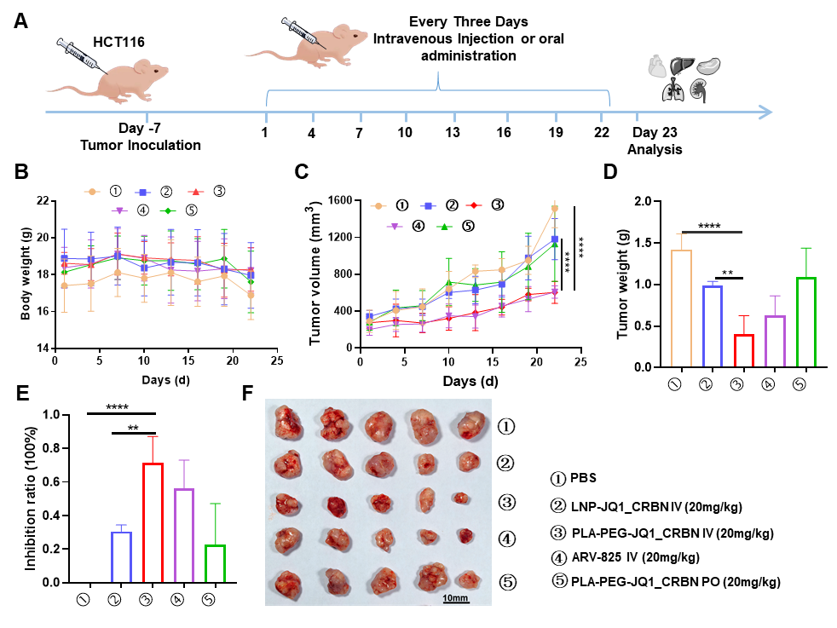
Figure S20. A) The administration plan for Balb/c mice. The CDX model was constructed using the HCT116 cell lines, and the drugs were intraperitoneally injected into the mice every three days. The treatment groups:①PBS;②LNP-JQ1_CRBN(20 mg/kg)③PLA-PEG-JQ1_CRBN IV(20 mg/kg)④ARV-825(20 mg/kg)⑤PLA-PEG-JQ1_CRBN PO(20 mg/kg); B) Body weight changes of mice throughout the treatment; C) Average tumor growth curves of each group throughout the treatment; D) Weight statistics of tumor tissue at the end point of the experiment; E) Calculated tumor growth inhibition rates in different groups of mice. Tumor growth inhibition rates (Tumor weight in PBS group-Tumor weight in each group)/Tumor weight in PBS group*100%; F) The images of tumor tissue at the end point of the experiment with scale bar 10mm. Data are analyzed by GraphPad Prism 8 (*p < 0.05, **p < 0.01, ***p < 0.001, ****p < 0.0001).

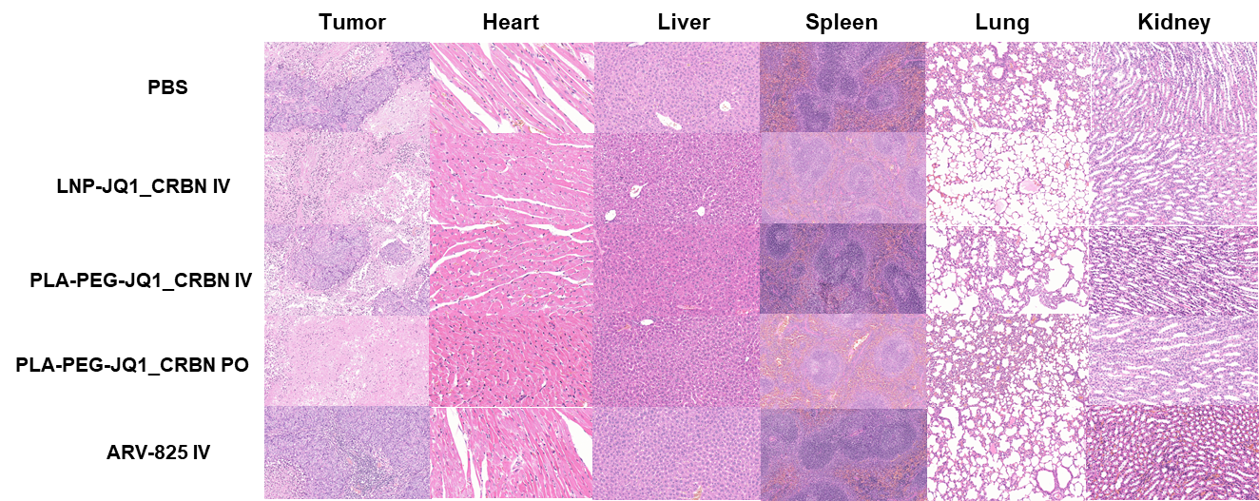
Figure S21. Hematoxylin-eosin staining (HE) sections of the Heart, Liver, Spleen, Lung, Kidney, and Tumor after treatment with different drugs in Figure S20.

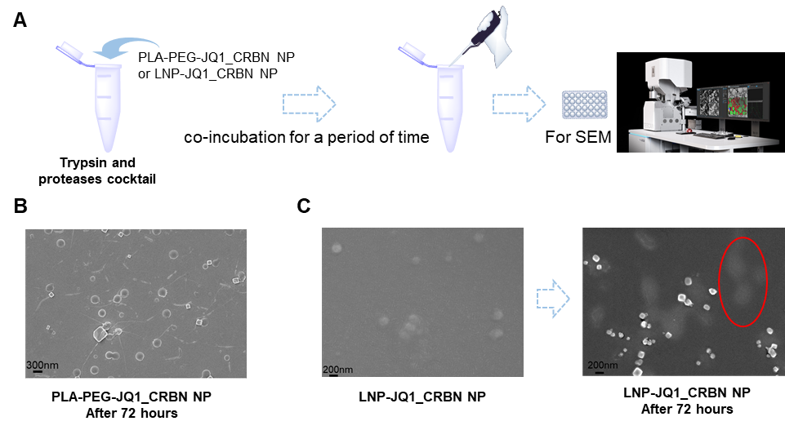
Figure S22. (A) Schematic diagram of morphology detection of different nanoparticles after co-incubation with trypsin enzymes and proteases. The morphology of PLA-PEG-JQ1_CRBN nanoparticles(B) or LNP-JQ1_CRBN(C) was observed by SEM. The cube block is the salt in the buffer.

Appendix

SEM morphology of different nanoparticles
PLA-PEG-JQ1_CRBN

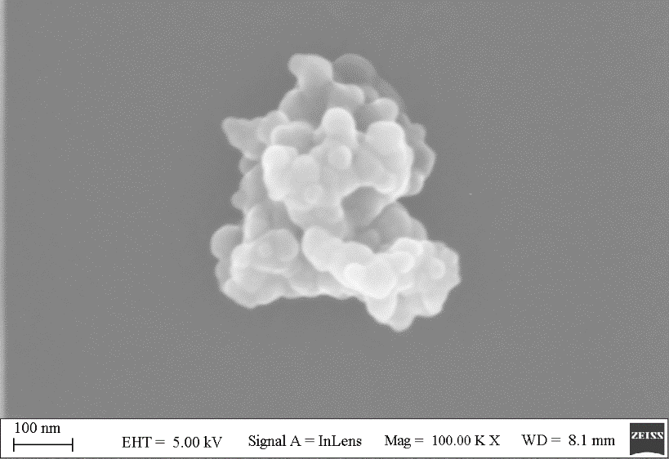
PLA-PEG-Pabo_CRBN

PLA-PEG-TMXF_CRBN

PLA-PEG-Cy3_Cy5

TEM morphology of PLA-PEG Nanoparticle
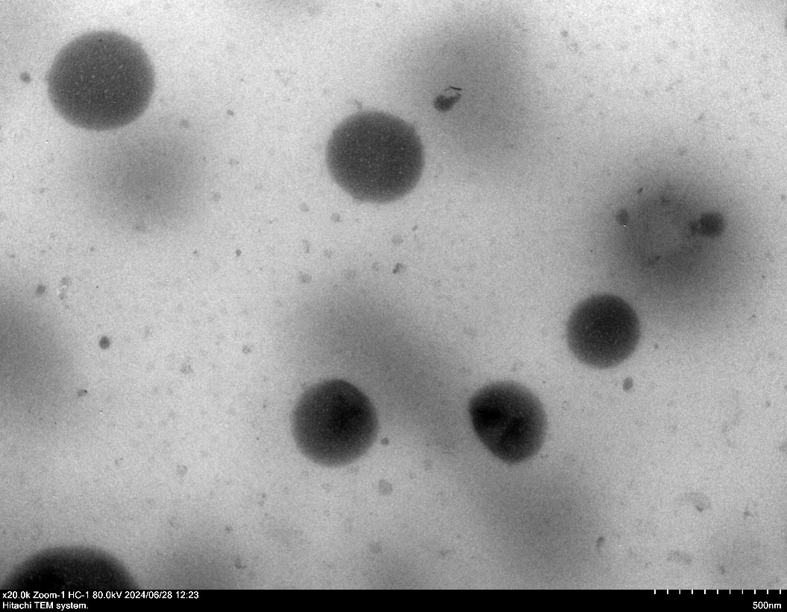

NMR spectrums of different PLA-PEG-Ligand
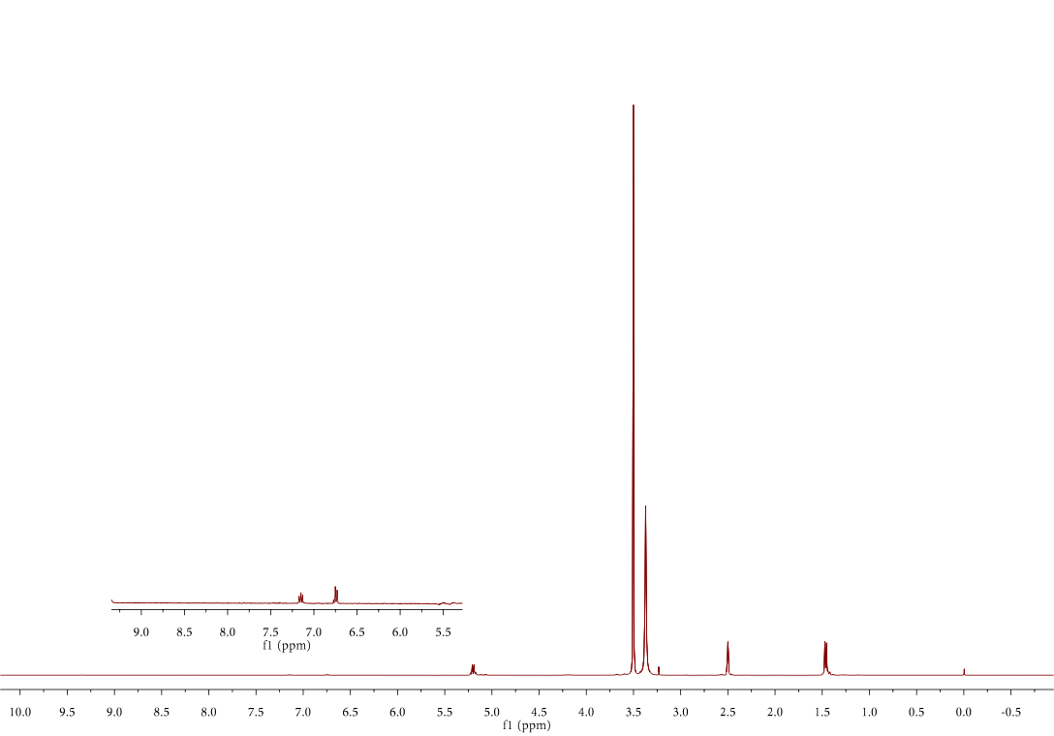
PLA-PEG-NHS (Solvent: DMSO-d6; The bands at 5.2 and 1.5 ppm are assigned to the methine and methyl protons of PLA blocks, respectively, while the bands at 3.6 ppm were characteristic of main chain methylene units in the PEG blocks.)
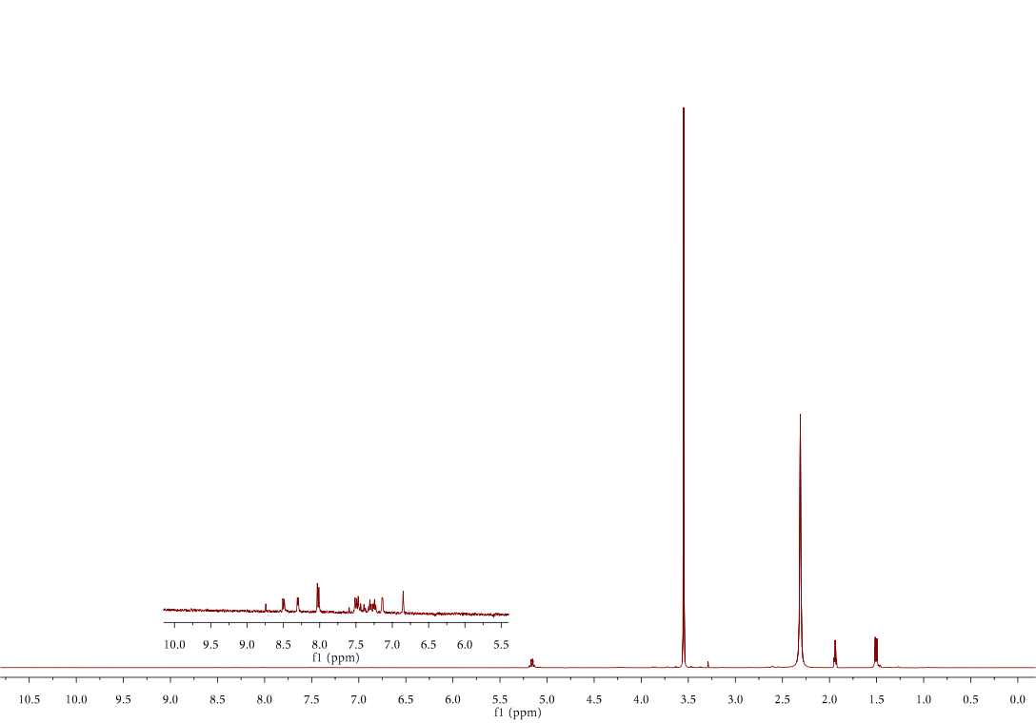
PLA-PEG-VHL (Solvent: CD₃CN; The expansion region is assigned to the ligand on the coupling.)
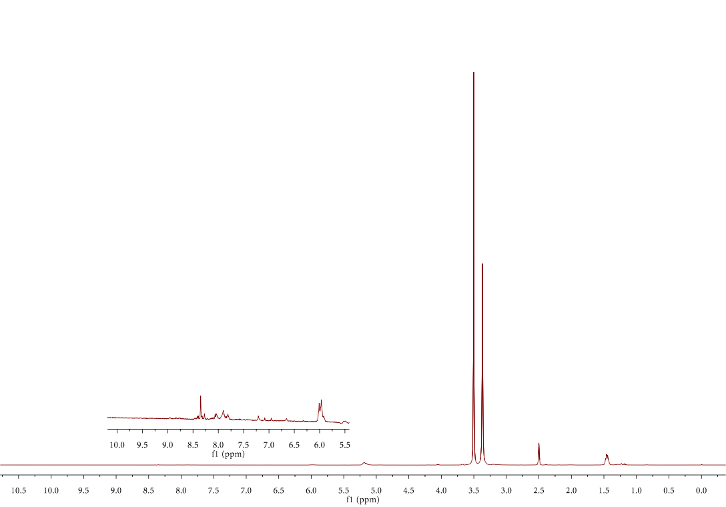
PLA-PEG-CRBN (Solvent: DMSO-d6; The expansion region is assigned to the ligand on the coupling.)
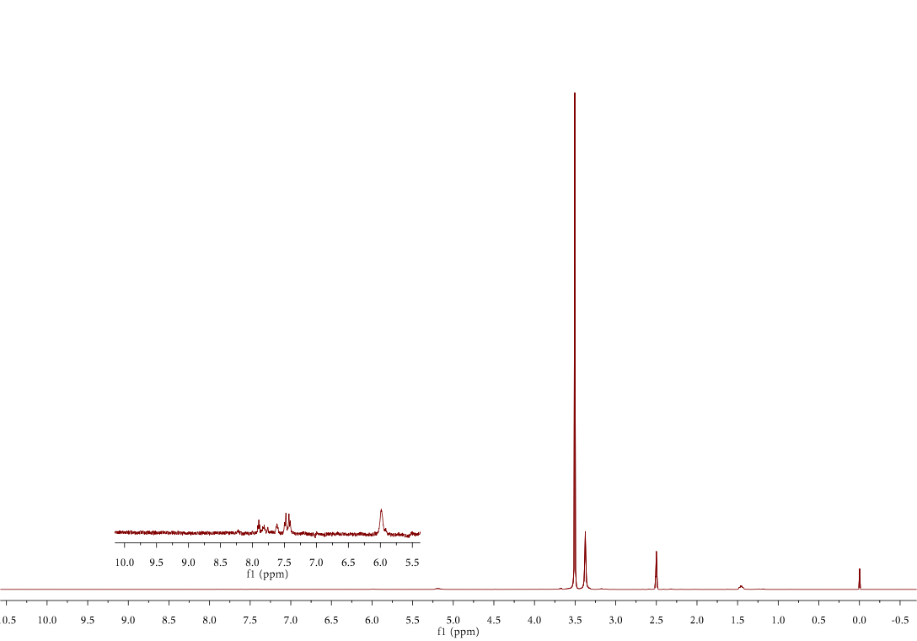
PLA-PEG-JQ1 (Solvent: DMSO-d6; The expansion region is assigned to the ligand on the coupling.)
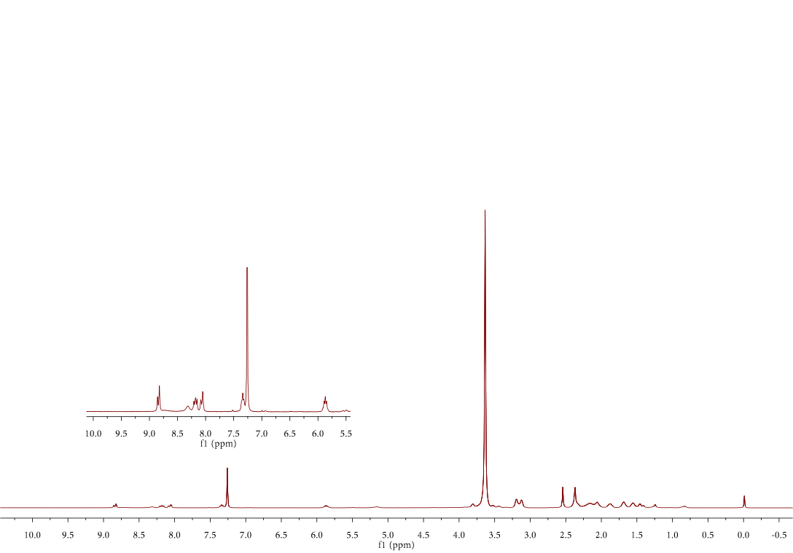
PLA-PEG-Pabo (Solvent: CDCl₃; The expansion region is assigned to the ligand on the coupling.)
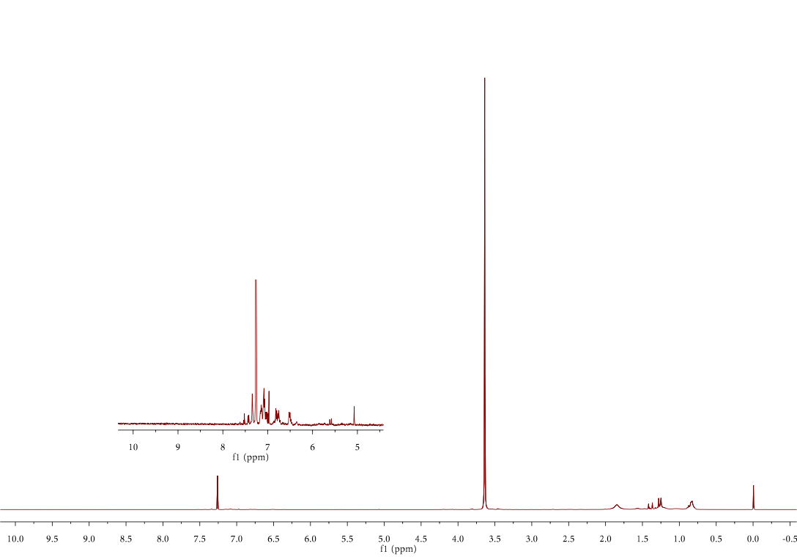
PLA-PEG-TMXF (Solvent: CDCl₃; The expansion region is assigned to the ligand on the coupling.)

Reference
1. Wang, R. N.; Yin, C. F.; Liu, C. R.; Sun, Y.; Xiao, P. P.; Li, J., et al., Phenylboronic Acid Modification Augments the Lysosome Escape and Antitumor Efficacy of a Cylindrical Polymer Brush-Based Prodrug. J Am Chem Soc 2021, 143 (49), 20927-20938.

