Supplementary Information

LepR-mesenchymal stem cells represent the main target of the nociceptive CGRP pathway in white adipose tissue browning

Yu-Ting Yen, May Chien, Yan Tung Kiu, Ru-Sing Lee, Hui-Teng Cheng, Shuei-Liong Lin, Dong Chuan Wu , I-Hsien Teng, Yi-Wen Lin, Yi-Hung Chen, Mien-Chie Hung, Shih-Chieh Hung*

Inventory
Online Materials and Methods
Supplementary Fig. 1 to 8
Supplementary Table 1 to 2

Online Materials and Methods
Animals
Mice were purchased from the Jackson Laboratory. Rosa26-CAG-loxp-stop-loxp-tdTomato mice (#007914), Rosa26-loxp-stop-loxp-iDTR (#007900) were crossed to LepR-cre mice (#008320) and maintained in C57BL/6 background. Male mice aged two- to six-month-old were used for the experiment. To treat mice with diphtheria toxin (DT), mice were intraperitoneally injected with 100 ng of DT (sigma) for 7 consecutive days. All animal studies and care of live animals were approved and performed following the guidelines made by the China Medical University Institutional Animal Care and Use Committee 2020-290 and 2022-342.

Cold exposure
Mice were housed at 6°C (cold) for 7 days in a controlled environmental with free access to food and water. Mice were maintained in a 12-hour light–dark cycle with 30% humidity on a normal diet. For drug treatment experiment, mice were received drug at day 1 before cold exposure and at day 4 during cold exposure.

Fasting treatment
Mice were fed with alternating a 24-hour-period of free access to food followed by 24-hour-fasting in one week duration.

Nuclei isolation
The nuclei isolation protocol was adapted from previous publication¹. Inguinal WAT was dissected from each mouse (6 mice for each treatment) and cut into small piece (1 mm³) with scissors. Quickly transfer inguinal WAT into a pre-wet 100 μm cell strainer and all together in a petri dish on ice. Add 3 ml ice-cold nuclei preparation buffer [(NPB) 10 mM HEPES (15630-080, Life Technologies) (pH 7.5), 1.5 mM MgCl₂ (M1028, Sigma-Aldrich), 10 mM KCl (P9541, Sigma-Aldrich), 250 mM sucrose (S7903, Sigma-Aldrich) and 0.1% IGEPAL CA-630 (NP-40) (I8896, Sigma-Aldrich) in DEPC water] to the inguinal WAT pieces and use syringe plunger to mince inguinal WAT with strainer. Be aware that inguinal WAT should be bathed with ice-cold NPB. Resuspend the minced inguinal WAT and pass it through the strainer and keep in the petri dish. Wash the plunger and strainer with 2 ml NPB then filter through the strainer. The homogenate (now is at petri dish, inguinal WAT debris is at upper side of the strainer) was then transferred to a new, pre-cooled 50 ml tube on ice. Centrifuge at 1,000 g for 10 min at 4℃. After aspirate the lipid layer, nuclear pellet was resuspended in 100 μl ice-cold nuclei resuspension buffer [(NRB) 1%BSA, 2 mM MgCl₂ (M1028, Sigma-Aldrich) and 0.04 U RNase inhibitor (03335399001, Roche) in 1X PBS]. The nuclei were counted using Countess® II FL Automated Cell Counter (Thermo Fisher Scientific) and 12,000 nuclei were submitted for snRNA-seq using the 10X Genomics system.

Single-nucleus RNA sequencing and data analysis
10X Genomics sequencing libraries were acquired by 10X Chromium Single Cell mRNA Seq 3’ v3.1 reagent kit. Nuclei solutions containing 700-1200 nuclei/μl were loaded into Chromium Controller. Sequencing was done by NovaSeq 6000 (Illumina) and alignment, demultiplexing, filtering was performed according to the manufacturer's protocol using Cell Ranger. Low-quality cells were excluded for cells with fewer than 200 unique genes, greater than 20% mitochondrial counts, and a gene expression novelty score (log10GenesPerUMI) of lower than 0.75. Furthermore, only genes expressed in more than 10 cells were kept for the downstream analysis. After quality control, the filtered matrix was normalized and scaled using the NormalizeData and ScaleData functions in Seurat, respectively. Clustering and annotation of the gene expression were performed according to the method scCATCH². scCATCH used an evidence-based scoring system by matching the identified potential marker genes to known cell markers in tissue-specific cell taxonomy reference database (CellMatch). Trajectory inference was calculated by Monocle3³. Monocle3 used the UMAP projection returned by Seurat at the dimensional reduction step to reduce computational time. It then uses the Louvain community detection algorithm to group mutually similar cells together. Groups that were located next to each other were merged into a “partition” (or “supergroup”). Finally, it constructed the trajectory by using the minimum spanning tree, then found the longest connected path in that tree; identifying the locations of branches and convergences for each partition/supergroup. Display of the clustering was done by the UMAP method⁴.

We employed a pseudo-bulk approach to analyze differential gene expression⁵. In this method, we aggregated the single cell counts at the sample level for each cluster. The count data were then subjected to differential gene expression analysis using DESeq2⁵, an R package available in Bioconductor. By applying the likelihood ratio test (LRT), we detected genes that exhibited significant differences in expression across at least two of the conditions (temperatures). To gain further insights into the biological functions associated with these genes, we conducted a hallmark gene sets term over-representation analysis on the sets of genes that were significantly up- or down-regulated.

Agent or drug administration
Mice were subcutaneously injected with three escalating doses (30 μg/kg, 70 μg/kg, 100 μg/kg) of resiniferatoxin (RTX; AG-CN2-0534, Adipogen Life Sciences) over three consecutive days. After a period of 4 weeks from the initial injection, cold treatment and fasting were administered to the mice. To manipulate the signaling of TRPM8 and TRPV1 in the inguinal WAT, AMG333 (6874, Tocris) and AMG9810 (2316, Tocris) were injected into the inguinal WAT. To block the white browning effect during cold treatment, CGRP (C0167, Sigma-Aldrich) was injected into the inguinal WAT. To disrupt CGRP function, CGRP receptor antagonist, BIBN4096 (SML2426, Sigma-Aldrich), was prepared by dissolving it in DMSO. Mice were then administered an intraperitoneal injection of 1 mg/kg BIBN4096 using a 10% Tween 80-PBS solution. Inguinal WAT injection was performed using the intra-fat injection method, following a previously described protocol⁶. Briefly, mice were anesthetized, and the target area was prepared by removing the majority of hair. A dorsal incision was made on the skin to access the fat pad directly. Care was taken to ensure proper exposure of the fat pad. The drug or substance of interest was injected directly into the exposed inguinal WAT using the intra-fat injection technique. Mice inguinal WATs received injection unilaterally on one side and the other side served as non-drug-treated inguinal WATs. After injection, incision was closed by sterile wound clips and 10 mg/kg Enrofloxacin was applied. After 30 min of drug injection, mice were treated with cold or fasting. The detailed protocols of agents or drugs used to manipulate CGRP release are listed in Supplementary Table 1.

Histology and immunostaining
Frozen sections were prepared for immunostaining. In brief, 16 μm sections were blocked with 10% BSA in 1% Triton X-100/PBS for 30 min at room temperature. The following primary antibodies were stained with 2% BSA in 0.05% Triton X-100/PBS overnight at 4℃: anti-LepR (1:10, 20966-1-AP, Proteintech), anti-COX4 (1:50, GTX114330, Genetex), anti-UCP1 (1:250, ab10983, Abcam), anti-CD137 (10 μg/ml, AF937, R&D), anti-TMEM26 (1:25, NBP2-27334, Novus Biologicals), anti-PGC-1α (1:50, bs-1832, Bioss), anti-Caspase 3 (1:400, 9661, Cell Signaling), anti-Tyrosine Hydroxylase (1:100, AB152, Millipore), anti-CGRP (1:50, bs-0791, Bioss; 1:500, ab36001, Abcam), anti-TRPM8 (1:200, GTX54866, Genetex), anti-TRPV1 (1:200, GTX54762 , Genetex), anti-CRLR (1:50, MAB10044, R&D), anti-Gαi (1:50, 5290S, Cell Signaling), anti-AC (1:50, sc-377243, Santa Cruz), anti-RAMP1 (1:50, GTX108525, Genetex), anti-RCP (1:250, ab139264, Abcam), anti-Sca1 (1:50, ab109211, Abcam), anti-EMCN (1:50, sc-65495, Santa Cruz), anti- Norepinephrin (1:500, IS1042, Immusmol SAS), anti-PGP9.5 (1:100, GTX634797 , Genetex), and anti-F4/80 (1:50, GTX26640, Genetex). Wash the sections with 0.05% Triton X-100/PBS three times and incubate with secondary antibodies with 2% BSA in 0.05% Triton X-100/PBS at room temperature for 1h. Secondary antibodies used were as follows: goat anti-rabbit-DyLight® 650 (1:50, A120-101D5, Bethyl Laboratories), goat anti-rabbit IgG antibody-FITC (1:50, A120-201F, Bethyl Laboratories), anti-rabbit-Dylight 488 (1:100, GTX213110-04, Genetex), goat anti-mouse IgG antibody –DyLight 488 (1:100, GTX213111-04, Genetex), goat anti-rat IgG antibody-pre-adsorbed-Cy5 (1:100, GTX26565, Genetex), and anti-goat-Alexa 488 (1:200, ab150129, Abcam). Images were acquired with Leica SP2 / SP8X confocal spectral microscope and ANDOR Dragonfly high speed confocal system in Medical Research Core Facilities, Office of Research & Development in China Medical University.

Whole-mount staining
Whole mount was prepared from clearing-free protocol with Z-depth reduction for processing intact inguinal WAT⁷. Briefly, mice were sacrificed, and inguinal WAT was carefully excised. Inguinal WAT was fixed in 2% paraformaldehyde at 4℃ for 8-24 h depending on thickness of tissue. After fixation, Z-depth reduction processed by clamping inguinal WAT between two large glass slides for 90 min at 4℃. Z-depth reduced inguinal WAT was treated in 2.5% BSA with 1% Triton X-100 for 16-24 h at 4℃ for blocking and permeabilization. Then, autofluorescence quenching are processed by the followings. Stepwise dehydrate in increasing concentrations of MeOH diluted in 1X PBS (50% MeOH for 1 h; 80% MeOH for 1 h; 100% MeOH for 2 h, replaced fresh after 1 h) at ~20℃. Bleach in 5% H₂O₂ in 20% DMSO/MeOH for 16-24 h at 4℃. This is then followed by rehydration in decreasing concentration of MeOH diluted in 1X PBS. (100% MeOH for 2 h, replaced fresh after 1 h; 20% DMSO/MeOH for 1 h; 80% MeOH for 1 h; 50% MeOH for 1 h; 1X PBS for 2 h, replaced fresh after 1 h) at ~20℃. Tissues were incubated with primary antibody for 48 h at 4℃, followed by wash and incubation with secondary fluorescent antibodies overnight. Lipid droplets were labelled by Nile Red (N3013, Sigma-Aldrich). Then, tissues were incubated with 100 ng/ml DAPI for 1 h at room temperature. Afterwards, tissues were placed on large glass slides with a few drops of glycerol based mounting media added and the coverslip placed on with weighting for 2 days and then sealed. Images were acquired with ANDOR Dragonfly high speed confocal system in Medical Research Core Facilities, Office of Research & Development in China Medical University.

Intraganglionic dorsal root ganglia (DRG) injection
AAV U6 expression vector is inserted with a promoter for human U6 to drive CGRP gene knockdown, which carried the reporter GFP driven by the PGK promoter. Serotype 9 AAV(AAV9) vectors encoding mouse CGRP shRNAs (AAV-shCGRP
TL500251A - AGGCAGTGCCTTTGAGGTCAATCTTGGAA) and AAV-Scramble (TR30021 - GCACTACCAGAGCTAACTCAGATAGTACT) were produced via the AAV Core of IBMS, Academia Sinica. The intraganglionic DRG injection was conducted following a previously reported method⁸. A midline incision was made along the dorsal skin to access the underlying dorsal muscles, which were carefully separated along the vertebral column to expose the DRGs. The DRGs were carefully isolated at the T13 and L1 vertebral levels. 200 nL of AAV9 viral vector (at a concentration of 1 × 10¹³ viral genomes/mL) in PBS containing 0.3% Fast Green FCF (Sigma-Aldrich) was injected into each ganglion through a pulled glass pipette with a Nanoliter Injector (RWD). Following the injection, the dorsal muscles and skin were sutured, and the animal was permitted to recover from anesthesia.

Quantitative reverse-transcription PCR (qRT-PCR)
Mice treated cold, fasting or non-treated (Ctrl) were euthanized to isolate inguinal WAT. Tissues were lysed and homogenized in TRIzol reagent (15596018, Ambion) and were phase-separated by bromochloropropane (BCP; BP 151, Molecular Research Center). RNA was precipitated by isopropanol form aqueous phase and washed with ethanol. After removing the ethanol followed by centrifugation, RNA was briefly air-dried and solubilized in DEPC water. Total RNA was subjected to reverse transcription (MMLV Reverse Transcript ion Kit; PT RT KIT, Protech Technology) and then qRT-PCR using SYBR green (iQ™ SYBR® Green Supermix; 1708882, Bio-Rad) on CFX96 Optical Reaction Module (Bio-Rad). Primers used in this study are listed in Supplementary Table 2.

Proximity Ligation Assay (PLA)
The PLA assay was performed according to the manufacture’s Duolink PLA fluorescence protocol (DUO92004, Sigma-Aldrich). In brief, the frozen sections were permeabilized by 1% Triton X-100/PBS for 30 min at room temperature. Sections were incubated with blocking buffer for 60 min at 37℃. The following first antibodies were stained with Duolink anti-body diluent over-night at 4℃: anti-CRLR (1:50, MAB10044, R&D), anti-CGRP (1:50, bs-0791, Bioss), anti-Gαi (1:50, 5290, Cell Signaling), and anti-AC (1:50, sc-377243, Santa Cruz). First, incubate the slides with Duolink PLA probes for 60 min at 37℃. Then, incubate the slides with Duolink PLA ligation buffer for 30 min at 37℃. Last, slides were incubated with Duolink PLA amplification buffer for 100 min at 37℃. Mount the slides by Duolink PLA mounting medium with DAPI. Images were acquired with Leica SP2 / SP8X confocal spectral microscope in Medical Research Core Facilities, Office of Research & Development in China Medical University.

In vivo macrophage depletion protocol
In the experimental procedure, we administered liposome-encapsulated clodronate (referred to as Clodronate) or liposomes as a control (referred to as the vehicle, CLD-8901 from Encapsula NanoSciences) to mice via intravenous (i.v.) injection. The injection volume for both substances was 0.2 ml, which corresponded to a dosage of 1 mg per mouse. The liposome-encapsulated clodronate and the liposomes used as a vehicle control were pre-treated 2 days before the initiation of the fasting protocol.

Analyses of publicly available single-cell RNA-sequencing data
Single-cell RNA-sequencing (ScRNA-seq) data from GSE176067 were analyzed using the R package Seurat⁹ (version 5), and the authors provided metadata on single-cell cell type annotations. To identify the differentially expressed genes in each of the subclusters, the FindAllMarkers function was applied with a minimum threshold of 30% of cells in the cluster expressing the gene and a minimum log2FC threshold of 1. Single-nucleus RNA-sequencing data from E-MTAB-8564 of human BAT cells¹⁰. The datasets can be explored interactively at https://batnetwork.org/.

Statistical analysis
Sample numbers and sizes were indicated by dots and data were displayed as the mean ± standard error of the mean (s.e.m.). Representative immunofluorescence images were obtained from 4–5 replicates in each group. Two-tailed unpaired Student t-test were performed for comparisons between two groups. One-way analysis of variance (ANOVA) was performed for multiple groups comparisons. Statistical analysis was executed by GraphPad Prism 5. P values were indicated in figures and significantly differences were considered as < 0.05.

Data Availability
snRNA-sequencing data are deposited at the Gene Expression Omnibus (GSE216925). https://www.ncbi.nlm.nih.gov/geo/query/acc.cgi?acc=GSM6697840

References
1 Van Hauwaert, E. L. et al. Isolation of nuclei from mouse white adipose tissues for single-nucleus genomics. STAR Protoc 2, 100612, doi:10.1016/j.xpro.2021.100612 (2021).
2 Shao, X. et al. scCATCH: Automatic Annotation on Cell Types of Clusters from Single-Cell RNA Sequencing Data. iScience 23, 100882, doi:10.1016/j.isci.2020.100882 (2020).
3 Trapnell, C. et al. The dynamics and regulators of cell fate decisions are revealed by pseudotemporal ordering of single cells. Nat Biotechnol 32, 381-386, doi:10.1038/nbt.2859 (2014).
4 Becht, E. et al. Dimensionality reduction for visualizing single-cell data using UMAP. Nat Biotechnol, doi:10.1038/nbt.4314 (2018).
5 Lun, A. T. L. & Marioni, J. C. Overcoming confounding plate effects in differential expression analyses of single-cell RNA-seq data. Biostatistics 18, 451-464, doi:10.1093/biostatistics/kxw055 (2017).
6 Vaughan, C. H., Zarebidaki, E., Ehlen, J. C. & Bartness, T. J. Analysis and measurement of the sympathetic and sensory innervation of white and brown adipose tissue. Methods Enzymol 537, 199-225, doi:10.1016/B978-0-12-411619-1.00011-2 (2014).
7 Willows, J. W., Blaszkiewicz, M. & Townsend, K. L. A clearing-free protocol for imaging intact whole adipose tissue innervation in mice. STAR Protoc 3, 101109, doi:10.1016/j.xpro.2021.101109 (2022).
8 Wang, Y. et al. The role of somatosensory innervation of adipose tissues. Nature 609, 569-574, doi:10.1038/s41586-022-05137-7 (2022).
9 Stuart, T. et al. Comprehensive Integration of Single-Cell Data. Cell 177, 1888-1902 e1821, doi:10.1016/j.cell.2019.05.031 (2019).
10 Sun, W. et al. snRNA-seq reveals a subpopulation of adipocytes that regulates thermogenesis. Nature 587, 98-102, doi:10.1038/s41586-020-2856-x (2020).
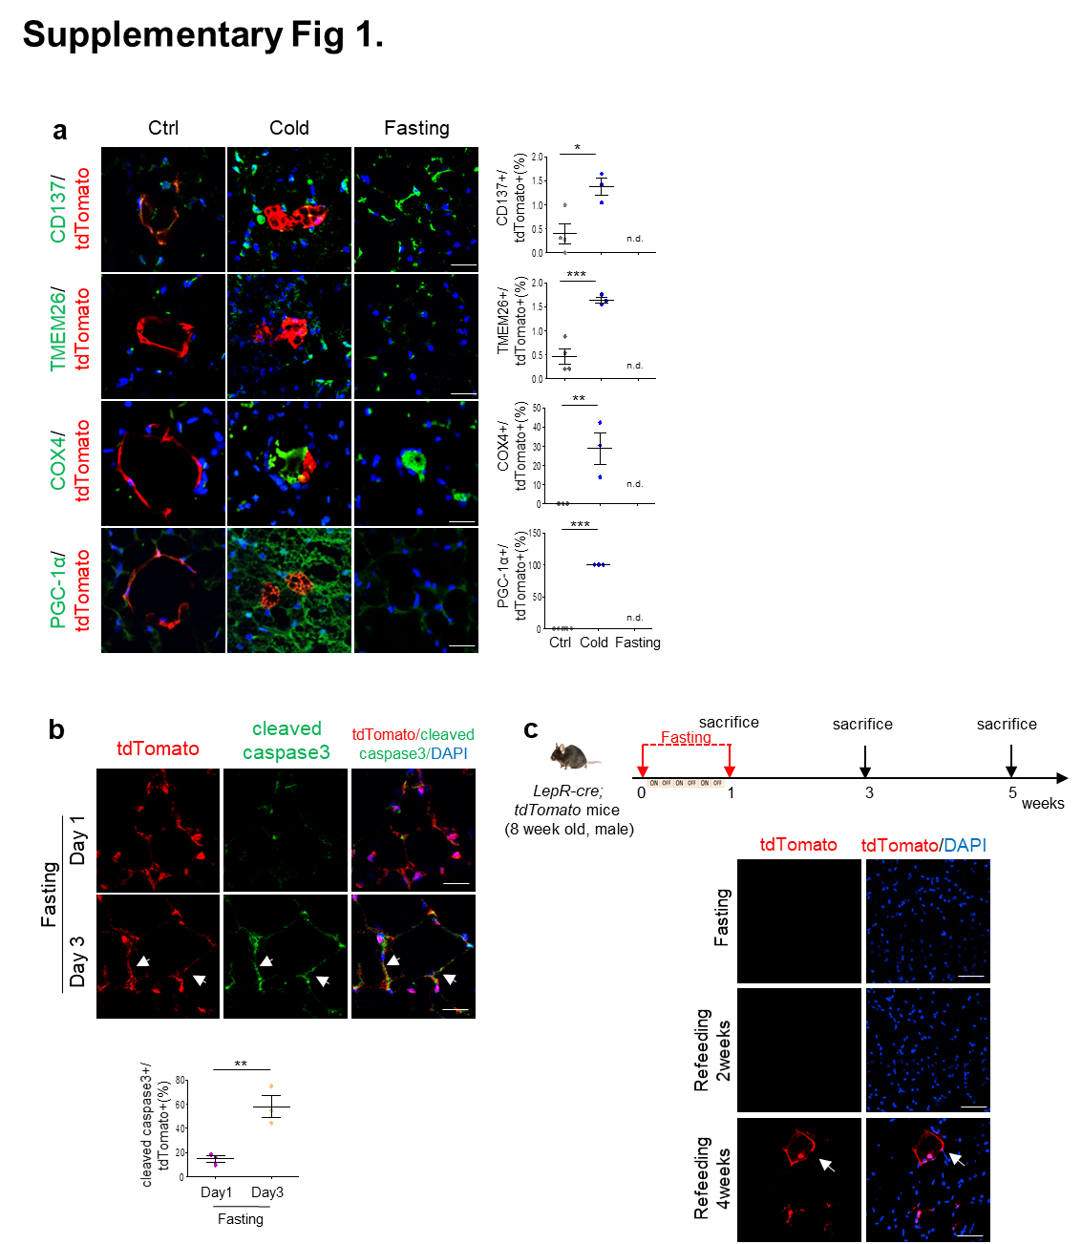
Supplementary Fig. 1: The responses of LepR-MSCs to cold- and fasting-induced WAT browning. Related to Fig. 2. (a) Representative confocal immunofluorescence images for tdTomato, CD137, TMEM26, COX4 and PGC-1α of inguinal WAT in LepR-cre;tdTomato mice in Ctrl, Cold and Fasting groups. Percentage of tdTomato+ cells positive for each molecule is shown to the right of each image panel. (b) LepR-cre;tdTomato mice were subjected to an alternate day fast with a 24 h fast followed by 24 h free access to food and followed by a 24 h fast. Day 0 indicates the beginning of the fast. Representative confocal immunofluorescence images for tdTomato and cleaved caspase-3 of inguinal WAT in LepR-cre;tdTomato mice after fasting for indicated days. Arrows indicate positive signals. Percentage of tdTomato+ cells positive for cleaved caspase3 is shown. (c) A flow chart illustrating the exposure of LepR-cre;tdTomato mice to three cycles of alternate-day fasting, followed by sacrifice at specified time intervals. Representative confocal immunofluorescence images for tdTomato expression are depicted. Data are shown as mean ± s.e.m, n values are shown in dot plots. P value was determined by one-way ANOVA with Tukey’s multiple comparison post test and unpaired two-sided t-tests. *P<0.05, **P<0.01, ***P<0.001. Scale bar, 50 μm.
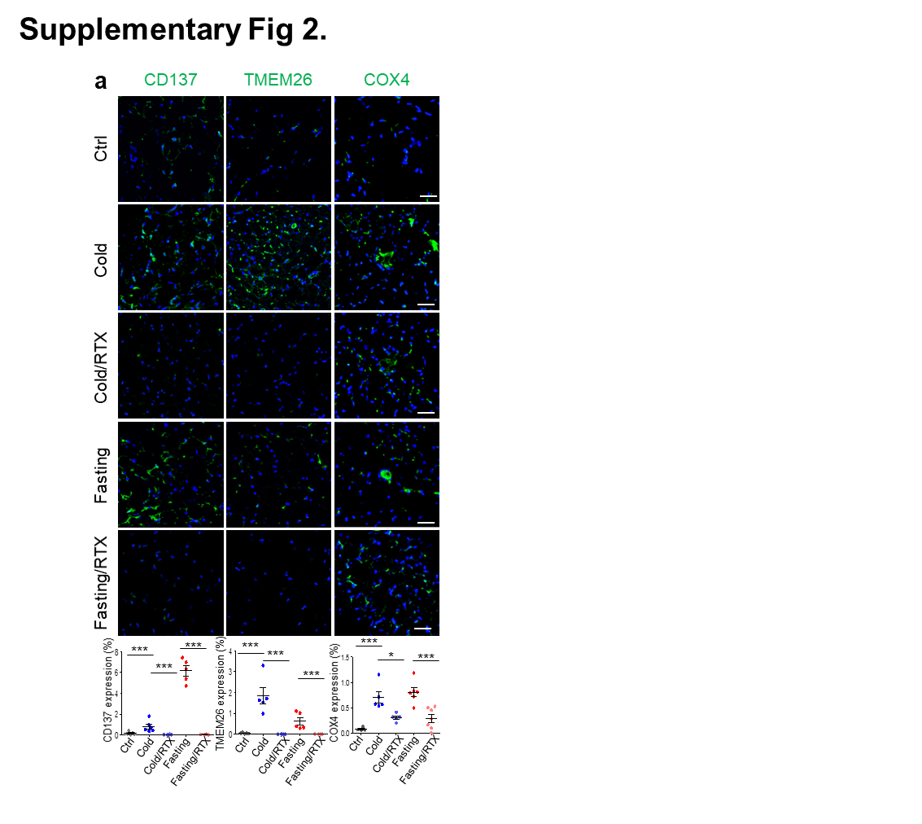
Supplementary Fig. 2: Nociceptive innervation controls cold- and fasting-induced WAT browning. Related to Fig.5. Representative confocal immunofluorescence images for CD137, TMEM26 and COX4 in inguinal WAT under different conditions. Quantification for each expression is shown below. N values are shown in dot plots. Data are shown as mean ± s.e.m. P value was determined by one-way ANOVA with Tukey’s multiple comparison post test. *P<0.05, ***P<0.001. Scale bar, 50 μm.

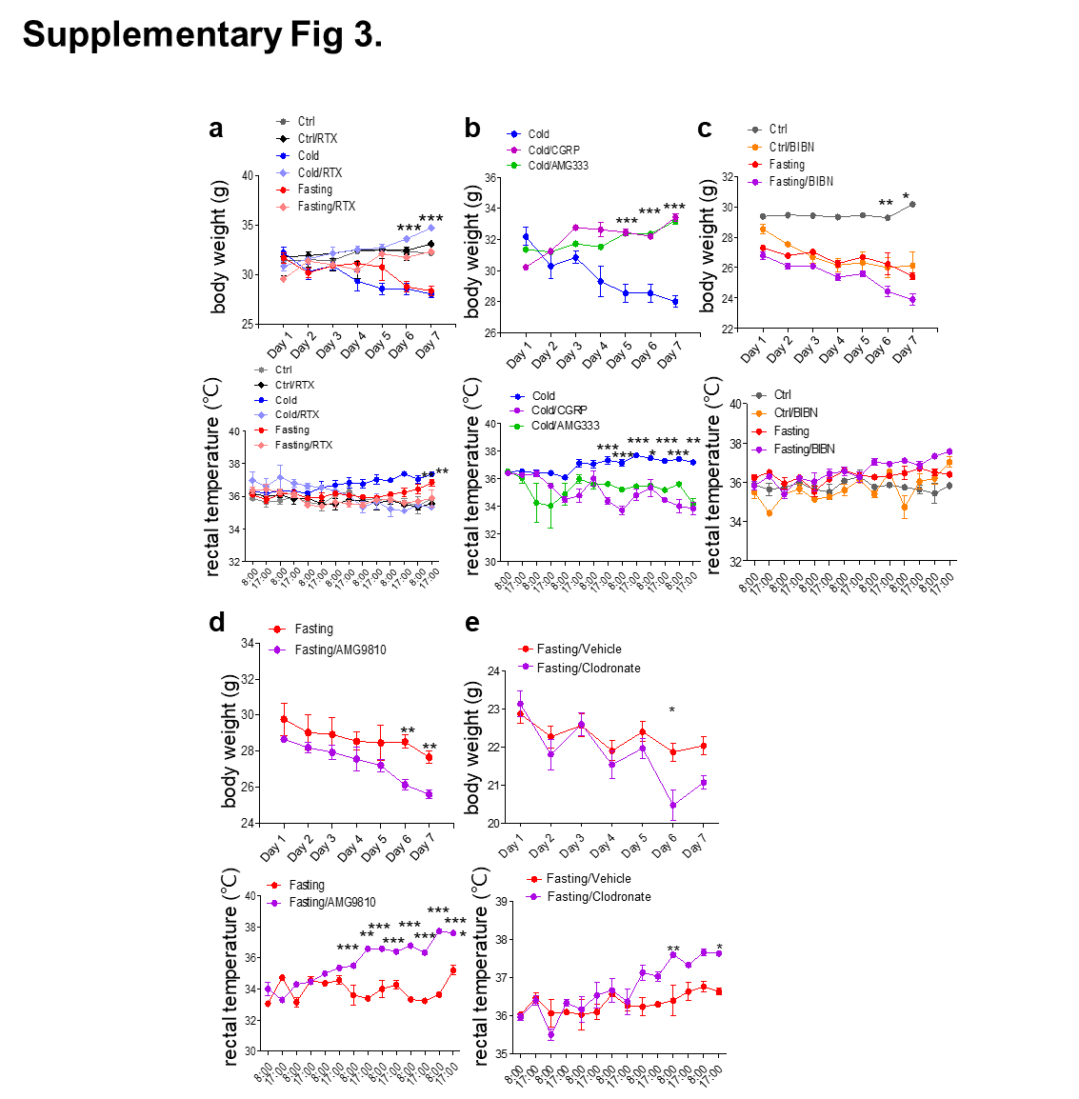

Supplementary Fig. 3: Nociceptive innervation affects body weight and rectal temperature. Related to Fig. 5 and 6. Body weight and rectal temperature changes (a) in Ctrl, Ctrl/RTX, Cold, Cold/RTX, Fasting, and Fasting/RTX treated mice; (b) in Cold, Cold/CGRP, and Cold/AMG333 treated mice; (c) in Ctrl and Ctrl/BIBN; Fasting and Fasting/BIBN treated mice; (d) in Fasting and Fasting/AMG9810 treated mice, and (e) in Fasting/vehicle and Fasting/Clodronate treated mice. Data of representative experiments are shown as mean ± s.e.m. P value was determined by one-way ANOVA with Tukey’s multiple comparison post test. *P<0.05, **P<0.01, ***P<0.001.
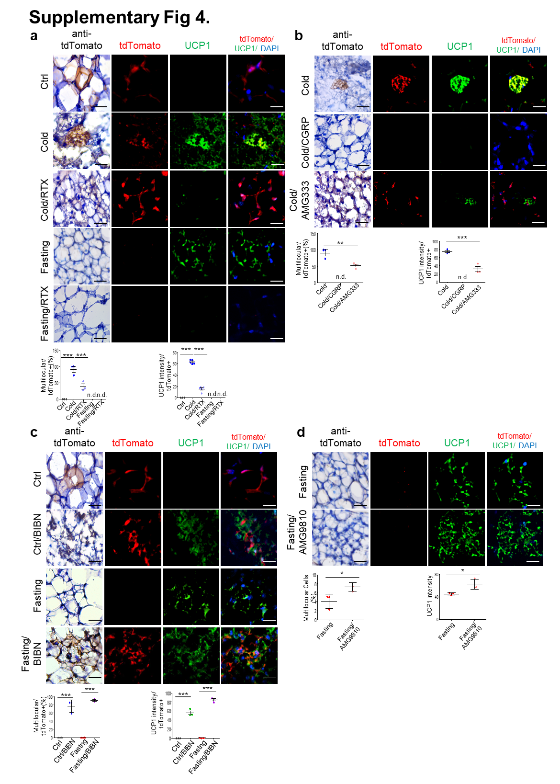
Supplementary Fig. 4: Nociceptive innervation controls WAT browning of LepR-MSCs. Related to Fig. 5 and 6. Representative confocal immunofluorescence images for tdTomato and UCP1 expression of inguinal WAT in LepR-cre;tdTomato mice (a) under Ctrl, Cold, Cold/RTX, Fasting, and Fasting/RTX conditions; (b) under Cold, Cold/CGRP, and Cold/AMG333 conditions; (c) under Ctrl and Ctrl/BIBN; Fasting and Fasting/BIBN conditions, and (d) under Fasting and Fasting/AMG9810 conditions. Quantification of each expression for tdTomato+ cells is shown below, n values are shown in dot plots. Data are shown as mean ± s.e.m. P value was determined by one-way ANOVA with Tukey’s multiple comparison post test and unpaired two-sided t-tests. *P<0.05, **P<0.01, ***P<0.001. Scale bar, 50 μm.

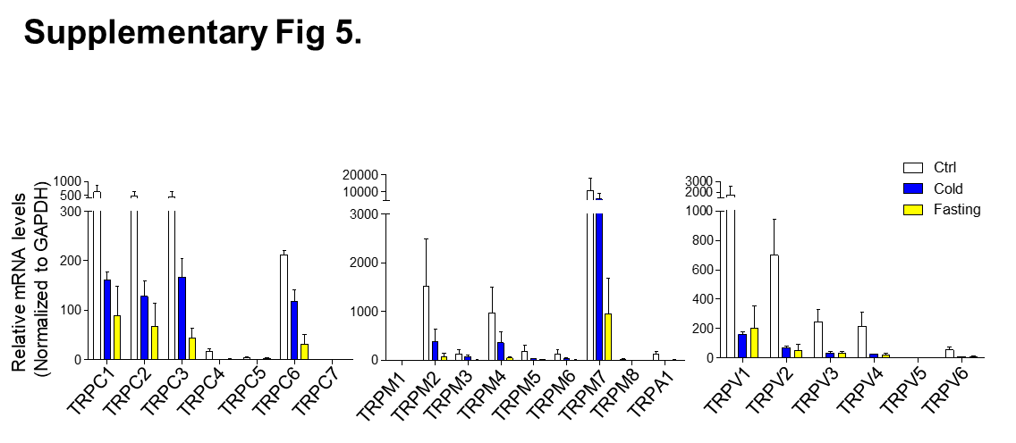
Supplementary Fig. 5: The expression profiles of TRP channels in inguinal WAT. Related to Fig. 6. Quantitative reverse-transcription PCR for the expression of each transient receptor potential (TRP) channel in inguinal WAT under different conditions. Transcript (mRNA) levels were normalized to GAPDH expression.

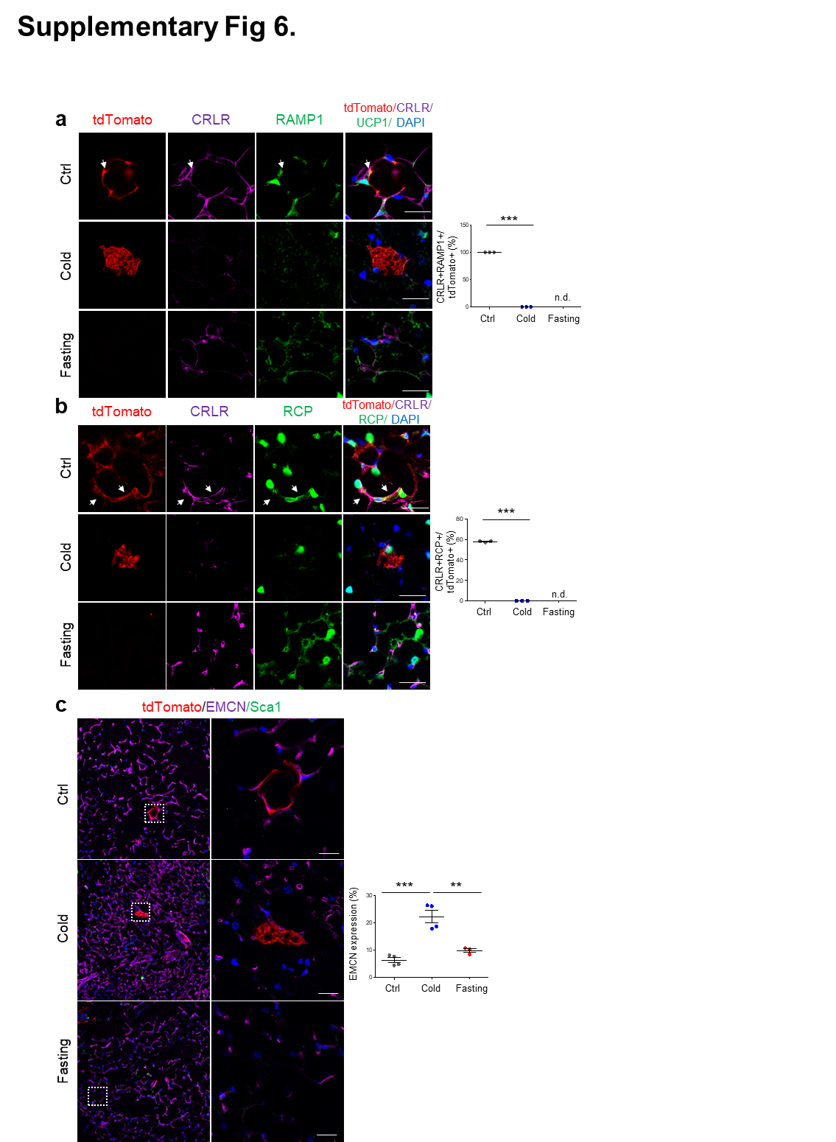
Supplementary Fig. 6: Colocalization of CRLR, RAMP1, and RCP in LepR-MSCs. Related to Fig 6. (a, b) Representative confocal immunofluorescence images of inguinal WAT in LepR-cre;tdTomato mice for (a) tdTomato, CRLR, and RAMP1 and for (b) tdTomato, CRLR and RCP under different conditions. Arrows indicate positive signals. Percentage of tdTomato+ cells positive for indicated molecules is shown to the right of each image panel. (c) Representative confocal immunofluorescence images of inguinal WAT in LepR-cre;tdTomato mice for tdTomato, EMCN (sinusoid marker), and Sca1 (arteriole marker). Rectangular areas are magnified in the right panels. Quantification of the expression under different conditions is shown to the right. Data are shown as mean ± s.e.m. P value was determined by one-way ANOVA with Tukey’s multiple comparison post test. **P<0.01, ***P<0.001. Scale bars, 50 μm.

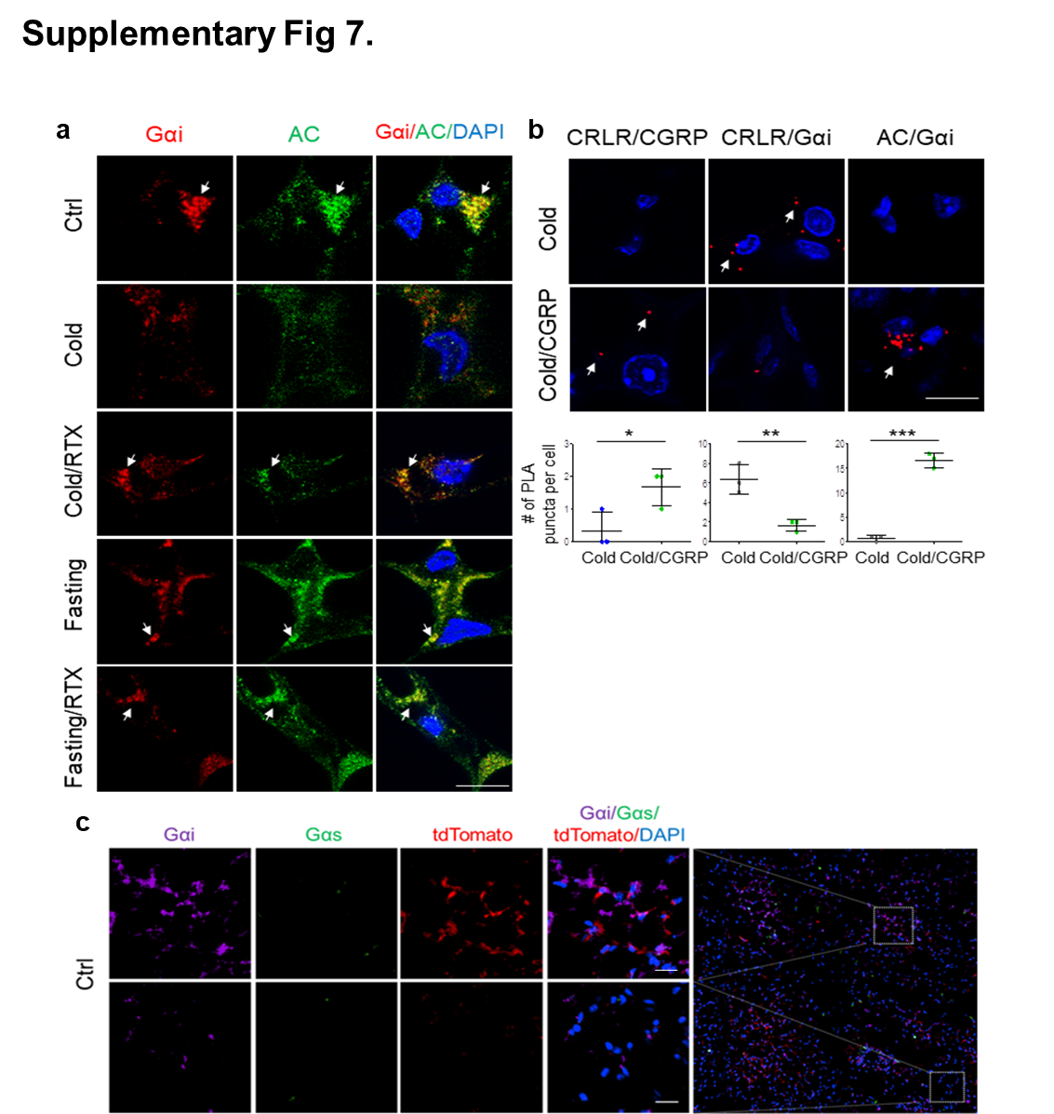
Supplementary Fig. 7: Signaling pathways involved the response of LepR-MSCs to CGRP. Related to Fig 7. (a) Representative confocal immunofluorescence images of inguinal WAT for Gαi and adenylate cyclase (AC) under different conditions.
(b) Proximity Ligation Assay (PLA) analysis for the co-localization of CRLR/CGRP, CRLR/Gαi, and AC/Gαi in inguinal WAT under different conditions. (c) Representative confocal immunofluorescence images of inguinal WAT for Gαi and Gαs. Arrows indicate positive signals. Data are shown as mean ± s.e.m. P value was determined by unpaired two-sided t-tests. *P<0.05, **P<0.01, ***P<0.001. Scale bar, 10 μm.

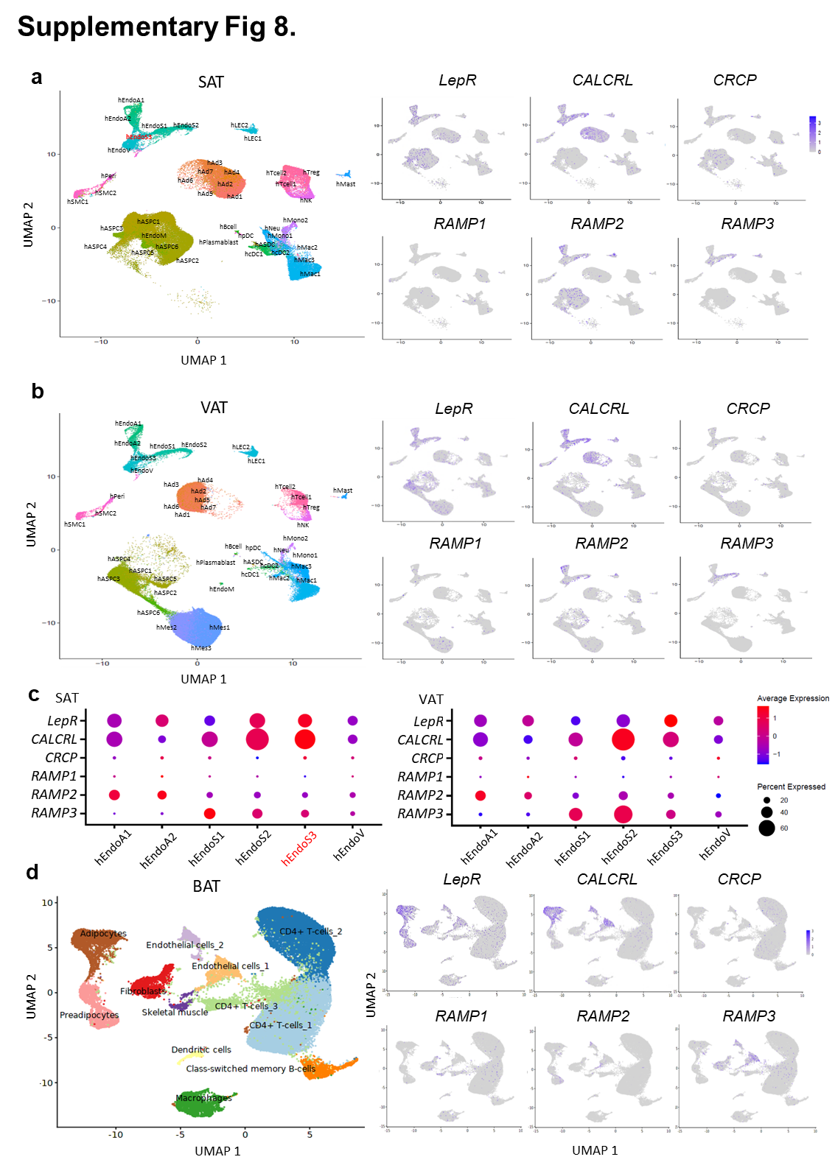Supplementary Fig. 8: Expression of LepR, CALCRL, CRCP and RAMPs in human WAT and brown adipose tissues. Related to Fig. 7. (a-b) Uniform manifold approximation and projection (UMAP) plots showing the landscapes of adipocytes, adipose stem and progenitor cells (ASPCs), vascular cells, lymphatic endothelial cells (LECs), smooth muscle cell (SMC), and immune cells in (a) human inguinal subcutaneous adipose tissue (SAT, n=86,064) and (b) perigonadal visceral adipose tissue (VAT, n=80,085). GEO accession number: GSE176067. The expression of LepR, CALCRL (encoding CRLR), CRCP (encoding RCP) and three RAMPs (encoding RAMP1, 2, and 3) in all clusters of cells is shown next to it. (c) Dot plot showing expression levels of 6 selected marker genes for different endothelial clusters that represent human endothelial arteriolar 1 (hEndoA1), human endothelial arteriolar 2 (hEndoA2), human endothelial stalk 1 (hEndoS1), human endothelial stalk 2 (hEndoS2), human endothelial stalk 3 (hEndoS3) and human endothelial venular cells (hEndoV). Larger dot means higher percentage of single cells expressing that gene, and smaller dot means lower percentage of single cells expressing that gene. Blue color represents the lowest expression, and red color represents the highest expression. The expression is logarithmically normalized. (d) UMA plots showing the landscapes of 36,590 nuclei from human brown adipose tissue. Access number: E-MTAB-8564. The expression of LepR, CALCRL, CRCP and three RAMPs in all clusters of cells is shown next to it.
Supplementary Table 1. Agonist and antagonist administration method, dosage and frequency.
Item |  | Drug | Injection method | Dose (concentration) | Frequency/Time point | Treatment protocol | UCP1
CGRP receptor | agonist | CGRPα (C0167, Sigma-Aldrich) | Direct injection to inguinal WAT site with 12 loci, each 1 μl | 0.2 mg/kg (0.5 μg /μl) | Once, 30 min before the starting of the treatment protocol | Cold/IF | ↓
 | antagonist | BIBN4096 (SML2426, Sigma-Aldrich) | Intraperitoneal injection, each injection for 100 μl | 1 mg/kg (0.03 mg/100 μl) | Twice, at Day 1 and Day 4 during the treatment protocol | CTR/IF | ↑
TRPV1 | agonist | Resiniferatoxin (RTX, AG-CN2-0534, AdipoGen Life Sciences) | Subcutaneous injection in three consecutive days | Day1 (30 μg/kg), Day2 (70 μg/kg), Day3 (100 μg/kg), (1μg/μl) | Triple, 4 weeks before the starting of the treatment protocol | Cold/IF | ↓
 | antagonist | AMG9810 (2316, Tocris) | Direct injection to inguinal WAT site with 12 loci, each 3.75 μl | 30 mg/kg (20 μg /μl) | Once, 30 min before the starting of the treatment protocol | Cold/IF | ↑
TRPM8 | antagonist | AMG333 (6874, Tocris) | Direct injection to inguinal WAT site with 15 loci, each 1 μl | 1 mg/kg (2 μg/μl) | Once, 30 min before the starting of the treatment protocol | Cold | ↓
IF: intermittent fasting

Supplementary Table 2. Primer sequences for qRT-PCR.

Gene | Forward primer (5’ – 3’) | Reverse primer (5’ – 3’)
Gapdh | CAAGCTCATTTCCTGGTATG | TCTTGCTCAGTGTCCTTGCT
Trpc1 | CAAGAT TTTGGGAAATTTCTGG | TTTATCCTCATGATTTGCTAT
Trpc2 | GATCCGGTTCATGTTCATCCT | GAGCGAGCAAACTTCCACTC
Trpc3 | TGACTTCCGTTGTGCTCAAATATG | CCTTCTGAAGCCTTCTCCTTCTGC
Trpc4 | TCTGCAGATATCTCTGGGAAGGATGC | AAGCTTTGTTCGAGCAAATTTCCATTC
Trpc5 | ATCTACTGCCTAGTACTACTGGCT | CAGCATGATCGGCAATGAGCTG
Trpc6 | AAAGATATCTTCAAATTCATGGTC | CACGTCCGCATCATCCTCAATTTC
Trpc7 | CGTGCTGTATGGGGTTTATAATG | GCTTTGGAATGCTGTTAGAC
Trpv1 | GCATCTTCTACTTCAACTTCTTCGTC | CCACATACTCCTTGCGATGGC
Trpv2 | CGGCACTTCCTCTCT | GTCGGTCACGGTCAA
Trpv3 | CAAGGACTGCCACCACCATC | CATCACAGTTGCCAGAGAGG
Trpv4 | GAGTCCTCAGTAGTGCCTGG | CAACAAGAAGGAGAGCAGTC
Trpv5 | CGTTGGTTCTTACGGGTTGAA | GTTTGGAGAACCACAGAGCCTCTA
Trpv6 | AACCAGCCTTCCACC | CCTCCATTAGCACCA
Trpm1 | TATCCTATGACACCAAGCCA | GGTCTTCCTTATTCTCCACG
Trpm2 | CAGATCCCAACCTACATTGACG | GAAGGTGTAGTTGAACATGGCGA
Trpm3 | CCTGTTCTTCTGGCA | GCTTCTCTGGCTCCT
Trpm4 | CCCTGAGGATGGTGTTGAGT | AGGAGCACTGGGATGTCAAT
Trpm5 | CAGATACTGAGGATGGCTGG | GGATCTTGGTGGATGTGCTA
Trpm6 | CCAGGTGCCGGTAATAACA | CTCTTGTGGCTGCCTTAGGT
Trpm7 | CGGAGCTGGTCGCACAATTA | CCTGGAAGACATCTGTGAGG
Trpm8 | TCCACGAGACTTCTTCACTT | GTGTATCTGAGGTCAGTCTT
Trpa1 | TGCTGCAGAAAAAAATCAAGTTGA | CCTTGGCTGAGAAGAAACTTTACACT

