Supplementary material

Table S1. Summary of the experimental conditions, the measured factor, and the F-tests p-value assessing the alignment of experimental rhythmicity with the 24-hour cosinor model calculation.
Individual serial number | Experiment | Type of measurement | Color code
1’ | 24-hours – baseline- no stimulus | Normalized siphon opening | Blue- dashed
2’ | 24-hours – baseline- no stimulus | Normalized siphon opening | Green- dashed
3’ | 24-hours – baseline- no stimulus | Normalized siphon opening | Gray
5’ | 24-hours – baseline- no stimulus | Normalized siphon opening | Orange
6’ | 24-hours – baseline- no stimulus | Normalized siphon opening | Black- dashed
8’ | 24-hours – baseline- no stimulus | Normalized siphon opening | Cyan- dashed
9’ | 24-hours – baseline- no stimulus | Normalized siphon opening | Red- dashed
4 | 24-hours stimulus every 2 hours | Normalized siphon opening | Blue
5 | 24-hours stimulus every 2 hours | Normalized siphon opening | Black
6 | 24-hours stimulus every 2 hours | Normalized siphon opening | Green
7 | 24-hours stimulus every 2 hours | Normalized siphon opening | Orange
8 | 24-hours stimulus every 2 hours | Normalized siphon opening | Cyan
9 | 24-hours stimulus every 2 hours | Normalized siphon opening | -
10 | 24-hours stimulus every 2 hours | Normalized siphon opening | -
4 | Stimulation every two hours | Recovery time | Blue
5 | Stimulation every two hours | Recovery time | Black
6 | Stimulation every two hours | Recovery time | Green
7 | Stimulation every two hours | Recovery time | Orange
8 | Stimulation every two hours | Recovery time | Cyan
9 | Stimulation every two hours | Recovery time | Purple
10 | Stimulation every two hours | Recovery time | Pink
4 | Stimulation every two hours | Electrophysiology (activity in 200 seconds) | Blue
5 | Stimulation every two hours | Electrophysiology (activity in 200 seconds) | Black
6 | Stimulation every two hours | Electrophysiology (activity in 200 seconds) | Green
7 | Stimulation every two hours | Electrophysiology (activity in 200 seconds) | Orange
8 | Stimulation every two hours | Electrophysiology (activity in 200 seconds) | Cyan

Table S2. BLAST analysis of Styela clava candidate clock‐gene homologs. Our behavioral findings are particularly intriguing given that canonical circadian clock genes well conserved across vertebrates and many invertebrates appear to be absent from ascidian genomes [38]. To explore this point, we examined the publicly available genome of the closely related species Styela clava (NCBI). We identified homologs of two genes previously reported to exhibit rhythmic expression in Ciona intestinalis (Hlf and E4bp4), as well as five additional genes that were non-rhythmic in that species [38] Consistent with earlier genomic surveys in Ciona, we did not detect clear homologs of the canonical vertebrate circadian genes (Per1-3, Clock, Bmal1-2, Cry1-2) in S. clava or in the available S. plicata genomes. But these results should be interpreted cautiously, owing to potential gene divergence, incomplete annotation, or lineage-specific loss, they raise the possibility that rhythmic behavior in ascidians is governed by noncanonical molecular or cellular oscillators rather than by a conserved circadian transcriptional feedback loop. Highly similar hits were retrieved with MegaBLAST, while more divergent hits were retrieved with Discontiguous MegaBLAST (BLASTn). Hits with E‐value > 1×10⁻⁵ or query coverage < 20 % were excluded as below our biological significance thresholds.
Gene Name | Source | Level of BLAST | Max Score | Total Score | Query Cover | E value | Per. Ident | Acc. Len | Comments
Casein Kinase I epsilon | Ciona genome | More dissimilar sequences (discontiguous megablast) | 737 | 737 | 27% | 0 | 78.17% | 2216 | The genes with the highest similarity to the human sequqnce
E4BP4 | Ciona genome | More dissimilar sequences (discontiguous megablast) | 49.1 | 49.1 | 8% | 1.00E-08 | 71.28% | 3616
FWD1 | Ciona genome | More dissimilar sequences (discontiguous megablast) | 870 | 870 | 55% | 0 | 74.25% | 2549
HLF | Ciona genome | More dissimilar sequences (discontiguous megablast) | 58.1 | 58.1 | 9% | 4.00E-11 | 66.49% | 3170
rev-erb | Ciona genome | More dissimilar sequences (discontiguous megablast) | 56.3 | 56.3 | 2% | 2.00E-10 | 75.64% | 2676 | to LOC120325544
ROR-A | Ciona genome | More dissimilar sequences (discontiguous megablast) | 215 | 336 | 33% | 1.00E-58 | 73.00% | 3791
RXR | Ciona genome | More dissimilar sequences (discontiguous megablast) | 372 | 372 | 50% | 5.00E-106 | 68.33% | 4312
BMAL1 | Human genome | N/A
BMAL2 | Human genome | N/A
CLOCK | Human genome | N/A
CRY1 | Human genome | N/A
CRY2 | Human genome | N/A
PER1 | Human genome | N/A
PER2 | Human genome | N/A
PER3 | Human genome | N/A
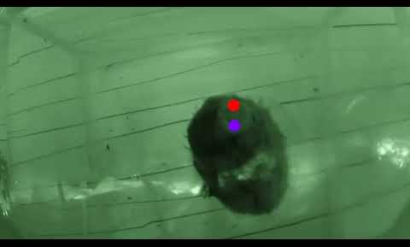

Video S1. Two-minute (downsampled) recording of siphon movement and tracking. The video was part of the basline behavior recordings, and includes no tactile stimulation in the experiment. The video includes a light transition, during which no behavioral response is observed (also be accessed via the following link: https://youtu.be/MCawKs2iVSs).

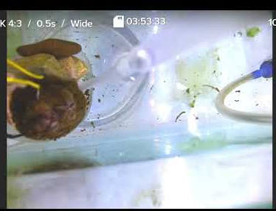
Video S2. An example of stimulating S. plicata while recording behavior and electrophysiology (also be accessed via the following link:
https://www.youtube.com/embed/IFIwt42Edg8?feature=oembed).

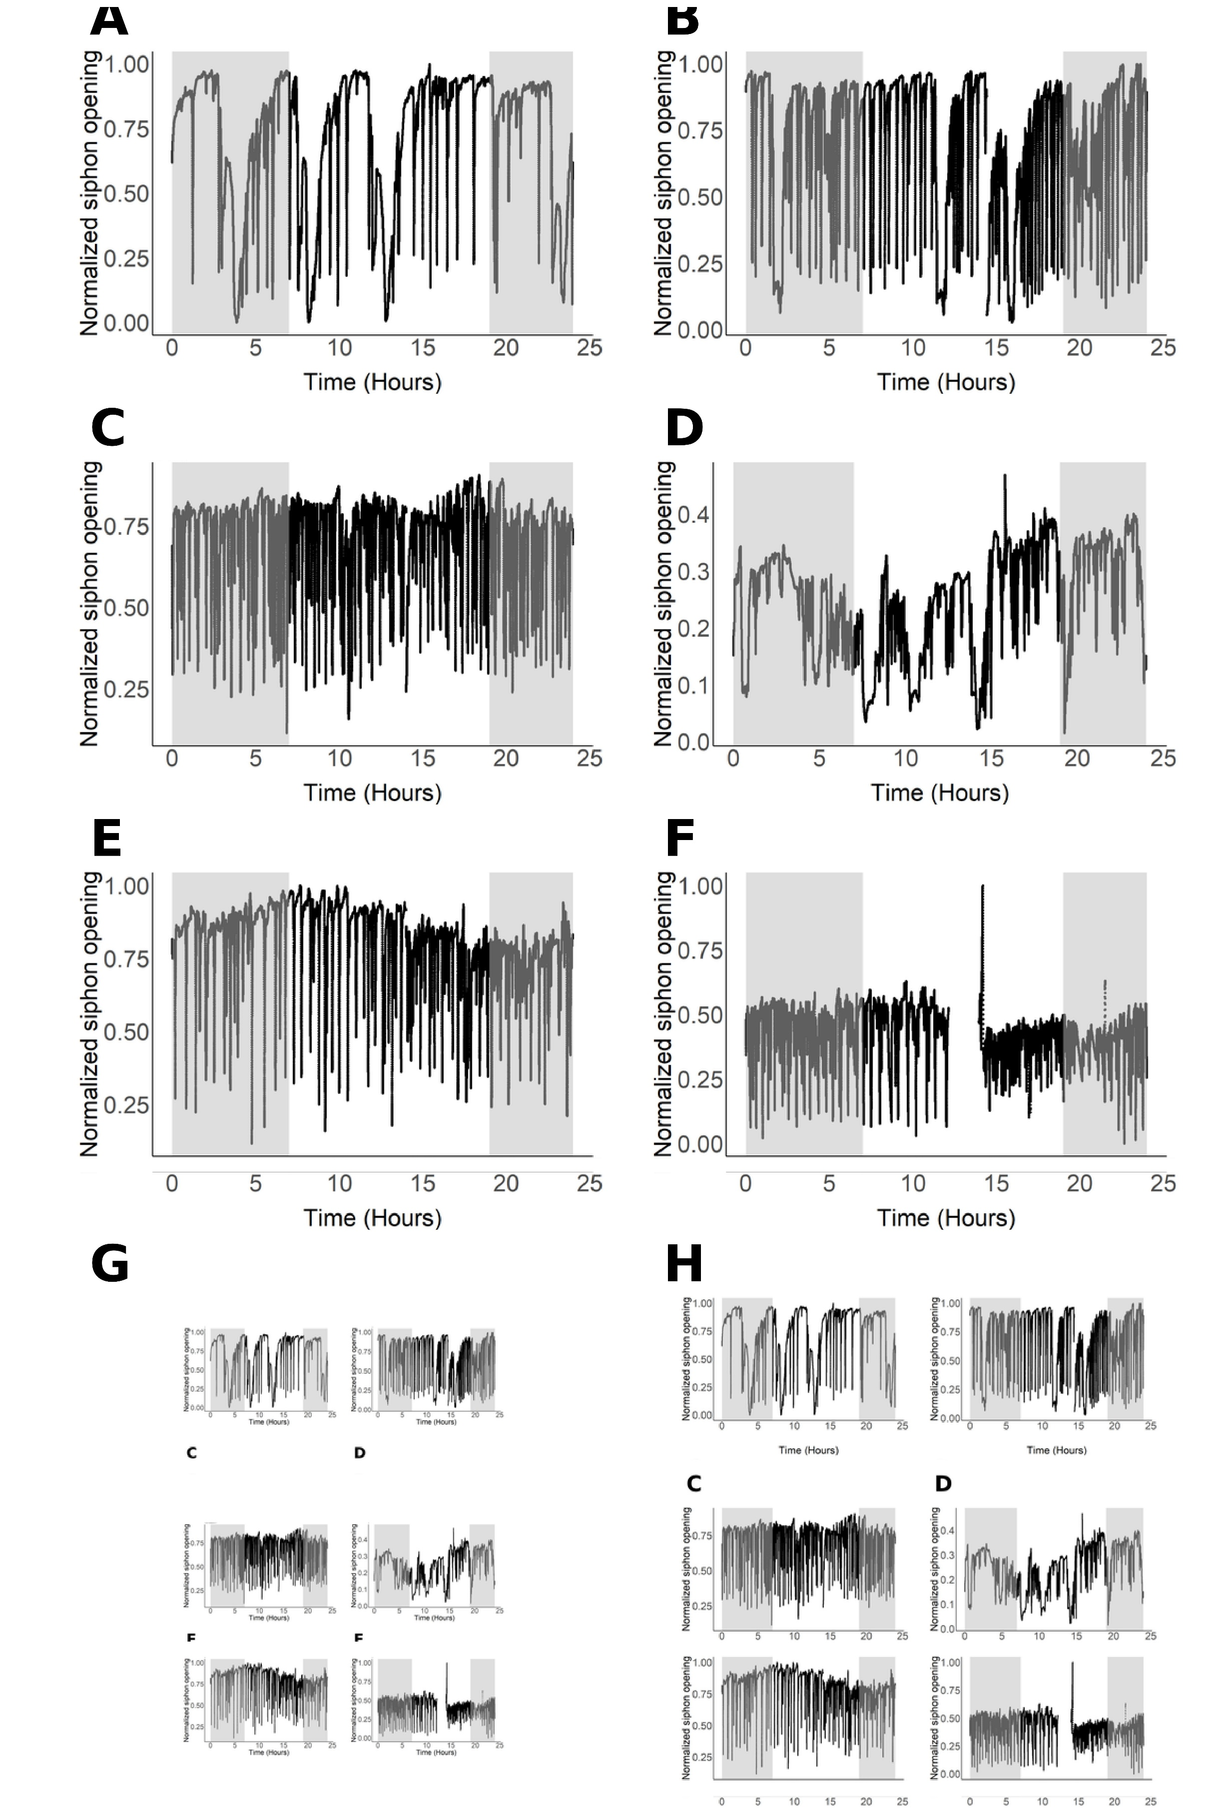

Figure S1. Raw siphon behavior during baseline experiments (Experiment I). Normalized siphon opening traces from individual animals are shown (black). Nighttime periods are indicated by the gray background.
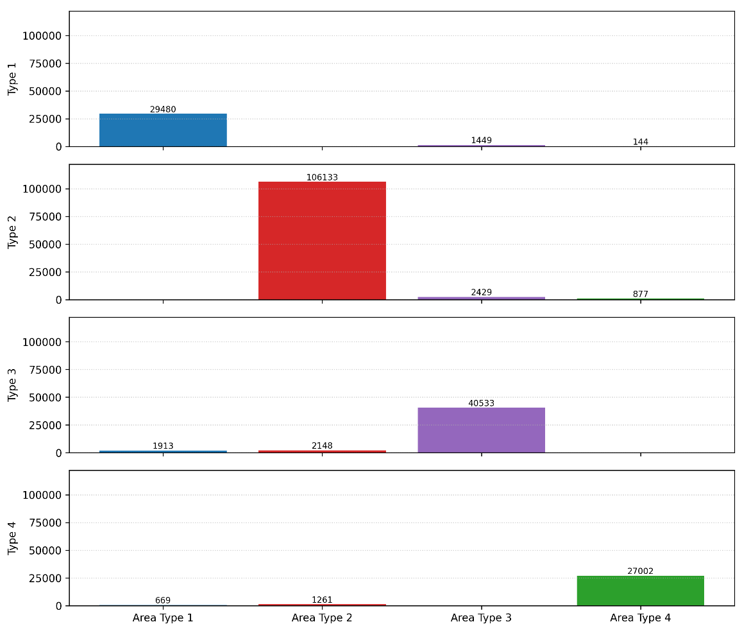
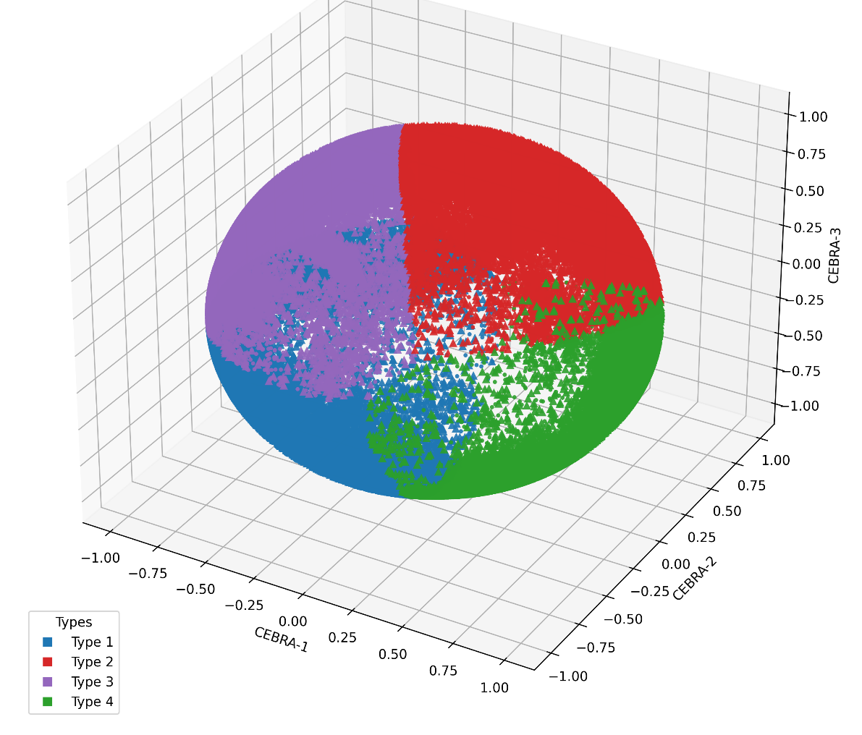
Figure S2 . Spike waveform embeddings and stability analysis using CEBRA. To characterize spike morphology within a compact and robust feature space, we employed the CEBRA (Contrastive Embedding for Behavior and Representation Analysis) framework [34]. CEBRA is a contrastive learning-based dimensionality reduction approach that embeds temporally ordered waveforms into a continuous low-dimensional manifold while preserving structural and temporal relationships among samples. In our context, this enabled the projection of high-dimensional spike waveforms into a feature space that captured subtle morphological differences and maintained temporal coherence across the recording. Compared with traditional linear techniques such as PCA, this representation provided greater stability and generalizability, facilitating the detection of recurring spike patterns within and across individuals [34]. To assess the robustness of this embedding and control for potential recording drift, we compared clusters derived from the first and second halves of each session. This approach allowed us to verify that waveform features remained consistent over time and that observed cluster structure reflected biological variability rather than temporal shifts in signal characteristics. (A) Three dimensional CEBRA embedding of spike waveforms colored by cluster identity (Types 1-4). Each point represents a single spike waveform embedded into a continuous feature space that preserves morphological similarity and temporal structure (circles represent the spikes from the first half of the recordings and triangles from the second half . (B) Quantifying the correspondence between second-half (triangle) spikes and the cluster boundaries defined by the first-half (circle) embeddings. Bars show the number of spikes from each type that fall within their own cluster area (diagonal) or within other cluster areas (off-diagonals), providing a control for temporal drift and confirming that cluster structure remains stable across the recording.


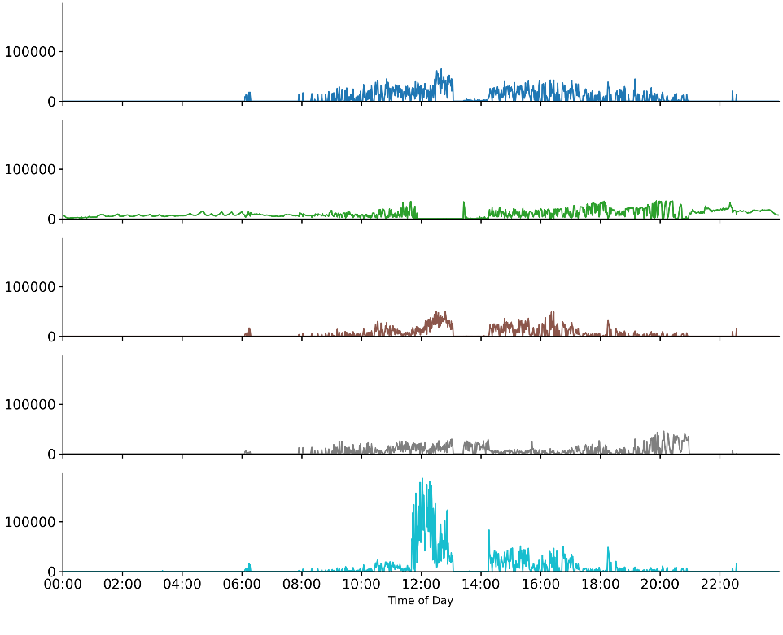
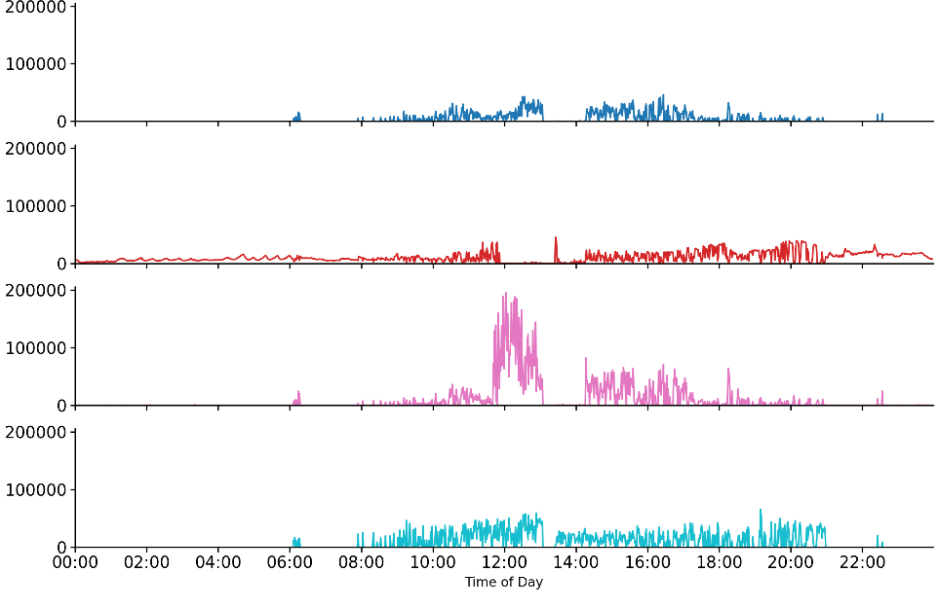
Figure S3. Comparison of raw spike counts using four- and five-type classifications. A&B): Spike count data from one animal, displayed with four-type (A) and five-type (B) classifications. C) Total spike counts summed across all animals over a 24-hour period. While using a valley-seeking algorithm to decide how many spike types we have. This figure present visually that 5 types doesn’t change the analysis significantly.

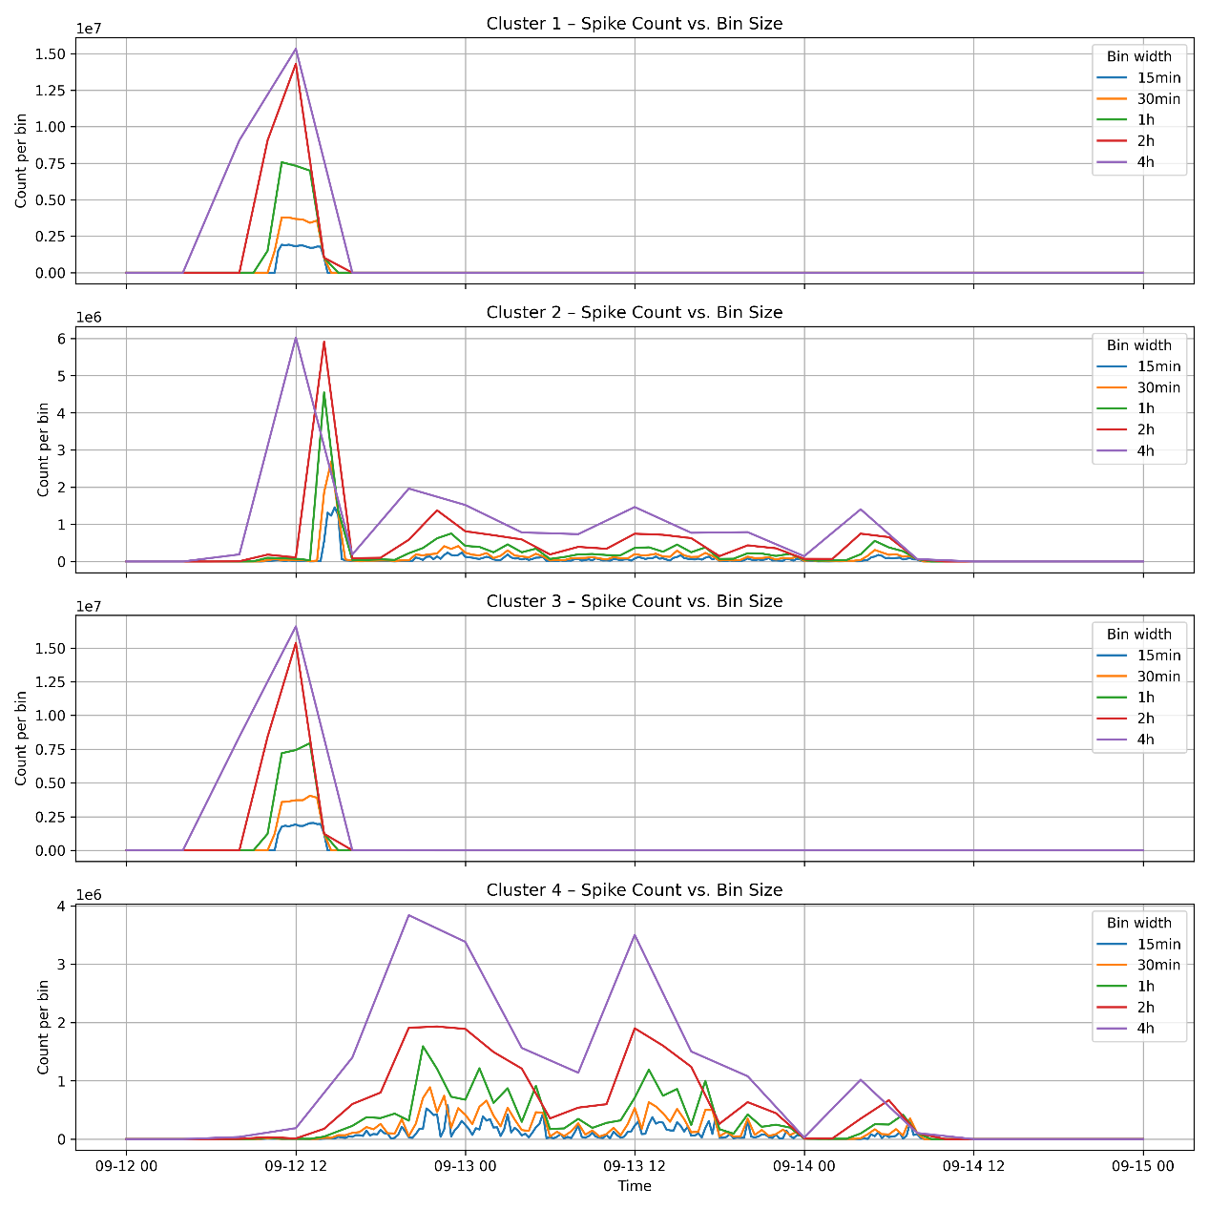
Figure S4. An example of bin-size sensitivity analysis across 48-hours recordings (experiment IV, animal 1) in the 4 spike types. We chose a 1-hour bin width for primary analyses, as it provided a balance between temporal resolution and noise reduction. Key trends were consistent across 1–2 hour bins, but smaller bins exhibited excessive variability and larger bins obscured event timing.

