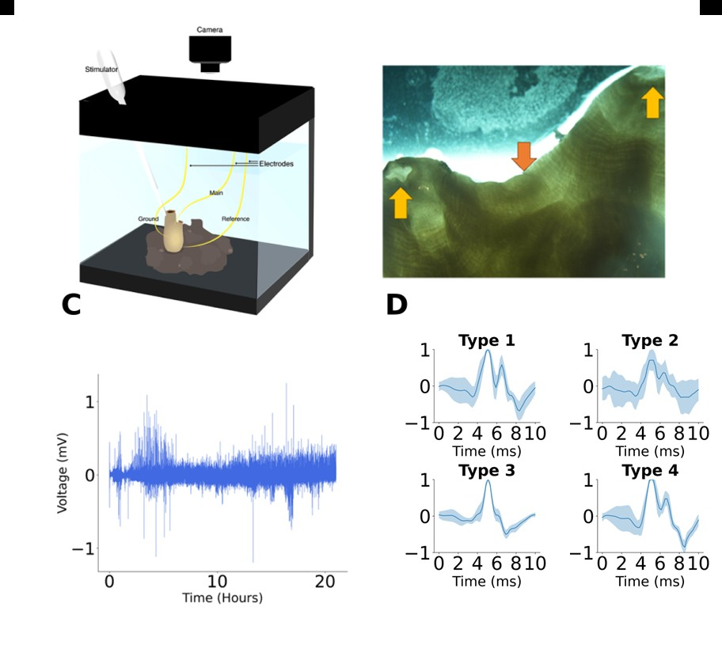
Figure 2. Experiment III experimental setup and representative electrophysiological recordings.
(A) Schematic of the recording setup showing electrode placement and behavioral monitoring. The main electrode was positioned on the cerebral ganglion, with reference and ground electrodes attached to the tunic. The stimulation probe and camera used for behavioral tracking are indicated. (B) Image of an adult Styela plicata after tunic removal. Yellow arrows indicate the siphons (oral siphon on the right), and the orange arrow marks the cerebral ganglion. (C) Ten-second segment from the recording shown in (C), illustrating typical spike activity. (D) Waveforms of the four identified spike types. Lines represent mean voltage, and shaded areas indicate standard deviation across detected events.

