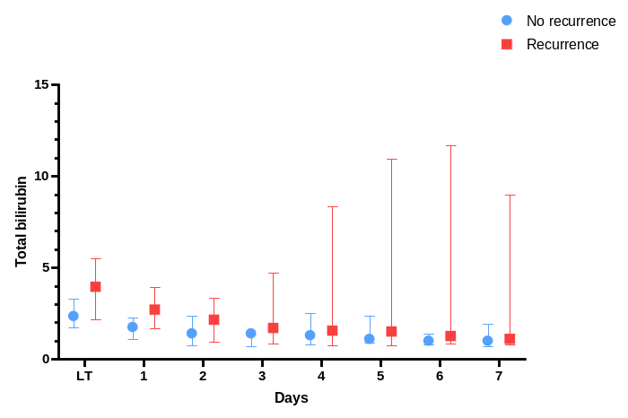
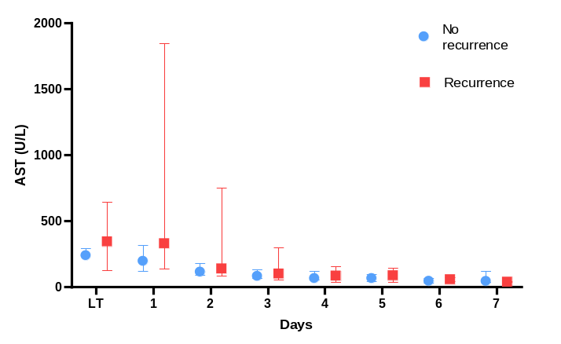
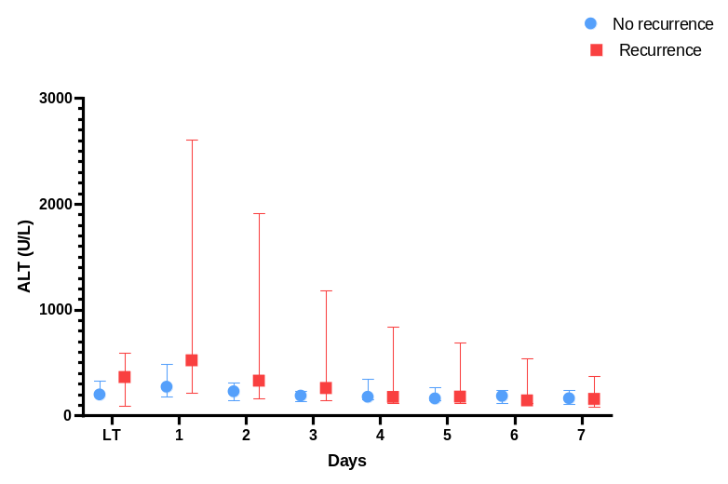
Supplementary Figure 1. Comparison of liver chemistry between recurrence group and no recurrence group, among beyond Milan

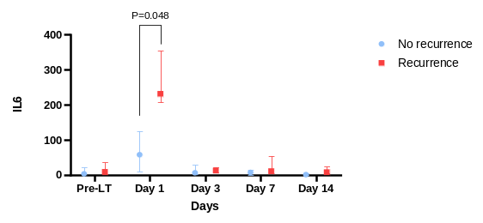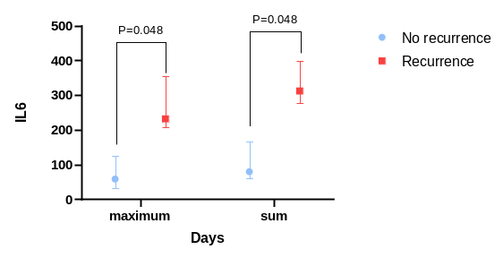
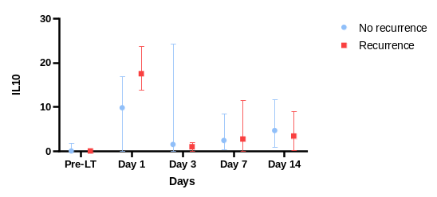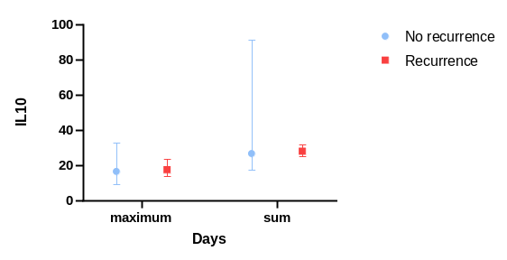
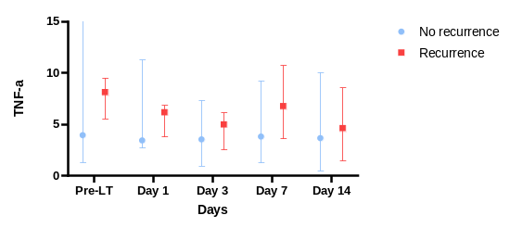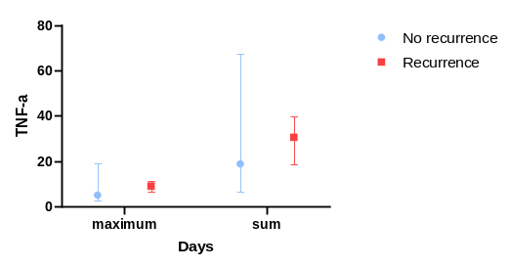
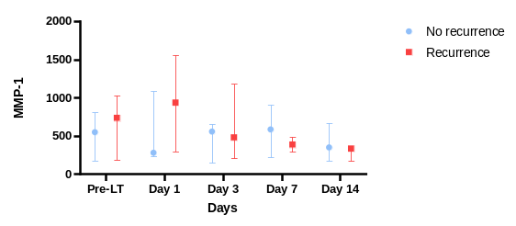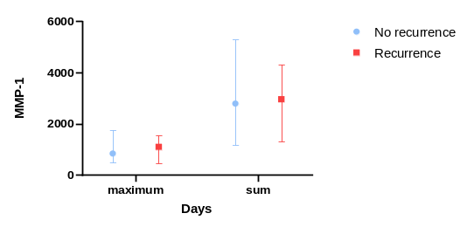
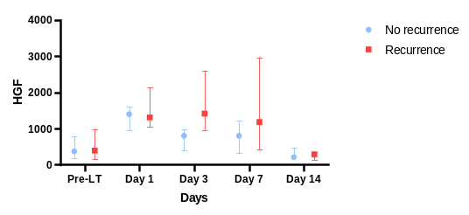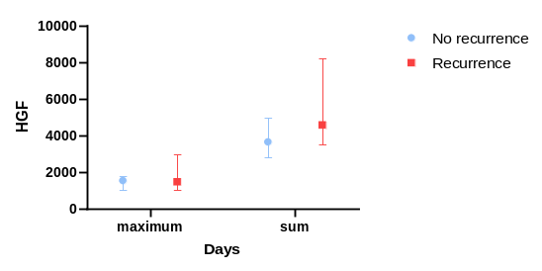
Supplementary Figure 2. Comparison of plasma cytokines between recurrence group and no recurrence group, among beyond Milan

 | No recurrence  (n=8) | Recurrence  (n=4) | P-value
Pre-transplant AFP (ng/mL) | 5.3 (2.9-21.0) | 36.9 (20.0-77.9) | 0.073
Pre-transplant PIVKA-II (mAU/L) | 67.5 (22-254) | 5449 (351-14777) | 0.028
Explanted graft pathology | 5 (4-5) | 8 (5-19) | 0.109
Median number of tumors (n) | 2.0 (1.1-4.8) | 8.4 (3.7-12.9) | 0.109
Median size of tumor (cm) | 4 (50.0%) | 4 (100.0%) | 0.208
Microvascular invasion | - | 1 (25.0%) | 0.333
Liver parenchyma at 2-week CT |  |  | 0.222
Normal | 6 (75.0%) | 1 (25.0%)
Partial congestion | 2 (25.0%) | 3 (75.0%)
Partial ischemia | - | -
Total volume, median (cm³) | 819 (791-832) | 946 (776-989) | 0.368
Normal volume, median (cm³) | 819 (750-832) | 855 (649-968) | 0.368
Congested volume, median (cm³) | 0 (0-40.5) | 89.5 (19.8-127.8) | 0.154
Congested proportion, median (%) | 0 (0-5.2) | 9.5 (2.1-16.9) | 0.154
Abbreviations: AFP, alpha-fetoprotein; PIVKA-II, protein induced by vitamin K absence-II; CT, computed tomography

Supplementary Table. Comparison of pre-transplant predictors and post-transplant outcomes between recurrence group and no recurrence group, among beyond Milan

