Supplementary material 1
Table S1 The genes overlapped between D. spathacea and chronic bronchitis
Name | Elements
Overlapped genes between D. spathacea and chronic bronchitis | NR3C2, NOS2, MMP3, FGFR1, SERPINA6, ALOX5, TTR, MMP8, CYP2C19, MDM2, EGFR, CD38, CXCR3, PIK3CA, FLT3, ADORA1, IL2, SYK, BCHE, G6PD, EPHX1, PDE5A, ADORA2A, MAPK8, CXCR2, ABL1, CHRM1, CD81, PRKCD, GSTP1, CFTR, SRC, ABCB1, PGR, CHRM2, ATP1A1, ADORA2B, NR3C1, BTK, CHRM4, MAPK14, GC, PDGFRB, TNF, LCK, PLA2G4A, MPO, AKT1, PIK3R1, STAT3, CCR5, F2, PTGS2, CHRM3, PDE4D, MCL1, MMP1, ADA, MMP12, CYP1B1, HSP90AA1, CASP3, MMP9, PARP1, PTPRC, ITGA4

Table S2 Effects of the ethanol extract of D. spathacea on NO production, IC₅₀ values, and cell viability in LPS-stimulated RAW 264.7 cells
Sample | Concentration (µg/mL) | Percentage of inhibition | IC₅₀ (µg/mL) | Cell viability (%)
Ethanol extract | 400 | 81.10 ± 2.10 | 25.34 ± 0.88 | 80.29 ± 0.65
Ethanol extract | 200 | 91.95 ± 0.61 | 25.34 ± 0.88 | 90.44 ± 2.63
Ethanol extract | 100 | 86.00 ± 1.64 | 25.34 ± 0.88 | 97.28 ± 1.54
Ethanol extract | 20 | 40.86 ± 1.19 | 25.34 ± 0.88 | 98.54 ± 2.75
Dexamethasone | 100 | 81.85 ± 1.48 | 14.18 ± 1.19 | 95.72 ± 2.07
Dexamethasone | 20 | 52.88 ± 1.23 | 14.18 ± 1.19 | 97.56 ± 1.57
Dexamethasone | 4 | 41.23 ± 1.71 | 14.18 ± 1.19 | 98.12 ± 1.54
Dexamethasone | 0.8 | 31.56 ± 0.78 | 14.18 ± 1.19 | 98.76 ± 2.11

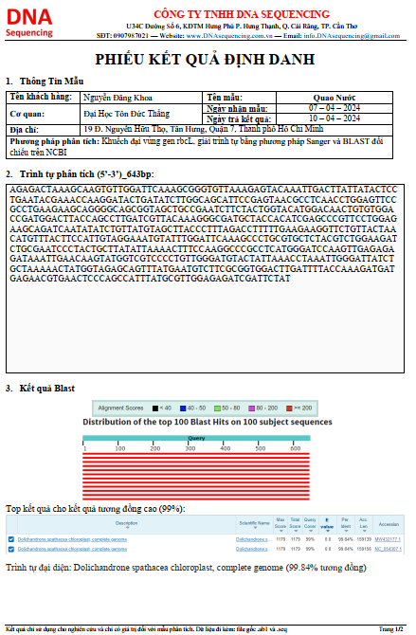 | 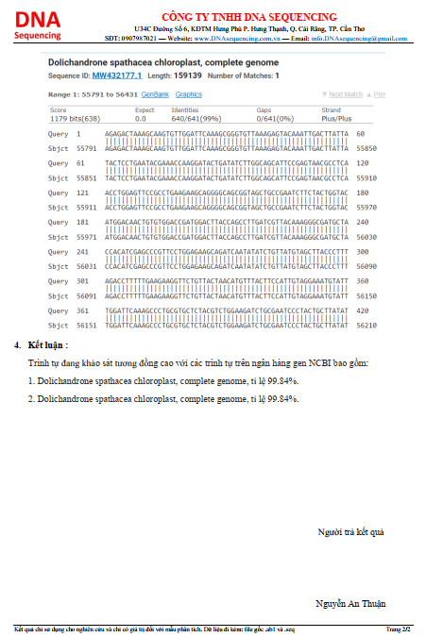
Fig. S1 The identification of D. spathacea was conducted using the rbcL gene region method

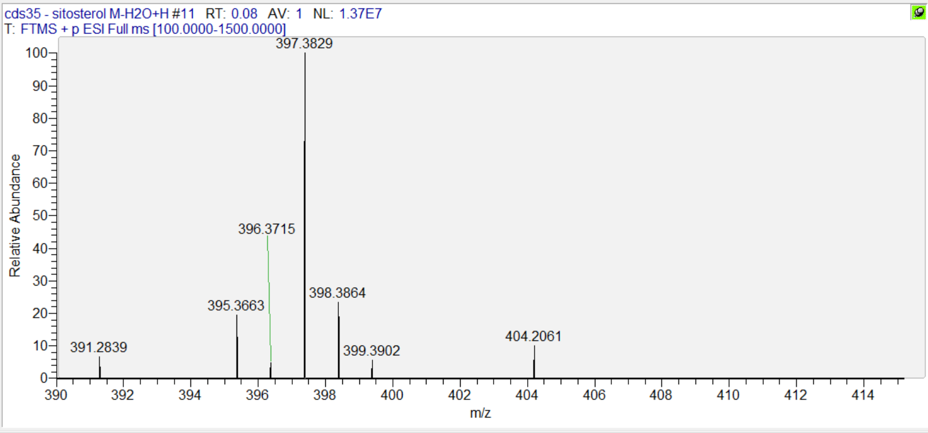
Fig. S2 HRESI-MS spectrum of beta-sitosterol (1)

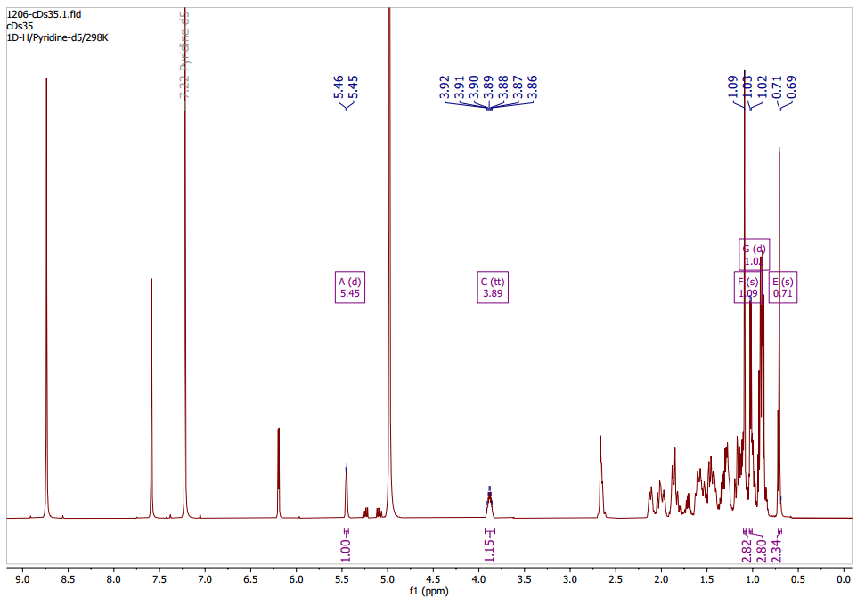
Fig. S3 ¹H-NMR spectrum (500 MHz, Pyr-d5) of beta-sitosterol (1)

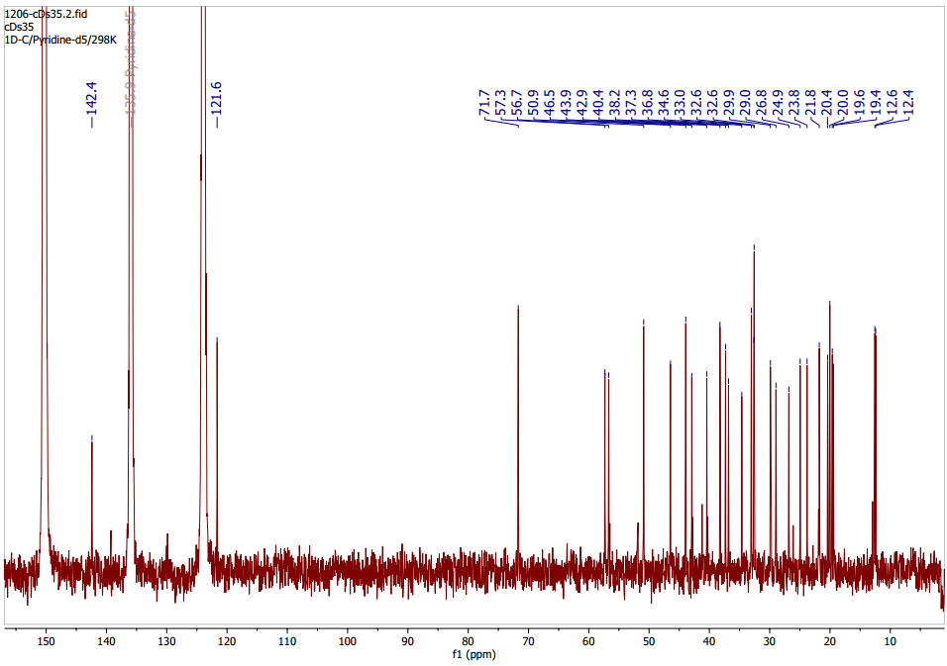
Fig. S4 ¹³C-NMR spectrum (500 MHz, Pyr-d5) of beta-sitosterol (1)

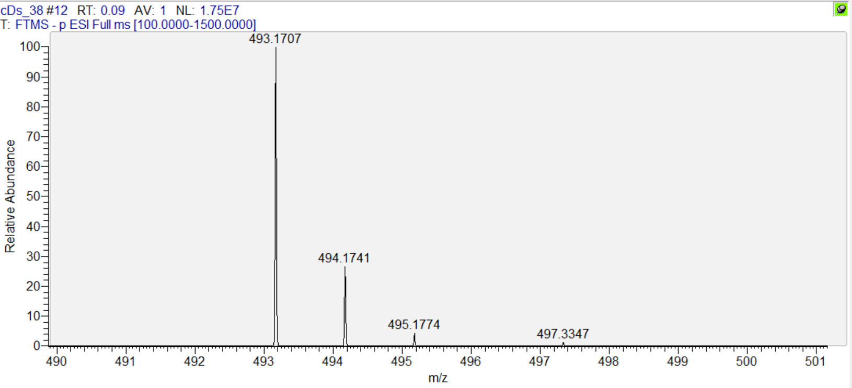
Fig. S5 HRESI-MS spectrum of 6-O-trans-p-coumaroyl ajugol (2)

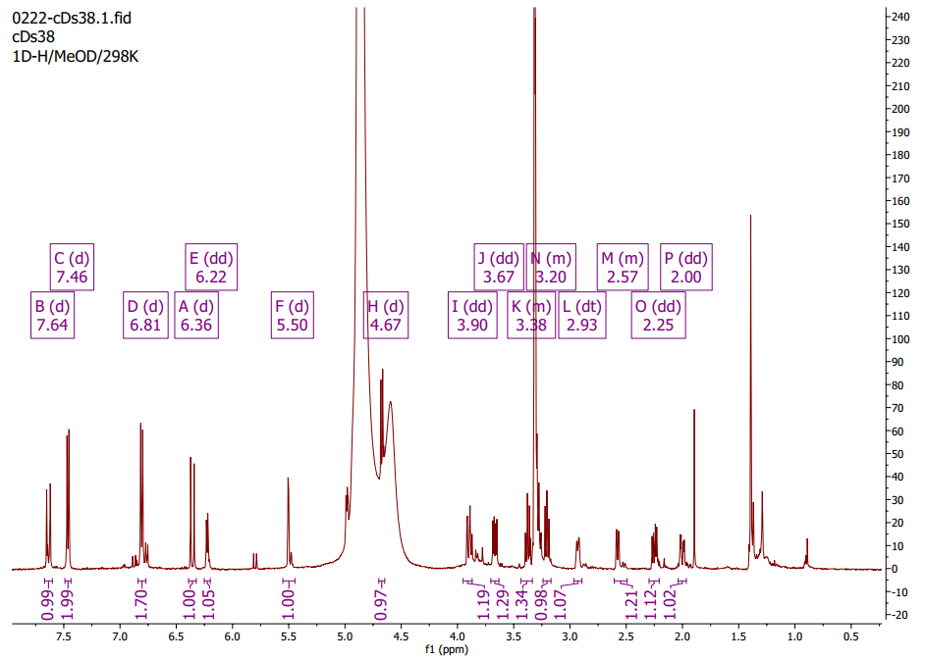
Fig. S6 ¹H-NMR spectrum (500 MHz, CD₃OD) of 6-O-trans-p-coumaroyl ajugol (2)
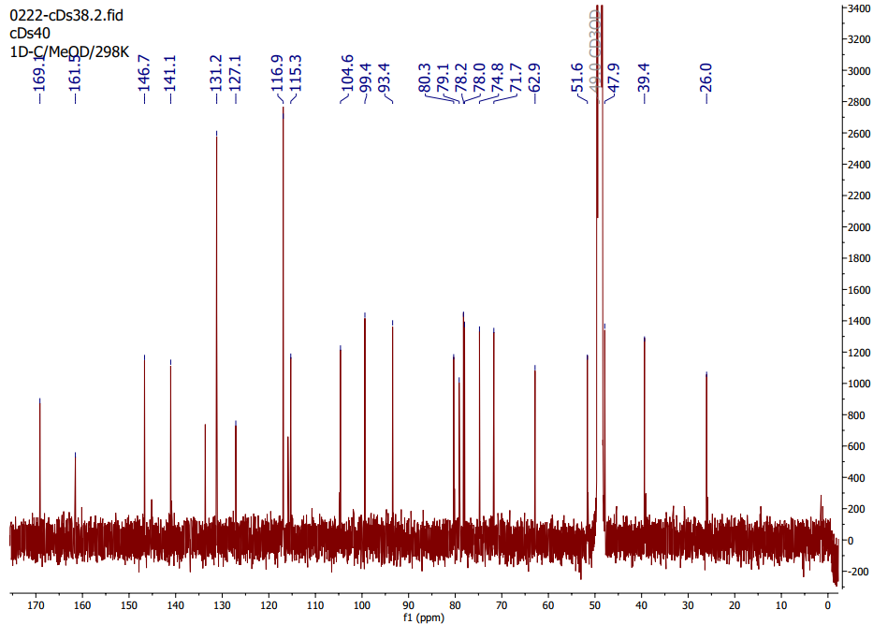
Fig. S7 ¹³C-NMR spectrum (500 MHz, CD₃OD) of 6-O-trans-p-coumaroyl ajugol (2)
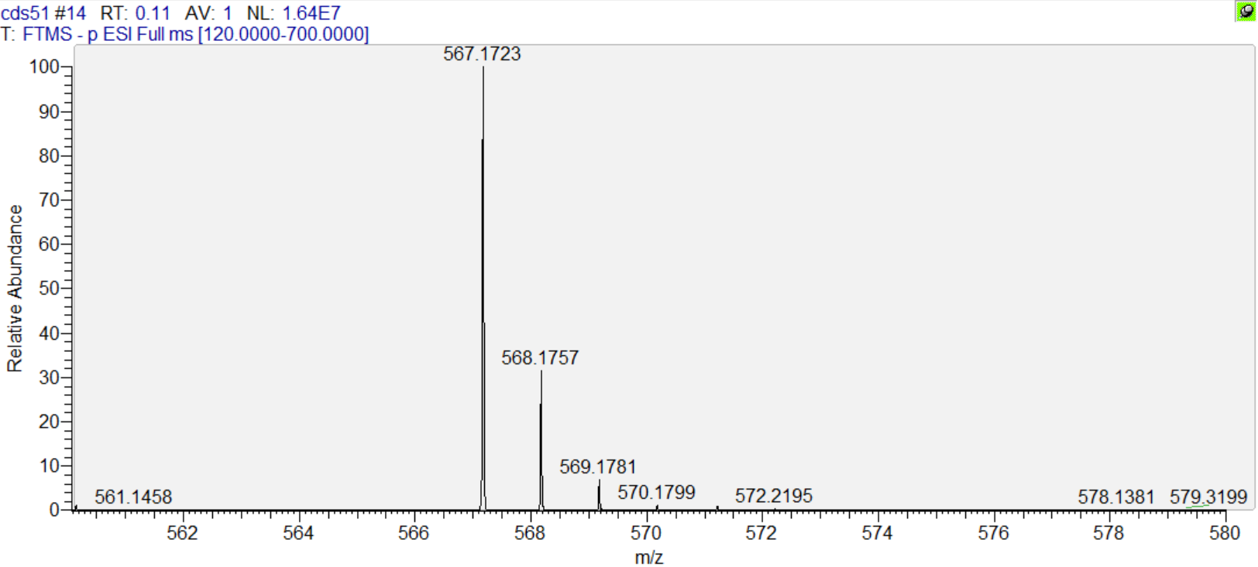
Fig. S8 HRESI-MS spectrum of 6-O-[(E)-4-methoxycinnamoyl]catalpol (3)

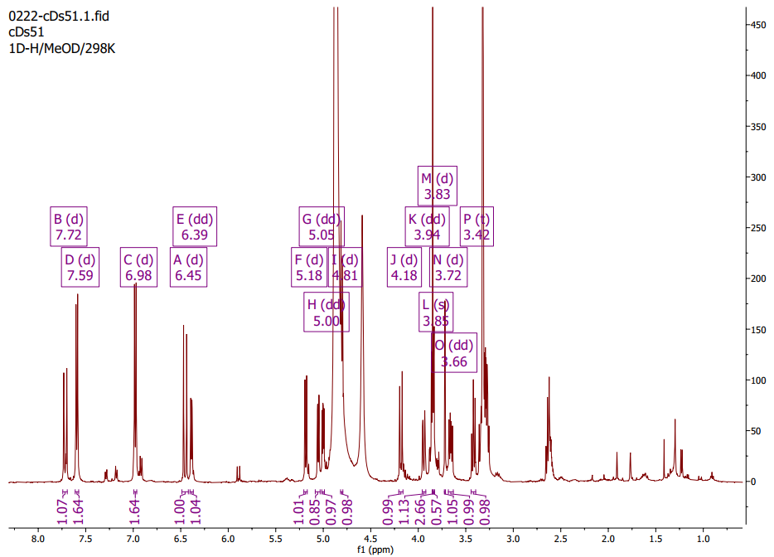
Fig. S9 ¹H-NMR spectrum (500 MHz, CD₃OD) of 6-O-[(E)-4-methoxycinnamoyl]catalpol (3)
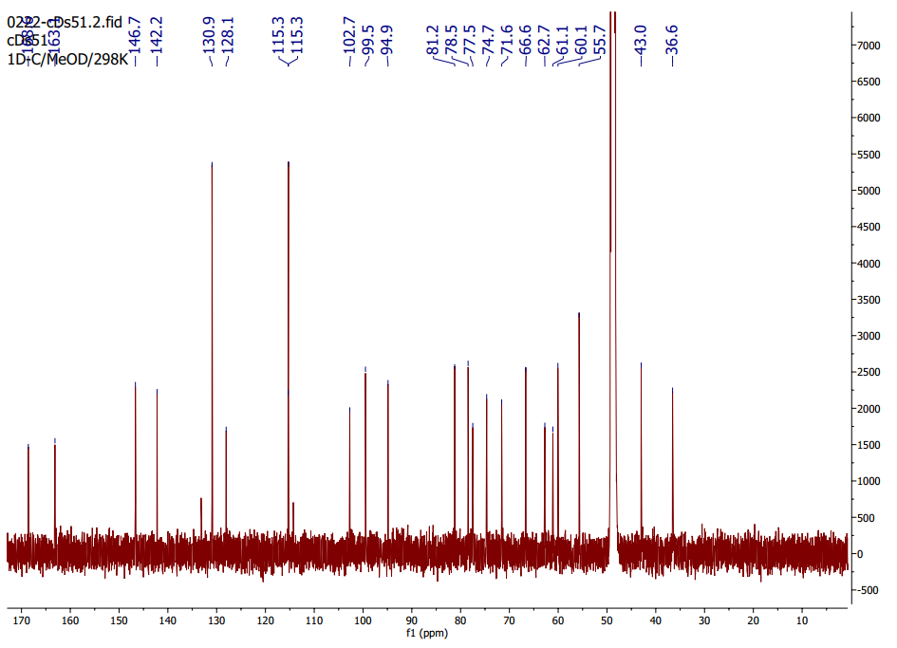
Fig. S10 ¹³C-NMR spectrum (500 MHz, CD₃OD) of 6-O-[(E)-4-methoxycinnamoyl]catalpol (3)
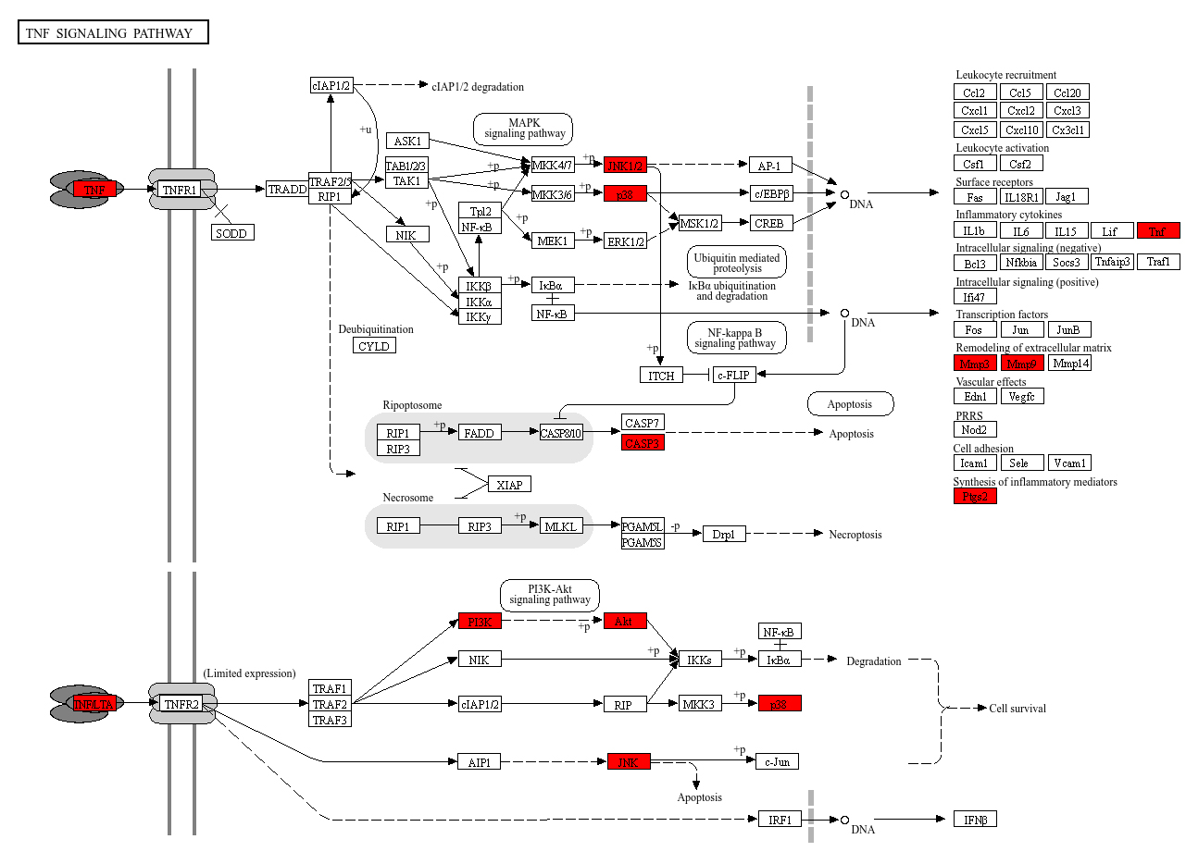
Fig. S11 The target genes of D. spathacea and CB involved in TNF signaling pathway
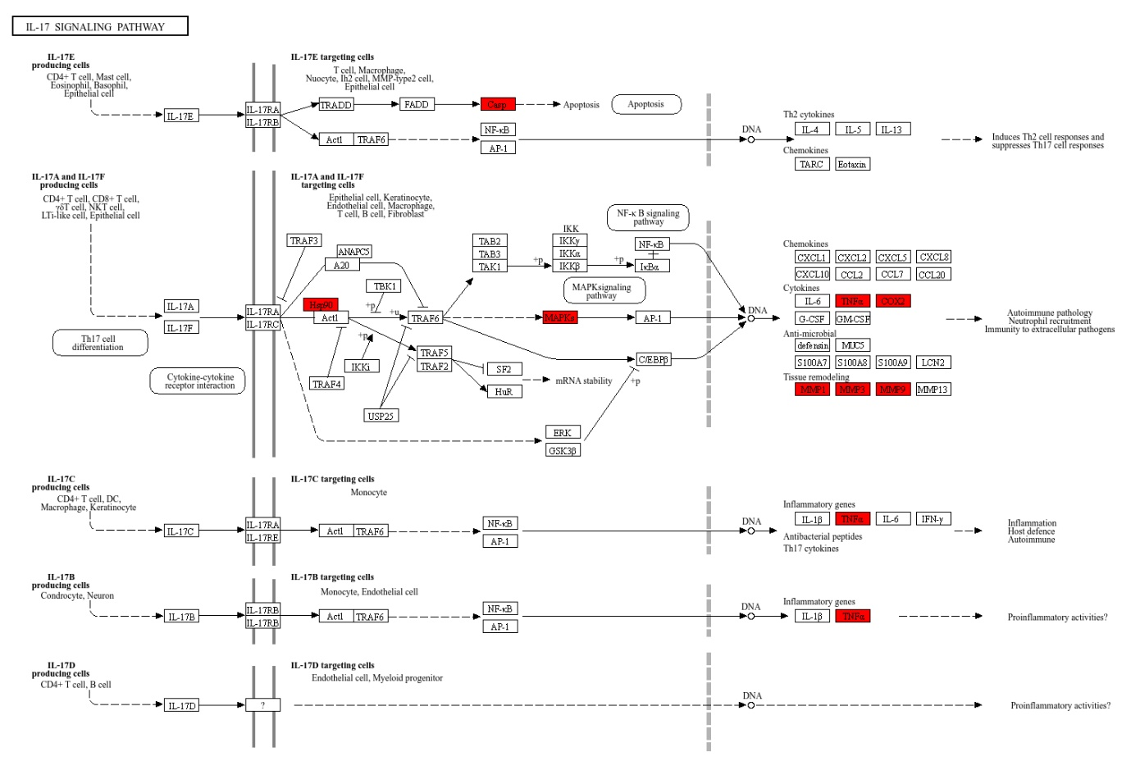
Fig. S12 The target genes of D. spathacea and CB involved in the IL-17 signaling pathway

