Supplementary data S1: list of 100 finger millet primers
SI.NO | PRIMER NAME | FORWARD PRIMER | REVERSE PRIMER | Tm (°C) | PRODUCT SIZE | SSR MOTIF
1 | UASBFM1 | TTCTCCAACTGCTTGACACACT | TACATCCAAGATCCATCCATCA | 56 | 396 | (TA)28
2 | UASBFM2 | TCCCCTTGTTTGTCATGTATTG | CGCCCTTAGCAGAACACTTATT | 56 | 354 | (AT)32
3 | UASBFM3 | ATTTGGGCTAGGGAGAGGTTTT | GCAACCGCCTTATTTGCTAGA | 56 | 398 | (AAT)6
4 | UASBFM4 | CAAAAGAGGACCCACCTATCAG | TCCTATGAGTTGGAGACTTGAGC | 55 | 394 | (AC)27
5 | UASBFM5 | GCTCCTCGTCCTCACCCC | ACGTACTCAGCGATGCACACC | 56 | 318 | (GGA)6
6 | UASBFM6 | GATTCTCACGAGGTGTCCCTAC | CTATCCAACCAACCACATTTCA | 56 | 304 | (TATC)18
7 | UASBFM7 | AAGACATGGAGACAAGAAGCAG | AGATTGTGAGATATACATGAGGGAG | 56 | 223 | (AT)37
8 | UASBFM8 | TTGGGTTCCTATGGTTTTCATC | TGGTGAACTAAATGGTGGTCAG | 56 | 220 | (TTG)6
9 | UASBFM9 | TCAACATCACCTCATTGCCTTA | GTGCAACAATTCAACAAGCTCA | 56 | 141 | (TGA)6
10 | UASBFM10 | GCTCCTCGTCCTCACCCC | ACGTACTCAGCGATGCACACC | 56 | 318 | (GGA)6
11 | UASBFM11 | GATTCTCACGAGGTGTCCCTAC | CTATCCAACCAACCACATTTCA | 56 | 304 | (TATC)18
12 | UASBFM12 | AAGACATGGAGACAAGAAGCAG | AGATTGTGAGATATACATGAGGGAG | 56 | 223 | (AT)37
13 | UASBFM13 | GGATGTGACCTTTTCTCCATTT | CACGACGACCTGCTATTACTTG | 56 | 302 | (GA)7
14 | UASBFM14 | ACGTGGTCCTCACTCTTCTCTC | TTGAATCTGGCATGGTACTCAC | 55 | 243 | (AG)11
15 | UASBFM15 | TTGGGTTCCTATGGTTTTCATC | TGGTGAACTAAATGGTGGTCAG | 55 | 220 | (TTG)6
16 | UASBFM16 | GCTCCTCGTCCTCACCCC | ACGTACTCAGCGATGCACACC | 56 | 318 | (GGA)6
17 | UASBFM17 | GATTCTCACGAGGTGTCCCTAC | CTATCCAACCAACCACATTTCA | 57 | 304 | (TATC)18
18 | UASBFM18 | AAGACATGGAGACAAGAAGCAG | AGATTGTGAGATATACATGAGGGAG | 57 | 223 | (AT)37
19 | UASBFM19 | ATGGTTGTGGAGAATTGAACCT | AGAAACCTCGGGTATGAAATGA | 52 | 381 | (AT)34
20 | UASBFM20 | AGAAGCATAGGAAAGGTGAAGC | CAAGCATTTTAGGAAGTGAAGC | 50 | 309 | (TGA)7
21 | UASBFM21 | ATTACTTTTGCCTCCTTTGCC | AGTTCCAATGTAGTCCAGCCTT | 52 | 212 | (TA)15
22 | UASBFM22 | TACACCGGAAGAAAGCCACTAT | TGGTGGATGGGAAGAAATAACT | 55 | 239 | (A)15
23 | UASBFM23 | CATGAATGCAACAACCAAC | CAGCCTCACTCTCCATATCA | 48 | 256 | (ATA)18
24 | UASBFM24 | GCCAATGATGATGAAGATGATG | CTTGTTACCCTTGCCATTTAGC | 52 | 285 | (ATG)23
25 | UASBFM25 | AGAACCCATAGGAGGACGATG | TTCTCTCTCTCTTTGACGACCC | 55 | 166 | (GA)27
26 | UASBFM26 | GAAACACCGAGTCAAAACAGAA | CTCCTCCTACACCAAACTCCAC | 56 | 372 | (AC)24
27 | UASBFM27 | TGAAGTCCCTTGATCCAAAGAT | GTCACTTGAGTTGTCGCTTGTC | 56 | 331 | (GAA)14
28 | UASBFM28 | CTCTCTACATCCCCGACCACT | AGGACAAGAACAACCTCACATACA | 48 | 305 | (CT)21
29 | UASBFM29 | GAAGCTGTCTCTGGTACACACG | TAATTGTCCCGTTCGTCTCTCT | 57 | 278 | (TG)6
30 | UASBFM30 | GGAGAGAATAAGGGGAGACCTG | CTGCTCTACCGCCAACAACTAC | 57 | 381 | (CCT)6
31 | UASBFM31 | ATGATCTCGATGGCTCTTTGAT | AAATGATACATGGTGCCTCACA | 52 | 258 | (G)15
32 | UASBFM32 | CTTCTAAACCCAATCGTCCAAT | AGGCTTGCTTGATCTTGATTCT | 52 | 351 | (GAT)12
33 | UASBFM33 | ATTTTCTCCTCCCTTTCTCACC | TTCTACAACTGGATGGATACCG | 53 | 384 | (AG)21
34 | UASBFM34 | ACTATCAACGTCTGCTCCTCCT | TACGTGCTGGTTGTGTTAGGTC | 56 | 208 | (TA)25
35 | UASBFM35 | TTACCCCTGACACACTCACAAG | CACGATGCAGAGTTGGAAATAA | 55 | 279 | (TC)10
36 | UASBFM36 | CATCTTCACCTTCACGTACCC | ATGCTTCATCTTACTGACTGCG | 56 | 204 | (ACG)6
37 | UASBFM37 | GAGCGCCTACGCATTAGTTTAC | ACCCAGGAGAAGAAGAAGAAAGA | 50 | 217 | (TTC)9
38 | UASBFM38 | TTGCTACAATGGCACTAACTGG | TAATAGCCAGGGAAGTTGCAGA | 55 | 387 | (TC)12
39 | UASBFM39 | CACTCTGGACCGAATAATCCAT | ACGACGATTTCCTCTTCCTCTT | 48 | 372 | (TCA)6
40 | UASBFM40 | AAAGTGTTAGGGCAAGAGGGAT | TCTTAGTGCCTCGTACATCCAA | 65 | 280 | (TAAT)8
41 | UASBFM41 | GTCCTTTGTGAGTGTGCTGGT | AACCGCCGCTACTTGTTATTT | 56 | 286 | (AT)24
42 | UASBFM42 | CTTACAAAATCCAAGACCAGCC | ATCGCTTCTCCTCCTCTTTCTT | 48 | 277 | (AC)9
43 | UASBFM43 | TCTGTCAATGCCTTTTCAAGTG | GGAGACTAGCAATAGACGTGCC | 46 | 282 | (CAA)7
44 | UASBFM44 | GGTTAAGAGAGACATGAAGGCG | TAAGAACTGGTTTGGGTGACAA | 50 | 383 | (TGT)9
45 | UASBFM45 | CTTGGTGTTTGGTGTATGCTTT | GGTTCGAGGAAGCTCTTGTTTA | 46 | 116 | (ATT)6
46 | UASBFM46 | ATGTCTGTCTCTGAACCAACGA | GAATGAAACCTTCCGTCCTG | 48 | 360 | (AAT)6
47 | UASBFM47 | TGAAAATACCGCCTATGCTTCT | GTTACACCAAATAGTGGCCCTG | 55 | 387 | (AG)10
48 | UASBFM48 | GTTGCTACTCTCTCGCTCCATT | TCTGAACTTGTCCTGATGCAGT | 56 | 294 | (TA)32
49 | UASBFM49 | ACCCCACCCCGTCTAACTAC | CTTGCTCTCTCGCAATTTCTCT | 55 | 195 | (CG)7
50 | UASBFM50 | ATGGCCTCTTGATTGTCTCTGT | GCAAAATTATCGTGAAGCACC | 53 | 288 | (ACA)6
51 | UASBFM51 | CCAGCTAGGGATAAGACCACAT | CACAATGGAAGAGAGGGAGAAC | 53 | 189 | (CT)8
52 | UASBFM52 | TTCTTGTGGTCTTGAGCTTTGA | TTGTCCCAAGCCTAATAAAGGA | 51 | 156 | (TCT)9
53 | UASBFM53 | AGAAAGGGAAGATCCAAGAACC | TAGGTTGCTCATGTGAATTTGG | 53, 54 | 198 | (AG)13
54 | UASBFM54 | GCTCCTCGACATACTGCTTCTT | ACCTCTCCTTCCCCGAGTT | 60 | 400 | (GCG)6
55 | UASBFM55 | AAAACGAGATTGGAAGCTGAAG | TACGCTGGAATGTATATGCGAC | 51 | 353 | (GA)16
56 | UASBFM56 | TCTCTTTCTCTGTAACTGGGGC | ATTATACTGGTTCGGGGAGAGC | 52 | 239 | (CA)15
57 | UASBFM57 | AGGAACCATTCAAGGAGAGCTT | TGAGGAGTATTTGCCTATTCGC | 53 | 373 | (G)12
58 | UASBFM58 | CAAGGTTTTATTCCACCAATGC | TGACAACTCAGGTTAATCACGC | 54 | 365 | (AT)18
59 | UASBFM59 | CCAGAAGAAGCGTCGGAG | CCGTCCCCACTAGAACCTT | 53, 54 | 400 | (G)10
60 | UASBFM60 | GCGAACTATTAAGACCATCTAACGA | GTCGGCAACAGGTGATTTCT | 54 | 236 | (TCTA)10
61 | UASBFM61 | ACAGTACAGGTCAGGTGGGC | CCAGGTACACGCCTTTGGTA | 56 | 385 | (A)107
62 | UASBFM62 | CGACCTTTTGAATCTTTGTTCC | CTCAGTGCTCTTCGGGATCTAT | 51 | 333 | (AT)8
63 | UASBFM63 | ACAAAGGGTGGTTGTAGTCGTT | AGATCACGCCCTATTCCCTC | 53,54 | 303 | (GA)26
64 | UASBFM64 | GCCCCTCTTTAGCTCTATCTCC | TGCAAGTTTCTCTCTCCTAGCC | 58 | 347 | (TC)12
65 | UASBFM65 | GCCGGTATCCTCATGGTATTTA | CAAAAGTTGATCCCTAGCAACC | 53 | 273 | (AG)8
66 | UASBFM66 | ATCGAATGGAACTCTGAAGGAA | TCTTGCTCAGGCTAAAGGAGAC | 51 | 218 | (GA)15
67 | UASBFM67 | TATCTAACGGATGCAAACATCG | CACTGATTGACCCTAGAGCACA | 51 | 260 | (AG)10
68 | UASBFM68 | TGGGAATTTTGTTTGGCTTC | GCCGAGTATTTGTTTGTTTGCT | 48 | 299 | (GT)8
69 | UASBFM69 | GCCTTTCAGCCGTTCATCT | GAGGGAGAGCGAGAAGGAGT | 53 | 391 | (GCG)6
70 | UASBFM70 | CTCGATTAGGTGCCAATGTGTA | GAGAAAGTGCAGGCCAAGTAGT | 53 | 302 | (TC)10
71 | UASBFM71 | CCGCAAGAAATTAGTAGCAAGG | GATCGAGACAGGGACTCACAC | 53 | 303 | (TC)43
72 | UASBFM72 | TTCAAAGCTGACTGAAAGGTGA | ATGGCAACAGAGCGAATAATG | 51 | 366 | (AT)8
73 | UASBFM73 | CTGGAGAGGAAATGCAAGAAAC | TGCGTTCAAGAGACTAAATGGA | 53 | 335 | (AAC)8
74 | UASBFM74 | CCTACAGAATCCAGATCGAACC | TCCTGATAGTTGCTTTGTGTGC | 55 | 399 | (GA)11
75 | UASBFM75 | GTCACCAAATGTAGCAATCCAA | GTAAATCACAAGTCACGGCTCA | 51 | 372 | (CGC)6
76 | UASBFM76 | TGAGTTCCCCTCTAACTACCGA | AGTTGGTATCTGTTCCTACCGC | 60 | 294 | (TC)7
77 | UASBFM77 | TTGATAGAGAGGCAAAGAGCAA | CGATGGTTCGTAGATTTTCACA | 55 | 286 | (TG)7
78 | UASBFM78 | GTTCCTTTCGACCTTTCCTTCT | TAACCCTAACTCCACATCCACC | 56 | 244 | (GA)29
79 | UASBFM79 | CAGTGAGACCGAAGAATTTGA | AAGTGTTAGGACAAGAGAGATGTTC | 57 | 327 | (AT)13
80 | UASBFM80 | GGCTAGTCTCAATGGATCTTTCA | CGTGCAAATGGTCGTTAGG | 57 | 383 | (AG)8
81 | UASBFM81 | AAGAGCTGATAGGAGCACAAGC | AGAAGAAGAAGGAGGAGGAGGA | 55 | 368 | (TCA)8
82 | UASBFM82 | ATCATCATCTCCTCCTCCTCCT | ACTGAAGGGTTGCATGGATTAG | 58 | 339 | (CTT)9
83 | UASBFM83 | AGTCAACTTTCAATCACCGCTT | TATATGCCACTTTCCCTATGGC | 55 | 355 | (TA)15
84 | UASBFM84 | CCTCAACTCAACTCCTCACCTC | TCTATGACAGCAGGGAAGGG | 55 | 371 | (TC)19
85 | UASBFM85 | GTTGTTTCGTCAAATGTTGTGG | GGGCTACTGTCATGCAATCTTT | 55 | 363 | (AG)20
86 | UASBFM86 | CATTCCTATCTCTCTCTCCTTCTTGT | GTATCCAACCCACCACTGAAAG | 60 | 400 | (TG)6
87 | UASBFM87 | ATTGTGTCATCAGGGCTTTTCT | CTCCAGGTATCAAAGGGCACTA | 55 | 345 | (AG)9
88 | UASBFM88 | CGACATGGTCTGTGATGAGAGT | TGTTACTGTCCTGGCTATGTGC | 59 | 363 | (AT)8
89 | UASBFM89 | CATCTACGTCCTCATCCTCCTC | GGACTACAGATCCAGGGTGTTC | 55 | 392 | (TCG)6
90 | UASBFM90 | AAGAGGAAAGGACCCACGTTAT | ACGATGGTAGGTATGACAAGGC | 55 | 396 | (AG)9
91 | UASBFM91 | CCATCGTTTTCATCCCTAGTTC | CATGTTTGATGTCGGAACAGAT | 55 | 317 | (AT)6
92 | UASBFM92 | GCCGAAGAACCAGACGAG | CTTCCGTTTGAGGCCATCT | 56 | 381 | (GCG)6
93 | UASBFM93 | AGAACGGTGTCATGTTGATCTG | ACTACTCTGTTGTCGCTGGGTT | 56 | 339 | (TTA)6
94 | UASBFM94 | TTTCGGCTTAGTTGAGAAGAGC | TTATCGAGCGTTTGTCTTGATG | 56 | 398 | (CT)8
95 | UASBFM95 | TAATTCTTTGTCGGAGCTTTGC | CTTGGCTTCTCCTCATCGTC | 53 | 298 | (CCT)11
96 | UASBFM96 | TGGGTTTGATGCAGGTATATGA | CCCAATGCTACTCAAGGAAATC | 56 | 382 | (TTG)6
97 | UASBFM97 | GGGGATGATACTAGGTTTTCTGC | CACGTATTCTCTGTCGTGTCGT | 57 | 335 | (AAG)10
98 | UASBFM98 | GCGCACTGAATAATCCTCAATC | CAACGAAGTAACCTGACACCAA | 56 | 371 | (GA)7
99 | UASBFM99 | TCAGACGCAAACAAAGACATTC | GGAGATGATACTACGAGTGGGG | 55 | 321 | (AC)10
100 | UASBFM100 | GCACCTCTGGAGTAACGAAAGT | AATTAGCAGAAGCCACCTGAAG | 57 | 363 | (GT)16

Supplementary data S2: Primers amplified in two browntop millet genotypes
SI. NO | NAME | SSR MOTIF | FORWARD PRIMER | REVERSE PRIMER | Tm (°C) | PRODUCT SIZE
1 | UASBFM5 | (GGA)6 | GCTCCTCGTCCTCACCCC | ACGTACTCAGCGATGCACACC | 56 | 318
2 | UASBFM10 | (GGA)6 | GCTCCTCGTCCTCACCCC | ACGTACTCAGCGATGCACACC | 56 | 318
3 | UASBFM16 | (GGA)6 | GCTCCTCGTCCTCACCCC | ACGTACTCAGCGATGCACACC | 56 | 318
4 | UASBFM26 | (AC)24 | GAAACACCGAGTCAAAACAGAA | CTCCTCCTACACCAAACTCCAC | 56 | 372
5 | UASBFM41 | (AT)24 | GTCCTTTGTGAGTGTGCTGGT | AACCGCCGCTACTTGTTATTT | 56 | 286
6 | UASBFM4 | (AC)27 | CAAAAGAGGACCCACCTATCAG | TCCTATGAGTTGGAGACTTGAGC | 55 | 394
7 | UASBFM14 | (AG)11 | ACGTGGTCCTCACTCTTCTCTC | TTGAATCTGGCATGGTACTCAC | 55 | 243
8 | UASBFM22 | (A)15 | TACACCGGAAGAAAGCCACTAT | TGGTGGATGGGAAGAAATAACT | 55 | 239
9 | UASBFM47 | (AG)10 | TGAAAATACCGCCTATGCTTCT | GTTACACCAAATAGTGGCCCTG | 55 | 387
10 | UASBFM92 | (GCG)6 | GCCGAAGAACCAGACGAG | CTTCCGTTTGAGGCCATCT | 56 | 381
11 | UASBFM77 | (TG)7 | TTGATAGAGAGGCAAAGAGCAA | CGATGGTTCGTAGATTTTCACA | 55 | 286
12 | UASBFM81 | (TCA)8 | AAGAGCTGATAGGAGCACAAGC | AGAAGAAGAAGGAGGAGGAGGA | 55 | 368
13 | UASBFM28 | (CT)21 | CTCTCTACATCCCCGACCACT | AGGACAAGAACAACCTCACATACA | 48 | 305
14 | UASBFM39 | (TCA)6 | CACTCTGGACCGAATAATCCAT | ACGACGATTTCCTCTTCCTCTT | 48 | 372
15 | UASBFM68 | (GT)8 | TGGGAATTTTGTTTGGCTTC | GCCGAGTATTTGTTTGTTTGCT | 48 | 299
16 | UASBFM90 | (AG)9 | AAGAGGAAAGGACCCACGTTAT | ACGATGGTAGGTATGACAAGGC | 55 | 396
17 | UASBFM99 | (AC)10 | TCAGACGCAAACAAAGACATTC | GGAGATGATACTACGAGTGGGG | 55 | 321
18 | UASBFM21 | (TA)15 | ATTACTTTTGCCTCCTTTGCC | AGTTCCAATGTAGTCCAGCCTT | 52 | 212
19 | UASBFM20 | (TGA)7 | AGAAGCATAGGAAAGGTGAAGC | CAAGCATTTTAGGAAGTGAAGC | 50 | 309
20 | UASBFM37 | (TTC)9 | GAGCGCCTACGCATTAGTTTAC | ACCCAGGAGAAGAAGAAGAAAGA | 50 | 217
21 | UASBFM44 | (TGT)9 | GGTTAAGAGAGACATGAAGGCG | TAAGAACTGGTTTGGGTGACAA | 50 | 383
22 | UASBFM69 | (GCG)6 | GCCTTTCAGCCGTTCATCT | GAGGGAGAGCGAGAAGGAGT | 53 | 391
23 | UASBFM70 | (TC)10 | CTCGATTAGGTGCCAATGTGTA | GAGAAAGTGCAGGCCAAGTAGT | 53 | 302
24 | UASBFM71 | (TC)43 | CCGCAAGAAATTAGTAGCAAGG | GATCGAGACAGGGACTCACAC | 53 | 303
25 | UASBFM45 | (ATT)6 | CTTGGTGTTTGGTGTATGCTTT | GGTTCGAGGAAGCTCTTGTTTA | 46 | 116
26 | UASBFM52 | (TCT)9 | TTCTTGTGGTCTTGAGCTTTGA | TTGTCCCAAGCCTAATAAAGGA | 51 | 156
27 | UASBFM55 | (GA)16 | AAAACGAGATTGGAAGCTGAAG | TACGCTGGAATGTATATGCGAC | 51 | 353
28 | UASBFM66 | (GA)15 | ATCGAATGGAACTCTGAAGGAA | TCTTGCTCAGGCTAAAGGAGAC | 51 | 218
29 | UASBFM72 | (AT)8 | TTCAAAGCTGACTGAAAGGTGA | ATGGCAACAGAGCGAATAATG | 51 | 366
30 | UASBFM75 | (CGC)6 | GTCACCAAATGTAGCAATCCAA | GTAAATCACAAGTCACGGCTCA | 51 | 372
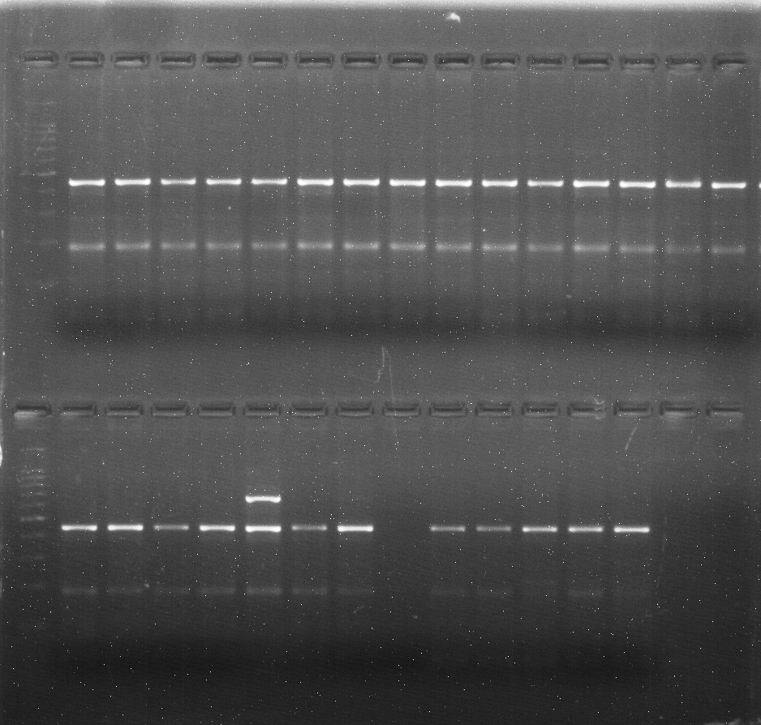
Supplementary data S3: Gel image of primer UASBFM5 tested for transferability on 27 browntop millet genotypes

15
14
13
12
11
8
7
9
10
L
6
5
4
3
2
1
28
27
26
25
24
23
22
21
20
19
18
17
16
L
100bp
100bp
1000bp
400bp
200bp
1000bp
400bp
200bp

1 | IC617961
2 | IC613353
3 | IC617956
4 | IC613554
5 | IC617954
6 | IC613547
7 | IC613551
8 | IC613552
9 | IC617959
10 | IC613556
11 | IC617953
12 | IC613557
13 | IC613559
14 | IC613550
15 | IC613546
16 | GPUBT-2
17 | KH-21 BIAVT-5010-44444ljhljhukyhbghb5555556567567556576576565165465465465465465465465455516546543216515010
18 | KH-21 BIAVT-5002
19 | KH-21 BIAVT-5001
20 | KH-21 BIAVT-1-5003
21 | KH-21 BIAVT-5009
22 | KH-21 BIAVT-5005
23 | KH-21 BIAVT-5011
24 | KH-21 BIAVT-5006
25 | KH-21 BIAVT-5008
26 | KH-21 BIAVT-2-5007
27 | KH-21 BIAVT-4-5004

