Supporting Information

Enhanced antibacterial activity and bioavailability of gallium-organic acid complexes: a promising antibiotic alternative
Yuhuan Qin ª, Wei Luo ^{a,b}, Xia Li ª, Xuepin Liao ^{a,b}, Bi Shi ^{a,b}
a Department of Biomass Chemistry and Engineering, Sichuan University, Chengdu 610065, China
b National Engineering Research Center of Clean Technology in Leather Industry, Sichuan University, Chengdu 610065, China

General Information
Antibacterial zone: Horizontal diffusion method (Oxford cup method): Determine the diameter of the circle of inhibition against three common pathogenic bacteria in poultry and livestock. Pour the autoclaved medium into a sterile petri dish while it is still hot, and wait for it to solidify to make a sterile plate. Pipette 600 μL of the pre-prepared bacterial suspension on the sterile plate, spread evenly by a sterile applicator, place a sterile Oxford cup lightly on the plate containing bacteria, take 150 μL of the 40 mmol/L concentration of the complex solution into the Oxford cup (the control group was 40 mmol/L LOA, 20 mmol/L and 10 mmol/L Ga³⁺), and incubate at 37 ℃ for 24 h. The diameter (mm) of the circle of inhibition of each plate was measured by vernier caliper.
Minimum inhibitory concentration (MIC). Agar dilution method: Prepare Ga-LOA gradient solution by two-fold dilution method, add it into 1-15 sterile test tubes respectively, use nutrient broth medium to dilute the complex solution, the first tube to add the complex mixed with MH medium and mix thoroughly, then suck 2 mL of the solution and add it into the next sterile test tube to mix well, and then repeat this to the twelfth sterile test tube, and then suck 2 mL of the solution into the next sterile test tube to mix well, and repeat this to the twelfth sterile test tube, and then suck 2 mL of the solution from the previous sterile test tube. The thirteenth sterile test tube from the last tube after mixing the solution sucked 2 mL discarded, take 100 μL of diluted bacterial suspension (107 CFU/mL) in equal quantities added to the 1-14 sterile test tubes, the fourteenth tube for the positive control, the fifteenth tube for the negative control, the test tube at 37℃ incubation for 24 h, to observe its growth, the last solution clarified the concentration of transparent test tubes that is, the minimum inhibitory concentration (MIC).
Minimum bactericidal concentration (MBC): 100 μL of the culture solution of the first three groups with minimum inhibitory concentration (MIC) and its concentration greater than the MIC were taken on sterile agar plate and incubated at 37℃ for 24 h. The growth was observed, and the lowest concentration of complexes of the agar plate with no bacterial growth was taken as the minimum bactericidal concentration (MBC).
Growth kinetics: S. aureus was selected to determine its growth kinetics curve. The logarithmic period of growth was measured to be 6-8 h. Appropriate amount of S. aureus after 8 h of expanded culture was centrifuged and diluted to prepare bacterial suspension (10⁷ CFU/mL), and MH liquid medium and Ga-LOA solution were mixed 1: 1 to make the concentration of the corresponding MIC. A number of test tubes were taken (divided into two groups, A and B), and 2 mL of MH liquid medium and 100 μL of bacterial suspension were added to them. In group A, 2 mL of Ga-LOA solution with 2 times MIC was added, and group B was the control group. 100 μL samples were taken every 3 h and added into the 96-well plate, and the OD value at 600 nm was measured by enzyme immunoassay detector. And the curves were plotted according to the results.
The content of rare earth ions in the cells: Scrape a ring from the slant medium to access the liquid medium activation and expansion of culture for 24 h, wash with sterile saline three times (4 ℃, centrifuged at 8000 r/min for 5 min), dilute the bacterial concentration of 10⁷ CFU/mL, take 1 mL of diluted bacterial solution and add 100 mL of the concentration of the MIC value of the Ga-LOA and the corresponding MIC value of Ga³⁺ in the MH. Ga³⁺ was incubated in MH medium for 24 h. 10 mL of the bacterial solution was taken every 3 h, and washed three times by centrifugation with sterile water, and then digested with concentrated nitric acid and hydrogen peroxide in the ratio of 2:1. The concentration of rare earth ions was determined by inductively coupled plasma emission spectrometry (ICP-OES) and the content in the cells was calculated.
Field Emission Scanning Electron Microscopy (FESEM) analysis: FESEM was used to observe the microscopic morphology of S. aureus cells under the condition of added complexes. Take an appropriate amount of S. aureus after 18 h of expanded culture in a centrifuge tube. It was washed three times with an equal volume of saline to collect the bacterium. Then the corresponding MIC concentration of the complex and its equimolar concentration of LOA and Ga³⁺ were added to the centrifuge tube and incubated on a shaking bed for 6 h. Then it was centrifuged to wash off the supernatant, washed three times with saline, discarded the supernatant, fixed with 2.5% glutaraldehyde, and then transferred to the EP tube and washed by centrifugation with an ethanol gradient (25%, 50%, 70%, and 100%), and finally dried the above cell samples at room temperature. Conductive gold spraying treatment was performed and then observed in field emission scanning microscope (FESEM).
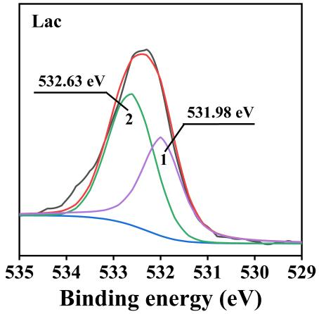
Figure S1 O1s XPS spectroscopy of Lac
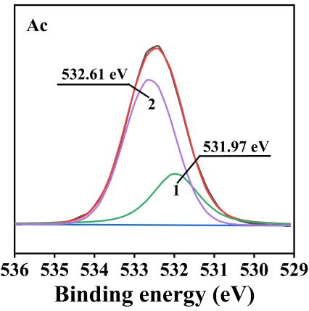
Figure S2 O1s XPS spectroscopy of Ac

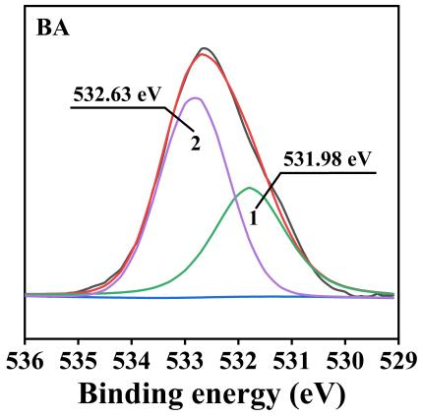
Figuer S3 O1s XPS spectroscopy of BA

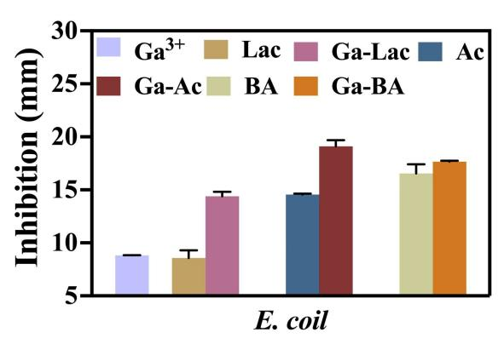
Figure S4Antibacterial activity (inhibition zone) of SOA, Ga³⁺ and Ga-SOA against E. coli, (SOA concentrations were all 40 mmol/L, Ga³⁺ concentrations in a were 20 mmol/L,and in were 10 mmol/L);
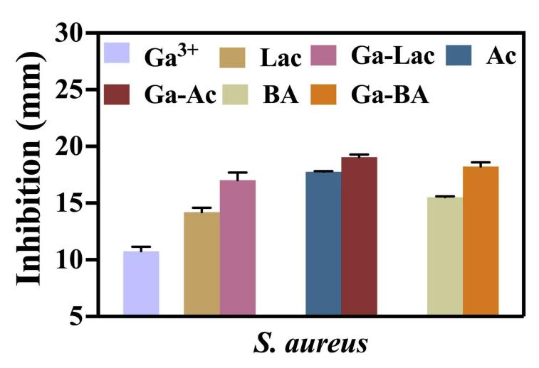
Figure S5 Antibacterial activity (inhibition zone) of SOA, Ga³⁺ and Ga-SOA against S. aureus, (SOA concentrations were all 40 mmol/L, Ga³⁺ concentrations in a were 20 mmol/L,and in were 10 mmol/L)
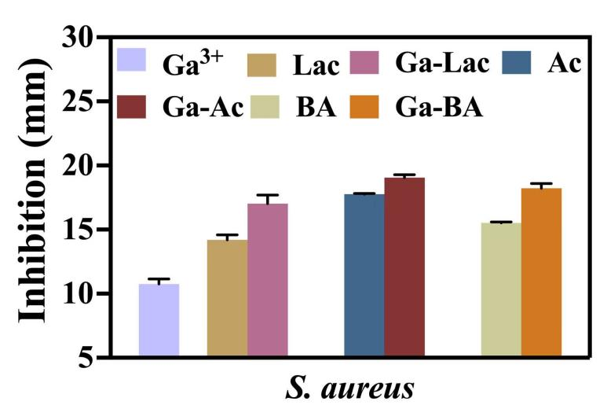
Figure S6 Antibacterial activity (inhibition zone) of SOA, Ga³⁺ and Ga-SOA against Salmonella, (SOA concentrations were all 40 mmol/L, Ga³⁺ concentrations in a were 20 mmol/L,and in were 10 mmol/L).

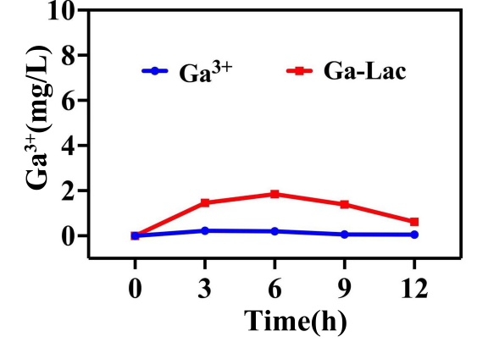
Figure S7 accumulation of Ga³⁺ in S. aureus
Membrane transport-related genes accounted for about 74.2% among the DEGs down-regulated by Ga-Lac vs Con,which were mainly concentrated in the ABC transporter system and PTS transporter system (Fig S8).
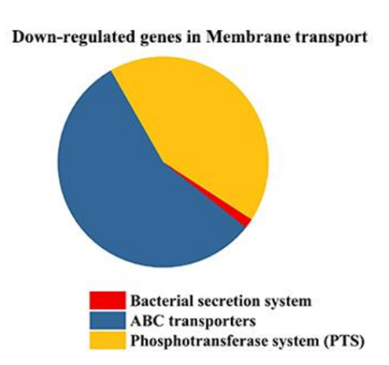
Figure S8 Down-regulated DEGs in Membrane transport.

