Supplementary material for:

Close-to-nature transformation: enhancing the chemical stability of organic carbon in Pinus massoniana and Cunninghamia lanceolata forests

Weiwei Shu^{a, b, c}, Angang Ming^{a, b, c,*}, Kun Yang^{a, b, c}, Hua Li^{a, b, c}, Huilin Min^{a, b, c}, Yi Taoª, Ji Zengª, Zhongguo Liª, Juling Weiª

ª Experimental Center of Tropical Forestry, Chinese Academy of Forestry, Pingxiang 532600, China;
^{b} Guangxi Youyiguan Forest Ecosystem Research Station, Pingxiang 532600, China
^{c} Youyiguan Forest Ecosystem Observation and Research Station of Guangxi, Pingxiang 532600, China
*Corresponding author: Angang Ming
Experimental Center of Tropical Forestry, Chinese Academy of Forestry, Pingxiang 532600, China, No. 201 KeYuan Road, Pingxiang 532600, Guangxi, China

Email: mingangang0111@163.com

Tel: +86-0771-8585023
Fax: +86-0771-8526320

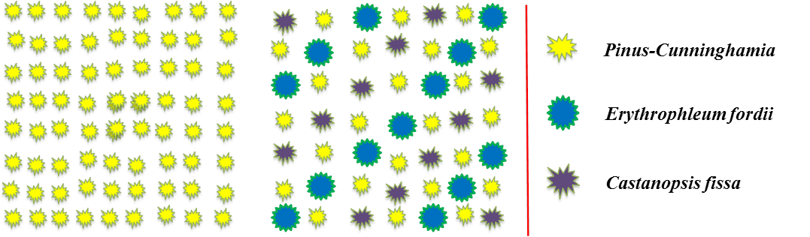
Fig. S1 Tree species layout diagram of unmodified pure forest (left) and close-to-nature transformation forest (right)

Figure S2 Differences in the mean values of soil bacterial richness (chao1 index) and soil bacterial diversity(Shannon-wiener index) across the four planted forest types (Pinus massoniana and Cunninghamia lanceolate close-to-nature forests (PCN, CCN) and their control pure forests (PCK, CCK)). Boxplots display the 25% and 75% quartiles, the median (horizontal line within the box), the maximum and minimum observed values within each dataset. Mean values are shown in white circles and outliers are shown in red circles. Different lowercase letters of the same category represent statistically significant differences (p < 0.05).

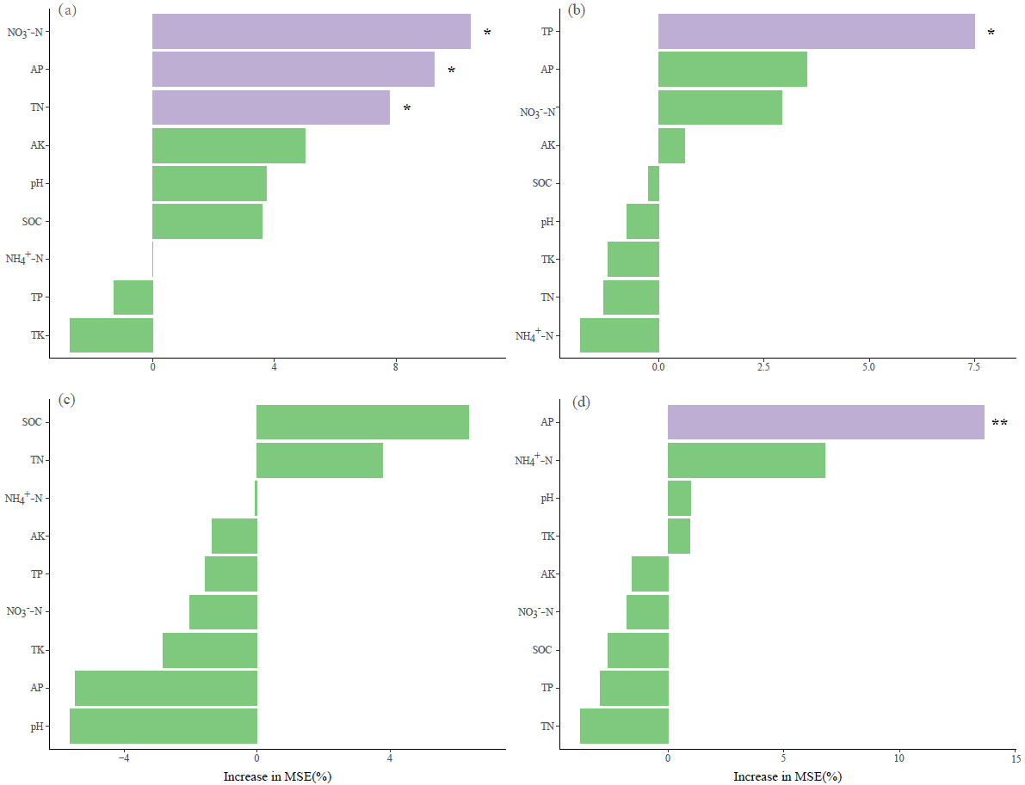
Figure S3 Random forest analysis indicating the effects of soil physicochemical properties on the abundances of alkyl C (a), O-alkyl C (b), aromatic C(c) and carbonyl C (d). SOC, Organic carbon; TN, Total nitrogen; TP, Total phosphorus; AP, Available phosphorus; NO₃—N, nitrate nitrogen; NH₄⁺-N, ammonium nitrogen. AK, available potassium; TK, total potassium.

