Supplemental Material
Table S1. Plant species frequencies within High Severity plots (N=5) and Moderate-High or Lower Severity plots (N=5). Forbs are only included if frequency meets or exceeds 60% (3/5 plots), anything below is denoted as a 0. Total % diversity across all plots for each plant functional type (PFT) for each year are denoted by bold text.

Species | High Severity (N=5) |  |  |  | Moderate High or Lower Severity (N=5)
 | 2004 | 2006 | 2013 | 2023 | 2004 | 2006 | 2013 | 2023
Trees | 6% | 29% | 31% | 30% | 7% | 31% | 44% | 46%
Abies lasiocarpa | 0% | 0% | 0% | 0% | 0% | 0% | 20% | 0%
Acer glabrum var. douglasii | 0% | 0% | 0% | 0% | 0% | 20% | 0% | 0%
Acer glabrum var. glabrum | 80% | 80% | 80% | 40% | 60% | 60% | 80% | 100%
Alnus incana | 0% | 0% | 20% | 0% | 0% | 20% | 0% | 40%
Alnus viridis var. sinuata | 0% | 20% | 20% | 0% | 0% | 0% | 0% | 0%
Betula occidentalis | 0% | 0% | 20% | 0% | 0% | 0% | 20% | 0%
Betula x utahensis | 0% | 20% | 20% | 60% | 0% | 0% | 0% | 0%
Larix occidentalis | 0% | 40% | 40% | 60% | 20% | 100% | 100% | 100%
Picea engelmanii | 0% | 40% | 60% | 60% | 0% | 40% | 80% | 100%
Pinus contorta var. latifolia | 0% | 100% | 100% | 100% | 0% | 80% | 100% | 100%
Pinus monticola | 0% | 0% | 0% | 0% | 0% | 0% | 20% | 40%
Populus balsamifera | 0% | 0% | 0% | 0% | 0% | 0% | 20% | 0%
Populus tremuloides | 0% | 80% | 80% | 100% | 0% | 100% | 100% | 100%
Pseudotsuga menziesii | 0% | 20% | 0% | 0% | 20% | 20% | 80% | 60%
Shrubs | 23% | 33% | 44% | 43% | 12% | 42% | 47% | 42%
Amelanchier alnifolia | 80% | 100% | 100% | 100% | 0% | 80% | 100% | 100%
Ceanothus sanguineus | 40% | 100% | 100% | 60% | 20% | 60% | 20% | 40%
Ceanothus velutinus | 0% | 0% | 40% | 0% | 0% | 0% | 0% | 0%
Holodiscus discolor | 0% | 40% | 40% | 40% | 0% | 0% | 0% | 0%
Lonicera involucrata | 0% | 0% | 0% | 0% | 0% | 20% | 40% | 0%
Lonicera utahensis | 0% | 40% | 20% | 40% | 0% | 40% | 40% | 60%
Mahonia repens | 80% | 80% | 80% | 100% | 0% | 60% | 40% | 0%
Paxistima myrsinites | 20% | 100% | 100% | 100% | 0% | 60% | 100% | 100%
Ribes lacustre | 0% | 0% | 0% | 0% | 0% | 20% | 60% | 40%
Ribes viscosissimum | 0% | 20% | 20% | 0% | 0% | 40% | 40% | 0%
Rosa acicularis | 80% | 60% | 60% | 100% | 0% | 0% | 0% | 0%
Rubus ideas var. strigosus | 0% | 0% | 0% | 0% | 0% | 80% | 60% | 0%
Rubus parviflorus | 60% | 60% | 80% | 60% | 100% | 100% | 100% | 100%
Salix boothii | 0% | 0% | 0% | 0% | 0% | 0% | 20% | 0%
Salix scouleriana | 40% | 80% | 80% | 60% | 0% | 100% | 80% | 100%
Shepherdia canadensis | 0% | 0% | 0% | 0% | 0% | 0% | 0% | 40%
Sorbus scopulina | 0% | 20% | 20% | 0% | 20% | 0% | 20% | 40%
Spiraea betulifolia var. lucida | 80% | 100% | 100% | 100% | 100% | 100% | 100% | 100%
Symphoricarpos albus var. laevigatus | 0% | 40% | 20% | 40% | 20% | 60% | 60% | 60%
Vaccinium caespitosum | 0% | 0% | 0% | 0% | 0% | 60% | 60% | 0%
Vaccinium membranaceum | 0% | 0% | 60% | 100% | 0% | 0% | 60% | 100%
Forbs | 16% | 21% | 21% | 15% | 19% | 37% | 39% | 29%
Adenocaulon bicolor | 0% | 0% | 0% | 0% | 0% | 0% | 0% | 60%
Anaphalis margaritacea | 0% | 100% | 100% | 0% | 0% | 100% | 80% | 60%
Apocynum androsaemifolium | 0% | 0% | 0% | 60% | 0% | 0% | 0% | 0%
Aralia nudicaulis | 0% | 0% | 0% | 0% | 60% | 60% | 60% | 100%
Arnica cordifolia | 0% | 0% | 60% | 60% | 0% | 0% | 0% | 0%
Arnica chamissonis | 0% | 0% | 0% | 0% | 0% | 80% | 60% | 60%
Arnica latifolia | 80% | 0% | 0% | 0% | 60% | 0% | 0% | 0%
Chamerion angustifolium | 100% | 100% | 100% | 100% | 100% | 100% | 100% | 100%
Cirsium arvense | 0% | 60% | 0% | 0% | 0% | 80% | 80% | 0%
Cirsium vulgare | 0% | 0% | 0% | 0% | 0% | 0% | 60% | 0%
Clintonia uniflora | 0% | 0% | 0% | 0% | 0% | 0% | 60% | 100%
Geranium bicknellii | 100% | 0% | 0% | 0% | 80% | 0% | 0% | 0%
Hieracium albiflorum | 0% | 0% | 80% | 0% | 0% | 0% | 100% | 0%
Hieracium caespitosum | 0% | 0% | 0% | 0% | 0% | 60% | 0% | 0%
Iliamna rivularis | 0% | 0% | 0% | 0% | 0% | 60% | 0% | 0%
Lactuca serriola | 80% | 60% | 0% | 0% | 60% | 0% | 0% | 0%
Maianthemum racemosum | 0% | 0% | 0% | 0% | 80% | 0% | 0% | 0%
Maianthemum stellatum | 0% | 0% | 0% | 0% | 0% | 60% | 60% | 0%
Solidago canadensis | 0% | 0% | 0% | 0% | 0% | 60% | 0% | 0%
Streptopus amplexifolius | 0% | 100% | 60% | 60% | 0% | 60% | 60% | 60%
Taraxacum officianale | 0% | 60% | 80% | 0% | 0% | 80% | 100% | 60%
Thalictrum occidentale | 0% | 0% | 0% | 0% | 0% | 60% | 80% | 60%
Xerophyllum tenax | 0% | 0% | 0% | 60% | 0% | 0% | 0% | 0%

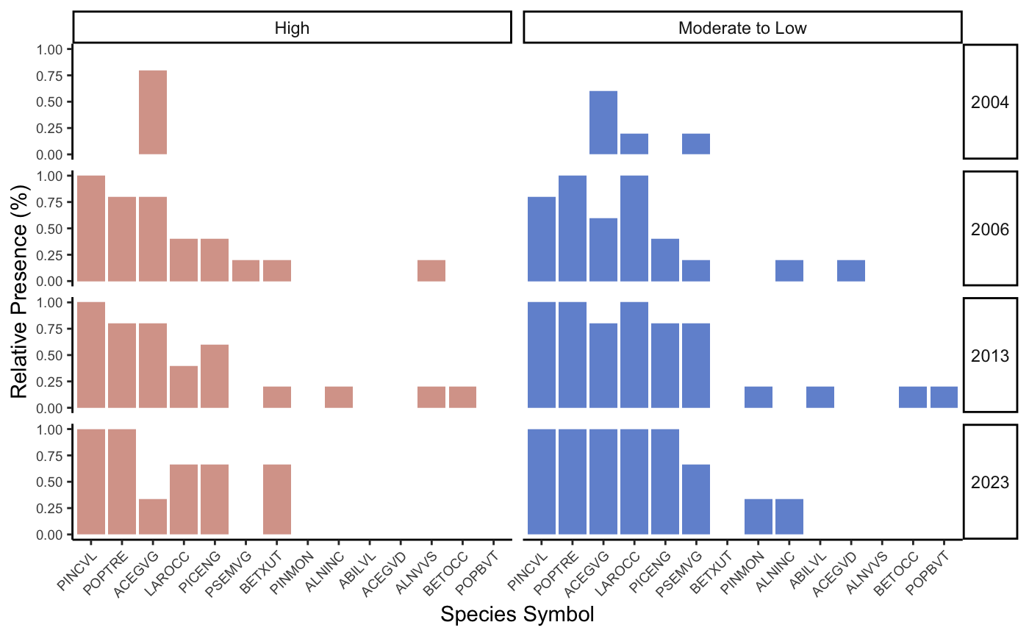
Figure S1. Tree Species Frequency in High (N=5) and Moderate to Low (N=5) severity plots. See Supplemental Table 2 for acronym details.

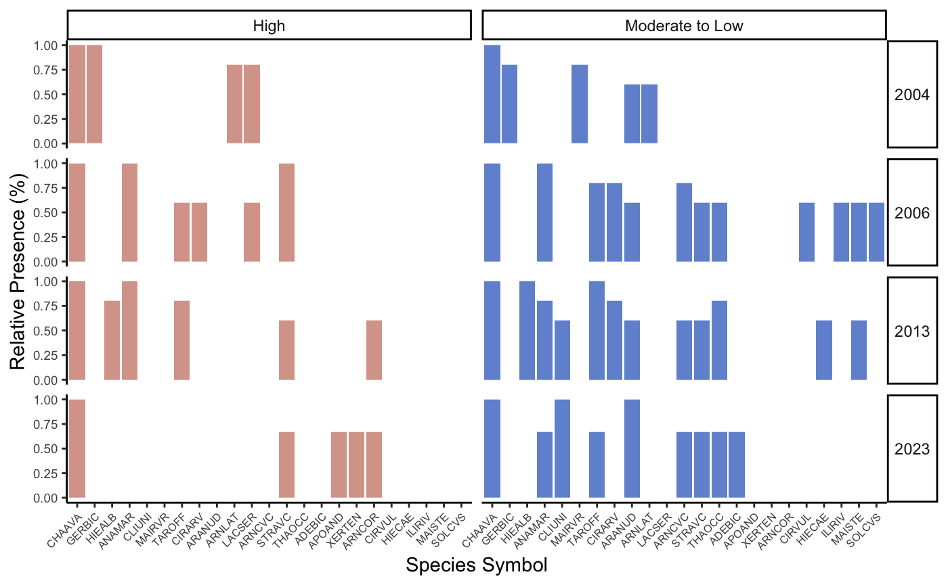
Figure S2. Forb Species Frequency for Species in High (N=5) and Moderate to Low (N=5) severity plots. Forb species are only included if their frequency meets or exceeds 60% (3 of 5 plots in each severity category). See Table S2 for acronym details.

Table S2. Cumulative list of vascular plant species recorded in the 10 GLAC Fire Effects Plots across the 2004, 2006, 2013 and 2023 plant inventories.

Species Code | Scientific Name | Common Name | Growth Form
PINCVL | P. contorta var. latifolia | Lodgepole Pine | Tree
POPTRE | Populus tremuloides | Quaking Aspen | Tree
LAROCC | Larix occidentalis | Western Larch | Tree
PICENG | Picea engelmanii | Engelmann Spruce | Tree
PSEMVG | Pseudotsuga menziesii | Douglas Fir | Tree
BETXUT | Betula papyrifera x Betula occendentalis = Betula x utahensis | Paper Birch | Tree
PINMON | Pinus monophylla | Western White Pine | Tree
ALNINC | Alnus incana | Mountain Alder | Tree
ABILVL | Abies lasiocarpa var. lasiocarpa | Subalpine Fir | Tree
ALNVVS | Alnus viridis var. sinuata | Sitka Alder | Tree
BETOCC | Betula occidentalis | Water Birch | Tree
POPBVT | Populus balsamifera var. trichocarpa | Black Cottonwood | Tree
ACEGVG | Acer glabrum var. glabrum | Rocky Mountain Maple | Tree
ACEGVD | Acer glabrum var. douglasii | Douglas Maple | Tree
SPIBVL | Spirea betufolia var. lucida | Shiny-leaf Spirea | Shrub
AMEALN | Amelanchier alnifolia | Common Serviceberry | Shrub
PAXMYR | Paxistima myrsinites | Mountain-lover | Shrub
SALSCO | Salix scouleriana | Scouler’s Willow | Shrub
MAHREP | Mahonia repens | Oregon Grape | Shrub
CEASAN | Ceanothus sanguineus | Red-stemmed Ceanothus | Shrub
SYMAVL | Symphoricarpos albus var. laevigatus | Common Snowberry | Shrub
CEAVEL | Ceanothus velutinus | Snowbrush Ceanothus | Shrub
LONUTA | Lonicera utahensis | Utah Honeysuckle | Shrub
HOLDIS | Holodiscus discolor | Oceanspray | Shrub
RIBLAC | Ribes lacustre | Swamp Currant | Shrub
SHECAN | Shepherdia canadensis | Buffaloberry | Shrub
LONIVI | Lonicera involucrata var. involucrata | Twinberry Honeysuckle | Shrub
RIBVVV | Ribes velutinum var. velutinum | Desert Gooseberry | Shrub
SORSVS | Sorbus sitchensis var. sitchensis | Sitka Mountain Ash | Shrub
SALBOO | Salix boothii | Booth’s Willow | Shrub
ROSACI | Rosa acicularis | Prickly Rose | Shrub
VACMEM | Vaccinium membranaceum | Thinleaf Huckleberry | Shrub
VACCAE | Vaccinium caespitosum | Dwarf Huckleberry | Shrub
RUBIVS | Rubus idaeus var. strigosus | Red Raspberry | Shrub
RUBPAR | Rubus parviflorus | Thimbleberry | Shrub
CHAAVA | Chamerion angustifolium var. angustifolium | Fireweed | Forb
GERBIC | Geranium bicknellii | Sticky Geranium | Forb
HIEALB | Hieracium albiflorum | White Hawkweed | Forb
ANAMAR | Anaphalis margaritacea | Pearly Everlasting | Forb
CLIUNI | Clintonia uniflora | Queencup Beadlily | Forb
MAIRVR | Maianthemum racemosum var. racemosum | Feathery Solomon’s Plume | Forb
TAROFF | Taraxacum officinale | Common Dandelion | Forb
CIRARV | Cirsium arvense | Canada Thistle | Forb
ARANUD | Aralia nudicaulis | Wild Sarsaparilla | Forb
ARNLAT | Arnica latifolia | Mountain Arnica | Forb
LACSER | Lactuca serriola | Prickly Lettuce | Forb
ARNCVC | Arnica chamissonis var. chamissonis | Leafy Arnica | Forb
STRAVC | Streptopus amplexifolius var. chalazatus | Twisted-Stalk | Forb
THAOCC | Thalictrum occidentale | Western Meadowrue | Forb
ADEBIC | Adenocaulon bicolor | Pathfinder | Forb
APOAND | Apocynum androsaemifolium | Spreading Dogbane | Forb
XERTEN | Xerophyllum tenax | Beargrass | Forb
ARNCOR | Arnica cordifolia | Heart-Leaf Arnica | Forb
CIRVUL | Cirsium vulgare | Bull Thistle | Forb
HIECAE | Hieracium caespitosum | Meadow Hawkweed | Forb
ILIRIV | Iliamna rivularis | Streambank Globemallow | Forb
MAISTE | Maianthemum stellatum | Starry Solomon’s Plume | Forb
SOLCVS | Solidago canadensis var. salebrosa | Canada Goldenrod | Forb

Table S3. Tukey HSD Post-Hoc Results for Differences in Species Richness across sampling years. Diagonal values represent the mean value for each sampling year, while off-diagonal values indicate the relative change between years. Values in parenthesis corresponds to p-values. Significant differences (p < 0.05) are shown in bold.

 | 2004 | 2006 | 2013 | 2023
2004 | 14.5 | +14.25 (0.0001) | +17.92 (0.0001) | +11.33 (0.0061)
2006 | +14.25 (0.0001) | 28.7 | +3.67 (0.54) | -2.92 (0.79)
2013 | +17.92 (0.0001) | +3.67 (0.54) | 32.4 | -6.59 (0.18)
2023 | +11.33 (0.0061) | -2.92 (0.79) | -6.59 (0.18) | 25.8

Table S4. Tukey HSD Post-Hoc Results for Differences in Shannon’s Index across sampling years. Diagonal values represent the mean value for each sampling year, while off-diagonal values indicate the relative change between years. Values in parenthesis corresponds to p-values. Significant differences (p < 0.05) are shown in bold.

 | 2004 | 2006 | 2013 | 2023
2004 | 1.51 | +0.46 (0.046) | +0.84 (0.0001) | +0.86 (0.0007)
2006 | +0.46 (0.046) | 1.97 | +0.37 (0.14) | +0.40 (0.20)
2013 | +0.84 (0.0001) | +0.37 (0.14) | 2.34 | +0.02 (0.99)
2023 | +0.86 (0.0007) | +0.40 (0.20) | +0.02 (0.99) | 2.36

Table S5. Tukey HSD Post-Hoc Results for Differences in Pielou’s Evenness across sampling years. Diagonal values represent the mean value for each sampling year, while off-diagonal values indicate the relative change between years. Values in parenthesis corresponds to p-values. Significant differences (p < 0.05) are shown in bold.

 | 2004 | 2006 | 2013 | 2023
2004 | 0.57 | +0.02 (0.97) | +0.11 (0.16) | +0.16 (0.03)
2006 | +0.02 (0.97) | 0.59 | +0.08 (0.33) | +0.17 (0.08)
2013 | +0.11 (0.16) | +0.08 (0.33) | 0.68 | +0.06 (0.76)
2023 | +0.16 (0.03) | +0.17 (0.08) | +0.06 (0.76) | 0.73

Table S6. Tukey HSD Post-Hoc Results for Differences in Tree Species Richness across sampling years. Diagonal values represent the mean value for each sampling year, while off-diagonal values indicate the relative change between years. Values in parenthesis corresponds to p-values. Significant differences (p < 0.05) are shown in bold.

 | 2004 | 2006 | 2013 | 2023
2004 | 0.90 | +3.30 (0.0001) | +4.42 (0.0001) | +4.32 (0.0001)
2006 | +3.30 (0.0001) | 4.20 | +1.12 (0.11) | +1.03 (0.26)
2013 | +4.42 (0.0001) | +1.12 (0.11) | 5.32 | +0.09 (0.99)
2023 | +4.32 (0.0001) | +1.03 (0.26) | +0.09 (0.99) | 5.23

Table S7. Tukey HSD Post-Hoc Results for Differences in Shrub Species Richness across sampling years. Diagonal values represent the mean value for each sampling year, while off-diagonal values indicate the relative change between years. Values in parenthesis corresponds to p-values. Significant differences (p < 0.05) are shown in bold.

 | 2004 | 2006 | 2013 | 2023
2004 | 4.08 | +5.22 (0.0001) | +6.33 (0.0001) | +4.97 (0.0001)
2006 | +5.22 (0.0001) | 9.30 | +1.11 (0.53) | -0.25 (0.99)
2013 | +6.33 (0.0001) | +1.11 (0.53) | 10.41 | -1.36 (0.48)
2023 | +4.97 (0.0001) | -0.25 (0.99) | -1.36 (0.48) | 9.05

Table S8. Tukey HSD Post-Hoc Results for Differences in Forb Species Richness across sampling years. Diagonal values represent the mean value for each sampling year, while off-diagonal values indicate the relative change between years. Values in parenthesis corresponds to p-values. Significant differences (p < 0.05) are shown in bold.

 | 2004 | 2006 | 2013 | 2023
2004 | 7.11 | +4.74 (0.06) | +5.56 (0.02) | +1.22 (0.93)
2006 | +4.74 (0.06) | 11.85 | +0.82 (0.97) | -3.52 (0.33)
2013 | +5.56 (0.02) | +0.82 (0.97) | 12.67 | -4.34 (0.17)
2023 | +1.22 (0.93) | -3.52 (0.33) | -4.34 (0.17) | 8.33

