Supplementary Information
Low-temperature molten salt enabled synthesis of solid-state emissive carbon dots with high endurance and >99% quantum yields
Yu Lan¹, Guang-Song Zheng², Run-Wei Song², Jing-Nan Hao², Jia-Lu Liu², Cheng-Long Shen^{2,*}, Jin-Yang Zhu^{3,*}, Sheng Cao¹, Jia-Long Zhao¹, Qing Lou^{2,*} , Chong-Xin Shan²

¹School of Physical Science and Technology, Guangxi University, Nanning 530004, China
²Henan Key Laboratory of Diamond Optoelectronic Material and Devices, Key Laboratory of Material physics, Ministry of Education, School of Physics, Zhengzhou University, Zhengzhou 450052, China
³State Centre for International Cooperation on Designer Low-Carbon & Environmental Materials, School of Materials Science and Engineering, Zhengzhou University, Zhengzhou 450001, P. R. China

E-mail: phyclshen@zzu.edu.cn (C. L. Shen), zhujinyang1127@zzu.edu.cn (J. Y. Zhu), louqing1986@zzu.edu.cn (Q. Lou)

Figure
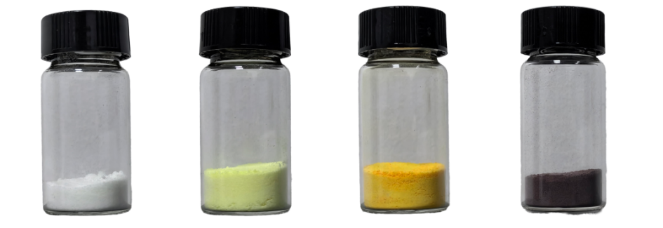
Fig. S1. Photographs of the B-CDs, G-CDs, Y-CDs, and NIR-CDs under sunlight.
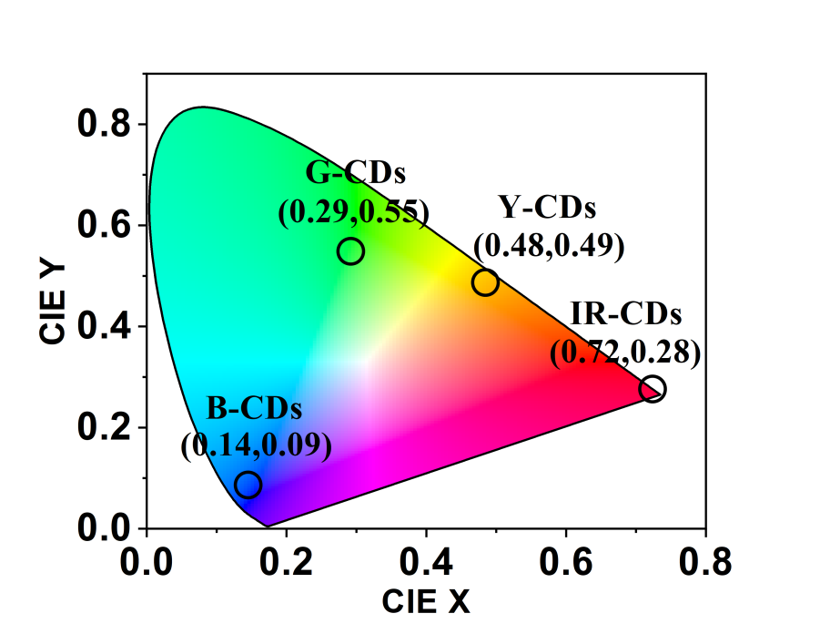
Fig. S2. CIE coordinate diagram of the FL emissions from the B-, G-, Y- and NIR-CDs.
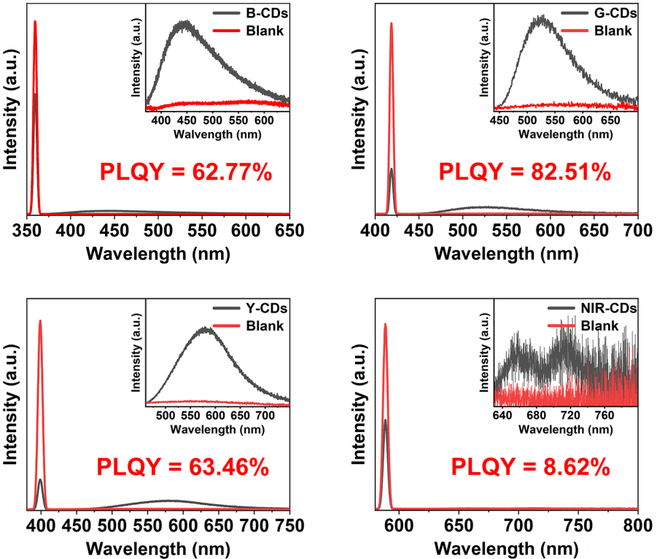
Fig. S3. The SSF emission spectra and corresponding SS QYs of the B-, G-, Y-, and NIR-CDs.
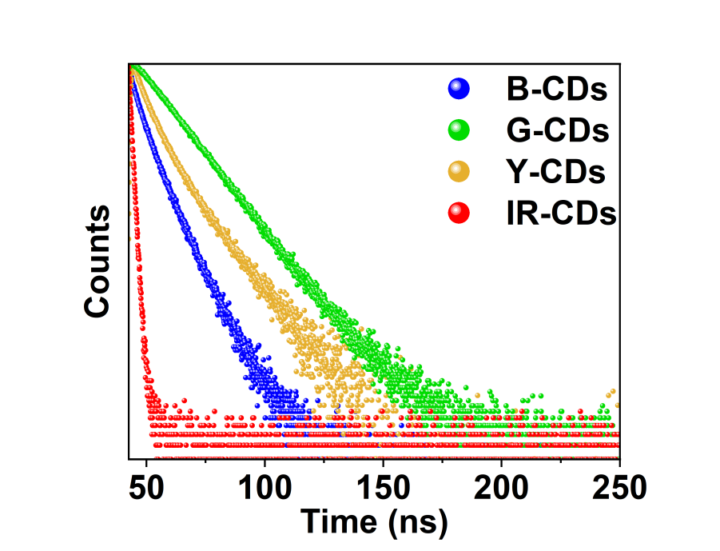
Fig. S4. Time-resolved FL spectra of the B-,G-,Y-, and NIR-CDs, respectively.
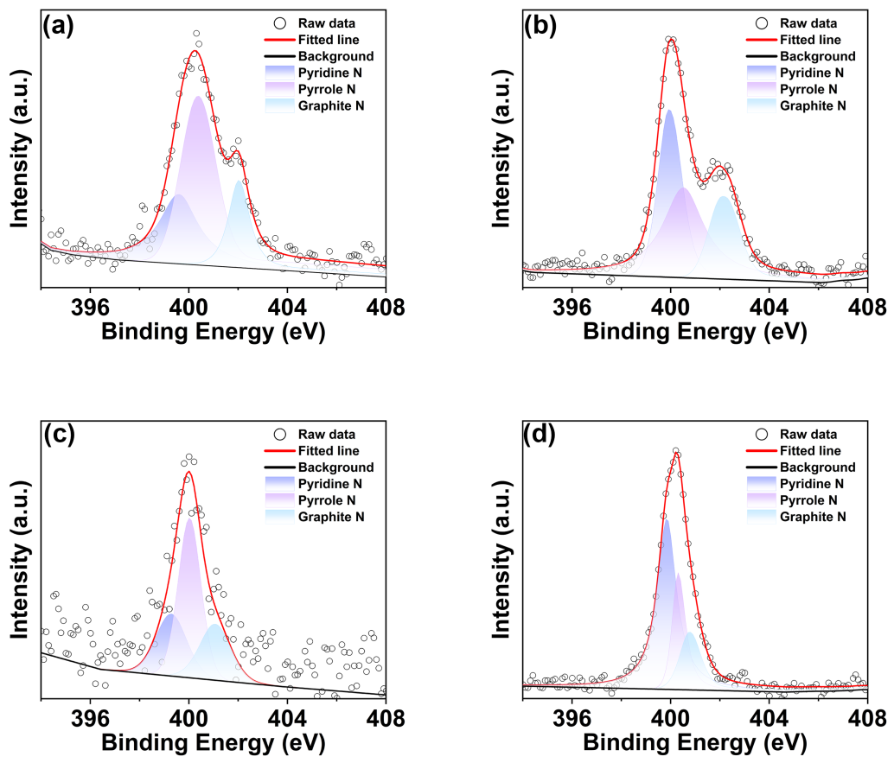
Fig. S5. High-resolution XPS N1s spectra of the B- (a), G- (b), Y- (c), and NIR-CDs (d).

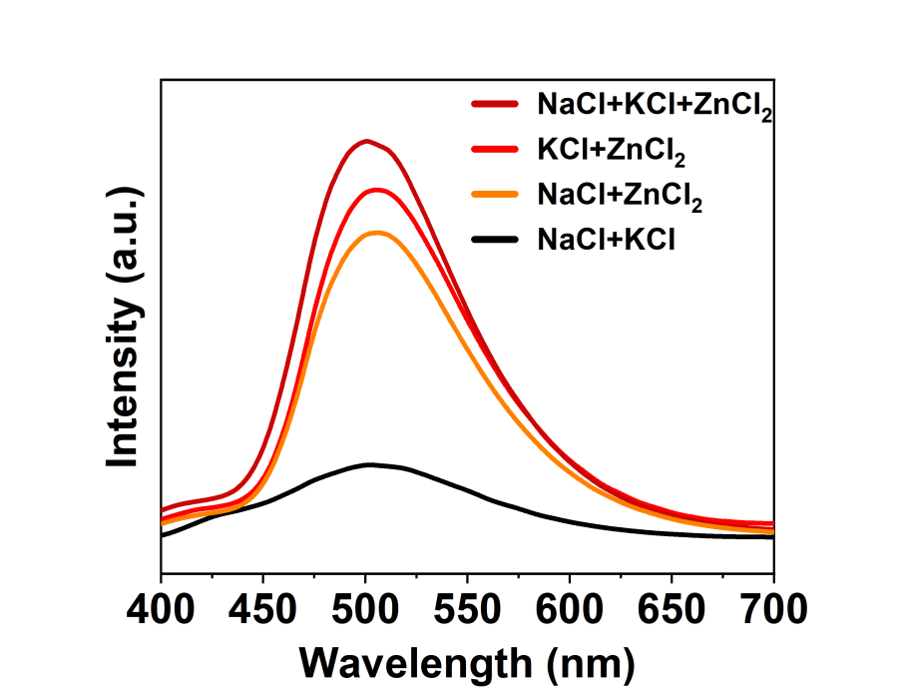
Fig. S6. The PL emission spectra of the G-CDs prepared with different molten salts under the same conditions.
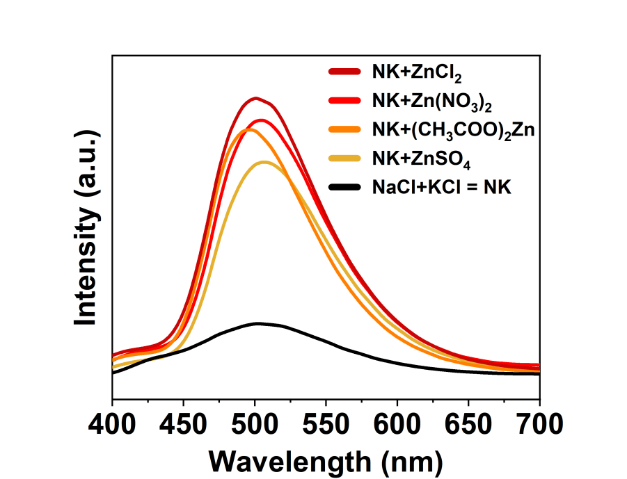
Fig. S7. The PL emission spectra of the G-CDs prepared by replacing ZnCl₂ with other zinc salts in the salt system under the same conditions.

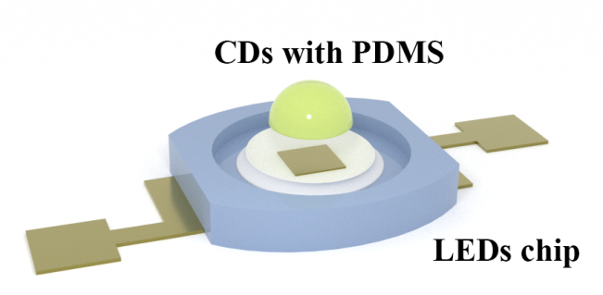
Fig. S8. Structure diagram of the CDs-based LEDs.

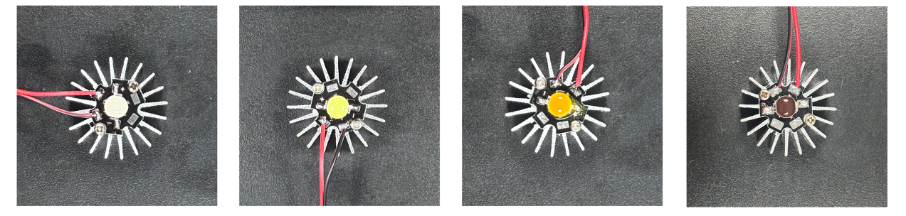
Fig. S9. Photographs for the B-LEDs, G-LEDs, Y-LEDs and NIR-LEDs under sunlight.
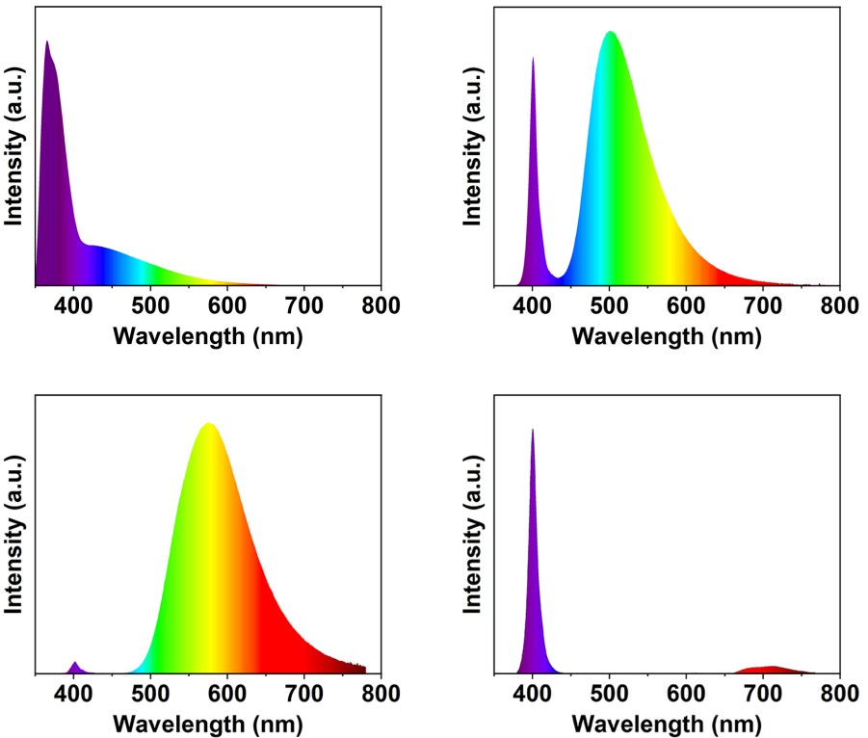
Fig. S10. EL emission spectra of the B-LEDs, G-LEDs, Y-LEDs and NIR-LEDs.

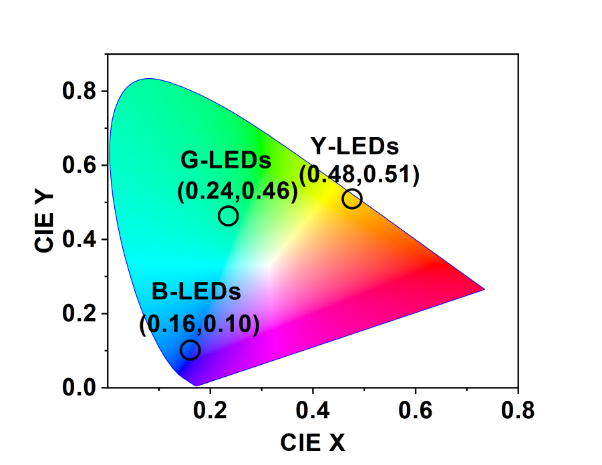
Fig. S11. CIE coordinate diagram of the B-LEDs, G-LEDs, and Y-LEDs.
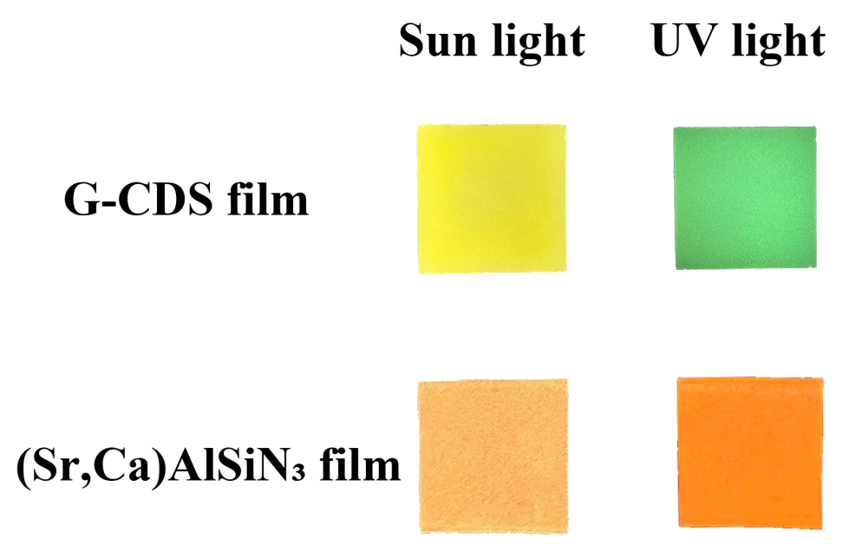
Fig. S12. Optical images of the color conversion films.

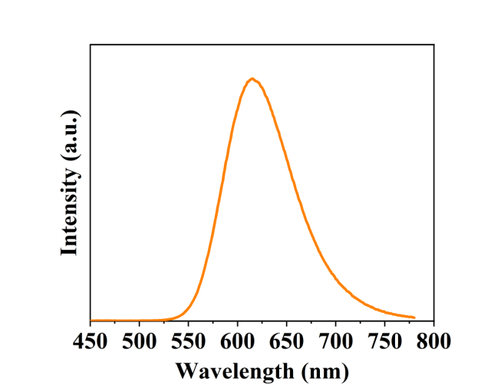
Fig. S13. PL emission spectrum of the (Sr,Ca)AlSiN₃.

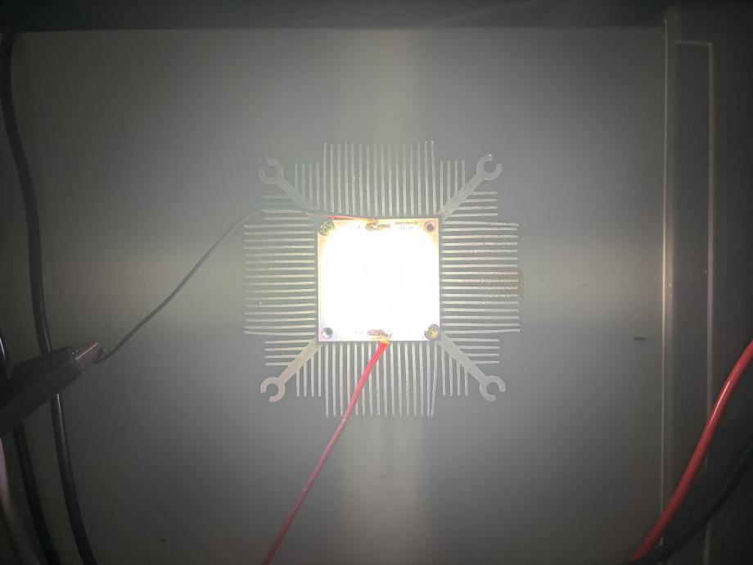
Fig. S14. Photograph of the white mini-LED.
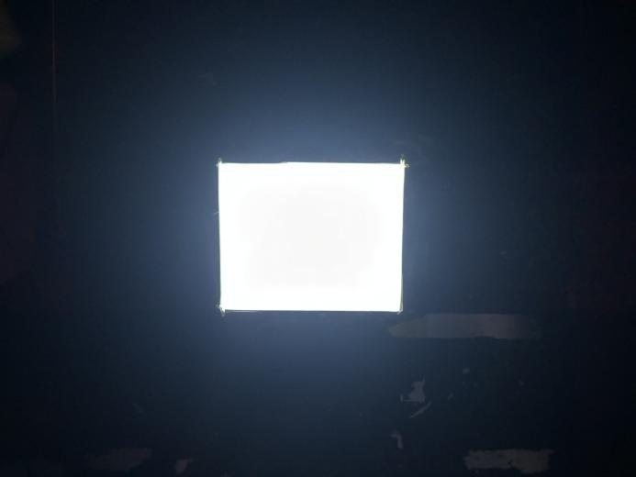
Fig. S15. Photographs of the mini-LED with light diffusing film.
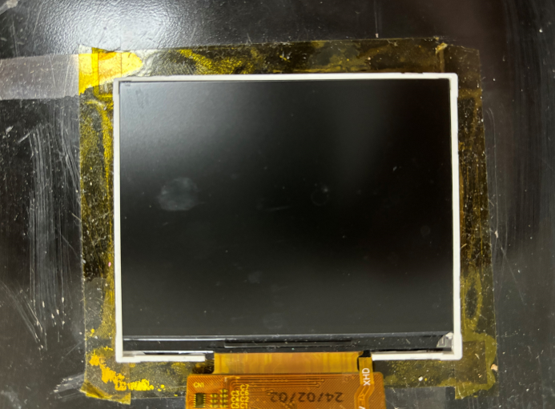
Fig. S16. The white backlight is assembled with a TFT-LCD to form a complete display.
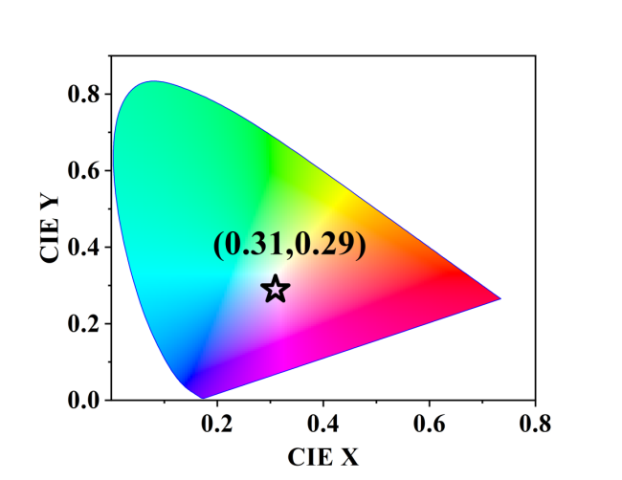
Fig. S17. CIE coordinate diagram of the mini-LED backlight.

Table S1 The specific experimental parameters for synthesizing B-, G-, Y-, and NIR-CDs.

Sample | precursor | Mixed salt | Temperature | Time
B-CDs | 1g CA, 2g UA | 2.00g NaCl,  2.55g KCl,  4.66g ZnCl₂ | 250 ℃ | 5 min
G-CDs | 1g CA, 2g UA | 2.00g NaCl,  2.55g KCl,  4.66g ZnCl₂ | 250 ℃ | 8 min
Y-CDs | 1g CA, 2g PG | 2.00g NaCl,  2.55g KCl,  4.66g ZnCl₂ | 250 ℃ | 10 min
NIR-CDs | 1g o-PD | 2.00g NaCl,  2.55g KCl,  4.66g ZnCl₂ | 300 ℃ | 10 min

Table S2 Comparison of the PL emission wavelengths and SSQY of different SSF CDs.

Sample | Fl emission wavelength | PL QY | Reference
Y-CD film | 553 nm | 98 % | 1
CDots@silica | 530 nm | 41 % | 2
B-CDs | 443 nm | 55.3 % | 3
G-CDs | 509 nm | 48.8 % | 3
Y-CDs | 563 nm | 36.7 % | 3
R-CDs | 613 nm | 27.9 % | 3
B-CDs | 425 nm | 81 % | 4
Cu4I6(pr-ted)2 NPs | 515 nm | 91.1 % | 5
CDs | 548 nm | 92.2 % | 5
Ba-CDs | 525 nm | 88.78 % | 6
Y-CDs | 570 nm | 67.7 % | 7
CDPs |  | 75.9 % | 8
Si-CDs@MAs | 526 nm | 64.46 % | 9
CDs | 527 nm | 83 % | 10
B-CDs |  | 48.2 % | 11
CDs-2 | 430 nm | 78 % | 12
B-SiCDs | 438 nm | 41 % | 13
G-SiCDs | 514 nm | 33 % | 13
Y-SiCDs | 577 nm | 57 % | 13
R-SiCDs | 633 nm | 26 % | 13
Y-CDs | 560 nm | 58.35 % | 14
NCD11 | 537 nm | 20.8 % | 15
NCD12 | 530 nm | 14.9 % | 15
NCD21 | 513 nm | 17.5 % | 15
B-CDs | 430 nm | 62.77 % | This work
G-CDs | 517 nm | 99.86 % | This work
Y-CDs | 594 nm | 63.46 % | This work
NIR-CDs | 660 nm | 8.62 % | This work

Table S3 Relative contents of different element in the B-CDs, G-CDs, Y-CDs, and NIR-CDs.

Sample | C 1s (%) | O 1s (%) | N 1s (%) | Zn 2p (%)
B-CDs | 63.75 | 29.36 | 0.48 | 6.41
G-CDs | 43.74 | 35.81 | 0.63 | 19.82
Y-CDs | 64.77 | 28.07 | 4.31 | 2.86
IR-CDs | 65.26 | 29.07 | 0.14 | 5.52

Table S4 Relative contents of different functional groups in the B-CDs, G-CDs, Y-CDs, and NIR-CDs.

Sample | C 1s (%) |  |  | O 1s (%)
 | C-C/C=C | C-O/C-N | C=O | C-O | C=O
B-CDs | 76.93 | 10.30 | 12.76 | 20.86 | 79.14
G-CDs | 76.63 | 13.71 | 12.66 | 27.70 | 72.30
Y-CDs | 73.98 | 13.45 | 12.57 | 49.20 | 50.80
NIR-CDs | 74.24 | 14.41 | 11.36 | 33.03 | 66.97

Table S5 The data grid for searching the optimal parameters consists of a total of 19×33×28×28×13×21=134,198,06419 search items.

Feature | Start | Step | Stop | Total
Ratio | 0.6 | 0.1 | 2.5 | 19
Sum | 1.6 | 0.1 | 4.81 | 33
NaCl | 1.2 | 0.1 | 4.00 | 28
KCl | 1.2 | 0.1 | 4.00 | 28
Temp | 225 | 5 | 286 | 13
Time | 200 | 20 | 601 | 21

Table S6 Comparison of the luminous efficiency of various LEDs

Phosphor | Current (mA) | luminous efficiency (lm W⁻¹) | Reference
Y-,R-,DR-,NIR-CDs | 20 | 54.6-87.5 | 7
RhB-CDs@u/SiO₂ | 350 | 120.1 | 16
D-CDs | — | 0.79-1.66 | 17
CDs-stained silks | 50 | 60.7 | 18
GQDs/SBA-15 | 20-40 | 61.38-129.62 | 19
CsPbI₃@WS-1 | — | 57.3 | 20
B-, G-, R-CQD | 20 | 31.3 | 21
G-CDs | 13.35 | 156.29 | This Work

References:
1. Guo J, et al. Yellow‐emissive carbon dots with high solid‐state photoluminescence. Adv. Funct. Mater. 32, 2110393 (2022).
2. Zhou D, et al. Conquering aggregation-induced solid-state luminescence quenching of carbon dots through a carbon dots-triggered silica gelation process. Chem. Mater. 29, 1779-1787 (2017).
3. Ding H, et al. Kilogram-scale synthesis of carbon dots with high-efficiency full-color solid-state fluorescence using an aggregation-induced emission strategy. Chem. Eng. J. 476, 146405 (2023).
4. Wang H, et al. Highly Luminescent Solid‐State Carbon Dots Embedded in a Boric Acid Matrix. Chem. Select 5, 13969-13973 (2020).
5. Chen J, Zhao H, Li Z, Zhao X, Gong X. Highly efficient tandem luminescent solar concentrators based on eco-friendly copper iodide based hybrid nanoparticles and carbon dots. Energy Environ. Sci. 15, 799-805 (2022).
6. Li J, Zhao H, Zhao X, Gong X. High‐Efficiency Luminescent Solar Concentrators Based on Carbon Dots with Simultaneously Ultrabright Solid‐State and Liquid‐State Luminescence. Adv. Funct. Mater., 2404473 (2024).
7. Xu B, et al. Solid‐State Fluorescent Carbon Dots with Unprecedented Efficiency from Visible to Near‐Infrared Region. Adv. Sci. 10, 2205788 (2023).
8. Wei JY, et al. Scalable synthesis of green fluorescent carbon dot powders with unprecedented efficiency. Adv. Opt. Mater. 8, 1901938 (2020).
9. Chen J, et al. Strategy to construct high thermal‐stability narrow‐band green‐emitting Si‐CDs@ MAs phosphor for wide‐color‐gamut backlight displays. Adv. Opt. Mater. 10, 2200851 (2022).
10. Liu X, Yan L, Zheng J, Yang Y, Liu X, Xu B. Highly optically and thermally stable carbon dots enabled by thermal annealing for laser illumination. J. Mater. Chem. C 11, 3562-3570 (2023).
11. Wang J, Zheng J, Yang Y, Liu X, Qiu J, Tian Y. Tunable full-color solid-state fluorescent carbon dots for light emitting diodes. Carbon 190, 22-31 (2022).
12. Liu X, Liu W, Zuo K, Zheng J, Wang M, Liu X. High color stability blue-to-violet room temperature phosphorescent carbon dot composites with ultralong lifetime for information encryption. ACS Sustainable Chem. Eng. 11, 1809-1819 (2023).
13. Hu G, et al. Rational synthesis of silane-functionalized carbon dots with high-efficiency full-color solid-state fluorescence for light emitting diodes. Carbon 203, 1-10 (2023).
14. Wan Z, et al. High‐efficiency solid‐state luminescence from hydrophilic carbon dots with aggregation‐induced emission characteristics. Adv. Funct. Mater. 33, 2207296 (2023).
15. Shen C-L, et al. In-situ embedding of carbon dots in a trisodium citrate crystal matrix for tunable solid-state fluorescence. Carbon 136, 359-368 (2018).
16. Zhu J, et al. Long-Wavelength Afterglow Emission with Nearly 100% Efficiency through Space-Confined Energy Transfer in Organic-Carbon Dot Hybrid. Nano Lett. 24, 13307-13314 (2024).
17. Li H, et al. Diamond-like carbon structure-doped carbon dots: A new class of self-quenching-resistant solid-state fluorescence materials toward light-emitting diodes. Carbon 149, 342-349 (2019).
18. Liu Y, et al. Perylenedioic Acid‐Derived Carbon Dots with Near 100% Quantum Yield in Aqueous Solution for Lasing and Lighting. Adv. Funct. Mater., 2401353 (2024).
19. Cui Z, et al. Efficient and environmentally friendly white light-emitting diodes with InP-based quantum dots embedded in mesoporous silica. J. Mater. Sci. Technol. 200, 104-111 (2024).
20. Yu X, Yang X, Zhang H, Liu K, Yu J. Unlocking the potential of CsPbI₃ perovskite as stable red phosphors by zeolite skeleton. Matter, (2024).
21. Wang Z, et al. 53% efficient red emissive carbon quantum dots for high color rendering and stable warm white‐light‐emitting diodes. Adv. Mater. 29, 1702910 (2017).

