Supporting information

A hybrid OTFT-SPR system for simultaneous electronic and optical sensing

Davood Hatami^{a,c,$}, Roger Hasler^{b,$}, Andrea Spanu^{c}, Jakub.Dostalek^{d,e}, Christoph Kleber^{b}, Wolfgang Knoll^{b}, Annalisa.Bonfiglio^{c*}

ª Department of Electrical and Electronic Engineering, University of Cagliari, via Marengo, 09123 Cagliari, Italy
^{b} Department of Chemistry and Physics of Materials, Faculty of Medicine and Dentistry, Danube Private University, 3500 Krems, Austria
^{c} University School for Advanced Studies (IUSS), Piazza della Vittoria 15, 27100 Pavia, Italy
^{d} Laboratory for Life Sciences and Technology (LiST), Faculty of Medicine and Dentistry, Danube Private University, 3500 Krems, Austria.
^{e} FZU-Institute of Physics, Czech Academy of Sciences, Na Slovance 2, Prague 182 21, Czech Republic
$ Contributed equally.
*E-mail: annalisa.bonfiglio@iusspavia.it
Output and transfer characteristics of the ExG-OTFT
Prior to the LbL assembly experiment, output and transfer characteristics of the ExG-OTFT in RE-biased and SS-biased configurations (Figure S1 and S2) were taken in the same electrolyte and flow rate as used in the actual PEM growth experiment. These characterizations were then used to set the working point of the transistor in saturation region for the real-time experiments for both configurations at V_{GS}=-3 V and V_{DS}=-5 V.
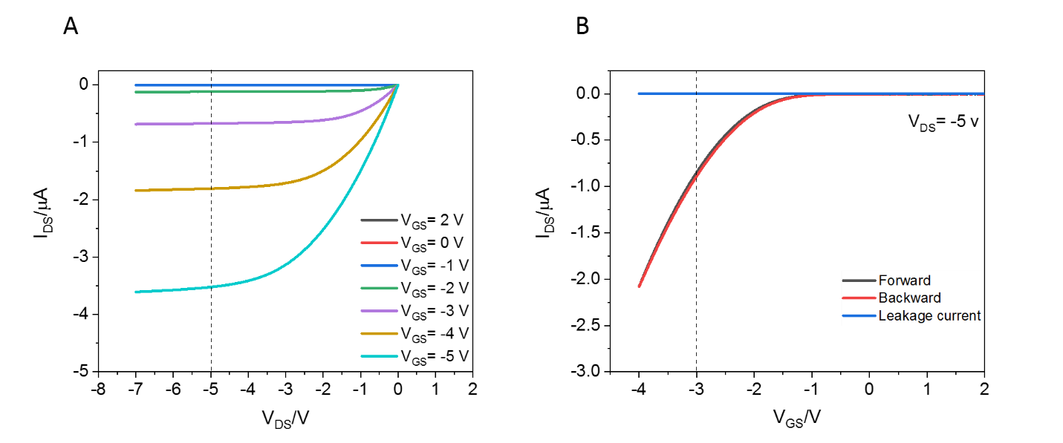
Figure S1: Output (A) and transfer characteristics (B) of the OFET in RE-biased configuration while 0.1 M KCl solution was being pumped into the flow-cell (50 µl/min flow rate). The dashed lines represent the set points of the FET during the experiment.

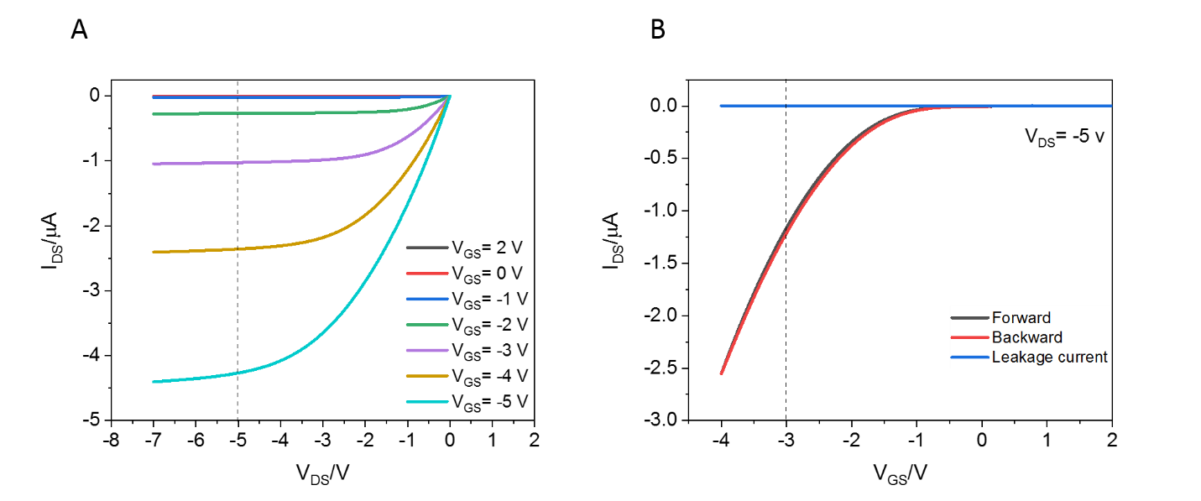
Figure S2. Output (A) and transfer characteristics (B) of the OFET in SS-biased configuration while 0.1 M KCl solution was being pumped into the flow-cell (50 µl/min flow rate). The dashed lines represent the set points of the FET during the experiment.

Noise cancellation and investigation of possible interfering events
Indeed, as universally acknowledged among researchers, any unintended occurrence such as fluctuations in temperature and light, as well as variations in doping levels (humidity), influence the Fermi-Dirac distribution function of charge carriers within the active material, thereby manifesting as noise or current drift. This situation becomes even more critical when employing a flow cell in the experimental setup to alter biological solutions, a common practice in most measurements involving bioFETs. Given that the shift in the transfer characteristics of the bioFET serves as the hallmark of the sensing event and can be influenced by numerous interfering phenomena, it is crucial to evaluate the system's noise level during real-time experiments to determine the minimum signal variation reliably distinguishable from the inherent noise. Therefore, in these measurements, we took special care to shield the measurement setup from noise as much as possible. As previously mentioned, the suggested design for a dual monitoring system enables the electronic component to be kept in an almost isolated environment, which is highly advantageous for precision monitoring applications. For this purpose, in our setup, the transistor component was housed in a securely grounded sealed incubation chamber, shielded with aluminum foil to protect it from ambient light and abrupt changes in temperature and humidity. However, under electrolyte flow (0.1 M KCl, 50 µL/min flow rate) a high noise level with sudden jumps of current can be occasionally observed. Interestingly, the noise level is reduced considerably (as shown in Figure S3) by carefully designing the positioning of the inlet and outlet of the flow-cell to avoid any contact of different electrolytes as well as electrolyte-vial materials, typically used as reservoir of solutions or to collect the waste, during the experiment. This simple experiment illustrates how different junctions, even electrolyte junctions made during the experiments, could indeed affect the ion distributions, which couples to the electron distributions in the active material/semiconductor, and potentially cause misinterpretation of the FET response.
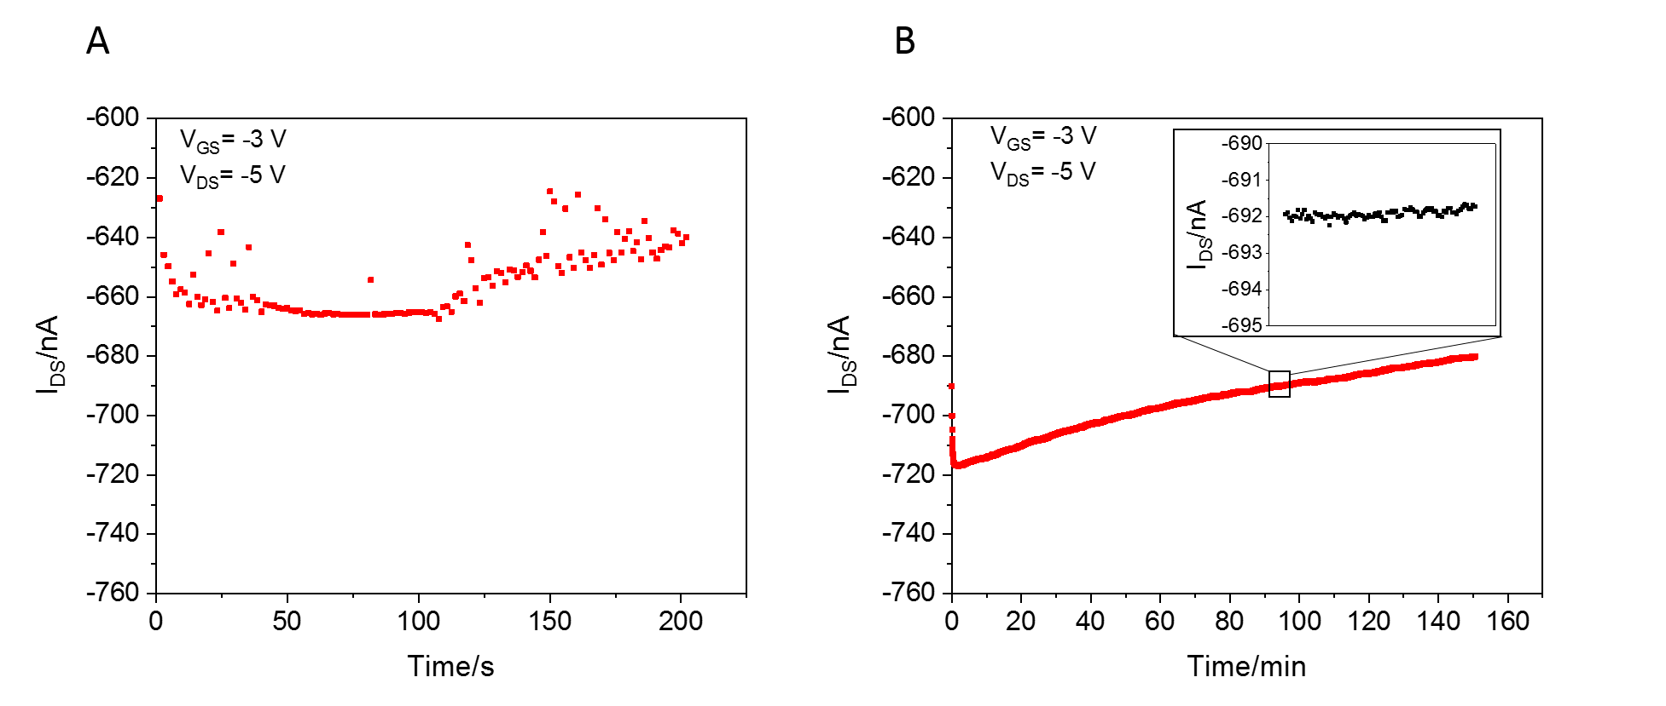
Figure S3. Comparison of transistor current noise levels in 50 µl/ml flow of 0.1 M KCl solution while the outlet tube of the flow-cell was left in a vial where the solutions were being collected (A) with respect to the situation in which the outlet tube was kept out of the vial (B) during the experiment. Inset: zoom of 200 s of raw data.

C) Equivalent circuit of FET
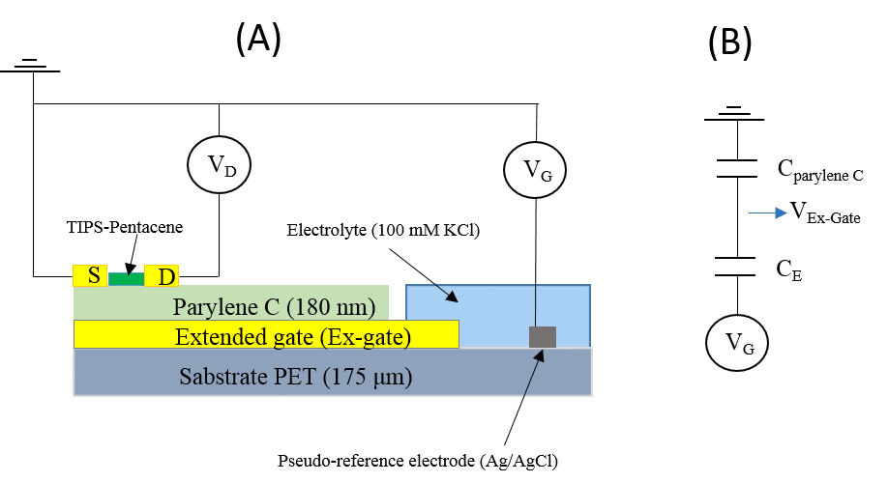
Figure S4: Device architecture (A) and (B) the equivalent circuit of extended-gate OFET biased by a pseudo-reference electrode through an electrolyte.
In our proposed architecture (Figure S4. A), including an OFET with an ex-gate, part of which acting as the sensing area present in a test solution, the equivalent circuit (Figure S4. B) consists of a series of capacitors that differ of several orders of magnitude. More specifically, the structure includes a gate dielectric (180 nm of Parylene C) whose specific capacitance (15 nF/cm² [1]) is three orders of magnitude less than that of the electric double layers (EDL) formed at the ex-gate (sensing surface) and reference electrode junctions with the electrolyte (indicated as C_{E} in Figure S4 B) which is in microfarad range [2]. As a result, the total capacitance (C_{Tot}) of the system can be assumed in good approximation to be fixed by the gate dielectric one. This results in an almost negligible potential gradient (determined by eq. S1) between the extended gate and the pseudo-reference electrode in the electrolyte ($\frac{C_{Tot}}{C_{E}}≈0$ ).

 | $$\left( V_{G}-V_{Ex-gate}\right)=\frac{C_{Tot}}{C_{E}} V_{G}$$ | (S1)

These two electrodes which, in electrochemical terms, act as working and counter electrodes, could, in principle, induce undesired electrochemical reactions at the interfaces if the potential gradient is high enough. However, very low values of the I_{GS} current, measured during PEM assembly (Figure 2) and in the transfer characteristic of the FET (Figure S1.B), always in the pico-ampere range, demonstrate the absence of a high potential gradient between the ex-gate (sensing surface) and the pseudo-reference electrode even if an electrostatic potential as high as -3 V is applied to bias the transistor.
In addition, the difference (orders of magnitude) between C_{Parylene C} and C_{E} implies that surface modifications of the sensing surface due to few nanometer-thick molecular layers , i.e. even the assembly of PEMs ( ≈ 1 nm per layer [3]), with way less than 50% of the surface coverage, could not lead to significant variations of the total capacitance. This has been validated experimentally by linear interpolation of $\sqrt{I_{DS}}$ vs. V_{G} before and after PEM assembly. In fact, linear interpolation of $\sqrt{I_{DS}}$ vs. V_{G} (Figure S5) around the region where the real-time experiment has been done, shows that the slope is not affected by PEM assembly in neither of the proposed configurations.

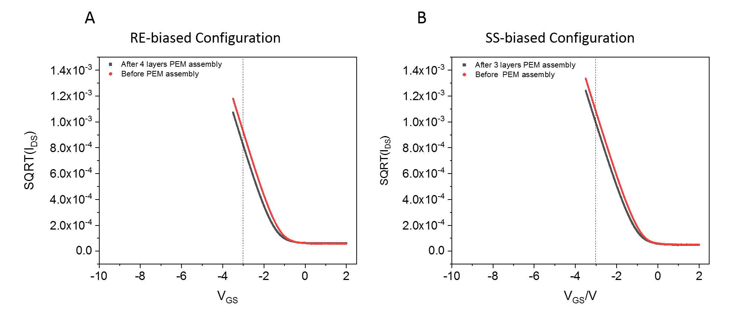
Figure S5. $\sqrt{I_{DS}}$ vs. V_{G} before and after PEM assembly in RE-biased configuration (A) and SS-biased configuration (B). The dashed lines represent the set points of the FET during the experiment.

Consequently, using eq. S2 which is an accepted model for this kind of FET, one could conclude that the product of the systems total capacitance, C_{Tot}, and the semiconductor mobility, μ, is fixed.

 | $$\sqrt{I_{DS}}={(V}_{G}-V_{th})\sqrt{\frac{W}{2L} μ C_{Tot }}$$ | (S2)

In this case, the FET response during PEM assembly cannot be attributed to either capacitance or mobility modulations but other parameters, including the threshold potential variations, ∆V_{th,} should be considered as the true source of the observed FET signal.
In order to evaluate the threshold potential variations from the real-time PEM assembly experiment, the current variation, ∆I, has been determined after the first layer deposition in 0.1 M KCl solution in order to have a reference medium with constant ionic strength for signal analysis. Assuming (C_{Tot} ∙ μ) is not changed, the threshold potential variations after the first layer deposition (∆V_{th1}), can be calculated using eq. S3.

 | $$\frac{∆I}{\frac{W}{L} μ C_{Par C }{(V}_{G}-V_{th0})}={ ∆V}_{th1}$$ | (S3)

where V_{th0,} the initial threshold potential, and the (C_{Tot} ∙ μ) product are extracted separately from the slope and the intercept of the linear interpolation $\sqrt{I_{DS}}$ vs. V_{G}, respectively, before any PEM assembly. In order to evaluate threshold potential variation caused by the second layer deposition, ∆V_{th2}, the same procedure has been followed, but, considering a modified initial threshold potential, V_{th01,} as

 | $$V_{th01}={V_{th0}+ ∆V}_{th1}$$ | (S4)

Therefore,

 | $$\frac{∆I}{\frac{W}{L} μ C_{Par C }{(V}_{G}-V_{th01})}={ ∆V}_{th2}$$ | (S5)

This procedure has been used to extract ∆V_{th} for all other subsequent layer depositions as reported. The extracted values are shown in Figure 3.

Wavelength Spectra of reflected light from MPG on a PET substrate and SPR response
As previously established, the MPG-structure is composed of two overlayed sinusoidal corrugations, prepared in a crossed pattern, and coated with a thin gold film [4]. It allows a diffraction-based cross coupling between the propagating SP modes on opposite interfaces of the gold film, exhibiting a characteristic of two overlapping Lorentzian dips with minima located at a shorter (λ_{S}) and longer (λ_{L}) wavelength in the reflectivity spectra R(λ).
The effect of applying an electrostatic potential, required to operate the transistor, on the reflectivity spectra was investigated for both configurations. To do so, the spectra before and after applying V_{GS} =-3 V were recorded (Figure S4). No significant alteration of the reflectivity spectra was observed, at least up to the resolution level required, indicating that the electrostatic potential does not lead to modulation of the spectra in neither of the configurations.
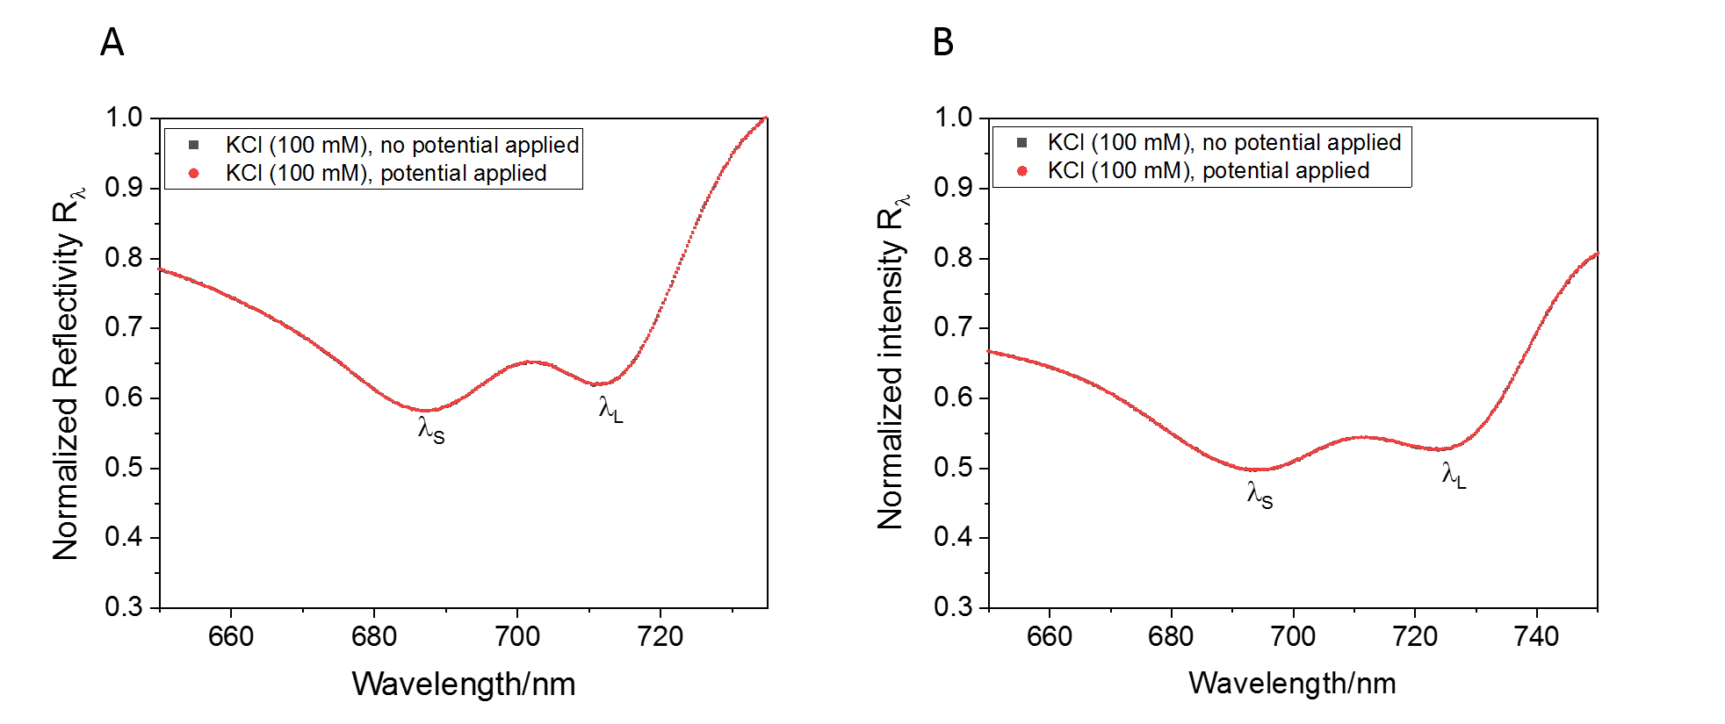
Figure S6. Normalized reflectivity spectra obtained in 0.1 M KCl solution before and while applying a gate potential (V_{GS}=-3 V) in RE-biased (A) and SS-biased (B) configurations.

In order to obtain an optical signal from the measured reflectivity spectra, a previously established method was utilized based on the anti-crossing modulation of the involved SPR resonances [5]. In brief, the minimum intensity of the short wavelength dip R (λ_{S}) and the long wavelength dip R (λ_{L}) were determined, averaging the values in a range of 100 spectral points in the vicinity to the minima positions. The SPR signal was then defined as the ratio between the averaged intensity values as $\overline{R}(λ_{L})/\overline{R}(λ_{S})$. The evaluated SPR response for the PEM assembly is shown in Figure S5 A and the extracted shifts per layer in Figure S5 B. The ratio of the slope of the linear fits, $∆(\frac{\overline{R}\left(λ_{L}\right)}{\overline{R}\left(λ_{S}\right)})$, in RE-biased and SS-biased configurations, that is assumed to be substrate independent, indicates almost 30% higher mass growth rate in SS-biased configuration (evaluated for the first six layers), where a direct negative potential is applied to the sensing surface, which is interestingly consistent with previously published studies [3].

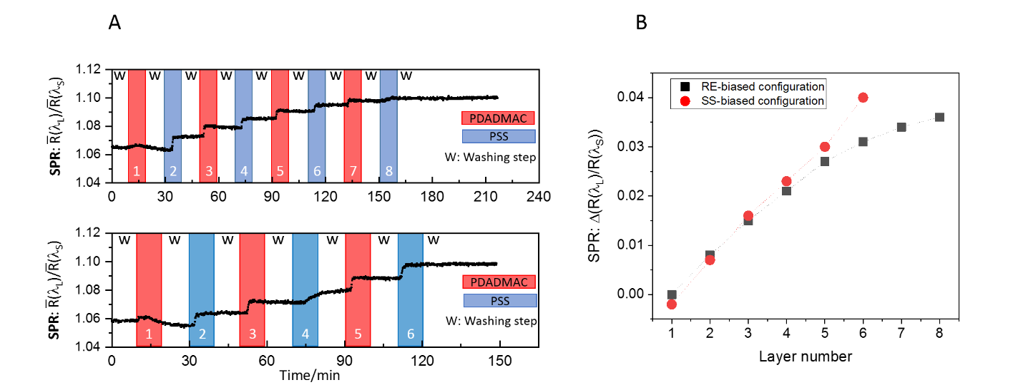
Figure S5. (A) Obtained SPR signal during PEM assembly experiment in RE-biased (top) and SS-biased configuration (bottom). (B) $∆\frac{\overline{R}\left(λ_{L}\right)}{\overline{R}\left(λ_{S}\right)}$ shift with respect to initial base line in 0.1 M KCl after each layer deposition.

References

1. Lai, S., Barbaro M., & Bonfiglio A., Tailoring the sensing performances of an OFET-based biosensor. Sensors and Actuators B: Chemical, 233: p. 314-319 (2016).
2. Bard, A.J., Faulkner L.R. & White H.S., Electrochemical methods: fundamentals and applications. (John Wiley & Sons 2022).
3. Aspermair, P., et al., Dual Monitoring of Surface Reactions in Real Time by Combined Surface-Plasmon Resonance and Field-Effect Transistor Interrogation. Journal of the American Chemical Society, 142(27): p. 11709-11716 (2020).
4. Hageneder, S., et al., Multi-diffractive grating for surface plasmon biosensors with direct back-side excitation. Optics Express, 28(26): p. 39770-39780 (2020).
5. Hasler, R., et al., Surface plasmon resonance biosensor with anti-crossing modulation readout. Sensors and Actuators B: Chemical, 417: p. 136163 (2024).

