Supplementary Information File for Paper Publication

TOPIC:
LEVELS AND HEALTH RISK ASSESSMENT OF ORGANOCHLORINE
RESIDUES IN VEGETABLES FROM RIVERS NIGER-BENUE CONFLUENCE IN LOKOJA, NORTH CENTRAL NIGERIA

Problem Statement
Micropollutants include trace metals, polycyclic aromatic hydrocarbons (PAHs), and organochlorine pesticide residues (OCPs). OCPs can accumulate in plants and animals and have the ability to travel great distances. There have been reports of severe health consequences, including headache, dizziness, anger, nausea, vomiting, anxiety, disorientation, convulsions, reproductive problems, neurotoxicity, tremor, hypertension, cardiovascular illnesses, human skin disorders, and cancer.
Pesticides are used by farmers all over the world, including in Nigeria, as a preventative measure against the potential for catastrophic crop loss due to pests and diseases.
Humans are exposed to OCPs through skin contact, contaminated food consumption, and direct inhalation. However there arose the need to check the levels and health risk assessment of organochlorine residues in vegetables cultivated and consumed around Rivers Niger – Benue Confluence in Lokoja, North Central Nigeria. Therefore this study examined fourteen distinct organochlorine insecticides. These included p,p′-DDE, lindane, α-lindane, β-lindane, methoxychlor, endosulfan, endosulfan I, endosulfan II, endosulfan sulphate, aldrin, heptachlor, heptachlor epoxide and p dieldrin. The possible health risks to humans from consuming contaminated vegetables were calculated, as were the levels of OCP residues in vegetable samples.

Method
The extraction was by Ultrasonication, while analysis of Organochlorine was carried out using gas chromatography interfaced with a mass selective detector. The chromatograms obtained after the analysis were given thus

APPENDIX 1: Chromatogram of Tomatoes Sample
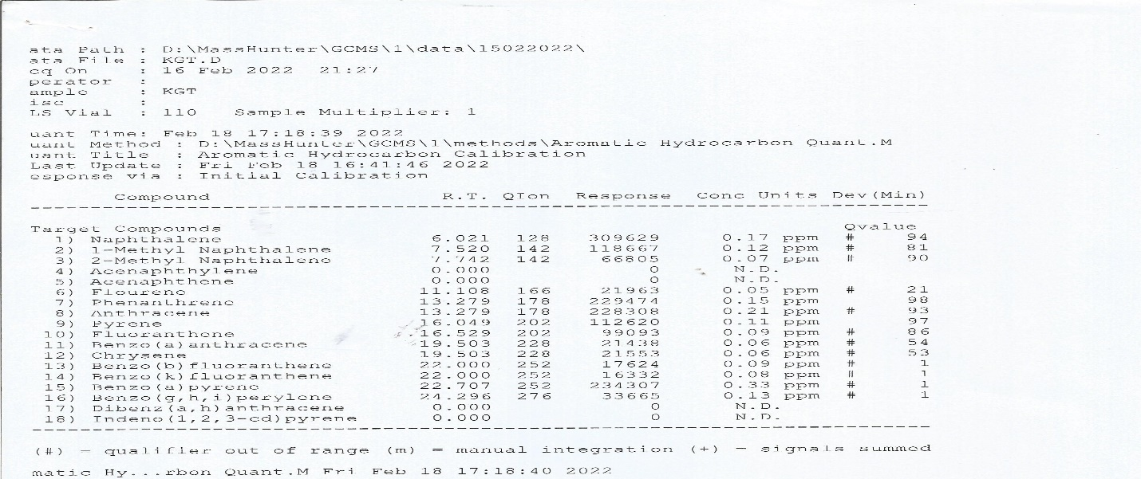

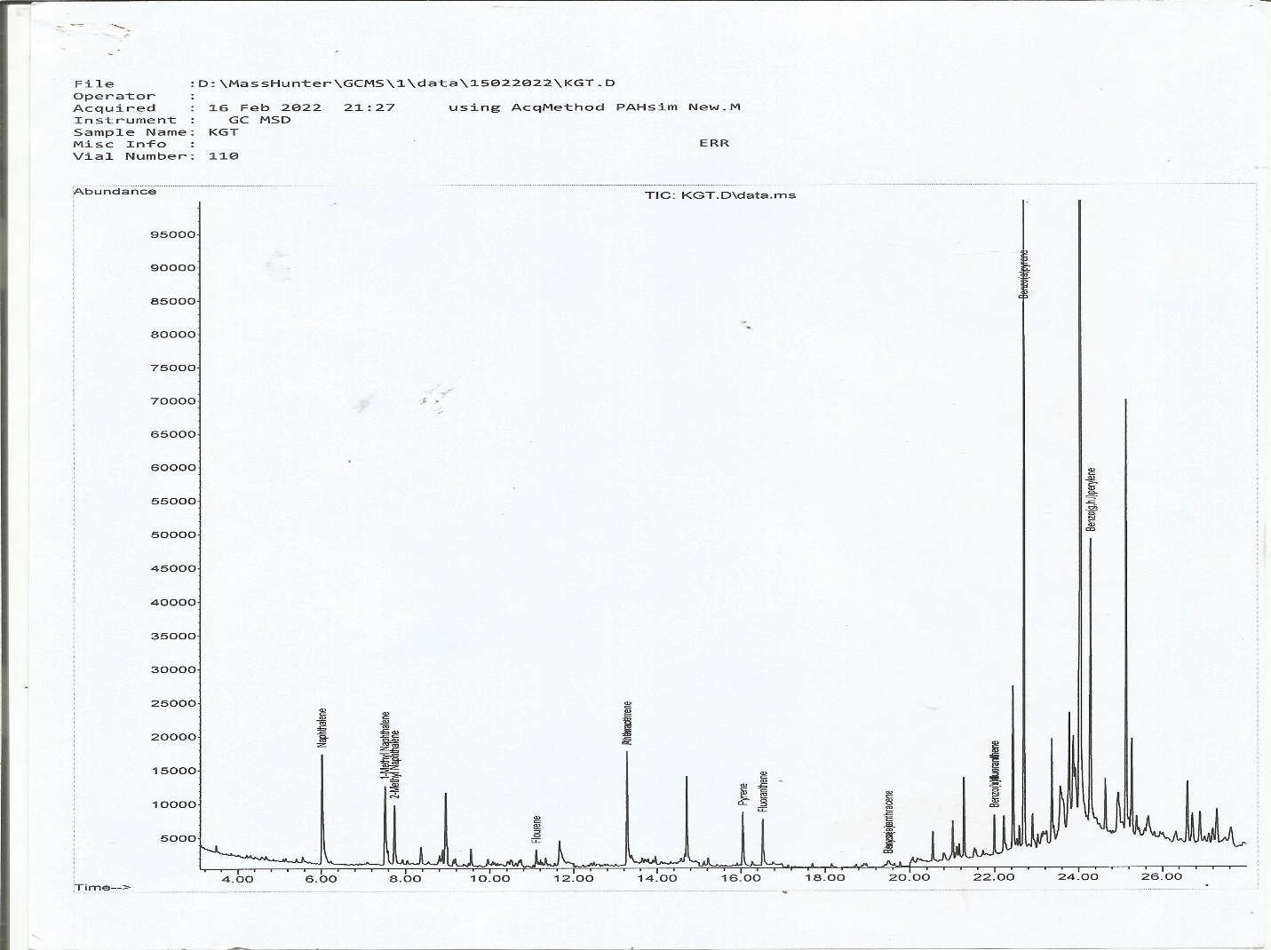

APPENDIX 2: Chromatogram of Spinach Sample
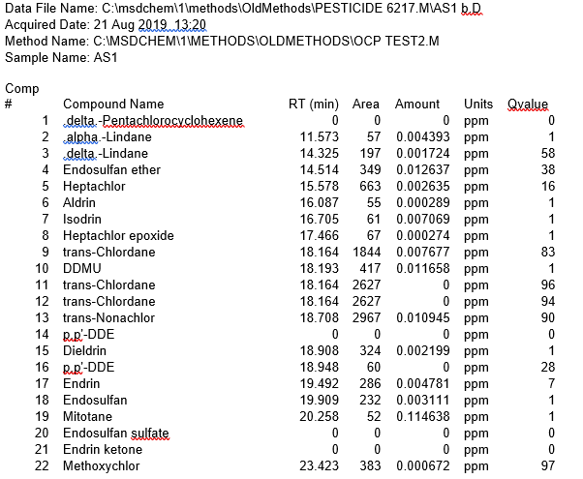

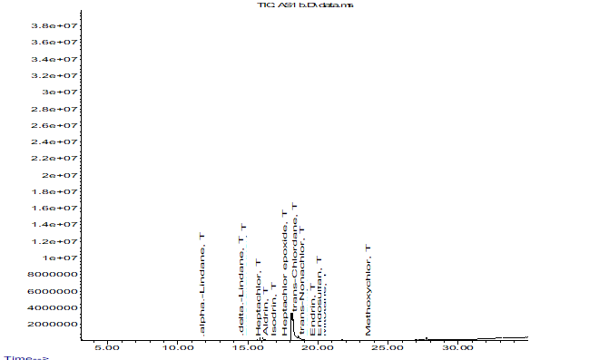

APPENDIX 3: Chromatogram of Spinach Sample
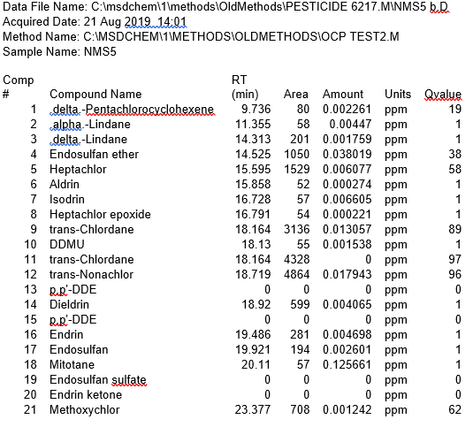

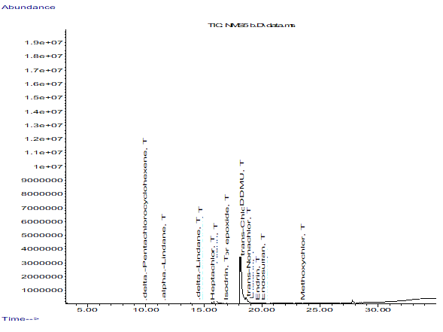

APPENDIX 4: Chromatogram of Spinach Sample
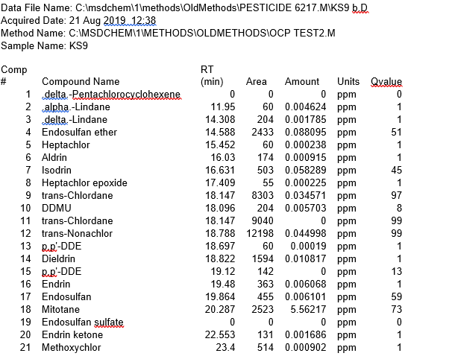

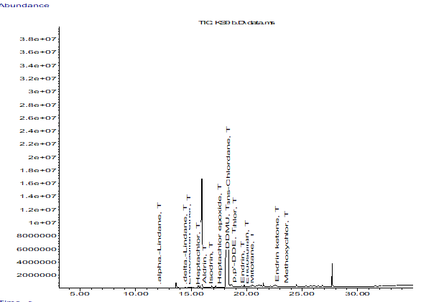

APPENDIX 5: Chromatogram of Spinach Sample
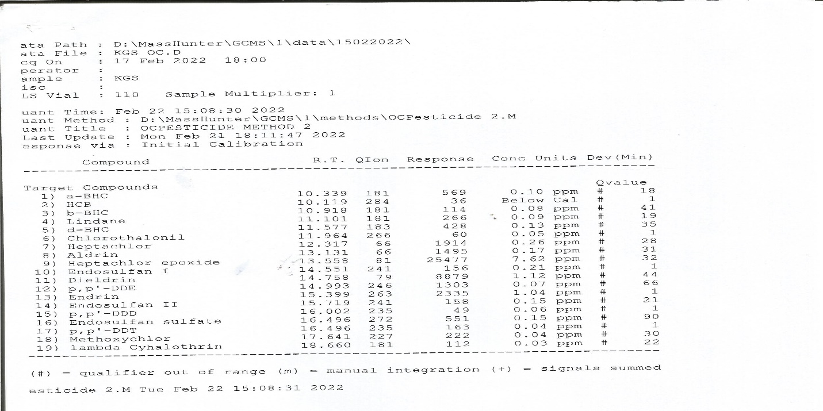

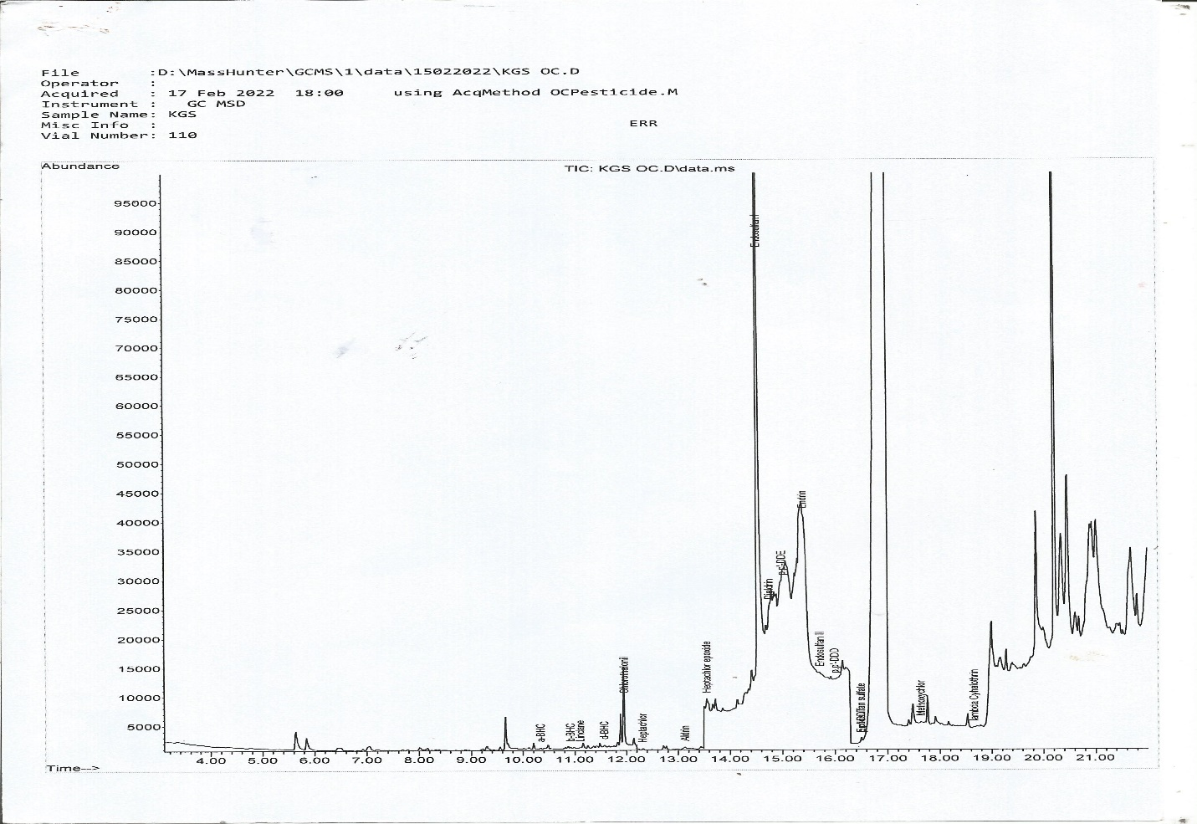

APPENDIX 6: Chromatogram of Spinach Sample
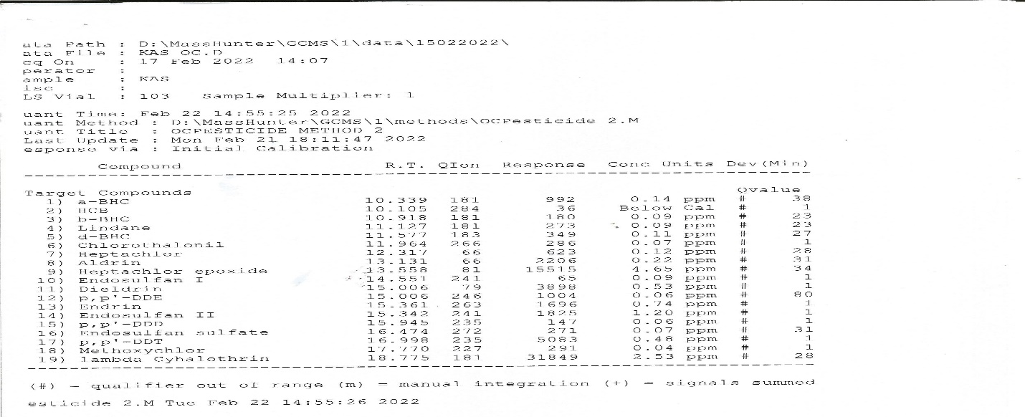

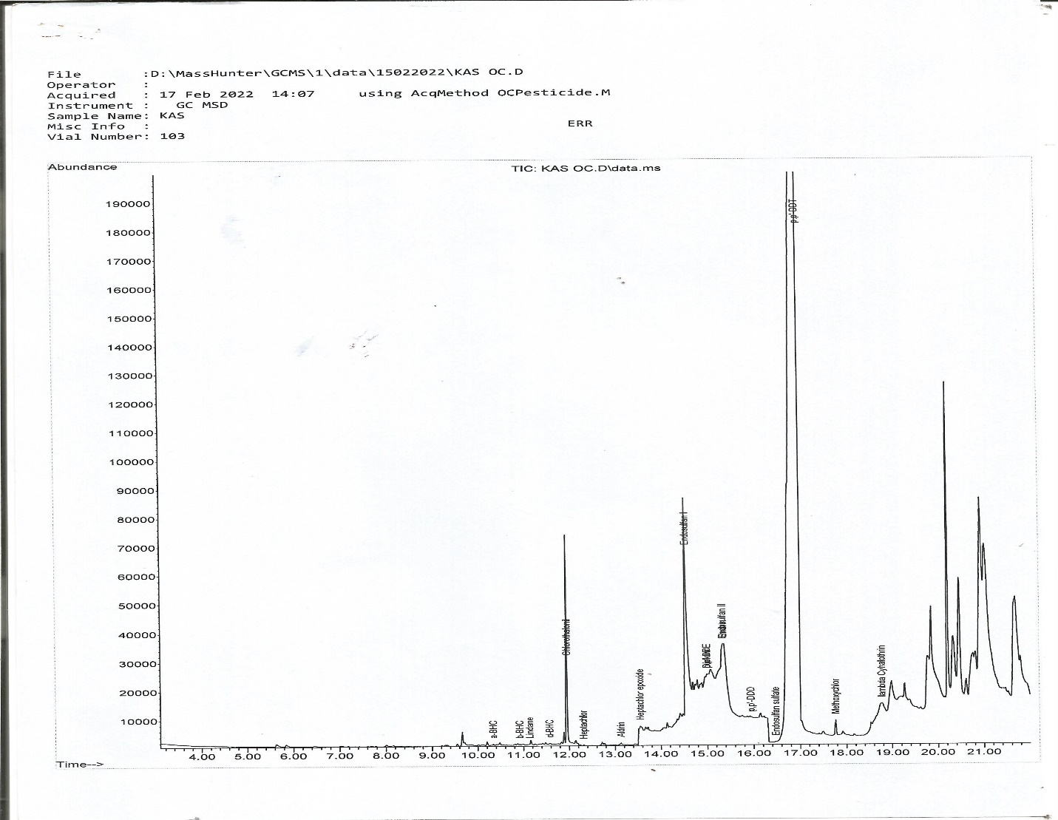

APPENDIX 7: Chromatogram of Pumpkin leaf Sample
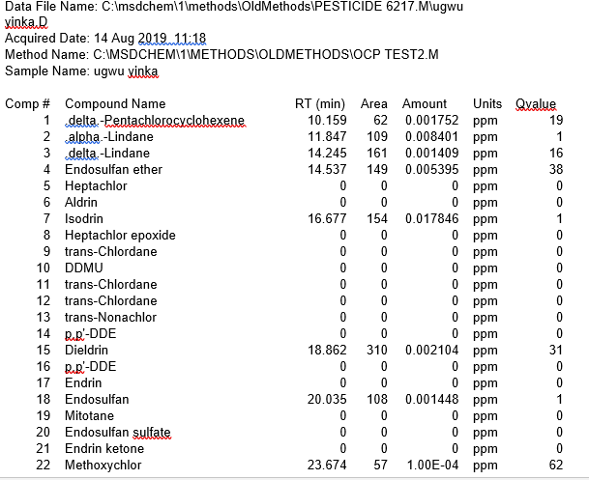
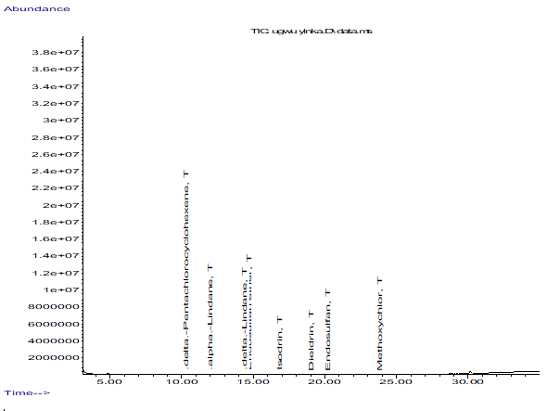

APPENDIX 8: Chromatogram of Pumpkin leaf Sample
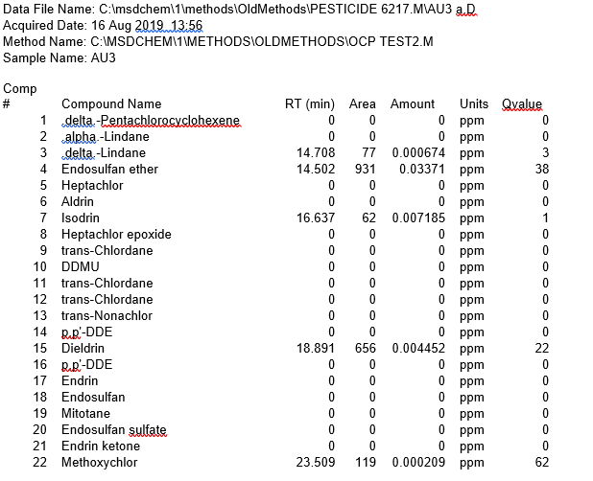

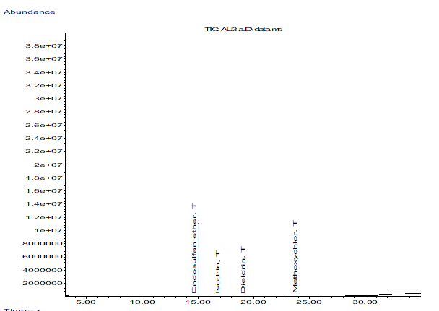

APPENDIX 9: Chromatogram of Pumpkin leaf Sample
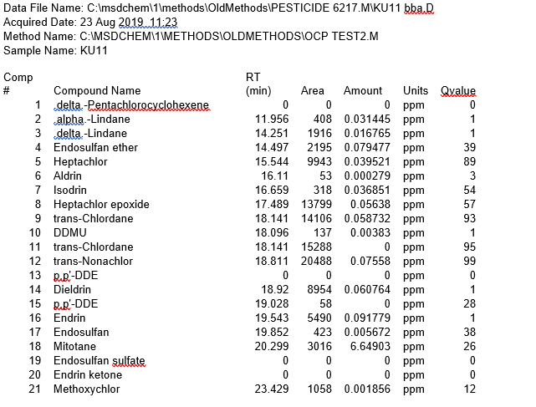
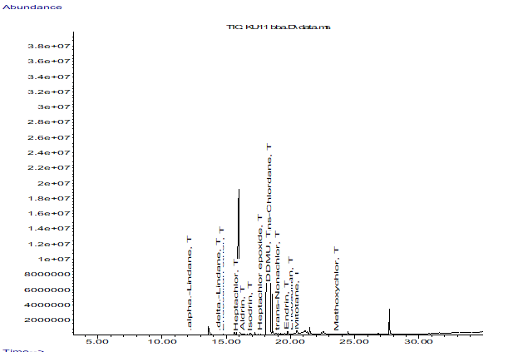

APPENDIX 10: Chromatogram of Pumpkin leaf Sample
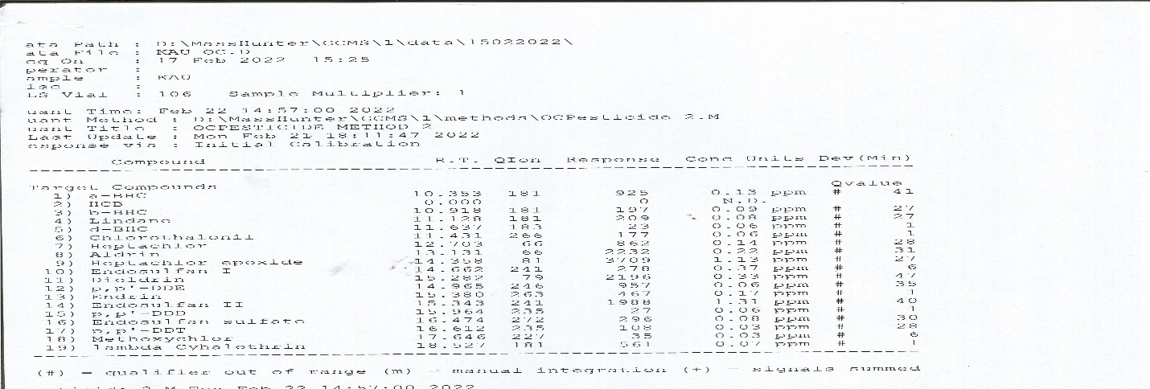

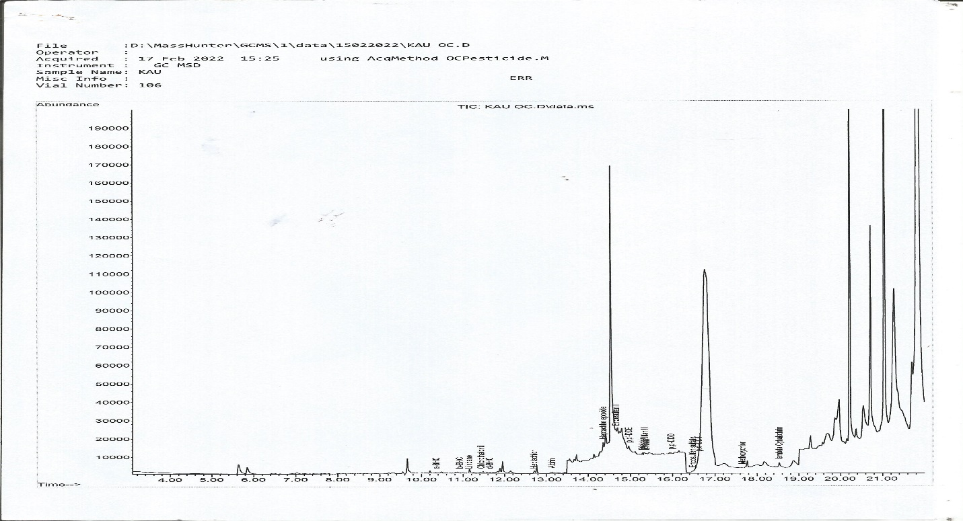

APPENDIX 11: Chromatogram of Pumpkin leaf Sample
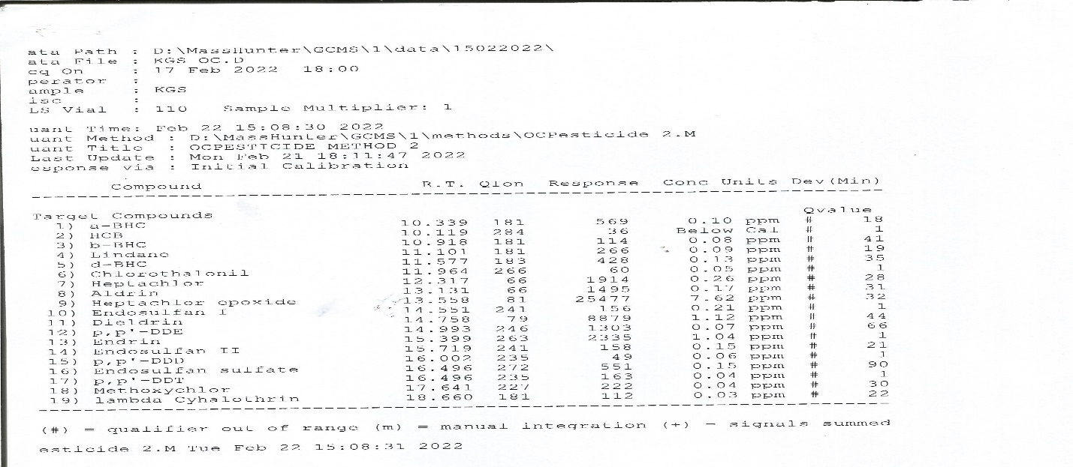

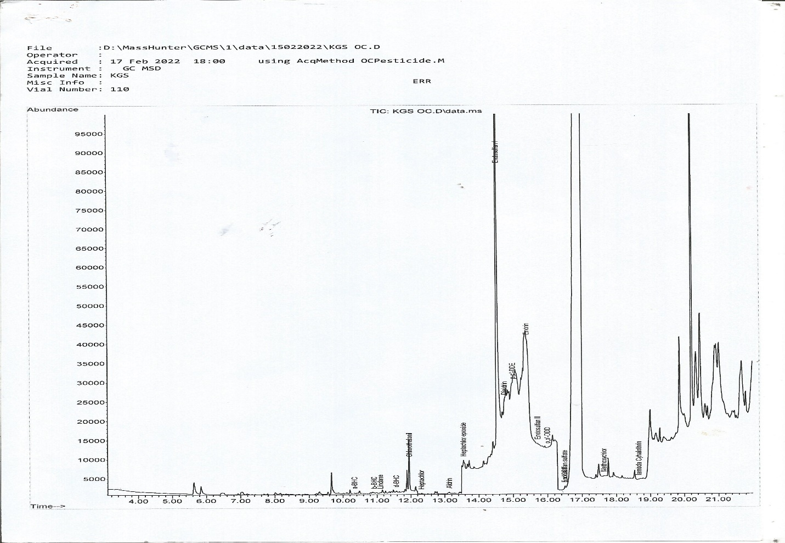

APPENDIX 12: Chromatogram of Jute leaf Sample
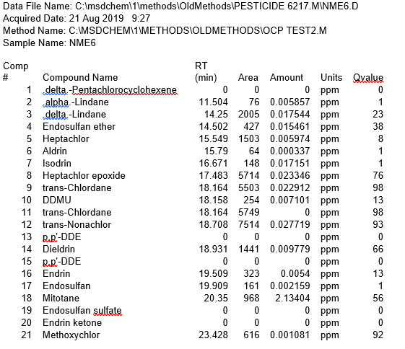
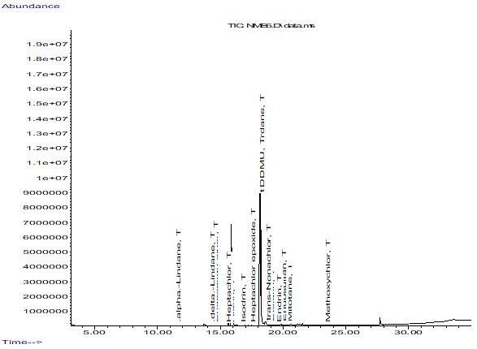

APPENDIX 13: Chromatogram of Jute leaf Sample
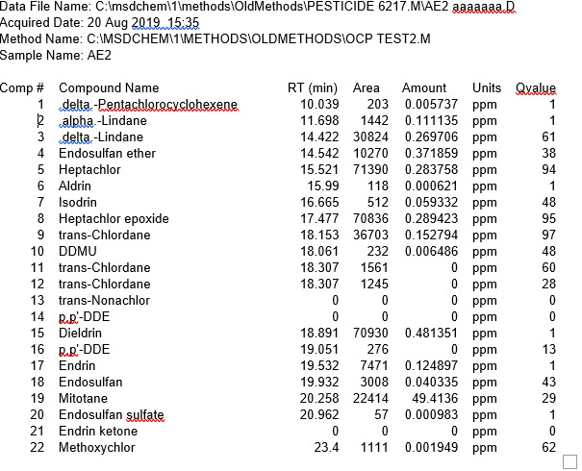

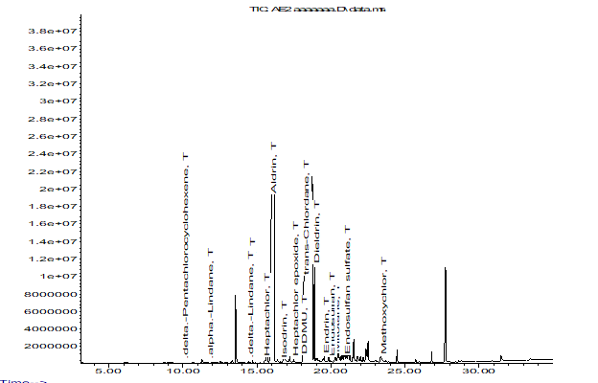

APPENDIX 14: Chromatogram of Jute leaf Sample
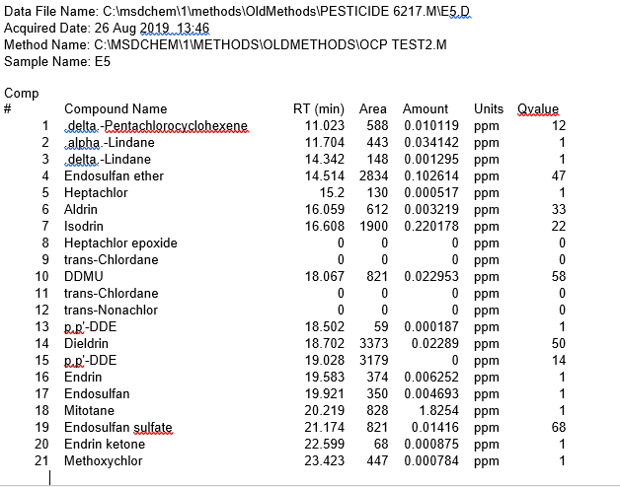

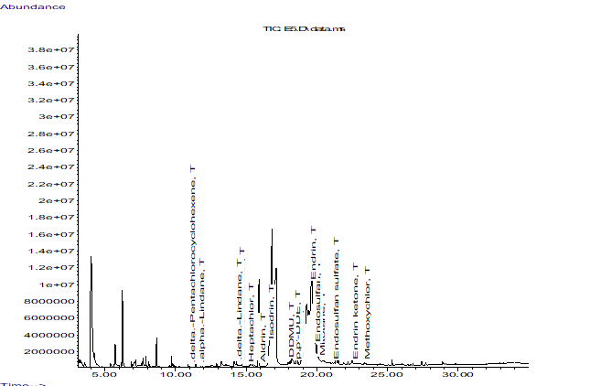

APPENDIX 15: Chromatogram of Jute leaf Sample
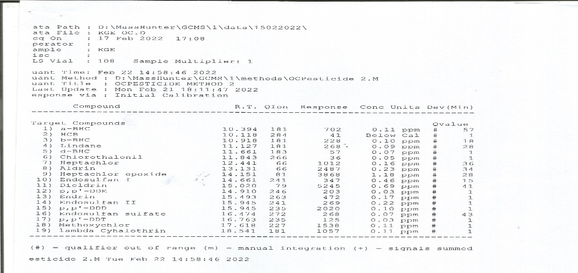

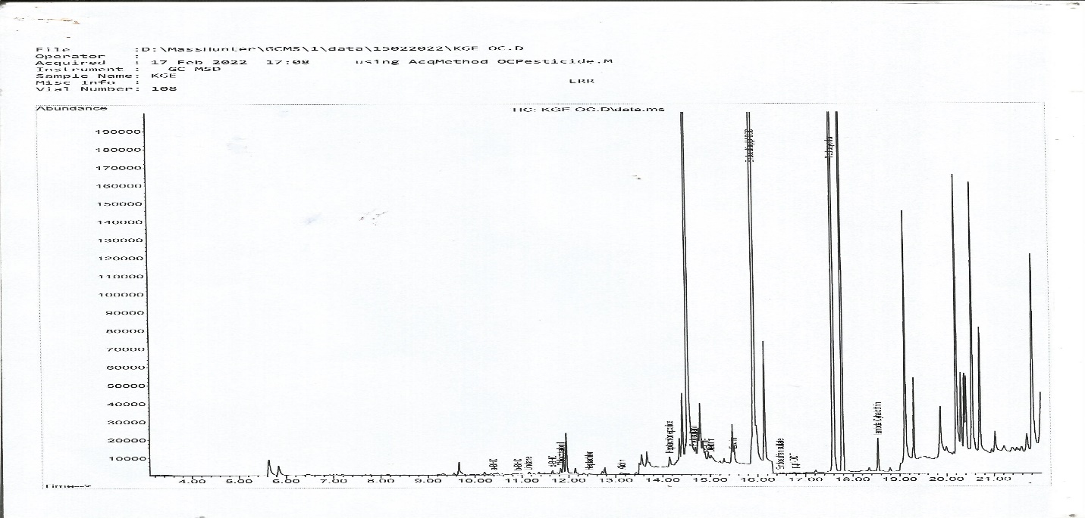

APPENDIX 16: Chromatogram of Jute leaf Sample
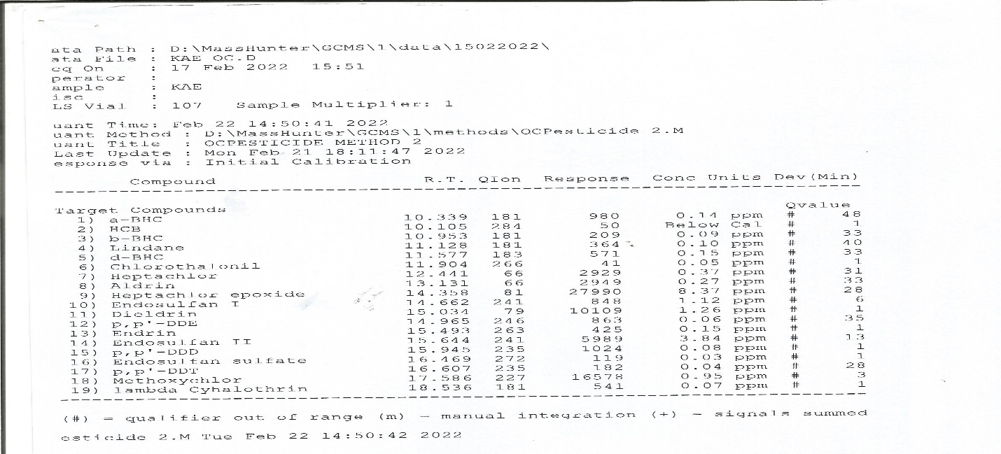

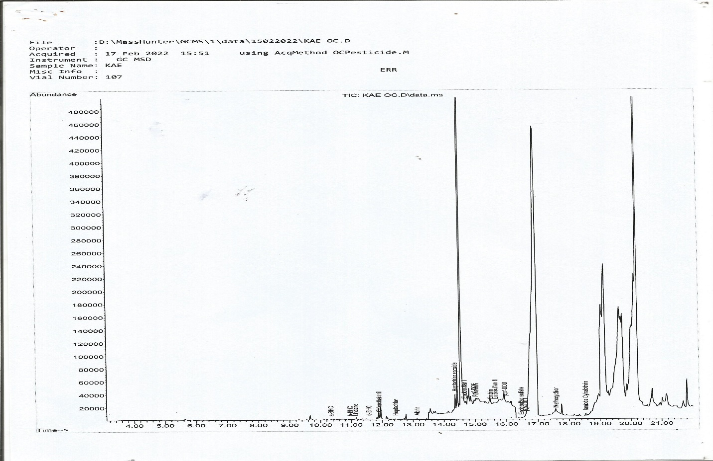

APPENDIX 16: Chromatogram of Jute leaf Sample
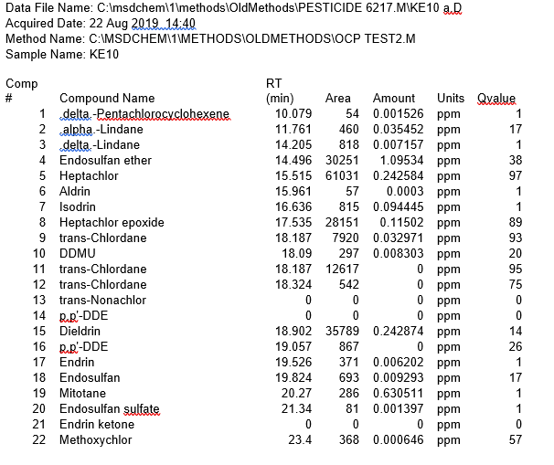

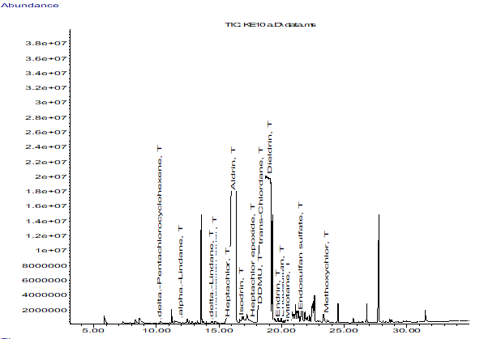

APPENDIX 17: Chromatogram of Okro Sample
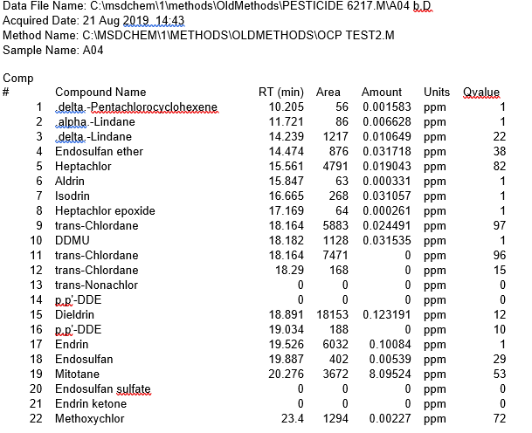
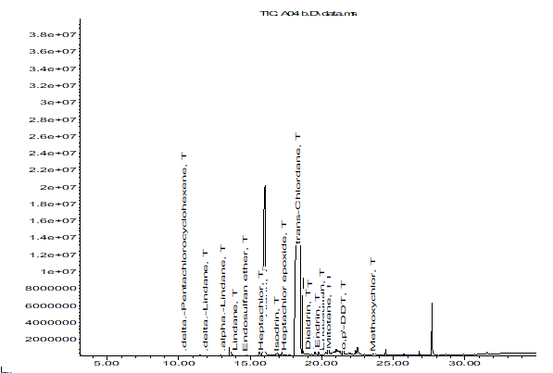

APPENDIX 18: Chromatogram of Okro Sample
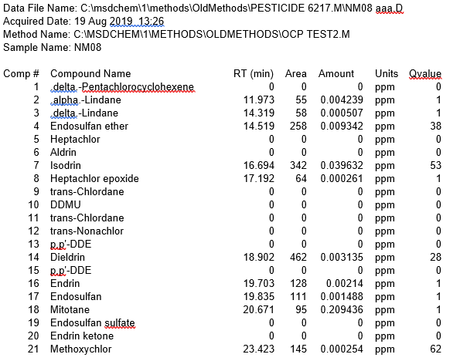
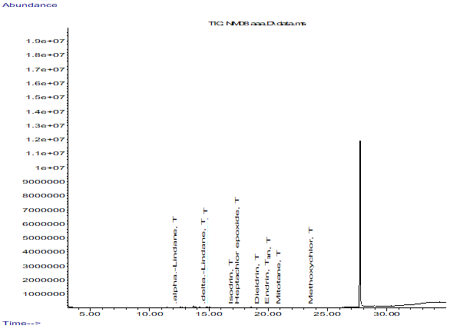

APPENDIX 19: Chromatogram of Okro Sample
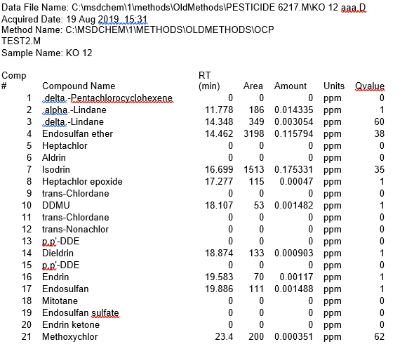
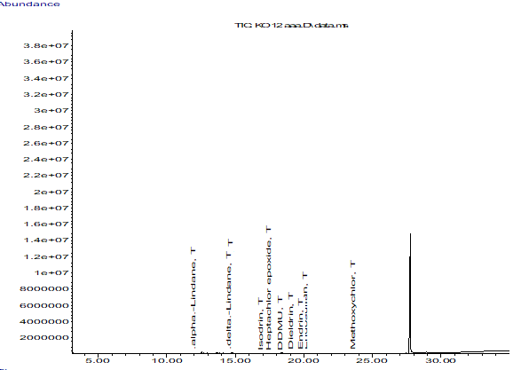

APPENDIX 20: Chromatogram of Okro Sample
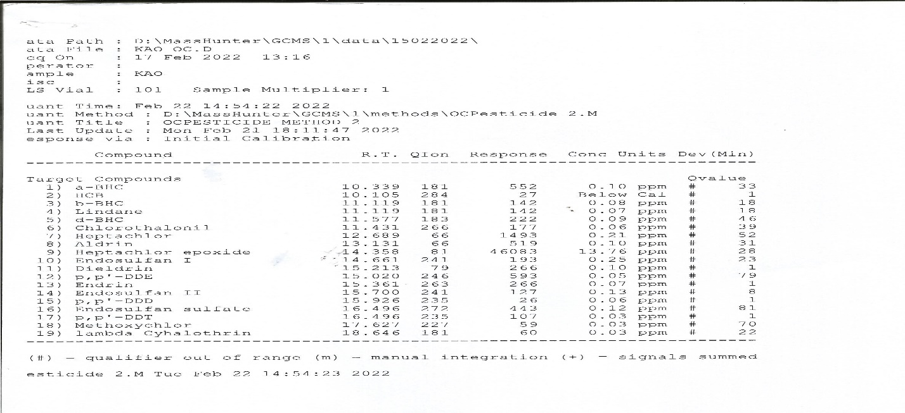

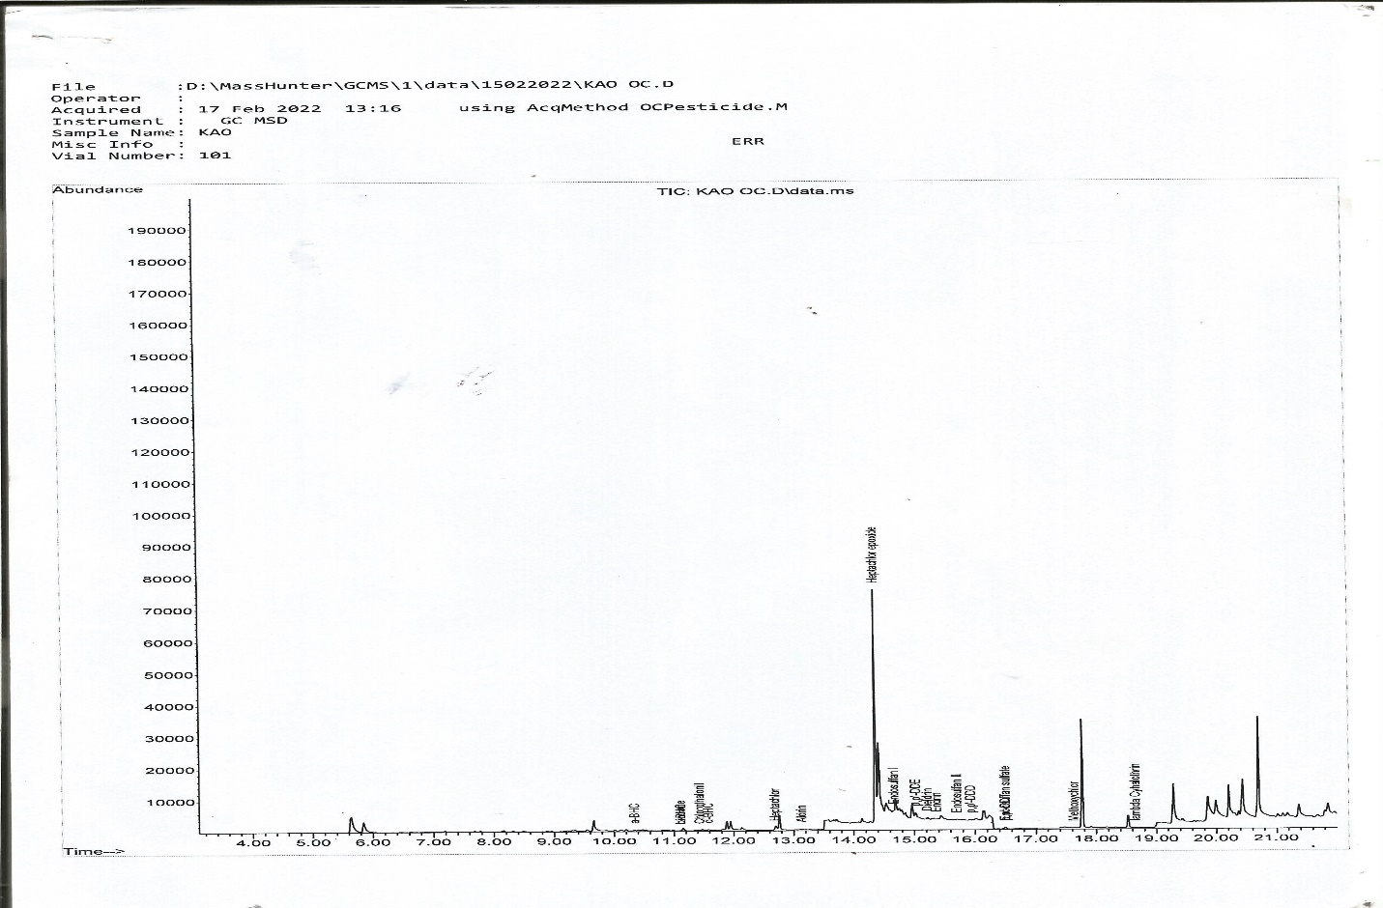

APPENDIX 21: Chromatogram of Okro Sample
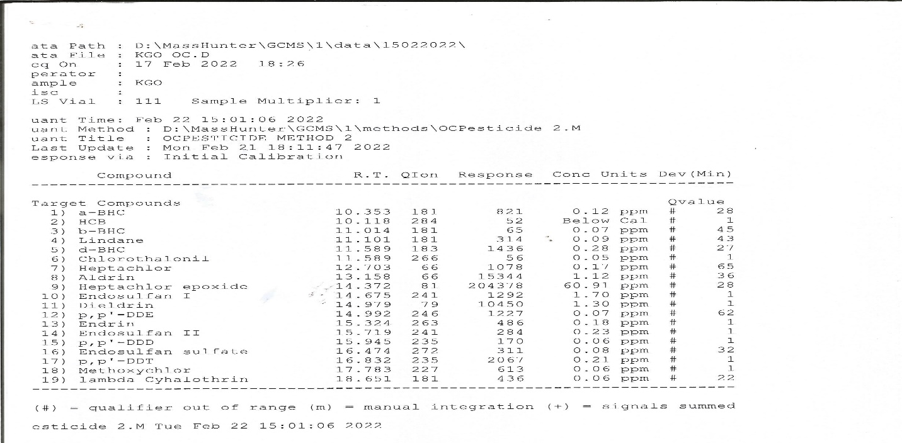

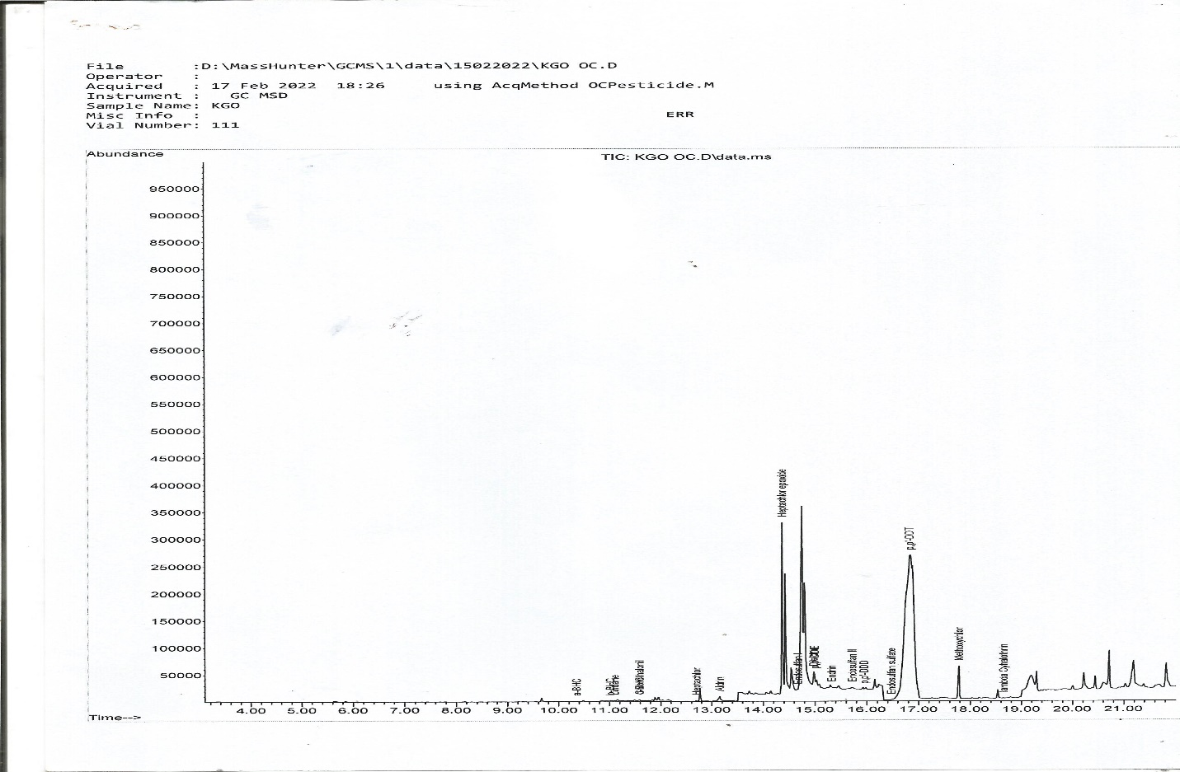

APPENDIX 22: Chromatogram of Tomatoes Sample
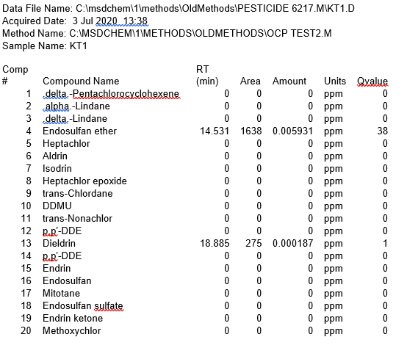
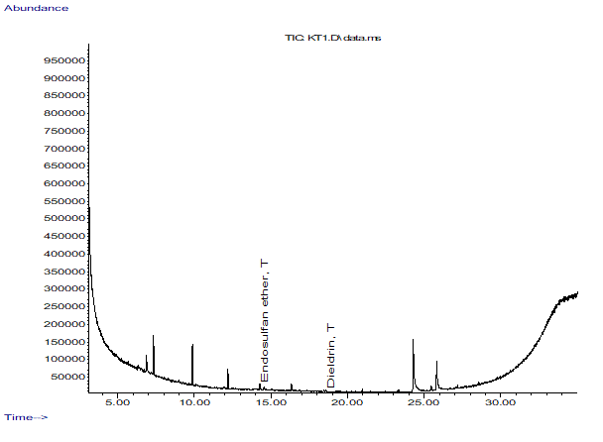

APPENDIX 23: Chromatogram of Tomatoes Sample
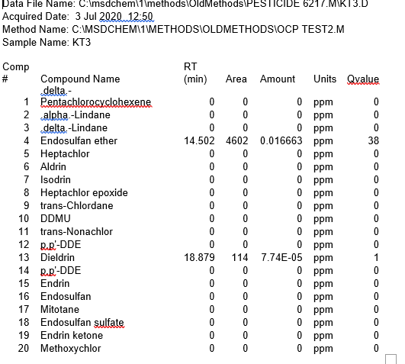
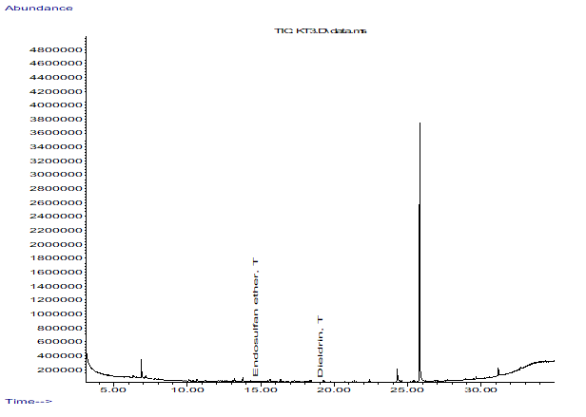

APPENDIX 24: Chromatogram of Tomatoes Sample
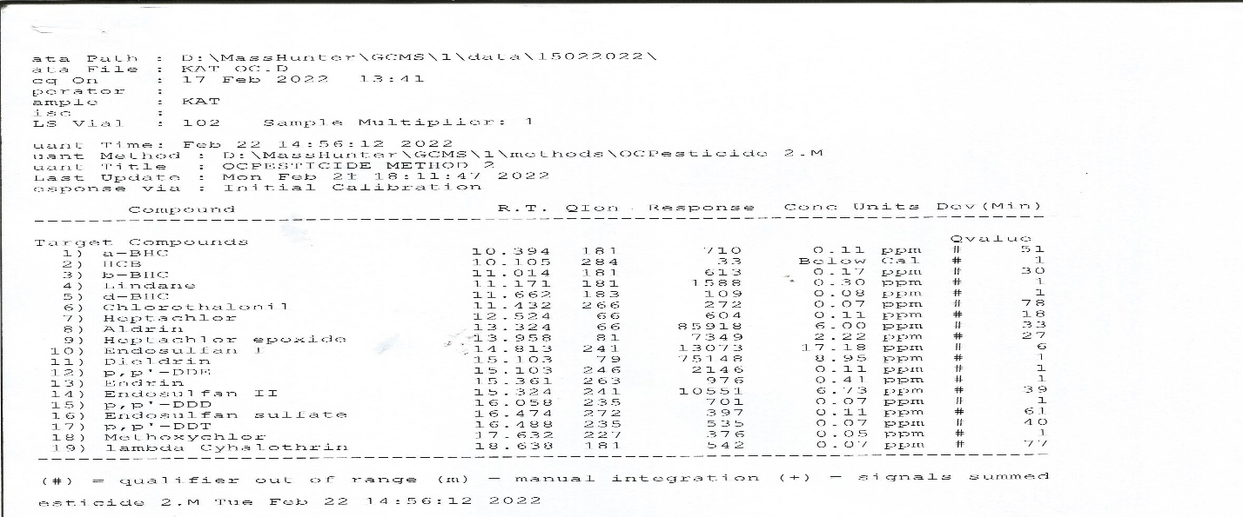

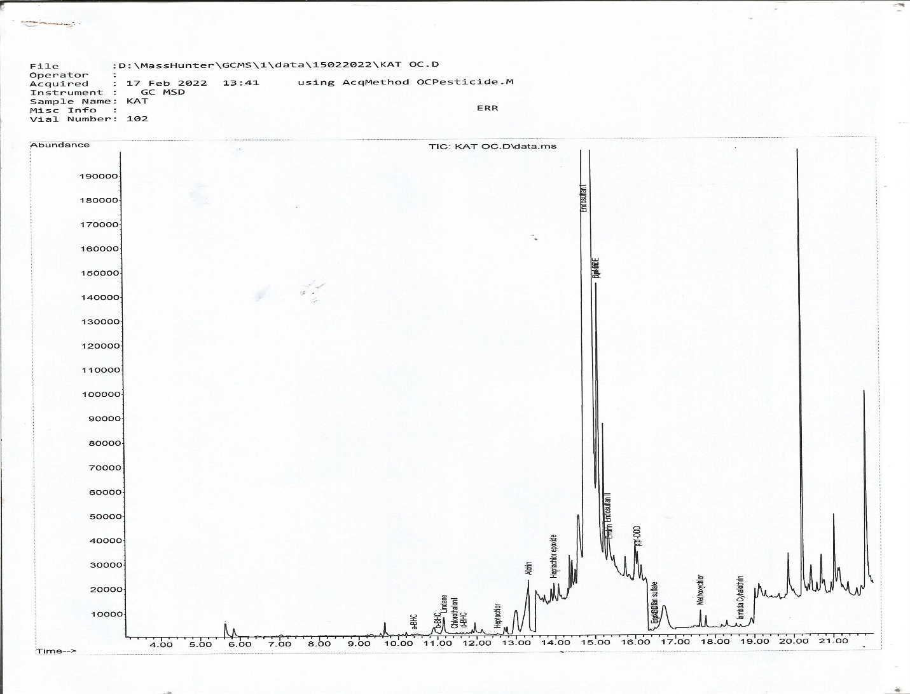

APPENDIX 25: Chromatogram of Tomatoes Sample
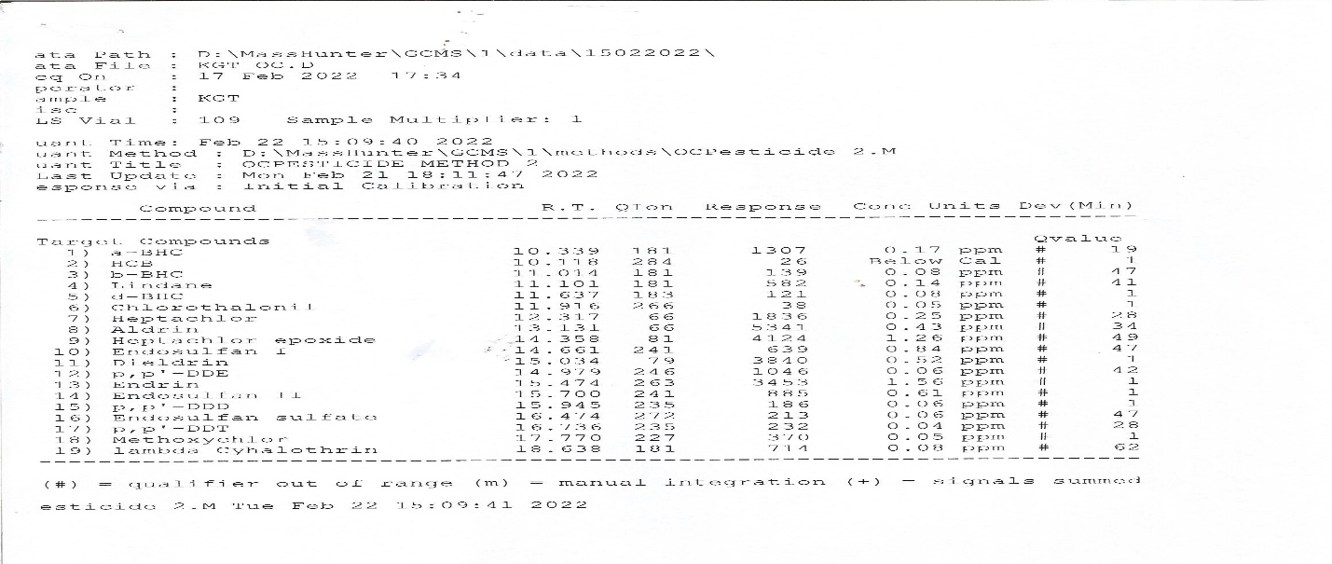

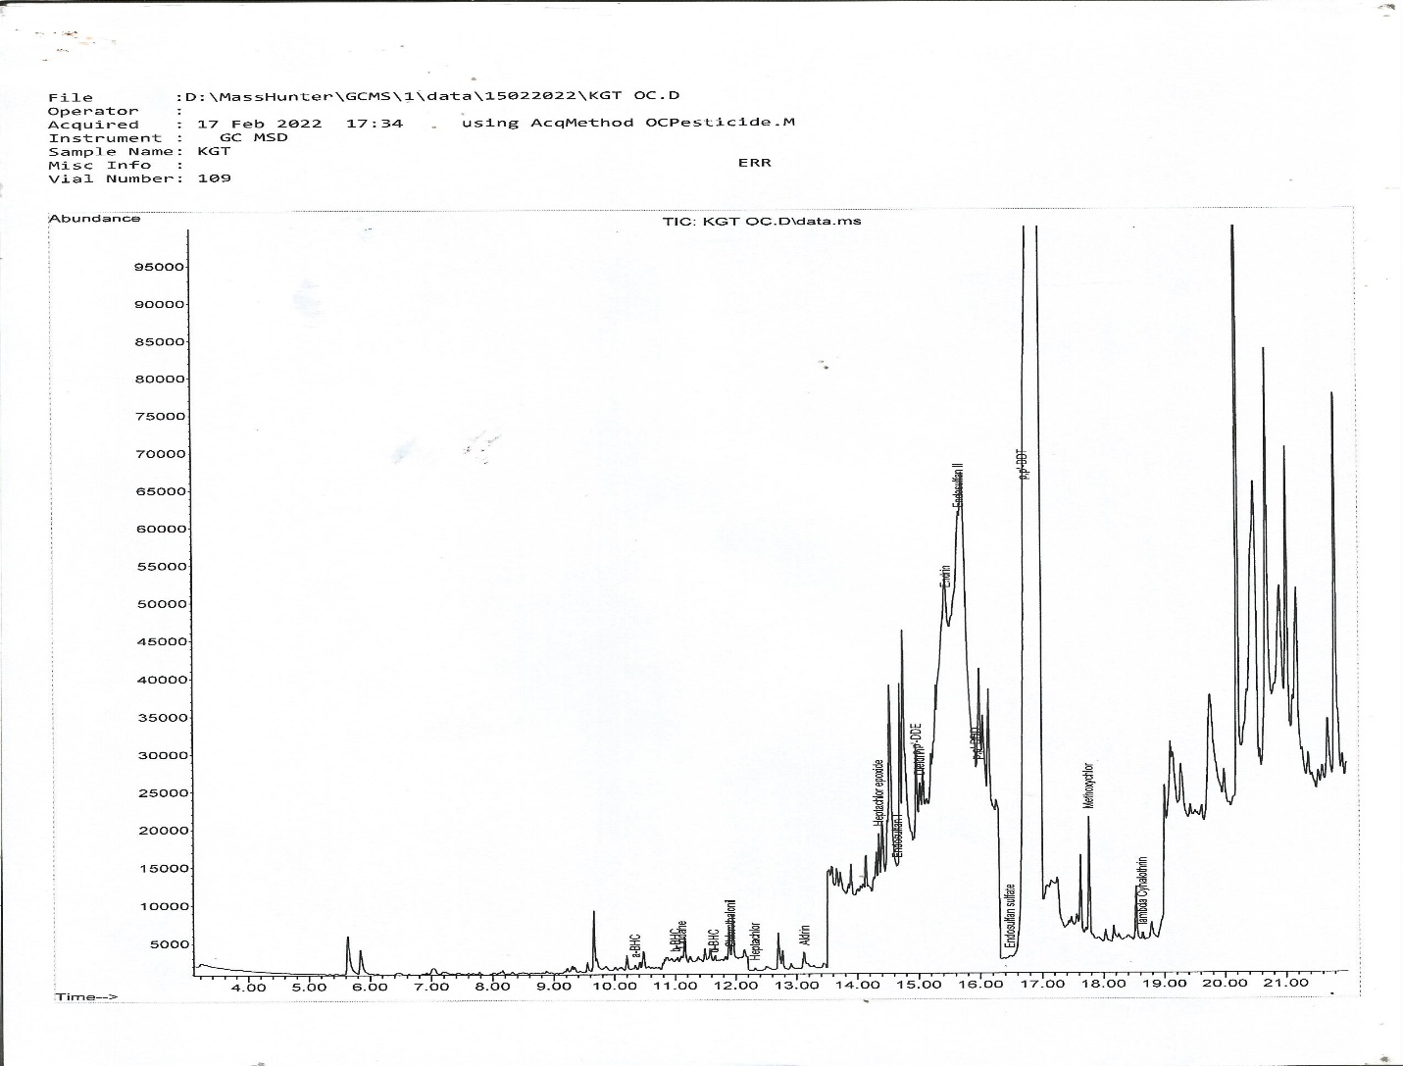

APPENDIX 26: Chromatogram of Cucumber Sample
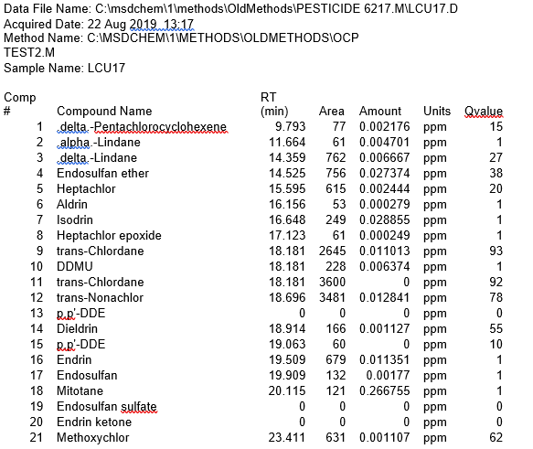
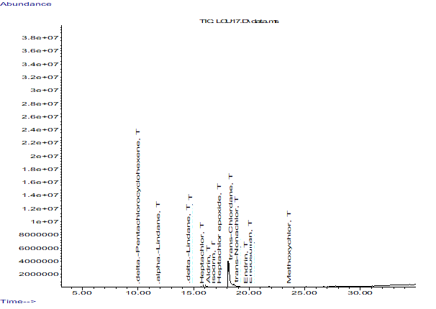

APPENDIX 27: Chromatogram of Cucumber Sample
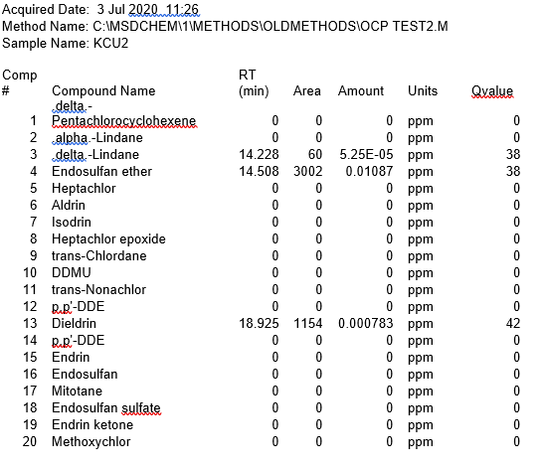
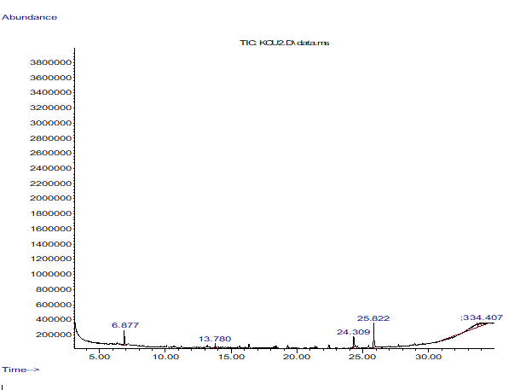

APPENDIX 28: Chromatogram of Cucumber Sample
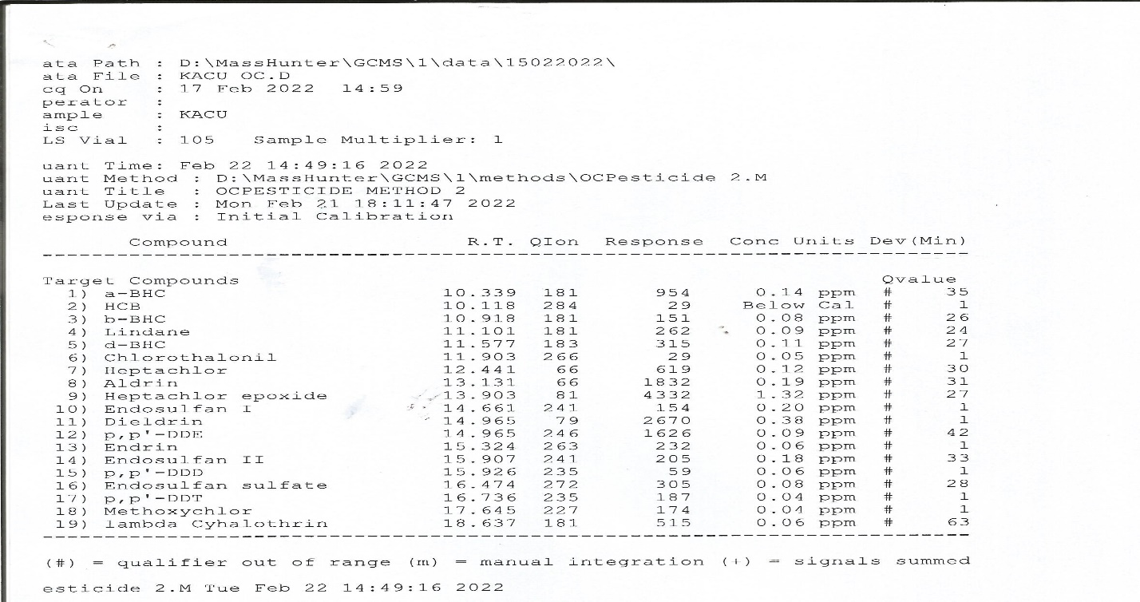

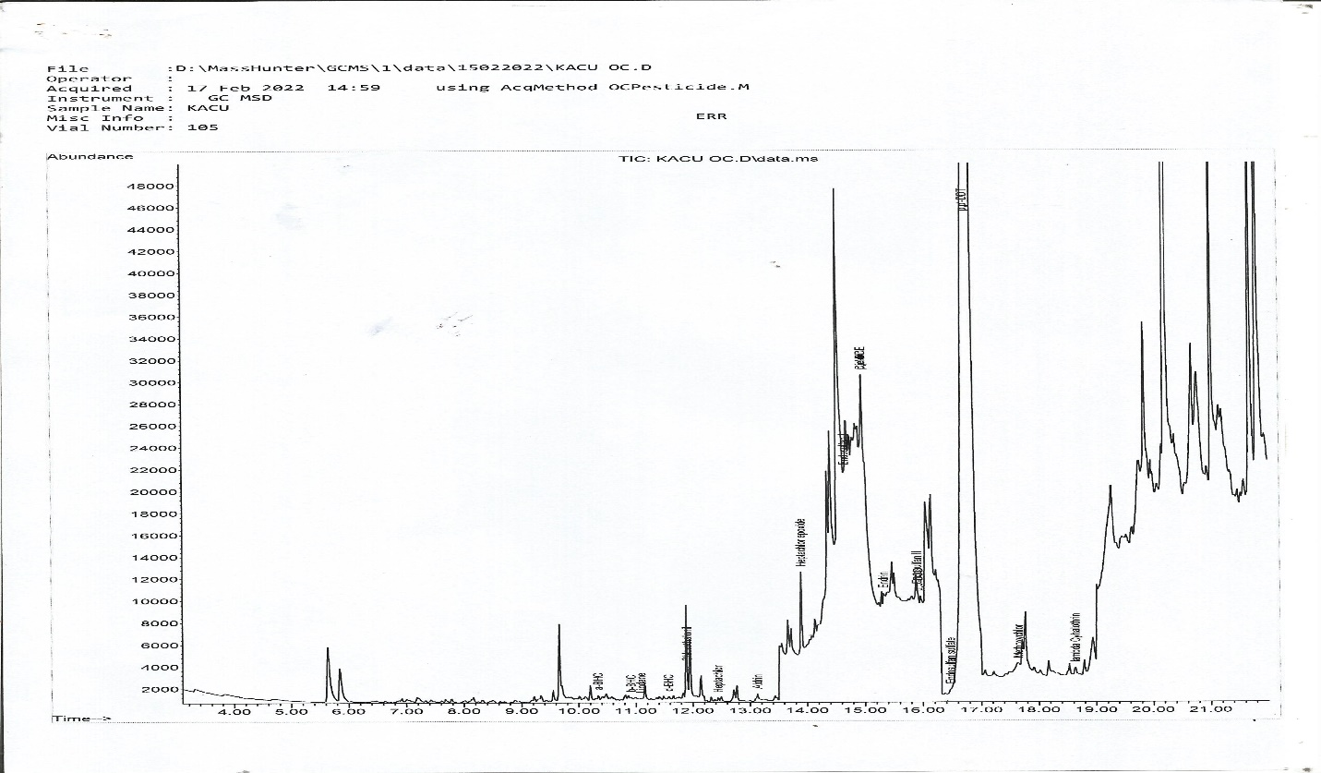

APPENDIX 29: Chromatogram of Cucumber Sample
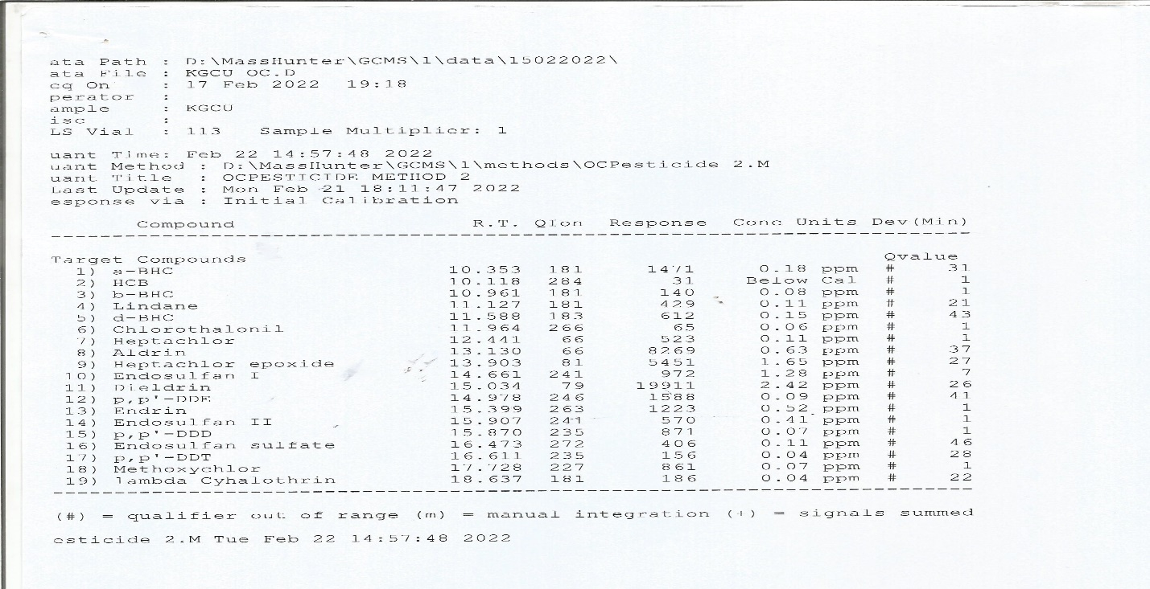

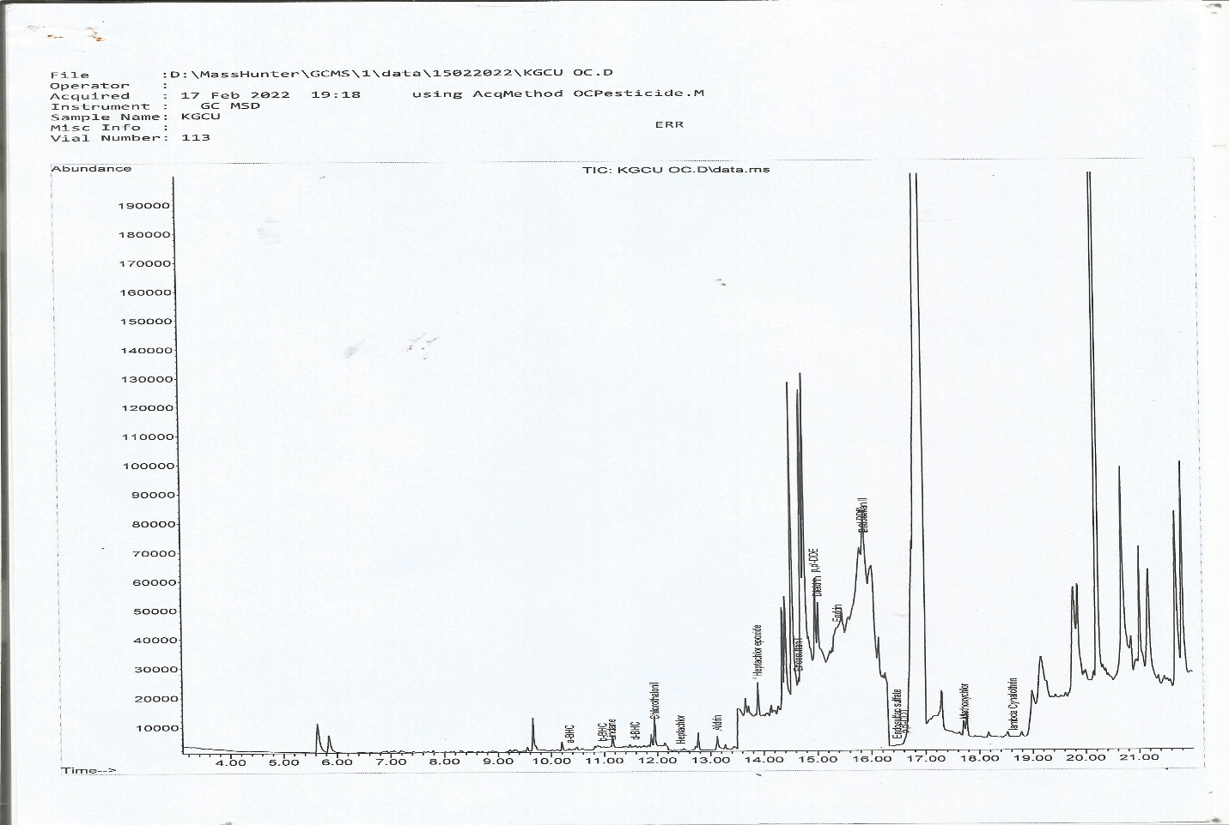

APPENDIX 30: Chromatogram of Garden egg Sample
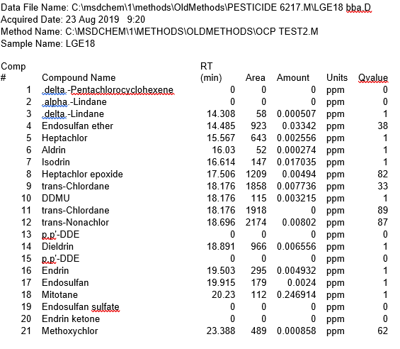

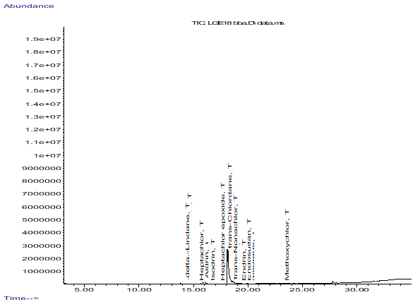

APPENDIX 31: Chromatogram of Garden egg Sample
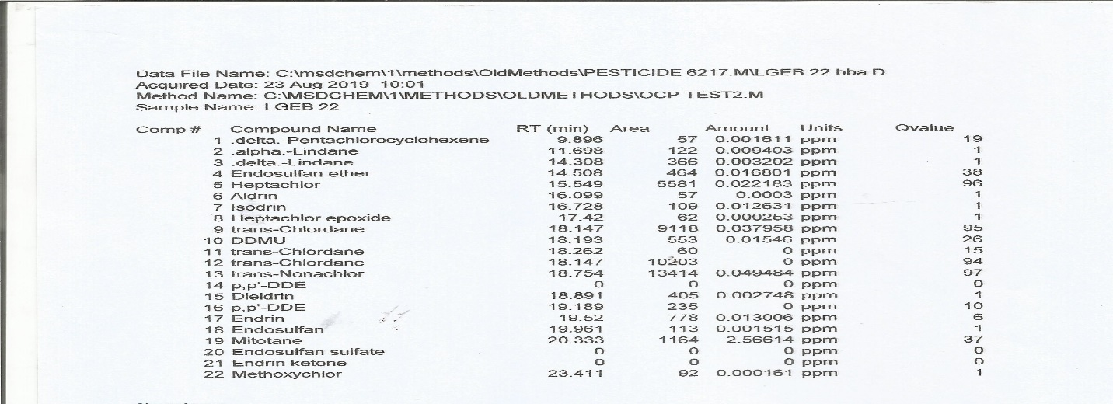

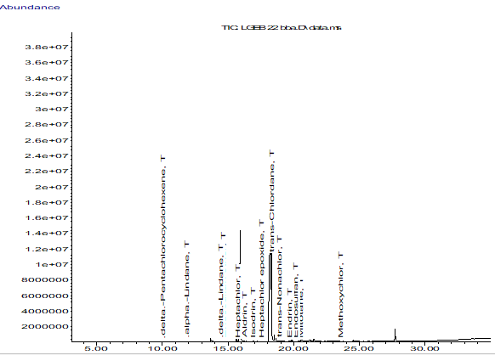

APPENDIX 32: Chromatogram of Garden egg Sample
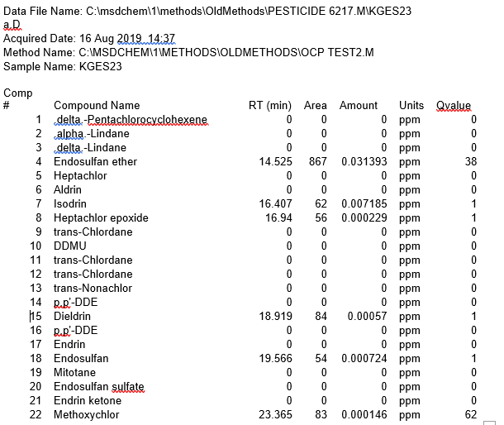

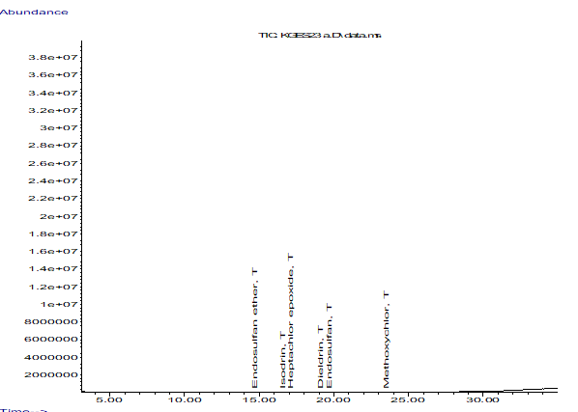

APPENDIX 33: Chromatogram of Garden egg Sample
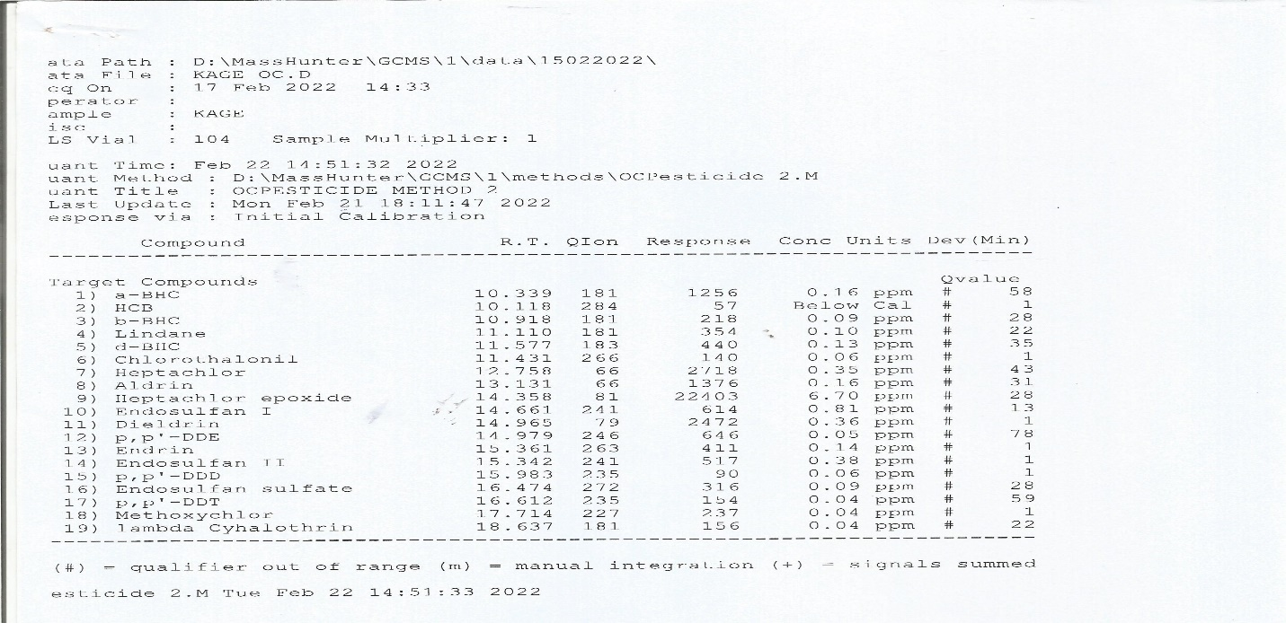

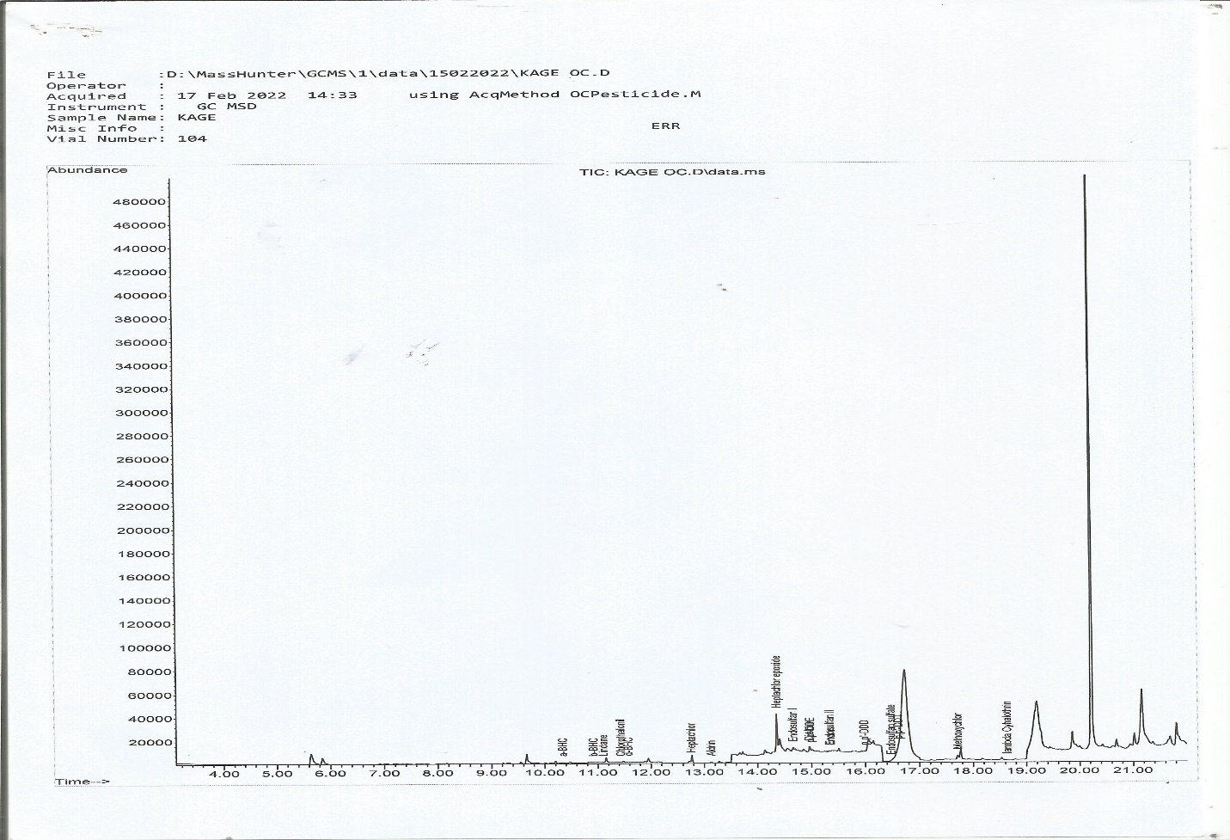

APPENDIX 34: Chromatogram of Garden egg Sample
