Handling electric connections in 3D-printed electrodes and sensors. Part I. Understanding and improving tracks and contacts

Ivan Verlangieri, Thawan Gomes de Oliveira, Fernando Silva Lopes, Ivano Gebhardt Rolf Gutz, Lúcio Angnes, and Claudimir Lucio do Lago*

Department of Fundamental Chemistry, Institute of Chemistry, University of São Paulo

SUPPLEMENTARY INFORMATION (SI)

Thermogravimetric Analysis
The curves for Easyfill PLA (Figure S1) and CB-PLA (Figure S2) were obtained according the conditions shown in Table S1.

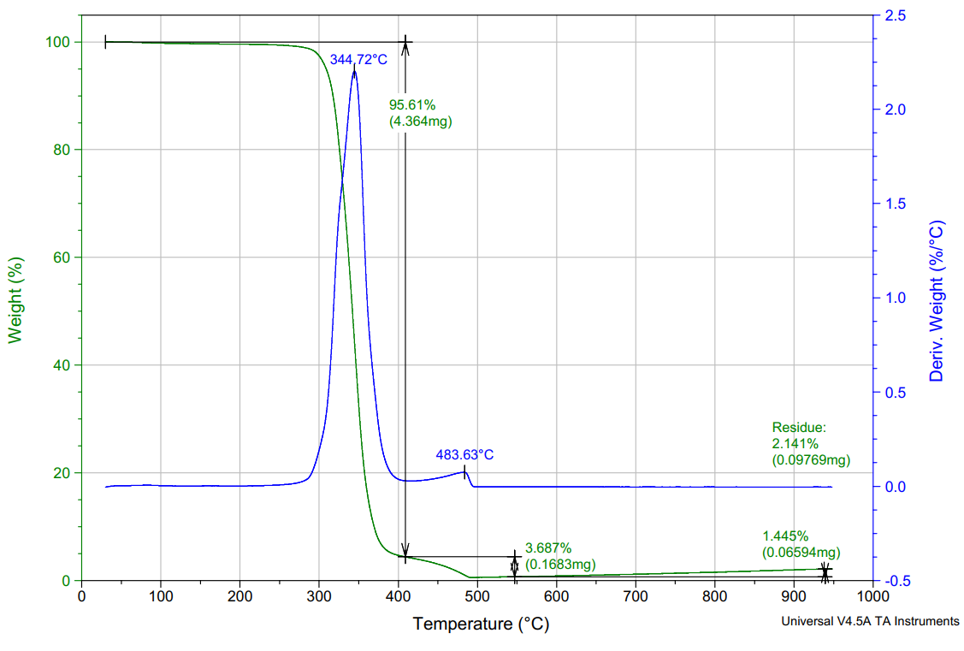

Figure S1. Thermogravimetric analysis curve of the Easyfill PLA filament sample.

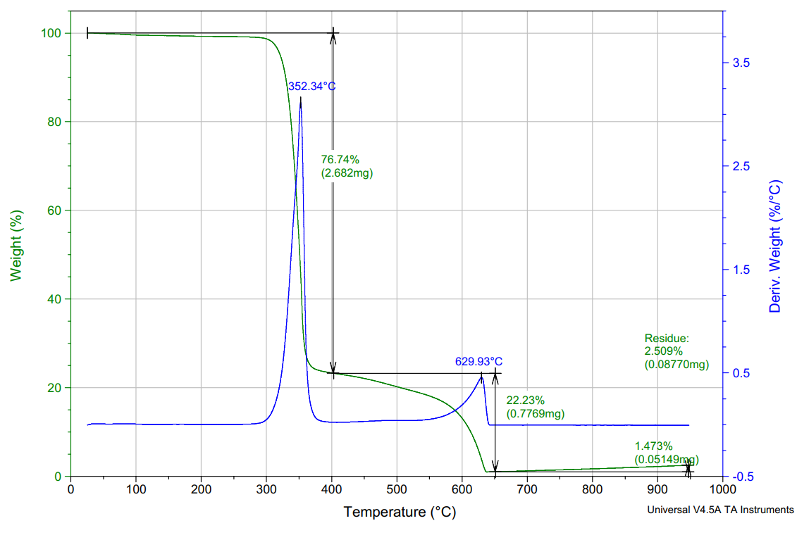

Figure S2. Thermogravimetric analysis curve of the CB-PLA PLA filament sample.

Table S1. TGA conditions obtained from the data file headers
Easyfill PLA | CB-PLA
Instrument TGA Q500 V20.13 Build 39  Module TGA  FurnaceType Standard  Size 4.56400 mg  Comment  Xcomment Pan: Platinum  Xcomment Gas1: Nitrogen  Xcomment Gas2: Air  Xcomment Balance Gas: Nitrogen 40.0 ml/min  Xcomment Sample Gas: Air 60.0 ml/min  Kcell 1.00000  TempCal 2 pts 152.21 154.16,363.56 356.94  Controls Gas 2 Event Off Sampling 0.5  AirCoolTime 10.0 min  AutoAnalysis Off  OrgMethod 1: Ramp 5.00 °C/min to 950.00 °C | Instrument TGA Q500 V20.13 Build 39  Module TGA  FurnaceType Standard  Size 3.49500 mg  Comment  Xcomment Pan: Platinum  Xcomment Gas1: Nitrogen  Xcomment Gas2: Air  Xcomment Balance Gas: Nitrogen 40.0 ml/min  Xcomment Sample Gas: Air 60.0 ml/min  Kcell 1.00000  TempCal 2 pts 152.21 154.16,363.56 356.94  Controls Gas 2 Event Off Sampling 0.5  AirCoolTime 10.0 min  AutoAnalysis Off  OrgMethod 1: Ramp 5.00 °C/min to 950.00 °C

Differential scanning calorimetry
The curves for Easyfill PLA (Figure S3) and CB-PLA (Figure S4) were obtained according the conditions shown in Table S2.

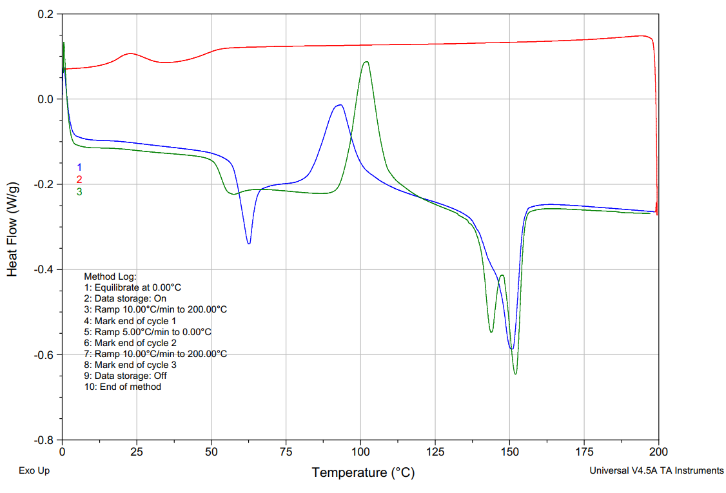
G
C
M

Figure S3. Differential scanning calorimetry heating curve of the Easyfill PLA filament sample. The regions were identified as: glass transition (G), crystallization (C) melting (M).
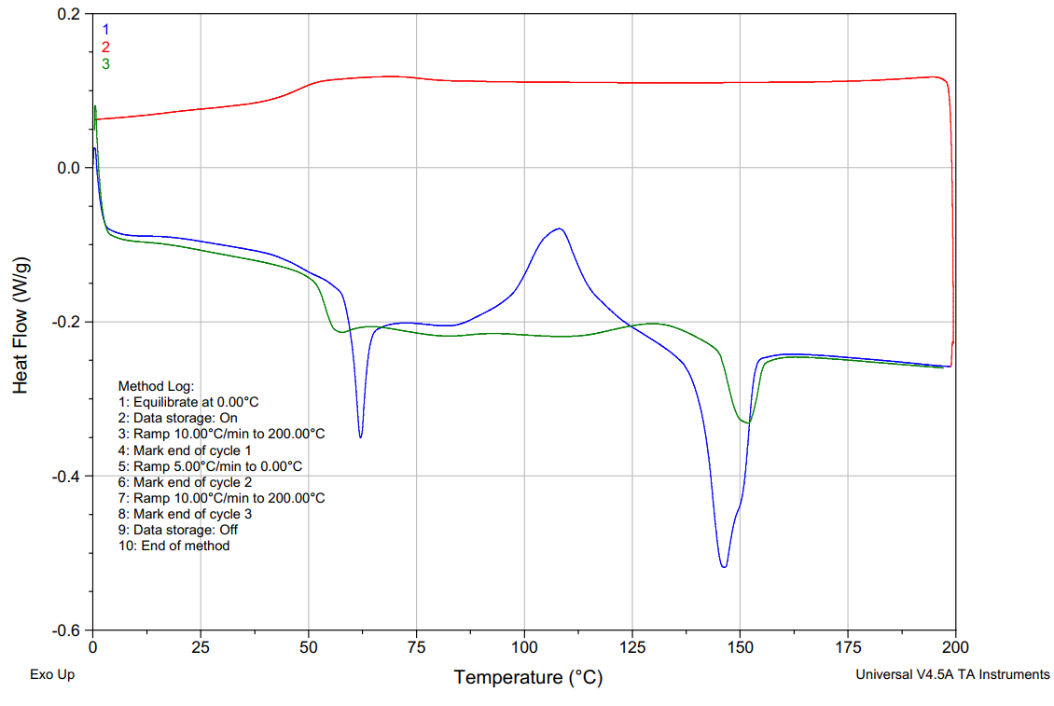
G
H
M

Figure S4. Differential scanning calorimetry heating of the CB-PLA PLA filament sample. The regions were identified as: glass transition (G) and melting (M). Since event H takes place only in the first scan, it can be either crystallization or loss of water.

Table S2. DSC conditions obtained from the data file headers
Easyfill PLA | CB-PLA
Instrument DSC Q20 V24.11 Build 124  Module DSC Standard Cell FC  Size 3.32000 mg  Comment  Xcomment Pan: Tzero Aluminum Hermetic  Xcomment Gas1: Nitrogen 50.0 ml/min  Xcomment Gas2: Air 50.0 ml/min  Exotherm UP  Kcell 1.01010  Calib -54.5216  TempCal 1 pts 157.53 156.60  TzeroDt Not loaded  TzeroDtz Not loaded  BaselineCal -0.0079 0.3995  AutoZero Delta T Offset 0.000 uV  AutoZero Delta T0 Offset 0.000 uV  MultiptCal 0  MultiPtDesc 0) Not set  Controls Gas 1 Event Off Sampling 0.2  CoolingUnit RCS (90)  SelHeatFlow Heat Flow (mW)  AutoLidII Installed  AutoAnalysis Off  OrgMethod 1: Equilibrate at 0.00 °C  OrgMethod 2: Data storage On  OrgMethod 3: Ramp 10.00 °C/min to 200.00 °C  OrgMethod 4: Mark end of cycle 1  OrgMethod 5: Ramp 5.00 °C/min to 0.00 °C  OrgMethod 6: Mark end of cycle 2  OrgMethod 7: Ramp 10.00 °C/min to 200.00 °C  OrgMethod 8: Mark end of cycle 3  OrgMethod 9: Data storage Off | Instrument DSC Q20 V24.11 Build 124  Module DSC Standard Cell FC  Size 3.38000 mg  Comment  Xcomment Pan: Tzero Aluminum Hermetic  Xcomment Gas1: Nitrogen 50.0 ml/min  Xcomment Gas2: Air 50.0 ml/min  Exotherm UP  Kcell 1.01010  Calib -54.5216  TempCal 1 pts 157.53 156.60  TzeroDt Not loaded  TzeroDtz Not loaded  BaselineCal -0.0079 0.3995  AutoZero Delta T Offset 0.000 uV  AutoZero Delta T0 Offset 0.000 uV  MultiptCal 0  MultiPtDesc 0) Not set  Controls Gas 1 Event Off Sampling 0.2  CoolingUnit RCS (90)  SelHeatFlow Heat Flow (mW)  AutoLidII Installed  AutoAnalysis Off  OrgMethod 1: Equilibrate at 0.00 °C  OrgMethod 2: Data storage On  OrgMethod 3: Ramp 10.00 °C/min to 200.00 °C  OrgMethod 4: Mark end of cycle 1  OrgMethod 5: Ramp 5.00 °C/min to 0.00 °C  OrgMethod 6: Mark end of cycle 2  OrgMethod 7: Ramp 10.00 °C/min to 200.00 °C  OrgMethod 8: Mark end of cycle 3  OrgMethod 9: Data storage Off

Electric contact resistance of CB-PLA 3D-printed parts
Table S3 shows the ECR and respective thermal coefficients (TC) for two heating cycles of three 3D-printed specimens. Among the studied contacts, the ECR varied from 89 to 233 Ω (25 °C), which are usually smaller than the ECR obtained for mechanical contacts.

Table S3. ECR of the contacts a and b (Figure 6) of 3D-printed specimens with 2.0 mm CB-PLA tracks
specimen | contact | cycle 1 |  |  |  | cycle 2
specimen | contact | ECR / Ω |  | TC |  | ECR / Ω |  | TC
specimen | contact | 25 °C | 40 °C | Ω/°C |  | 25 °C | 40 °C | Ω/°C
1 | a | 89.0 | 109.2 | 1.4 |  | 99.2 | 127.4 | 1.8
1 | c | 210.8 | 233.1 | 1.5 |  | 206.6 | 256.9 | 3.4
2 | a | 166.4 | 202.4 | 2.4 |  | 180.4 | 234.4 | 3.6
2 | c | 105.3 | 124.1 | 1.3 |  | 115.9 | 145.6 | 2.0
3 | a | 143.7 | 171.4 | 1.8 |  | 158.0 | 204.1 | 3.1
3 | c | 177.7 | 206.0 | 1.9 |  | 193.0 | 248.1 | 3.7

Design and 3D printing conditions
Table S1 shows the parameters employed for 3D-printing of the specimens, which basically used two different tracks: 0.5 and 2.0 mm as shown in Figure S5. These tracks are not completely solid, because of the gaps formed during the printing process (Figure S6).

Table S4. Printing parameters
Parameter | Extruder 1 (PLA Easy) | Extruder 2 (CB-PLA) | Unit
Layer height | 0.15 | 0.15 | mm
Line width | 0.45 | 0.45 | mm
Wall line count | 3 | 3 | -
Layers top/bottom | 5/4 | 5/4 | -
Infill density | 10 | 10 – 100 | %
Infill pattern | Grid | Grid | -
Printing temperature | 210 | 195 | °C
Build plate temperature | 50 | 50 | °C
Retraction distance | 5.0 | 5.0 | mm
Retraction speed | 60.0 | 60.0 | mm s⁻¹
Travel avoid distance | 0.625 | 0.625 | mm
Z hop when retracted | Yes | Yes | -
Z hop only over printed parts | Yes | Yes | -
Z hop height | 1.0 | 1.0 | mm
Z hop after extruder switch | Yes | Yes | -
Fan speed | 100 | 100 | %

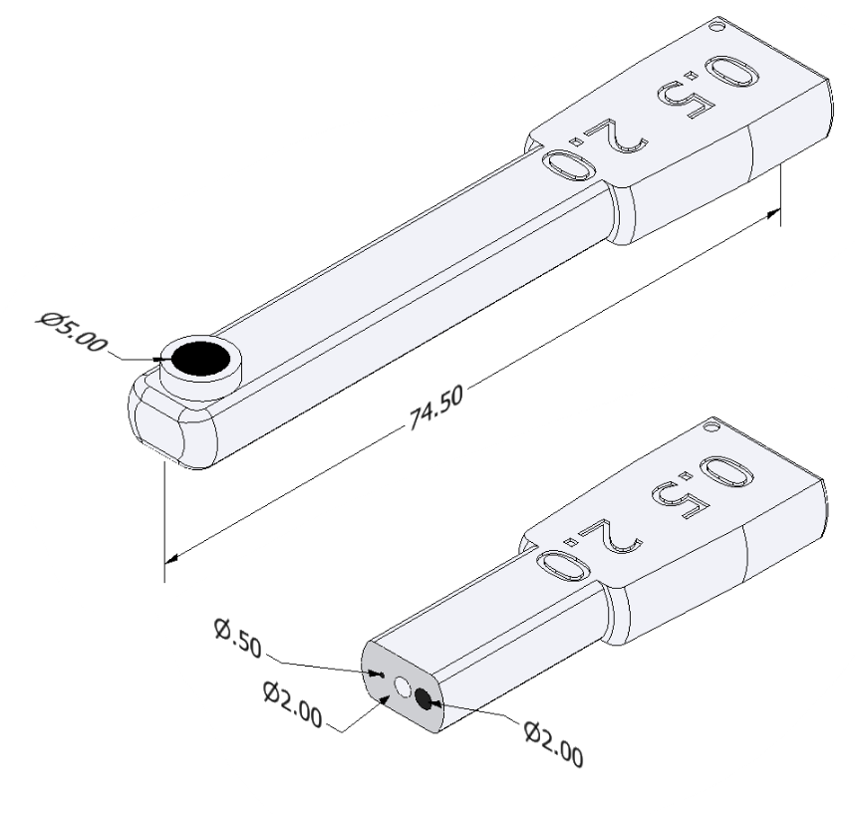
Figure S5. Main dimensions of the test specimen for electrochemical evaluation. The central hole (2.0 mm) is used to insert the steel wire, while the CB-PLA tracks with 0.5 and 2.0 mm in diameters are the alternative connections.

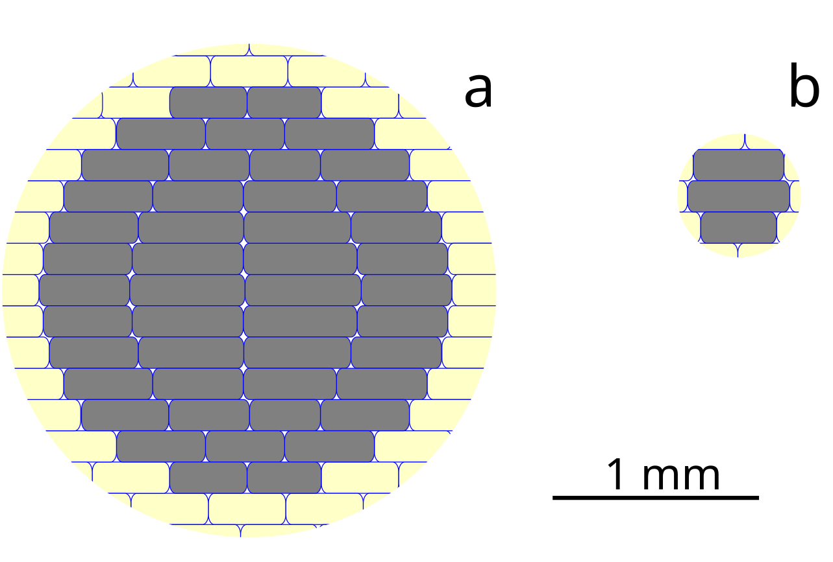
Figure S6. Graphical representation of the cross-section profile for the tracks with diameters 2.0 mm (a) and 0.5 mm (b). The CB-PLA tracks are in gray and the insulation polymer in yellow. The slicer controls the amount of polymer to be delivered in each 0.15 mm layer to obtain the best representation of cylindrical tracks. The size of the gaps between the filaments also depends on the extrusion options.

