Temperature perception questionnaire (translated from German [original language] to English) based on “The experienced temperature sensitivity and regulation survey” (Van Someren et al.)

Numeric rating scale 6 (QST)
BEFORE QUANTITATIVE SENSORY TESTING
This survey contains 41 questions.
To be completed by the investigator:
Room temperature (in °C):
Skin temperature before warming up the hands (in °C):
(in the same region of the hand where the probe will be placed)
If <28 °C: Hold subject's hands under warm water for 20 seconds.
Skin temperature after warming up (in °C):
(question can be skipped for temperatures >28 °C)

Numeric rating scale 6
- How would you rate the CURRENT ROOM TEMPERATURE?
 | Very cold  0 | 1 | 2 | 3 | 4 | 5 | 6 | 7 | 8 | 9 | Very warm  10

- I feel WARM in the following situations: When I am sitting quietly (e.g. at the computer, watching TV, reading).

 | Not at all  0 | 1 | 2 | 3 | 4 | 5 | 6 | 7 | 8 | 9 | often  10

- I feel WARM in the following situations: During daily activities.

 | Not at all  0 | 1 | 2 | 3 | 4 | 5 | 6 | 7 | 8 | 9 | often  10

- I feel WARM in the following situations: While I am at home.

 | Not at all  0 | 1 | 2 | 3 | 4 | 5 | 6 | 7 | 8 | 9 | often  10

- I feel WARM in the following situations: While I am in a building or room but not at home.

 | Not at all  0 | 1 | 2 | 3 | 4 | 5 | 6 | 7 | 8 | 9 | often  10

- I feel WARM in the following situations: When I concentrate hard.

 | Not at all  0 | 1 |  | 2 |  | 3 |  | 4 |  | 5 |  | 6 |  | 7 |  | 8 |  | 9 |  | often  10
- I feel WARM in the following situations: In bed.

 | Not at all  0 | 1 | 2 | 3 | 4 | 5 | 6 | 7 | 8 | 9 | often  10

- I feel WARM in the following situations: When I am outside.

 | Not at all  0 | 1 | 2 | 3 | 4 | 5 | 6 | 7 | 8 | 9 | often  10

- I feel COLD in the following situations: When I am sitting quietly (e.g. at the computer, watching TV, reading).

 | Not at all  0 | 1 | 2 | 3 | 4 | 5 | 6 | 7 | 8 | 9 | often  10

- I feel COLD in the following situations: During daily activities.

 | Not at all  0 | 1 | 2 | 3 | 4 | 5 | 6 | 7 | 8 | 9 | often  10

- I feel COLD in the following situations: While I am at home.

 | Not at all  0 | 1 | 2 | 3 | 4 | 5 | 6 | 7 | 8 | 9 | often  10

- I feel COLD in the following situations: While I am in a building or room but not at home.

 | Not at all  0 | 1 | 2 | 3 | 4 | 5 | 6 | 7 | 8 | 9 | often  10

- I feel COLD in the following situations: In bed.

 | Not at all  0 | 1 | 2 | 3 | 4 | 5 | 6 | 7 | 8 | 9 | often  10

- I feel COLD in the following situations: When I'm outside.

 | Not at all  0 | 1 | 2 | 3 | 4 | 5 | 6 | 7 | 8 | 9 | often  10

- I feel COLD in the following situations: When I concentrate hard.

 | Not at all  0 | 1 | 2 | 3 | 4 | 5 | 6 | 7 | 8 | 9 | often  10

Now two more questions about other temperature sensations
- I feel a sudden heat rising inside me.

 | Not at all  0 | 1 | 2 | 3 | 4 | 5 | 6 | 7 | 8 | 9 | often  10

- I feel a sudden cold rising inside me.

 | Not at all  0 | 1 | 2 | 3 | 4 | 5 | 6 | 7 | 8 | 9 | often  10

Skin temperature (in °C) at the location on the hand where the probe was placed:
Summary Score Warm = Sum of scores of items 2+3+4+5+6+7+8
Summary Score Cold = Sum of scores of items 9+10+11+12+13+14+15

Additional Figure for Spearman correlation
(A)
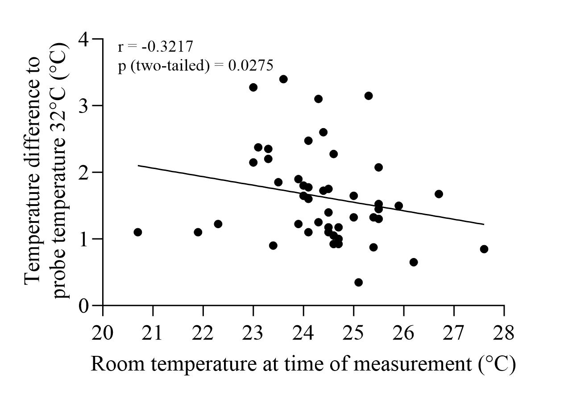
(B)
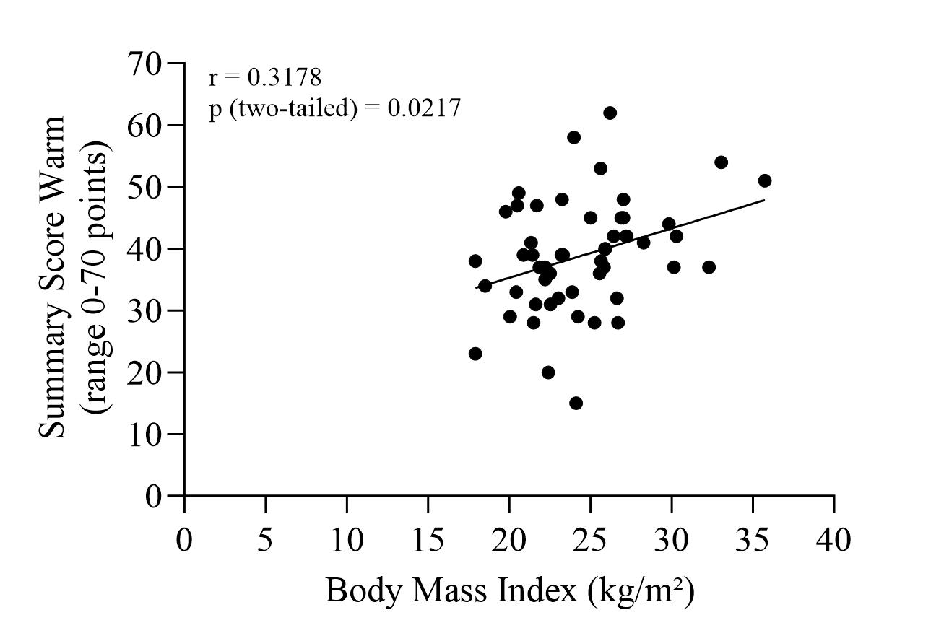
Figure S1: Spearman correlation of (A) temperature detection threshold “warm” and room temperature and (B) Summary score warm and body mass index.

Additional analyses of subjective temperature perception with Durbin-Skillings-Mack-Test
There was no difference in the evaluation of the current room temperature between the assigned sexes at birth (p=0.41). Trans women evaluated the current room temperature higher after 6 months of treatment with GAHT (p=0.049, post-hoc: non-significant in Conover’s procedure). There were no changes in the evaluation of the current room temperature in trans men (p=0.79), cis men (p=0.70) or cis women (p=0.72) (data not shown).

Results calculated with Friedman-Test (persons with missing data time points excluded)
Testosterone and estradiol concentrations
Four cis women, who were treated with hormonal contraceptives with ethinylestradiol during the measurements were excluded from the analysis of estradiol concentrations. As expected, testosterone serum concentrations decreased significantly in trans women during 6 months of gender affirming hormone therapy (GAHT, p≤0.0001, Dunn’s Test 0 vs. 3 months p=0.0085, 0 vs. 6 months p=0.0002, 3 vs. 6 months p=0.86), estradiol concentrations increased significantly (p=0.0006, Dunn’s Test 0 vs. 3 months p=0.0029, 0 vs. 6 months p=0.0167, 3 vs. 6 months p>0.9999). In trans men, testosterone concentrations increased significantly (p≤0.0001, Dunn’s Test 0 vs. 3 months p=0.0003, 0 vs. 6 months p=0.0006, 3 vs. 6 months p>0.9999), while serum estradiol concentrations remained unchanged (p=0.79). Testosterone concentrations in cis men and cis women remained unchanged (p=0.53 and p=0.81), as well as estradiol concentrations (p=0.79 and p=0.74).
Quantitative sensory testing for temperature sensation
In trans women, over the period of six months of GAHT, the thresholds for both “cold” (p=0.0008, Dunn’s Test 0 vs. 3 months p=0.0024, 0 vs. 6 months p=0.0219, 3 vs. 6 months p>0.9999) and “warm” (p=0.046, Dunn’s Test 0 vs. 3 months p=0.3526, 0 vs. 6 months p=0.0417, 3 vs. 6 months p>0.9999) detection decreased significantly. There were no significant changes in temperature detection thresholds in trans men (p=0.47 and p=0.79), cis women (p=0.90 and p=0.32), and cis men (p=0.24 and p=0.12).
There were no significant changes in the temperature associated with “cold pain” or “heat pain” in any of the four study groups over the study period (data not shown).
Temperature perception questionnaire
For the summary scores cold and warm, over the period of six months of GAHT, neither in trans women (p=0.12 and p=0.22), nor trans men (p=0.12 and p=0.74), nor cis men (p=0.71 and p=0.53) nor cis women (p=0.32 and p=0.19), we found statistically significant changes.
Trans men reported over the period of 6 months of GAHT an increase in sudden feelings of coldness (p=0.0196, Dunn’s Test 0 vs. 3 months p=0.6072, 0 vs. 6 months p=0.6072, 3 vs. 6 months p=0.0324), but no changes in hot flushes (p=0.46). No significant changes in sudden feelings of coldness and heat were detected in trans women (p=0.40 and p=0.58), cis men (p=0.18 and p=0.28), and cis women (p=0.94 and p=0.47) (data not shown).
Trans women evaluated the current room temperature higher after 6 months of treatment with GAHT (p=0.0129, Dunn’s Test 0 vs. 3 months p>0.9999, 0 vs. 6 months p=0.4068, 3 vs. 6 months p=0.0570). There were no changes in the evaluation of the current room temperature in trans men (p=0.66), cis men (p=0.74) or cis women (p=0.91) (data not shown).

