Supplemental Table 1: Preoperative Cardiac Diagnoses | Overall (n = 72) | Two-Ventricle (n = 56) | Single-Ventricle (n=16) | p-value
 |  |  |  | 0.097
AV septal defect | 2 (2.8) | 1 (1.8) | 1 (6.3)
Coarctation or Aortic Arch hypoplasia | 9 (12.5) | 9 (16.1) | --
with VSD | 1 (1.4) | 1 (1.8) | --
Double outlet right ventricle | 4 (5.6) | 3 (5.4) | 1 (6.3)
Hypoplastic left heart syndrome | 5 (6.9) | -- | 5 (31.3)
Interrupted aortic arch | 2 (2.8) | 2 (3.6) | --
Pulmonary Atresia with IVS | 1 (1.4) | -- | 1 (6.3)
Pulmonary atresia with VSD | 1 (1.4) | 1 (1.8) | --
Single Ventricle |  | -- | 7 (43.8)
Double inlet left ventricle | 3 (4.2) | -- | 3 (18.8)
Heterotaxy | 2 (2.8) | -- | 2 (12.5)
Unbalanced Canal | 2 (2.8) | -- | 2 (12.5)
D-Transposed great vessels | 27 (48.2) | 27 (48.2) | --
with IVS | 17 (23.6) | 17 (30.4) | --
with VSD | 10 (13.9) | 10 (17.9) | --
L-Transposed great vessels | 1 (1.4) | -- | 1 (6.3)
Tetralogy of Fallot | 2 (2.8) | 2 (3.6) | --
Total anomalous pulmonary venous connection | 3 (4.2) | 3 (5.4) | --
Truncus arteriosus | 1 (1.4) | 1 (1.8) | --
VSD | 1 (1.4) | 1 (1.8) | --
p-values represents Fisher’s Exact test. AV = atrioventricular; IVS = Intact ventricular septum. VSD = Ventricular septal defect;
Supplementary Table 2: Malformation and Genetic Diagnoses | Overall (n = 72) | Two-Ventricle (n = 56) | Single-Ventricle (n=16) | p
Genetic conditions identified (%): |  |  |  | < 0.001
22q11.1 duplication | 1 (1.4) | 1 (1.4) | 0 (0)
MT-ATP6 mutation | 1 (1.4) | 1 (1.4) | 0 (0)
Phelan-McDermid Syndrome 22q13 deletion syndrome | 1 (1.4) | 1 (1.4) | 0 (0)
Alagille syndrome (intrahepatic biliary duct agenesis) | 1 (1.4) | 1 (1.4) | 0 (0)
Cat-eye syndrome | 1 (1.4) | 1 (1.4) | 0 (0)
DiGeorge syndrome (velocardiofacial syndrome) (conotruncal anomaly face syndrome) (22q11 deletion) | 2 (2.8) | 2 (2.8) | 0 (0)
Klinefelter syndrome (XXY Syndrome) | 1 (1.4) | 1 (1.4) | 0 (0)
Primary ciliary dyskinesia (PCD) | 1 (1.4) | 1 (1.4) | 0 (0)
Trisomy 21 | 1 (1.4) | 1 (1.4) | 0 (0)
505.5 Kb deletion in the long arm of chromosome X | 1 (1.4) | 1 (1.4) | 0 (0)
Prolonged QT syndrome (maternally inherited LP variant in KCNQ1) | 1 (1.4) | 1 (1.4) | 0 (0)
1q21.1 & 16p13.11 microduplication syndromes in same patient | 1 (1.4) | 1 (1.4) | 0 (0)
Major Malformation Type (%): |  |  |  | 0.017
Single kidney | 1 (1.4) | 1 (1.8) | 0 (0)
Bronchomalacia | 1 (1.4) | 1 (1.8) | 0 (0)
Absent corpus callosum, ventriculomegaly, Congenital choledochal cyst, AV malformation cerebral, asplenia | 1 (1.4) | 0 (0) | 1 (6.2)
Anorectal malformation with rectourethral fistula | 1 (1.4) | 1 (1.8) | 0 (0)
Anorectal malformation with rectoperineal fistula | 1 (1.4) | 1 (1.8) | 0 (0)
Bilateral hydronephrosis, epispadias with penile chordae, bilateral undescended testes dysplastic nails and thrombocytopenia | 1 (1.4) | 1 (1.8) | 0 (0)
Congenital right hemidiaphragm paresis | 1 (1.4) | 1 (1.8) | 0 (0)
Neuronal migration disorder | 1 (1.4) | 1 (1.8) | 0 (0)
Right Scimitar vein | 1 (1.4) | 0 (0) | 1 (6.2)
p-values represents Fisher’s Exact test.
Supplementary Table 3: Preoperative Complications | Overall (n = 72) | Two-Ventricle (n = 56) | Single-Ventricle (n=16) | p-value
Total preoperative complications per patient | 0 [0, 1] | 0 [0, 1] | 0 [0, 1] | 0.671
Preoperative complications: |  |  |  | 0.05
Bronchopulmonary dysplasia | 3 (4.2) | 3 (5.4) | 0
Cardiopulmonary resuscitation | 1 (1.4) | 1 (1.8) | 0
Shock | 6 (8.3) | 6 (10.7) | 0
Mechanical Ventilation | 11 (15.3) | 8 (14.3) | 3 (18.8)
Hypercoagulable state | 2 (2.8) | 2 (3.6) | 0
Stroke, CVA, or Intracranial hemorrhage > Grade 2 | 1 (1.4) | 1 (1.8) | 0
Colostomy | 1 (1.4) | 1 (1.8) | 0
Non-invasive respiratory support | 13 (18.1) | 11 (19.6) | 2 (12.5)
Seizures | 1 (1.4) | 0 | 1 (6.3)
Hepatic dysfunction | 1 (1.4) | 1 (1.8) | 0
Renal dysfunction | 1 (1.4) | 1 (1.8) | 0
Necrotizing Enterocoloitis | 1 (1.4) | 1 (1.8) | 0
Sepsis | 6 (8.3) | 3 (5.4) | 3 (18.8)
p-values represents Fisher’s Exact test. CVA = Cerebrovascular accident.

 | Supplementary Table 4: Regression model for postoperative length of stay | Coefficient |  | 2.5% CI | 97.5% CI |  |  | p-value
(Intercept) |  |  | 0.0000 | 0.0000 |  | 0.0067 | <0.001
Race: Black/African American |  |  | 1.8897 | 1.2516 |  | 2.8531 | 0.002
Race: Asian |  |  | 1.1261 | 0.6956 |  | 1.8231 | 0.629
Race: Other |  |  | 1.0814 | 0.8216 |  | 1.4233 | 0.577
Race: Unknown |  |  | 1.4463 | 0.9382 |  | 2.2295 | 0.095
Transferred in to our hospital |  |  | 0.3614 | 0.2498 |  | 0.5227 | <0.001
Gestational Age (weeks) |  |  | 1.3609 | 1.1753 |  | 1.5758 | <0.001
Hypoplastic Left Heart Syndrome |  |  | 0.7830 | 0.5911 |  | 1.0372 | 0.088
Weight at Surgery (grams) |  |  | 0.9988 | 0.9985 |  | 0.9991 | <0.001
Delayed Sternal Closure |  |  | 1.6898 | 1.3083 |  | 2.1826 | <0.001
Length of postoperative MV (days) |  |  | 1.0038 | 1.0004 |  | 1.0071 | 0.027
Discharge weight (grams) |  |  | 1.0010 | 1.0008 |  | 1.0012 | <0.001
Major Malformation |  |  | 1.4376 | 1.0342 |  | 1.9983 | 0.031
Five minute APGAR score |  |  | 1.2289 | 1.0004 |  | 1.5095 | 0.05
Early Unplanned Reintervention |  |  | 1.3828 | 0.8187 |  | 2.3356 | 0.226
Intercept base model references: Race: White/Caucasian, infant born at our hospital, no hypoplastic left heart syndrome, delayed sternal closure, major malformation or early unplanned reintervention (< 30 days); CI = Confidence interval, MV = Mechanical Ventilation: APGAR Score = Composite score assessing breathing, heart rate, muscle tone, reflexes and skin color after birth. Postoperative length of stay was log transformed for the analysis. The coefficients were exponentiated back and represent percent change in expected value. For example, for every increased day of postoperative mechanical ventilation, there is a 0.38% increase in length of stay.

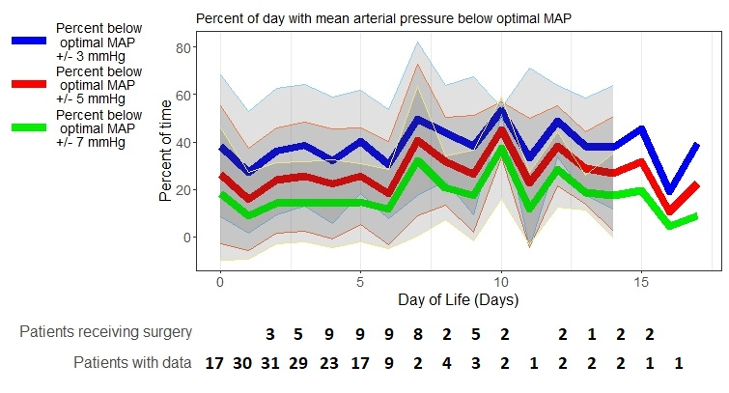
Supplemental Figure 1. Percent of day with impaired autoregulation (COx > 0.3) for clinical range of MAP_{OPT} ±3, 5, and 7 mmHg between birth and surgery. Dark lines represent the mean with standard deviation ribbons in gray. Table under graph shows number of patients with data per day and number receiving surgery on that day of life. MAP = mean arterial blood pressure.

