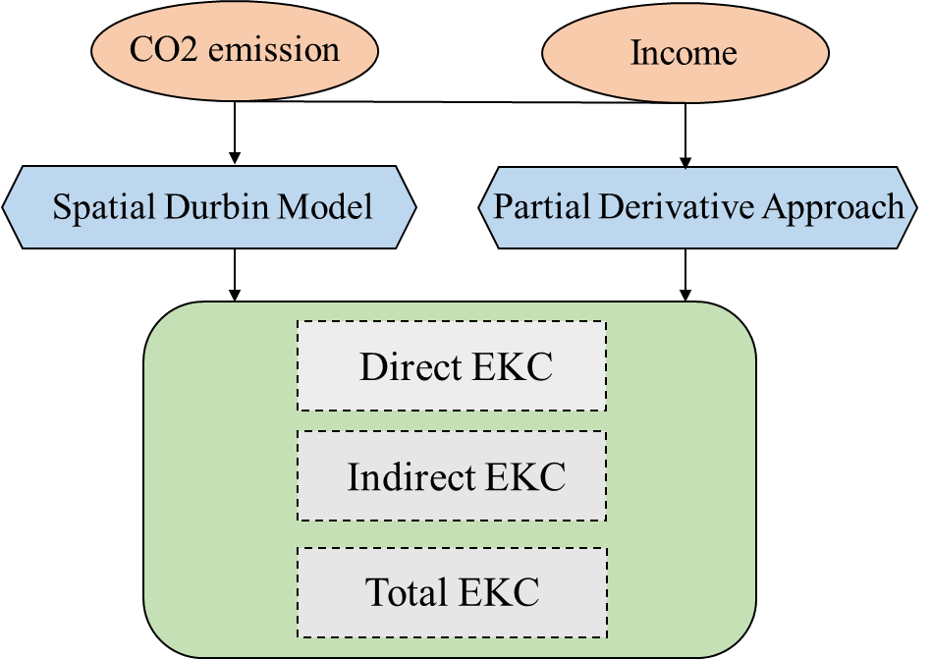
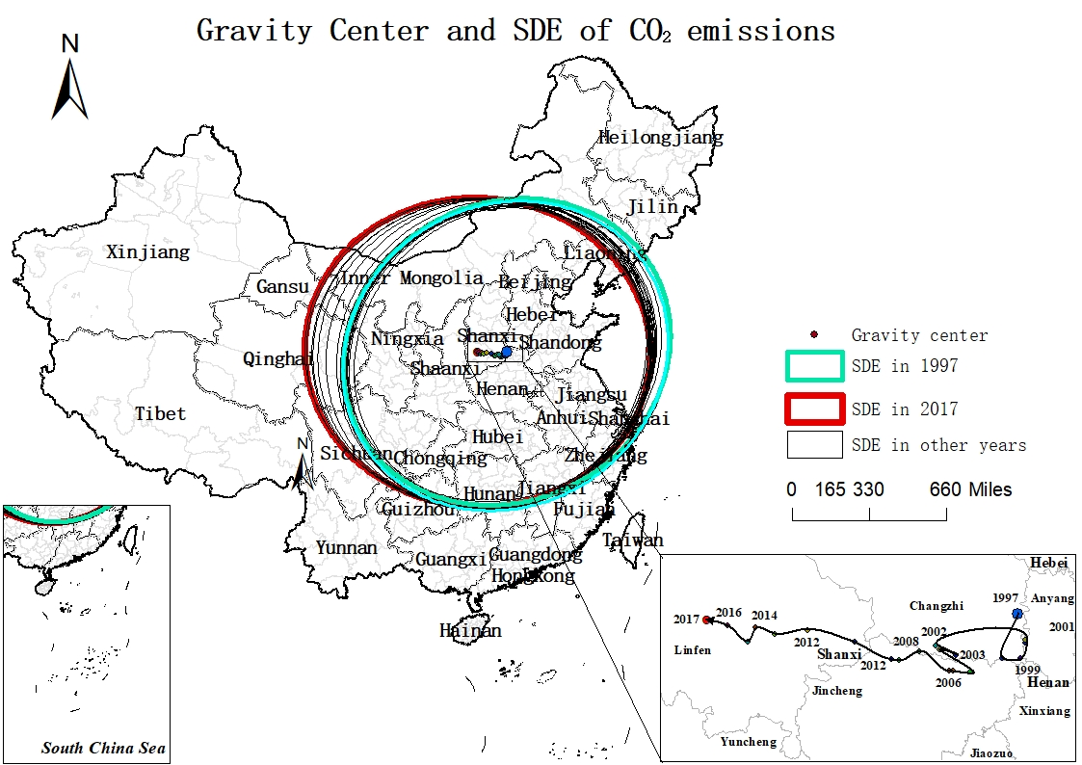
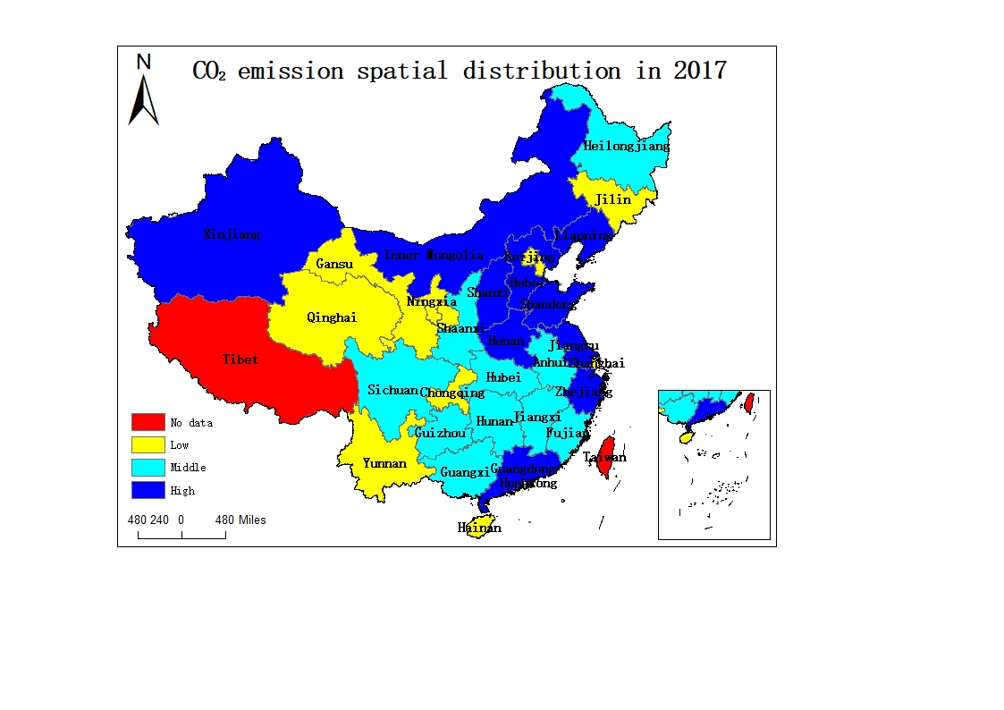
This graph is the summary of the paper. Using an annual panel dataset collected over the 1997-2017 period in China, this study first analyzed the spatiotemporal evolutionary process of CO2 emissions and subsequently developed direct, indirect and total EKCs based spatial Durbin model (SDM) and partial derivative approach. These results indicate that, first, CO2 emissions have characteristic positive spatial autocorrelation, with gravity centers that have shifted westward. Second, the direct EKC forms a line, while the total EKC resembles a lying-S shape as well as the total EKC, which indicates that compared to local economic growth, neighboring growth plays a very different role in impacting local CO2 emissions. Furthermore, neighboring economic growth seems to have stronger impacts on local emissions, and the turning point of the total EKC comes much earlier than that of the conventional EKC due to the spillover effects of economic growth. Finally, the growth of the population, as well as the rise of energy intensity, can stimulate CO2 emissions in both local and neighboring regions. Industrialization seems to have a nonsignificant impact on emissions changes due to the offsetting effects of the positive direct and negative indirect impacts of the share of secondary industry. Improvements in local urbanization may lead to an increase in emissions, while neighboring improvements may have stronger restricting effects; thus, urbanization improvement is beneficial to emissions reduction. This study provides more scientific information from both local and neighboring perspectives, which may differ from conventional results but still be beneficial for emissions reduction policy makers to introduce corresponding measures.

