Targeting SLC7A11 ameliorates ulcerative colitis by promoting efferocytosis through the ERK1/2 pathway
Meiyi You¹, Jichang Li¹, Xin Wang¹, Yucun Liu¹, Shanwen Chen¹, Pengyuan Wang¹

1, Department of Gastrointestinal Surgery, Peking University First Hospital, Beijing, 100034, People’s Republic of China

Correspondence: Shanwen Chen, Department of Gastrointestinal Surgery, Peking University First Hospital, Beijing, 100034, People’s Republic of China, Email: shanwen@pku.edu.cn; Pengyuan Wang, Department of Gastrointestinal Surgery, Peking University First Hospital, Beijing, 100034, People’s Republic of China, Email: pengyuan_wang@bjmu.ed.cn
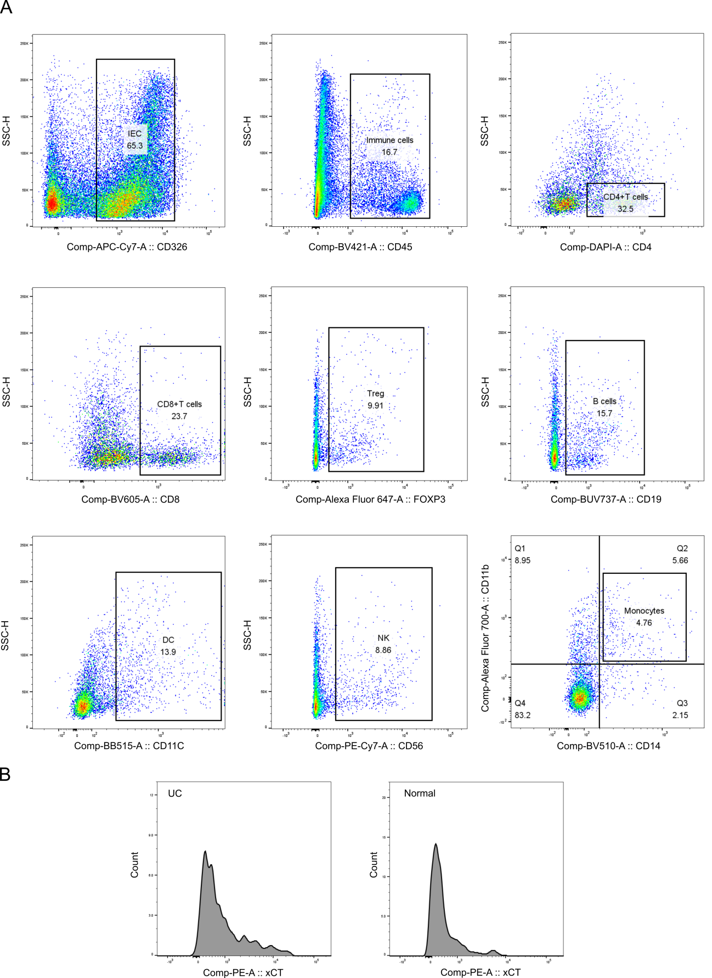
Fig.S1
A Markers of various cells in flow cytometry. B Representative image of SLC7A11 fluorescence intensity of DCs in inflamed colonic epithelial tissue and normal colonic epithelial tissue of UC patients.

Fig.S2
A Proportion of individual immune cells counted by flow cytometry in inflamed colonic epithelial tissue and normal colonic epithelial tissue of UC patients. B Western blotting analysis of SLC7A11 protein expression in different tissues of WT and SLC7A11^{-/+} mice.

