EXTENDED DATA FIGURES

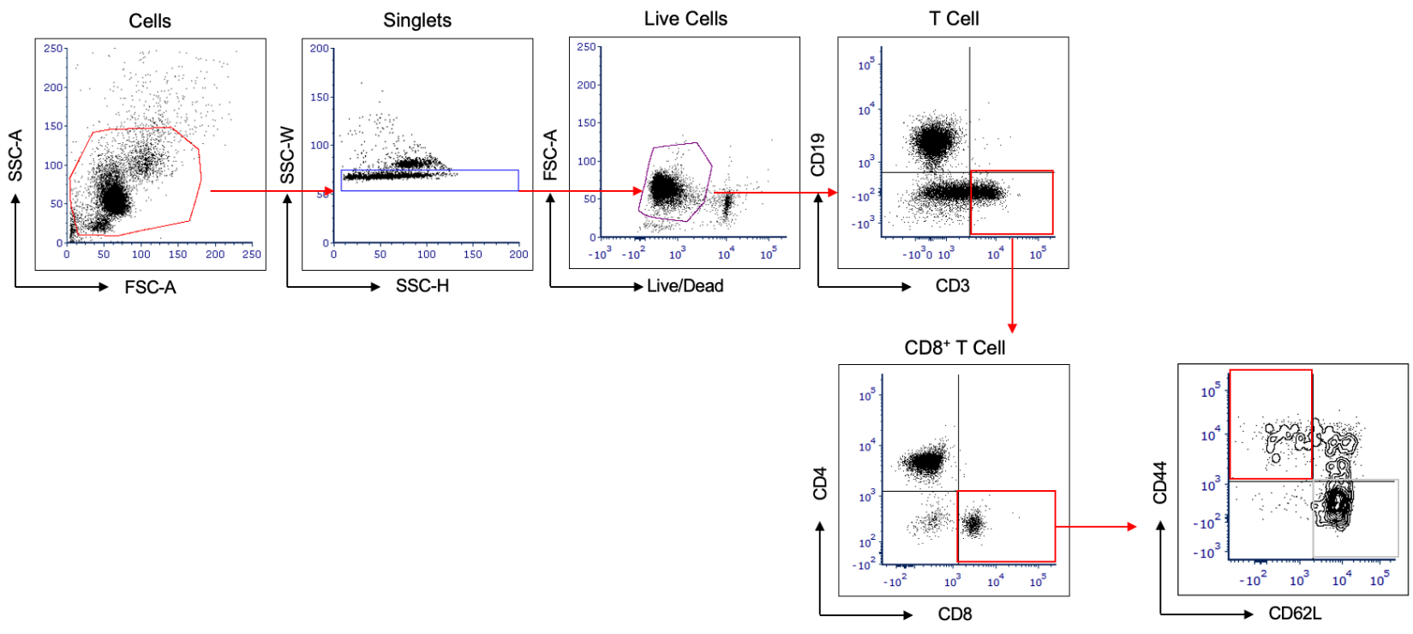

Extended Data Figure 1: Gating strategy for Fig 2b. Viable lymphocytes isolated from the spleen were first gated and subsequently selected for CD19⁺ B cells or CD3⁺ T cells. CD3⁺ T cells were further subdivided into CD4⁺ and CD8⁺ T cell populations. Within the CD8⁺ T cells, CD44 and CD62L expression levels were used to distinguish Naïve (CD44^{low} CD62L^{high}) and Activated (CD44^{high} CD62L^{low}) cells.

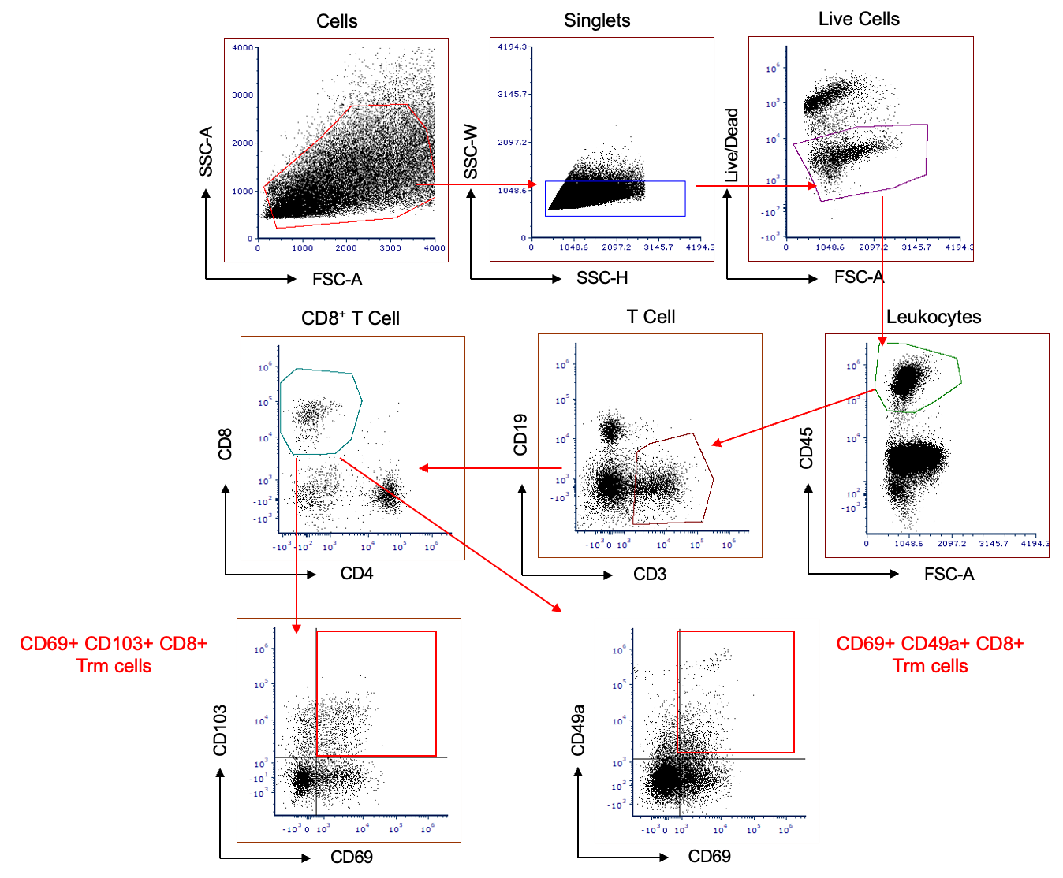

Extended Data Figure 2: Gating strategy for Fig 3. Viable single cells isolated from the tumors were initially gated to select CD45+ leukocytes. CD3+ T cells were then identified within this population and further classified into CD4+ and CD8+ T cell subpopulations. Among the CD8+ T cells, tissue-resident memory cells (Trm cells) were identified based on the co-expression of CD69 with either CD103 or CD49a.

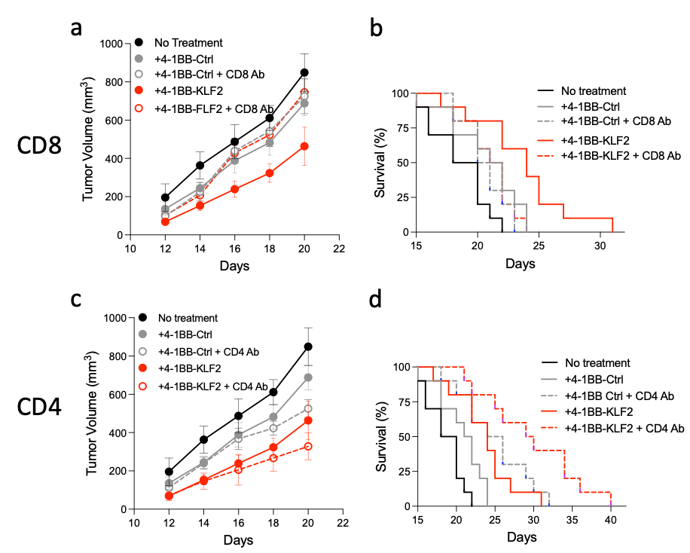
Extended Data Figure 3. KLF2 downregulation enhanced tumor inhibition is mediated by CD8+ T cells. Mice were treated weekly three times with CD8, panels a and b, or CD4, panels c and d, depleting antibodies starting 3 days post B16/F10 tumor implantation vaccinated with GVAX, and treated with either 4-1BB-Ctrl siRNA or 4-1BB-KLF2 siRNA as described in Fig. 4a. Panels a and c, tumor progression; Panels b and d, survival.
Statistical analysis. Comparisons of groups showing significance (p<0.05) and trend to significance (p=0.05 to 0.07) are shown for survival and tumor progression. Survival. 4-1BB-KLF2 siRNA versus no treatment or 4-1BB-Ctrl siRNA, p=0.0013 and 0.029 respectively (panels b or d); 4-1BB-KLF2 siRNA versus 4-1BB KLF2 siRNA + CD8 antibody, p=0.018 (panel b); 4-1BB-KLF2 siRNA + CD4 Ab versus 4-1BB-KLF2 siRNA, p=0.015, and 4-1BB-Ctrl siRNA + CD4 antibody versus 4-1BB-Ctrl siRNA, p=0.0156 (panel d).Tumor progression. 4-1BB-KLF2 siRNA versus no treatment (panels a and c), d14 0.0299, d16 0.0198, d18, 0.0027, d20 0.0198; 4-1BB KLF2 versus 4-1BB-Ctrl siRNA, d14, 0.0399, d12, 0.072, d16, 0.0634, d18, 0.0683.; 4-1BB-KLF2 siRNA versus 4-1BB KLF2 siRNA + CD8 antibody (panel a), d16 0.0053, d18 0.0029, d20, 0.036

