Supplementary Information

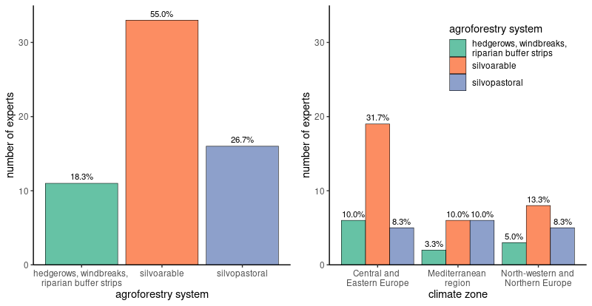
SI Fig. 1: Number of experts (n = 60) per agroforestry system and climate zone.

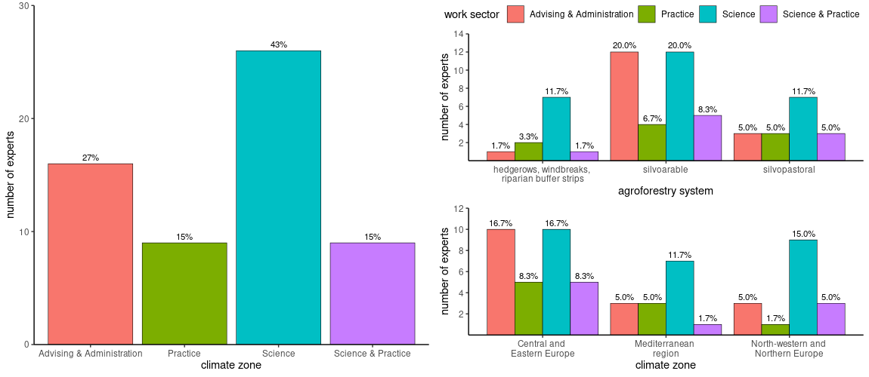
SI Fig. 2: Work sectors of experts (n = 60) – per agroforestry system and climate zone
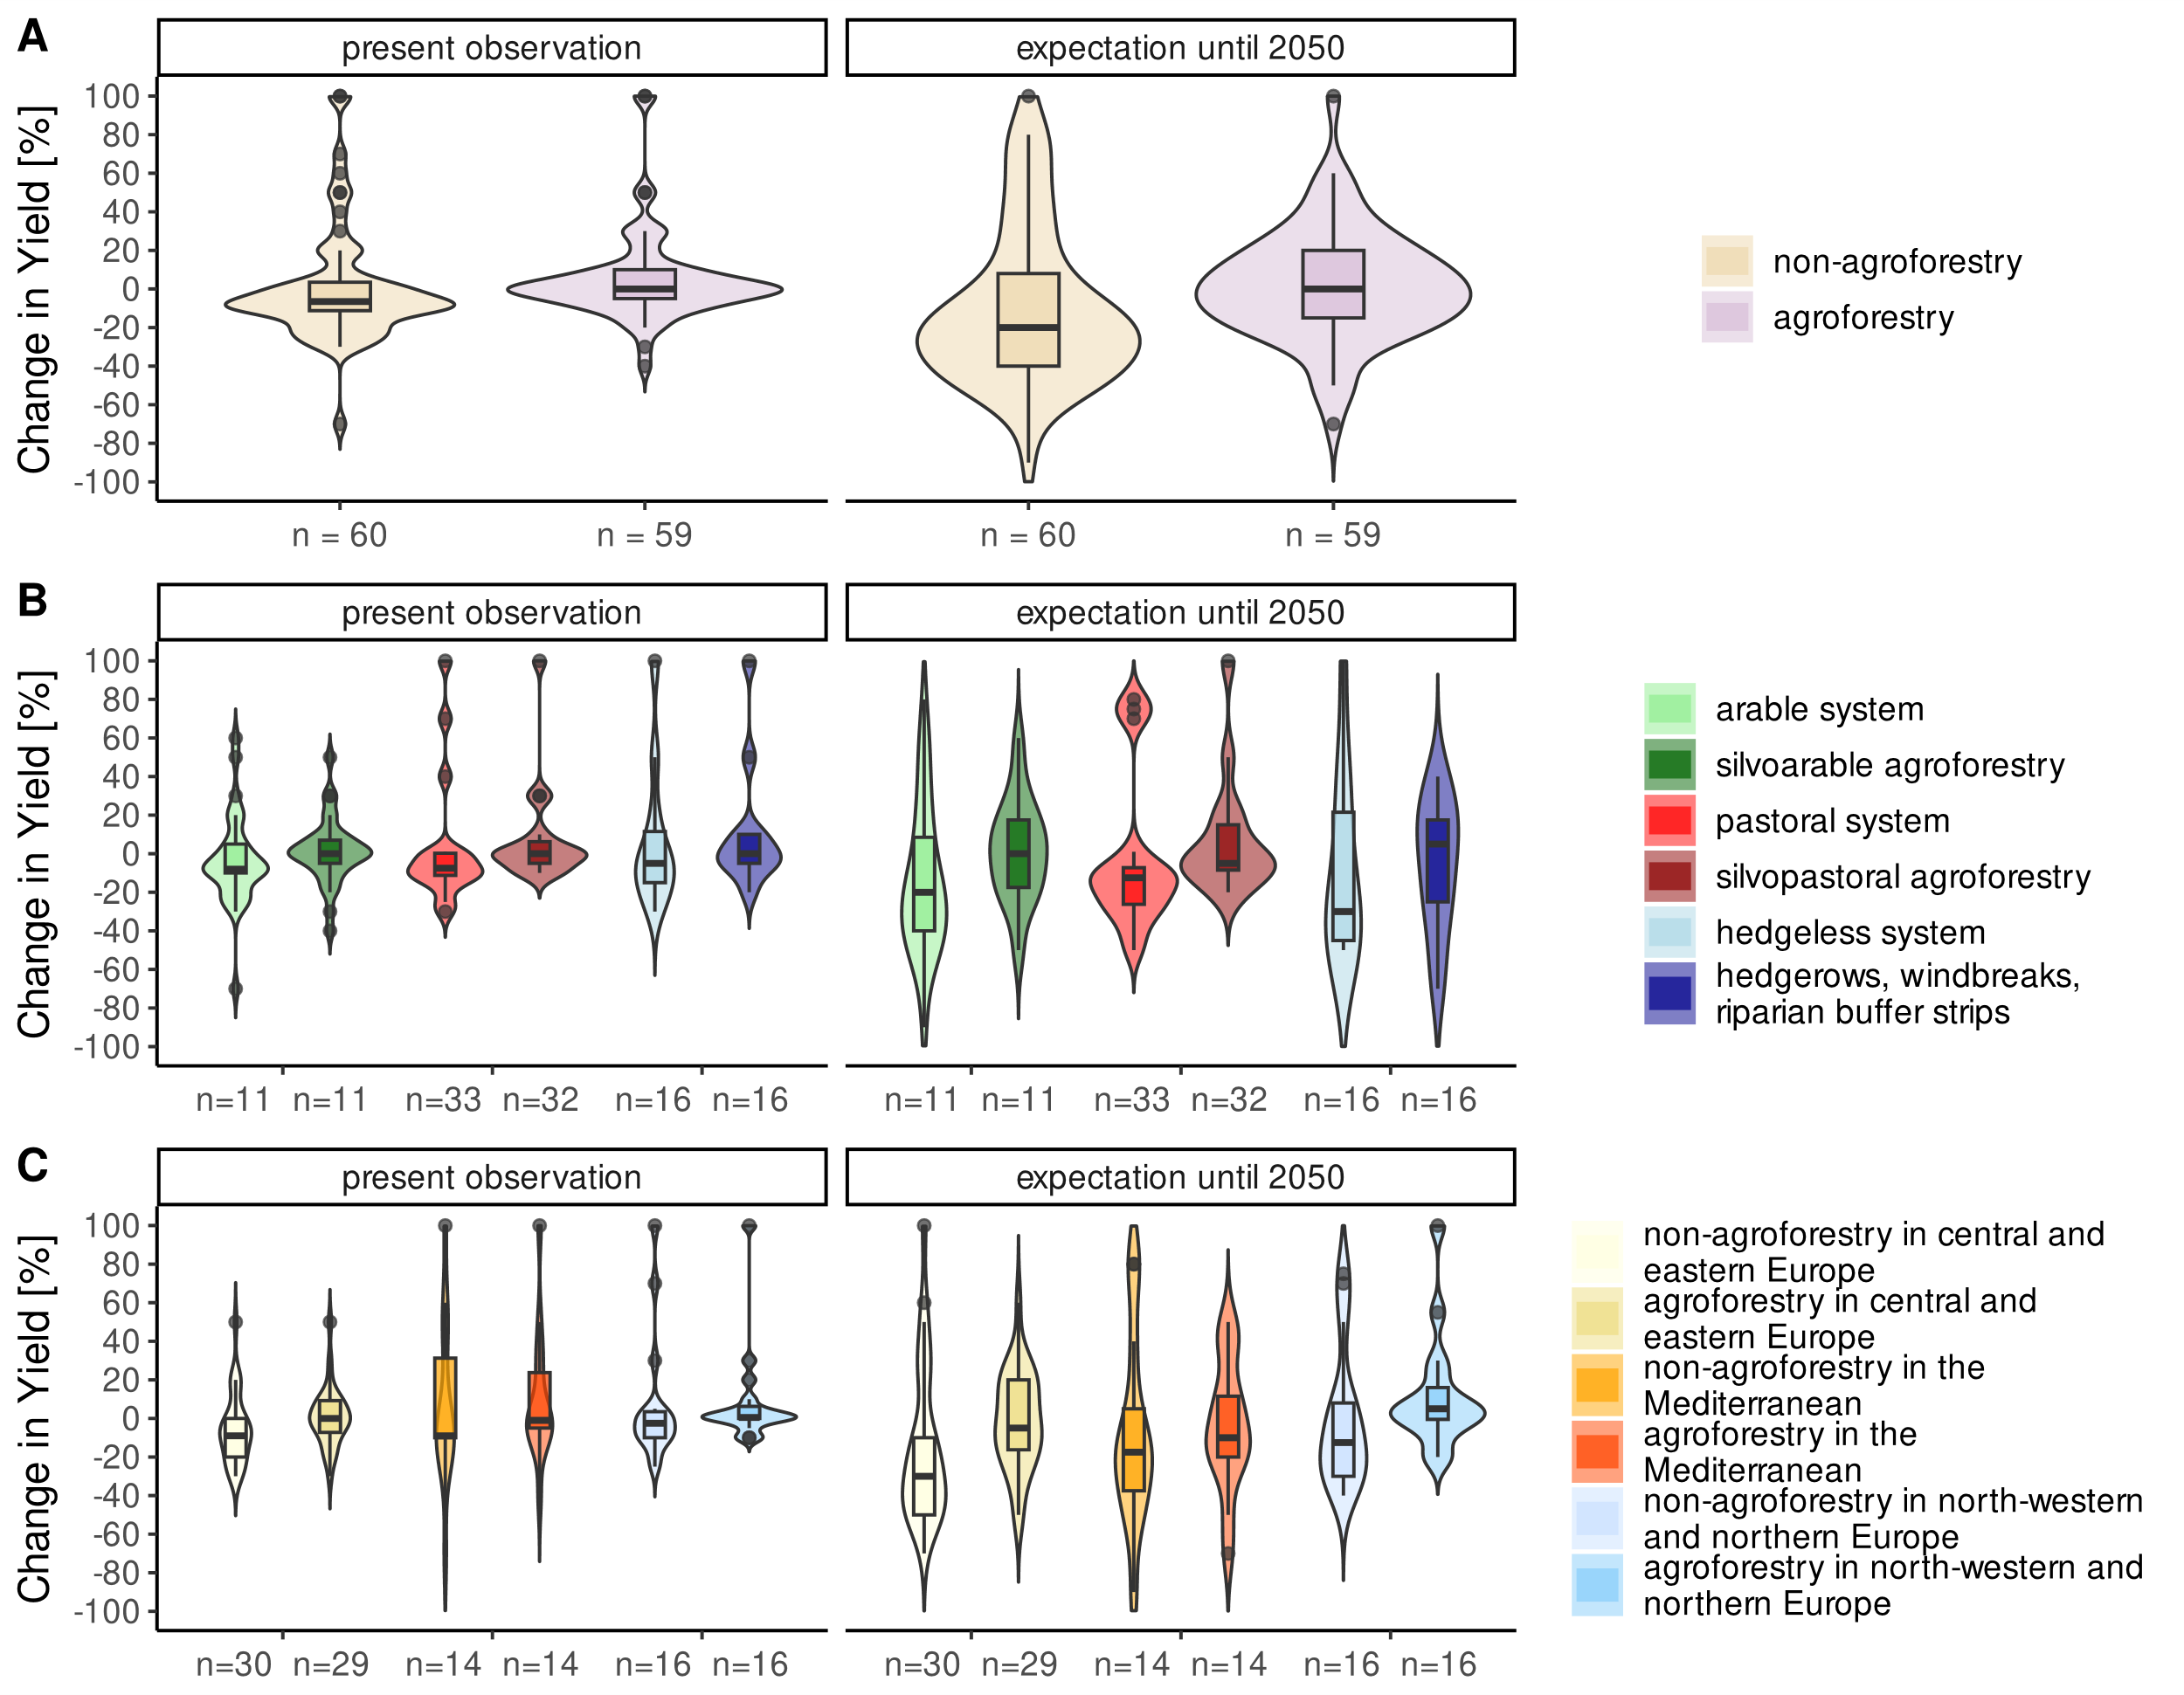
SI Fig. 3: Presently observed and by 2050 expected effects of climate change on yield in % of yield change (-100% = complete yield failure, +100% = double yield). Comparison of agroforestry and non-agroforestry systems (A) across all agricultural systems and climate zones, between each agroforestry system and its reference system (B) and between each agroforestry system and its reference system within a climate zone (C). The box plots range from the first to the third quartile where the horizontal line shows the median. The vertical lines go from each quartile to the minimum or maximum, respectively.

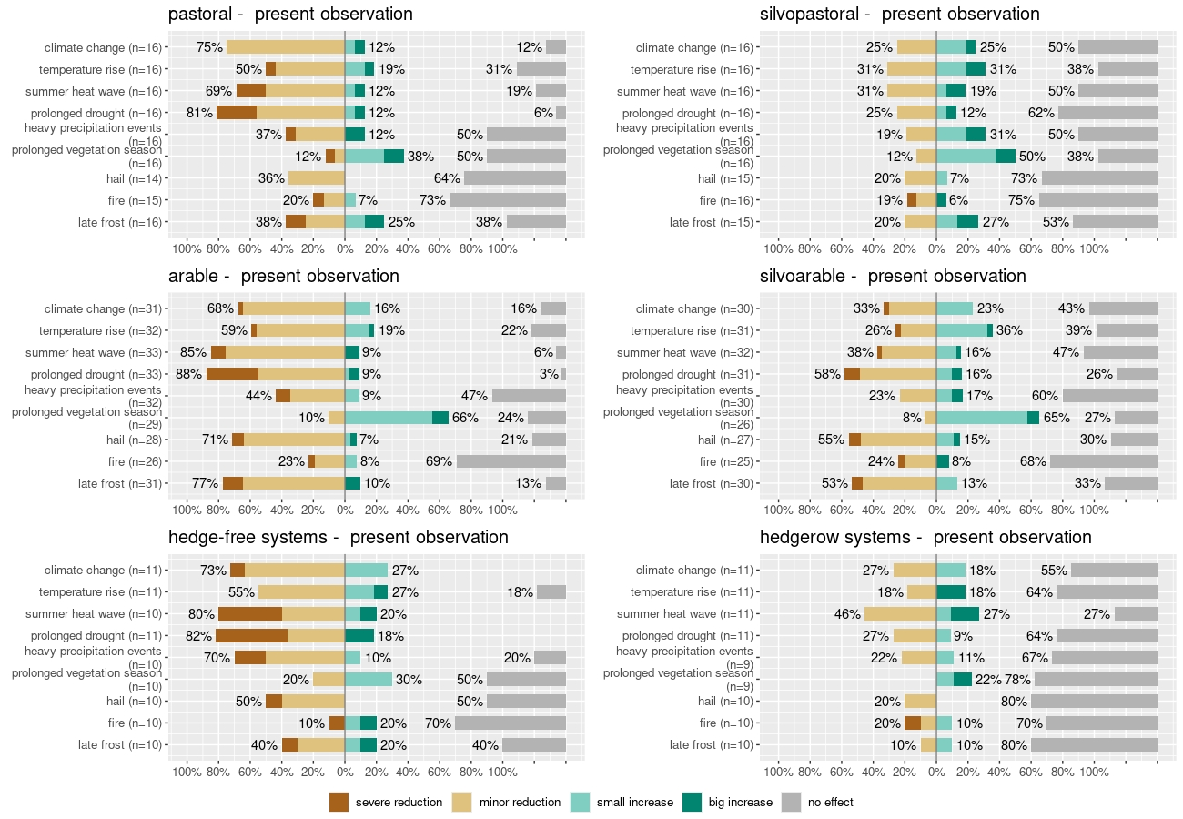
Fig. 1
SI Fig. 4: Summary of experts’ assessment of changes in quality of saleable products due to the impact of nine climate change variables on a five-level Likert scale from -2 (severe reduction) to +2 (big increase) for present observations. The non-agroforestry systems in the left-hand column correspond to the respective agroforestry systems in the right-hand column, i.e., pastoral – silvopastoral, arable – silvoarable and hedge-free systems – hedgerow systems. The sample size is indicated in breaks for each climate change variable. The percentages at each bar represent the sum of both stacked bars.

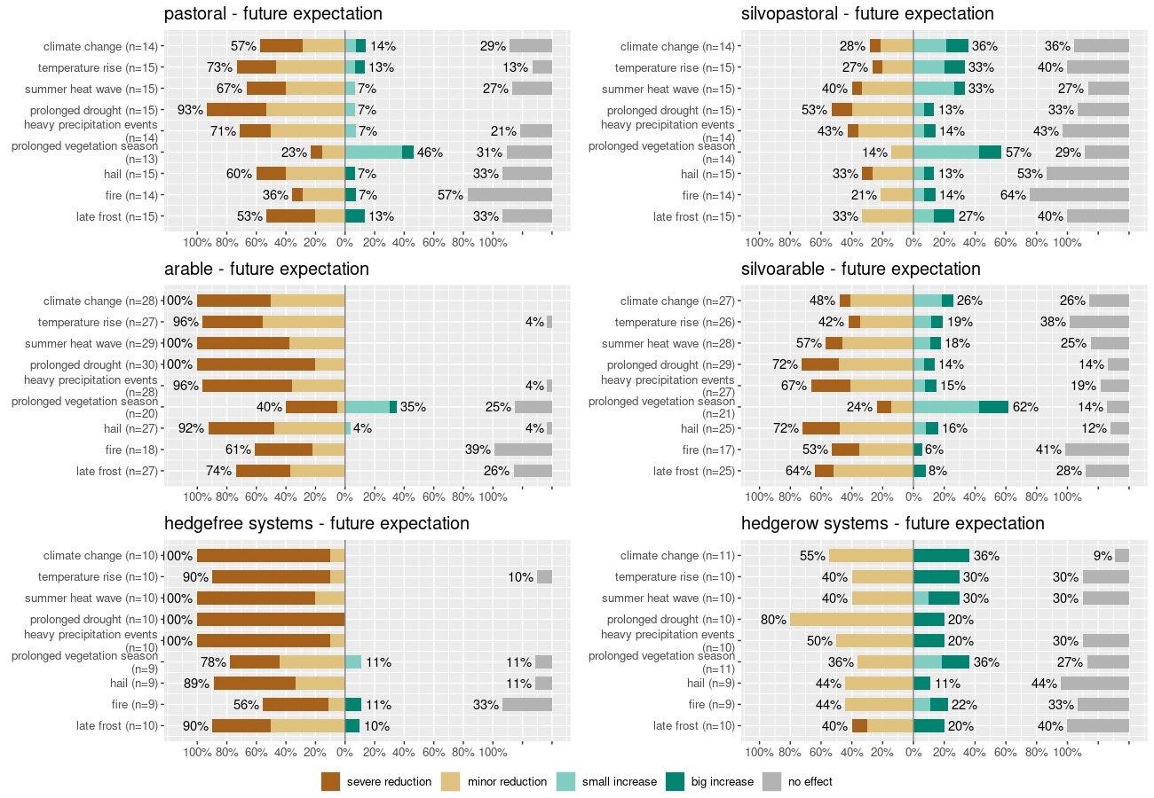
Fig. 5:
SI Fig. 5: Summary of experts’ assessment of changes in quality of saleable products due to the impact of nine climate change variables on a five-level Likert scale from -2 (severe reduction) to +2 (big increase) for future expectations (until 2050). The non-agroforestry systems in the left-hand column correspond to the respective agroforestry systems in the right-hand column, i.e., pastoral – silvopastoral, arable – silvoarable and hedge-free systems – hedgerow systems. The sample size is indicated in breaks for each climate change variable. The percentages at each bar represent the sum of both stacked bars.

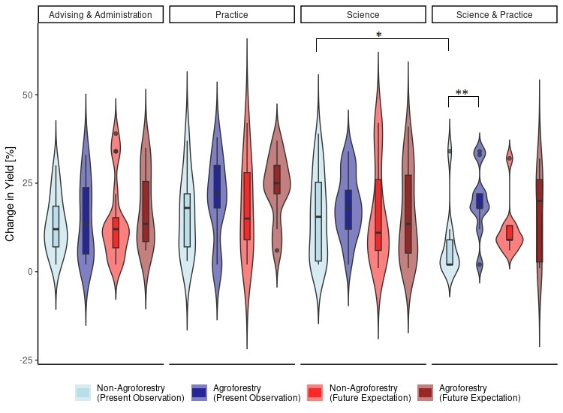
Fig. 3: Experts’ assessment of changes in yield for present observations and future expectations (until 2050) in non-agroforestry and agroforestry systems within different work sectors. The box plots range from the first to the third quartile where the horizontal line shows the median. The vertical lines go from each quartile to the minimum or maximum, respectively. Statistical significance is indicated with brackets and stars (*: p < 0.05, **: p < 0.01) for comparisons between either same systems, same time and different work sector or same time, same work sector and different time.

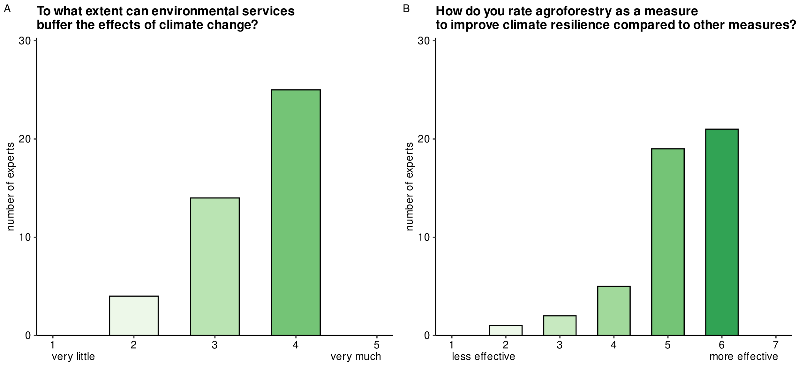
SI Fig. 6: Experts’ rating (A) on the extent of buffer capacity of environmental services to climate change and (B) on agroforestry as a measure to improve climate change resilience compared to other measures.

