Investigation of Nitrogen Conversion Efficiency in Hydrogen-based Autotrophic Nitrate Reduction Reactor
Yu-Fei Zhao¹, Chun-Yu Lai¹, He-Ping Zhao^{1,*}

- MOE Key Lab of Environmental Remediation and Ecosystem Health, College of Environmental and Resource Science, Zhejiang University, Hangzhou, China, 310058.

* Correspondence to Dr. He-Ping Zhao. Tel (Fax): 0086-571-88982739, E-mail: zhaohp@zju.edu.cn

Table S1 Simulation of wastewater configuration components
 | Concentration (mg/L)
KH₂PO₄ | 0.7
MgSO₄·7H₂O | 5
CaCl₂·2H₂O | 1
FeSO₄·7H₂O | 1
NaHCO₃ | 10
trace element solution | 1

Table S2 Components of trace element solution
 | Concentration (mg/L)
ZnSO₄·7H₂O | 100
MnCl₂·4H₂O | 30
H₃BO₃ | 300
CoCl₂·6H₂O | 300
NiCl₂·2H₂O | 10
Na₂SO₄·2H₂O | 30
Na₂SeO₃ | 30

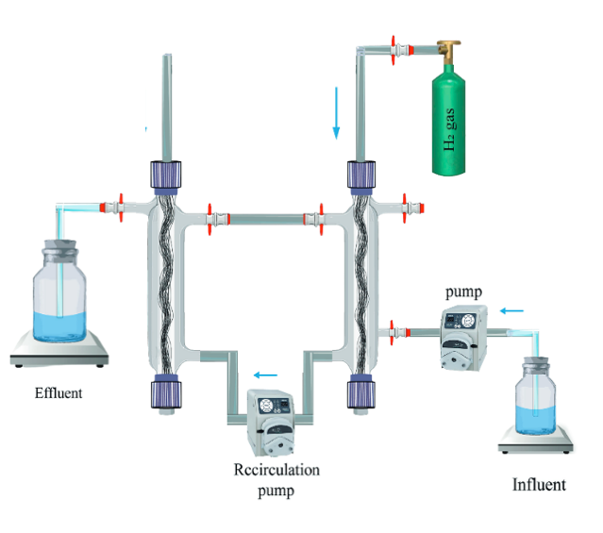
Fig. S1 The schematic diagram of the reactor configuration

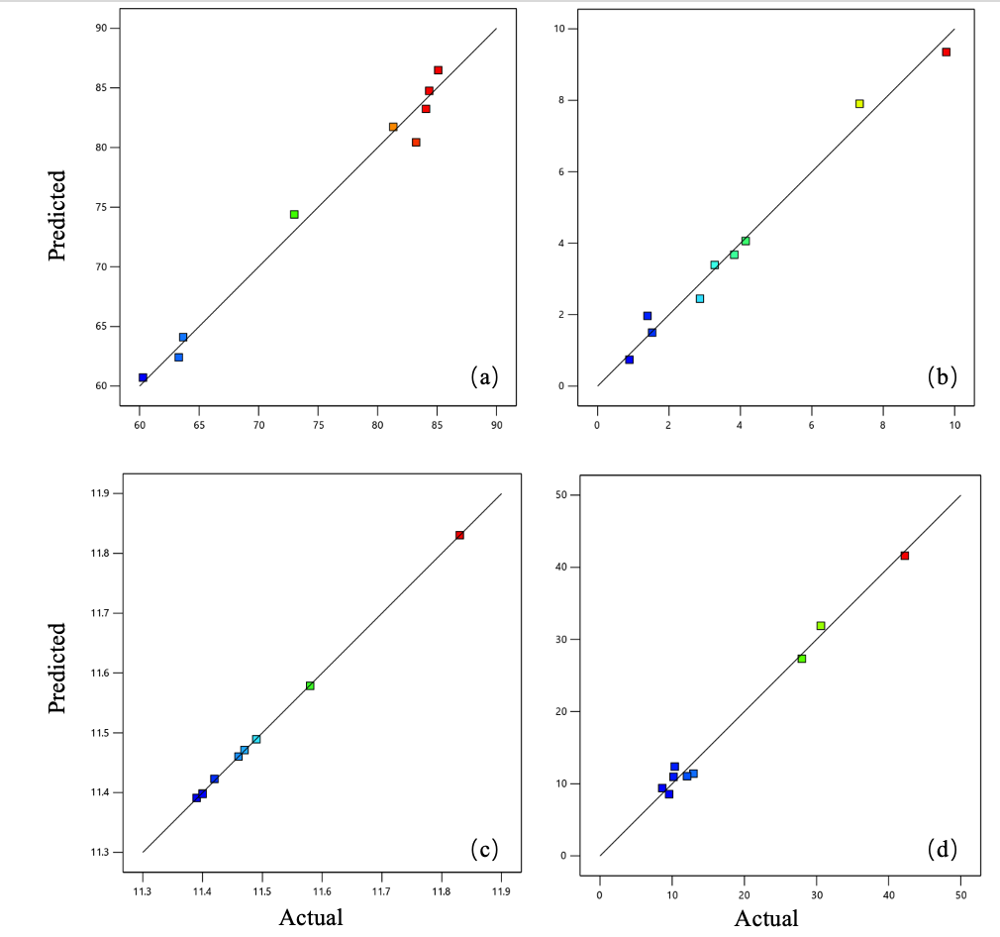
Fig. S2 The linear correlation of (a) ACR, (b) NAR, (c) pH and (d) TNR between the predicted value and the practical value

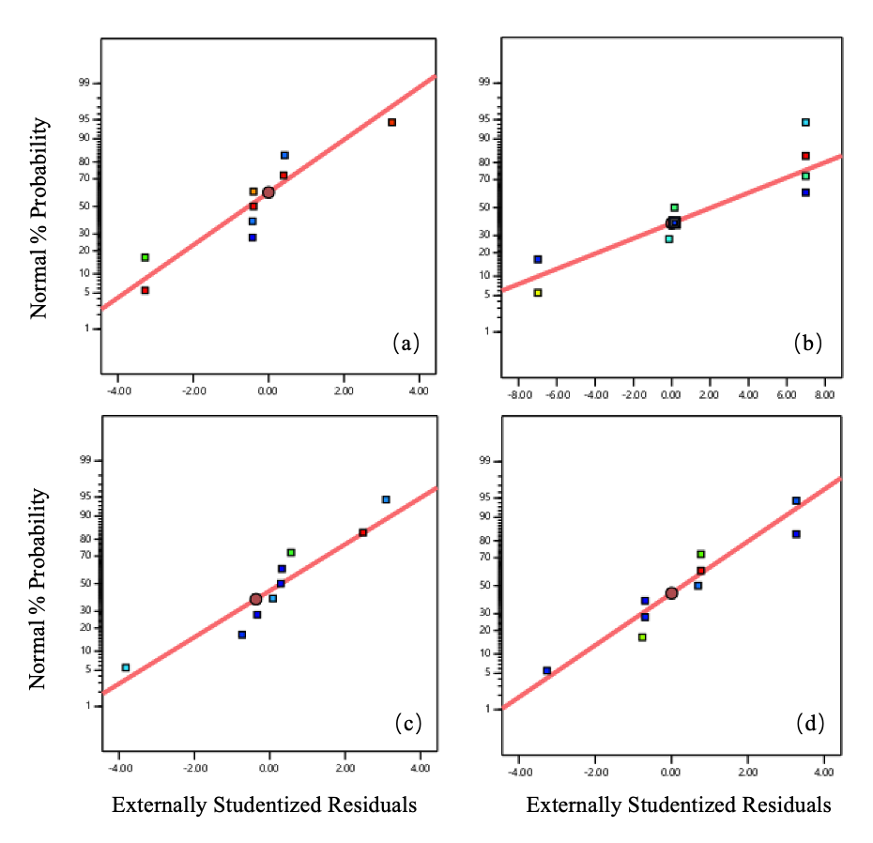
Fig. S3 The normal plot of (a) ACR, (b) NAR, (c) pH and (d) TNR of the externally studentized residuals

