Supporting Information
Structured illumination flowmetry
Haichun Liu¹, Jerker Widengren¹
¹Department of Applied Physics, KTH Royal Institute of Technology, S-106 91, Stockholm, Sweden

Section 1: Er-Ho upconversion emission mechanism
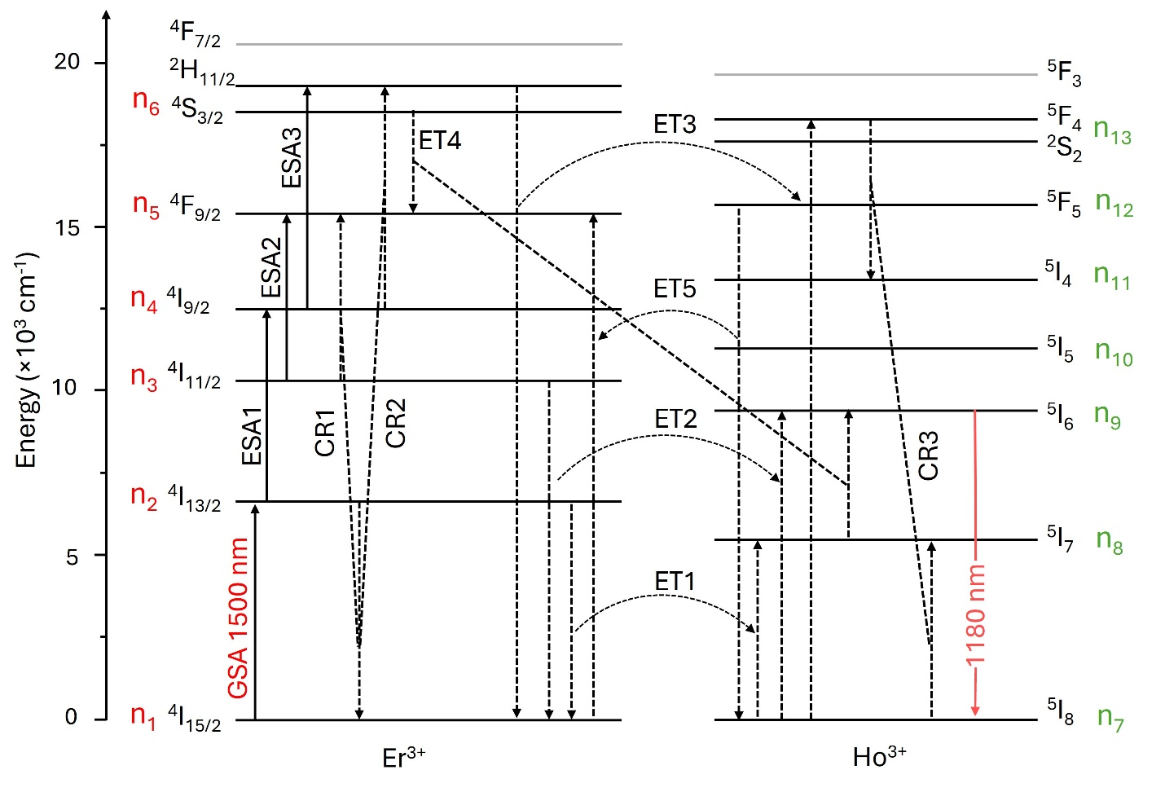
Figure S1. Model of electronic states and their major transitions in NIR-II NaErF₄:Ho@NaYF₄ core-shell UCNPs excited at ~1500 nm. GSA, ESA, CR and ET denote ground state absorption, excited state absorption, cross-relaxation and energy transfer, respectively. Emission at ~1180 nm indicated by a red line.
Following the electronic state model for generation of upconversion emission of NaErF₄:Ho@NaYF₄ core-shell UCNPs (at 1180 nm from Ho³⁺ ions) under excitation of 1500 nm light, as is depicted in Figure S1, the upconversion processes can be modeled using the following set of rate equations:
Er³⁺(⁴I_{15/2}): $\frac{dn_{1}}{dt}=-\frac{σ_{GSA}I_{exc}(t) }{hv_{exc}}n_{1}+\frac{n_{3}}{τ_{3}}+\frac{n_{4}}{τ_{4}}+\frac{n_{5}}{τ_{5}}+\frac{n_{6}}{τ_{6}}+$ $c_{1}n_{2}n_{3}+$ $c_{2}n_{2}n_{4}+ w_{ET1}n_{2}n_{7}+w_{ET2}n_{3}n_{7} +w_{ET3}n_{6}n_{7}+w_{ET5}n_{5}n_{7}$ (S1)
Er³⁺(⁴I_{13/2}): $\frac{dn_{2}}{dt}={\frac{σ_{GSA}I_{exc}(t)}{hv_{exc}}n_{1}-\frac{σ_{ESA1}I_{exc}(t)}{hv_{exc}}n_{2}+β}_{3}n_{3}- c_{1}n_{2}n_{3}- c_{2}n_{2}n_{4}- w_{ET1}n_{2}n_{7}$ (S2)
Er³⁺(⁴I_{11/2}): $\frac{dn_{3}}{dt}=-\frac{σ_{ESA2}I_{exc}(t)}{hv_{exc}}n_{3}-β_{3}n_{3}+β_{4}n_{4}-\frac{n_{3}}{τ_{3}}- c_{1}n_{2}n_{3}$ $-w_{ET2}n_{3}n_{7}$ (S3)
Er³⁺(⁴I_{9/2}): $\frac{dn_{4}}{dt}=\frac{σ_{ESA1}I_{exc}(t)}{hv_{exc}}n_{2}-\frac{σ_{ESA3}I_{exc}(t)}{hv_{exc}}n_{4}- c_{2}n_{2}n_{4}-\frac{n_{4}}{τ_{4}}-β_{4}n_{4}+β_{5}n_{5}$ (S4)
Er³⁺(⁴F_{9/2}): $\frac{dn_{5}}{dt}=\frac{σ_{ESA2}I_{exc}(t)}{hv_{exc}}n_{3}+ c_{1}n_{2}n_{3}-\frac{n_{5}}{τ_{5}}-β_{5}n_{5}+β_{6}n_{6}+w_{ET4}n_{6}n_{8}-w_{ET5}n_{5}n_{7}$ (S5)
Er³⁺(⁴S_{3/2} /²H_{11/2}): $\frac{dn_{6}}{dt}=\frac{σ_{ESA3}I_{exc}(t)}{hv_{exc}}n_{4}+ c_{2}n_{2}n_{4}-β_{6}n_{6}-\frac{n_{6}}{τ_{6}}$ $-w_{ET3}n_{6}n_{7}$ -$w_{ET4}n_{6}n_{8}$ (S6)
Ho³⁺(⁵I₈): $\frac{dn_{7}}{dt}=\frac{n_{9}}{τ_{9}}+\frac{n_{13}}{τ_{13}}+\frac{n_{12}}{τ_{12}}-$ $c_{3}n_{7}n_{13}- w_{ET1}n_{2}n_{7}-w_{ET2}n_{3}n_{7}-w_{ET3}n_{6}n_{7}$-$w_{ET5}n_{5}n_{7}$
(S7)
Ho³⁺(⁵I₇): $\frac{dn_{8}}{dt}=β_{9}n_{9}+ c_{3}n_{7}n_{13}+w_{ET1}n_{2}n_{7}$-$w_{ET4}n_{6}n_{8}$ (S8)
Ho³⁺(⁵I₆): $\frac{dn_{9}}{dt}=-β_{9}n_{9}+β_{10}n_{10}-\frac{n_{9}}{τ_{9}}+w_{ET2}n_{3}n_{7}+w_{ET4}n_{6}n_{8}$ (S9)
Ho³⁺(⁵I₅): $\frac{dn_{10}}{dt}=-β_{10}n_{10}+β_{11}n_{11}$ (S10)
Ho³⁺(⁵I₄): $\frac{dn_{11}}{dt}=c_{3}n_{7}n_{13}-β_{11}n_{11}+β_{12}n_{12}$ (S11)
Ho³⁺(⁵F₅): $\frac{dn_{12}}{dt}=$ $w_{ET5}n_{5}n_{7}-\frac{n_{12}}{τ_{12}}-β_{12}n_{12}+β_{13}n_{13}$ (S12)
Ho³⁺(⁵F₄ /²S₂): $\frac{dn_{13}}{dt}=w_{ET3}n_{6}n_{7}- c_{3}n_{7}n_{13}-β_{13}n_{13}-\frac{n_{13}}{τ_{13}}$ (S13)
Here, $n_{i} (i=1 to 6)$ represent the populations of Er³⁺ ions in the ⁴I_{15/2}, ⁴I_{13/2}, ⁴I_{11/2}, ⁴I_{9/2}, ⁴F_{9/2}, ²H_{11/2}/⁴S_{3/2} states, respectively, and $n_{j} (j=7 to 13)$ denote the populations of Ho³⁺ ions in the ⁵I₈, ⁵I₇, ⁵I₆, ⁵I₅, ⁵I₄, ⁵F₅, ⁵F₄/²S₂ states, respectively. $τ_{i} (i=2, 3, 4, 5, 6, 8, 9, 10, 11, 12, 13)$ represent the radiative decay lifetimes of the ⁴I_{13/2}, ⁴I_{11/2}, ⁴I_{9/2}, ⁴F_{9/2}, ²H_{11/2}/⁴S_{3/2} states of Er³⁺ and the ⁵I₇, ⁵I₆, ⁵I₅, ⁵I₄, ⁵F₅, ⁵F₄/²S₂ states of Ho³⁺, respectively. $β_{i} (i=3, 4, 5, 6, 9, 10, 11, 12, 13)$ represents the non-radiative decay rates of the ⁴I_{11/2}, ⁴I_{9/2}, ⁴F_{9/2}, ²H_{11/2}/⁴S_{3/2} states of Er³⁺ and the ⁵I₆, ⁵I₅, ⁵I₄, ⁵F₅, ⁵F₄/²S₂ states of Ho³⁺, respectively. $w_{ETi} (i=1 to 5)$ denote the coefficients of the interionic energy transfer processes: ⁴I_{13/2} (Er³⁺) + ⁵I₈ (Ho³⁺)→⁴I_{15/2} (Er³⁺) + ⁵I₇ (Ho³⁺), ⁴I_{11/2} (Er³⁺) + ⁵I₈ (Ho³⁺)→⁴I_{15/2} (Er³⁺) + ⁵I₆ (Ho³⁺), ²H_{11/2}/⁴S_{3/2} (Er³⁺) + ⁵I₈ (Ho³⁺)→⁴I_{15/2} (Er³⁺) + ⁵F₄/²S₂ (Ho³⁺), ²H_{11/2}/⁴S_{3/2} (Er³⁺) + ⁵I₇ (Ho³⁺)→⁴F_{9/2} (Er³⁺) + ⁵I₆ (Ho³⁺), ⁵I₈ (Ho³⁺) + ⁴F_{9/2} (Er³⁺)→⁵F₇ (Ho³⁺) + ⁴I_{15/2} (Er³⁺), respectively. $σ_{GSA}$ denotes the absorption cross-section for the ground-state absorption process of Er³⁺: ⁴I_{15/2}→⁴I_{13/2} at 1500 nm. $I_{exc}(t)$ is the excitation intensity function at 1500 nm. $h$ is the Planck’s constant. $v_{exc}$ is the frequency of excitation photon at 1500 nm. $σ_{ESA1}$, $σ_{ESA2}$, and $σ_{ESA3}$ denote the absorption cross-sections for the excited state absorption processes ⁴I_{13/2}→⁴I_{9/2}, ⁴I_{11/2}→⁴F_{9/2}, ⁴I_{9/2}→²H_{11/2}/⁴S_{3/2}, respectively, of Er³⁺ at ~1500 nm. $c_{i} (i=1 to 3)$ denote the coefficients of the cross-relaxation processes: ⁴I_{13/2} (Er³⁺) + ⁴I_{11/2} (Er³⁺)→⁴I_{15/2}(Er³⁺) + ⁴F_{9/2} (Er³⁺), ⁴I_{13/2} (Er³⁺) + ⁴I_{9/2} (Er³⁺)→⁴I_{15/2}(Er³⁺) + ²H_{11/2}/⁴S_{3/2} (Er³⁺), ⁵I₈ (Ho³⁺) + ⁵F₄/²S₂ (Ho³⁺)→⁵I₄ (Ho³⁺) + ⁵I₇ (Ho³⁺), respectively.

Table S1 Values of key photophysical parameters used in the simulations of the Er³⁺/Ho³⁺ co-doped UCNP photodynamics
$σ_{GSA}$(cm²) |  | $σ_{ESA1}$(cm²) |  | $σ_{ESA2}$(cm²) |  | $σ_{ESA3}$(cm²) | $w_{ET1}$(cm³s⁻¹) | $w_{ET2}$(cm³s⁻¹) | $w_{ET3}$ (cm³s⁻¹) | $w_{ET4}$(cm³s⁻¹) | $w_{ET5}$(cm³s⁻¹)
8×10⁻²¹ | 8×10⁻²⁰ |  | 4×10⁻²⁰ |  | 8×10⁻²⁰ |  | 1.8×10⁻¹⁶ | 1.8×10⁻¹⁶ | 1.8×10⁻¹⁶ | 1.8×10⁻¹⁶ | 1.8×10⁻¹⁶
β₃(s⁻¹) | β₄(s⁻¹) |  | β₅(s⁻¹) |  | β₆(s⁻¹) |  | β₉(s⁻¹) | β₁₀(s⁻¹) | β₁₁(s⁻¹) | β₁₂(s⁻¹) | β₁₃(s⁻¹)
5×10² | 5×10⁴ |  | 2×10⁴ |  | 8×10³ |  | 8×10³ | 1×10⁴ | 2×10⁴ | 3×10⁴ | 3×10⁴
τ₂(μs) | τ₃(μs) |  | τ₄(μs) |  | τ₅(μs) |  | τ₆(μs) | τ₈(μs) | τ₉(μs) | τ₁₀(μs) | τ₁₁(μs)
7.5×10³ | 1×10³ |  | 200 |  | 200 |  | 100 | 7.5×10³ | 1×10³ | 50 | 50
τ₁₂(μs) | τ₁₃(μs) |  | c₁(cm³s⁻¹) |  | c₂(cm³s⁻¹) |  | c₃(cm³s⁻¹)
150 | 100 |  | 3×10⁻¹⁸ |  | 3×10⁻¹⁸ |  | 3×10⁻¹⁸

Figure S2 Temporal UCL response (from a NaErF₄:Ho@NaYF₄ core-shell UCNP) to a sinusoidally modulated excitation intensity.
Figure S3 Excitation pattern, I_{exc}(x) (orange), providing a structured illumination, and the resulting UCL pattern, I_{UCL}(x) (blue), from UCNPs (NaErF₄:Ho@NaYF₄ core-shell UCNPs) as they flow along a channel at a constant velocity ($v_{c}=2 mm/s$). A phase shift between I_{exc}(x) and I_{UCL}(x) can be clearly noticed.

