Table S1 Traits statics during the seedling stage of RIL, together with their parents and natural population.
Trait |  | Parents |  |  |  |  | Recombinant Inbred Lines |  |  |  |  |  |  |  |  |  |  | Natural Population
 |  | 9311 |  | PA64s |  |  | Minimum |  | Maximum |  | Mean |  | Variance | Heritability | Skewness |  | Kurtosis | Minimum |  | Maximum | Mean |  | Variance | Heritability | Skewness | Kurtosis
CFW |  | 0.63 |  | 0.43 |  |  | 0.29 |  | 0.75 |  | 0.45 |  | 6.67E-03 | 0.52 | 1.03 |  | 1.95 | 0.05 |  | 0.17 | 0.09 |  | 3.89E-04 | 0.66 | 0.90 | 1.50
FW | 0.53 |  | 0.37 |  | 0.28 |  |  | 0.68 |  | 0.42 |  | 5.54E-03 |  | 0.52 | 0.89 | 1.16 |  | 0.05 | 0.14 |  | 0.08 | 2.04E-04 |  | 0.66 | 0.83 | 1.82
CDW |  | 0.12 |  | 0.08 |  |  | 0.07 |  | 0.13 |  | 0.09 |  | 1.88E-04 | 0.62 | 0.80 |  | 0.69 | 0.01 |  | 0.04 | 0.02 |  | 1.96E-05 | 0.37 | 0.74 | 0.78
DW |  | 0.11 |  | 0.08 |  | 0.06 |  |  | 0.13 |  | 0.09 |  | 1.70E-04 | 0.62 | 0.56 |  | 0.48 | 0.01 |  | 0.04 | 0.02 |  | 1.20E-05 | 0.37 | 1.36 | 4.78
SL |  | 11.25 |  | 9.35 |  |  | 7.30 |  | 15.90 |  | 10.54 |  | 2.26E+00 | 0.64 | 0.54 |  | 0.78 | 7.80 |  | 27.90 | 13.90 |  | 9.01E+00 | 0.77 | 1.03 | 2.26
CSL |  | 16.10 |  | 13.75 |  |  | 8.10 |  | 18.00 |  | 14.09 |  | 3.34E+00 | 0.64 | 0.19 |  | 0.33 | 8.40 |  | 28.90 | 16.37 |  | 1.68E+01 | 0.77 | 0.42 | -0.17
SR |  | 0.88 |  | 0.78 |  |  | 0.41 |  | 1.00 |  | 0.91 |  | 1.02E-02 | / | -1.95 |  | 5.06 | 0.18 |  | 1.00 | 0.92 |  | 2.17E-02 | / | -2.69 | 7.76
CSL, CFW, CDW indicate shoot length, fresh weight, and dry weight of the seedlings in control groups. SL, FW, DW indicate shoot length, fresh weight, and dry weight of the seedling in treat groups. SR indicates survival rate.

Table S2 Candidate QTLs identified by GWAS.
Traits | Linkage-QTL | Chromosome | LeadSNP | P-value
CDW | qCDW_ind1 | 1 | 15695725 | 6.66E-07
 | qCDW_ind5 | 5 | 6378944 | 2.30E-07
CFW | qCFW_ind6 | 6 | 4678729 | 3.65E-07
 | qCFW_ind9 | 9 | 20789266 | 2.14E-07
 | qCFW_ind10 | 10 | 2803244 | 8.33E-10
 | qCFW_ind11 | 11 | 6077844 | 3.83E-07
CSL | qCSL_ind2 | 2 | 18612268 | 2.11E-06
 | qCSL_ind5-1 | 5 | 403333 | 1.21E-06
 | qCSL_ind5-2 | 5 | 2578370 | 6.01E-07
 | qCSL_ind10 | 10 | 400257 | 2.50E-07
DW | qDW_ind1 | 1 | 30643464 | 1.02E-07
 | qDW_ind2-1 | 2 | 7355144 | 9.42E-07
 | qDW_ind2-2 | 2 | 24214962 | 3.96E-08
 | qDW_ind4-1 | 4 | 9055746 | 9.39E-07
 | qDW_ind4-2 | 4 | 21035439 | 4.65E-07
 | qDW_ind5-1 | 5 | 11499534 | 1.48E-07
 | qDW_ind5-2 | 5 | 13221663 | 9.11E-08
 | qDW_ind5-3 | 5 | 24370635 | 2.48E-07
 | qDW_ind7 | 7 | 17922137 | 1.68E-08
 | qDW_ind8 | 8 | 3190430 | 5.58E-08
 | qDW_ind9 | 9 | 96431 | 6.19E-07
 | qDW_ind10 | 10 | 475876 | 3.00E-08
FW | qFW_ind1-1 | 1 | 16851744 | 9.12E-08
 | qFW_ind1-2 | 1 | 24043619 | 6.51E-07
 | qFW_ind2-1 | 2 | 942193 | 3.57E-07
 | qFW_ind2-2 | 2 | 7740802 | 1.50E-08
 | qFW_ind5-1 | 5 | 4809270 | 7.41E-07
 | qFW_ind6-1 | 6 | 5692071 | 2.79E-07
 | qFW_ind6-2 | 6 | 24763407 | 6.04E-07
 | qFW_ind8-1 | 8 | 3190537 | 4.57E-08
 | qFW_ind10-1 | 10 | 2628436 | 2.12E-07
SL | qSL-ind1 | 1 | 33159557 | 4.72E-07
 | qSL-ind7 | 7 | 11408739 | 6.30E-07
 | qSL-ind8-1 | 8 | 17106337 | 4.82E-08
 | qSL-ind8-2 | 8 | 25945911 | 8.80E-07
 | qSL-ind10 | 10 | 503514 | 1.93E-07
 | qSL-ind11-1 | 11 | 7271380 | 5.25E-08
 | qSL-ind11-2 | 11 | 23654774 | 8.13E-07
 | qSL-ind12 | 12 | 13518162 | 3.11E-07
SR | qSR_ind1-1 | 1 | 4578608 | 3.38E-08
Traits | Linkage-QTL | Chromosome | LeadSNP | P-value
SR | qSR_ind1-2 | 1 | 10087572 | 4.32E-08
 | qSR_ind1-3 | 1 | 11948923 | 1.07E-07
 | qSR_ind1-4 | 1 | 13042387 | 8.68E-08
 | qSR_ind1-5 | 1 | 13624893 | 1.63E-07
 | qSR_ind1-6 | 1 | 16073967 | 1.09E-07
 | qSR_ind1-7 | 1 | 33427195 | 4.08E-08
 | qSR_ind1-8 | 1 | 42815810 | 1.87E-07
 | qSR_ind2-1 | 2 | 6483259 | 3.98E-08
 | qSR_ind2-2 | 2 | 17903021 | 7.25E-07
 | qSR_ind2-3 | 2 | 24662672 | 1.32E-08
 | qSR_ind3-1 | 3 | 300929 | 7.32E-08
 | qSR_ind3-2 | 3 | 3521746 | 4.58E-07
 | qSR_ind3-3 | 3 | 4746385 | 1.79E-07
 | qSR_ind3-4 | 3 | 13376526 | 1.84E-09
 | qSR_ind3-5 | 3 | 14164909 | 7.67E-08
 | qSR_ind3-6 | 3 | 21467558 | 1.85E-07
 | qSR_ind3-7 | 3 | 23196721 | 3.64E-07
 | qSR_ind3-8 | 3 | 30362842 | 1.43E-07
 | qSR_ind3-9 | 3 | 33481705 | 9.35E-08
 | qSR_ind4-1 | 4 | 732698 | 1.85E-07
 | qSR_ind4-2 | 4 | 1396038 | 1.74E-07
 | qSR_ind4-3 | 4 | 4422893 | 1.68E-07
 | qSR_ind4-4 | 4 | 4666903 | 2.16E-08
 | qSR_ind4-5 | 4 | 7134602 | 7.62E-08
 | qSR_ind4-6 | 4 | 11833339 | 6.22E-08
 | qSR_ind4-7 | 4 | 12634503 | 6.85E-08
 | qSR_ind4-8 | 4 | 16315342 | 8.00E-09
 | qSR_ind4-9 | 4 | 18765786 | 1.67E-08
 | qSR_ind4-10 | 4 | 21029822 | 5.33E-07
 | qSR_ind4-11 | 4 | 23343879 | 1.33E-07
 | qSR_ind4-12 | 4 | 28705929 | 5.40E-08
 | qSR_ind5-1 | 5 | 5121670 | 6.19E-07
 | qSR_ind5-2 | 5 | 8961002 | 1.00E-07
 | qSR_ind5-3 | 5 | 9275531 | 1.60E-07
 | qSR_ind5-4 | 5 | 9952329 | 9.85E-09
 | qSR_ind5-5 | 5 | 10209130 | 2.24E-07
 | qSR_ind5-6 | 5 | 11913110 | 2.42E-07
 | qSR_ind5-7 | 5 | 12494751 | 6.47E-07
 | qSR_ind5-8 | 5 | 13131662 | 4.25E-08
 | qSR_ind5-9 | 5 | 15936997 | 2.25E-08
 | qSR_ind5-10 | 5 | 19749618 | 2.32E-07
Traits | Linkage-QTL | Chromosome | LeadSNP | P-value
SR | qSR_ind5-11 | 5 | 22802644 | 9.50E-08
 | qSR_ind6-1 | 6 | 2468598 | 3.12E-08
 | qSR_ind6-2 | 6 | 14109103 | 1.34E-10
 | qSR_ind6-3 | 6 | 16845854 | 5.38E-08
 | qSR_ind6-4 | 6 | 17469133 | 2.59E-08
 | qSR_ind6-5 | 6 | 18513585 | 1.66E-09
 | qSR_ind7-1 | 7 | 3660372 | 1.95E-07
 | qSR_ind7-2 | 7 | 14451289 | 5.75E-08
 | qSR_ind7-3 | 7 | 17387084 | 7.11E-10
 | qSR_ind7-4 | 7 | 18007927 | 1.97E-07
 | qSR_ind8-1 | 8 | 2397636 | 2.27E-08
 | qSR_ind8-2 | 8 | 3071479 | 8.71E-08
 | qSR_ind8-3 | 8 | 4063203 | 4.25E-07
 | qSR_ind8-4 | 8 | 4259130 | 2.31E-08
 | qSR_ind8-5 | 8 | 9473199 | 1.02E-08
 | qSR_ind8-6 | 8 | 16039302 | 7.84E-07
 | qSR_ind8-7 | 8 | 16678638 | 3.13E-07
 | qSR_ind8-8 | 8 | 22515168 | 3.15E-08
 | qSR_ind9-1 | 9 | 1746880 | 6.04E-08
 | qSR_ind9-2 | 9 | 15261914 | 2.36E-07
 | qSR_ind9-3 | 9 | 21645459 | 4.88E-07
 | qSR_ind9-4 | 9 | 22745472 | 1.79E-09
 | qSR_ind10-1 | 10 | 3989989 | 4.80E-07
 | qSR_ind10-2 | 10 | 6939742 | 4.86E-08
 | qSR_ind10-3 | 10 | 7875075 | 4.23E-08
 | qSR_ind11-1 | 11 | 936305 | 1.17E-07
 | qSR_ind11-2 | 11 | 11009454 | 6.90E-08
 | qSR_ind11-3 | 11 | 18865118 | 2.21E-07
 | qSR_ind11-4 | 11 | 21818005 | 4.53E-07
 | qSR_ind12-1 | 12 | 119359 | 5.87E-08
 | qSR_ind12-2 | 12 | 565346 | 8.69E-08
 | qSR_ind12-3 | 12 | 7817107 | 6.47E-10
 | qSR_ind12-4 | 12 | 11011200 | 3.89E-07
 | qSR_ind12-5 | 12 | 11629746 | 2.04E-07
 | qSR_ind12-6 | 12 | 16671789 | 1.69E-07
 | qSR_ind12-7 | 12 | 26525394 | 4.45E-10
CSL, CFW, CDW indicate shoot length, fresh weight, and dry weight of the seedlings in control groups. SL, FW, DW indicate shoot length, fresh weight, and dry weight of the seedling in treat groups. SR indicates survival rate.

Table S3 Annotation information of candidate genes identified in GWAS and linkage analysis.
Chromosome | Candidate Gene | Start | End | Comment Information
6 | LOC_Os06g10770 | 5621926 | 5625701 | peptidase putative expressed
6 | LOC_Os06g10780 | 5629416 | 5631997 | AP2 domain containing protein expressed
6 | LOC_Os06g10790 | 5633354 | 5635721 | lectin-like receptor kinase putative expressed
6 | LOC_Os06g10800 | 5636936 | 5637931 | zinc finger family protein putative expressed
6 | LOC_Os06g10810 | 5638272 | 5641660 | phosphate carrier protein mitochondrial precursor putative expressed
6 | LOC_Os06g10820 | 5642245 | 5642880 | helix-loop-helix DNA-binding domain containing protein expressed
6 | LOC_Os06g10830 | 5648264 | 5650906 | retrotransposon protein putative unclassified expressed
6 | LOC_Os06g10840 | 5653538 | 5653942 | expressed protein
6 | LOC_Os06g10850 | 5657850 | 5661265 | lipase putative expressed
6 | LOC_Os06g10860 | 5663968 | 5665309 | glucosyltransferase putative expressed
6 | LOC_Os06g10870 | 5665965 | 5667013 | retrotransposon protein putative unclassified expressed
6 | LOC_Os06g10880 | 5677080 | 5682126 | bZIP transcription factor putative expressed
6 | LOC_Os06g10890 | 5688535 | 5690095 | sterol carrier protein-2 putative expressed
7 | LOC_Os07g30280 | 17902640 | 17904772 | csAtPR5 putative expressed
7 | LOC_Os07g30300 | 17907341 | 17912298 | small G protein family protein putative expressed
7 | LOC_Os07g30310 | 17914477 | 17924844 | retrotransposon protein putative Ty3-gypsy subclass expressed
7 | LOC_Os07g30320 | 17934883 | 17940840 | retrotransposon protein putative Ty3-gypsy subclass expressed
7 | LOC_Os07g30330 | 17945639 | 17947265 | cytokinin-O-glucosyltransferase 2 putative expressed
7 | LOC_Os07g30340 | 17956245 | 17956571 | retrotransposon protein putative unclassified

Table S4 KEGG pathway analysis of DEGs
#Term | Database | ID | Input number | Background number | P-Value | Corrected P-Value
Metabolic pathways | KEGG PATHWAY | osa01100 | 112 | 2290 | 1.41E-10 | 3.04E-08
Pyruvate metabolism | KEGG PATHWAY | osa00620 | 14 | 86 | 2.10E-07 | 9.68E-06
Starch and sucrose metabolism | KEGG PATHWAY | osa00500 | 18 | 161 | 6.78E-07 | 2.91E-05
Biosynthesis of unsaturated fatty acids | KEGG PATHWAY | osa01040 | 7 | 28 | 2.22E-05 | 0.000484901
Carbon metabolism | KEGG PATHWAY | osa01200 | 20 | 271 | 5.34E-05 | 0.000908139
Fatty acid metabolism | KEGG PATHWAY | osa01212 | 10 | 75 | 5.36E-05 | 0.000908139
Biosynthesis of secondary metabolites | KEGG PATHWAY | osa01110 | 54 | 1177 | 5.78E-05 | 0.000908455
Carbon fixation in photosynthetic organisms | KEGG PATHWAY | osa00710 | 10 | 77 | 6.55E-05 | 0.000917033
Phenylpropanoid biosynthesis | KEGG PATHWAY | osa00940 | 17 | 233 | 0.000214794 | 0.001948271
Plant hormone signal transduction | KEGG PATHWAY | osa04075 | 17 | 240 | 0.0002968 | 0.002654711
Cysteine and methionine metabolism | KEGG PATHWAY | osa00270 | 11 | 119 | 0.000450026 | 0.003602569
Amino sugar and nucleotide sugar metabolism | KEGG PATHWAY | osa00520 | 13 | 161 | 0.000476415 | 0.003602569
Limonene and pinene degradation | KEGG PATHWAY | osa00903 | 3 | 8 | 0.002232842 | 0.011454978
MAPK signaling pathway - plant | KEGG PATHWAY | osa04016 | 11 | 151 | 0.002699569 | 0.013582207
Huntington disease | PANTHER | P00029 | 5 | 36 | 0.003483573 | 0.01739086
Valine, leucine and isoleucine degradation | KEGG PATHWAY | osa00280 | 5 | 45 | 0.008192552 | 0.037685741
Glycine, serine and threonine metabolism | KEGG PATHWAY | osa00260 | 6 | 68 | 0.010704714 | 0.048208643

PrimerName | Primers sequence（5'-3')
WH-C1 | Forward | TGAGGAGGAAGAGCTCGTGA
WH-C1 | Reverse | CGACGACCTCGATCAGCTAC
WH-C2 | Forward | TGAATCCTTGCAGCTTGGCT
WH-C2 | Reverse | ATTTGCGGGGAAAAGGGACA
WH-E1 | Forward | GACATGAACCTCGGATGGCA
WH-E1 | Reverse | ACTCGATCGATCAGCGTGTC
WH-E2 | Forward | GAGTACCGCGAGCTCAAGAA
WH-E2 | Reverse | TGCCATCCGAGGTTCATGTC
WH-H1 | Forward | GGGAACATCCCCAACACGAT
WH-H1 | Reverse | GATCCTCTCACGCAGGTAGC
WH-H2 | Forward | GCTCACACATACAAGCGCAG
WH-H2 | Reverse | CGCACTCCTTCGTCTACCTC
WH-J1 | Forward | ATGCTTCCCTAACGCGGAAA
WH-J1 | Reverse | GGCAATGGACCACCTAGGAC
WH-J2 | Forward | GGGCTCACTGCACGAGTAAT
WH-J2 | Reverse | TTCCGCGTTAGGGAAGCATT
WH-K1 | Forward | CTGCCCACCAAGGCGTAATA
WH-K1 | Reverse | CACGGGAAACCCAACCCTAA
WH-K2 | Forward | GCATGCCATCGTCCTACTGT
WH-K2 | Reverse | ACTCGTTAGCACGGGAAACC
WH-L1 | Forward | GCTGGGCTGGTCTATGAGTC
WH-L1 | Reverse | TCTAGCAGAGGCTCATGGGT
WH-L2 | Forward | ATCGCTGGTGGCAACTTCTC
WH-L2 | Reverse | GAGGCTCATGGGTCCTCTTG
WH-N1 | Forward | GGGAGGCGATAAGAAGGACG
WH-N1 | Reverse | CATGGTGTTTGGGCTTGGTG
WH-N2 | Forward | AGCCCAAACACCATGGGAAG
WH-N2 | Reverse | TGAGAGAGCGTCATGGGTGA
WH-P1 | Forward | CCGTATACGACTGGGTGGTG
WH-P1 | Reverse | AGATCACGCCTTCACCTGTC
WH-P2 | Forward | CACCGTATACGACTGGGTGG
WH-P2 | Reverse | GCAGAGCTTAGCTGCTCGAT
WH-R1 | Forward | TCCTTCTCGTCTCCCACGAT
WH-R1 | Reverse | AGCCTGAACCATACCCCTCT
WH-R2 | Forward | GGCTGCGAAGTTCCCAATTC
WH-R2 | Reverse | GCTACATCGTGGGAGACGAG
WH-S1 | Forward | AGAACTGGCAGCGAAGACAA
WH-S1 | Reverse | TGAGGTATCGTCCAGCTCCA
WH-S2 | Forward | GCAACACAGGCATTGGACTG
WH-S2 | Reverse | TGTCTTCGCTGCCAGTTCTT
Table S5 The primer sequence of qRT-PCR.

Fig. S1 Material response to heat stress.
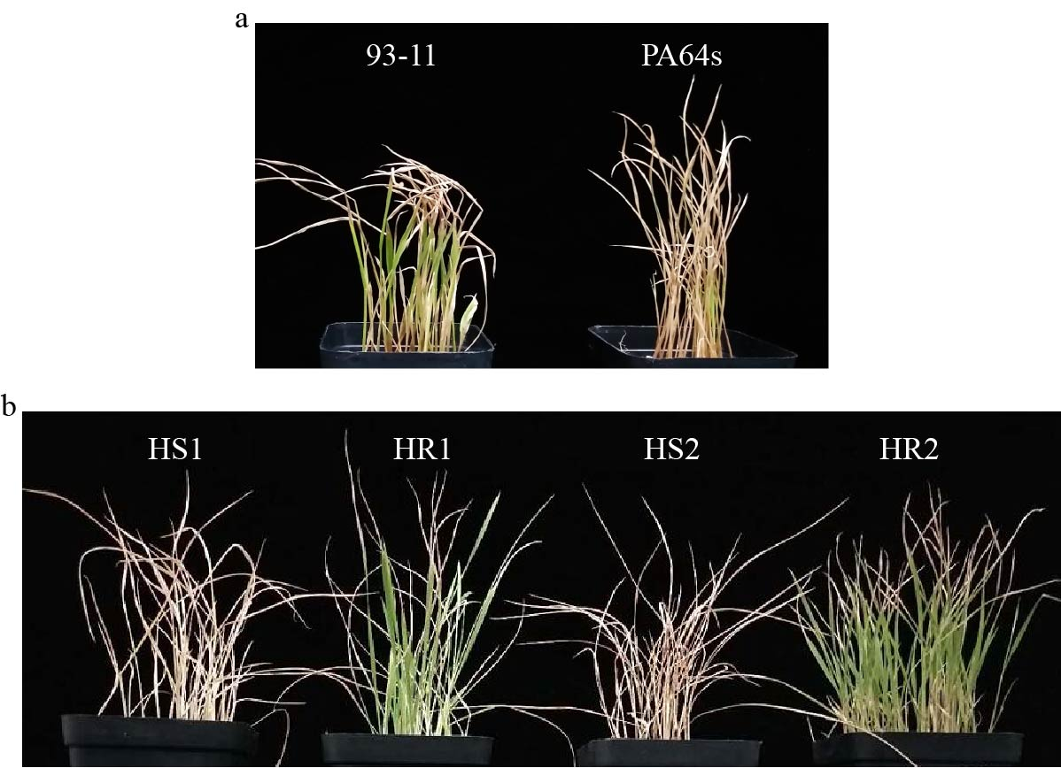
- The parent material of the recombinant inbred line after heat treatment. (b) Heat treatment of extreme materials used for transcriptome sequencing.HR1 and HR2 represent two varieties with higher survival rate after heat treatment. HS1 and HS2 represent two heat-sensitive varieties, and the survival rate after heat treatment is low.
Fig. S2 Normal distribution maps of biomass traits and survival rate in the RIL in control and treatment groups. 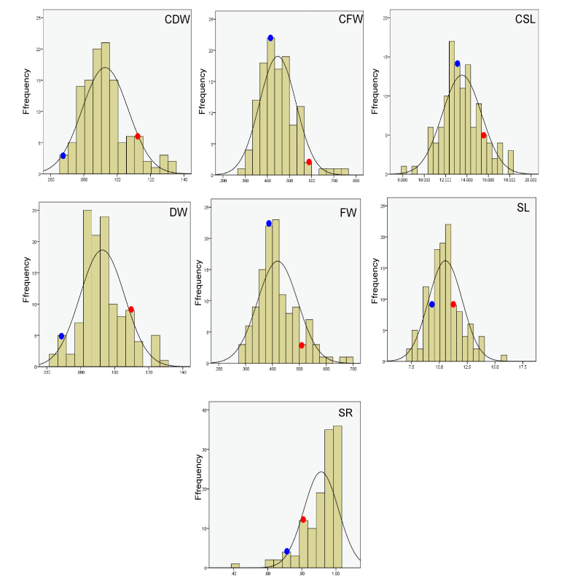
CSL, CFW, CDW indicate shoot length, fresh weight, and dry weight of the seedlings in control groupss. SL, FW, DW indicate shoot length, fresh weight, and dry weight of the seedling in treat groups. SR indicates survival rate. The dot indicates the label the parents position, where blue represents the parent PA64s, and red represents the parent 93-11.

Fig. S3 Normal distribution maps of biomass traits and survival rate in the natural population in control and treatment groups.
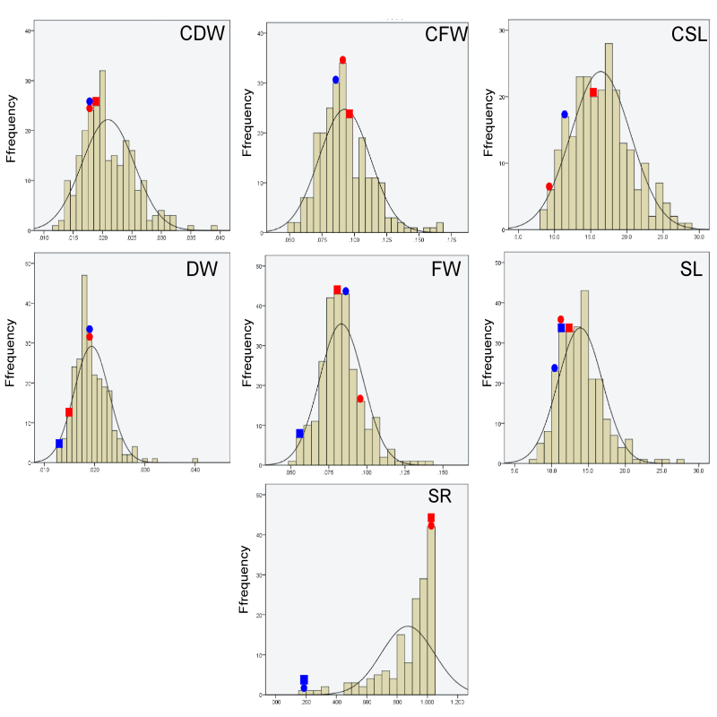
CSL, CFW, CDW indicate shoot length, fresh weight, and dry weight of the seedlings in control groupss. SL, FW, DW indicate shoot length, fresh weight, and dry weight of the seedling in treat groups. SR indicates survival rate.The dots indicate the existing phenotypic data of the two selected species with extreme survival rates. Red indicates the two varieties with higher survival rate after heat treatment, and blue indicates the two varieties with lower survival rate.
Fig. S4 QQplots for Genome-wide association analysis in the treatment and control groups of the natural population.

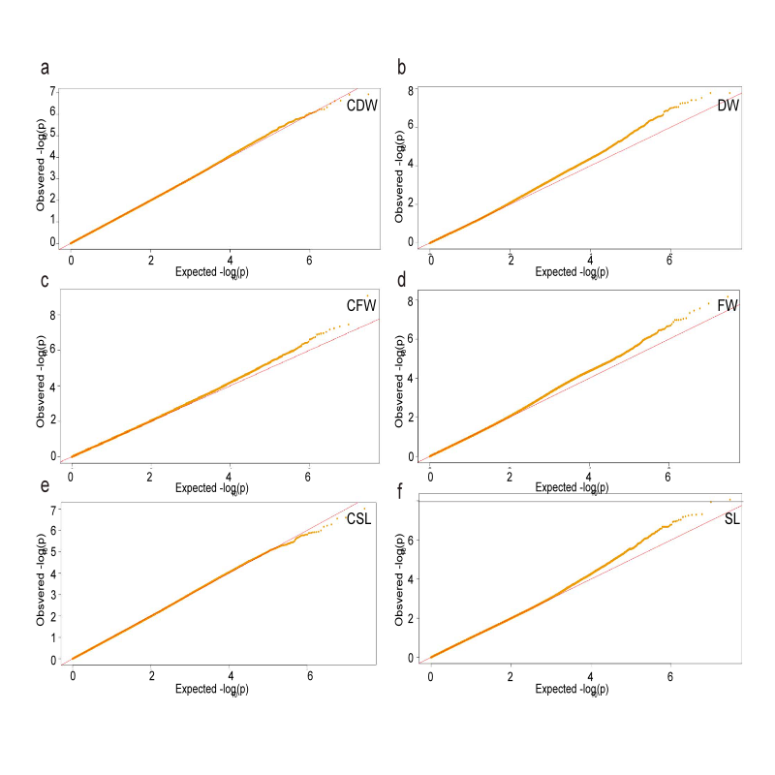
CSL, CFW, CDW indicate shoot length, fresh weight, and dry weight of the seedlings in control groups. SL, FW, DW indicate shoot length, fresh weight, and dry weight of the seedling in treat groups. SR indicates survival rate.

