EXTENDED DATA TABLES
Extended Data Table 1 | Binding affinity between CT-P59 and SARS-CoV-2 RBD mutants determined by BLI
Sample ID | K_{D} (M) | ka (1/Ms) | kd (1/s)
RBD WT | 2.51E-10 | 7.08E+05 | 1.78E-04
RBD A435S | 2.82E-10 | 1.07E+06 | 3.01E-04
RBD F342L | 1.98E-10 | 9.81E+05 | 1.94E-04
RBD G476S | 1.61E-10 | 9.07E+05 | 1.46E-04
RBD K458R | 2.36E-10 | 1.04E+06 | 2.46E-04
RBD N354D | 2.94E-10 | 8.61E+05 | 2.53E-04
RBD V367F | 2.92E-10 | 9.07E+05 | 2.65E-04
RBD V483A | 3.91E-10 | 9.04E+05 | 3.54E-04
RBD W436R | 2.21E-10 | 8.16E+05 | 1.80E-04

Extended Data Table 2 | Data collection and refinement statistics
 | CT-P59 Fab/SARS-CoV-2-RBD
Data collection
Space group | I222
Cell dimensions
a, b, c (Å) | 65.55, 167.60, 169.05
α, β, γ (°) | 90.00, 90.00, 90.00
Resolution (Å) | 29.76-2.71 (2.81 - 2.71) *
R_{sym} or R_{merge} | 0.245 (2.145)
I / σI | 12.44 (1.63)
Completeness (%) | 99.78 (99.88)
Redundancy | 13.6 (13.1)
Refinement
Resolution (Å) | 29.76-2.71
No. reflections | 25734
R_{work} / R_{free} | 0.2167 / 0.2420
No. atoms
Protein | 4850
Ligand/ion | 70
Water | 65
B-factors
Protein | 64.53
Ligand/ion | 118.46
Water | 53.09
R.m.s. deviations
Bond lengths (Å) | 0.003
Bond angles (°) | 0.588
One crystal was used for data collection and refinement.
*Values in parentheses are for highest-resolution shell.
Extended Data Table 3 | Interacting residues between CT-P59 and SARS-CoV-2 RBD
SARS-CoV-2 RBD | Heavy chain | SARS-CoV-2 RBD | Light chain
R403 | D56* | V483 | Y33
K417 | S32 | E484 | Y33*
Y449 | Y60, R105, R107 | G485 | Y33, D51
N450 | R107* | F486 | Y50, D51*
L452 | Y106, R107
Y453 | W55, D56*
L455 | S32, W55, L104
F456 | S32, L104
E484 | R109*, Y111
G485 | Y111
F486 | P101, Y111*, Y113
Y489 | P101, G102, L104, Y111,
F490 | Y106, R109
L492 | R105,Y106
Q493 | D54, W55, N58, L104, R105*
S494 | R105*,Y106, R107*
Y495 | N58
G496 | N58
Y505 | D56, D57
Van der Waals contact was analyzed at the distance cutoff of 4.5 Å and the H-bonds at the distance cutoff of 3.5 Å (*) using Contact program in CCP4 suite.

EXTENDED DATA FIGURES

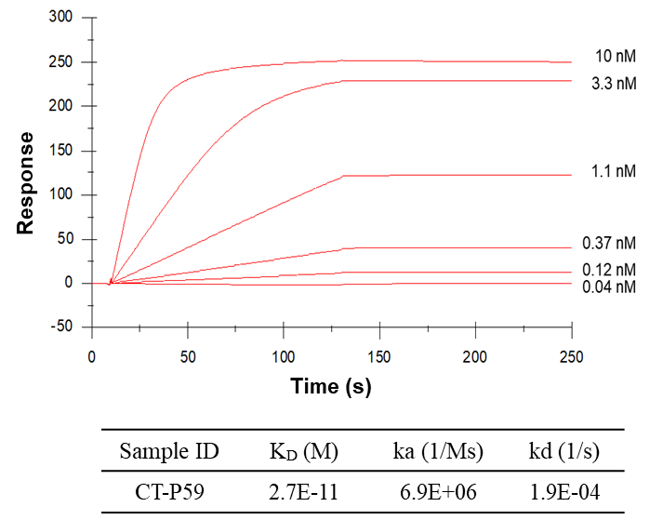

Extended Data Fig. 1 | Binding affinity of CT-P59 was determined by SPR. Several concentrations of CT-P59 were serially injected and dissociated then the dissociation constant was evaluated by sensorgram fitting using the kinetic model (bivalent analyte). Data is expressed as the mean of two independent experiments. ka, binding rate of CT-P59 with SARS-CoV-2 RBD; kd, dissociation rate; K_{D}, affinity of CT-P59 for the RBD.

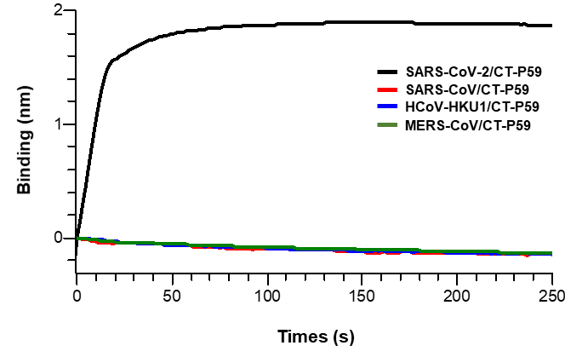

Extended Data Fig. 2 | Binding specificity of CT-P59 by biolayer interferometry (BLI). The binding specificity of CT-P59 was measured with four different RBD proteins derived from closely related beta-coronaviruses such as SARS-CoV-2 (black), SARS-CoV (red), HCoV-HKU1 (blue), and MERS-CoV (green) which cause COVID-19, severe acute respiratory syndrome, common cold, and Middle East Respiratory Syndrome, respectively. The binding sensorgrams of CT-P59 toward the four different RBD proteins were presented.

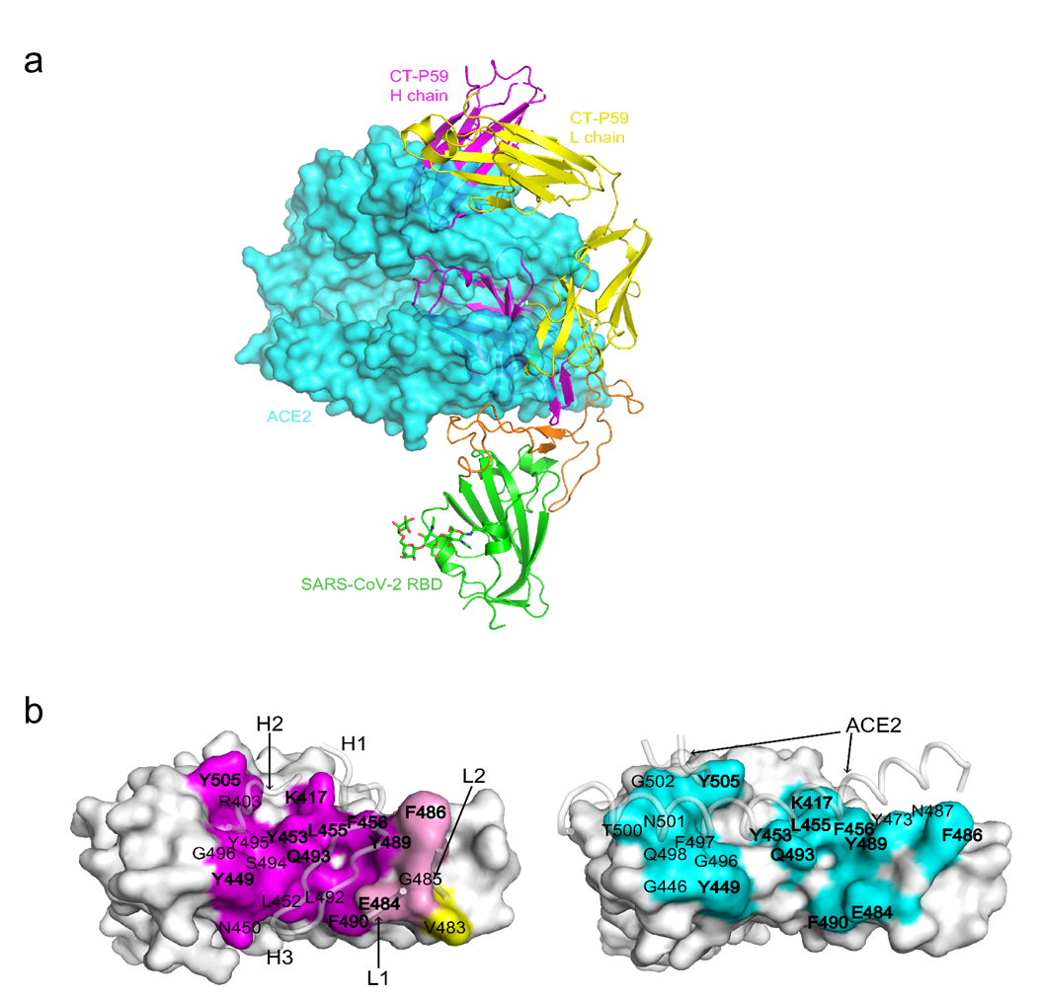

Extended Data Fig. 3 | SARS-CoV-2 RBD interaction with CT-P59 and ACE2. a, Superposition of CT-P59 and ACE2. The RBD domains of the CT-P59 Fab/SARS-CoV-2 RBD complex and the RBD-ACE2 complex (PDB 6LZG) were superimposed. ACE2 is shown as a surface model. b, Comparison of the RBD interfaces interacting with CT-P59 (left) or ACE2 (right). The residues interacting with heavy chain, light chain or both are coloured in magenta, yellow and pink, respectively. The residues interacting with ACE2 are coloured cyan. The structural segments interacting the RBD are shown in ribbon. The residues interacting both CT-P59 and ACE2 are labelled in bold letters.

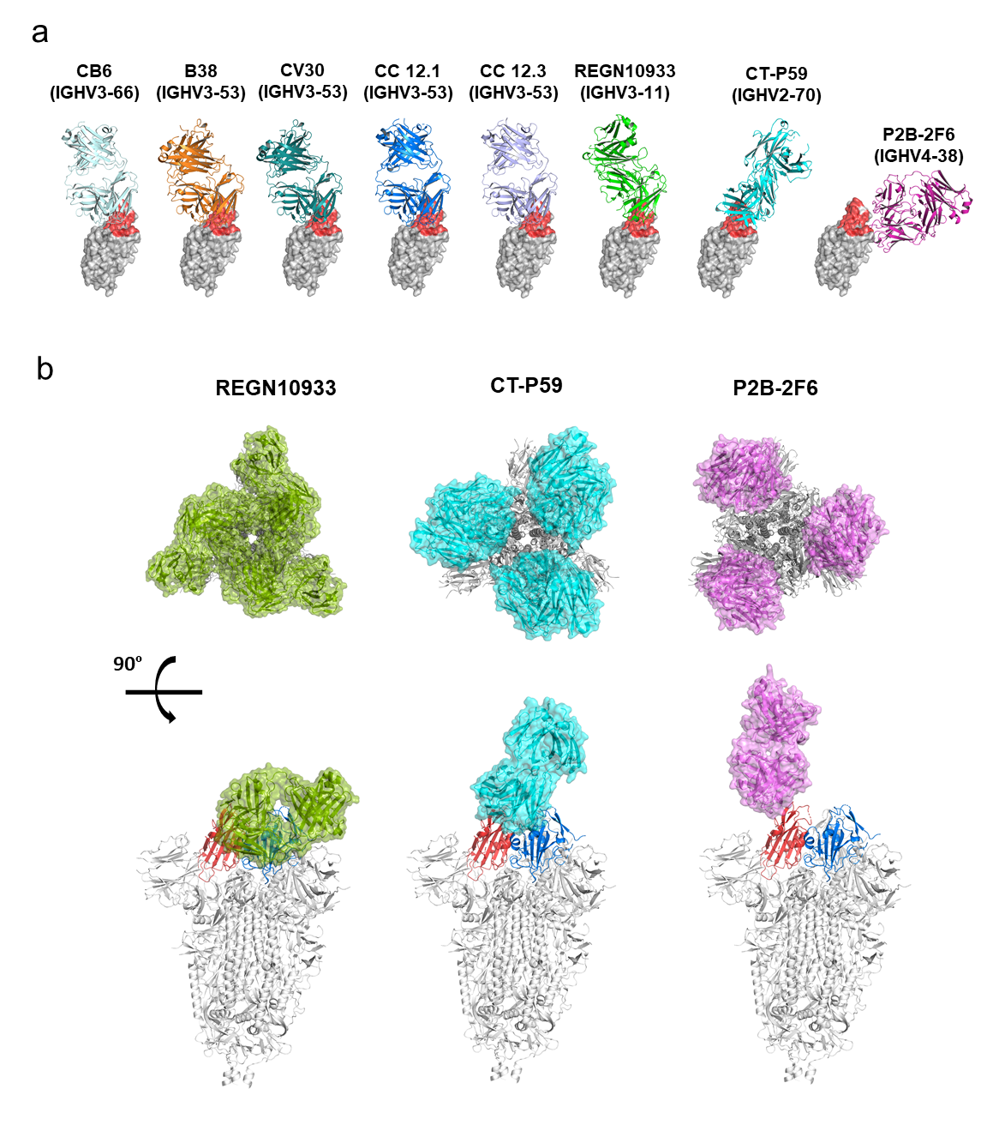
Extended Data Fig. 4 | Structural comparison with ACE2 blocking neutralizing antibodies with SARS-CoV-2 RBD. a, Binding orientation between antibodies (ribbon diagram) and SARS-CoV-2 RBD (gray surface filling model highlighted with ACE2 interaction region in red). b, Superposition of neutralizing antibodies and “down” conformation of SARS-CoV-2 S protein in trimer (PDB 6VXX). The RBD combined with antibodies is colored in red and the adjacent RBD is colored in blue

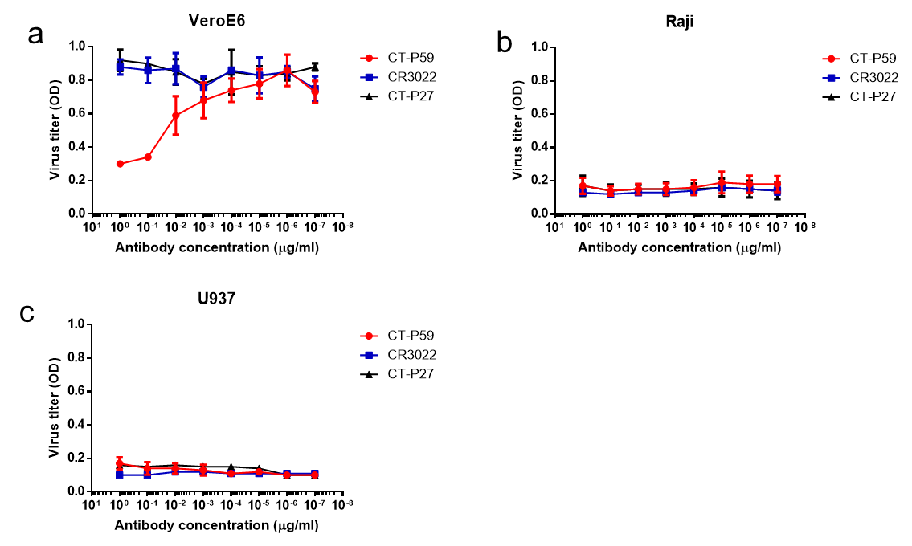

Extended Data Fig. 5 | No evidence of ADE caused by CT-P59 bound to SARS-CoV-2 in permissive cells and Fc receptor (FcR)-bearing cells. a, FcR-independent ADE. SARS-CoV-2 was mixed with a wide range of antibodies; CT-P59 (red circle), CR3022 (blue square) and CT-P27 (black triangle). VeroE6 were infected with virus-antibody complex. The virus titers were determined by optical density (OD) using anti-nucleocapsid antibody. b, FcγR II-dependent ADE. In vitro ADE assay was performed as described in (a) except Raji cells. c, FcγR I&II-dependent ADE. In vitro ADE assay was carried out as described in (a) except U937 cells. The experiments were performed in triplicates (CR3022 and CT-P27) or in quadriplicates (CT-P59). Average and standard deviation of virus titers were depicted as dot and error bar, respectively.

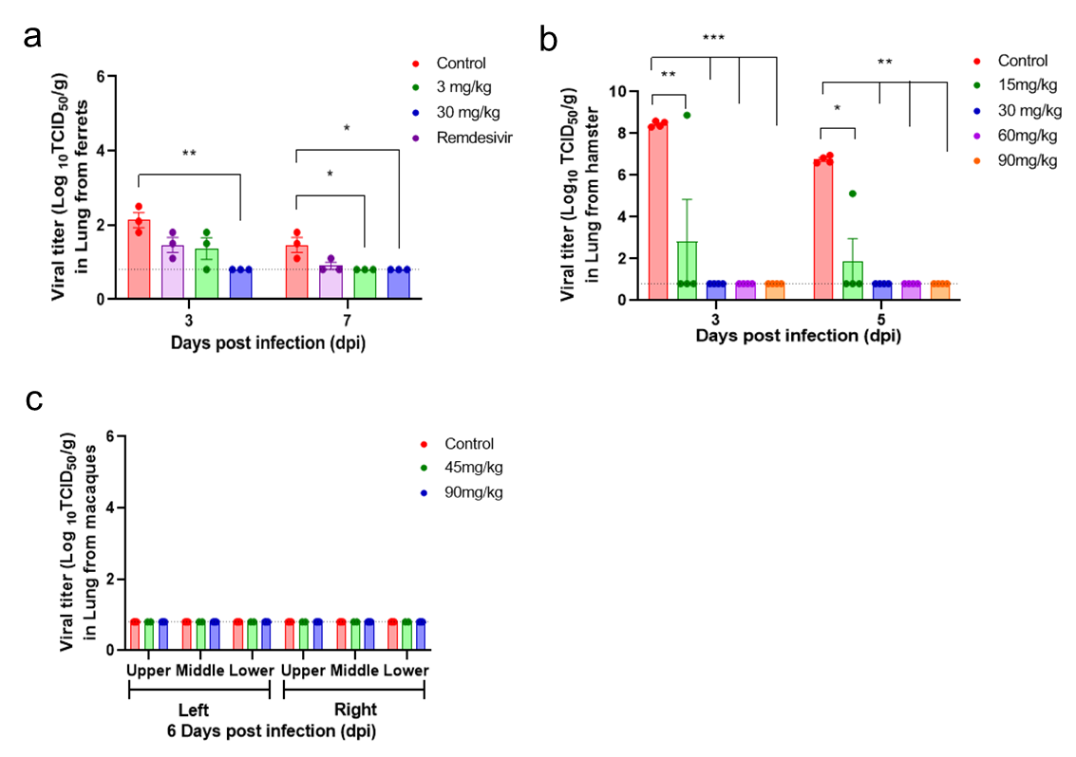

Extended Data Fig. 6 | Viral titers in lungs of animal models. a, Ferrets (n=6/group) were challenged with SARS-CoV-2 intranasally and intratracheally. Vehicle, 3, or 30 mg/kg of CT-P59 were administered intravenously 24 hours after virus inoculation. Remdesivir (18 mg/kg per ferret) was administered daily via oral gavage. Three ferrets per group were euthanized at 3 and 7 dpi, and viral titers in lungs were determined. b, Golden Syrian hamsters (n=12/group) were intranasally challenged with SARS-CoV-2. Vehicle and 15, 30, 60 and 90 mg/kg of CT-P59 were intraperitoneally administered 24 hours after virus inoculation. Four animals were sacrificed for virus titration from each group at 3, and 5 dpi. c, rhesus monkeys (control n=3, 45 mg/kg n=2, 90 mg/kg n=3) and 10^{6.4} TCID₅₀ of SARS-CoV-2 via in a combination of intranasal, intratracheal, ocular and oral routes. Vehicle, 45 mg/kg and 90 mg/kg of CT-P59 were administered intravenously after 24 hours of virus inoculation. All rhesus monkeys were euthanized at 6 dpi and viral titers in lung were determined by TCID₅₀. Viral titers are shown as means ± SEM and titers below the limit of detection are shown as 0.8 log₁₀TCID₅₀/ml (dashed lines). Asterisks indicate statistical significance between the control and each group as determined by two-way ANOVA and subsequent Dunnett’s test. (* indicates P < 0.05, ** indicates P < 0.01, *** indicates P < 0.001 and **** indicates P < 0.0001).
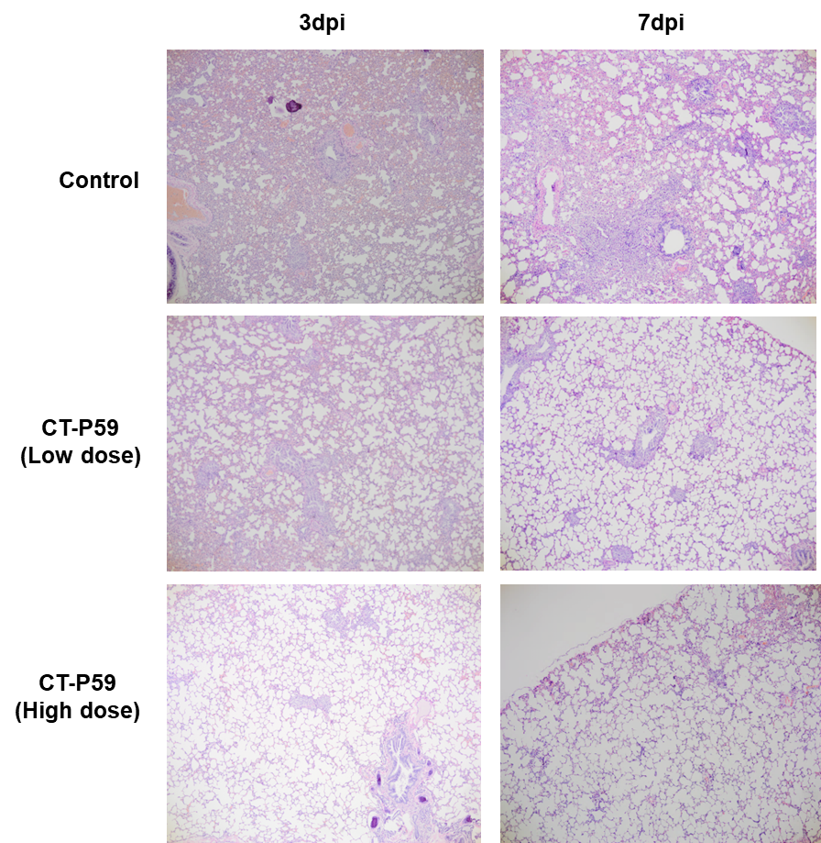

Extended Data Fig. 7 | H&E-stained sections of animal lung. Ferrets (n=6/group) were challenged with 10^{5.5} TCID₅₀/ml of SARS-CoV-2 via, intranasal and intratracheal routes (total 1 mL). Vehicle, 3, or 30 mg/kg of CT-P59 were administered intravenously 24 hours after virus inoculation. Three ferrets per group were euthanized at 3 and 7 dpi, and lungs were collected to identify histopathology.

