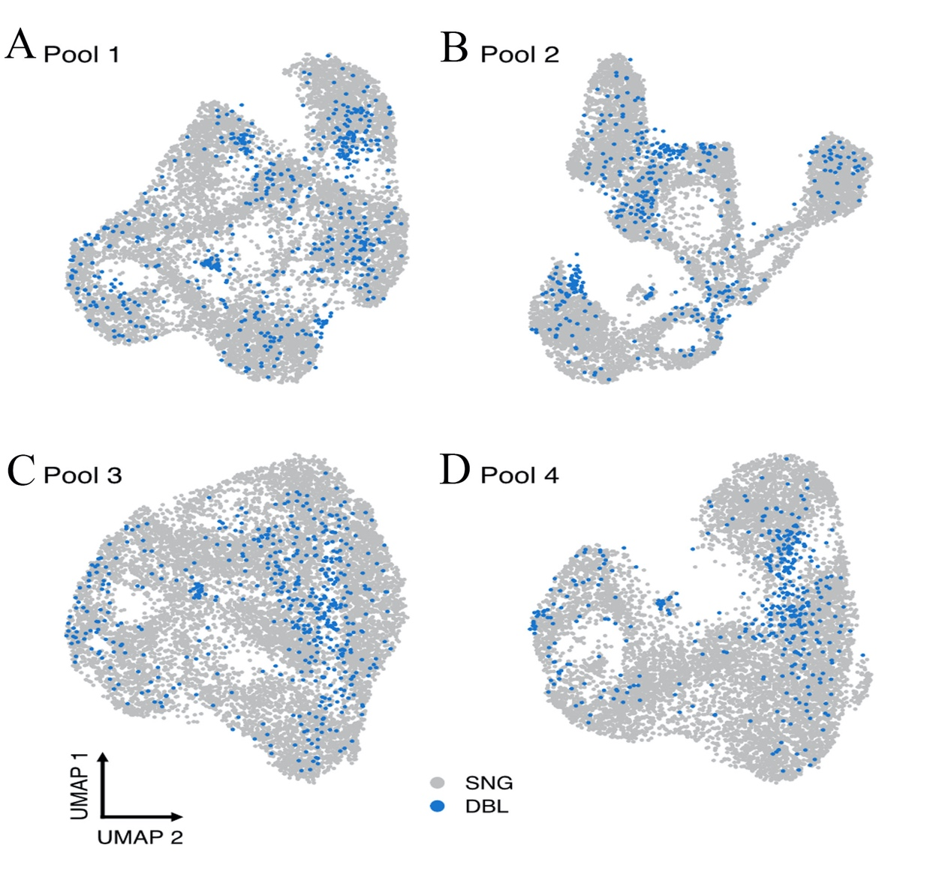
Supplementary Figure 1: Identification of singlets and doublets in scRNA-seq data. UMAP plots of all cells in the scRNA-seq experiment coloured by singlet and doublet status as determined via Demuxlet. Doublets were randomly spread between each pool. (A) Pool 1, (B) Pool 2, (C) Pool 3 and (D) Pool 4. Doublets were subsequently removed from downstream analysis. SNG = Singlet; DBL = Doublets.

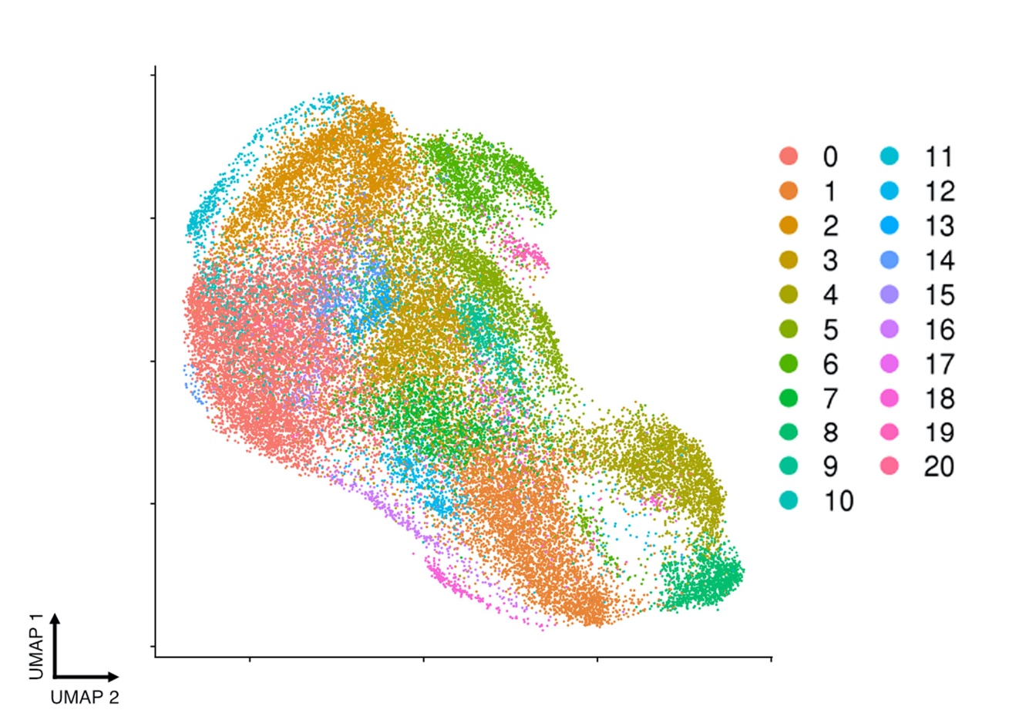
Supplementary Figure 2: Bioinformatic clustering of mesenchymal derived cells at increasingly finer resolution. Using the clustree software cell clusters can be defined at various levels of resolution. We examined the clusters created when resolution was defined at various levels, subsequently selecting a 0.6 resolution for subsequent analysis. Additional resolutions at 1.0 shows the increasing number of clusters that can be identified as resolution is increased.

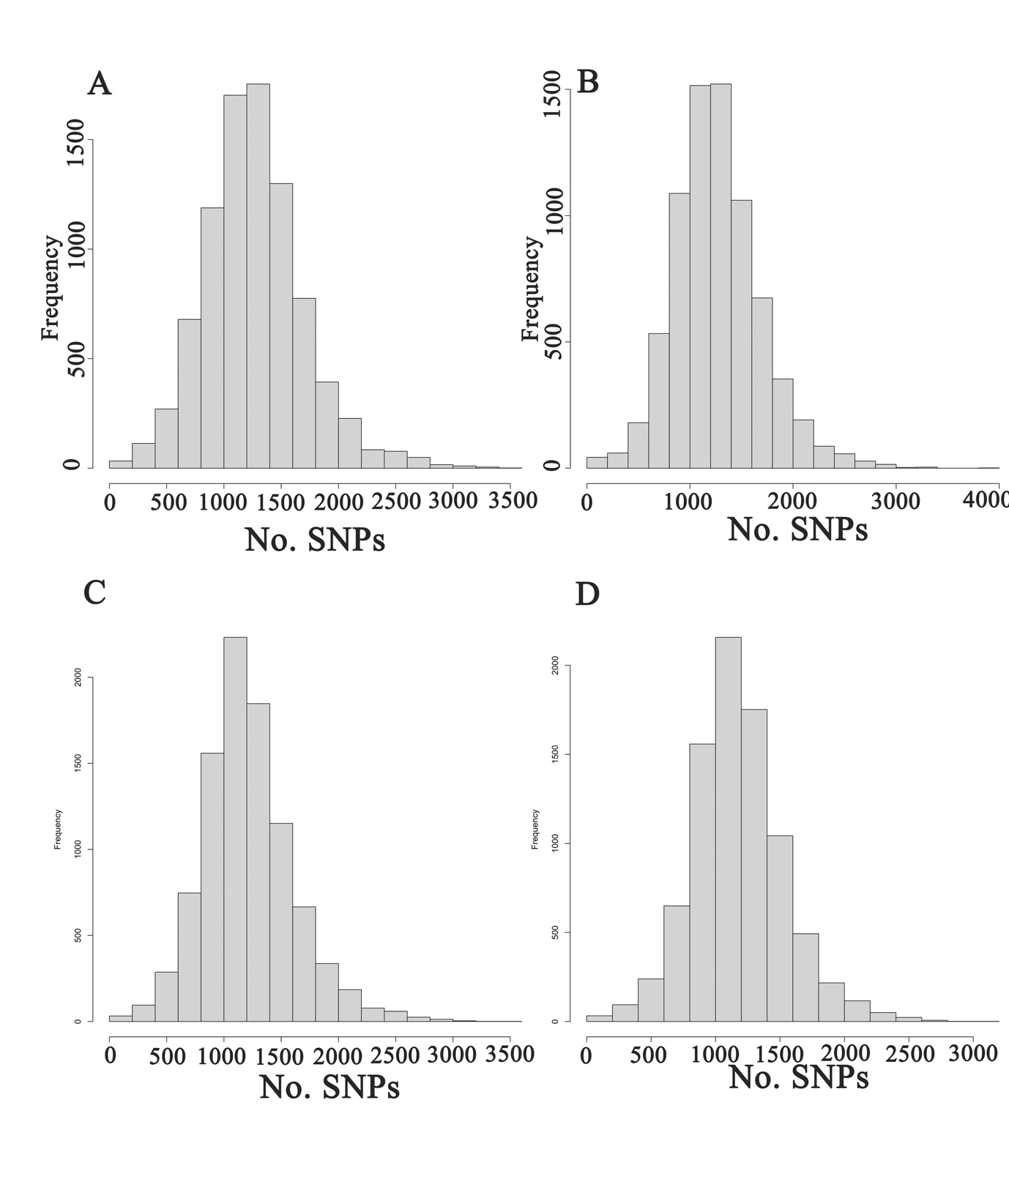
Supplementary Figure 3: Using genotyping information to identify individuals in each pool. Using genotype data generated from GSA chips SNPs were aligned against the scRNA-seq data using the Demuxlet software. The number of SNPs ranged from 13 – 3,970 SNPs/cell with the average number being (A) 1,264 SNPs/cell for pool 1, (B) 1,270 SNPs/cell for pool 2, (C) 1,213 SNPs/cell for pool 3 and (D) 1,176 SNPs/cell for pool 4.

