Supplementary information

Band-gap-tunable carbon quantum dots for surface-enhanced Raman scattering
Menglin Ning^{1#}, Zhuohan Jing^{1#}, Haolin Chen^{2#}, Kaili Xie¹, Yu Su¹, Jiaqi Liu¹, Dantong Shen², Jieyi Chen¹, Biwen Yang¹, Zhouyi Guo¹, Bo Xu² and Zhiming Liu^{1*}
¹ MOE Key Laboratory of Laser Life Science & Guangdong Provincial Key Laboratory of Laser Life Science, College of Biophotonics, School of Optoelectronic Science and Engineering, South China Normal University, Guangzhou 510631, PR China
² Department of Anesthesiology, General Hospital of Southern Theater Command of People’s Liberation Army, Guangzhou 510010, China
# These authors contributed equally to this work.
* Corresponding author:
E-mail addresses: liuzm021@126.com (Z. Liu)

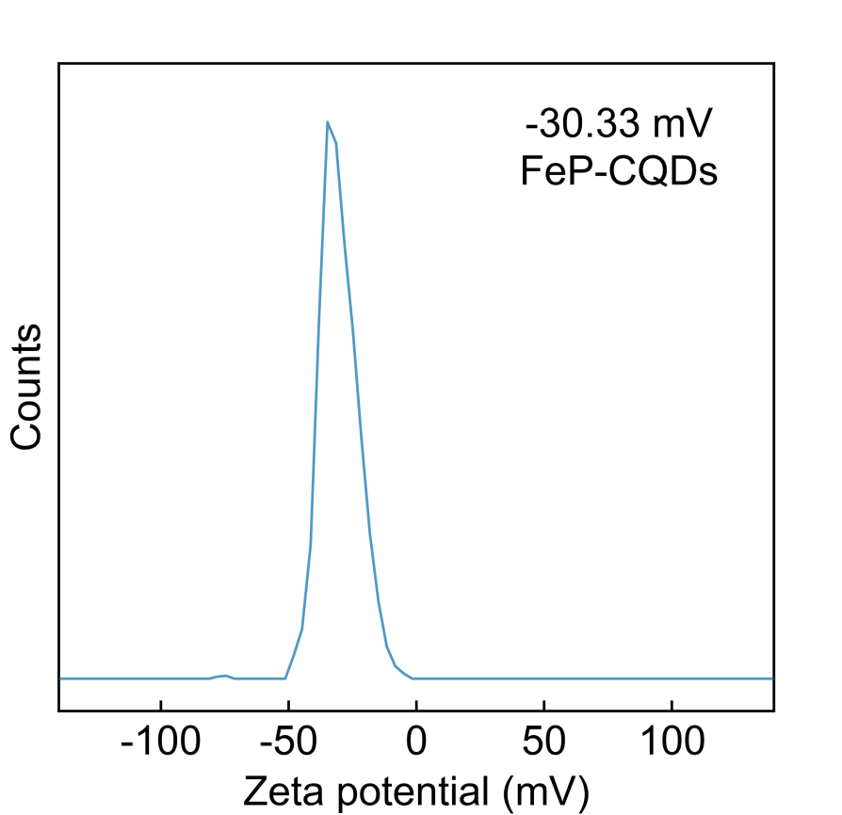
Fig. S1 The zeta potential of FeP-CQDs.
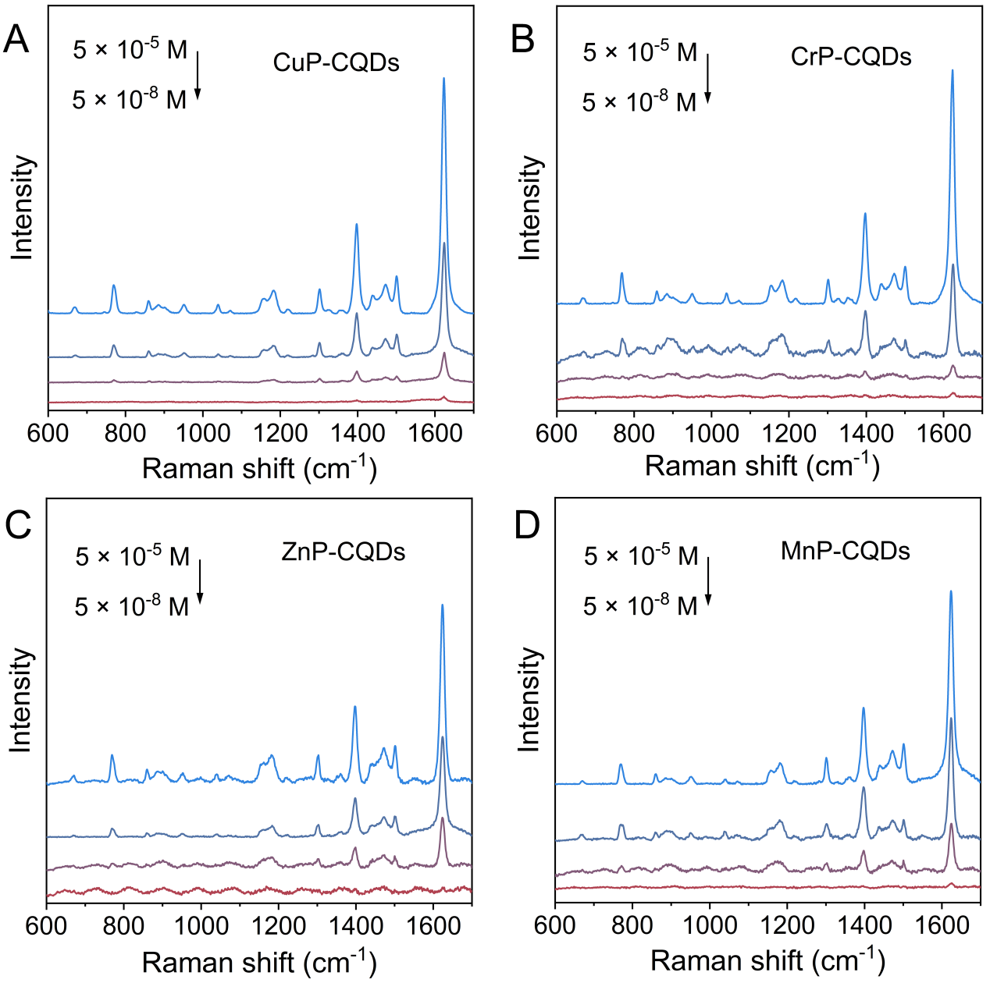
Fig. S2 SERS performance of other MPN-CQDs under 633 nm laser excitation. (A) CuP-CQDs, (B) CrP-CQDs, (C) ZnP-CQDs, and (D) MnP-CQDs.
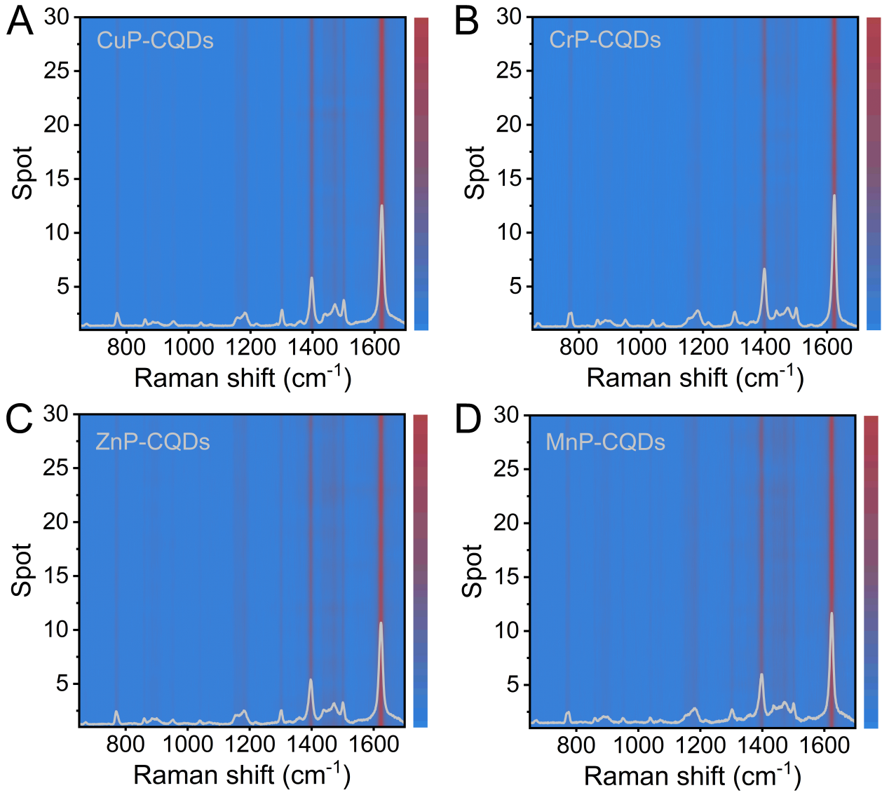
Fig. S3 SERS reproducibility of other MPN-CQDs. (A) CuP-CQDs, (B) CrP-CQDs, (C) ZnP-CQDs, and (D) MnP-CQDs. The SERS spectral maps of MB were constructed by plotting 30 random spectral lines.

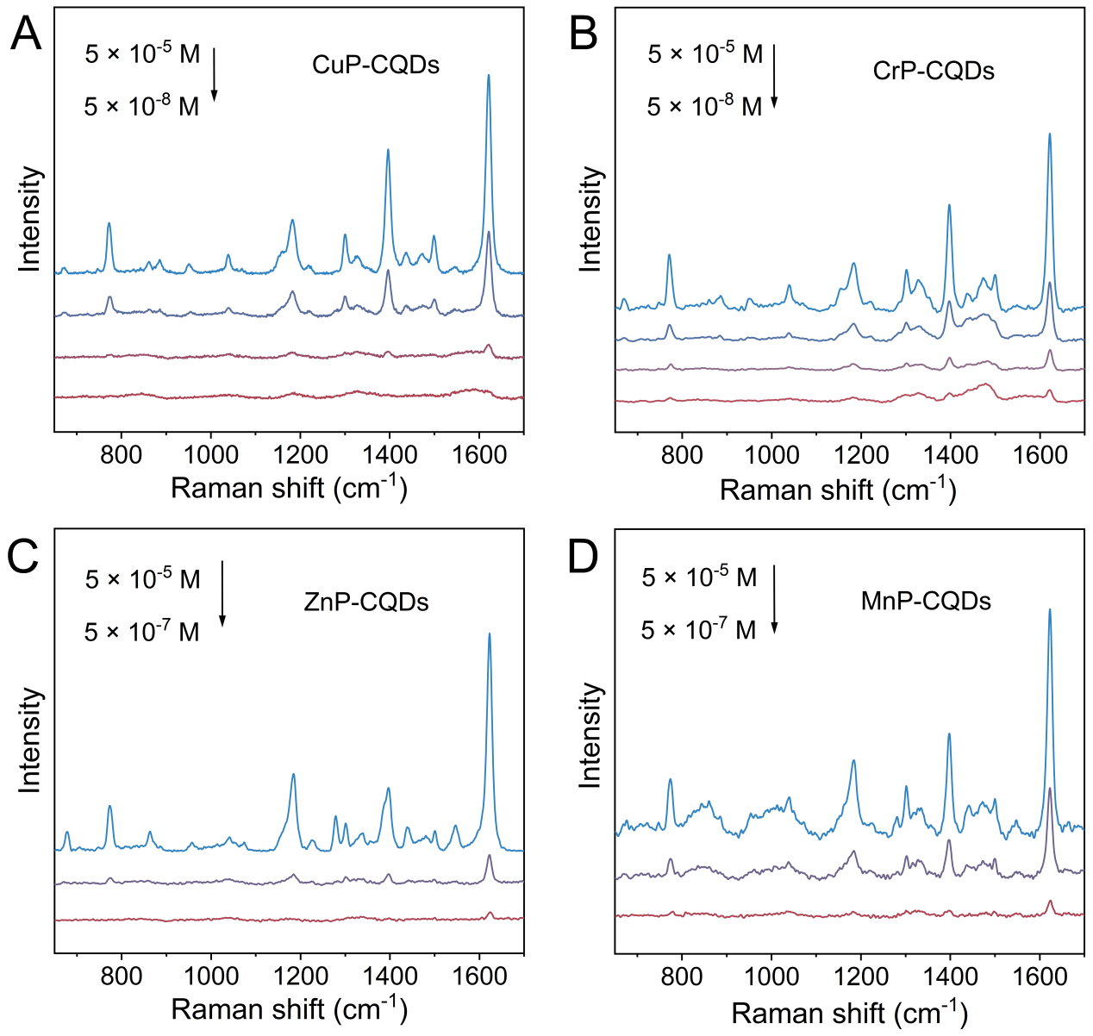
Fig. S4 SERS performance of other MPN-CQDs under 785 nm laser excitation. (A) CuP-CQDs, (B) CrP-CQDs, (C) ZnP-CQDs, and (D) MnP-CQDs.

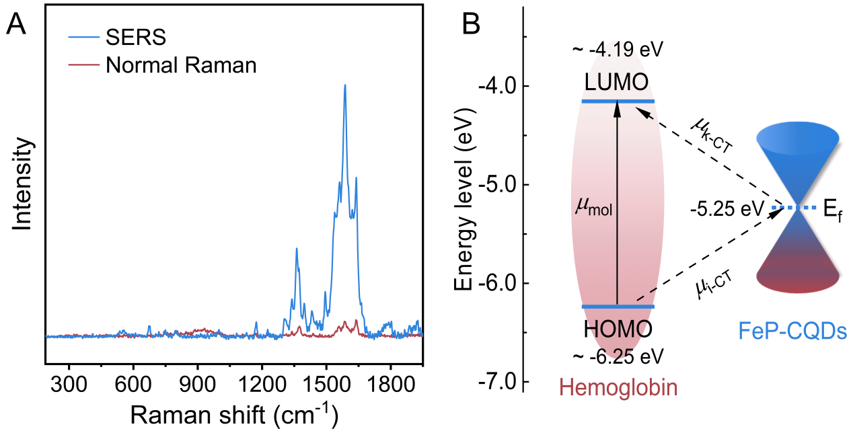
Fig. S5 SERS activity of FeP-CQDs on bovine Hb. (A) The Raman spectra of 1 mg/mL bovine Hb before and after deposited on FeP-CQDs under 514.5 nm laser excitation, respectively. (B) Schematic illustration of the charge transfer process between bovine Hb and FeP-CQDs.

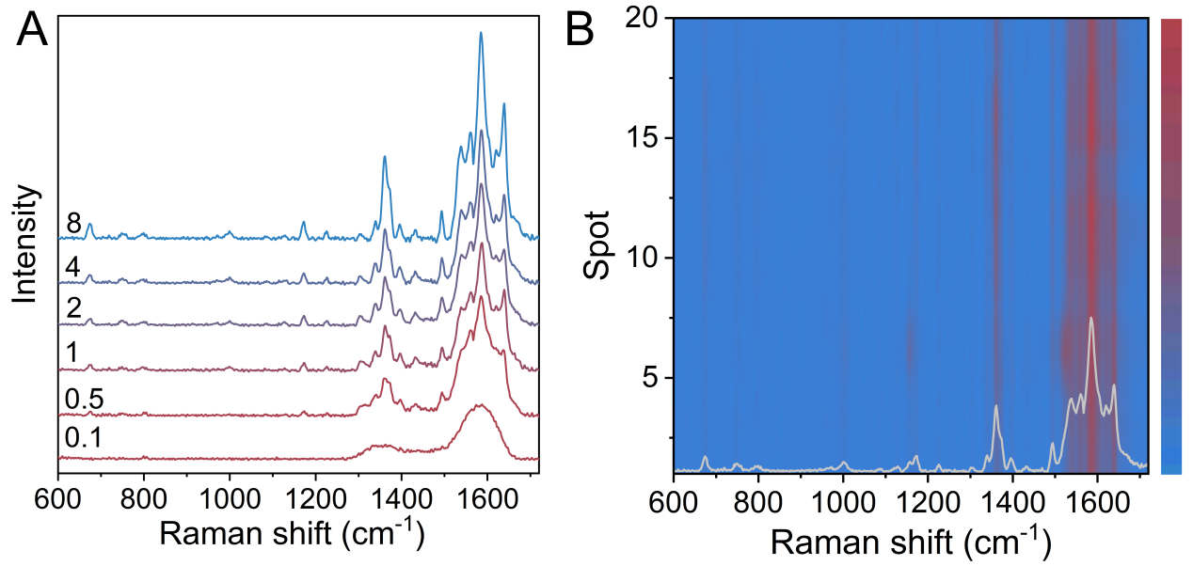
Fig. S6 Detection of bovine Hb based on FeP-CQDs. (A) Concentration-dependent SERS spectra of bovine Hb on FeP-CQDs under 514.5 nm laser. (B) SERS spectral map of bovine Hb plotted by 20 random spectral lines.

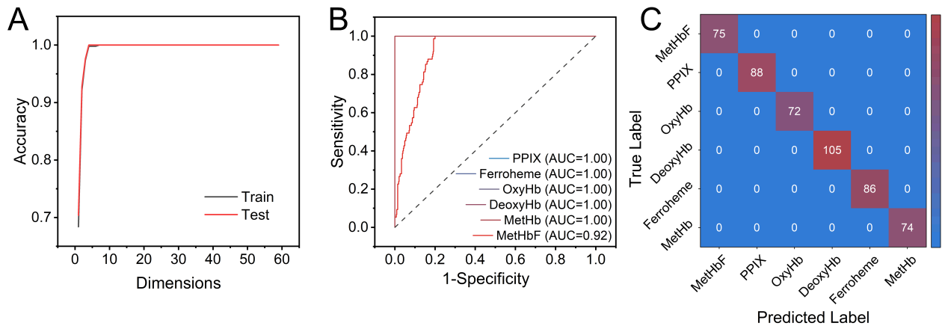
Fig. S7 The outcomes of PCA-LDA algorithm using the training set. (A) The accuracies of training and testing curves using PCA-LDA algorithm for the SERS data. Relationship between the output dimensions of PCA and the accuracy of the PCA - LDA classification model; (B) ROC curves and corresponding AUCs of the training set; (C) Confusion matrix of the training set.

Table S1 Tentative assignments of the SERS bands of bovine Hb induced by FeP-CQDs
Raman shift (cm⁻¹) | Reported results (cm⁻¹) |  | Band assignment
1637(m) | Low spin: 1640-1644 |  | v(C_{ɑ}C_{m})_{asym}
1586(s) | 1583 |  | v(C_{ɑ}C_{m})_{asym}
1539(w) | 1544 |  | v(C_{β}C_{β})
1493(w) | 1501 |  | v(C_{ɑ}C_{m})_{sym}
1359(m) | Deoxy-Mb: 1355-1362 |  | v(pyr half-ring)_{sym}
1170(w) |  | 1169 | v(pyr half-ring)_{asym}
674(w) |  | 674 | δ(pyr deform)_{sym}

