Supplementary data
Supplementary Figure 1.
Supplementary figure 1. The expression of EGFL6 in different types of cancer. (A) EGFL6 expression data in TIMER2.0 database. (B) Comparison of EGFL6 expression levels across 33 different cancer types. (C) EGFL6 expression levels in 16 paired cancer types.

Supplementary figure 2.
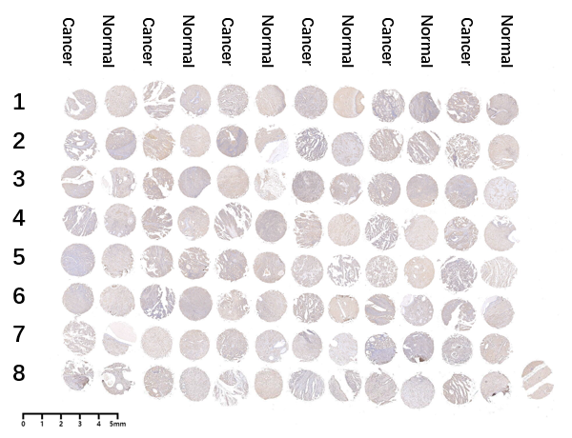
Supplementary figure 2. Tissue microarray analysis of EGFL6 expression in UCEC.

Supplementary Figure 3.
Supplementary figure 3. Analysis of EGFL6 mutation in UCEC. (A) The mutation profile of EGFL6 in UCEC. (B) Evaluation of Overall Survival (OS) in relation to the mutation status of EGFL6. (C) Assessment of Disease-Specific Survival (DSS) with respect to EGFL6 mutation status. (D) Analysis of Disease-Free Survival (DFS) in correlation with the mutation status of EGFL6. (E) Examination of Progression-Free Interval (PFI) associated with mutations in EGFL6.

Supplementary Figure 4.
Supplementary figure 4. Immune infiltration analysis of EGFL6 expression in UCEC across various immune cell types. (A) Activated dendric cells. (B) CD4+ T cells (resting). (C) M2 macrophages. (D) Relationship between EGFL6 and activated dendric cells. (E) Correlation between EGFL6 expression and resting CD4 memory T cells. (F) Association between EGFL6 expression and M2 macrophages.

Supplementary Figure 5.
Supplementary Figure 5. The relationship between the expression levels EGFL6 expression and unfavorable prognosis across various types of cancer. (A) Analysis of overall survival. (B) Analysis of disease specific survival. (C) Analysis of progression free interval. (D) ROC curve for EGFL6 in BLCA. (E) ROC curve for EGFL6 in HNSC. (F) ROC curve for EGFL6 in PAAD. (G) ROC curve for EGFL6 in KIRC. (H) ROC curve for EGFL6 in KIRP. (I) ROC curve for EGFL6 in LIHC.
Supplementary Table 1a. Univariate and multivariate Cox regression analysis of EGFL6 in OS in UCEC.
Characteristics | Total | Univariate |  | Multivariate
Characteristics | Total | HR (95% CI) | P | HR (95% CI) | P
Clinical stage | 553 | 8.082 (4.497 - 14.524) | < 0.001 | 2.840 (0.775 - 10.409) | 0.115
Age | 551 | 1.850 (1.162 - 2.944) | 0.009 | 1.863 (0.865 - 4.010) | 0.112
Primary therapy outcome | 482 | 0.110 (0.060 - 0.204) | < 0.001 | 0.233 (0.072 - 0.753) | 0.015
Residual tumor | 414 | 5.547 (2.889 - 10.649) | < 0.001 | 1.900 (0.575 - 6.277) | 0.292
Histological type | 553 | 0.379 (0.252 - 0.571) | < 0.001 | 0.633 (0.282 - 1.419) | 0.267
Histologic grade | 542 | 13.303 (3.262 - 54.242) | < 0.001 | 8.741 (1.109 - 68.869) | 0.040
Radiation therapy | 529 | 0.596 (0.387 - 0.919) | 0.019 | 0.393 (0.197 - 0.785) | 0.008
Tumor invasion(%) | 475 | 2.825 (1.752 - 4.554) | < 0.001 | 1.215 (0.597 - 2.472) | 0.591
EGFL6 | 553 | 1.187 (1.062 - 1.326) | 0.002 | 0.896 (0.738 - 1.089) | 0.271

Supplementary Table 1b. Univariate and multivariate Cox rtegression analysis of EGFL6 in DSS in UCEC.
Characteristics | Total | Univariate |  | Multivariate
Characteristics | Total | HR (95% CI) | P | HR (95% CI) | P
Age | 549 | 1.217 (0.725 - 2.045) | 0.457
Clinical stage | 551 | 16.848 (8.290 - 34.238) | < 0.001 | 3.882 (0.723 - 20.839) | 0.114
Primary therapy outcome | 482 | 0.062 (0.032 - 0.120) | < 0.001 | 0.114 (0.029 - 0.441) | 0.002
Histological type | 551 | 0.279 (0.170 - 0.459) | < 0.001 | 0.451 (0.176 - 1.159) | 0.098
Residual tumor | 414 | 9.474 (4.744 - 18.921) | < 0.001 | 2.531 (0.642 - 9.979) | 0.185
Tumor invasion(%) | 475 | 3.296 (1.808 - 6.011) | < 0.001 | 0.793 (0.302 - 2.087) | 0.639
Radiation therapy | 527 | 0.601 (0.353 - 1.026) | 0.062 | 0.329 (0.124 - 0.871) | 0.025
EGFL6 | 551 | 1.253 (1.099 - 1.429) | < 0.001 | 0.928 (0.728 - 1.183) | 0.546

Supplementary Table 1c. Univariate and multivariate Cox regression analysis of EGFL6 in PFI in UCEC.
Characteristics | Total | Univariate |  | Multivariate
Characteristics | Total | HR (95% CI) | P | HR (95% CI) | P
Age | 551 | 1.356 (0.936 - 1.966) | 0.107
Clinical stage | 553 | 6.852 (4.093 - 11.471) | < 0.001 | 5.073 (1.829 - 14.068) | 0.002
Primary therapy outcome | 482 | 0.059 (0.035 - 0.098) | < 0.001 | 0.064 (0.023 - 0.176) | < 0.001
Histological type | 553 | 0.472 (0.332 - 0.672) | < 0.001 | 0.291 (0.147 - 0.575) | < 0.001
Residual tumor | 414 | 5.235 (2.835 - 9.669) | < 0.001 | 0.713 (0.234 - 2.170) | 0.552
Tumor invasion(%) | 475 | 1.897 (1.298 - 2.773) | < 0.001 | 1.265 (0.699 - 2.290) | 0.437
Radiation therapy | 529 | 1.102 (0.776 - 1.566) | 0.588
Histologic grade | 542 | 3.304 (1.720 - 6.345) | < 0.001 | 1.273 (0.446 - 3.636) | 0.652
EGFL6 | 553 | 1.087 (0.986 - 1.197) | 0.093 | 0.851 (0.721 - 1.005) | 0.057

