Supplementary Appendix
The Effects of Arts-Based Interventions in the Treatment and Management of Non-Communicable Diseases: An Umbrella Review and Meta-Analysis.

Contents
Supplementary material 1: Definition of Non-Communicable Diseases 4
Supplementary material 2: PRIOR checklist 5
Supplementary material 3: Specialized search query for databases 7
Supplementary material 4: NCD population table 10
Supplementary material 5: Characteristics of included systematic reviews 12
Supplementary material 6: List of excluded systematic reviews 26
5a. List of excluded reviews and reason for exclusion 26
6b: List of reviews excluded from analysis and reason for exclusion 31
Supplementary material 7: Assessment of review quality AMSTAR 2 32
Summary plot of assessment items of AMSTAR-2 for all SRs 32
AMSTAR-2 ratings for each review 33
Supplementary material 8: Forest Plots 40
Cancer 40
Cardiovascular Diseases 41
Chronic Respiratory Diseases 42
Mental Health Conditions 43
Neurological conditions 44
Supplementary material 9: Subgroup analyses 47
Cancer 47
Cardiovascular Diseases 48
Chronic Respiratory Diseases 50
Mental Health 50
Neurological Conditions 52
Supplementary material 10: Funnel plots 54
Overall 54
Cancer 55
Cardiovascular Diseases 55
Mental Health Conditions 56
Neurological Conditions 56
Supplementary material 11: Video examples of arts-based interventions 57
References 59

Supplementary material 1: Definition of Non-Communicable Diseases
This review includes noncommunicable diseases (NCD) as defined by the NCD alliance and the WHO and includes:
Cancer: “Cancer is a term used for a group of diseases that can affect any part of the body. These are also known as malignant tumours and neoplasms. Cancer is characterized by rapid abnormal cell growth, which then spreads to other parts of the body via a process called metastasis. A major cause of cancer death is when these abnormal cells form lumps in our vital organs.”¹
Cardiovascular disease (CVD): “Cardiovascular disease is a class of diseases that affect the heart and blood vessels (veins and arteries). They are usually caused by fatty deposits that build up inside the arteries and result in an increased risk of blood clots, but can also be linked to damage in the arteries of organs like the brain, heart, kidneys and eyes. Strokes can be caused by bleeding from a blood vessel in the brain or from blood clots.”²
Chronic respiratory diseases (CRD): “Chronic respiratory diseases (CRDs) are diseases of the airways and other structures of the lung, and are among the leading causes of morbidity and mortality worldwide. Some of the most common chronic respiratory diseases are chronic obstructive pulmonary disease (COPD), asthma, lung cancer, and occupational lung diseases.”³
Diabetes: “Diabetes is a chronic disease that occurs when the pancreas is no longer able to make insulin, or when the body cannot make good use of the insulin it produces. Insulin is a hormone made by the pancreas, that acts like a key to let glucose from the food we eat pass from the blood stream into the cells in the body to produce energy.”⁴
Mental health and neurological conditions: “Mental health conditions and neurological disorders are conditions that affect thoughts, emotions, behaviours, and relationships. These include disorders that cause a high burden of disease such as depression, bipolar affective disorder, schizophrenia, anxiety disorders, dementia, substance use disorders, among many others. These conditions can be experienced in isolation; however, they often occur alongside other noncommunicable diseases such as cardiovascular disease, diabetes, respiratory diseases and cancers.”⁵ In our review, we separated mental health from neurological conditions.

Supplementary material 2: PRIOR checklist
Gates M, Gates A, Pieper D, et al. Reporting guideline for overviews of reviews of healthcare interventions: development of the PRIOR statement. BMJ 2022;378:e070849. doi:10.1136/bmj-2022-070849.
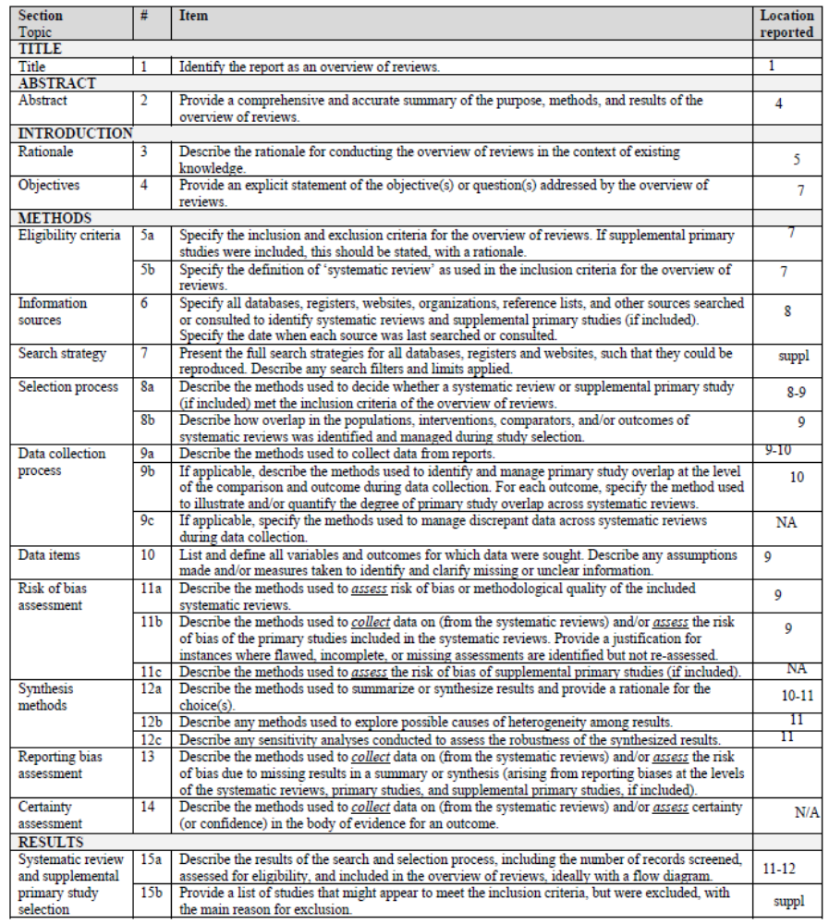
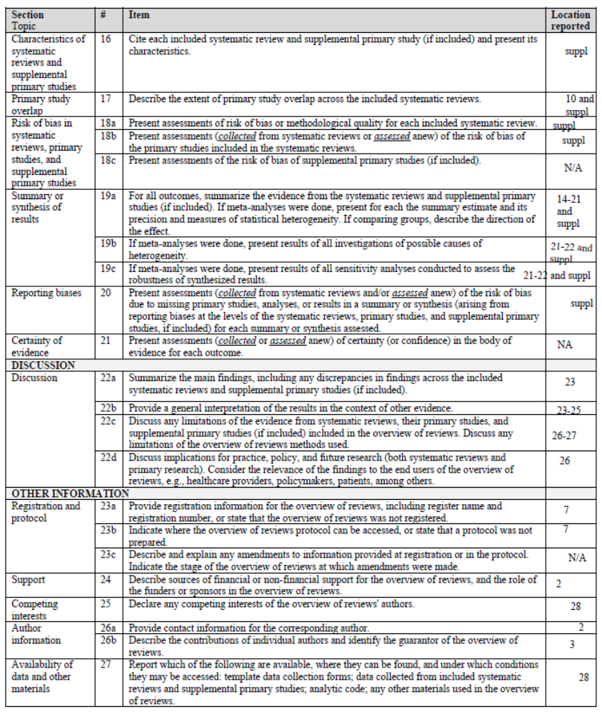

Supplementary material 3: Specialized search query for databases

CINAHL search string
S1 | MH "Art+" OR MH "Creative Arts Therapy+" OR TI(art OR arts OR artistic OR music* OR danc* OR drama OR dramatherapy OR bibliotherapy OR poetry OR (therapeutic N1 theat*)) OR AB(art OR arts OR artistic OR music* OR danc* OR drama OR dramatherapy OR bibliotherapy OR poetry OR (therapeutic N1 theat*)) OR SU(art OR arts OR artistic OR music* OR danc* OR drama OR dramatherapy OR bibliotherapy OR poetry OR (therapeutic N1 theat*))
S2 | MH "Meta Analysis" OR ZT "meta analysis" OR TI((Meta N2 analy*) OR metaanaly*) OR AB((Meta N2 analy*) OR metaanaly*) OR SU((Meta N2 analy*) OR metaanaly*)
S3 | S1 AND S2
S4 | MH "Antiretroviral Therapy, Highly Active" OR TX (antiretroviral OR "anti-retroviral" OR (assisted N0 reproduct* N0 (treatment OR technolog*)) OR (accelerated N0 resolution N0 therapy) OR (“anti-retro” N0 viral N0 therap*) OR (Atraumatic N1 Restorat* N1 Treatment*) OR (accelerated N1 resolution N1 therapy) OR "martial art*")
S5 | S3 NOT S4

Cochrane Database of Systematic Reviews search string
#1 | (art OR arts OR artistic OR music OR dance OR drama OR dramatherapy OR bibliotherapy OR poetry OR (therapeutic NEAR/1 theat*)):ti,kw
#2 | (antiretroviral OR "anti-retroviral" OR ((assisted OR artificial) NEAR/1 reproduct* NEAR/1 (techn* OR treat*)) OR "accelerated resolution therapy" OR ("anti-retro viral" NEAR/1 therap*) OR (Atraumatic NEAR/1 Restorat* NEAR/1 Treatment*) OR (accelerated NEAR/1 resolution NEAR/1 therap*) OR "State of the art" OR "martial art" OR "martial arts" OR "State of art" OR "art no" OR "the art of"):ti,ab,kw
#3 | #1 NOT #2
 | Cochrane Reviews

Embase (Elsevier) search string
#1 | 'art therapy'/exp OR 'dance therapy'/exp OR 'bibliotherapy'/exp OR 'drama therapy'/exp OR 'music therapy'/exp OR 'play therapy'/exp OR (art OR arts OR artistic OR music OR dance OR drama OR dramatherapy OR bibliotherapy OR poetry OR (therapeutic NEAR/1 theat*)):ti,ab,kw
#2 | 'meta analysis'/exp OR ((Meta NEAR/2 analy*) OR metaanaly*):ti,ab,kw,it
#3 | #1 AND #2
#4 | 'antiretroviral therapy'/exp OR 'atraumatic restorative treatment'/exp OR (antiretroviral OR anti-retroviral OR "assisted reproductive treat*" OR (assisted NEAR/1 reproduct* NEAR/1 technolog*) OR "accelerated resolution therapy" OR "anti-retro viral therap*" OR (Atraumatic NEAR/1 Restorat* NEAR/1 Treatment*) OR (accelerated NEAR/1 resolution NEAR/1 therapy) OR "State of the art" OR "martial art*" OR "State of art" OR "art no" OR "the art of"):ti,ab,kw
#5 | #3 NOT #4

Medline (EBSCO) search string
S1 | MH "Art+" OR MH "Sensory Art Therapies" OR MH "Play Therapy" OR MH "Music Therapy" OR MH "Dance Therapy" OR MH "Art Therapy" OR TI(art OR arts OR artistic OR music* OR danc* OR drama OR dramatherapy OR bibliotherapy OR poetry OR (therapeutic N1 theat*)) OR AB(art OR arts OR artistic OR music* OR danc* OR drama OR dramatherapy OR bibliotherapy OR poetry OR (therapeutic N1 theat*)) OR SU(art OR arts OR artistic OR music* OR danc* OR drama OR dramatherapy OR bibliotherapy OR poetry OR (therapeutic N1 theat*))
S2 | MH "Meta-Analysis as Topic+" OR ZT "meta analysis" OR TI((Meta N2 analy*) OR metaanaly*) OR AB((Meta N2 analy*) OR metaanaly*) OR SU((Meta N2 analy*) OR metaanaly*)
S3 | S1 AND S2
S4 | MH "Antiretroviral Therapy, Highly Active" OR MH "Martial Arts+" OR TX (antiretroviral OR "anti-retroviral" OR (assisted N0 reproduct* N0 (treatment OR technolog*)) OR (accelerated N0 resolution N0 therapy) OR (“anti-retro” N0 viral N0 therap*) OR (Atraumatic N1 Restorat* N1 Treatment*) OR (accelerated N1 resolution N1 therapy) OR "martial art*")
S5 | S3 NOT S4

PsycInfo (EBSCO) search string
S1 | DE "Art" OR DE "Crafts" OR DE "Drawing" OR DE "Painting (Art)" OR DE "Photographic Art" OR DE "Sculpturing" OR DE "Arts" OR DE "Dance" OR DE "Improvisation" OR DE "Music" OR DE "Theatre" OR DE "Drama" OR DE "Creative Arts Therapy" OR DE "Art Therapy" OR DE "Dance Therapy" OR DE "Music Therapy" OR DE "Psychodrama" OR DE "Play Therapy" OR DE "Poetry" OR DE "Poetry Therapy" OR DE "Creative Writing" OR DE "Bibliotherapy" OR DE "Expressive Psychotherapy" OR TI(art OR arts OR artistic OR music* OR danc* OR drama OR dramatherapy OR bibliotherapy OR poetry OR (therapeutic N1 theat*)) OR AB(art OR arts OR artistic OR music* OR danc* OR drama OR dramatherapy OR bibliotherapy OR poetry OR (therapeutic N1 theat*)) OR SU(art OR arts OR artistic OR music* OR danc* OR drama OR dramatherapy OR bibliotherapy OR poetry OR (therapeutic N1 theat*))
S2 | DE "Meta Analysis" OR TI((Meta N2 analy*) OR metaanaly*) OR AB((Meta N2 analy*) OR metaanaly*) OR SU((Meta N2 analy*) OR metaanaly*)
S3 | S1 AND S2
S4 | DE "Antiretroviral Drugs" OR DE "Martial Arts" OR TX (antiretroviral OR "anti-retroviral" OR (assisted N0 reproduct* N0 (treatment OR technolog*)) OR (accelerated N0 resolution N0 therapy) OR (“anti-retro” N0 viral N0 therap*) OR (Atraumatic N1 Restorat* N1 Treatment*) OR (accelerated N1 resolution N1 therapy) OR "martial art*")
S5 | S3 NOT S4

Web of Science search string
#1 | TS=(art OR arts OR artistic OR music OR dance OR drama OR dramatherapy OR bibliotherapy OR poetry OR (therapeutic NEAR/1 theat*))
#2 | TS=((Meta NEAR/2 analy*) OR metaanaly*)
#3 | #1 AND #2
#4 | TS=(antiretroviral OR anti-retroviral OR ((assisted OR artificial) NEAR/1 reproduct* NEAR/1 (techn* OR treat*)) OR "accelerated resolution therapy" OR "anti-retro viral therap*" OR (Atraumatic NEAR/1 Restorat* NEAR/1 Treatment*) OR (accelerated NEAR/1 resolution NEAR/1 therapy) OR "martial art*")
#5 | #3 NOT #4

Supplementary material 4: NCD population table
NCD Population | Types of illness and disorders included across reviews
Cancer | - Breast  - Cancer patients receiving chemotherapy  - Gynecological  - Hematological  - Lung  - Mixed cancer populations
Cardiovascular | - Cardiac procedure (e.g. catheterization)  - Cardiac surgery  - Coronary heart disease  - Chronic heart failure  - Hypertension  - Post-stroke  - Stroke
Diabetes | - N/A
Mental health disorders | - Anxiety  - Clinical stress disorder  - Clinical Depression  - Non-clinical depression  - Postpartum depression  - Psychiatric disorder  - Psychotic disorder  - Schizophrenia  - Substance use disorders  - Trauma  - Mixed mental health populations
Neurological disorders | - Alzheimer’s disease  - Autism spectrum disorder  - Cerebral palsy  - Dementia  - Down syndrome  - Intellectual disability  - Mild and moderate cognitive impairment  - Mild and major neurocognitive disorder  - Multiple sclerosis  - Parkinson’s disease  - Traumatic brain injury
Chronic respiratory disorders | - Chronic lung disease  - Chronic obstructive pulmonary disease

Supplementary material 5: Characteristics of included systematic reviews

Author/Year | Countryª | Search dates | Design | No. of Studies | Population | Modality/ Intervention type | Outcome domain | Specific outcome | Quality  (AMSTAR 2) | Funding
CANCER
*Bradt 2021⁶ | USA | Inception-April 2020 | RCTs, CCTs | 81 |  | Music/Mixed | Psychological, Physical, QoL | Mood, depression, anxiety, fatigue, physical functioning, pain, HR, RR, SBP, DBP, O2-sat, QoL | High | Yes
*Bradt 2015⁷ | USA | Inception-July 2014 | RCTs, CCTs | 3 |  | Dance/CAT | Psychological, Physical | Depression, stress, anxiety, fatigue, body image | High | No
*Bro 2018⁸ | Denmark | Inception – Sept 2016 | RCTs | 25 |  | Music/Mixed | Psychological, Physical, QoL | Nausea, anxiety, mood, pain, depression, fatigue, distress, QoL | Low | Yes
*Cheng 2021⁹ | China | Inception-May 2020 | RCTs | 19 | Breast, gynecological | Mixed/Mixed | Psychological, Physical, QoL | QoL, anxiety, depression, pain, fatigue, sleep disturbance, anger, vigor, tension, confusion, stress | Low | Yes
*da Silva Santa 2021¹⁰ | Brazil | Inception-2020 | RCTs, CCTs | 11 |  | Music/Mixed | Psychological, Physical, QoL | Pain, anxiety, QoL, HR | Moderate | NR
*Geng, 2023¹¹ | China | Inception-March 2023 | RCTs | 32 | Breast | Dance/AATI | Psychological | Depressive symptoms | High | Yes
*Hung, 2018¹² | Taiwan | Inception-2016 | RCTs | 12 |  | Music/Mixed | Physical | Pain relief | Low | NR
*Jiang 2020¹³ | China | Inception-August 2019 | RCTs, CCTs | 12 |  | Art/Mixed | Psychological, Physical, QoL | QoL, anxiety, depression, fatigue | Low | Yes
*Jiang 2023¹⁴ | China | Inception-December 2022 | RCTs | 14 | Lung cancer | Music/Mixed | Physical | Sleep quality | Critically low | NR
*Köhler 2020¹⁵ | Germany | Inception-February 2019 | RCTs, CCTs | 30 |  | Music/CAT | Psychological, Physical, QoL | Psychological well-being, QoL, physical symptom distress | Moderate | Yes
*Li 2020¹⁶ | China | Inception-September 2018 | RCTs | 19 |  | Music/Mixed | Psychological, Physical, QoL | QoL, anxiety, depression, pain | Low | Yes
*Nelson 2023¹⁷ | Ireland | Inception-October 2022 | RCTs, CCTs | 18 |  | Dance/AATI | Psychological, Physical, QoL | Functional capacity, fatigue, QoL, depression | Critically low | Yes
*Nguyen 2022¹⁸ | China | Inception-December 2020 | RCTs | 9 |  | Music/Mixed | Psychological, QoL | Anxiety, depression, QoL | Moderate | NR
Nightingale 2013¹⁹ | USA | Inception-2011 | RCTs | 13 |  | Music/Mixed | Psychological | Anxiety | Low | No
*Puetz 2013²⁰ | USA | Inception-January 2012 | RCTs | 27 |  | Mixed/Mixed | Psychological, Physical, QoL | Anxiety, depression, pain, cancer-related fatigue, QoL | Critically low | NR
*Qi 2021²¹ | China | Inception-June 2020 | RCTs | 8 |  | Music/Mixed | Physical | Cancer-related fatigue | Moderate | Yes
Sezgin 2022²² | Turkey | Inception-August 2021 | RCTs | 6 | Hematological | Music/CAT | Physical | Fatigue | Low | NR
*Tang 2019²³ | China | Inception-July 2017 | RCTs | 9 | Breast | Mixed/Mixed | Psychological | Anxiety, depression | Critically low | NR
*Tsai 2014²⁴ | Taiwan | 2002-2012 | RCTs, CCTs | 21 |  | Music/Mixed | Psychological, Physical | Anxiety, depression, pain, fatigue | Low | No
*Wang 2018²⁵ | China | Inception-September 2017 | RCTs | 30 | Breast | Music/AATI | Psychological, Physical | DBP, HR, anxiety, depression, SBP | Low | NR
*Wei 2020²⁶ | China | Inception-November 2019 | RCTs | 10 | Chemotherapy patients | Music/AATI | Physical | Acute nausea, acute vomiting, delayed nausea, delayed vomiting | Low | NR
*Xia 2023²⁷ | China | Inception-April 2022 | RCTs, CCTs | 13 |  | Art/Mixed | Psychological, Physical, QoL | Anxiety, depression, fatigue, QoL | Moderate | NR
*Xu 2020²⁸ | China | Inception-December 2019 | RCTs, CCTs | 9 | Breast | Mixed/Mixed | Psychological | Anxiety, depression | Critically low | Yes
*Yang 2021²⁹ | China | Inception-December 2020 | RCTs | 22 |  | Music/AATI | Psychological, Physical, QoL | Anxiety, depression, QoL, sleep quality, functional impairment | Low | Yes
*Yangöz 2019³⁰ | Turkey | Inception-2018 | RCTs | 6 |  | Music/Mixed | Physical | Cancer-related pain | Low | No
Zhang 2012³¹ | China | Inception-March 2011 | RCTs | 32 |  | Music/Mixed | Psychological, Physical, QoL | Anxiety, depression, pain, fatigue, HR, RR, SBP, DBP, QoL | Low | NR
*Zhang 2015³² | China | Inception-November 2014 | RCTs | 7 | Breast; mixed | Art/Mixed | Psychological | Anxiety, depression | Low | Yes
*Zhang 2023³³ | China | Inception-May 2023 | RCTs | 10 |  | Poetry/AATI | Psychological | Anxiety | Moderate | Yes
CARDIOVASCULAR
*Bradt 2013³⁴ | USA | Inception-2012 | RCTs, CCTs | 26 | CHD | Music/Mixed | Psychological, Physical | Psychological distress, anxiety, depression, mood, HR, HR variability, RR, SBP, DBP, MAP, O2-sat, pain, Sleep quality | High | Yes
*Cao 2023³⁵ | China | Inception-October 2022 | RCTs | 20 | Hypertension | Music/AATI | Psychological, Physical | SBP, DBP, HR, anxiety, depression, sleep quality | Low | No
*Chan 2023³⁶ | Hong Kong | Inception-February 2022 | RCTs | 7 | Stroke | Art/Mixed | Psychological, Physical, QoL | Depressive symptoms, anxiety, activities of daily living, upper limb function, hand function | High | No
*Chandrababu 2021³⁷ | India | January 2000-December 2017 | RCTs | 14 | Cardiac surgery | Music/Mixed | Psychological, Physical | Anxiety, pain | Low | NR
*Conceição 2016³⁸ | Brazil | Inception-February 2016 | RCTs | 4 | hypertension | Dance/Mixed | Physical | SBP, DBP, exercise capacity | Critically low | NR
*Dayuan 2022³⁹ | China | Inception-October 2022 | RCTs | 20 | Post-stroke | Music/AATI | Psychological, Physical, QoL | Depression, stroke-related impairment, ADLs | Critically low | Yes
*do Amaral 2016⁴⁰ | Brazil | Inception-February 2016 | RCTs | 3 | Hypertension | Music/AATI | Physical | SBP, DBP | Low | NR
*Gomes Neto 2014⁴¹ | Brazil | Inception-August 2013 | RCTs | 2 | Chronic heart failure | Dance/AATI | Physical, QoL | Exercise capacity, QoL | Critically low | No
*Jayakar 2017⁴² | Canada | Inception-May 2015 | RCTs | 15 | Cardiac catheterization | Music/AATI | Psychological | Anxiety | Low | NR
*Kakar 2021⁴³ | Netherlands | January 1992-October 2019 | RCTs, CCTs | 20 | Cardiac surgery | Music/Mixed | Psychological, Physical | SBP, DBP, HR, RR, MAP, postop anxiety, postop pain, O2-sat | Moderate | No
*Lee 2021⁴⁴ | USA | January 2000-August 2018 | RCTs | 22 | Post-stroke | Music/CAT | Psychological | Depressive symptoms | Low | Yes
*Liu 2022⁴⁵ | China | Inception-March 2021 | RCTs | 6 | Post-stroke | Music/Mixed | Cognitive | Functional communication, comprehension, repetition, naming | Moderate | NR
*Liu 2023⁴⁶ | China | Inception-April 2021 | RCTs | 42 | Cardiac surgery | Music/AATI | Psychological, Physical | Pain intensity, anxiety | Low | Yes
*Magee 2017⁴⁷ | Australia | Inception-January 2016 | RCTs, CCTs | 29 | Stroke | Music/Mixed | Physical, Cognitive, QoL | Communication, gait velocity, stride length, general gait, gait cadence, timing of upper extremity, balance, QoL | High | Yes
*Peng 2021⁴⁸ | China | Inception-March 2020 | RCTs | 5 | Hypertension | Dance/Mixed | Physical | SBP, DBP | Moderate | NR
*Roche Bueno 2019⁴⁹ | Spain | Inception-September 2018 | RCTs, CCTs | 6 | Post-stroke | Music/AATI | Physical | Functionality of the upper limb | Low | NR
*Su 2021⁵⁰ | Taiwan | 1966-January 2019 | RCTs, CCTs | 10 | Coronary procedure | Music/Mixed | Psychological, Physical | Anxiety, discomfort, pain, HR, SBP, DBP | Low | Yes
*Wang 2020⁵¹ | China | Inception-June 2019 | RCTs | 14 | Cardiac Procedure | Music/AATI | Physical | Pain, HR, RR, SBP, DBP | Low | Yes
*Wang 2022⁵² | China | Inception-July 2022 | RCTs | 22 | Stroke | Music/Mixed | Physical | Step length, cadence, velocity, overall motor function, balance | Moderate | NR
*Yang 2019⁵³ | China | Inception-May 2018 | RCTs | 6 | Post-stroke | Music/AATI | Cognitive | Auditory comprehension, repetition, spontaneous speech, speak aloud, reading, naming, language function | High | Yes
*Yoo 2016⁵⁴ | Korea | 1990-December 2014 | RCTs, CCTs | 10 | Stroke | Music/Mixed | Physical | Gait velocity, gait cadence, stride length, upper extremity function | Critically low | Yes
*Zhang 2016⁵⁵ | China | Inception-April 2016 | RCTs, CCTs | 10 | Post-stroke | Music/Mixed | Physical, Cognitive | Executive functions, upper-limb motor function, total motor function | Low | NR
DIABETES
*Yang 2021⁵⁶ | China | Inception-January 2021 | RCTs | 5 |  | Mixed/Mixed | Psychological, Physical | Depression, blood glucose, anxiety, glycated hemoglobin | Low | Yes
MENTAL HEALTH DISORDERS
*Aalbers 2017⁵⁷ | Norway | Inception-2017 | RCTs, CCTs | 9 | Depression, Anxiety | Music/Mixed | Psychological | Severity of depressive symptoms, anxiety | High | Yes
*Abbing 2023⁵⁸ | Netherlands | Inception-June 2020 | RCTs, CCTs | 23 |  | Mixed/CAT | Psychological, QoL | Antisocial behavior, psychiatric symptoms, social functioning, pschological functioning | Moderate | NR
*Atchison 2022⁵⁹ | Canada | Inception-March 2022 | RCTs | 80 | Anxiety | Music/Mixed | Psychological | Anxiety | Moderate | Yes
*Bighelli 2023⁶⁰ | Germany | Inception-September 2021 | RCTs | 58 | Schizophrenia | Mixed/Mixed | QoL | Daily functioning | Low | Yes
*Chen 2021⁶¹ | China | Inception-November 2018 | RCTs | 35 | Depression | Music/AATI | Psychological | Depression | Low | Yes
*de Witte 2022⁶² | The Netherlands | Inception-May 2019 | RCTs, CCTs | 47 |  | Music/CAT | Psychological | Stress-related outcomes | High | Yes
*Geipel 2018⁶³ | Germany | Inception-2015 | RCTs, CCTs | 5 | Anxiety, depression | Music/Mixed | QoL | Reducing internalising symptoms | Low | No
*Geretsegger 2017⁶⁴ | Norway | Inception-January 2015 | RCTs | 18 | Schizophrenia | Music/Mixed | Psychological, Cognitive, QoL | General mental state, negative symptoms, depression, general functioning; social functioning; cognitive abstract thinking; general behavior score | High | Yes
*Gerger 2022⁶⁵ | Netherlands | Inception-September 2020 | RCTs | 44 | Trauma | Poetry/AATI | Psychological | PTSD symptoms | High | NR
*Ghetti 2022⁶⁶ | Norway | Inception-February 2021 | RCTs | 21 | Substance use disorders | Music/CAT | Psychological | Depression, substance craving, motivation for treatment/ change, motivation to stay sober/clean | High | Yes
*Gold 2009⁶⁷ | Norway | Inception-May 2006 | RCTs, CCTs | 15 |  | Music/CAT | Psychological, Physical, QoL | Global state improvement, anxiety, positive symptoms, QoL, satisfaction | Low | Yes
*Guo 2020⁶⁸ | China | Inception-May 2019 | RCTs | 14 | Depression | Dance/AATI | Psychological | Depressive symptoms | Critically low | Yes
*Jenabi 2023⁶⁹ | Canada | Inception-February 2022 | RCTs, CCTs | 8 | Depression | Art/Mixed | Psychological | Depression | Critically low | Yes
*Jia 2020⁷⁰ | China | Inception-January 2020 | RCTs, CCTs | 18 | Schizophrenia | Music/Mixed | Psychological, QoL | Total symptoms, negative symptoms, positive symptoms, depression symptoms, QoL | Low | Yes
*Jiang 2023⁷¹ | Malaysia | December 2019-October 2022 | RCTs, CCTs | 25 | Mixed populations (only included mental health population in review) | Drama/Mixed | Psychological, Cognitive, QoL | Depression, anxiety, cognitive functioning, QoL, pyschological well-being, communication skills, self-regard | Moderate | No
*Karkou 2019⁷² | UK | Inception-March 2018 | RCTs, CCTs | 8 | Depression | Dance/CAT | Psychological | Depression | Low | NR
*Koch 2019⁷³ | Germany | January 2012-April 2018 | RCTs | 41 | Schizophrenia | Dance/Mixed | Psychological | Positive symptoms | Moderate | Yes
*Laws 2019⁷⁴ | UK | Inception-May 2019 | RCTs | 9 | Schizophrenia | Mixed/Mixed | Psychological | Total symptoms, positive symptoms, negative symptoms | Moderate | NR
*Lutgens 2017⁷⁵ | Canada | Inception-October 2015 | RCTs | 95 | Schizophrenia/psychotic disorder | Art/CAT | Psychological | Negative symptoms in psychosis | Critically low | Yes
Meekums 2015⁷⁶ | UK | 1950-2014 | RCTs | 3 | Depression | Dance/Mixed | Psychological | Depression score | High | Yes
*Orkibi 2023⁷⁷ | Israel | Inception-January 2021 | RCTs, CCTs | 30 | Mixed population | Psychodrama/CAT | Psychological | Mental health outcomes: feelings, thoughts, behavior | Low | NR
*Reinhold 2018⁷⁸ | Germany | 1986-September 2015 | RCTs | 39 | Clinical stress disorder, major depression | Poetry/AATI | Psychological | Depression | Low | NR
*Sabeena 2022⁷⁹ | India | 2001-2021 | RCTs, CCTs | 36 | Clinical & non-clinical depression | Art/Mixed | Psychological | Depression | Critically low | NR
*Steenhuis 2015⁸⁰ | The Netherlands | Inception-2015 | RCTs | 10 | Psychotic disorder | Music/Mixed | Psychological | Depressive symptoms | Low | Yes
*Tang 2020⁸¹ | China | Inception-2020 | RCTs | 55 |  | Music/Mixed | Psychological | Depression | Low | Yes
*Tseng 2016⁸² | Taiwan | Inception-September 2015 | RCTs, CCTs | 12 | Schizophrenia | Music/Mixed | Psychological | Total psychopathology, positive symptoms, negative symptoms, mood symptoms | Critically low | No
*Yan 2019⁸³ | China | Inception-March 2019 | RCTs | 12 | Depression | Music/AATI | Psychological, Physical | Depression, sleep quality | Moderate | Yes
*Yang 2019⁸⁴ | China | Inception-November 2018 | RCTs | 7 | postpartum depression | Music/AATI | Psychological | Depression, anxiety | Moderate | NR
*Yijing 2018⁸⁵ | China | NR | RCTs | 4 | Depression | Dance/Mixed | Psychological | Depression | Critically low | Yes
*Zhao 2016⁸⁶ | China | Inception-September 2014 | RCTs | 19 | Depression | Music/AATI | Psychological | Depressive symptoms | Critically low | Yes
NEUROLOGICAL DISORDERS
*Álvarez-Bueno 2023⁸⁷ | Spain | Inception-April 2021 | RCTs, CCTs | 56 | Parkinson’s | Dance/AATI | Physical | Motor symptoms | Low | Yes
*Barnish 2020⁸⁸ | UK | Inception-February 2020 | RCTs, CCTs | 56 | Parkinson’s | Dance/AATI | Physical, QoL | Motor function, mobility, QoL | Critically low | No
*Batubara 2023⁸⁹ | Indonesia | January 2001-August 2021 | RCTs, CCTs | 9 | Mild/major neurocognitive disorder | Art/AATI | Psychological, Cognitive, QoL | Depression, cognitive function, QoL | Low | No
*Bian 2021⁹⁰ | China | Inception-November 2020 | RCTs | 7 | Dementia | Music/AATI | Cognitive | Overall cognition | Low | Yes
*Burley 2022⁹¹ | Australia | 2012-2020 | RCTs, CCTs | 37 | Dementia | Music/Mixed | Psychological | Depression | Critically low | Yes
*Carapellotti 2020⁹² | UK | Inception-March 2020 | RCTs | 16 | Parkinson’s | Dance/AATI | Psychological, Physical, QoL | Motor impairment, balance, forward gait velocity, backward gait velocity, stride length, freezing of gait, endurance, mobility, QoL, depression | Low | Yes
*Chan 2020⁹³ | China | Inception-August 2019 | RCTs | 5 | MCI | Dance/AATI | Cognitive | Global cognition, attention, immediate recall, delayed recall, working memory, language, mental flexibility, visuospatial ability | Moderate | Yes
*Chang 2015⁹⁴ | Taiwan | 2000-February 2014 | RCTs | 10 | Dementia | Music/Mixed | Psychological, Cognitive | Disruptive behaviors, anxiety, depressive mood, cognitive functioning | Low | Yes
*Chen 2022⁹⁵ | China | Inception-January 2021 | RCTs, CCTs | 7 | Autism | Dance/Mixed | Psychological | Negative symptoms, empathy | Critically low | Yes
*de Almeida 2021⁹⁶ | Brazil | Inception-May 2019 | RCTs, CCTs | 11 | Parkinson’s | Dance/Mixed | Physical | Postural control | Critically low | NR
*de Dreu 2012⁹⁷ | Netherlands | Inception-August 2011 | RCTs | 6 | Parkinson’s | Mixed/Mixed | Physical | Balance, mobility, stride length, motor, walking velocity, freezing of gait | Critically low | NR
*Dorris 2021⁹⁸ | USA | Inception-March 2021 | RCTs | 21 | MCI or Dementia | Music/Mixed | Cognitive | Global cognitive functioning | Low | Yes
*dos Santos Delabary 2018⁹⁹ | Brazil | Inception-August 2017 | RCTs | 5 | Parkinson’s | Dance/AATI | Physical, QoL | Motor symptoms, functional mobility, freezing of gait, QoL, motor symptoms, endurance, gait velocity forward, gait velocity backward | Critically low | No
*Ernst 2024¹⁰⁰ | Germany | Inception-May 2021 | RCTs | 154 | Parkinson’s | Dance/Mixed | Physical, QoL | Severity of motor signs, QoL | High | Yes
*Fusar-Poli 2018¹⁰¹ | Italy | Inception-September 2016 | RCTs | 7 | Dementia | Music/Mixed | Cognitive | Global cognition, complex attention, language, learning and memory, perceptual motor function | Moderate | No
*Geretsegger 2022¹⁰² | Italy | Inception-August 2021 | RCTs, CCTs | 26 | Autism | Music/CAT | Psychological, Cognitive, QoL | Global improvement in symptoms, social interaction, non-verbal communication, verbal communication, QoL, total symptom severity, adaptive behavior, quality of family relationships, identity formation | High | Yes
*Ghai 2018¹⁰³ | Germany | Inception-December 2017 | RCTs, CCTs | 5 | Multiple sclerosis | Music/AATI | Physical | Gait, stride length, cadence, timed 25 ft. walking test | Low | Yes
*Ghai 2022¹⁰⁴ | Germany | 1970-March 2022 | RCTs, CCTs | 14 | Cerebral palsy | Music/Mixed | Physical | Gait speed, stride length, cadence, gross motor function—standing, gross motor function—walking | Low | Yes
*Goh 2023¹⁰⁵ | Australia | Inception-June 2021 | RCTs, CCTs | 65 | Parkinson’s | Dance/AATI | Physical | Freezing of gait | Moderate | Yes
*Hao 2022¹⁰⁶ | China | Inception-April 2022 | RCTs | 60 | Parkinson’s | Dance/Mixed | Physical | Motor symptoms, mobility, balance | Critically low | No
*Hasan 2022¹⁰⁷ | Germany | Inception-April 2020 | RCTs | 14 | Parkinson’s | Dance/Mixed | Psychological, Physical, Cognitive, QoL | Freezing of gait, endurance, forward velocity, backward velocity, balance, depressive symptoms, apathy, cognitive function, psychosocial, motor symptoms, timed up and go,  gait/walking velocity, executive functions | Low | No
*Hidalgo-Agudo 2020¹⁰⁸ | Spain | 2013-2017 | RCTs | 11 | Parkinson’s | Dance/AATI | Physical | Motor function, balance | Low | Yes
*Ismail 2021¹⁰⁹ | Malaysia | Inception-June 2021 | RCTs | 20 | Parkinson’s | Dance/AATI | Psychological, Physical, Cognitive, QoL | Non-motor experiences of daily living, motor experiences of daily living, motor symptoms, balance, freezing of gait, agility,  walking distance, cognitive function, depressive symptoms,  fatigue, QoL, forward velocity | Low | Yes
*Ito 2022¹¹⁰ | Japan | January 2000-April 2021 | RCTs | 19 | MCI and Dementia | Music/Mixed | Cognitive | General cognitive function, episodic memory, processing speed, executive function | Low | Yes
*Jin 2022¹¹¹ | China | Inception-August 2022 | RCTs | 107 | MCI or dementia | Music/CAT | Psychological | Depression, neuropsychiatric function | Moderate | Yes
*Kalyani 2019¹¹² | Australia | Inception-September 2017 | RCTs, CCTs | 27 | Parkinson’s | Dance/AATI | Physical, Cognitive | Gait velocity, endurance, global cognition, motor, freezing of gait, gait | Low | NR
*Ke 2022¹¹³ | China | Inception-October 2021 | RCTs | 8 | Autism | Music/CAT | Psychological, Cognitive | Symptom severity, social reactions, social adaptation, speech | Low | Yes
*Kim 2016¹¹⁴ | Korea | Inception-2014 | RCTs | 16 | Dementia | Music/Mixed | Psychological | Behavioral problems | Critically low | NR
*Kong 2015¹¹⁵ | Korea | Inception-October 2014 | RCTs | 10 | Dementia | Music/Mixed | Psychological | Agitation | Moderate | Yes
*Kwok 2016¹¹⁶ | Hong Kong | Inception-January 2016 | RCTs, CCTs | 10 | Parkinson’s | Dance/AATI | Physical | Postural instability | Critically low | No
*Lee 2023¹¹⁷ | Korea | Inception-June 2022 | RCTs, CCTs | 13 | Parkinson’s | Music/Mixed | Physical, Cognitive, QoL | Cadence, velocity, stride length, mobility, cognitive flexibility, inhibition, QoL | Moderate | No
*Li 2022¹¹⁸ | China | Inception-January 2021 | RCTs | 26 | Parkinson’s | Dance/Mixed | Physical | Physical function, functional mobility, balance, walking capacity | Critically low | Yes
*Liang 2019¹¹⁹ | China | Inception-October 2018 | RCTs | 31 | Dementia | Music/Mixed | Cognitive | Cognitive function | Moderate | Yes
*Liang 2018¹²⁰ | China | Inception-March 2017 | RCTs | 17 | MCI or Dementia | Music/Mixed | Cognitive | General cognitive function | Low | NR
Lorenzo-García 2023¹²¹ | Spain | Inception-January 2022 | RCTs | 48 | Parkinson’s | Dance/AATI | QoL | QoL | Low | NR
*Lötzke 2015¹²² | Germany | Inception-January 2015 | RCTs, CCTs | 13 | Parkinson’s | Dance/AATI | Physical | Motor severity, balance, gait, freezing of gait | Critically low | No
*Masika 2020¹²³ | China | Inception-September 2019 | RCTs, CCTs | 12 | MCI | Art/Mixed | Psychological | Depression, anxiety | Low | Yes
*May 2021¹²⁴ | Australia | Inception-February 2018 | RCTs, CCTs | 19 | Children with ASD, ID, Down’s syndrome | Dance/AATI | Physical | Balance | High | Yes
*Mazzarin 2017¹²⁵ | Brazil | Inception-April 2015 | RCTs, CCTs | 9 | Parkinson’s | Dance/AATI | Physical | Mobility, balance | Low | No
*Mishra 2021¹²⁶ | India | Inception-August 2020 | RCTs, CCTs | 6 | TBI | Music/Mixed | Physical, Cognitive | Gait velocity, gait cadence, stride length, memory, executive function | Low | NR
*Moreno-Morales 2020¹²⁷ | Spain | 1990-2020 | RCTs | 8 | Dementia | Music/Mixed | Psychological, Cognitive, QoL | Cognitive function, QoL, depressive state | Low | NR
*Mustafaoglu 2022¹²⁸ | USA | Inception-December 2021 | RCTs | 60 | Parkinson’s | Dance/AATI | Physical, QoL | Improving functional mobility, balance performance, motor function, gait speed, health-related QoL | Moderate | No
*Na 2019¹²⁹ | Korea | Inception-April 2017 | RCTs, CCTs | 23 | Dementia | Music/Mixed | Psychological, Cognitive | Behavioral and psychological, cognitive function | Moderate | Yes
*Pedersen 2017¹³⁰ | Norway | Inception-February 2016 | RCTs | 12 | Dementia | Music/Mixed | Psychological | Agitation | Critically low | NR
*Radder 2020¹³¹ | Netherlands | Inception-June 2020 | RCTs | 191 | Parkinson’s | Dance/AATI | Physical | Motor symptoms, balance, gait outcomes | Critically low | Yes
*Sharp 2014¹³² | UK | Inception-January 2014 | RCTs | 5 | Parkinson’s | Dance/AATI | Physical, QoL | Motor, balance, freezing of gait, velocity, endurance, QoL | Moderate | No
*Shi 2016¹³³ | China | August 2000-August 2015 | RCTs | 6 | Children with ASD | Music/Mixed | Psychological, Cognitive | Mood, social skills, behavior, sensory perception, language | Critically low | NR
*Simpkins 2023¹³⁴ | USA | Inception-June 2022 | RCTs | 14 | Parkinson’s | Dance/Mixed | Physical | Improving balance | Low | NR
*Tang 2019¹³⁵ | China | Inception-March 2019 | RCTs, CCTs | 19 | Parkinson’s | Dance/AATI | Physical, QoL | Motor symptoms, daily living, risk for a fall, balance | Critically low | No
*Tsoi 2018¹³⁶ | China | Inception-September 2017 | RCTs, CCTs | 38 | Dementia | Music/Mixed | Psychological, Cognitive | Cognitive function, apathy, depressive symptoms, agitation, behavioral problems | Low | NR
*Ueda 2013¹³⁷ | Japan | 1973-2011 | RCTs, CCTs | 20 | Dementia | Music/Mixed | Psychological, Cognitive | Anxiety, behavioral symptoms of dementia, depression | Low | NR
*van der Steen 2017¹³⁸ | Netherlands | Inception-June 2017 | RCTs | 17 | Dementia | Music/Mixed | Psychological, Cognitive, QoL | Cognition, emotional well-being, depression, anxiety, agitation or aggression, overall behavioral problems, generalized verbal communicative skills,  cognition, social behavior,  non-generalized verbal communicative skills | High | Yes
*Wang 2020¹³⁹ | China | Inception-February 2019 | RCTs | 25 | MCI | Music/AATI | Cognitive | Cognitive function | Moderate | NR
*Wang 2021¹⁴⁰ | China | Inception-May 2021 | RCTs | 14 | Parkinson’s | Dance/Mixed | Cognitive | Global cognitive function | Critically low | NR
*Wang 2022¹⁴¹ | China | 1970-March 2021 | RCTs | 5 | MCI and Dementia | Dance/Mixed | Psychological | Depression | Moderate | NR
*Wang 2022¹⁴² | China | Inception-February 2021 | RCTs | 19 | Parkinson’s | Music/Mixed | Physical, QoL | Cadence, velocity, step length, stride length, endurance, mobility, ADLs, overall motor function, balance | Low | NR
*Wang 2020¹⁴³ | China | January 2000-December 2017 | RCTs | 15 | Alzheimer’s | Music/Mixed | Cognitive, QoL | Cognitive function, ADLs | Low | NR
*Wang 2023¹⁴⁴ | China | Inception-2022 | RCTs | 39 | Mild-moderate cognitive impairment | Mixed/Mixed | Cognitive | Cognitive function | Low | Yes
*Wei 2020¹⁴⁵ | China | August 1998-August 2018 | RCTs | 25 | Alzheimer’s | Music/AATI | Cognitive | Global cognition | Critically low | Yes
*Wong 2022¹⁴⁶ | China | January 2010-December 2019 | RCTs | 9 | Dementia | Music/Mixed | Psychological, Cognitive | Cognitive function, neuropsychiatric symptoms | Critically low | NR
*Wu 2021¹⁴⁷ | China | Inception-April 2020 | RCTs | 52 | Parkinson’s | Dance/Mixed | Physical | Motor outcomes, balance, TUG outcome, BBS outcome | Moderate | Yes
*Yang 2019¹⁴⁸ | China | Inception-February 2018 | RCTs | 13 | Dementia | Music/Mixed | Psychological, Cognitive, QoL | behavioral problems, cognitive function, QoL, anxiety, depression | Critically low | Yes
*Yang 2022¹⁴⁹ | China | Inception-June 2022 | RCTs | 250 | Parkinson’s | Dance/AATI | Psychological, Physical, Cognitive | Depression, balance, gait velocity, walking distance, freezing of gait, cognition | Moderate | Yes
*Ye 2022¹⁵⁰ | China | January 2000-August 2021 | RCTs | 18 | Parkinson’s | Music/Mixed | Psychological, Physical, QoL | Stride length, stride duration, speed, step frequency, swing, mobility, balance, fear of falling, freezing of gait, ADL, general motor function, QoL | Low | NR
*Zhang 2019¹⁵¹ | China | Inception-December 2018 | RCTs | 7 | Parkinson’s | Dance/AATI | Psychological, Cognitive | Global cognitive function, executive function, depression, apathy | Low | No
*Zhang 2017¹⁵² | China | Inception-September 2016 | RCTs, CCTs | 34 | Dementia | Music/Mixed | Psychological, Cognitive, QoL | disruptive behavior, cognitive function, depression, anxiety, QoL | Moderate | NR
*Zhou 2021¹⁵³ | China | Inception-December 2020 | RCTs | 17 | Parkinson’s | Mixed/Mixed | Psychological, Physical, QoL | Motor function, balance, gait cadence, stride length, freezing of gait, walking velocity, mental health, QoL | Low | Yes
*Zhu 2020¹⁵⁴ | China | Inception-February 2019 | RCTs | 5 | MCI | Dance/AATI | Cognitive | Global cognition, executive function, verbal fluency, immediate recall ability, delayed recall ability | Low | Yes
CHRONIC RESPIRATORY DISORDERS
*Huang 2021¹⁵⁵ | China | Inception-June 2019 | RCTs | 12 | COPD | Music/AATI | Psychological, Physical, QoL | QoL, dyspnea, anxiety, depression, breathing frequency, SBP, DBP | Low | NR
*Kim 2021¹⁵⁶ | Korea | 1990-August 2020 | RCTs | 3 | Chronic lung disease | Music/Mixed | Physical | Forced expiratory volume, Forced vital capacity, maximal inspiratory pressure, maximal expiratory pressure | Low | NR
*Lee 2015¹⁵⁷ | Canada | Inception-June 2014 | RCTs, CCTs | 13 | COPD | Music/AATI | Physical | Exercise capacity | Moderate | None
*McNamara 2017¹⁵⁸ | Australia | Inception-August 2017 | RCTs | 3 | COPD | Music/AATI | Psychological, Physical, QoL | Health-related QoL-respiratory specific, health-related QoL-generic, anxiety, depression, peak exercise capacity | High | Yes
MORE THAN ONE NCD POPULATION
*Nyssen 2016¹⁵⁹ | UK | Inception-January 2015 | RCTs, CCTs | 64 | Cancer, Psychiatric disorders | Poetry/AATI | Psychological, Physical | Positive mood, negative mood, depression, anxiety, lung function | Low | Yes

CAT: creative arts therapies; AATI: arts with therapeutic intent; TBI: traumatic brain injury; ADLs: Activities of Daily Life; DBP: Diastolic Blood Pressure; HR: Heart Rate; MAP: Mean Arterial pressure; MCI: Mild Cognitive Impairment; O2-sat: Oxygen Saturation; Postop: Postoperative; QoL: quality of life; RR: Respiratory Rate; SBP: Systolic Blood pressure;
ª country of the lead author of the review
*denotes that the review contributed data to the meta-analyses of one or more of the listed outcomes

Supplementary material 6: List of excluded systematic reviews

5a. List of excluded reviews and reason for exclusion

Author | Reason for exclusion
Ab Shukor 2021¹⁶⁰ | Wrong population
Abdelhakim 2019¹⁶¹ | Wrong population
Apodaca 2003¹⁶² | Wrong intervention
Auliya 2022¹⁶³ | Wrong population
Bai 2022¹⁶⁴ | Wrong population
Bausewein 2013¹⁶⁵ | Wrong study design
Bechtold 2009¹⁶⁶ | Wrong population
Bieleninik 2016¹⁶⁷ | Wrong population
Boehm 2014¹⁶⁸ | Issues with quantitative data
Bradt 2013¹⁶⁹ | Wrong population
Bradt 2014¹⁷⁰ | Wrong population
Bradt 2014¹⁷¹ | Wrong population
Burrai 2020¹⁷² | Wrong population
Campbell 2010¹⁷³ | Wrong publication type
Castañeda-Babarro 2020¹⁷⁴ | Wrong population
Castro 2015¹⁷⁵ | Wrong publication type
Chae 2021¹⁷⁶ | Issues with quantitative data
Chan 2010¹⁷⁷ | Wrong population
Chen 2016¹⁷⁸ | Wrong population
Chen 2020¹⁷⁹ | Wrong intervention
Chen 2021¹⁸⁰ | Wrong population
Cheng 2021¹⁸¹ | Wrong population
Chow 2023¹⁸² | Wrong study design
Chuang 2019¹⁸³ | Wrong population
Clark 2012¹⁸⁴ | Wrong population
Cooper 2020¹⁸⁵ | Wrong population
Corbijn van Willenswaard 2017¹⁸⁶ | Wrong population
Cuijpers 1997¹⁸⁷ | Wrong intervention
Dale 2021¹⁸⁸ | Wrong population
Dastgheib 2014¹⁸⁹ | Wrong study design
de Niet 2009¹⁹⁰ | Wrong population
De Silva 2013¹⁹¹ | Issues with quantitative data
de Witte 2020¹⁹² | Wrong population
Delfa-Lobato 2021¹⁹³ | Wrong population
Deshmukh 2018¹⁹⁴ | Wrong study design
Diaz 2022¹⁹⁵ | Wrong publication type
Dileo 2006¹⁹⁶ | Wrong population
Drahota 2012¹⁹⁷ | Wrong population
Duarte Machado 2023¹⁹⁸ | Wrong study design
Düzgün 2020¹⁹⁹ | Wrong population
Evans 2001²⁰⁰ | Wrong population
Evans 2002²⁰¹ | Wrong population
Feng 2018²⁰² | Wrong population
Fernández-García 2018²⁰³ | Wrong publication type
Fleming 2016²⁰⁴ | Wrong population
Fong Yan 2018²⁰⁵ | Wrong population
Frank 2022²⁰⁶ | Mixed NCD populations for all effect sizes
Fu 2019²⁰⁷ | Wrong population
Fu 2020²⁰⁸ | Wrong population
Gao 2019²⁰⁹ | Wrong population
García-Perdomo 2019²¹⁰ | Wrong population
Garza-Villarreal 2017²¹¹ | Wrong population
Gold 2004²¹² | Issues with quantitative data
Gordon 2015²¹³ | Wrong population
Gregory 2004²¹⁴ | Wrong intervention
Grossman 2022²¹⁵ | Wrong study design
Gurbuz-Dogan 2021²¹⁶ | Wrong population
Haslbeck 2023²¹⁷ | Wrong population
Hewston 2021²¹⁸ | Wrong population
Hole 2015²¹⁹ | Wrong population
Hu 2021²²⁰ | Wrong population
Huda 2023²²¹ | Wrong population
Jespersen 2015²²² | Wrong population
Karkou 2023²²³ | Wrong study design
Kim 2015²²⁴ | Wrong population
Kim 2019²²⁵ | Wrong population
Kim 2019²²⁶ | Wrong intervention
Kim 2022²²⁷ | Wrong publication type
Klassen 2008²²⁸ | Wrong population
Kühlmann 2016²²⁹ | Issues with quantitative data
Kühlmann 2018²³⁰ | Wrong population
Kyriakides 2018²³¹ | Wrong population
Lai 2020²³² | Wrong intervention
Lang 2013²³³ | Wrong population
Laopaiboon 2009²³⁴ | Wrong population
Lee 2015²³⁵ | Wrong population
Lee 2016²³⁶ | Wrong population
Lewandowska 2020²³⁷ | Wrong population
Li 2015²³⁸ | Wrong population
Li 2017²³⁹ | Wrong population
Li 2020²⁴⁰ | Wrong study design
Li 2022²⁴¹ | Wrong population
Li 2023²⁴² | Wrong population
Lieber 2019²⁴³ | Wrong population
Lin 2019²⁴⁴ | Wrong population
Lin 2019²⁴⁵ | Wrong population
Lin 2020²⁴⁶ | Wrong population
Liu 2021²⁴⁷ | Wrong population
Liu 2021²⁴⁸ | Wrong population
Liu 2023²⁴⁹ | Issues with quantitative data
Llovet 2017²⁵⁰ | Wrong population
Loomba 2012²⁵¹ | Wrong population
Lourida 2020²⁵² | Wrong intervention
Lu 2021²⁵³ | Wrong population
Manyande 2015²⁵⁴ | Wrong population
Marrs 1995²⁵⁵ | Wrong intervention
Martin-Saavedra 2018²⁵⁶ | Wrong population
Mattle 2020²⁵⁷ | Wrong population
Maw 2018²⁵⁸ | Wrong publication type
McConnell 2016²⁵⁹ | Wrong population
Meng 2020²⁶⁰ | Wrong population
Montgomery 2006²⁶¹ | Wrong intervention
Morison 2022²⁶² | Wrong study design
Murillo-García 2018²⁶³ | Wrong population
Murillo-García 2021²⁶⁴ | Wrong population
Murillo-García 2022²⁶⁵ | Wrong population
Newland 2020²⁶⁶ | Wrong study design
O'Connell 2021²⁶⁷ | Wrong population
Oberoi 2020²⁶⁸ | Wrong study design
Panteleeva 2018²⁶⁹ | Wrong population
Park 2022²⁷⁰ | Issues with quantitative data
Pelletier 2004²⁷¹ | Wrong population
Peters 2012²⁷² | Wrong population
Pietschnig 2010²⁷³ | Wrong population
Podolski 2023²⁷⁴ | Wrong population
Popa 2017²⁷⁵ | Wrong intervention
Qian 2020²⁷⁶ | Wrong population
Qian 2023²⁷⁷ | Wrong population
Ren 2013²⁷⁸ | Wrong population
Richard-Lalonde 2020²⁷⁹ | Wrong population
Ritter 1996²⁸⁰ | Issues with quantitative data
Rittiwong 2022²⁸¹ | Wrong population
Rittiwong 2023²⁸² | Wrong population
Rodrigues-Krause 2016²⁸³ | Wrong population
Román-Caballero 2018²⁸⁴ | Wrong population
Ruddy 2005²⁸⁵ | Wrong study design
Ruddy 2007²⁸⁶ | Wrong study design
Rudin 2007²⁸⁷ | Wrong population
Sala 2020²⁸⁸ | Wrong population
Salihu 2021²⁸⁹ | Wrong population
Santiváñez-Acosta 2020²⁹⁰ | Wrong population
Sesso 2020²⁹¹ | Wrong study design
Shanahan 2015²⁹² | Issues with quantitative data
Shanmuganandan 2017²⁹³ | Wrong population
Sheikh-Wu 2021²⁹⁴ | Wrong study design
Shen 2014²⁹⁵ | Wrong population
Sherrington 2019²⁹⁶ | Wrong intervention
Silva 2018²⁹⁷ | Wrong population
Silverman 2003²⁹⁸ | Issues with quantitative data
Smith 2018²⁹⁹ | Wrong population
Song 2018³⁰⁰ | Wrong population
Standley 1986³⁰¹ | Wrong population
Standley 1996³⁰² | Wrong population
Standley 2002³⁰³ | Wrong population
Standley 2012³⁰⁴ | Wrong population
Tam 2008³⁰⁵ | Wrong population
Tam 2016³⁰⁶ | Wrong population
Tang 2021³⁰⁷ | Wrong population
Tao 2016³⁰⁸ | Wrong intervention
Terry 2020³⁰⁹ | Wrong population
Tjasink 2023³¹⁰ | Wrong population
Tonkin 2023³¹¹ | Issues with quantitative data
Van Criekinge 2019³¹² | Mixed NCD populations for all effect sizes
van der Heijden 2015³¹³ | Wrong population
van Lankveld 2021³¹⁴ | Wrong intervention
Vasileios 2022³¹⁵ | Wrong population
Vasionytė 2013³¹⁶ | Wrong study design
Vetter 2015³¹⁷ | Wrong population
Wang 2014³¹⁸ | Wrong population
Wang 2014³¹⁹ | Wrong population
Wang 2020³²⁰ | Wrong population
Wang 2020³²¹ | Issues with quantitative data
Wang 2021³²² | Wrong population
Wang 2021³²³ | Wrong population
Wang 2022³²⁴ | Wrong publication type
Wang 2022³²⁵ | Issues with quantitative data
Wang 2023³²⁶ | Issues with quantitative data
Whipple 2004³²⁷ | Wrong study design
Wu 2020³²⁸ | Wrong population
Wu 2021³²⁹ | Wrong population
Wu 2021³³⁰ | Wrong population
Xu 2017³³¹ | Wrong population
Yangöz 2022³³² | Wrong population
Ye 2021³³³ | Wrong population
Yin 2023³³⁴ | Wrong publication type
You 2002³³⁵ | Issues with quantitative data
Yu 2020³³⁶ | Wrong population
Yuan 2018³³⁷ | Wrong intervention
Yuan 2021³³⁸ | Not all studies included arts-based interventions
Yuan 2022³³⁹ | Wrong population
Yue 2021³⁴⁰ | Wrong population
Zang 2023³⁴¹ | Issues with quantitative data
Zapata-Copete 2019³⁴² | Wrong population
Zhang 2017³⁴³ | Wrong intervention
Zhang 2023³⁴⁴ | Issues with quantitative data
Zhang 2023³⁴⁵ | Wrong study design
Zhu 2021³⁴⁶ | Wrong population
Zimpel 2020³⁴⁷ | Wrong population

6b: List of reviews excluded from analysis and reason for exclusion

Author | Reason for exclusion
Lorenzo-García 2023¹²¹ | Overlap with other review
Meekums 2015⁷⁶ | Overlap with other review
Nightingale 2013¹⁹ | Overlap with other review
Sezgin 2022²² | Overlap with other review
Zhang 2012³¹ | Overlap with other review

Supplementary material 7: Assessment of review quality AMSTAR 2

Summary plot of assessment items of AMSTAR-2 for all SRs

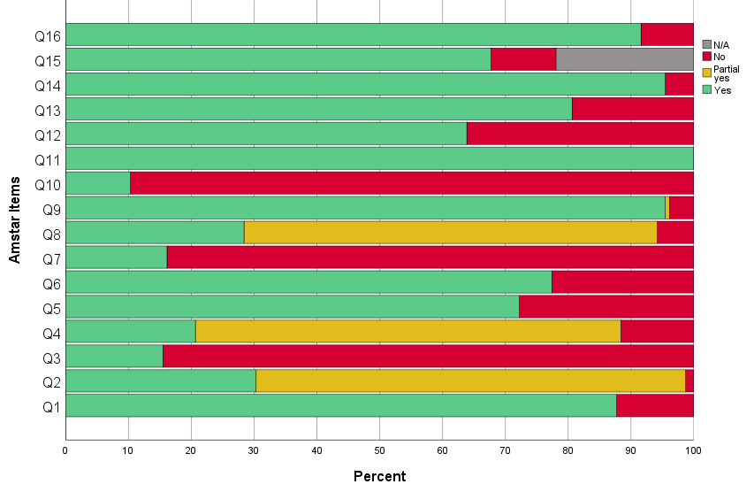

AMSTAR-2 ratings for each review
Author | 1 | 2* | 3 | 4* | 5 | 6 | 7 | 8 | 9* | 10 | 11* | 12 | 13* | 14 | 15* | 16 | Overall
Aalbers 2017⁵⁷ | Y | Y | N | Y | Y | Y | Y | Y | Y | Y | Y | Y | Y | Y | Y | Y | High
Abbing 2023⁵⁸ | Y | Y | N | P Y | Y | Y | Y | Y | Y | N | Y | Y | Y | Y | Y | Y | Moderate
Álvarez-Bueno 2023⁸⁷ | Y | P Y | N | P Y | Y | Y | N | N | Y | N | Y | Y | Y | Y | Y | Y | Low
Atchison 2022⁵⁹ | Y | P Y | N | Y | Y | Y | N | Y | Y | Y | Y | N | Y | Y | N | Y | Moderate
Barnish 2020⁸⁸ | N | P Y | N | P Y | Y | Y | N | Y | Y | Y | Y | Y | Y | Y | N | Y | Critically low
Batubara 2023⁸⁹ | Y | P Y | N | P Y | N | Y | N | Y | Y | N | Y | Y | Y | Y | Y | Y | Low
Bian 2021⁹⁰ | Y | P Y | N | P Y | Y | Y | N | P Y | Y | N | Y | N | Y | Y | N/A | Y | Low
Bighelli 2023⁶⁰ | Y | P Y | N | P Y | Y | Y | N | P Y | Y | N | Y | Y | Y | Y | Y | Y | Low
Bradt 2013³⁴ | Y | Y | N | Y | Y | Y | Y | Y | Y | Y | Y | Y | Y | Y | N/A | Y | High
Bradt 2015⁷ | Y | Y | N | Y | Y | Y | Y | Y | Y | Y | Y | Y | Y | Y | Y | Y | High
Bradt 2021⁶ | Y | Y | N | Y | Y | Y | Y | Y | Y | Y | Y | Y | Y | Y | Y | Y | High
Bro 2018⁸ | Y | P Y | N | P Y | Y | N | N | P Y | Y | N | Y | N | Y | Y | Y | N | Low
Burley 2022⁹¹ | Y | P Y | N | P Y | N | N | N | P Y | N | N | Y | Y | Y | Y | Y | Y | Critically low
Cao 2023³⁵ | Y | P Y | N | P Y | Y | Y | N | P Y | Y | N | Y | Y | Y | Y | Y | Y | Low
Carapellotti 2020⁹² | Y | P Y | Y | P Y | Y | N | Y | P Y | Y | N | Y | Y | Y | Y | Y | Y | Low
Chan 2020⁹³ | Y | Y | N | P Y | Y | Y | N | P Y | Y | N | Y | Y | Y | Y | Y | Y | Moderate
Chan 2023³⁶ | Y | Y | N | Y | Y | Y | N | Y | Y | N | Y | Y | Y | Y | Y | Y | High
Chandrababu 2021³⁷ | Y | P Y | N | P Y | N | Y | N | P Y | Y | N | Y | Y | Y | Y | Y | Y | Low
Chang 2015⁹⁴ | Y | P Y | Y | N | N | Y | N | P Y | Y | N | Y | Y | Y | Y | Y | Y | Low
Chen 2021⁶¹ | Y | Y | N | P Y | Y | Y | N | Y | Y | N | Y | Y | Y | Y | N | Y | Low
Chen 2022⁹⁵ | Y | P Y | N | P Y | Y | Y | N | P Y | Y | N | Y | Y | Y | Y | N | Y | Critically low
Cheng 2021⁹ | N | P Y | N | P Y | N | N | N | N | Y | N | Y | Y | Y | Y | Y | Y | Low
Conceição 2016³⁸ | Y | P Y | N | P Y | Y | Y | Y | P Y | Y | N | Y | N | N | Y | N/A | Y | Critically low
da Silva Santa 2021¹⁰ | Y | P Y | N | Y | Y | Y | N | P Y | Y | N | Y | N | N | Y | N/A | Y | Moderate
Dayuan 2022³⁹ | Y | P Y | N | P Y | Y | Y | N | P Y | Y | N | Y | N | N | Y | Y | Y | Critically low
de Almeida 2021⁹⁶ | Y | P Y | N | P Y | Y | Y | N | P Y | Y | N | Y | Y | Y | Y | N | Y | Critically low
de Dreu 2012⁹⁷ | Y | P Y | N | P Y | Y | N | N | P Y | Y | N | Y | N | N | Y | N/A | Y | Critically low
de Witte 2022⁶² | Y | Y | Y | Y | Y | Y | N | P Y | Y | N | Y | Y | Y | Y | Y | Y | High
do Amaral 2016⁴⁰ | N | P Y | N | P Y | Y | Y | Y | P Y | Y | N | Y | N | Y | N | N/A | Y | Low
Dorris 2021⁹⁸ | Y | P Y | N | N | Y | N | N | P Y | Y | N | Y | Y | Y | Y | Y | Y | Low
dos Santos Delabary 2018⁹⁹ | Y | P Y | N | P Y | Y | Y | N | P Y | Y | N | Y | N | N | Y | N/A |  | Critically low
Ernst 2024¹⁰⁰ | Y | Y | Y | Y | Y | Y | Y | Y | Y | Y | Y | Y | Y | Y | Y | Y | High
Fusar-Poli 2018¹⁰¹ | Y | Y | Y | P Y | N | N | N | P Y | Y | N | Y | N | N | Y | N/A | Y | Moderate
Geipel 2018⁶³ | Y | P Y | N | P Y | Y | N | Y | P Y | Y | N | Y | N | Y | Y | Y | Y | Low
Geng 2023¹¹ | Y | Y | Y | Y | Y | Y | N | P Y | Y | N | Y | N | Y | Y | Y | Y | High
Geretsegger 2017⁶⁴ | Y | Y | N | Y | Y | Y | Y | Y | Y | Y | Y | Y | Y | Y | Y | Y | High
Geretsegger 2022¹⁰² | Y | Y | N | Y | Y | Y | Y | Y | Y | Y | Y | Y | Y | Y | Y | Y | High
Gerger 2022⁶⁵ | Y | Y | N | Y | Y | Y | N | P Y | Y | N | Y | N | Y | N | N/A | Y | High
Ghai 2018¹⁰³ | N | P Y | N | P Y | N | N | N | P Y | Y | N | Y | Y | Y | Y | Y | Y | Low
Ghai 2022¹⁰⁴ | Y | P Y | N | P Y | Y | N | N | P Y | Y | N | Y | Y | Y | Y | Y | Y | Low
Ghetti 2022⁶⁶ | Y | Y | N | Y | Y | Y | Y | Y | Y | Y | Y | Y | Y | Y | Y | Y | High
Goh 2023¹⁰⁵ | Y | Y | N | P Y | Y | Y | N | Y | Y | N | Y | N | Y | Y | Y | Y | Moderate
Gold 2009⁶⁷ | Y | P Y | Y | P Y | Y | Y | N | Y | Y | N | Y | Y | Y | Y | N/A | Y | Low
Gomes Neto 2014⁴¹ | N | P Y | N | P Y | Y | Y | N | P Y | Y | N | Y | N | N | N | N/A | Y | Critically low
Guo 2020⁶⁸ | Y | P Y | N | P Y | N | N | N | P Y | Y | N | Y | N | N | Y | Y | Y | Critically low
Hao 2022¹⁰⁶ | Y | P Y | N | P Y | Y | N | N | P Y | Y | N | Y | N | N | Y | Y |  | Critically low
Hasan 2022¹⁰⁷ | Y | P Y | N | P Y | Y | N | N | Y | Y | N | Y | N | Y | Y | N/A | Y | Low
Hidalgo-Agudo 2020¹⁰⁸ | Y | P Y | N | N | Y | Y | N | P Y | Y | N | Y | N | Y | Y | N/A | Y | low
Huang 2021¹⁵⁵ | N | P Y | N | P Y | Y | Y | N | P Y | Y | N | Y | Y | Y | Y | Y | Y | Low
Hung 2018¹² | Y | P Y | N | P Y | N | N | N | P Y | Y | N | Y | Y | Y | Y | Y | N | Low
Ismail 2021¹⁰⁹ | Y | P Y | N | Y | Y | Y | Y | Y | Y | N | Y | Y | Y | Y | N | Y | low
Ito 2022¹¹⁰ | Y | P Y | N | P Y | Y | Y | N | P Y | Y | N | Y | Y | Y | Y | N/A | Y | Low
Jayakar 2017⁴² | Y | P Y | N | P Y | N | Y | Y | Y | Y | N | Y | Y | Y | Y | Y | N | Low
Jenabi 2023⁶⁹ | N | P Y | N | P Y | Y | Y | N | P Y | Y | N | Y | N | N | Y | Y | Y | Critically low
Jia 2020⁷⁰ | Y | P Y | N | P Y | Y | Y | N | P Y | Y | N | Y | Y | Y | Y | Y | Y | Low
Jiang 2020¹³ | Y | P Y | N | P Y | Y | Y | N | P Y | Y | N | Y | Y | Y | Y | Y | Y | Low
Jiang 2023⁷¹ | Y | Y | N | P Y | Y | N | N | P Y | Y | N | Y | Y | N | Y | Y | Y | Moderate
Jiang 2023¹⁴ | Y | P Y | N | P Y | Y | N | N | P Y | Y | N | Y | N | N | Y | Y | N | Critically low
Jin 2022¹¹¹ | Y | P Y | N | Y | Y | N | N | P Y | Y | N | Y | Y | Y | Y | Y | Y | Moderate
Kakar 2021⁴³ | Y | Y | N | P Y | Y | Y | N | Y | Y | N | Y | Y | Y | Y | Y | Y | Moderate
Kalyani 2019¹¹² | Y | P Y | N | P Y | Y | Y | Y | P Y | Y | N | Y | Y | Y | Y | N/A | Y | Low
Karkou 2019⁷² | Y | P Y | Y | P Y | Y | Y | N | Y | Y | Y | Y | Y | Y | Y | Y | Y | Low
Ke 2022¹¹³ | Y | P Y | N | P Y | N | Y | N | P Y | Y | N | Y | Y | Y | Y | Y | Y | Low
Kim 2016¹¹⁴ | Y | Y | Y | P Y | Y | Y | Y | P Y | N | N | Y | N | N | Y | Y | Y | Critically low
Kim 2021¹⁵⁶ | Y | P Y | N | P Y | N | N | N | P Y | Y | N | Y | N | Y | Y | N/A | N | Low
Koch 2019⁷³ | N | P Y | Y | Y | N | N | Y | N | Y | N | Y | Y | Y | Y | Y | Y | Moderate
Köhler 2020¹⁵ | Y | Y | N | P Y | Y | Y | N | Y | Y | N | Y | Y | Y | Y | Y | Y | Moderate
Kong 2015¹¹⁵ | Y | P Y | N | Y | Y | Y | N | P Y | Y | N | Y | N | Y | N | Y | Y | Moderate
Kwok 2016¹¹⁶ | Y | P Y | Y | N | N | N | N | P Y | Y | N | Y | N | Y | Y | N | Y | Critically low
Laws 2019⁷⁴ | Y | P Y | Y | P Y | N | N | N | N | Y | N | Y | Y | Y | Y | Y | Y | Moderate
Lee 2015¹⁵⁷ | Y | Y | N | P Y | Y | N | N | P Y | Y | N | Y | Y | Y | Y | Y | Y | Moderate
Lee 2021⁴⁴ | Y | P Y | N | P Y | Y | Y | N | P Y | Y | N | Y | Y | Y | Y | Y | Y | Low
Lee 2023¹¹⁷ | Y | Y | N | P Y | Y | Y | N | P Y | Y | N | Y | N | Y | Y | N/A | Y | Moderate
Li 2020¹⁶ | Y | P Y | N | P Y | Y | Y | N | P Y | Y | N | Y | Y | Y | Y | Y | Y | Low
Li 2022¹¹⁸ | Y | P Y | N | P Y | N | Y | N | P Y | Y | N | Y | N | N | Y | N | Y | Critically low
Liang 2018¹²⁰ | Y | P Y | Y | P Y | Y | Y | N | P Y | Y | N | Y | Y | Y | Y | Y | Y | Low
Liang 2019¹¹⁹ | Y | P Y | N | Y | Y | Y | N | P Y | Y | N | Y | Y | Y | Y | Y | Y | Moderate
Liu 2022⁴⁵ | Y | Y | N | P Y | Y | Y | N | P Y | Y | N | Y | N | Y | Y | N/A | Y | Moderate
Liu 2023⁴⁶ | Y | P Y | N | P Y | Y | Y | N | P Y | Y | N | Y | N | Y | Y | Y | Y | Low
Lorenzo-García 2023¹²¹ | Y | P Y | N | P Y | Y | Y | N | P Y | Y | N | Y | Y | Y | Y | Y | Y | low
Lötzke 2015¹²² | N | P Y | N | N | N | N | N | Y | N | N | Y | N | N | Y | N | Y | critically low
Lutgens 2017⁷⁵ | Y | P Y | N | P Y | N | N | N | P Y | N | N | Y | Y | Y | Y | Y | Y | Critically low
Magee 2017⁴⁷ | Y | Y | N | Y | Y | Y | Y | Y | Y | Y | Y | Y | Y | Y | Y | Y | High
Masika 2020¹²³ | Y | Y | N | P Y | Y | Y | N | Y | Y | N | Y | Y | Y | Y | N | Y | Low
May 2021¹²⁴ | Y | Y | N | Y | Y | Y | N | P Y | Y | N | Y | N | Y | Y | Y | Y | High
Mazzarin 2017¹²⁵ | Y | P Y | N | P Y | Y | Y | N | Y | Y | N | Y | N | Y | Y | N/A | Y | Low
McNamara 2017¹⁵⁸ | Y | Y | Y | Y | Y | Y | Y | Y | Y | Y | Y | Y | Y | Y | Y | Y | High
Meekums 2015⁷⁶ | Y | Y | Y | Y | Y | Y | Y | Y | Y | N | Y | Y | Y | Y | Y | Y | High
Mishra 2021¹²⁶ | N | P Y | N | P Y | N | Y | N | N | Y | N | Y | Y | Y | Y | N/A | Y | Low
Moreno-Morales 2020¹²⁷ | Y | P Y | N | P Y | Y | Y | N | P Y | Y | N | Y | Y | Y | Y | Y | Y | Low
Mustafaoglu 2022¹²⁸ | Y | Y | N | P Y | Y | Y | N | P Y | Y | N | Y | N | Y | Y | Y | Y | Moderate
Na 2019¹²⁹ | Y | Y | N | P Y | Y | Y | N | P Y | Y | N | Y | Y | Y | Y | N/A | Y | Moderate
Nelson 2023¹⁷ | Y | P Y | Y | P Y | Y | N | N | Y | Y | N | Y | N | N | Y | N | Y | Critically low
Nguyen 2022¹⁸ | Y | Y | N | P Y | Y | Y | N | Y | Y | N | Y | Y | Y | Y | N/A | Y | Moderate
Nightingale 2013¹⁹ | N | P Y | Y | P Y | N | N | N | P Y | Y | N | Y | Y | Y | Y | Y | Y | Low
Nyssen 2016¹⁵⁹ | Y | Y | Y | Y | Y | Y | Y | Y | Y | Y | Y | Y | Y | Y | N | Y | Low
Orkibi 2023⁷⁷ | Y | P Y | Y | P Y | Y | Y | N | P Y | Y | N | Y | Y | Y | Y | Y | Y | Low
Pedersen 2017¹³⁰ | N | N | Y | P Y | N | N | N | P Y | N | N | Y | N | N | Y | Y | N | Critically low
Peng 2021⁴⁸ | N | P Y | N | Y | N | Y | Y | P Y | Y | N | Y | Y | Y | Y | Y | Y | Moderate
Puetz 2013²⁰ | Y | P Y | N | P Y | N | Y | N | P Y | P Y | N | Y | N | N | Y | Y | N | Critically low
Qi 2021²¹ | Y | P Y | N | Y | Y | Y | N | P Y | Y | N | Y | Y | Y | Y | Y | Y | Moderate
Radder 2020¹³¹ | Y | P Y | N | P Y | N | N | N | P Y | N | N | Y | Y | Y | Y | Y | Y | Critically low
Reinhold 2018⁷⁸ | Y | P Y | N | P Y | N | N | N | P Y | Y | N | Y | Y | Y | Y | Y | Y | Low
Roche Bueno 2019⁴⁹ | Y | Y | N | P Y | Y | Y | N | P Y | Y | N | Y | N | N | Y | N/A | Y | Low
Sabeena 2022⁷⁹ | Y | P Y | N | N | N | N | N | N | Y | N | Y | N | N | Y | Y | Y | Critically low
Sezgin 2022²² | Y | Y | N | N | Y | Y | N | Y | Y | N | Y | N | Y | Y | Y | Y | Low
Sharp 2014¹³² | Y | P Y | N | Y | Y | Y | Y | P Y | Y | N | Y | N | Y | Y | N/A | N | Moderate
Shi 2016¹³³ | Y | P Y | N | P Y | N | Y | N | P Y | Y | N | Y | N | Y | N | N | Y | Critically low
Simpkins 2023¹³⁴ | Y | P Y | N | P Y | N | Y | N | P Y | Y | N | Y | Y | Y | Y | Y | Y | low
Steenhuis 2015⁸⁰ | Y | P Y | N | P Y | Y | N | N | Y | Y | N | Y | Y | Y | Y | Y | Y | Low
Su 2021⁵⁰ | Y | P Y | N | N | Y | Y | N | Y | Y | N | Y | Y | Y | Y | Y | Y | Low
Tang 2019¹³⁵ | N | P Y | N | N | N | Y | N | P Y | Y | N | Y | N | Y | Y | N | Y | Critically low
Tang 2019²³ | N | P Y | N | N | Y | Y | N | P Y | Y | N | Y | Y | Y | Y | N | Y | Critically low
Tang 2020⁸¹ | Y | P Y | N | P Y | Y | Y | N | P Y | Y | N | Y | Y | Y | Y | Y | Y | Low
Tsai 2014²⁴ | Y | P Y | Y | P Y | Y | Y | N | P Y | Y | N | Y | Y | Y | Y | Y | Y | Low
Tseng 2016⁸² | Y | P Y | N | N | N | N | N | P Y | Y | N | Y | Y | N | Y | Y | Y | Critically low
Tsoi 2018¹³⁶ | Y | P Y | N | Y | Y | Y | N | P Y | Y | N | Y | Y | N | Y | Y | Y | Low
Ueda 2013¹³⁷ | Y | P Y | Y | P Y | Y | Y | N | N | Y | N | Y | Y | Y | Y | Y | N | Low
van der Steen 2018¹³⁸ | Y | Y | N | Y | Y | Y | Y | Y | Y | Y | Y | Y | Y | Y | Y | Y | High
Wang 2018²⁵ | Y | P Y | N | P Y | N | Y | N | P Y | Y | N | Y | Y | Y | Y | Y | Y | Low
Wang 2020¹³⁹ | Y | Y | N | P Y | Y | Y | N | P Y | Y | N | Y | Y | Y | Y | Y | Y | Moderate
Wang 2020¹⁴³ | N | P Y | N | N | N | N | N | P Y | Y | N | Y | Y | Y | Y | Y | Y | Low
Wang 2020⁵¹ | Y | P Y | N | P Y | Y | Y | N | Y | Y | N | Y | Y | Y | Y | Y | Y | Low
Wang 2021¹⁴⁰ | Y | P Y | N | P Y | N | Y | N | P Y | Y | N | Y | N | N | Y | Y | Y | Critically low
Wang 2022¹⁴¹ | Y | P Y | N | Y | Y | Y | N | Y | Y | Y | Y | Y | Y | Y | N/A |  | Moderate
Wang 2022¹⁴² | Y | P Y | N | P Y | Y | Y | N | Y | Y | N | Y | N | Y | Y | Y | Y | Low
Wang 2022⁵² | Y | Y | N | P Y | Y | Y | N | Y | Y | N | Y | Y | Y | Y | Y | Y | Moderate
Wang 2023¹⁴⁴ | N | P Y | N | P Y | N | Y | N | P Y | Y | N | Y | N | Y | Y | Y | Y | Low
Wei 2020¹⁴⁵ | Y | N | N | N | N | Y | N | P Y | Y | N | Y | Y | Y | Y | N/A | Y | Critically low
Wei 2020²⁶ | Y | P Y | Y | P Y | Y | Y | N | P Y | Y | N | Y | N | Y | Y | N/A | N | Low
Wong 2022¹⁴⁶ | Y | P Y | N | P Y | N | N | N | P Y | Y | N | Y | Y | Y | Y | N | Y | Critically low
Wu 2021¹⁴⁷ | Y | Y | N | P Y | N | Y | N | P Y | Y | N | Y | N | Y | Y | Y | Y | Moderate
Xia 2023²⁷ | Y | Y | N | P Y | Y | Y | N | P Y | Y | N | Y | N | N | Y | Y | Y | Moderate
Xu 2020²⁸ | N | P Y | N | P Y | Y | Y | N | N | Y | N | Y | N | N | N | Y | Y | Critically low
Yan 2019⁸³ | Y | Y | N | P Y | Y | Y | N | P Y | Y | N | Y | N | Y | Y | Y | N | Moderate
Yang 2019⁵³ | Y | Y | N | Y | Y | Y | N | Y | Y | N | Y | Y | Y | Y | Y | Y | high
Yang 2019¹⁴⁸ | Y | P Y | N | P Y | N | Y | N | P Y | Y | N | Y | N | N | N | Y | N | Critically low
Yang 2019⁸⁴ | Y | Y | N | P Y | Y | Y | N | P Y | Y | N | Y | Y | Y | Y | N/A | Y | Moderate
Yang 2021⁵⁶ | Y | P Y | N | Y | Y | Y | N | P Y | Y | N | Y | N | N | Y | N/A | Y | Low
Yang 2021²⁹ | Y | P Y | N | P Y | Y | Y | N | P Y | Y | N | Y | N | Y | Y | Y | Y | Low
Yang 2022¹⁴⁹ | Y | Y | N | P Y | Y | Y | N | P Y | Y | N | Y | Y | Y | Y | Y | Y | Moderate
Yangöz 2019³⁰ | Y | P Y | N | P Y | N | Y | N | P Y | Y | N | Y | Y | Y | Y | Y | Y | Low
Ye 2022¹⁵⁰ | Y | P Y | N | N | N | Y | N | P Y | Y | N | Y | Y | Y | Y | Y | Y | Low
Yijing 2018⁸⁵ | N | P Y | N | N | Y | Y | N | P Y | Y | N | Y | N | N | Y | N/A | N | Critically low
Yoo 2016⁵⁴ | Y | P Y | N | P Y | N | N | N | P Y | Y | N | Y | Y | N | Y | Y | Y | Critically low
Zhang 2012³¹ | Y | P Y | Y | P Y | N | Y | N | Y | Y | N | Y | Y | Y | Y | N/A | Y | Low
Zhang 2015³² | Y | P Y | N | N | Y | Y | N | P Y | Y | N | Y | Y | Y | Y | Y | Y | Low
Zhang 2016⁵⁵ | Y | Y | N | N | Y | Y | N | Y | Y | N | Y | Y | Y | Y | N/A | Y | Low
Zhang 2017¹⁵² | Y | Y | N | P Y | Y | Y | N | Y | Y | N | Y | Y | Y | Y | Y | Y | Moderate
Zhang 2019¹⁵¹ | Y | P Y | N | P Y | Y | Y | N | P Y | Y | N | Y | Y | Y | Y | N/A | Y | Low
Zhang 2023³³ | Y | Y | N | P Y | Y | Y | N | N | Y | N | Y | Y | Y | Y | Y | Y | Moderate
Zhao 2016⁸⁶ | Y | P Y | N | P Y | N | Y | N | P Y | Y | N | Y | N | N | Y | Y | Y | Critically low
Zhou 2021¹⁵³ | Y | P Y | N | P Y | Y | Y | N | P Y | Y | N | Y | Y | Y | Y | Y | Y | Low
Zhu 2020¹⁵⁴ | Y | P Y | N | P Y | Y | Y | N | P Y | Y | N | Y | Y | Y | Y | N/A | Y | Low
1-Question and inclusion; 2-Protocol; 3-Study design; 4-Comprehensive search; 5-Study selection; 6-Data extraction; 7-Excluded studies justification; 8-Included studied details; 9-Risk of Bias; 10-Source of funding of included studies; 11-Appropriate statistical methods for analysis; 12-RoB impact on meta-analyses; 13-RoB interpretation; 14-Explanation for heterogeneity; 15-Publication bias; 16-Conflict of interest. Items 2-4-9-11-13-15 were considered critical.
Legend: Y: yes; N: no; PY: partial yes
Note: We did not consider item 7 a critical item, as suggested in the AMSTAR-2 guidelines. Only 17% of included SR provided a list of excluded studies with reason for exclusion. It is only in recent years that online supplementary materials are common amongst journals. We suspect that prior to that, journals may have not allowed for or may have discouraged lengthy tables in the Appendix.

Supplementary material 8: Forest Plots

Cancer
Physical Outcomes

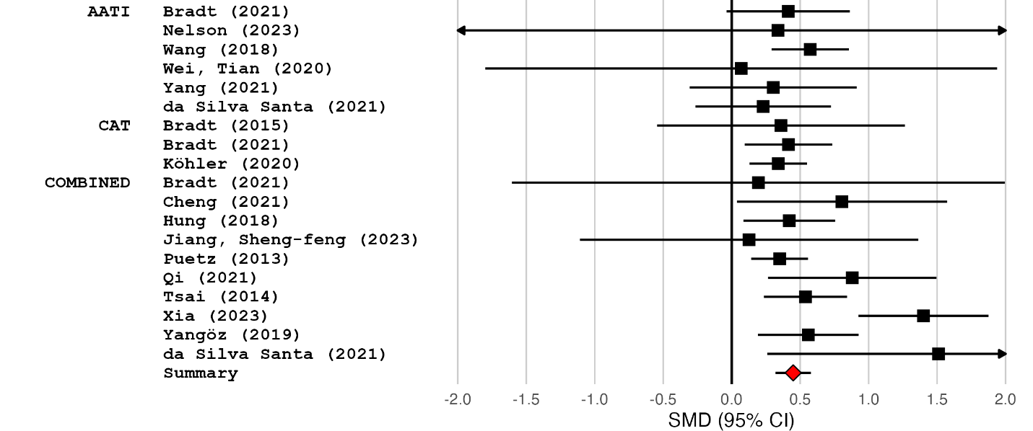

Psychological Outcomes

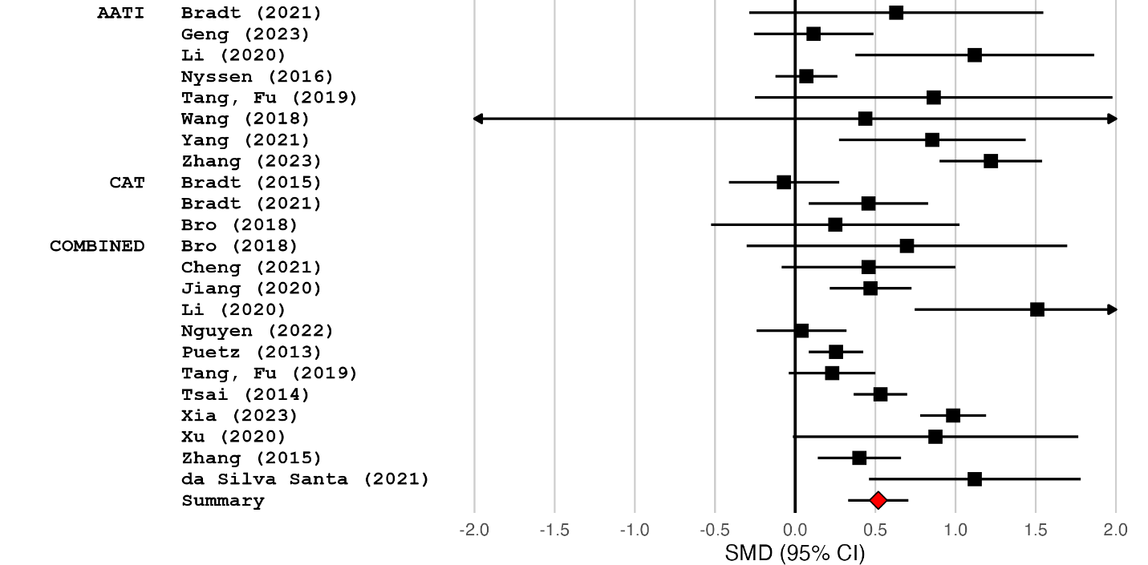

Quality of Life Outcomes

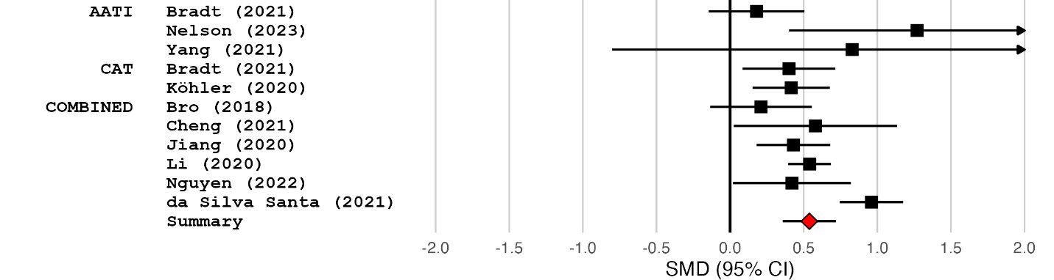

Cardiovascular Diseases
Physical outcomes

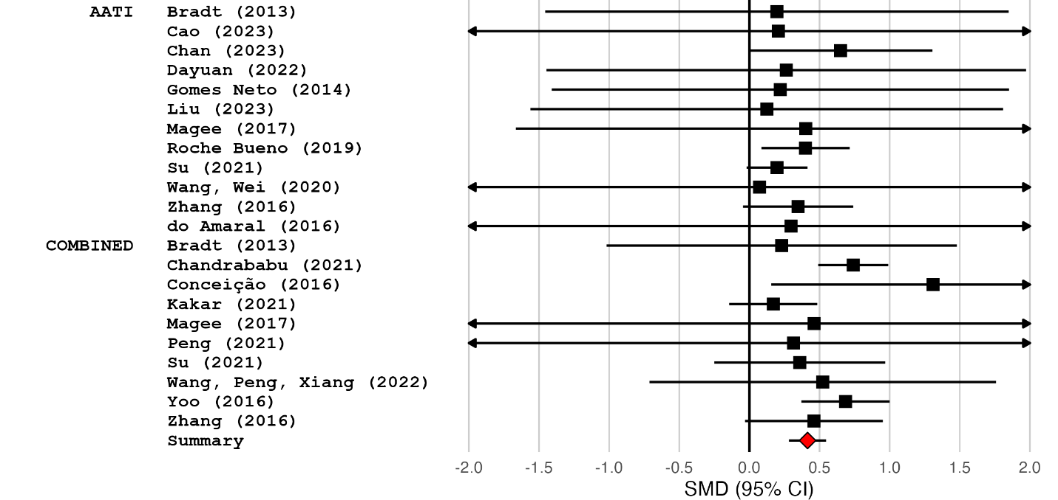

Psychological Outcomes
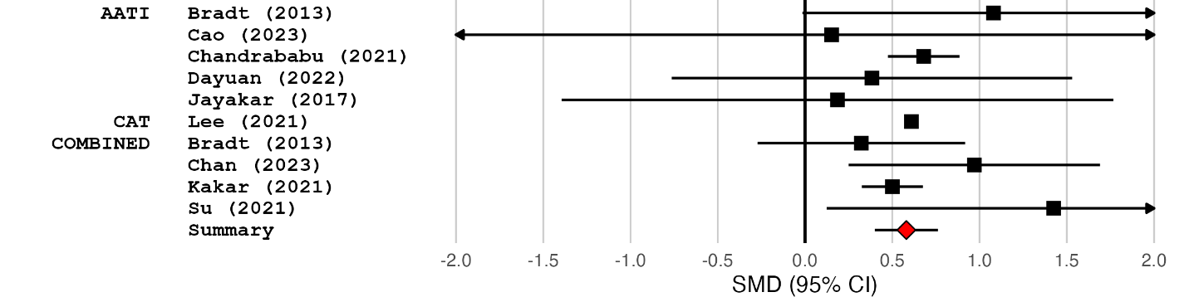

Cognitive Outcomes

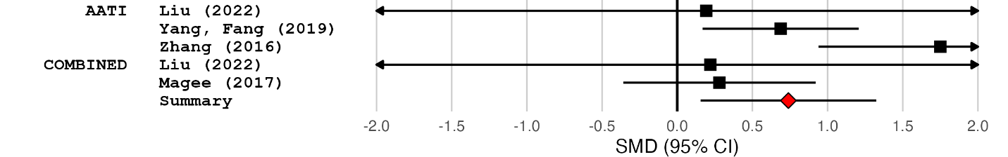

Quality of Life Outcomes

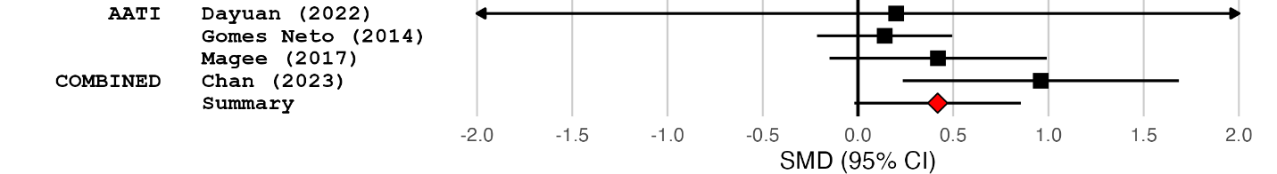

Chronic Respiratory Diseases
Physical Outcomes

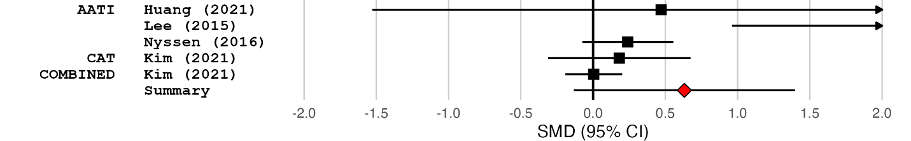

Psychological Outcomes

Quality of Life Outcomes

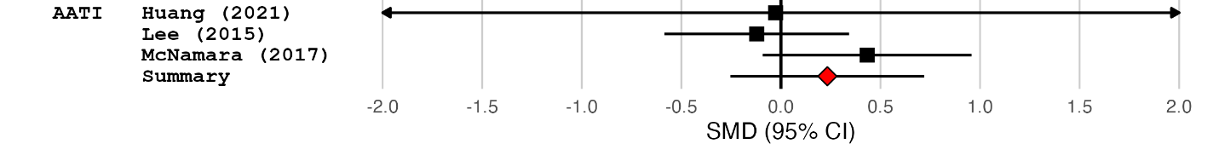

Mental Health Conditions
Psychological Outcomes

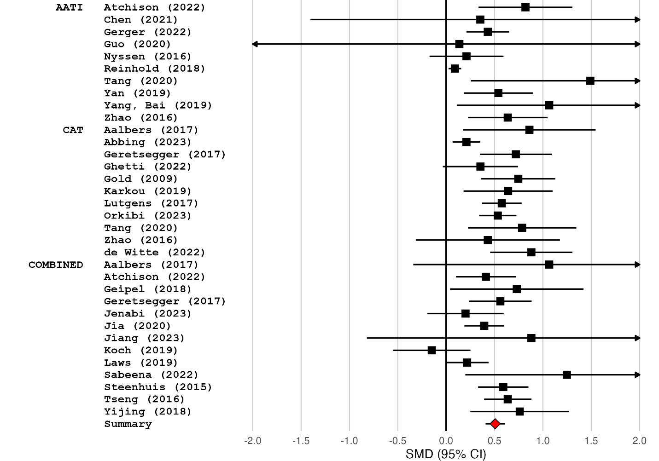

Cognitive Outcomes

Quality of Life Outcomes

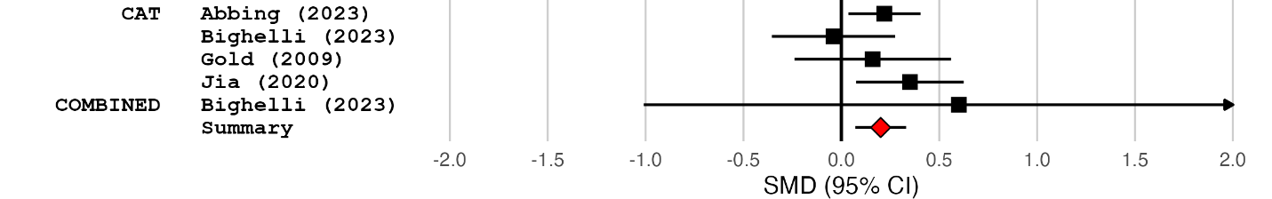

Neurological conditions

Physical Outcomes
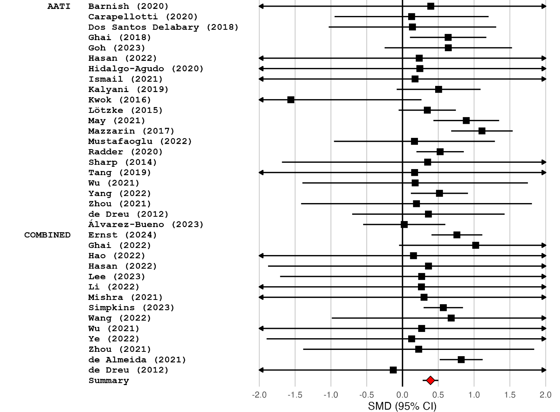

Psychological Outcomes

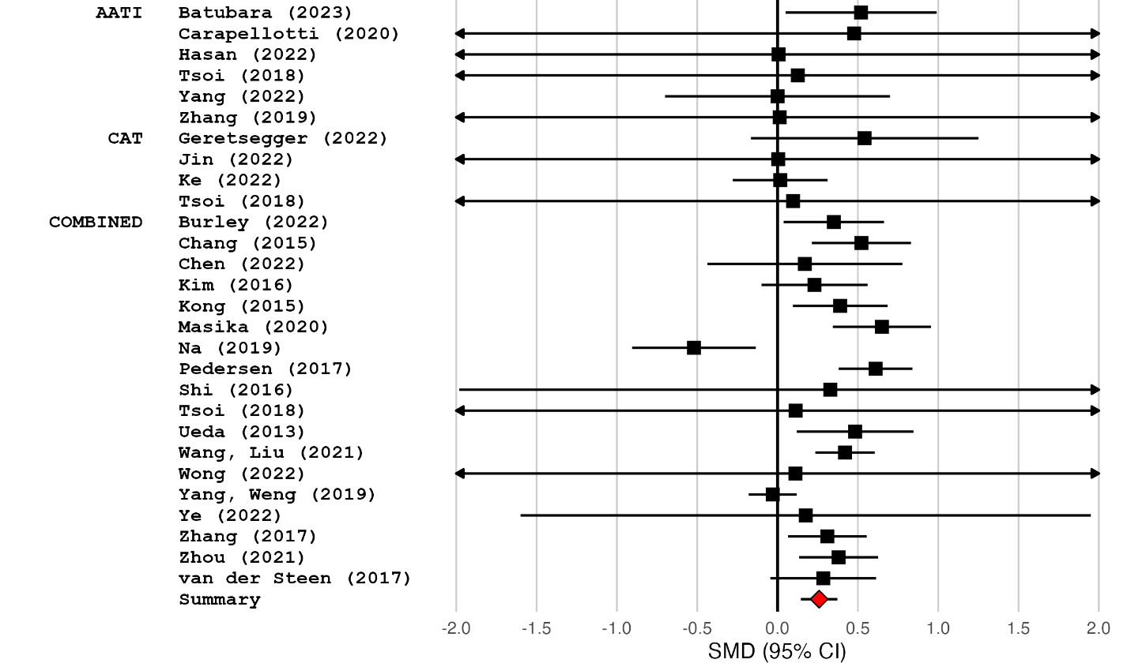
Cognitive Outcomes
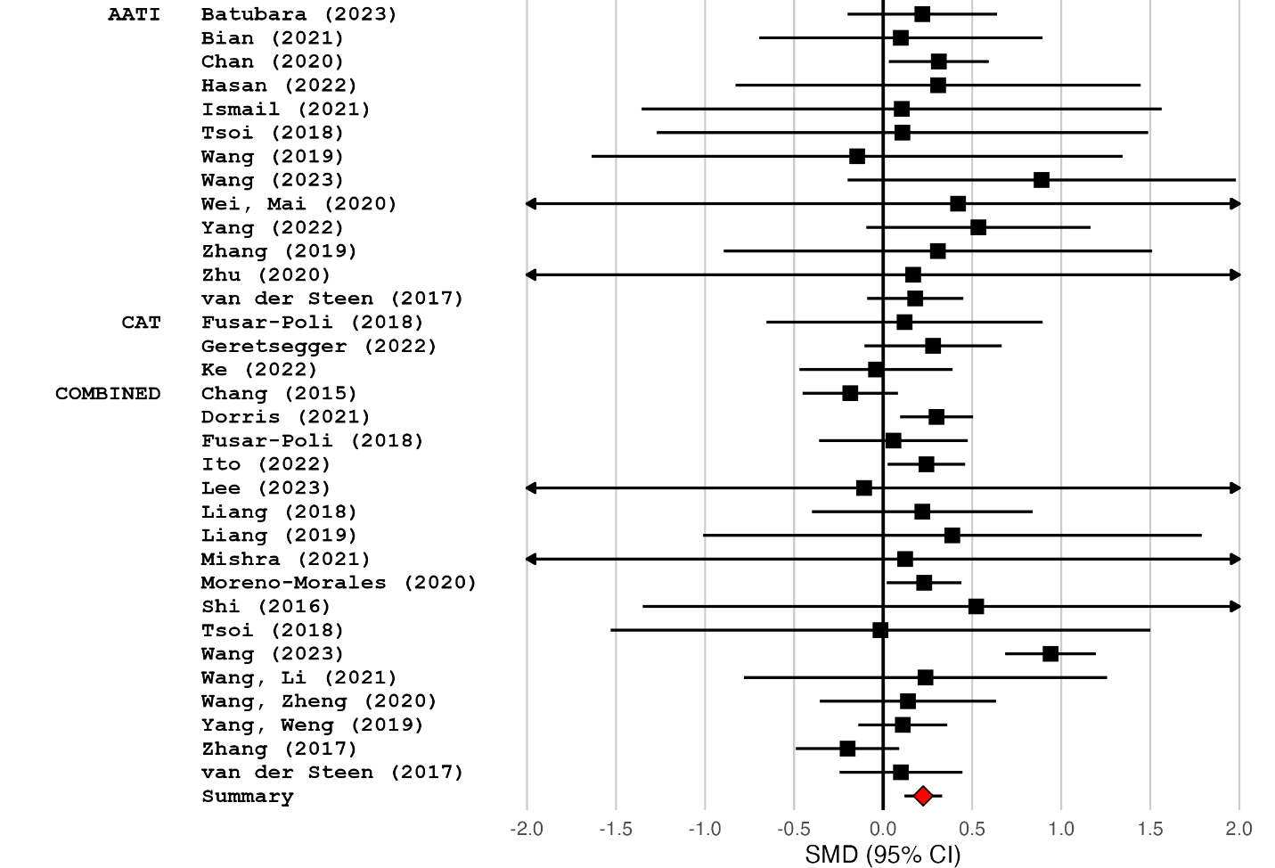
Quality of Life Outcomes

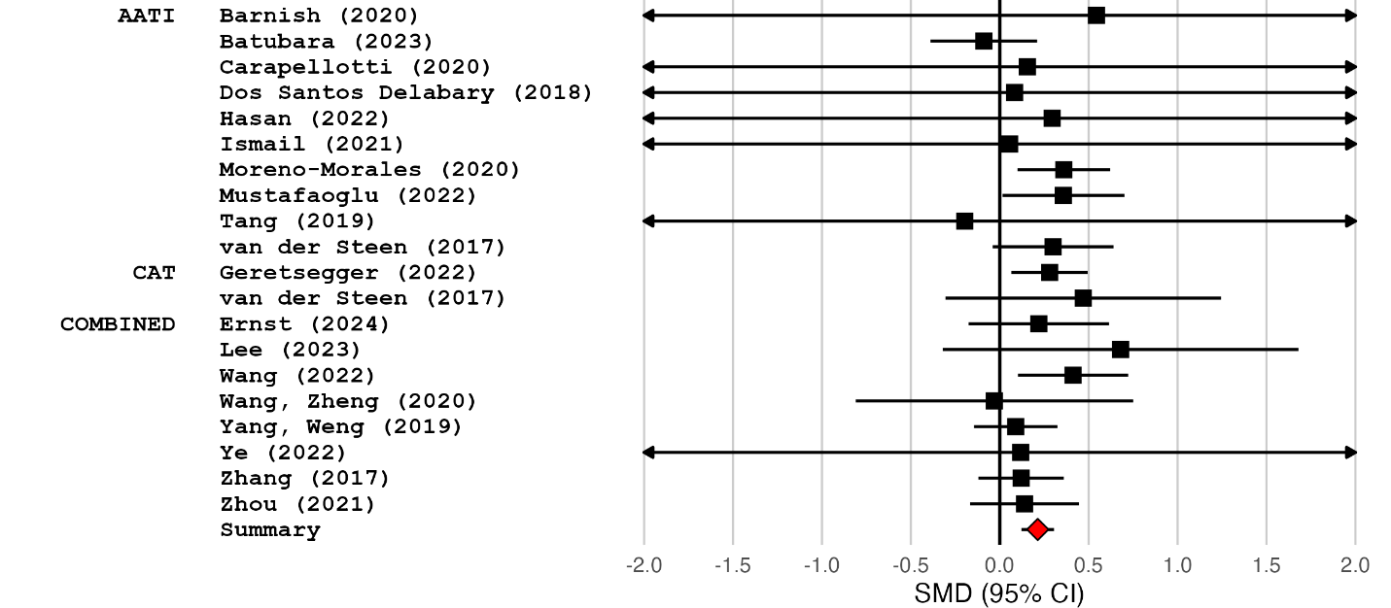

Supplementary material 9: Subgroup analyses

Cancer
Subgroup | S | k | SMD | 95% CI | Q(df) | p
OUTCOME CHARACTERISTICS
Psychological outcomes |  |  |  |  | Q(2) = 2.612 | 0.271
Anxiety/Stress | 15 | 21 | 0.61 | 0.37, 0.84
Depression | 16 | 18 | 0.47 | 0.26, 0.68
Mood | 3 | 5 | 0.28 | -0.04, 0.61
Physical outcomes |  |  |  |  | Q(2) = 0.272 | 0.873
Physical rehabilitation | 2 | 2 | 0.78 | -0.75, 2.3
Physical symptoms | 12 | 16 | 0.40 | 0.20, 0.61
Physiological responses | 3 | 9 | 0.37 | 0.06, 0.68
REVIEW CHARACTERISTICS
Design |  |  |  |  | Q(1) = 0.204 | 0.652
RCT only | 18 | 60 | 0.45 | 0.28, 0.62
RCT & CCT | 8 | 36 | 0.50 | 0.36, 0.64
Study quality (AMSTAR-2) |  |  |  |  | Q(3) = 8.049 | 0.045
High | 3 | 24 | 0.13 | -0.13, 0.39
Moderate | 5 | 13 | 0.65 | 0.31, 0.99
Low | 13 | 47 | 0.50 | 0.34, 0.66
Critically low | 5 | 12 | 0.36 | 0.22, 0.50
Type of control condition |  |  |  |  | Q(2) = 1.508 | 0.471
Active controls | 1 | 1 | 0.18 | -0.28, 0.64
CAU/TAU/Waitlist | 16 | 72 | 0.46 | 0.29, 0.63
Mixed controls | 11 | 23 | 0.49 | 0.32, 0.66
INTERVENTION CHARACTERISTICS
Type of intervention (Physical outcomes) |  |  |  |  | Q(2) = 3.94 | 0.139
AATI | 6 | 13 | 0.30 | 0.10, 0.49
CAT | 3 | 4 | 0.37 | 0.22, 0.51
COMBINED | 10 | 18 | 0.59 | 0.36, 0.81
Type of intervention (Psychological outcomes) |  |  |  |  | Q(2) = 3.398 | 0.183
AATI | 8 | 16 | 0.67 | 0.30, 1.04
CAT | 3 | 8 | 0.18 | -0.22, 0.58
COMBINED | 12 | 24 | 0.53 | 0.34, 0.72
Type of intervention (Quality of life outcomes) |  |  |  |  | Q(2) = 2.762 | 0.251
AATI | 3 | 4 | 0.81 | 0.06, 1.56
CAT | 2 | 3 | 0.37 | 0.24, 0.50
COMBINED | 6 | 6 | 0.54 | 0.32, 0.76
Type of modality (Physical outcomes) |  |  |  |  | Q(3) = 16.318 | 0.001
Music | 11 | 27 | 0.39 | 0.26, 0.52
Dance | 2 | 3 | 0.42 | 0.16, 0.67
Art | 1 | 1 | 1.40 | 0.92, 1.88
Mixed arts | 2 | 4 | 0.46 | 0.12, 0.80
Type of modality (Psychological outcomes) |  |  |  |  | Q(4) = 23.47 | <0.001
Music | 9 | 22 | 0.67 | 0.41, 0.94
Dance | 2 | 6 | -0.03 | -0.21, 0.15
Art | 3 | 4 | 0.63 | 0.26, 1.00
Poetry/EW | 2 | 4 | 0.63 | -0.50, 1.77
Mixed arts | 4 | 12 | 0.31 | 0.20, 0.42
Type of modality (Quality of life outcomes) |  |  |  |  | Q(3) = 3.387 | 0.336
Music | 7 | 10 | 0.52 | 0.30, 0.75
Dance | 1 | 1 | 1.27 | 0.40, 2.14
Art | 1 | 1 | 0.43 | 0.18, 0.68
Mixed arts | 1 | 1 | 0.58 | 0.03, 1.13

Cardiovascular Diseases

Subgroup | S | k | SMD | 95% CI | Q(df) | p
OUTCOME CHARACTERISTICS
Psychological outcomes |  |  |  |  | Q(2) = 0.847 | 0.655
Anxiety/Stress | 6 | 7 | 0.59 | 0.45, 0.74
Depression | 5 | 6 | 0.53 | 0.11, 0.95
Mood | 1 | 1 | 1.08 | -0.01, 2.17
Physical outcomes |  |  |  |  | Q(2) = 17.761 | <0.001
Physical rehabilitation | 9 | 30 | 0.50 | 0.34, 0.67
Physical symptoms | 3 | 3 | 0.32 | 0.11, 0.53
Physiological responses | 7 | 29 | 0.10 | 0.01, 0.20
REVIEW CHARACTERISTICS
Design |  |  |  |  | Q(1) = 1.281 | 0.258
RCT only | 17 | 71 | 0.51 | 0.36, 0.66
RCT & CCT | 5 | 30 | 0.38 | 0.21, 0.55
Study quality (AMSTAR-2) |  |  |  |  | Q(3) = 0.759 | 0.859
High | 4 | 35 | 0.54 | 0.26, 0.81
Moderate | 5 | 30 | 0.39 | 0.17, 0.60
Low | 9 | 25 | 0.46 | 0.27, 0.65
Critically low | 4 | 11 | 0.50 | 0.12, 0.89
Type of control condition |  |  |  |  | Q(2) = 1.513 | 0.469
Active controls | 3 | 9 | 0.31 | 0.03, 0.60
CAU/TAU/Waitlist | 16 | 67 | 0.49 | 0.32, 0.65
Mixed controls | 7 | 25 | 0.51 | 0.36, 0.67
INTERVENTION CHARACTERISTICS
Type of intervention (Physical outcomes) |  |  |  |  | Q(1) = 3.296 | 0.069
AATI | 12 | 39 | 0.30 | 0.21, 0.39
COMBINED | 10 | 29 | 0.49 | 0.30, 0.67
Type of intervention (Psychological outcomes) |  |  |  |  | Q(2) = 0.274 | 0.872
AATI | 5 | 6 | 0.66 | 0.47, 0.86
CAT | 1 | 1 | 0.61 | 0.59, 0.63
COMBINED | 4 | 7 | 0.64 | 0.24, 1.03
Type of intervention (Quality of life outcomes) |  |  |  |  | Q(1) = 3.409 | 0.065
AATI | 3 | 3 | 0.22 | -0.08, 0.52
COMBINED | 1 | 1 | 0.96 | 0.23, 1.69
Type of intervention (Cognitive outcomes) |  |  |  |  | Q(1) = 2.073 | 0.15
AATI | 3 | 12 | 1.11 | 0.11, 2.10
COMBINED | 2 | 3 | 0.27 | -0.30, 0.83
Type of modality (Physical outcomes) |  |  |  |  | Q(2) = 0.787 | 0.675
Music | 14 | 61 | 0.39 | 0.25, 0.52
Dance | 3 | 5 | 0.60 | -0.25, 1.46
Art | 1 | 2 | 0.77 | 0.40, 1.14
Type of modality (Psychological outcomes) |  |  |  |  | Q(1) = 1.361 | 0.243
Music | 8 | 12 | 0.53 | 0.36, 0.70
Mixed arts | 1 | 2 | 1.05 | 0.60, 1.51
Type of modality (Quality of life outcomes) |  |  |  |  | Q(2) = 4.097 | 0.129
Music | 2 | 2 | 0.42 | -0.15, 0.99
Dance | 1 | 1 | 0.14 | -0.21, 0.49
Mixed arts | 1 | 1 | 0.96 | 0.24, 1.68
POPULATION CHARACTERISTICS
CVD population (Physical outcomes) |  |  |  |  | Q(2) = 2.699 | 0.259
Cardiovascular procedures | 5 | 21 | 0.31 | 0.03, 0.59
Heart diseases | 2 | 11 | 0.25 | -0.05, 0.54
Stroke | 7 | 27 | 0.50 | 0.33, 0.66
CVD population (Psychological outcomes) |  |  |  |  | Q(2) = 0.381 | 0.827
Cardiovascular procedures | 4 | 4 | 0.59 | 0.42, 0.77
Heart diseases | 1 | 4 | 0.51 | -0.21, 1.23
Stroke | 3 | 5 | 0.69 | 0.38, 1.00
CVD population (Quality of life outcomes) |  |  |  |  | Q(1) = 2.44 | 0.118
Heart diseases | 1 | 1 | 0.14 | -0.21, 0.50
Stroke | 3 | 3 | 0.64 | 0.12, 1.16

Chronic Respiratory Diseases

Subgroup | S | k | SMD | 95% CI | Q(df) | p
OUTCOME CHARACTERISTICS
Psychological outcomes |  |  |  |  | Q(1) = 0.782 | 0.377
Anxiety/Stress | 2 | 2 | 1.13 | -0.32, 2.57
Depression | 2 | 2 | 0.44 | -0.06, 0.94
Physical outcomes |  |  |  |  | Q(1) = 0.358 | 0.55
Physical rehabilitation | 2 | 5 | 1.98 | -2.55, 6.5
Physiological responses | 1 | 4 | 0.47 | -1.53, 2.47
REVIEW CHARACTERISTICS
Design |  |  |  |  | Q(1) = 2.778 | 0.096
RCT only | 4 | 17 | 0.45 | -0.05, 0.95
RCT & CCT | 1 | 2 | 2.29 | 0.19, 4.40
Study quality (AMSTAR-2) |  |  |  |  | Q(2) = 6.291 | 0.236
High | 1 | 5 | 0.10 | -0.35, 0.56
Moderate | 1 | 2 | 2.29 | 0.19, 4.40
Low | 3 | 12 | 0.48 | -0.21, 1.17
Type of control condition |  |  |  |  | Q(2) = 4.929 | 0.085
Active controls | 2 | 5 | 0.08 | -0.11, 0.27
CAU/TAU/Waitlist | 2 | 9 | 0.89 | 0.20, 1.58
Mixed controls | 1 | 5 | 0.40 | -0.18, 0.99
INTERVENTION CHARACTERISTICS
Type of intervention |  |  |  |  | Q(2) = 3.285 | 0.194
AATI | 4 | 15 | 0.48 | -0.01, 0.98
CAT | 1 | 2 | 0.18 | -0.31, 0.67
COMBINED | 1 | 2 | 0.00 | -0.19, 0.20
Type of modality |  |  |  |  | Q(1) = 0.213 | 0.644
Music | 4 | 18 | 0.39 | -0.16, 0.94
Poetry/EW | 1 | 1 | 0.24 | -0.07, 0.55

Mental Health
Subgroup | S | k | SMD | 95% CI | Q(df) | p
OUTCOME CHARACTERISTICS
Psychological outcomes |  |  |  |  | Q(2) = 1.164 | 0.559
Anxiety/Stress | 8 | 11 | 0.71 | 0.46, 0.95
Depression | 17 | 24 | 0.57 | 0.41, 0.72
Mood | 1 | 1 | 0.68 | 0.43, 0.92
REVIEW CHARACTERISTICS
Design |  |  |  |  | Q(1) = 0.469 | 0.493
RCT only | 19 | 48 | 0.47 | 0.35, 0.59
RCT & CCT | 11 | 29 | 0.54 | 0.38, 0.70
Study quality (AMSTAR-2) |  |  |  |  | Q(3) = 6.442 | 0.092
High | 5 | 22 | 0.52 | 0.33, 0.70
Moderate | 7 | 20 | 0.47 | 0.16, 0.77
Low | 10 | 20 | 0.41 | 0.29, 0.53
Critically low | 8 | 15 | 0.65 | 0.51, 0.80
Type of control condition |  |  |  |  | Q(2) = 6.084 | 0.048
Active controls | 5 | 7 | 0.34 | 0.18, 0.51
CAU/TAU/Waitlist | 18 | 39 | 0.58 | 0.46, 0.70
Mixed controls | 15 | 31 | 0.40 | 0.23, 0.58
INTERVENTION CHARACTERISTICS
Type of intervention (Psychological outcomes) |  |  |  |  | Q(2) = 0.765 | 0.682
AATI | 10 | 16 | 0.56 | 0.32, 0.79
CAT | 11 | 32 | 0.54 | 0.39, 0.68
COMBINED | 13 | 21 | 0.46 | 0.31, 0.61
Type of intervention (Quality of life outcomes) |  |  |  |  | Q(1) = 0.236 | 0.627
CAT | 4 | 4 | 0.20 | 0.07, 0.33
COMBINED | 1 | 1 | 0.60 | -1.01, 2.21
Type of modality (Psychological outcomes) |  |  |  |  | Q(5) = 31.324 | <0.001
Music | 16 | 45 | 0.60 | 0.48, 0.71
Dance | 4 | 4 | 0.40 | -0.16, 0.96
Drama | 2 | 5 | 0.60 | -0.18, 1.38
Art | 4 | 5 | 0.46 | 0.3, 0.63
Poetry/EW | 3 | 4 | 0.22 | 0.02, 0.41
Mixed arts | 2 | 6 | 0.18 | 0.07, 0.29
Type of modality (Quality of life outcomes) |  |  |  |  | Q(2) = 3.035 | 0.219
Music | 3 | 3 | 0.30 | 0.07, 0.52
Art | 1 | 1 | -0.04 | -0.36, 0.28
Mixed arts | 1 | 1 | 0.22 | 0.04, 0.40
POPULATION CHARACTERISTICS
Mental health disorder |  |  |  |  | Q(1) = 0.623 | 0.43
No | 8 | 13 | 0.61 | 0.28, 0.94
Yes | 22 | 64 | 0.47 | 0.37, 0.58
Type of disorder |  |  |  |  | Q(3) = 17.377 | 0.001
Depressive disorder | 8 | 20 | 0.74 | 0.59, 0.88
Mixed diagnosis | 4 | 12 | 0.30 | 0.13, 0.47
PTSD | 1 | 1 | 0.43 | 0.21, 0.65
Schizophrenia/psychosis | 8 | 23 | 0.42 | 0.28, 0.56

Neurological Conditions
Subgroup | S | k | SMD | 95% CI | Q(df) | p
OUTCOME CHARACTERISTICS
Psychological outcomes |  |  |  |  | Q(2) = 0.108 | 0.947
Anxiety/Stress | 3 | 4 | 0.35 | 0.13, 0.57
Depression | 10 | 11 | 0.34 | 0.24, 0.45
Mood | 1 | 1 | 0.52 | -0.57, 1.61
Physical outcomes |  |  |  |  | Q(1) = 0.004 | 0.95
Physical rehabilitation | 32 | 137 | 0.39 | 0.28, 0.50
Physical symptoms | 1 | 1 | 0.04 | -10.64, 10.72
REVIEW CHARACTERISTICS
Design |  |  |  |  | Q(1) = 1.892 | 0.169
RCT only | 49 | 200 | 0.27 | 0.20, 0.35
RCT & CCT | 17 | 76 | 0.41 | 0.25, 0.56
Study quality (AMSTAR-2) |  |  |  |  | Q(3) = 1.96 | 0.581
High | 4 | 23 | 0.42 | 0.14, 0.71
Moderate | 15 | 53 | 0.25 | 0.14, 0.36
Low | 29 | 140 | 0.34 | 0.24, 0.45
Critically low | 19 | 60 | 0.27 | 0.10, 0.43
Type of control condition |  |  |  |  | Q(2) = 2.034 | 0.362
Active controls | 16 | 47 | 0.42 | 0.20, 0.64
CAU/TAU/Waitlist | 28 | 115 | 0.26 | 0.19, 0.33
Mixed controls | 34 | 114 | 0.32 | 0.21, 0.42
INTERVENTION CHARACTERISTICS
Type of intervention (Physical outcomes) |  |  |  |  | Q(1) = 0.681 | 0.409
AATI | 22 | 94 | 0.36 | 0.25, 0.47
COMBINED | 14 | 46 | 0.46 | 0.22, 0.69
Type of intervention (Psychological outcomes) |  |  |  |  | Q(2) = 1.207 | 0.547
AATI | 6 | 8 | 0.33 | -0.08, 0.74
CAT | 4 | 10 | 0.14 | -0.08, 0.37
COMBINED | 18 | 36 | 0.28 | 0.14, 0.42
Type of intervention (Quality of life outcomes) |  |  |  |  | Q(2) = 0.805 | 0.669
AATI | 10 | 14 | 0.22 | 0.01, 0.43
CAT | 2 | 2 | 0.29 | 0.09, 0.50
COMBINED | 8 | 8 | 0.18 | 0.05, 0.30
Type of intervention (Cognitive outcomes) |  |  |  |  | Q(2) = 2.585 | 0.275
AATI | 13 | 28 | 0.32 | 0.22, 0.41
CAT | 3 | 4 | 0.18 | -0.06, 0.41
COMBINED | 17 | 26 | 0.19 | 0.03, 0.36
Type of modality (Physical outcomes) |  |  |  |  | Q(3) = 8.579 | 0.035
Music | 6 | 32 | 0.59 | 0.29, 0.89
Dance | 25 | 96 | 0.41 | 0.26, 0.56
Drama | 1 | 1 | -0.07 | -0.66, 0.52
Mixed arts | 2 | 11 | 0.02 | -0.30, 0.35
Type of modality (Psychological outcomes) |  |  |  |  | Q(3) = 6.768 | 0.08
Music | 17 | 42 | 0.25 | 0.12, 0.38
Dance | 6 | 9 | 0.10 | -0.47, 0.68
Art | 2 | 2 | 0.61 | 0.35, 0.87
Mixed arts | 1 | 1 | 0.38 | 0.14, 0.62
Type of modality (Quality of life outcomes) |  |  |  |  | Q(3) = 3.499 | 0.321
Music | 9 | 10 | 0.25 | 0.14, 0.35
Dance | 8 | 12 | 0.28 | 0.03, 0.53
Art | 1 | 1 | -0.09 | -0.39, 0.21
Mixed arts | 1 | 1 | 0.14 | -0.17, 0.45
Type of modality (Cognitive outcomes) |  |  |  |  | Q(2) = 10.07 | 0.007
Music | 21 | 35 | 0.14 | 0.06, 0.22
Dance | 7 | 21 | 0.34 | 0.24, 0.45
Art | 2 | 2 | 0.60 | -0.10, 1.30
POPULATION CHARACTERISTICS
Type of neurological population |  |  |  |  | Q(2) = 0.549 | 0.76
Brain injuries | 1 | 5 | 0.23 | -10.62, 11.08
Neurodegenerative | 59 | 244 | 0.31 | 0.24, 0.37
Neurodevelopmental | 6 | 27 | 0.44 | 0.07, 0.80
Neurodegenerative population |  |  |  |  | Q(1) = 0.024 | 0.876
Dementia/Alzheimer's | 28 | 80 | 0.29 | 0.21, 0.36
Parkinson's disease | 31 | 160 | 0.31 | 0.21, 0.42

Supplementary material 10: Funnel plots

Overall
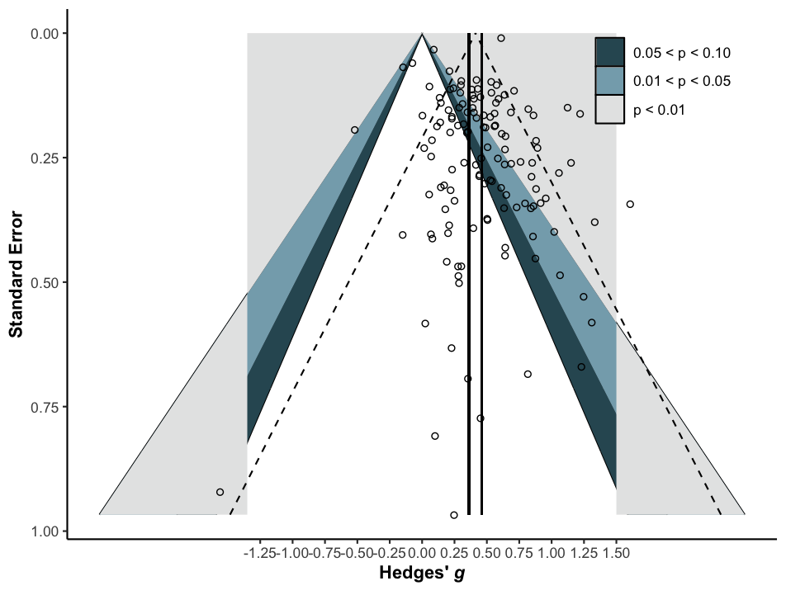

Cancer
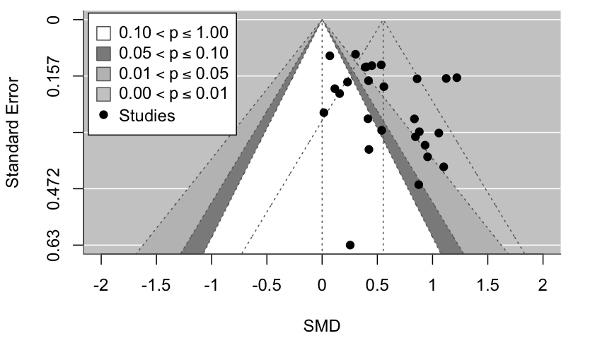

Cardiovascular Diseases
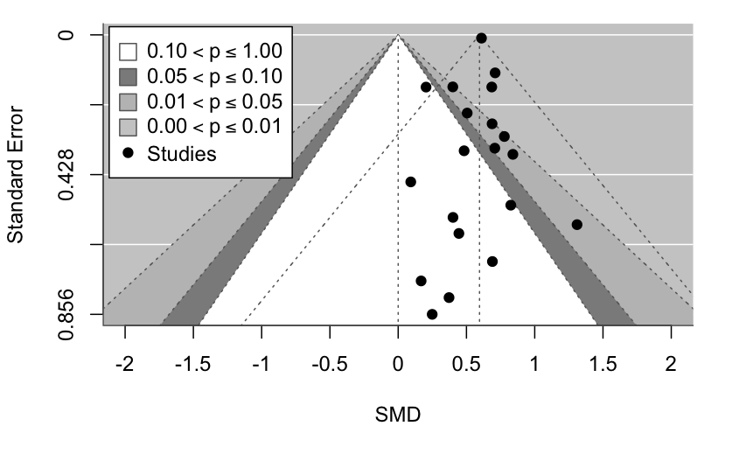

Mental Health Conditions
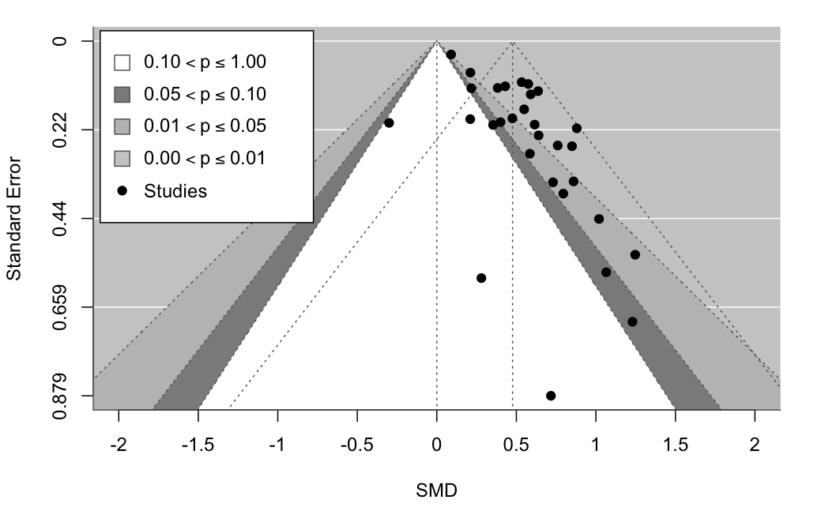

Neurological Conditions
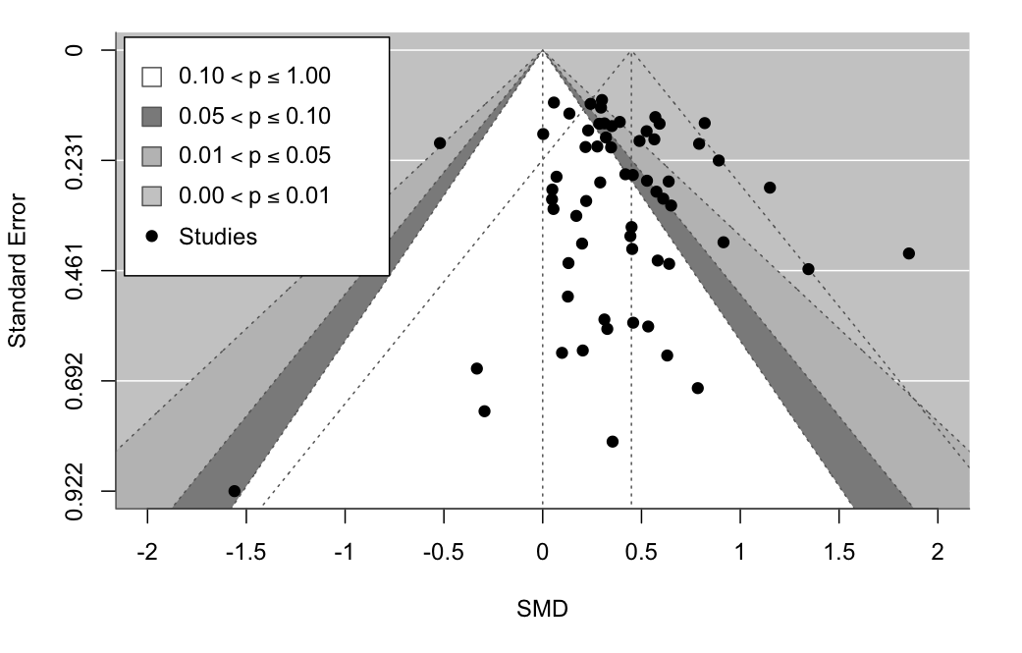

Supplementary material 11: Video examples of arts-based interventions
ParkinSong is a therapeutic, group-based singing program specifically designed for people living with Parkinson’s disease. It is an evidence-based intervention developed by music therapists and speech pathologists to help address the voice, speech, and communication difficulties often caused by Parkinson’s. This clip presents footage of a ParkinSong choir in action as well as interviews with chief investigator A/Prof Jeanette Tamplin, ParkinSong facilitators and participants: https://youtu.be/ro69ZJUrXkE

Remini-Sing is a therapeutic choir program designed for people living with dementia in the community and their family care partners. The 90-minute weekly music therapist facilitated choir sessions focus on enhancing emotional wellbeing, social connection, and relationship quality: https://youtu.be/fK2VLzMJSWM

Charlotte: Music and postnatal depression: This film follows the story of Charlotte who, after her daughter Cara was born, suffered from postnatal depression. In addition to working with a psychotherapist and counsellor, Charlotte began going to Melodies for Mums, a singing group specifically designed for women experiencing postnatal depression. This is her story about discovering the joy of singing with her baby. Produced by WHO Europe: https://www.jameelartshealthlab.org/outreach/films/arts-and-health-stories-charlotte

Arve: Music Therapy and Addiction
This film follows the story of Arve who battled substance addiction for over a decade, but is now living drug-free and finding positivity and purpose through music therapy. Produced by WHO Europe: https://www.jameelartshealthlab.org/outreach/films/art-and-health-stories-arve

Psychodrama and drama therapy: this clip presents testimonies of participants in a randomized controlled trial of a 12-week tele-drama-based intervention aimed at improving social connectedness, well-being, and depressive symptoms among 111 adults with constricted life-space mobility: https://youtu.be/2q8gFh04wpE

Drama Therapy and eating disorders
This film documents a section of the CoActive Therapeutic Theatre protocol in drama therapy as used to treat disordered eating behaviors. Produced by the Theatre & Health Lab in the NYU Program in Drama Therapy: https://www.youtube.com/watch?v=8VhGgiowPuI

Dance Movement Therapy: This clip presents dance movement therapy with traumatized participants with intellectual disabilities after the Ahrvalley flood (Germany) of 2021 (Production by Help, e.V): Tanztherapie im Ahrtal | Help – Hilfe zur Selbsthilfe

Bengt: Dance and Parkinson's Disease: This film follows the story of Bengt, after being diagnosed with Parkinson’s disease, struggled to find meaning and purpose in life. This is his story about learning to live with a life-long disease and finding joy through dance. Produced by WHO Europe: https://www.jameelartshealthlab.org/outreach/films/arts-and-health-stories-bengt

Art Therapy: This clip presents the use of art therapy in a hospital setting with patients with various needs: https://www.youtube.com/watch?v=8e-clYqNA0I

Arts for the Blues: Arts for the Blues is an arts-based group psychotherapy for depression developed by arts therapists, psychologists, artists and researchers at the universities of Edge Hill and Salford in the North West of England. It is an evidence-based model used with children and adults that incorporates visual arts, movement, creative writing, and music making: https://www.youtube.com/watch?v=7NGUQglXItQ&t=2s

Manjusha: Expressive Art Therapy and Cancer
This film follows Manjusha as she navigates life after a diagnosis of cancer. Through her engagement with expressive arts therapy, she finds renewed strength, emotional resilience, and a sense of belonging within her community. The film highlights how the arts can support healing and wellbeing, while also revealing how creative expression opens space for Manjusha to reclaim her story, expand her sense of self, and find ways of coping that are rooted in meaning, connection, and hope. Produced by WHO Europe and the Jameel Arts & Health Lab: https://www.jameelartshealthlab.org/outreach/films/art-and-health-stories-arve-2

References
1. NCD Alliance. Cancer [Internet]. Geneva, Switzerland: NCD Alliance; 2017 [cited 2024 Aug 2]. Available from: https://ncdalliance.org/why-ncds/ncds/cancer.
2. NCD Alliance. Cardiovascular diseases [Internet]. Geneva, Switzerland: NCD Alliance; 2017 [cited 2024 Aug 2]. Available from: https://ncdalliance.org/why-ncds/ncds/cardiovascular-diseases.
3. NCD Alliance. Chronic respiratory diseases [Internet]. Geneva, Switzerland: NCD Alliance; 2017 [cited 2024 Aug 2]. Available from: https://ncdalliance.org/why-ncds/ncds/chronic-respiratory-diseases-0.
4. NCD Alliance. Diabetes [Internet]. Geneva, Switzerland: NCD Alliance; 2017 [cited 2024 Aug 2]. Available from: https://ncdalliance.org/why-ncds/ncds/diabetes.
5. NCD Alliance. Mental health and neurological disorders [Internet]. Geneva, Switzerland: NCD Alliance; 2017 [cited 2024 Aug 2]. Available from: https://ncdalliance.org/why-ncds/ncds/mental-health-and-neurological-disorders.
6. Bradt J, Dileo C, Myers-Coffman K, Biondo J. Music interventions for improving psychological and physical outcomes in people with cancer. Cochrane Database Syst Rev. 2021;10(10):CD006911.doi:10.1002/14651858.CD006911.pub4
7. Bradt J, Shim M, Goodill SW. Dance/movement therapy for improving psychological and physical outcomes in cancer patients. Cochrane Database Syst Rev. 2015;1(1):Cd007103.doi:10.1002/14651858.CD007103.pub3
8. Bro ML, Jespersen KV, Hansen JB, Vuust P, Abildgaard N, Gram J, et al. Kind of blue: a systematic review and meta-analysis of music interventions in cancer treatment. Psychooncology. 2018;27(2):386-400.doi:10.1002/pon.4470
9. Cheng P, Xu L, Zhang J, Liu W, Zhu J. Role of arts therapy in patients with breast and gynecological cancers: a systematic review and meta-analysis. J Palliat Med. 2021;24(3):443-52.doi:10.1089/jpm.2020.0468
10. da Silva Santa IN, Schveitzer MC, dos Santos M, Ghelman R, Filho VO. Music interventions in pediatric oncology: systematic review and meta-analysis. Complement Ther Med. 2021;59:102725.doi:10.1016/j.ctim.2021.102725
11. Geng L, Duan Y, Li X, Yue S, Li R, Liu H, et al. Comparative efficacy of mind-body exercise for depression in breast cancer survivors: a systematic review and network meta-analysis. Worldviews Evid Based Nurs. 2023;20(6):593-609.doi:10.1111/wvn.12669
12. Hung TT, Liu YC, Tsai PC, Lin MF. The pain-relief efficacy of passive music-based interventions in cancer patients undergoing diagnostic biopsies and surgery: a systematic review and meta-analysis. Hu Li Za Zhi. 2018;65(1):70-82.doi:10.6224/jn.201802_65(1).10
13. Jiang XH, Chen XJ, Xie QQ, Feng YS, Chen S, Peng JS. Effects of art therapy in cancer care: a systematic review and meta-analysis. Eur J Cancer Care (Engl). 2020;29(5):e13277.doi:10.1111/ecc.13277
14. Jiang S-f, Yao Q, Sun H-q, Ding L. Effect of music therapy on sleep quality in lung cancer patients: a meta-analysis. Chin J Convalescent Med. 2023;32(9):909-14.doi:10.13517/j.cnki.ccm.2023.09.004
15. Köhler F, Martin ZS, Hertrampf RS, Gäbel C, Kessler J, Ditzen B, et al. Music therapy in the psychosocial treatment of adult cancer patients: a systematic review and meta-analysis. Front Psychol. 2020;11:651.doi:10.3389/fpsyg.2020.00651
16. Li Y, Xing X, Shi X, Yan P, Chen Y, Li M, et al. The effectiveness of music therapy for patients with cancer: a systematic review and meta-analysis. J Adv Nurs. 2020;76(5):1111-23.doi:10.1111/jan.14313
17. Nelson E, Kelly D, Ni Bhriain O, Garry F, Clifford AM, Allardyce JM. The effectiveness of community dance in people with cancer: a mixed-methods systematic review and meta-analysis. Health Promot Int. 2023;38(4).doi:10.1093/heapro/daad077
18. Nguyen KT, Xiao J, Chan DNS, Zhang M, Chan CWH. Effects of music intervention on anxiety, depression, and quality of life of cancer patients receiving chemotherapy: a systematic review and meta-analysis. Support Care Cancer. 2022;30(7):5615-26.doi:10.1007/s00520-022-06881-2
19. Nightingale CL, Rodriguez C, Carnaby G. The impact of music interventions on anxiety for adult cancer patients: a meta-analysis and systematic review. Integr Cancer Ther. 2013;12(5):393-403.doi:10.1177/1534735413485817
20. Puetz TW, Morley CA, Herring MP. Effects of creative arts therapies on psychological symptoms and quality of life in patients with cancer. JAMA Intern Med. 2013;173(11):960-9.doi:10.1001/jamainternmed.2013.836
21. Qi Y, Lin L, Dong B, Xu E, Bao Z, Qi J, et al. Music interventions can alleviate cancer-related fatigue: a metaanalysis. Support Care Cancer. 2021;29(7):3461-70.doi:10.1007/s00520-021-05986-4
22. Sezgin MG, Bektas H. The effect of music therapy interventions on fatigue in patients with hematological cancers: a systematic review and meta-analysis of randomized controlled trials. Support Care Cancer. 2022;30(11):8733-44.doi:10.1007/s00520-022-07198-w
23. Tang Y, Fu F, Gao H, Shen L, Chi I, Bai Z. Art therapy for anxiety, depression, and fatigue in females with breast cancer: a systematic review. J Psychosoc Oncol. 2019;37(1):79-95.doi:10.1080/07347332.2018.1506855
24. Tsai HF, Chen YR, Chung MH, Liao YM, Chi MJ, Chang CC, et al. Effectiveness of music intervention in ameliorating cancer patients' anxiety, depression, pain, and fatigue: a meta-analysis. Cancer Nurs. 2014;37(6):E35-50.doi:10.1097/NCC.0000000000000116
25. Wang X, Zhang Y, Fan Y, Tan XS, Lei X. Effects of music intervention on the physical and mental status of patients with breast cancer: a systematic review and meta-analysis. Breast Care (Basel). 2018;13(3):183-90.doi:10.1159/000487073
26. Wei TT, Tian X, Zhang FY, Qiang WM, Bai AL. Music interventions for chemotherapy-induced nausea and vomiting: a systematic review and meta-analysis. Support Care Cancer. 2020;28(9):4031-41.doi:10.1007/s00520-020-05409-w
27. Xia Y, An X, Xue Y, Wang H. Effect of painting therapy on adult malignant tumor patients: A systematic review <绘画疗法对成年恶性肿瘤病人干预效果的系统评价-循证护理>. Chinese Evidence-based Nursing. 2023;9(10):1738-44.doi:10.12102/j.issn.2095-8668.2023.10.005
28. Xu L, Cheng P, Wu Y, Zhang J, Zhu J, Cui J, et al. The effects of art therapy on anxiety and depression in breast cancer patients: an updated meta-analysis. Eur J Cancer Care (Engl). 2020;29(5):e13266.doi:10.1111/ecc.13266
29. Yang T, Wang S, Wang R, Wei Y, Kang Y, Liu Y, et al. Effectiveness of five-element music therapy in cancer patients: a systematic review and meta-analysis. Complement Ther Clin Pract. 2021;44:101416.doi:10.1016/j.ctcp.2021.101416
30. Yangöz ST, Özer Z. The effect of music intervention on patients with cancer-related pain: a systematic review and meta-analysis of randomized controlled trials. J Adv Nurs. 2019;75(12):3362-73.doi:10.1111/jan.14184
31. Zhang JM, Wang P, Yao JX, Zhao L, Davis MP, Walsh D, et al. Music interventions for psychological and physical outcomes in cancer: a systematic review and meta-analysis. Support Care Cancer. 2012;20(12):3043-53.doi:10.1007/s00520-012-1606-5
32. Zhang MF, Wen YS, Liu WY, Peng LF, Wu XD, Liu QW. Effectiveness of mindfulness-based therapy for reducing anxiety and depression in patients with cancer: a meta-analysis. Medicine (Baltimore). 2015;94(45):e0897-0.doi:10.1097/MD.0000000000000897
33. Zhang C, Xu S, Wen X, Liu M. The effect of expressive writing on Chinese cancer patients: a systematic review and meta‐analysis of randomized control trails. Clin Psychol Psychother. 2023;30(6):1357-68.doi:10.1002/cpp.2878
34. Bradt J, Dileo C, Potvin N. Music for stress and anxiety reduction in coronary heart disease patients. Cochrane Database Syst Rev. 2013;2013(12):Cd006577.doi:10.1002/14651858.CD006577.pub3
35. Cao M, Zhang Z. Adjuvant music therapy for patients with hypertension: a meta-analysis and systematic review. BMC Complement Med Ther. 2023;23(1):110.doi:10.1186/s12906-023-03929-6
36. Chan MWM, Lo SHS, Sit JWH, Choi KC, Tao A. Effects of visual arts-based interventions on physical and psychosocial outcomes of people with stroke: a systematic review and meta-analysis. Int J Nurs Stud Adv. 2023;5:100126.doi:10.1016/j.ijnsa.2023.100126
37. Chandrababu R, Ramesh J, Devi ES, Nayak BS, George A. Effectiveness of music on anxiety and pain among cardiac surgery patients: a quantitative systematic review and meta-analysis of randomized controlled trials. Int J Nurs Pract. 2021;27(4):e12928.doi:10.1111/ijn.12928
38. Conceição LSR, Neto MG, do Amaral MAS, Martins-Filho PRS, Carvalho VO. Effect of dance therapy on blood pressure and exercise capacity of individuals with hypertension: a systematic review and meta-analysis. Int J Cardiol. 2016;220:553-7.doi:10.1016/j.ijcard.2016.06.182
39. Dayuan Z, Lan L, Hui C, Huanjie L, Deliang L, Yihui D. The effect of music as an intervention for post-stroke depression: a systematic review and meta-analysis. Complement Ther Med. 2022;71:102901.doi:10.1016/j.ctim.2022.102901
40. do Amaral MA, Neto MG, de Queiroz JG, Martins-Filho PR, Saquetto MB, Oliveira Carvalho V. Effect of music therapy on blood pressure of individuals with hypertension: a systematic review and meta-analysis. Int J Cardiol. 2016;214:461-4.doi:10.1016/j.ijcard.2016.03.197
41. Gomes Neto M, Menezes MA, Oliveira Carvalho V. Dance therapy in patients with chronic heart failure: a systematic review and a meta-analysis. Clin Rehabil. 2014;28(12):1172-9.doi:10.1177/0269215514534089
42. Jayakar JP, Alter DA. Music for anxiety reduction in patients undergoing cardiac catheterization: a systematic review and meta-analysis of randomized controlled trials. Complement Ther Clin Pract. 2017;28:122-30.doi:10.1016/j.ctcp.2017.05.011
43. Kakar E, Billar RJ, van Rosmalen J, Klimek M, Takkenberg JJM, Jeekel J. Music intervention to relieve anxiety and pain in adults undergoing cardiac surgery: a systematic review and meta-analysis. Open Heart. 2021;8(1).doi:10.1136/openhrt-2020-001474
44. Lee Y, Chen B, Fong MWM, Lee JM, Nicol GE, Lenze EJ, et al. Effectiveness of non-pharmacological interventions for treating post-stroke depressive symptoms: systematic review and meta-analysis of randomized controlled trials. Top Stroke Rehabil. 2021;28(4):289-320.doi:10.1080/10749357.2020.1803583
45. Liu Q, Li W, Yin Y, Zhao Z, Yang Y, Zhao Y, et al. The effect of music therapy on language recovery in patients with aphasia after stroke: a systematic review and meta-analysis. Neurol Sci. 2022;43(2):863-72.doi:10.1007/s10072-021-05743-9
46. Liu M, Ni R, Huang S, Yang X, Lin Q, Lin P, et al. Efficacy of non-pharmacological interventions in pain relief and opioid consumption after cardiac surgery: a systematic review and Bayesian network meta-analysis. J Clin Nurs. 2023;32(15-16):4626-37.doi:10.1111/jocn.16482
47. Magee WL, Clark I, Tamplin J, Bradt J. Music interventions for acquired brain injury. Cochrane Database Syst Rev. 2017;1(1):CD006787.doi:10.1002/14651858.CD006787.pub3
48. Peng Y, Su Y, Wang YD, Yuan LR, Wang R, Dai JS. Effects of regular dance therapy intervention on blood pressure in hypertension individuals: a systematic review and meta-analysis. J Sports Med Phys Fitness. 2021;61(2):301-9.doi:10.23736/s0022-4707.20.11088-0
49. Roche Bueno JC, Mincholé Lapuente E. Efficacy of music therapy in functional recovery of the upper limb after a stroke: a systematic review and meta-analysis. Rehabilitacion (Madr). 2019;53(3):181-8.doi:10.1016/j.rh.2019.02.002
50. Su SF, Yeh WT. Music interventions in percutaneous coronary procedures: a meta-analysis. Clin Nurs Res. 2021;30(2):135-45.doi:10.1177/1054773819883171
51. Wang Y, Wei J, Guan X, Zhang Y, Zhang Y, Zhang N, et al. Music intervention in pain relief of cardiovascular patients in cardiac procedures: a systematic review and meta-analysis. Pain Med. 2020;21(11):3055-65.doi:10.1093/pm/pnaa148
52. Wang L, Peng JL, Xiang W, Huang YJ, Chen AL. Effects of rhythmic auditory stimulation on motor function and balance ability in stroke: a systematic review and meta-analysis of clinical randomized controlled studies. Front Neurosci. 2022;16:1043575.doi:10.3389/fnins.2022.1043575
53. Yang Y, Fang YY, Gao J, Geng GL. Effects of five-element music on language recovery in patients with poststroke aphasia: a systematic review and meta-analysis. J Altern Complement Med. 2019;25(10):993-1004.doi:10.1089/acm.2018.0479
54. Yoo GE, Kim SJ. Rhythmic auditory cueing in motor rehabilitation for stroke patients: systematic review and meta-analysis. J Music Ther. 2016;53(2):149-77.doi:10.1093/jmt/thw003
55. Zhang Y, Cai J, Zhang Y, Ren T, Zhao M, Zhao Q. Improvement in stroke-induced motor dysfunction by music-supported therapy: a systematic review and meta-analysis. Sci Rep. 2016;6:38521.doi:10.1038/srep38521
56. Yang Q, Shao Q, Xu Q, Shi H, Li L. Art therapy alleviates the levels of depression and blood glucose in diabetic patients: a systematic review and meta-analysis. Front Psychol. 2021;12:639626.doi:10.3389/fpsyg.2021.639626
57. Aalbers S, Fusar‐Poli L, Freeman RE, Spreen M, Ket JCF, Vink AC, et al. Music therapy for depression. Cochrane Database Syst Rev. 2017;2017(11):CD004517-CD.doi:10.1002/14651858.CD004517.pub3
58. Abbing A, Haeyen S, Nyapati S, Verboon P, van Hooren S. Effectiveness and mechanisms of the arts therapies in forensic care. A systematic review, narrative synthesis, and meta analysis. Front Psychiatry. 2023;14:1128252.doi:10.3389/fpsyt.2023.1128252
59. Atchison K, Watt JA, Ewert D, Toohey AM, Ismail Z, Goodarzi Z. Non-pharmacologic and pharmacologic treatments for anxiety in long-term care: a systematic review and meta-analysis. Age Ageing. 2022;51(9).doi:10.1093/ageing/afac195
60. Bighelli I, Wallis S, Reitmeir C, Schwermann F, Salahuddin NH, Leucht S. Effects of psychological treatments on functioning in people with Schizophrenia: a systematic review and meta-analysis of randomized controlled trials. Eur Arch Psychiatry Clin Neurosci. 2023;273(4):779-810.doi:10.1007/s00406-022-01526-1
61. Chen YJ, Li XX, Pan B, Wang B, Jing GZ, Liu QQ, et al. Non-pharmacological interventions for older adults with depressive symptoms: a network meta-analysis of 35 randomized controlled trials. Aging Ment Health. 2021;25(5):773-86.doi:10.1080/13607863.2019.1704219
62. de Witte M, Pinho ADS, Stams GJ, Moonen X, Bos AER, van Hooren S. Music therapy for stress reduction: a systematic review and meta-analysis. Health Psychol Rev. 2022;16(1):134-59.doi:10.1080/17437199.2020.1846580
63. Geipel J, Koenig J, Hillecke TK, Resch F, Kaess M. Music-based interventions to reduce internalizing symptoms in children and adolescents: a meta-analysis. J Affect Disord. 2018;225:647-56.doi:10.1016/j.jad.2017.08.035
64. Geretsegger M, Mössler KA, Bieleninik L, Chen XJ, Heldal TO, Gold C. Music therapy for people with schizophrenia and schizophrenia-like disorders. Cochrane Database Syst Rev. 2017;5(5):CD004025.doi:10.1002/14651858.CD004025.pub4
65. Gerger H, Werner CP, Gaab J, Cuijpers P. Comparative efficacy and acceptability of expressive writing treatments compared with psychotherapy, other writing treatments, and waiting list control for adult trauma survivors: a systematic review and network meta-analysis. Psychol Med. 2022;52(15):1-13.doi:10.1017/S0033291721000143
66. Ghetti C, Chen XJ, Brenner AK, Hakvoort LG, Lien L, Fachner J, et al. Music therapy for people with substance use disorders. Cochrane Database Syst Rev. 2022;5(5):CD012576.doi:10.1002/14651858.CD012576.pub3
67. Gold C, Solli HP, Krüger V, Lie SA. Dose-response relationship in music therapy for people with serious mental disorders: systematic review and meta-analysis. Clin Psychol Rev. 2009;29(3):193-207.doi:10.1016/j.cpr.2009.01.001
68. Guo S, Liu F, Shen J, Wei M, Yang Y. Comparative efficacy of seven exercise interventions for symptoms of depression in college students: a network of meta-analysis. Medicine (Baltimore). 2020;99(47):e23058.doi:10.1097/MD.0000000000023058
69. Jenabi E, Bashirian S, Ayubi E, Rafiee M, Bashirian M. The effect of the art therapy interventions on depression symptoms among older adults: a meta-analysis of controlled clinical trials. J Geriatr Psychiatry Neurol. 2023;36(3):185-92.doi:10.1177/08919887221130264
70. Jia R, Liang D, Yu J, Lu G, Wang Z, Wu Z, et al. The effectiveness of adjunct music therapy for patients with schizophrenia: a meta-analysis. Psychiatry Res. 2020;293:113464.doi:10.1016/j.psychres.2020.113464
71. Jiang L, Alizadeh F, Cui W. Effectiveness of drama-based intervention in improving mental health and well-being: a systematic review and meta-analysis during the COVID-19 pandemic and post-pandemic period. Healthcare (Basel). 2023;11(6).doi:10.3390/healthcare11060839
72. Karkou V, Aithal S, Zubala A, Meekums B. Effectiveness of dance movement therapy in the treatment of adults with depression: a systematic review with meta-analyses. Front Psychol. 2019;10:936.doi:10.3389/fpsyg.2019.00936
73. Koch SC, Riege RFF, Tisborn K, Biondo J, Martin L, Beelmann A. Effects of dance movement therapy and dance on health-related psychological outcomes. A meta-analysis update. Front Psychol. 2019;10:1806.doi:10.3389/fpsyg.2019.01806
74. Laws KR, Conway W. Do adjunctive art therapies reduce symptomatology in schizophrenia? A meta-analysis. World J Psychiatry. 2019;9(8):107-20.doi:10.5498/wjp.v9.i8.107
75. Lutgens D, Gariepy G, Malla A. Psychological and psychosocial interventions for negative symptoms in psychosis: systematic review and meta-analysis. Br J Psychiatry. 2017;210(5):324-32.doi:10.1192/bjp.bp.116.197103
76. Meekums B, Karkou V, Nelson EA. Dance movement therapy for depression. Cochrane Database Syst Rev. 2015;2016(6).doi:10.1002/14651858.CD009895.pub2
77. Orkibi H, Keisari S, Sajnani NL, de Witte M. Effectiveness of drama-based therapies on mental health outcomes: a systematic review and meta-analysis of controlled studies. Psychol Aesthet Creat Arts. 2023.doi:10.1037/aca0000582
78. Reinhold M, Bürkner P-C, Holling H. Effects of expressive writing on depressive symptoms—a meta-analysis. Clin Psychol (New York). 2018;25(1).doi:10.1111/cpsp.12224
79. Sabeena PK, Kumar VS. Psycho-social intervention for managing depression among older adults—a meta-analysis. J Evid Based Psychother. 2022;22(2):1-30.doi:10.24193/jebp.2022.2.10
80. Steenhuis LA, Nauta MH, Bocking CL, Pijnenborg GH. Treating depressive symptoms in psychosis: a network meta-analysis on the effects of non-verbal therapies. PLoS One. 2015;10(10):e0140637.doi:10.1371/journal.pone.0140637
81. Tang Q, Huang Z, Zhou H, Ye P. Effects of music therapy on depression: a meta-analysis of randomized controlled trials. PLoS One. 2020;15(11):e0240862.doi:10.1371/journal.pone.0240862
82. Tseng PT, Chen YW, Lin PY, Tu KY, Wang HY, Cheng YS, et al. Significant treatment effect of adjunct music therapy to standard treatment on the positive, negative, and mood symptoms of schizophrenic patients: a meta-analysis. BMC Psychiatry. 2016;16:16.doi:10.1186/s12888-016-0718-8
83. Yan X, Chen T, Peng S, Liu Q, Xu X. Intervention effect of five-element music therapy for patients with depression: a meta-analysis. Nursing of Integrated Traditional Chinese and Western Medicine. 2019;5(10):1-5.doi:10.11997/nitcwm.201910001
84. Yang WJ, Bai YM, Qin L, Xu XL, Bao KF, Xiao JL, et al. The effectiveness of music therapy for postpartum depression: a systematic review and meta-analysis. Complement Ther Clin Pract. 2019;37:93-101.doi:10.1016/j.ctcp.2019.09.002
85. Yijing C, Jie C, Bingxiang Y. Systematic review of dance movement therapy effect on depression patients. Chinese Nursing Research. 2018;32(10):1543-50.doi:10.12102/j.issn.1009-6493.2018.10.014
86. Zhao K, Bai ZG, Bo A, Chi I. A systematic review and meta-analysis of music therapy for the older adults with depression. Int J Geriatr Psychiatry. 2016;31(11):1188-98.doi:10.1002/gps.4494
87. Álvarez-Bueno C, Deeks JJ, Cavero-Redondo I, Jolly K, Torres-Costoso AI, Price M, et al. Effect of exercise on motor symptoms in patients with Parkinson's disease: a network meta-analysis. J Geriatr Phys Ther. 2023;46(2):E87-E105.doi:10.1519/JPT.0000000000000322
88. Barnish MS, Barran SM. A systematic review of active group-based dance, singing, music therapy and theatrical interventions for quality of life, functional communication, speech, motor function and cognitive status in people with Parkinson's disease. BMC Neurol. 2020;20(1):371.doi:10.1186/s12883-020-01938-3
89. Batubara SO, Saragih ID, Mulyadi M, Lee BO. Effects of art therapy for people with mild or major neurocognitive disorders: a systematic review and meta-analysis. Arch Psychiatr Nurs. 2023;45:61-71.doi:10.1016/j.apnu.2023.04.011
90. Bian X, Wang Y, Zhao X, Zhang Z, Ding C. Does music therapy affect the global cognitive function of patients with dementia? A meta-analysis. NeuroRehabilitation. 2021;48(4):553-62.doi:10.3233/NRE-210018
91. Burley CV, Burns K, Lam BCP, Brodaty H. Nonpharmacological approaches reduce symptoms of depression in dementia: a systematic review and meta-analysis. Ageing Res Rev. 2022;79:101669.doi:10.1016/j.arr.2022.101669
92. Carapellotti AM, Stevenson R, Doumas M. The efficacy of dance for improving motor impairments, non-motor symptoms, and quality of life in Parkinson's disease: a systematic review and meta-analysis. PLoS One. 2020;15(8):e0236820.doi:10.1371/journal.pone.0236820
93. Chan JSY, Wu J, Deng K, Yan JH. The effectiveness of dance interventions on cognition in patients with mild cognitive impairment: a meta-analysis of randomized controlled trials. Neurosci Biobehav Rev. 2020;118:80-8.doi:10.1016/j.neubiorev.2020.07.017
94. Chang YS, Chu H, Yang CY, Tsai JC, Chung MH, Liao YM, et al. The efficacy of music therapy for people with dementia: a meta-analysis of randomised controlled trials. J Clin Nurs. 2015;24(23-24):3425-40.doi:10.1111/jocn.12976
95. Chen T, Wen R, Liu H, Zhong X, Jiang C. Dance intervention for negative symptoms in individuals with autism spectrum disorder: a systematic review and meta-analysis. Complement Ther Clin Pract. 2022;47:101565.doi:10.1016/j.ctcp.2022.101565
96. de Almeida HS, Porto F, Porretti M, Lopes G, Fiorot D, Bunn PDS, et al. Effect of dance on postural control in people with Parkinson's disease: a meta-analysis review. J Aging Phys Act. 2021;29(1):130-41.doi:10.1123/japa.2019-0255
97. de Dreu MJ, van der Wilk AS, Poppe E, Kwakkel G, van Wegen EE. Rehabilitation, exercise therapy and music in patients with Parkinson's disease: a meta-analysis of the effects of music-based movement therapy on walking ability, balance and quality of life. Parkinsonism Relat Disord. 2012;18 Suppl 1:S114-9.doi:10.1016/S1353-8020(11)70036-0
98. Dorris JL, Neely S, Terhorst L, VonVille HM, Rodakowski J. Effects of music participation for mild cognitive impairment and dementia: a systematic review and meta-analysis. J Am Geriatr Soc. 2021;69(9):2659-67.doi:10.1111/jgs.17208
99. dos Santos Delabary M, Komeroski IG, Monteiro EP, Costa RR, Haas AN. Effects of dance practice on functional mobility, motor symptoms and quality of life in people with Parkinson's disease: a systematic review with meta-analysis. Aging Clin Exp Res. 2018;30(7):727-35.doi:10.1007/s40520-017-0836-2
100. Ernst M, Folkerts AK, Gollan R, Lieker E, Caro-Valenzuela J, Adams A, et al. Physical exercise for people with Parkinson's disease: a systematic review and network meta-analysis. Cochrane Database Syst Rev. 2024;4(4):CD013856.doi:10.1002/14651858.CD013856.pub3
101. Fusar-Poli L, Bieleninik L, Brondino N, Chen XJ, Gold C. The effect of music therapy on cognitive functions in patients with dementia: a systematic review and meta-analysis. Aging Ment Health. 2018;22(9):1097-106.doi:10.1080/13607863.2017.1348474
102. Geretsegger M, Fusar-Poli L, Elefant C, Mössler KA, Vitale G, Gold C. Music therapy for autistic people. Cochrane Database Syst Rev. 2022;5(5):CD004381.doi:10.1002/14651858.CD004381.pub4
103. Ghai S, Ghai I. Effects of rhythmic auditory cueing in gait rehabilitation for multiple sclerosis: a mini systematic review and meta-analysis. Front Neurol. 2018;9:386.doi:10.3389/fneur.2018.00386
104. Ghai S, Ghai I, Narciss S. Auditory stimulation improves gait and posture in cerebral palsy: a systematic review with between- and within-group meta-analysis. Children (Basel). 2022;9(11).doi:10.3390/children9111752
105. Goh L, Canning CG, Song J, Clemson L, Allen NE. The effect of rehabilitation interventions on freezing of gait in people with Parkinson's disease is unclear: a systematic review and meta-analyses. Disabil Rehabil. 2023;45(19):3199-218.doi:10.1080/09638288.2022.2120099
106. Hao Z, Zhang X, Chen P. Effects of ten different exercise interventions on motor function in Parkinson's disease patients—a network meta-analysis of randomized controlled trials. Brain Sci. 2022;12(6).doi:10.3390/brainsci12060698
107. Hasan SM, Alshafie S, Hasabo EA, Saleh M, Elnaiem W, Qasem A, et al. Efficacy of dance for Parkinson's disease: a pooled analysis of 372 patients. J Neurol. 2022;269(3):1195-208.doi:10.1007/s00415-021-10589-4
108. Hidalgo-Agudo RD, Lucena-Anton D, Luque-Moreno C, Heredia-Rizo AM, Moral-Munoz JA. Additional physical interventions to conventional physical therapy in Parkinson's disease: a systematic review and meta-analysis of randomized clinical trials. J Clin Med. 2020;9(4).doi:10.3390/jcm9041038
109. Ismail SR, Lee SWH, Merom D, Megat Kamaruddin PSN, Chong MS, Ong T, et al. Evidence of disease severity, cognitive and physical outcomes of dance interventions for persons with Parkinson's disease: a systematic review and meta-analysis. BMC Geriatr. 2021;21(1):503.doi:10.1186/s12877-021-02446-w
110. Ito E, Nouchi R, Dinet J, Cheng CH, Husebø BS. The effect of music-based intervention on general cognitive and executive functions, and episodic memory in people with mild cognitive impairment and dementia: a systematic review and meta-analysis of recent randomized controlled trials. Healthcare (Basel). 2022;10(8).doi:10.3390/healthcare10081462
111. Jin B, Xv Y, Zhang B, Qiao L, Liu H. Comparative efficacy and acceptability of treatments for depressive symptoms in cognitive impairment: a systematic review and Bayesian network meta-analysis. Front Aging Neurosci. 2022;14:1037414.doi:10.3389/fnagi.2022.1037414
112. Kalyani HHN, Sullivan K, Moyle G, Brauer S, Jeffrey ER, Roeder L, et al. Effects of dance on gait, cognition, and dual-tasking in Parkinson’s disease: a systematic review and meta-analysis. J Parkinsons Dis. 2019;9:335-49.doi:10.3233/JPD-181516
113. Ke X, Song W, Yang M, Li J, Liu W. Effectiveness of music therapy in children with autism spectrum disorder: a systematic review and meta-analysis. Front Psychiatry. 2022;13:905113.doi:10.3389/fpsyt.2022.905113
114. Kim EY, Hwang SD, Kim EJ. Stimulation-oriented interventions for behavioral problems among people with dementia: a systematic review and meta-analysis. J Korean Acad Nurs. 2016;46(4):475-89.doi:10.4040/jkan.2016.46.4.475
115. Kong E-H, Park M. Effects of music therapy on agitation in dementia: systematic review and meta-analysis. Korean J Adult Nurs. 2015;27(1)
116. Kwok JY, Choi KC, Chan HY. Effects of mind-body exercises on the physiological and psychosocial well-being of individuals with Parkinson's disease: a systematic review and meta-analysis. Complement Ther Med. 2016;29:121-31.doi:10.1016/j.ctim.2016.09.016
117. Lee H, Ko B. Effects of music-based interventions on motor and non-motor symptoms in patients with Parkinson's disease: a systematic review and meta-analysis. Int J Environ Res Public Health. 2023;20(2).doi:10.3390/ijerph20021046
118. Li X, Gao Z, Yu H, Gu Y, Yang G. Effect of long-term exercise therapy on motor symptoms in Parkinson disease patients: a systematic review and meta-analysis of randomized controlled trials. Am J Phys Med Rehabil. 2022;101(10):905-12.doi:10.1097/PHM.0000000000002052
119. Liang JH, Lin L, Wang YQ, Jia RX, Qu XY, Li J, et al. Non-pharmacological therapeutic strategy options for patients with dementia based on cognitive function—a Bayesian network meta-analysis of randomized controlled trials. Ageing Res Rev. 2019;56:100965.doi:10.1016/j.arr.2019.100965
120. Liang JH, Xu Y, Lin L, Jia RX, Zhang HB, Hang L. Comparison of multiple interventions for older adults with Alzheimer disease or mild cognitive impairment: a PRISMA-compliant network meta-analysis. Medicine (Baltimore). 2018;97(20):e10744.doi:10.1097/MD.0000000000010744
121. Lorenzo-García P, Nuñez de Arenas-Arroyo S, Cavero-Redondo I, Guzmán-Pavón MJ, Priego-Jiménez S, Álvarez-Bueno C. Physical exercise interventions on quality of life in Parkinson disease: a network meta-analysis. J Neurol Phys Ther. 2023;47(2):64-74.doi:10.1097/NPT.0000000000000414
122. Lötzke D, Ostermann T, Büssing A. Argentine tango in Parkinson disease—a systematic review and meta-analysis. BMC Neurol. 2015;15:226.doi:10.1186/s12883-015-0484-0
123. Masika GM, Yu DSF, Li PWC. Visual art therapy as a treatment option for cognitive decline among older adults. A systematic review and meta-analysis. J Adv Nurs. 2020;76(8):1892-910.doi:10.1111/jan.14362
124. May T, Chan ES, Lindor E, McGinley J, Skouteris H, Austin D, et al. Physical, cognitive, psychological and social effects of dance in children with disabilities: systematic review and meta-analysis. Disabil Rehabil. 2021;43(1):13-26.doi:10.1080/09638288.2019.1615139
125. Mazzarin CM, Valderramas SR, de Paula Ferreira M, Tiepolo E, Guérios L, Parisotto D, et al. Effects of dance and of tai chi on functional mobility, balance, and agility in Parkinson disease. Top Geriatr Rehabil. 2017;33(4):262-72.doi:10.1097/tgr.0000000000000163
126. Mishra R, Florez-Perdomo WA, Shrivatava A, Chouksey P, Raj S, Moscote-Salazar LR, et al. Role of music therapy in traumatic brain injury: a systematic review and meta-analysis. World Neurosurg. 2021;146:197-204.doi:10.1016/j.wneu.2020.10.130
127. Moreno-Morales C, Calero R, Moreno-Morales P, Pintado C. Music therapy in the treatment of dementia: a systematic review and meta-analysis. Front Med (Lausanne). 2020;7:160.doi:10.3389/fmed.2020.00160
128. Mustafaoglu R, Ahmed I, Pang MYC. Which type of mind-body exercise is most effective in improving functional performance and quality of life in patients with Parkinson's disease? A systematic review with network meta-analysis. Acta Neurol Belg. 2022;122(6):1433-46.doi:10.1007/s13760-022-02070-4
129. Na R, Yang JH, Yeom Y, Kim YJ, Byun S, Kim K, et al. A systematic review and meta-analysis of nonpharmacological interventions for moderate to severe dementia. Psychiatry Investig. 2019;16(5):325-35.doi:10.30773/pi.2019.02.11.2
130. Pedersen SKA, Andersen PN, Lugo RG, Andreassen M, Sütterlin S. Effects of music on agitation in dementia: a meta-analysis. Front Psychol. 2017;8:742.doi:10.3389/fpsyg.2017.00742
131. Radder DLM, Ligia Silva de Lima A, Domingos J, Keus SHJ, van Nimwegen M, Bloem BR, et al. Physiotherapy in Parkinson's disease: A meta-analysis of present treatment modalities. Neurorehabil Neural Repair. 2020;34(10):871-80.doi:10.1177/1545968320952799
132. Sharp K, Hewitt J. Dance as an intervention for people with Parkinson's disease: a systematic review and meta-analysis. Neurosci Biobehav Rev. 2014;47:445-56.doi:10.1016/j.neubiorev.2014.09.009
133. Shi Z-M, Lin G-H, Xie Q. Effects of music therapy on mood, language, behavior, and social skills in children with autism: a meta-analysis. Chinese Nursing Research. 2016;3(3):137-41.doi:10.1016/j.cnre.2016.06.018
134. Simpkins C, Yang F. Do dance style and intervention duration matter in improving balance among people with Parkinson's disease? A systematic review with meta-analysis. Parkinsonism Relat Disord. 2023;106:105231.doi:10.1016/j.parkreldis.2022.105231
135. Tang L, Fang Y, Yin J. The effects of exercise interventions on Parkinson's disease: a Bayesian network meta-analysis. J Clin Neurosci. 2019;70:47-54.doi:10.1016/j.jocn.2019.08.092
136. Tsoi KKF, Chan JYC, Ng YM, Lee MMY, Kwok TCY, Wong SYS. Receptive music therapy is more effective than interactive music therapy to relieve behavioral and psychological symptoms of dementia: a systematic review and meta-analysis. J Am Med Dir Assoc. 2018;19(7):568-76.e3.doi:10.1016/j.jamda.2017.12.009
137. Ueda T, Suzukamo Y, Sato M, Izumi S. Effects of music therapy on behavioral and psychological symptoms of dementia: a systematic review and meta-analysis. Ageing Res Rev. 2013;12(2):628-41.doi:10.1016/j.arr.2013.02.003
138. van der Steen JT, van Soest-Poortvliet MC, van der Wouden JC, Bruinsma MS, Scholten RJ, Vink AC. Music-based therapeutic interventions for people with dementia. Cochrane Database Syst Rev. 2017;5(5):CD003477.doi:10.1002/14651858.CD003477.pub3
139. Wang YQ, Jia RX, Liang JH, Li J, Qian S, Li JY, et al. Effects of non-pharmacological therapies for people with mild cognitive impairment. A Bayesian network meta-analysis. Int J Geriatr Psychiatry. 2020;35(6):591-600.doi:10.1002/gps.5289
140. Wang K, Li K, Zhang P, Ge S, Wen X, Wu Z, et al. Mind–body exercises for non-motor symptoms of patients with Parkinson’s disease: a systematic review and meta-analysis. Front Aging Neurosci. 2021;13:770920-.doi:10.3389/fnagi.2021.770920
141. Wang Y, Liu M, Tan Y, Dong Z, Wu J, Cui H, et al. Effectiveness of dance-based interventions on depression for persons with MCI and dementia: a systematic review and meta-analysis. Front Psychol. 2022;12:709208.doi:10.3389/fpsyg.2021.709208
142. Wang L, Peng JL, Ou-Yang JB, Gan L, Zeng S, Wang HY, et al. Effects of rhythmic auditory stimulation on gait and motor function in Parkinson's disease: a systematic review and meta-analysis of clinical randomized controlled studies. Front Neurol. 2022;13:818559.doi:10.3389/fneur.2022.818559
143. Wang Y, Zheng T, Liao Y-T, Li L, Zhang Y. A meta-analysis of the effect of music therapy on Alzheimer’s disease. Int J Clin Exp Med. 2020;13(2):317-29
144. Wang YY, Wang XX, Chen L, Liu Y, Li YR. A systematic review and network meta-analysis comparing various non-pharmacological treatments for older people with mild cognitive impairment. Asian J Psychiatr. 2023;86:103635.doi:10.1016/j.ajp.2023.103635
145. Wei S, Mai Y, Peng W, Ma J, Sun C, Li G, et al. The effect of nonpharmacologic therapy on global cognitive functions in patients with Alzheimer's disease: an updated meta-analysis of randomized controlled trials. Int J Neurosci. 2020;130(1):28-44.doi:10.1080/00207454.2019.1638377
146. Wong C. Effectiveness of music intervention on cognitive function and neuropsychiatric symptoms in the elderly with dementia: a meta-analysis. Front Nurs. 2022;9(2):143-53.doi:10.2478/fon-2022-0020
147. Wu C, Xu Y, Guo H, Tang C, Chen D, Zhu M. Effects of aerobic exercise and mind-body exercise in Parkinson’s disease: a mixed-treatment comparison analysis. Front Aging Neurosci. 2021;13:739115-.doi:10.3389/fnagi.2021.739115
148. Yang Y, Weng Y, Song Y, Bo Y. Meta-analysis of intervention effect of music therapy on dementia patients Chinese Nursing Research 2019;33(8):1275-82.doi:10.12102/j.issn.1009-6493.2019.08.001
149. Yang Y, Wang G, Zhang S, Wang H, Zhou W, Ren F, et al. Efficacy and evaluation of therapeutic exercises on adults with Parkinson's disease: a systematic review and network meta-analysis. BMC Geriatr. 2022;22(1):813.doi:10.1186/s12877-022-03510-9
150. Ye X, Li L, He R, Jia Y, Poon W. Rhythmic auditory stimulation promotes gait recovery in Parkinson's patients: a systematic review and meta-analysis. Front Neurol. 2022;13:940419.doi:10.3389/fneur.2022.940419
151. Zhang Q, Hu J, Wei L, Jia Y, Jin Y. Effects of dance therapy on cognitive and mood symptoms in people with Parkinson's disease: a systematic review and meta-analysis. Complement Ther Clin Pract. 2019;36:12-7.doi:10.1016/j.ctcp.2019.04.005
152. Zhang Y, Cai J, An L, Hui F, Ren T, Ma H, et al. Does music therapy enhance behavioral and cognitive function in elderly dementia patients? A systematic review and meta-analysis. Ageing Res Rev. 2017;35:1-11.doi:10.1016/j.arr.2016.12.003
153. Zhou Z, Zhou R, Wei W, Luan R, Li K. Effects of music-based movement therapy on motor function, balance, gait, mental health, and quality of life for patients with Parkinson's disease: a systematic review and meta-analysis. Clin Rehabil. 2021;35(7):937-51.doi:10.1177/0269215521990526
154. Zhu Y, Zhong Q, Ji J, Ma J, Wu H, Gao Y, et al. Effects of aerobic dance on cognition in older adults with mild cognitive impairment: a systematic review and meta-analysis. J Alzheimers Dis. 2020;74(2):679-90.doi:10.3233/JAD-190681
155. Huang J, Yuan X, Zhang N, Qiu H, Chen X. Music therapy in adults with COPD. Respir Care. 2021;66(3):501-9.doi:10.4187/respcare.07489
156. Kim S-A, Kim Y-S. Singing improves lung function in chronic lung disease: systematic review and meta-analysis. Journal of Special Education & Rehabilitation Science. 2021;60(4):253-71.doi:10.23944/Jsers.2021.12.60.4.12
157. Lee AL, Desveaux L, Goldstein RS, Brooks D. Distractive auditory stimuli in the form of music in individuals with COPD: a systematic review. Chest. 2015;148(2):417-29.doi:10.1378/chest.14-2168
158. McNamara RJ, Epsley C, Coren E, McKeough ZJ. Singing for adults with chronic obstructive pulmonary disease (COPD). Cochrane Database Syst Rev. 2017;12(12):CD012296.doi:10.1002/14651858.CD012296.pub2
159. Nyssen OP, Taylor SJ, Wong G, Steed E, Bourke L, Lord J, et al. Does therapeutic writing help people with long-term conditions? Systematic review, realist synthesis and economic considerations. Health Technol Assess. 2016;20(27):vii-xxxvii, 1-367.doi:10.3310/hta20270
160. Ab Shukor NF, Han W, Lee J, Seo YJ. Crucial music components needed for speech perception enhancement of pediatric cochlear implant users: a systematic review and meta-analysis. Audiol Neurootol. 2021;26(6):389-413.doi:10.1159/000515136
161. Abdelhakim AM, Samy A, Abbas AM. Effect of music in reducing patient anxiety during colposcopy: a systematic review and meta-analysis of randomized controlled trials. Fertil Steril. 2019;112(3).doi:10.1016/j.fertnstert.2019.07.664
162. Apodaca TR, Miller WR. A meta-analysis of the effectiveness of bibliotherapy for alcohol problems. J Clin Psychol. 2003;59(3):289-304.doi:10.1002/jclp.10130
163. Auliya EP, Yudiarso A. Application of dance movement therapy to stress levels: a meta-analysis study. J Psiko Studia. 2022;11(1).doi:10.30872/psikostudia.v11i1.7273
164. Bai Z, Li Y, Yang Y, Xie C, Zhu Z, Xu Y, et al. The effectiveness of plaza dancing on psychological well-being and ill-being: a systematic review and meta-analysis. Front Psychol. 2022;13:864327.doi:10.3389/fpsyg.2022.864327
165. Bausewein C, Booth S, Gysels M, Higginson IJ. Non-pharmacological interventions for breathlessness in advanced stages of malignant and non-malignant diseases. Cochrane Database Syst Rev. 2013;2013(11):CD005623.doi:10.1002/14651858.CD005623.pub3
166. Bechtold ML, Puli SR, Othman MO, Bartalos CR, Marshall JB, Roy PK. Effect of music on patients undergoing colonoscopy: a meta-analysis of randomized controlled trials. Dig Dis Sci. 2009;54(1):19-24.doi:10.1007/s10620-008-0312-0
167. Bieleninik Ł, Ghetti C, Gold C. Music therapy for preterm infants and their parents: a meta-analysis. Pediatrics. 2016;138(3).doi:10.1542/peds.2016-0971
168. Boehm K, Cramer H, Staroszynski T, Ostermann T. Arts therapies for anxiety, depression, and quality of life in breast cancer patients: a systematic review and meta-analysis. Evid Based Complement Alternat Med. 2014;2014:103297.doi:10.1155/2014/103297
169. Bradt J, Dileo C, Shim M. Music interventions for preoperative anxiety. Cochrane Database Syst Rev. 2013;2013(6):CD006908.doi:10.1002/14651858.CD006908.pub2
170. Bradt J, Dileo C. Music therapy for end-of-life care. Cochrane Database Syst Rev. 2014(1):CD007169.10.1002/14651858.CD007169.pub2
171. Bradt J, Dileo C. Music interventions for mechanically ventilated patients. Cochrane Database Syst Rev. 2014;2014(12):CD006902.doi:10.1002/14651858.CD006902.pub3
172. Burrai F, Forton Magavern E, Micheluzzi V, Magnaghi C, Apuzzo L, Brioni E. Effectiveness of music to improve anxiety in hemodialysis patients: a systematic review and meta-analysis. Holist Nurs Pract. 2020;34(6):324-33.doi:10.1097/HNP.0000000000000411
173. Campbell ER. The effectiveness of art therapy in reducing symptoms of trauma, anxiety, and stress: a meta-analysis [dissertation]. Illinois, US: Wheaton College Graduate School; 2010.
174. Castañeda-Babarro A, Marqués-Jiménez D, Calleja-González J, Viribay A, León-Guereño P, Mielgo-Ayuso J. Effect of listening to music on Wingate Anaerobic Test performance. A systematic review and meta-analysis. Int J Environ Res Public Health. 2020;17(12).doi:10.3390/ijerph17124564
175. Castro LY. Art therapy and the effect it has on levels of aggression and hostility with inpatient psychiatric settings: a meta-analysis [thesis]. Indiana, US: Saint Mary-of-the-Woods College; 2015.
176. Chae JH, Kim YS, Han MY. Effects of non-pharmacological interventions on cancer patients with sleep disorder: a meta-analysis. Asian Oncol Nurs. 2021;21(1).doi:10.5388/aon.2021.21.1.1
177. Chan MF, Wong ZY, Thayala NV. A systematic review on the effectiveness of music listening in reducing depressive symptoms in adults. JBI Libr Syst Rev. 2010;8(31):1242-87.doi:10.11124/jbisrir-2010-163
178. Chen XJ, Leith H, Aarø LE, Manger T, Gold C. Music therapy for improving mental health problems of offenders in correctional settings: systematic review and meta-analysis. J Exp Criminol. 2016;12(2):209-28.doi:10.1007/s11292-015-9250-y
179. Chen K, Tan Y, Lu Y, Wu J, Liu X, Zhao Y. Effect of exercise on quality of life in Parkinson's disease: a systematic review and meta-analysis. Parkinsons Dis. 2020;2020:3257623.doi:10.1155/2020/3257623
180. Chen CT, Tung HH, Fang CJ, Wang JL, Ko NY, Chang YJ, et al. Effect of music therapy on improving sleep quality in older adults: a systematic review and meta-analysis. J Am Geriatr Soc. 2021;69(7):1925-32.doi:10.1111/jgs.17149
181. Cheng J, Zhang H, Bao H, Hong H. Music-based interventions for pain relief in patients undergoing hemodialysis: a PRISMA-compliant systematic review and meta-analysis. Medicine (Baltimore). 2021;100(2):e24102.doi:10.1097/MD.0000000000024102
182. Chow R, Bergner R, Prsic E. Music therapy effectiveness by duration in patients with cancer: a meta-regression. BMJ Support Palliat Care. 2023;13(1):117-20.doi:10.1136/bmjspcare-2021-003163
183. Chuang CH, Chen PC, Lee CS, Chen CH, Tu YK, Wu SC. Music intervention for pain and anxiety management of the primiparous women during labour: a systematic review and meta-analysis. J Adv Nurs. 2019;75(4):723-33.doi:10.1111/jan.13871
184. Clark IN, Taylor NF, Baker F. Music interventions and physical activity in older adults: a systematic literature review and meta-analysis. J Rehabil Med. 2012;44(9):710-9.doi:10.2340/16501977-1025
185. Cooper PK. It’s all in your head: a meta-analysis on the effects of music training on cognitive measures in schoolchildren. Int J Music Educ. 2020;38(3):321-36.doi:10.1177/0255761419881495
186. Corbijn van Willenswaard K, Lynn F, McNeill J, McQueen K, Dennis CL, Lobel M, et al. Music interventions to reduce stress and anxiety in pregnancy: a systematic review and meta-analysis. BMC Psychiatry. 2017;17(1):271.doi:10.1186/s12888-017-1432-x
187. Cuijpers P. Bibliotherapy in unipolar depression: a meta-analysis. J Behav Ther Exp Psychiatry. 1997;28(2):139-47.doi:10.1016/s0005-7916(97)00005-0
188. Dale VH. The impact of perioperative music on abdominal surgery patients' experience of postoperative pain: a systematic review and meta-analysis. J Perioper Pract. 2021;31(1-2):31-43.doi:10.1177/1750458920943375
189. Dastgheib SS, Layegh P, Sadeghi R, Foroughipur M, Shoeibi A, Gorji A. The effects of Mozart's music on interictal activity in epileptic patients: systematic review and meta-analysis of the literature. Curr Neurol Neurosci Rep. 2014;14(1):420.doi:10.1007/s11910-013-0420-x
190. de Niet G, Tiemens B, Lendemeijer B, Hutschemaekers G. Music-assisted relaxation to improve sleep quality: meta-analysis. J Adv Nurs. 2009;65(7):1356-64.doi:10.1111/j.1365-2648.2009.04982.x
191. De Silva MJ, Cooper S, Li HL, Lund C, Patel V. Effect of psychosocial interventions on social functioning in depression and schizophrenia: meta-analysis. Br J Psychiatry. 2013;202(4):253-60.doi:10.1192/bjp.bp.112.118018
192. de Witte M, Spruit A, van Hooren S, Moonen X, Stams GJ. Effects of music interventions on stress-related outcomes: a systematic review and two meta-analyses. Health Psychol Rev. 2020;14(2):294-324.doi:10.1080/17437199.2019.1627897
193. Delfa-Lobato L, Guàrdia-Olmos J, Feliu-Torruella M. Benefits of cultural activities on people with cognitive impairment: a systematic review. Front Psychol. 2021;12:762392.doi:10.3389/fpsyg.2021.762392
194. Deshmukh SR, Holmes J, Cardno A. Art therapy for people with dementia. Cochrane Database Syst Rev. 2018;9(9):CD011073.doi:10.1002/14651858.CD011073.pub2
195. Diaz A. The effectiveness of dance therapy in improving balance and gait in individuals with Parkinson’s disease: a meta-analysis [dissertation]. California, US: California State University, Fresno; 2022.
196. Dileo C. Effects of music and music therapy on medical patients: a meta-analysis of the research and implications for the future. J Soc Integr Oncol. 2006;4(2):67-70.doi:10.2310/7200.2006.002
197. Drahota A, Ward D, Mackenzie H, Stores R, Higgins B, Gal D, et al. Sensory environment on health-related outcomes of hospital patients. Cochrane Database Syst Rev. 2012;2012(3):CD005315.doi:10.1002/14651858.CD005315.pub2
198. Duarte Machado E, Cole MH, Miller L, McGuckian TB, Wilson PH. The efficacy of dance interventions for the activity and participation of individuals with cerebral palsy—a systematic review and meta-analysis. Disabil Rehabil. 2024;46(8):1485-501.doi:10.1080/09638288.2023.2200259
199. Düzgün MV, Özer Z. The effects of music intervention on breast milk production in breastfeeding mothers: a systematic review and meta-analysis of randomized controlled trials. J Adv Nurs. 2020;76(12):3307-16.doi:10.1111/jan.14589
200. Evans D. Music as an intervention for hospital patients: a systematic review. Int J Evid Based Healthc. 2001;4:218-79
201. Evans D. The effectiveness of music as an intervention for hospital patients: a systematic review. J Adv Nurs. 2002;37(1):8-18.doi:10.1046/j.1365-2648.2002.02052.x
202. Feng F, Zhang Y, Hou J, Cai J, Jiang Q, Li X, et al. Can music improve sleep quality in adults with primary insomnia? A systematic review and network meta-analysis. Int J Nurs Stud. 2018;77:189-96.doi:10.1016/j.ijnurstu.2017.10.011
203. Fernández-García D, Campa Menéndez E, Gómez Salgado J, Navarro Abal Y. Efectos de la musicoterapia en las habilidades de comunicación de niños con autismo/The effects of music therapy on communication skills in children with autism. Revista ROL de enfermería. 2018;41(5):54-63
204. Fleming PS, Strydom H, Katsaros C, MacDonald L, Curatolo M, Fudalej P, et al. Non-pharmacological interventions for alleviating pain during orthodontic treatment. Cochrane Database Syst Rev. 2016;12(12):CD010263.doi:10.1002/14651858.CD010263.pub2
205. Fong Yan A, Cobley S, Chan C, Pappas E, Nicholson LL, Ward RE, et al. The effectiveness of dance interventions on physical health outcomes compared to other forms of physical activity: a systematic review and meta-analysis. Sports Med. 2018;48(4):933-51.doi:10.1007/s40279-017-0853-5
206. Frank HE, Munro PE, Clark I, Lee AL. The effect of music listening during pulmonary or cardiac rehabilitation on clinical outcomes: a systematic review and meta-analysis. Cardiopulm Phys Ther J. 2023;34(1):13-29.doi:10.1097/cpt.0000000000000204
207. Fu VX, Oomens P, Sneiders D, van den Berg SAA, Feelders RA, Wijnhoven BPL, et al. The effect of perioperative music on the stress response to surgery: a meta-analysis. J Surg Res. 2019;244:444-55.doi:10.1016/j.jss.2019.06.052
208. Fu VX, Oomens P, Klimek M, Verhofstad MHJ, Jeekel J. The effect of perioperative music on medication requirement and hospital length of stay: a meta-analysis. Ann Surg. 2020;272(6):961-72.doi:10.1097/SLA.0000000000003506
209. Gao Y, Wei Y, Yang W, Jiang L, Li X, Ding J, et al. The effectiveness of music therapy for terminally ill patients: a meta-analysis and systematic review. J Pain Symptom Manage. 2019;57(2):319-29.doi:10.1016/j.jpainsymman.2018.10.504
210. García-Perdomo HA, Montealegre Cardona LM, Cordoba-Wagner MJ, Zapata-Copete JA. Music to reduce pain and anxiety in cystoscopy: a systematic review and meta-analysis. J Complement Integr Med. 2019;16(3).doi:10.1515/jcim-2018-0095
211. Garza-Villarreal EA, Pando V, Vuust P, Parsons C. Music-induced analgesia in chronic pain conditions: a systematic review and meta-analysis. Pain Physician. 2017;20(7):597-610
212. Gold C, Voracek M, Wigram T. Effects of music therapy for children and adolescents with psychopathology: a meta-analysis. J Child Psychol Psychiatry. 2004;45(6):1054-63.doi:10.1111/j.1469-7610.2004.t01-1-00298.x
213. Gordon RL, Fehd HM, McCandliss BD. Does music training enhance literacy skills? A meta-analysis. Front Psychol. 2015;6:1777.doi:10.3389/fpsyg.2015.01777
214. Gregory RJ, Schwer Canning S, Lee TW, Wise JC. Cognitive bibliotherapy for depression: a meta-analysis. Prof Psychol Res Pr. 2004;35(3):275-80.doi:10.1037/0735-7028.35.3.275
215. Grossman NJ. Effectiveness of dance compared to exercise training as an intervention for improving motor function and mobility in Parkinson’s disease: a meta analysis [dissertation]. California, US: California State University, Fresno; 2022.
216. Gurbuz-Dogan RN, Ali A, Candy B, King M. The effectiveness of Sufi music for mental health outcomes. a systematic review and meta-analysis of 21 randomised trials. Complement Ther Med. 2021;57:102664.doi:10.1016/j.ctim.2021.102664
217. Haslbeck FB, Mueller K, Karen T, Loewy J, Meerpohl JJ, Bassler D. Musical and vocal interventions to improve neurodevelopmental outcomes for preterm infants. Cochrane Database Syst Rev. 2023;9(9):CD013472.doi:10.1002/14651858.CD013472.pub2
218. Hewston P, Kennedy CC, Borhan S, Merom D, Santaguida P, Ioannidis G, et al. Effects of dance on cognitive function in older adults: a systematic review and meta-analysis. Age Ageing. 2021;50(4):1084-92.doi:10.1093/ageing/afaa270
219. Hole J, Hirsch M, Ball E, Meads C. Music as an aid for postoperative recovery in adults: a systematic review and meta-analysis. Lancet. 2015;386(10004):1659-71.doi:10.1016/S0140-6736(15)60169-6
220. Hu W, Yang K, Zhang L, Lu X. Effect of media distraction (audio-visual and music) for pain and anxiety control in patients undergoing shock-wave lithotripsy: a systematic review and meta-analysis. Exp Ther Med. 2021;21(6):623.doi:10.3892/etm.2021.10055
221. Huda N, Banda KJ, Liu AI, Huang TW. Effects of music therapy on spiritual well-being among patients with advanced cancer in palliative care: a meta-analysis of randomized controlled trials. Semin Oncol Nurs. 2023;39(6):151481.doi:10.1016/j.soncn.2023.151481
222. Jespersen KV, Koenig J, Jennum P, Vuust P. Music for insomnia in adults. Cochrane Database Syst Rev. 2015;2015(8):CD010459.doi:10.1002/14651858.CD010459.pub2
223. Karkou V, Aithal S, Richards M, Hiley E, Meekums B. Dance movement therapy for dementia. Cochrane Database Syst Rev. 2023;8(8):CD011022.doi:10.1002/14651858.CD011022.pub3
224. Kim Y, Evangelista LS, Park YG. Anxiolytic effects of music interventions in patients receiving incenter hemodialysis: a systematic review and meta-analysis. Nephrol Nurs J. 2015;42(4):339-47; quiz 48
225. Kim SJ, Yoo GE. Instrument playing as a cognitive intervention task for older adults: a systematic review and meta-analysis. Front Psychol. 2019;10:151.doi:10.3389/fpsyg.2019.00151
226. Kim H-Y, Lee M-N. Effects of non-pharmacological interventions for preoperative anxiety in surgical patient: a systematic review and meta-analysis. J Korean Acad Fundam Nurs. 2019;26(4):248-59.doi:10.7739/jkafn.2019.26.4.248
227. Kim M, Song Y. A systematic review and meta-analysis of music therapy on depression for stroke patients. J Korean Acad Fundam Nurs. 2022;29(4):416-29.doi:10.7739/jkafn.2022.29.4.416
228. Klassen JA, Liang Y, Tjosvold L, Klassen TP, Hartling L. Music for pain and anxiety in children undergoing medical procedures: a systematic review of randomized controlled trials. Ambul Pediatr. 2008;8(2):117-28.doi:10.1016/j.ambp.2007.12.005
229. Kühlmann AY, Etnel JR, Roos-Hesselink JW, Jeekel J, Bogers AJ, Takkenberg JJ. Systematic review and meta-analysis of music interventions in hypertension treatment: a quest for answers. BMC Cardiovasc Disord. 2016;16:69.doi:10.1186/s12872-016-0244-0
230. Kühlmann AYR, de Rooij A, Kroese LF, van Dijk M, Hunink MGM, Jeekel J. Meta-analysis evaluating music interventions for anxiety and pain in surgery. Br J Surg. 2018;105(7):773-83.doi:10.1002/bjs.10853
231. Kyriakides R, Jones P, Geraghty R, Skolarikos A, Liatsikos E, Traxer O, et al. Effect of music on outpatient urological procedures: a systematic review and meta-analysis from the European Association of Urology Section of Uro-Technology. J Urol. 2018;199(5):1319-27.doi:10.1016/j.juro.2017.11.117
232. Lai X, Wen H, Li Y, Lu L, Tang C. The comparative efficacy of multiple interventions for mild cognitive impairment in Alzheimer's disease: a Bayesian network meta-analysis. Front Aging Neurosci. 2020;12:121.doi:10.3389/fnagi.2020.00121
233. Lang D, Lim LC. Effects of art therapy for family caregivers of cancer patients: a systematic review protocol. JBI Database System Rev Implement Rep. 2013;11(8):64-72.doi:10.11124/jbisrir-2013-573
234. Laopaiboon M, Lumbiganon P, Martis R, Vatanasapt P, Somjaivong B. Music during caesarean section under regional anaesthesia for improving maternal and infant outcomes. Cochrane Database Syst Rev. 2009(2):CD006914.doi:10.1002/14651858.CD006914.pub2
235. Lee BK, Patall EA, Cawthon SW, Steingut RR. The effect of drama-based pedagogy on prek–16 outcomes: a meta-analysis of research from 1985 to 2012. Rev Educ Res. 2015;85(1):3-49.doi:10.3102/0034654314540477
236. Lee JH. The effects of music on pain: a meta-analysis. J Music Ther. 2016;53(4):430-77.doi:10.1093/jmt/thw012
237. Lewandowska K, Węziak-Białowolska D. The impact of theatre on empathy and self-esteem: a meta-analysis. Creat Res J. 2020;32(3):237-45.doi:10.1080/10400419.2020.1821553
238. Li HC, Wang HH, Chou FH, Chen KM. The effect of music therapy on cognitive functioning among older adults: a systematic review and meta-analysis. J Am Med Dir Assoc. 2015;16(1):71-7.doi:10.1016/j.jamda.2014.10.004
239. Li J, Zhou L, Wang Y. The effects of music intervention on burn patients during treatment procedures: a systematic review and meta-analysis of randomized controlled trials. BMC Complement Altern Med. 2017;17(1):158.doi:10.1186/s12906-017-1669-4
240. Li X, Li C, Hu N, Wang T. Music interventions for disorders of consciousness: a systematic review and meta-analysis. J Neurosci Nurs. 2020;52(4):146-51.doi:10.1097/JNN.0000000000000511
241. Li M, Jiang X, Ren Y. Public square dancing intervention on subjective well-being of middle-aged and elderly people: a meta-analysis. Int J Ment Health Promot. 2022;24(1):129-42.doi:10.32604/ijmhp.2022.016671
242. Li H, Jiang H, Wang J, Zhou J, Liang H, Chen G, et al. Effects of mind-body exercises for osteoporosis in older adults: a systematic review and meta-analysis of randomized controlled trials. Geriatr Orthop Surg Rehabil. 2023;14:21514593231195237.doi:10.1177/21514593231195237
243. Lieber AC, Bose J, Zhang X, Seltzberg H, Loewy J, Rossetti A, et al. Effects of music therapy on anxiety and physiologic parameters in angiography: a systematic review and meta-analysis. J Neurointerv Surg. 2019;11(4):416-23.doi:10.1136/neurintsurg-2018-014313
244. Lin HH, Chang YC, Chou HH, Chang CP, Huang MY, Liu SJ, et al. Effect of music interventions on anxiety during labor: a systematic review and meta-analysis of randomized controlled trials. PeerJ. 2019;7:e6945.doi:10.7717/peerj.6945
245. Lin CJ, Chang YC, Chang YH, Hsiao YH, Lin HH, Liu SJ, et al. Music interventions for anxiety in pregnant women: a systematic review and meta-analysis of randomized controlled trials. J Clin Med. 2019;8(11).doi:10.3390/jcm8111884
246. Lin CL, Hwang SL, Jiang P, Hsiung NH. Effect of music therapy on pain after orthopedic surgery—a systematic review and meta-analysis. Pain Pract. 2020;20(4):422-36.doi:10.1111/papr.12864
247. Liu X, Shen PL, Tsai YS. Dance intervention effects on physical function in healthy older adults: a systematic review and meta-analysis. Aging Clin Exp Res. 2021;33(2):253-63.doi:10.1007/s40520-019-01440-y
248. Liu C, Su M, Jiao Y, Ji Y, Zhu S. Effects of dance interventions on cognition, psycho-behavioral symptoms, motor functions, and quality of life in older adult patients with mild cognitive impairment: a meta-analysis and systematic review. Front Aging Neurosci. 2021;13:706609.doi:10.3389/fnagi.2021.706609
249. Liu X, Wang G, Cao Y. Association of nonpharmacological interventions for cognitive function in older adults with mild cognitive impairment: a systematic review and network meta-analysis. Aging Clin Exp Res. 2023;35(3):463-78.doi:10.1007/s40520-022-02333-3
250. Llovet AK. Meta-analysis of specific music therapy measures and their implications for the health care system. Health Care Manag (Frederick). 2017;36(1):60-8.doi:10.1097/HCM.0000000000000135
251. Loomba RS, Arora R, Shah PH, Chandrasekar S, Molnar J. Effects of music on systolic blood pressure, diastolic blood pressure, and heart rate: a meta-analysis. Indian Heart J. 2012;64(3):309-13.doi:10.1016/S0019-4832(12)60094-7
252. Lourida I, Gwernan-Jones R, Abbott R, Rogers M, Green C, Ball S, et al. Activity interventions to improve the experience of care in hospital for people living with dementia: a systematic review. BMC Geriatr. 2020;20(1):131.doi:10.1186/s12877-020-01534-7
253. Lu G, Jia R, Liang D, Yu J, Wu Z, Chen C. Effects of music therapy on anxiety: a meta-analysis of randomized controlled trials. Psychiatry Res. 2021;304:114137.doi:10.1016/j.psychres.2021.114137
254. Manyande A, Cyna AM, Yip P, Chooi C, Middleton P. Non-pharmacological interventions for assisting the induction of anaesthesia in children. Cochrane Database Syst Rev. 2015;2015(7):CD006447.doi:10.1002/14651858.CD006447.pub3
255. Marrs RW. A meta-analysis of bibliotherapy studies. Am J Community Psychol. 1995;23(6):843-70.doi:10.1007/BF02507018
256. Martin-Saavedra JS, Vergara-Mendez LD, Pradilla I, Vélez-van-Meerbeke A, Talero-Gutiérrez C. Standardizing music characteristics for the management of pain: a systematic review and meta-analysis of clinical trials. Complement Ther Med. 2018;41:81-9.doi:10.1016/j.ctim.2018.07.008
257. Mattle M, Chocano-Bedoya PO, Fischbacher M, Meyer U, Abderhalden LA, Lang W, et al. Association of dance-based mind-motor activities with falls and physical function among healthy older adults: a systematic review and meta-analysis. JAMA Netw Open. 2020;3(9):e2017688.doi:10.1001/jamanetworkopen.2020.17688
258. Maw SS, Haga C. Effectiveness of cognitive, developmental, and behavioural interventions for autism spectrum disorder in preschool-aged children: a systematic review and meta-analysis. Heliyon. 2018;4(9):e00763.doi:10.1016/j.heliyon.2018.e00763
259. McConnell T, Scott D, Porter S. Music therapy for end-of-life care: an updated systematic review. Palliat Med. 2016;30(9):877-83.doi:10.1177/0269216316635387
260. Meng X, Li G, Jia Y, Liu Y, Shang B, Liu P, et al. Effects of dance intervention on global cognition, executive function and memory of older adults: a meta-analysis and systematic review. Aging Clin Exp Res. 2020;32(1):7-19.doi:10.1007/s40520-019-01159-w
261. Montgomery P, Bjornstad G, Dennis J. Media-based behavioural treatments for behavioural problems in children. Cochrane Database Syst Rev. 2006;2006(1):CD002206.doi:10.1002/14651858.CD002206.pub3
262. Morison L, Simonds L, Stewart SF. Effectiveness of creative arts-based interventions for treating children and adolescents exposed to traumatic events: a systematic review of the quantitative evidence and meta-analysis. Arts Health. 2022;14(3):237-62.doi:10.1080/17533015.2021.2009529
263. Murillo-Garcia A, Villafaina S, Adsuar JC, Gusi N, Collado-Mateo D. Effects of dance on pain in patients with fibromyalgia: a systematic review and meta-analysis. Evid Based Complement Alternat Med. 2018;2018:8709748.doi:10.1155/2018/8709748
264. Murillo-Garcia A, Villafaina S, Collado-Mateo D, Leon-Llamas JL, Gusi N. Effect of dance therapies on motor-cognitive dual-task performance in middle-aged and older adults: a systematic review and meta-analysis. Disabil Rehabil. 2021;43(22):3147-58.doi:10.1080/09638288.2020.1735537
265. Murillo-Garcia A, Adsuar JC, Villafaina S, Collado-Mateo D, Gusi N. Creative versus repetitive dance therapies to reduce the impact of fibromyalgia and pain: a systematic review and meta-analysis. Complement Ther Clin Pract. 2022;47:101577.doi:10.1016/j.ctcp.2022.101577
266. Newland P, Bettencourt BA. Effectiveness of mindfulness-based art therapy for symptoms of anxiety, depression, and fatigue: a systematic review and meta-analysis. Complement Ther Clin Pract. 2020;41:101246.doi:10.1016/j.ctcp.2020.101246
267. O'Connell MA, Khashan AS, Leahy-Warren P, Stewart F, O'Neill SM. Interventions for fear of childbirth including tocophobia. Cochrane Database Syst Rev. 2021;7(7):CD013321.doi:10.1002/14651858.CD013321.pub2
268. Oberoi S, Yang J, Woodgate RL, Niraula S, Banerji S, Israels SJ, et al. Association of mindfulness-based interventions with anxiety severity in adults with cancer: a systematic review and meta-analysis. JAMA Netw Open. 2020;3(8):e2012598.doi:10.1001/jamanetworkopen.2020.12598
269. Panteleeva Y, Ceschi G, Glowinski D, Courvoisier DS, Grandjean D. Music for anxiety? Meta-analysis of anxiety reduction in non-clinical samples. Psychol Music. 2018;46(4):473-87.doi:10.1177/0305735617712424
270. Park YJ, Lee MK. Effects of nurse-led nonpharmacological pain interventions for patients with cancer: a systematic review and meta-analysis. J Nurs Scholarsh. 2022;54(4):422-33.doi:10.1111/jnu.12750
271. Pelletier CL. The effect of music on decreasing arousal due to stress: a meta-analysis. J Music Ther. 2004;41(3):192-214
272. Peters H. Dance/dance movement therapy and general wellbeing, depression, and anxiety: a meta-analysis [thesis]. Tasmania, AU: University of Tasmania; 2012.
273. Pietschnig J, Voracek M, Formann AK. Mozart effect–Shmozart effect: a meta-analysis. Intelligence. 2010;38(3):314-23.doi:10.1016/j.intell.2010.03.001
274. Podolski OS, Whitfield T, Schaaf L, Cornaro C, Köbe T, Koch S, et al. The impact of dance movement interventions on psychological health in older adults without dementia: a systematic review and meta-analysis. Brain Sci. 2023;13(7).doi:10.3390/brainsci13070981
275. Popa D, Porumbu D. Bibliotherapy in clinical context: an umbrella review. Bull Transilvania Univ Braşov, Series VII: Social sciences, Law. 2017;10 (59)(2 Special Issue):165-74
276. Qian J, Zhou X, Sun X, Wu M, Sun S, Yu X. Effects of expressive writing intervention for women's PTSD, depression, anxiety and stress related to pregnancy: a meta-analysis of randomized controlled trials. Psychiatry Res. 2020;288:112933.doi:10.1016/j.psychres.2020.112933
277. Qian J, Sun S, Wang M, Sun X, Yu X. Art-based interventions for women's mental health in pregnancy and postpartum: a meta-analysis of randomised controlled trials. Front Psychiatry. 2023;14:1112951.doi:10.3389/fpsyt.2023.1112951
278. Ren J, Xia J. Dance therapy for schizophrenia. Cochrane Database Syst Rev. 2013(10):CD006868.doi:10.1002/14651858.CD006868.pub3
279. Richard-Lalonde M, Gélinas C, Boitor M, Gosselin E, Feeley N, Cossette S, et al. The effect of music on pain in the adult intensive care unit: a systematic review of randomized controlled trials. J Pain Symptom Manage. 2020;59(6):1304-19 e6.doi:10.1016/j.jpainsymman.2019.12.359
280. Ritter M, Low KG. Effects of dance/movement therapy: a meta-analysis. Arts Psychother. 1996;23(3):249-60.doi:10.1016/0197-4556(96)00027-5
281. Rittiwong T. Health promoting interventions in older adults [dissertation]. Missouri, US: Saint Louis University; 2022.
282. Rittiwong T, Reangsing C, Schneider JK. The effects of dance interventions on depression in older adults: a meta-analysis. J Appl Gerontol. 2023;42(9):2009-24.doi:10.1177/07334648231172357
283. Rodrigues-Krause J, Farinha JB, Krause M, Reischak-Oliveira A. Effects of dance interventions on cardiovascular risk with ageing: systematic review and meta-analysis. Complement Ther Med. 2016;29:16-28.doi:10.1016/j.ctim.2016.09.004
284. Román-Caballero R, Arnedo M, Triviño M, Lupiáñez J. Musical practice as an enhancer of cognitive function in healthy aging—a systematic review and meta-analysis. PLoS One. 2018;13(11):e0207957.doi:10.1371/journal.pone.0207957
285. Ruddy R, Milnes D. Art therapy for schizophrenia or schizophrenia-like illnesses. Cochrane Database Syst Rev. 2005(4):CD003728.doi:10.1002/14651858.CD003728.pub2
286. Ruddy RA, Dent-Brown K. Drama therapy for schizophrenia or schizophrenia-like illnesses. Cochrane Database Syst Rev. 2007(1):CD005378.doi:10.1002/14651858.CD005378.pub2
287. Rudin D, Kiss A, Wetz RV, Sottile VM. Music in the endoscopy suite: a meta-analysis of randomized controlled studies. Endoscopy. 2007;39(6):507-10.doi:10.1055/s-2007-966362
288. Sala G, Gobet F. Cognitive and academic benefits of music training with children: a multilevel meta-analysis. Mem Cognit. 2020;48(8):1429-41.doi:10.3758/s13421-020-01060-2
289. Salihu D, Kwan RYC, Wong EML. The effect of dancing interventions on depression symptoms, anxiety, and stress in adults without musculoskeletal disorders: an integrative review and meta-analysis. Complement Ther Clin Pract. 2021;45:101467.doi:10.1016/j.ctcp.2021.101467
290. Santiváñez-Acosta R, Tapia-López ELN, Santero M. Music therapy in pain and anxiety management during labor: a systematic review and meta-analysis. Medicina (Kaunas). 2020;56(10).doi:10.3390/medicina56100526
291. Sesso G, Sicca F. Safe and sound: meta-analyzing the Mozart effect on epilepsy. Clin Neurophysiol. 2020;131(7):1610-20.doi:10.1016/j.clinph.2020.03.039
292. Shanahan J, Morris ME, Bhriain ON, Saunders J, Clifford AM. Dance for people with Parkinson disease: what is the evidence telling us? Arch Phys Med Rehabil. 2015;96(1):141-53.doi:10.1016/j.apmr.2014.08.017
293. Shanmuganandan AP, Siddiqui MRS, Farkas N, Sran K, Thomas R, Mohamed S, et al. Does music reduce anxiety and discomfort during flexible sigmoidoscopy? A systematic review and meta-analysis. World J Gastrointest Endosc. 2017;9(5):228-37.doi:10.4253/wjge.v9.i5.228
294. Sheikh-Wu SF, Kauffman MA, Anglade D, Shamsaldeen F, Ahn S, Downs CA. Effectiveness of different music interventions on managing symptoms in cancer survivors: a meta-analysis. Eur J Oncol Nurs. 2021;52:101968.doi:10.1016/j.ejon.2021.101968
295. Shen F, Han J. Effectiveness of entertainment education in communicating health information: a systematic review. Asian J Commun. 2014;24(6):605-16.doi:10.1080/01292986.2014.927895
296. Sherrington C, Fairhall NJ, Wallbank GK, Tiedemann A, Michaleff ZA, Howard K, et al. Exercise for preventing falls in older people living in the community. Cochrane Database Syst Rev. 2019;1(1):CD012424.doi:10.1002/14651858.CD012424.pub2
297. Silva PA, Cochrane A, Farrell H. The effectiveness of technology-mediated dance interventions and their impact on psychosocial factors in older adults: a systematic review and meta-analysis. Games Health J. 2018;7(6):347-61.doi:10.1089/g4h.2017.0197
298. Silverman MJ. The influence of music on the symptoms of psychosis: a meta-analysis. J Music Ther. 2003;40(1):27-40.doi:10.1093/jmt/40.1.27
299. Smith CA, Levett KM, Collins CT, Armour M, Dahlen HG, Suganuma M. Relaxation techniques for pain management in labour. Cochrane Database Syst Rev. 2018;3(3):CD009514.doi:10.1002/14651858.CD009514.pub2
300. Song M, Li N, Zhang X, Shang Y, Yan L, Chu J, et al. Music for reducing the anxiety and pain of patients undergoing a biopsy: a meta-analysis. J Adv Nurs. 2018;74(5):1016-29.doi:10.1111/jan.13509
301. Standley JM. Music research in medical/dental treatment: meta-analysis and clinical applications. J Music Ther. 1986;23(2):56-122.doi:10.1093/jmt/23.2.56
302. Standley JM. A meta-analysis on the effects of music as reinforcement for education/therapy objectives. J Res Mus Educ. 1996;44(2):105-33.doi:10.2307/3345665
303. Standley JM. A meta-analysis of the efficacy of music therapy for premature infants. J Pediatr Nurs. 2002;17(2):107-13.doi:10.1053/jpdn.2002.124128
304. Standley J. Music therapy research in the NICU: an updated meta-analysis. Neonatal Netw. 2012;31(5):311-6.doi:10.1891/0730-0832.31.5.311
305. Tam WW, Wong EL, Twinn SF. Effect of music on procedure time and sedation during colonoscopy: a meta-analysis. World J Gastroenterol. 2008;14(34):5336-43.doi:10.3748/wjg.14.5336
306. Tam WW, Lo KK, Hui DS. The effect of music during bronchoscopy: a meta-analysis. Heart Lung. 2016;45(2):86-94.doi:10.1016/j.hrtlng.2015.12.004
307. Tang YW, Teoh SL, Yeo JHH, Ngim CF, Lai NM, Durrant SJ, et al. Music-based intervention for improving sleep quality of adults without sleep disorder: a systematic review and meta-analysis. Behav Sleep Med. 2021;20(2):241-59.doi:10.1080/15402002.2021.1915787
308. Tao WW, Jiang H, Tao XM, Jiang P, Sha LY, Sun XC. Effects of acupuncture, tuina, tai chi, qigong, and traditional Chinese medicine five-element music therapy on symptom management and quality of life for cancer patients: a meta-analysis. J Pain Symptom Manage. 2016;51(4):728-47.doi:10.1016/j.jpainsymman.2015.11.027
309. Terry PC, Karageorghis CI, Curran ML, Martin OV, Parsons-Smith RL. Effects of music in exercise and sport: a meta-analytic review. Psychol Bull. 2020;146(2):91-117.doi:10.1037/bul0000216
310. Tjasink M, Keiller E, Stephens M, Carr CE, Priebe S. Art therapy-based interventions to address burnout and psychosocial distress in healthcare workers—a systematic review. BMC Health Serv Res. 2023;23(1):1059.doi:10.1186/s12913-023-09958-8
311. Tonkin PG, Miller TD, Hartmann TE, Skein M. The effects of exercise on non-motor experiences of daily living experienced in Parkinson's disease: a systematic review and network meta-analysis. Clin Park Relat Disord. 2023;9:100203.doi:10.1016/j.prdoa.2023.100203
312. Van Criekinge T, D'Août K, O'Brien J, Coutinho E. Effect of music listening on hypertonia in neurologically impaired patients—systematic review. PeerJ. 2019;7:e8228.doi:10.7717/peerj.8228
313. van der Heijden MJ, Oliai Araghi S, van Dijk M, Jeekel J, Hunink MG. The effects of perioperative music interventions in pediatric surgery: a systematic review and meta-analysis of randomized controlled trials. PLoS One. 2015;10(8):e0133608.doi:10.1371/journal.pone.0133608
314. van Lankveld JJDM, van de Wetering FT, Wylie K, Scholten RJPM. Bibliotherapy for sexual dysfunctions: a systematic review and meta-analysis. J Sex Med. 2021;18(3):582-614.doi:10.1016/j.jsxm.2020.12.009
315. Vasileios P, Styliani P, Nifon G, Pavlos S, Aris F, Ioannis P. Managing fibromyalgia with complementary and alternative medical exercise: a systematic review and meta-analysis of clinical trials. Rheumatol Int. 2022;42(11):1909-23.doi:10.1007/s00296-022-05151-y
316. Vasionytė I, Madison G. Musical intervention for patients with dementia: a meta-analysis. J Clin Nurs. 2013;22(9-10):1203-16.doi:10.1111/jocn.12166
317. Vetter D, Barth J, Uyulmaz S, Uyulmaz S, Vonlanthen R, Belli G, et al. Effects of art on surgical patients: a systematic review and meta-analysis. Ann Surg. 2015;262(5):704-13.doi:10.1097/SLA.0000000000001480
318. Wang MC, Zhang LY, Zhang YL, Zhang YW, Xu XD, Zhang YC. Effect of music in endoscopy procedures: systematic review and meta-analysis of randomized controlled trials. Pain Med. 2014;15(10):1786-94.doi:10.1111/pme.12514
319. Wang CF, Sun YL, Zang HX. Music therapy improves sleep quality in acute and chronic sleep disorders: a meta-analysis of 10 randomized studies. Int J Nurs Stud. 2014;51(1):51-62.doi:10.1016/j.ijnurstu.2013.03.008
320. Wang M, Yi G, Gao H, Wu B, Zhou Y. Music-based interventions to improve fibromyalgia syndrome: a meta-analysis. Explore (NY). 2020;16(6):357-62.doi:10.1016/j.explore.2020.05.012
321. Wang Q, Ding F, Chen D, Zhang X, Shen K, Fan Y, et al. Intervention effect of psychodrama on depression and anxiety: a meta-analysis based on Chinese samples. Arts Psychother. 2020;69.doi:10.1016/j.aip.2020.101661
322. Wang Z, Feng D, Wei W. Impact of music on anxiety and pain control during extracorporeal shockwave lithotripsy: a protocol for systematic review and meta-analysis. Medicine (Baltimore). 2021;100(4):e23684.doi:10.1097/MD.0000000000023684
323. Wang C, Li G, Zheng L, Meng X, Meng Q, Wang S, et al. Effects of music intervention on sleep quality of older adults: a systematic review and meta-analysis. Complement Ther Med. 2021;59:102719.doi:10.1016/j.ctim.2021.102719
324. Wang X, Shen H, Wang Y, Ma H, Liang Y. Effect of tango on motor symptoms in patients with Parkinson's disease: a systematic review and meta-analysis. Research Square [Preprint]. 2022.doi:10.21203/rs.3.rs-1086569/v1 [cited 6 Aug 2024]
325. Wang Y, Sun X, Li F, Li Q, Jin Y. Efficacy of non-pharmacological interventions for depression in individuals with Parkinson's disease: a systematic review and network meta-analysis. Front Aging Neurosci. 2022;14:1050715.doi:10.3389/fnagi.2022.1050715
326. Wang D, Cui WJ, Hou ZH, Gao Y. Effectiveness of different exercises in improving postural balance among Parkinson's disease patients: a systematic review and network meta-analysis. Front Aging Neurosci. 2023;15:1215495.doi:10.3389/fnagi.2023.1215495
327. Whipple J. Music in intervention for children and adolescents with autism: a meta-analysis. J Music Ther. 2004;41(2):90-106.doi:10.1093/jmt/41.2.90
328. Wu Q, Liu Z, Pang X, Cheng L. Efficacy of five-element music interventions in perinatal mental health and labor pain: a meta-analysis. Complement Ther Clin Pract. 2020;40:101217.doi:10.1016/j.ctcp.2020.101217
329. Wu VX, Chi Y, Lee JK, Goh HS, Chen DYM, Haugan G, et al. The effect of dance interventions on cognition, neuroplasticity, physical function, depression, and quality of life for older adults with mild cognitive impairment: a systematic review and meta-analysis. Int J Nurs Stud. 2021;122:104025.doi:10.1016/j.ijnurstu.2021.104025
330. Wu XL, Ji B, Yao SD, Wang LL, Jiang ZY. Effect of music intervention during hemodialysis: a comprehensive meta-analysis. Eur Rev Med Pharmacol Sci. 2021;25(10):3822-34.doi:10.26355/eurrev_202105_25950
331. Xu B, Sui Y, Zhu C, Yang X, Zhou J, Li L, et al. Music intervention on cognitive dysfunction in healthy older adults: a systematic review and meta-analysis. Neurol Sci. 2017;38(6):983-92.doi:10.1007/s10072-017-2878-9
332. Yangöz ST, Özer Z. Effects of music intervention on physical and psychological problems in adults receiving haemodialysis treatment: a systematic review and meta-analysis. J Clin Nurs. 2022;31(23-24):3305-26.doi:10.1111/jocn.16199
333. Ye P, Huang Z, Zhou H, Tang Q. Music-based intervention to reduce aggressive behavior in children and adolescents: a meta-analysis. Medicine (Baltimore). 2021;100(4):e23894.doi:10.1097/MD.0000000000023894
334. Yin Z, Dong X, Zhang M. Effects of visual-art therapy on depression in patients: a systematic review and meta-analysis. Asian J Surg. 2023;46(5):2259-60.doi:10.1016/j.asjsur.2022.12.005
335. You Z-y, Wang J-z. Meta-analysis of assisted music therapy for chronic schizophrenia. Zhongguo Yi Xue Ke Xue Yuan Xue Bao. 2002;24(6):564-7
336. Yu R, Zhuo Y, Feng E, Wang W, Lin W, Lin F, et al. The effect of musical interventions in improving short-term pain outcomes following total knee replacement: a meta-analysis and systematic review. J Orthop Surg Res. 2020;15(1):465.doi:10.1186/s13018-020-01995-x
337. Yuan S, Zhou X, Zhang Y, Zhang H, Pu J, Yang L, et al. Comparative efficacy and acceptability of bibliotherapy for depression and anxiety disorders in children and adolescents: a meta-analysis of randomized clinical trials. Neuropsychiatr Dis Treat. 2018;14:353-65.doi:10.2147/NDT.S152747
338. Yuan Z, Li B, Ye X, Zhu X. Systematic review and meta-analysis of the effects of group painting therapy on the negative emotions of depressed adolescent patients. Ann Palliat Med. 2021;10(10):10744-55.doi:10.21037/apm-21-2474
339. Yuan Y, Li X, Liu W. Dance activity interventions targeting cognitive functioning in older adults with mild cognitive impairment: a meta-analysis. Front Psychol. 2022;13:966675.doi:10.3389/fpsyg.2022.966675
340. Yue W, Han X, Luo J, Zeng Z, Yang M. Effect of music therapy on preterm infants in neonatal intensive care unit: systematic review and meta-analysis of randomized controlled trials. J Adv Nurs. 2021;77(2):635-52.doi:10.1111/jan.14630
341. Zang L, Cheng C, Zhou Y, Liu X. Music therapy effect on anxiety reduction among patients with cancer: a meta-analysis. Front Psychol. 2023;13:1028934.doi:10.3389/fpsyg.2022.1028934
342. Zapata-Copete JA, Cordoba-Wagner MJ, García-Perdomo HA. Role of music in a plastic surgery setting: a systematic review and meta-analysis. Indian J Plast Surg. 2019;52(2):160-5.doi:10.1055/s-0039-1696792
343. Zhang S, Liu D, Ye D, Li H, Chen F. Can music-based movement therapy improve motor dysfunction in patients with Parkinson's disease? Systematic review and meta-analysis. Neurol Sci. 2017;38(9):1629-36.doi:10.1007/s10072-017-3020-8
344. Zhang M, Li F, Wang D, Ba X, Liu Z. Exercise sustains motor function in Parkinson's disease: evidence from 109 randomized controlled trials on over 4,600 patients. Front Aging Neurosci. 2023;15:1071803.doi:10.3389/fnagi.2023.1071803
345. Zhang J, Yu Z, Zhang N, Zhao W, Wei B, He R, et al. Does music intervention relieve depression or anxiety in people living with dementia? A systematic review and meta-analysis. Aging Ment Health. 2023;27(10):1864-75.doi:10.1080/13607863.2023.2214091
346. Zhu Y, Wang R, Tang X, Li Q, Xu G, Zhang A. The effect of music, massage, yoga and exercise on antenatal depression: a meta-analysis. J Affect Disord. 2021;292:592-602.doi:10.1016/j.jad.2021.05.122
347. Zimpel SA, Torloni MR, Porfírio GJ, Flumignan RL, da Silva EM. Complementary and alternative therapies for post-caesarean pain. Cochrane Database Syst Rev. 2020;9(9):CD011216.doi:10.1002/14651858.CD011216.pub2

