Supplementary Appendix
The Effects of Arts-Based Interventions in the Treatment and Management of Non-Communicable Diseases: An Umbrella Review and Meta-Analysis.

Contents
Supplementary material 1: Definition of Terms 4
Non-Communicable Diseases 4
Arts-based Interventions 4
Supplementary material 2: PRIOR checklist 7
Supplementary material 3: Specialised search query for databases 7
Supplementary material 4: Characteristics of included SRs 10
Supplementary material 5: List of excluded studies 26
5a. List of excluded studies and reason for exclusion 26
5b: List of studies excluded from analysis and reason for exclusion 31
Supplementary material 6: Assessment of review quality AMSTAR 2 32
Summary plot of assessment items of AMSTAR-2 for all SRs 32
AMSTAR-2 ratings for each review 33
Supplementary material 7: Forest Plots 39
Cancer 39
Cardiovascular Diseases 42
Chronic Respiratory Diseases 44
Mental Health Conditions 45
Neurological conditions 48
Supplementary material 8: Moderation analyses 52
Cancer 52
Cardiovascular Diseases 53
Chronic Respiratory Diseases 55
Mental Health 55
Neurological Conditions 57
Supplementary material 9: Publication bias funnel plot 60
Overall 60
Cancer 61
Cardiovascular Diseases 61
Mental Health Conditions 62
Neurological Conditions 62
References 63

Supplementary material 1: Definition of Terms

Non-Communicable Diseases
This review includes noncommunicable diseases (NCD) as defined by the NCD alliance and the WHO and includes:
Cancer: “Cancer is a term used for a group of diseases that can affect any part of the body. These are also known as malignant tumours and neoplasms. Cancer is characterised by rapid abnormal cell growth, which then spreads to other parts of the body via a process called metastasis. A major cause of cancer death is when these abnormal cells form lumps in our vital organs.”¹
Cardiovascular disease (CVD): “Cardiovascular disease is a class of diseases that affect the heart and blood vessels (veins and arteries). They are usually caused by fatty deposits that build up inside the arteries and result in an increased risk of blood clots, but can also be linked to damage in the arteries of organs like the brain, heart, kidneys and eyes. Strokes can be caused by bleeding from a blood vessel in the brain or from blood clots.”²
Chronic respiratory diseases (CRD): “Chronic respiratory diseases (CRDs) are diseases of the airways and other structures of the lung, and are among the leading causes of morbidity and mortality worldwide. Some of the most common chronic respiratory diseases are chronic obstructive pulmonary disease (COPD), asthma, lung cancer, and occupational lung diseases.”³
Diabetes: “Diabetes is a chronic disease that occurs when the pancreas is no longer able to make insulin, or when the body cannot make good use of the insulin it produces. Insulin is a hormone made by the pancreas, that acts like a key to let glucose from the food we eat pass from the blood stream into the cells in the body to produce energy.”⁴
Mental health and neurological conditions: “Mental health conditions and neurological disorders are conditions that affect thoughts, emotions, behaviours, and relationships. These include disorders that cause a high burden of disease such as depression, bipolar affective disorder, schizophrenia, anxiety disorders, dementia, substance use disorders, among many others. These conditions can be experienced in isolation; however, they often occur alongside other noncommunicable diseases such as cardiovascular disease, diabetes, respiratory diseases and cancers.”⁵

Arts-based Interventions
1. Creative Arts Therapies (CAT): is an umbrella term for health professions that share an intentional use of the creative arts within a professional client-creative arts therapist relationship to achieve therapeutic goals.⁶ More specifically, this concerns: art therapy, dance movement therapy, drama therapy/psychodrama, music therapy, poetry therapy. The CATs are used with individuals, groups, and families of all ages and abilities. Creative arts therapists complete extensive education and clinical training.
Art therapy: Art therapy is a health profession that relies on active art-making, creative processes, and applied psychological theory within a psychotherapeutic relationship with a trained art therapist. Art therapy supports a variety of rehabilitation goals and fosters personal growth.⁷⁻¹⁰
Dance movement therapy: Dance movement therapy is a health profession that uses movement therapeutically ‘to further the emotional, cognitive, physical, spiritual and social integration of the individual’¹¹. Dance movement therapy relies on sensory (receptive) and motor (active) processes such as interoception, body resources, rhythm, bodily expression and interaction, play, and creative processes within a therapeutic relationship with a trained dance movement therapist.¹²⁻¹⁴ Dance movement therapy (Europe) is also referred to as dance/movement therapy (USA and Australia) and dance movement psychotherapy (UK).
Drama therapy: Drama therapy is a health profession that intentionally uses drama or theater processes, such as embodiment, play, improvisation, storymaking and storytelling, role-play, and performance, to achieve therapeutic goals. Drama therapists employ drama therapeutic approaches that reflect their philosophical orientation and which are suited to participant needs and interests.^{15, 16} Psychodrama uses guided role-play and specific techniques (e.g., soliloquy, double, mirror, role-reversal, future projection, empty chair, embodied sculpting, etc.) to explore clients’ personal and interpersonal issues and facilitate insight, change, and integration on emotional, cognitive, and behavioral levels.^{17, 18} Both drama therapy and psychodrama rely on the use of dramatic reality within a therapeutic relationship with a trained drama therapist or psychodramatist.
Music therapy: Music therapy is a health profession that uses music within a therapeutic relationship with a trained music therapist to optimize a client’s physical, social, communicative, emotional, cognitive, and spiritual health and well-being. To achieve these goals, music therapists use tailored music experiences including listening to music, playing instruments, singing, improvising music using voice and/or instruments, and composing music.¹⁹⁻²³
Poetry therapy: Poetry therapy, a specific form of bibliotherapy, is a health profession that uses “language, symbol, and story in therapeutic, educational, growth, and community-building capacities. It relies upon the use of poems, stories, song lyrics, imagery, and metaphor to facilitate personal growth, healing, and greater self-awareness.”²⁴
2. Arts Activities with stated Therapeutic Intent (AATI): is an umbrella term covering a broad range of arts-based activities (e.g. in music, dance, drama, art, poetry and/or creative writing) that are designed with the intention of promoting health and well-being.²⁵⁻²⁷ These activities may be receptive such as witnessing an exhibit or music listening, or active such as participating in a dance or theatre program.

Supplementary material 2: PRIOR checklist
PRIOR Checklist
(Gates M, Gates A, Pieper D, et al. Reporting guideline for overviews of reviews of healthcare interventions: development of the PRIOR statement. BMJ 2022;378:e070849. doi:10.1136/bmj-2022-070849.)
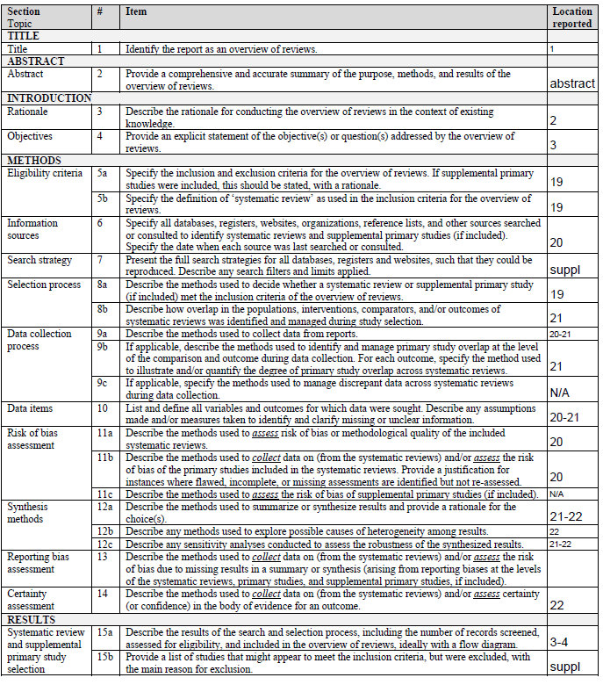
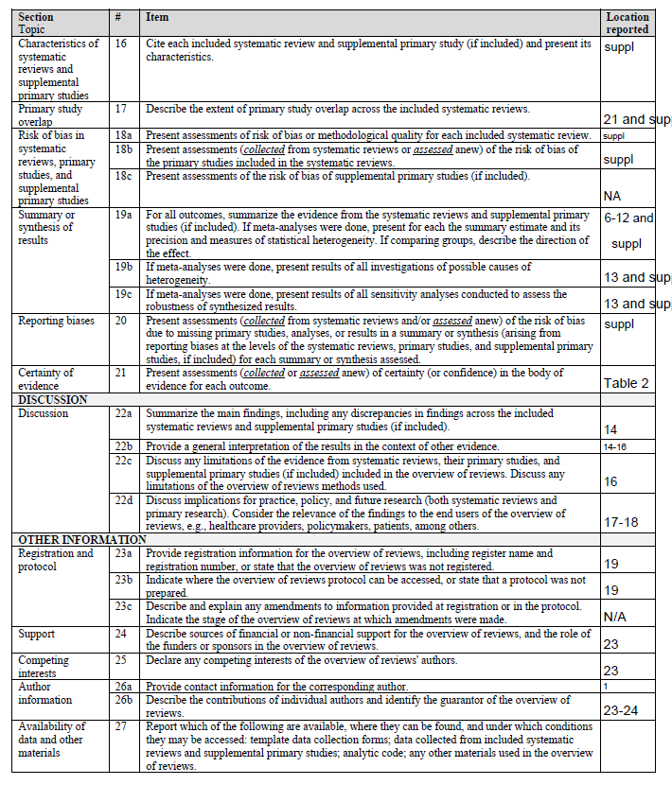

Supplementary material 3: Specialised search query for databases

CINAHL search string
S1 | MH "Art+" OR MH "Creative Arts Therapy+" OR TI(art OR arts OR artistic OR music* OR danc* OR drama OR dramatherapy OR bibliotherapy OR poetry OR (therapeutic N1 theat*)) OR AB(art OR arts OR artistic OR music* OR danc* OR drama OR dramatherapy OR bibliotherapy OR poetry OR (therapeutic N1 theat*)) OR SU(art OR arts OR artistic OR music* OR danc* OR drama OR dramatherapy OR bibliotherapy OR poetry OR (therapeutic N1 theat*))
S2 | MH "Meta Analysis" OR ZT "meta analysis" OR TI((Meta N2 analy*) OR metaanaly*) OR AB((Meta N2 analy*) OR metaanaly*) OR SU((Meta N2 analy*) OR metaanaly*)
S3 | S1 AND S2
S4 | MH "Antiretroviral Therapy, Highly Active" OR TX (antiretroviral OR "anti-retroviral" OR (assisted N0 reproduct* N0 (treatment OR technolog*)) OR (accelerated N0 resolution N0 therapy) OR (“anti-retro” N0 viral N0 therap*) OR (Atraumatic N1 Restorat* N1 Treatment*) OR (accelerated N1 resolution N1 therapy) OR "martial art*")
S5 | S3 NOT S4

Cochrane Database of Systematic Reviews search string
#1 | (art OR arts OR artistic OR music OR dance OR drama OR dramatherapy OR bibliotherapy OR poetry OR (therapeutic NEAR/1 theat*)):ti,kw
#2 | (antiretroviral OR "anti-retroviral" OR ((assisted OR artificial) NEAR/1 reproduct* NEAR/1 (techn* OR treat*)) OR "accelerated resolution therapy" OR ("anti-retro viral" NEAR/1 therap*) OR (Atraumatic NEAR/1 Restorat* NEAR/1 Treatment*) OR (accelerated NEAR/1 resolution NEAR/1 therap*) OR "State of the art" OR "martial art" OR "martial arts" OR "State of art" OR "art no" OR "the art of"):ti,ab,kw
#3 | #1 NOT #2
 | Cochrane Reviews

Embase (Elsevier) search string
#1 | 'art therapy'/exp OR 'dance therapy'/exp OR 'bibliotherapy'/exp OR 'drama therapy'/exp OR 'music therapy'/exp OR 'play therapy'/exp OR (art OR arts OR artistic OR music OR dance OR drama OR dramatherapy OR bibliotherapy OR poetry OR (therapeutic NEAR/1 theat*)):ti,ab,kw
#2 | 'meta analysis'/exp OR ((Meta NEAR/2 analy*) OR metaanaly*):ti,ab,kw,it
#3 | #1 AND #2
#4 | 'antiretroviral therapy'/exp OR 'atraumatic restorative treatment'/exp OR (antiretroviral OR anti-retroviral OR "assisted reproductive treat*" OR (assisted NEAR/1 reproduct* NEAR/1 technolog*) OR "accelerated resolution therapy" OR "anti-retro viral therap*" OR (Atraumatic NEAR/1 Restorat* NEAR/1 Treatment*) OR (accelerated NEAR/1 resolution NEAR/1 therapy) OR "State of the art" OR "martial art*" OR "State of art" OR "art no" OR "the art of"):ti,ab,kw
#5 | #3 NOT #4

Medline (EBSCO) search string
S1 | MH "Art+" OR MH "Sensory Art Therapies" OR MH "Play Therapy" OR MH "Music Therapy" OR MH "Dance Therapy" OR MH "Art Therapy" OR TI(art OR arts OR artistic OR music* OR danc* OR drama OR dramatherapy OR bibliotherapy OR poetry OR (therapeutic N1 theat*)) OR AB(art OR arts OR artistic OR music* OR danc* OR drama OR dramatherapy OR bibliotherapy OR poetry OR (therapeutic N1 theat*)) OR SU(art OR arts OR artistic OR music* OR danc* OR drama OR dramatherapy OR bibliotherapy OR poetry OR (therapeutic N1 theat*))
S2 | MH "Meta-Analysis as Topic+" OR ZT "meta analysis" OR TI((Meta N2 analy*) OR metaanaly*) OR AB((Meta N2 analy*) OR metaanaly*) OR SU((Meta N2 analy*) OR metaanaly*)
S3 | S1 AND S2
S4 | MH "Antiretroviral Therapy, Highly Active" OR MH "Martial Arts+" OR TX (antiretroviral OR "anti-retroviral" OR (assisted N0 reproduct* N0 (treatment OR technolog*)) OR (accelerated N0 resolution N0 therapy) OR (“anti-retro” N0 viral N0 therap*) OR (Atraumatic N1 Restorat* N1 Treatment*) OR (accelerated N1 resolution N1 therapy) OR "martial art*")
S5 | S3 NOT S4

PsycInfo (EBSCO) search string
S1 | DE "Art" OR DE "Crafts" OR DE "Drawing" OR DE "Painting (Art)" OR DE "Photographic Art" OR DE "Sculpturing" OR DE "Arts" OR DE "Dance" OR DE "Improvisation" OR DE "Music" OR DE "Theatre" OR DE "Drama" OR DE "Creative Arts Therapy" OR DE "Art Therapy" OR DE "Dance Therapy" OR DE "Music Therapy" OR DE "Psychodrama" OR DE "Play Therapy" OR DE "Poetry" OR DE "Poetry Therapy" OR DE "Creative Writing" OR DE "Bibliotherapy" OR DE "Expressive Psychotherapy" OR TI(art OR arts OR artistic OR music* OR danc* OR drama OR dramatherapy OR bibliotherapy OR poetry OR (therapeutic N1 theat*)) OR AB(art OR arts OR artistic OR music* OR danc* OR drama OR dramatherapy OR bibliotherapy OR poetry OR (therapeutic N1 theat*)) OR SU(art OR arts OR artistic OR music* OR danc* OR drama OR dramatherapy OR bibliotherapy OR poetry OR (therapeutic N1 theat*))
S2 | DE "Meta Analysis" OR TI((Meta N2 analy*) OR metaanaly*) OR AB((Meta N2 analy*) OR metaanaly*) OR SU((Meta N2 analy*) OR metaanaly*)
S3 | S1 AND S2
S4 | DE "Antiretroviral Drugs" OR DE "Martial Arts" OR TX (antiretroviral OR "anti-retroviral" OR (assisted N0 reproduct* N0 (treatment OR technolog*)) OR (accelerated N0 resolution N0 therapy) OR (“anti-retro” N0 viral N0 therap*) OR (Atraumatic N1 Restorat* N1 Treatment*) OR (accelerated N1 resolution N1 therapy) OR "martial art*")
S5 | S3 NOT S4

Web of Science search string
#1 | TS=(art OR arts OR artistic OR music OR dance OR drama OR dramatherapy OR bibliotherapy OR poetry OR (therapeutic NEAR/1 theat*))
#2 | TS=((Meta NEAR/2 analy*) OR metaanaly*)
#3 | #1 AND #2
#4 | TS=(antiretroviral OR anti-retroviral OR ((assisted OR artificial) NEAR/1 reproduct* NEAR/1 (techn* OR treat*)) OR "accelerated resolution therapy" OR "anti-retro viral therap*" OR (Atraumatic NEAR/1 Restorat* NEAR/1 Treatment*) OR (accelerated NEAR/1 resolution NEAR/1 therapy) OR "martial art*")
#5 | #3 NOT #4

Supplementary material 4: Characteristics of included SRs

Author/Year | Countryª | Search dates | Design | No. of Studies | Population | Modality/ Intervention type | Outcome domain | Specific outcome | Quality  (AMSTAR 2) | Funding
CANCER
*Bradt 2021²⁸ | USA | Inception-April 2020 | RCTs, CCTs | 81 |  | Music/Mixed | Psychological, Physical, QoL | Mood, depression, anxiety, fatigue, physical functioning, pain, HR, RR, SBP, DBP, O2-sat, QoL | High | Yes
*Bradt 2015²⁹ | USA | Inception-July 2014 | RCTs, CCTs | 3 |  | Dance/CAT | Psychological, Physical | Depression, stress, anxiety, fatigue, body image | High | No
*Bro 2018³⁰ | Denmark | Inception – Sept 2016 | RCTs | 25 |  | Music/Mixed | Psychological, Physical, QoL | Nausea, anxiety, mood, pain, depression, fatigue, distress, QoL | Low | Yes
*Cheng 2021³¹ | China | Inception-May 2020 | RCTs | 19 | Breast, gynecological | Mixed/Mixed | Psychological, Physical, QoL | QoL, anxiety, depression, pain, fatigue, sleep disturbance, anger, vigor, tension, confusion, stress | Low | Yes
*da Silva Santa 2021³² | Brazil | Inception-2020 | RCTs, CCTs | 11 |  | Music/Mixed | Psychological, Physical, QoL | Pain, anxiety, QoL, HR | Moderate | NR
*Geng, 2023³³ | China | Inception-March 2023 | RCTs | 32 | Breast | Dance/AATI | Psychological | Depressive symptoms | High | Yes
*Hung, 2018³⁴ | Taiwan | Inception-2016 | RCTs | 12 |  | Music/Mixed | Physical | Pain relief | Low | NR
*Jiang 2020³⁵ | China | Inception-August 2019 | RCTs, CCTs | 12 |  | Art/Mixed | Psychological, Physical, QoL | QoL, anxiety, depression, fatigue | Low | Yes
*Jiang 2023³⁶ | China | Inception-December 2022 | RCTs | 14 | Lung cancer | Music/Mixed | Physical | Sleep quality | Critically low | NR
*Köhler 2020³⁷ | Germany | Inception-February 2019 | RCTs, CCTs | 30 |  | Music/CAT | Psychological, Physical, QoL | Psychological well-being, QoL, physical symptom distress | Moderate | Yes
*Li 2020³⁸ | China | Inception-September 2018 | RCTs | 19 |  | Music/Mixed | Psychological, Physical, QoL | QoL, anxiety, depression, pain | Low | Yes
*Nelson 2023³⁹ | Ireland | Inception-October 2022 | RCTs, CCTs | 18 |  | Dance/AATI | Psychological, Physical, QoL | Functional capacity, fatigue, QoL, depression | Critically low | Yes
*Nguyen 2022⁴⁰ | China | Inception-December 2020 | RCTs | 9 |  | Music/Mixed | Psychological, QoL | Anxiety, depression, QoL | Moderate | NR
Nightingale 2013⁴¹ | USA | Inception-2011 | RCTs | 13 |  | Music/Mixed | Psychological | Anxiety | Low | No
*Park 2022⁴² | South Korea | January 2008-December 2020 | RCTs | 22 |  | Music/AATI | Psychological | Pain, emotional symptoms | Low | Yes
*Puetz 2013⁴³ | USA | Inception-January 2012 | RCTs | 27 |  | Mixed/Mixed | Psychological, Physical, QoL | Anxiety, depression, pain, cancer-related fatigue, QoL | Critically low | NR
*Qi 2021⁴⁴ | China | Inception-June 2020 | RCTs | 8 |  | Music/Mixed | Physical | Cancer-related fatigue | Moderate | Yes
Sezgin 2022⁴⁵ | Turkey | Inception-August 2021 | RCTs | 6 | Hematological | Music/CAT | Physical | Fatigue | Low | NR
*Tang 2019⁴⁶ | China | Inception-July 2017 | RCTs | 9 | Breast | Mixed/Mixed | Psychological | Anxiety, depression | Critically low | NR
*Tsai 2014⁴⁷ | Taiwan | 2002-2012 | RCTs, CCTs | 21 |  | Music/Mixed | Psychological, Physical | Anxiety, depression, pain, fatigue | Low | No
*Wang 2018⁴⁸ | China | Inception-September 2017 | RCTs | 30 | Breast | Music/AATI | Psychological, Physical | DBP, HR, anxiety, depression, SBP | Low | NR
*Wei 2020⁴⁹ | China | Inception-November 2019 | RCTs | 10 | Chemotherapy patients | Music/AATI | Physical | Acute nausea, acute vomiting, delayed nausea, delayed vomiting | Low | NR
*Xia 2023⁵⁰ | China | Inception-April 2022 | RCTs, CCTs | 13 |  | Art/Mixed | Psychological, Physical, QoL | Anxiety, depression, fatigue, QoL | Moderate | NR
*Xu 2020⁵¹ | China | Inception-December 2019 | RCTs, CCTs | 9 | Breast | Mixed/Mixed | Psychological | Anxiety, depression | Critically low | Yes
*Yang 2021⁵² | China | Inception-December 2020 | RCTs | 22 |  | Music/AATI | Psychological, Physical, QoL | Anxiety, depression, QoL, sleep quality, functional impairment | Low | Yes
*Yangöz 2019⁵³ | Turkey | Inception-2018 | RCTs | 6 |  | Music/Mixed | Physical | Cancer-related pain | Low | No
Zhang 2012⁵⁴ | China | Inception-March 2011 | RCTs | 32 |  | Music/Mixed | Psychological, Physical, QoL | Anxiety, depression, pain, fatigue, HR, RR, SBP, DBP, QoL | Low | NR
*Zhang 2015⁵⁵ | China | Inception-November 2014 | RCTs | 7 | Breast; mixed | Art/Mixed | Psychological | Anxiety, depression | Low | Yes
*Zhang 2023⁵⁶ | China | Inception-May 2023 | RCTs | 10 |  | Poetry/AATI | Psychological | Anxiety | Moderate | Yes
CARDIOVASCULAR
*Bradt 2013⁵⁷ | USA | Inception-2012 | RCTs, CCTs | 26 | CHD | Music/Mixed | Psychological, Physical | Psychological distress, anxiety, depression, mood, HR, HR variability, RR, SBP, DBP, MAP, O2-sat, pain, Sleep quality | High | Yes
*Cao 2023⁵⁸ | China | Inception-October 2022 | RCTs | 20 | Hypertension | Music/AATI | Psychological, Physical | SBP, DBP, HR, anxiety, depression, sleep quality | Low | No
*Chan 2023⁵⁹ | Hong Kong | Inception-February 2022 | RCTs | 7 | Stroke | Art/Mixed | Psychological, Physical, QoL | Depressive symptoms, anxiety, activities of daily living, upper limb function, hand function | High | No
*Chandrababu 2021⁶⁰ | India | January 2000-December 2017 | RCTs | 14 | Cardiac surgery | Music/Mixed | Psychological, Physical | Anxiety, pain | Low | NR
*Conceição 2016⁶¹ | Brazil | Inception-February 2016 | RCTs | 4 | hypertension | Dance/Mixed | Physical | SBP, DBP, exercise capacity | Critically low | NR
*Dayuan 2022⁶² | China | Inception-October 2022 | RCTs | 20 | Post-stroke | Music/AATI | Psychological, Physical, QoL, Other | Depression, stroke-related impairment, ADLs | Critically low | Yes
*do Amaral 2016⁶³ | Brazil | Inception-February 2016 | RCTs | 3 | Hypertension | Music/AATI | Physical | SBP, DBP | Low | NR
*Gomes Neto 2014⁶⁴ | Brazil | Inception-August 2013 | RCTs | 2 | Chronic heart failure | Dance/AATI | Physical, QoL | Exercise capacity, QoL | Critically low | No
*Jayakar 2017⁶⁵ | Canada | Inception-May 2015 | RCTs | 15 | Cardiac catheterization | Music/AATI | Psychological | Anxiety | Low | NR
*Kakar 2021⁶⁶ | Netherlands | January 1992-October 2019 | RCTs, CCTs | 20 | Cardiac surgery | Music/Mixed | Psychological, Physical, Other | Perioperative opioid use, SBP, DBP, HR, RR, MAP, length of stay, time on mechanical ventilator, postop anxiety, postop pain, O2-sat | Moderate | No
*Lee 2021⁶⁷ | USA | January 2000-August 2018 | RCTs | 22 | Post-stroke | Music/CAT | Psychological | Depressive symptoms | Low | Yes
*Liu 2022⁶⁸ | China | Inception-March 2021 | RCTs | 6 | Post-stroke | Music/Mixed | Cognitive | Functional communication, comprehension, repetition, naming | Moderate | NR
*Liu 2023⁶⁹ | China | Inception-April 2021 | RCTs | 42 | Cardiac surgery | Music/AATI | Psychological, Physical, Other | Pain intensity, opioid consumption, anxiety | Low | Yes
*Magee 2017⁷⁰ | Australia | Inception-January 2016 | RCTs, CCTs | 29 | Stroke | Music/Mixed | Physical, Cognitive, QoL | Communication, gait velocity, stride length, general gait, gait cadence, timing of upper extremity, balance, QoL | High | Yes
*Peng 2021⁷¹ | China | Inception-March 2020 | RCTs | 5 | Hypertension | Dance/Mixed | Physical | SBP, DBP | Moderate | NR
*Roche Bueno 2019⁷² | Spain | Inception-September 2018 | RCTs, CCTs | 6 | Post-stroke | Music/AATI | Physical | Functionality of the upper limb | Low | NR
*Su 2021⁷³ | Taiwan | 1966-January 2019 | RCTs, CCTs | 10 | Coronary procedure | Music/Mixed | Psychological, Physical | Anxiety, discomfort, pain, HR, SBP, DBP | Low | Yes
*Wang 2020⁷⁴ | China | Inception-June 2019 | RCTs | 14 | Cardiac Procedure | Music/AATI | Physical | Pain, HR, RR, SBP, DBP | Low | Yes
*Wang 2022⁷⁵ | China | Inception-July 2022 | RCTs | 22 | Stroke | Music/Mixed | Physical | Step length, cadence, velocity, overall motor function, balance | Moderate | NR
*Yang 2019⁷⁶ | China | Inception-May 2018 | RCTs | 6 | Post-stroke | Music/AATI | Cognitive | Auditory comprehension, repetition, spontaneous speech, speak aloud, reading, naming, language function | High | Yes
*Yoo 2016⁷⁷ | Korea | 1990-December 2014 | RCTs, CCTs | 10 | Stroke | Music/Mixed | Physical | Gait velocity, gait cadence, stride length, upper extremity function | Critically low | Yes
*Zhang 2016⁷⁸ | China | Inception-April 2016 | RCTs, CCTs | 10 | Post-stroke | Music/Mixed | Physical, Cognitive | Executive functions, upper-limb motor function, total motor function | Low | NR
DIABETES
*Yang 2021⁷⁹ | China | Inception-January 2021 | RCTs | 5 |  | Mixed/Mixed | Psychological, Physical | Depression, blood glucose, anxiety, glycated hemoglobin | Low | Yes
MENTAL HEALTH DISORDERS
*Aalbers 2017⁸⁰ | Norway | Inception-2017 | RCTs, CCTs | 9 | Depression, Anxiety | Music/Mixed | Psychological | Severity of depressive symptoms, anxiety | High | Yes
*Abbing 2023⁸¹ | Netherlands | Inception-June 2020 | RCTs, CCTs | 23 |  | Mixed/CAT | Psychological, QoL | Antisocial behavior, psychiatric symptoms, social functioning, pschological functioning; forensic outcomes | Moderate | NR
*Atchison 2022⁸² | Canada | Inception-March 2022 | RCTs | 80 | Anxiety | Music/Mixed | Psychological | Anxiety | Moderate | Yes
*Bighelli 2023⁸³ | Germany | Inception-September 2021 | RCTs | 58 | Schizophrenia | Mixed/Mixed | QoL | Daily functioning | Low | Yes
*Chen 2021⁸⁴ | China | Inception-November 2018 | RCTs | 35 | Depression | Music/AATI | Psychological | Depression | Low | Yes
*de Witte 2022⁸⁵ | The Netherlands | Inception-May 2019 | RCTs, CCTs | 47 |  | Music/CAT | Psychological | Stress-related outcomes | High | Yes
*Geipel 2018⁸⁶ | Germany | Inception-2015 | RCTs, CCTs | 5 | Anxiety, depression | Music/Mixed | QoL | Reducing internalising symptoms | Low | No
*Geretsegger 2017⁸⁷ | Norway | Inception-January 2015 | RCTs | 18 | Schizophrenia | Music/Mixed | Psychological, Cognitive | General mental state, negative symptoms, depression, general functioning; social functioning; cognitive abstract thinking; general behaviour score | High | Yes
*Gerger 2022⁸⁸ | Netherlands | Inception-September 2020 | RCTs | 44 | Trauma | Poetry/AATI | Psychological | PTSD symptoms | High | NR
*Ghetti 2022⁸⁹ | Norway | Inception-February 2021 | RCTs | 21 | Substance use disorders | Music/CAT | Psychological, Other | Depression, aubstance craving, motivation for treatment/ change, motivation to stay sober/clean, retention in treatment, substance craving | High | Yes
*Gold 2009⁹⁰ | Norway | Inception-May 2006 | RCTs, CCTs | 15 |  | Music/CAT | Psychological, Physical, QoL, Other | Global state improvement, anxiety, positive symptoms, QoL, satisfaction, medication level | Low | Yes
*Guo 2020⁹¹ | China | Inception-May 2019 | RCTs | 14 | Depression | Dance/AATI | Psychological | Depressive symptoms | Critically low | Yes
*Jenabi 2023⁹² | Canada | Inception-February 2022 | RCTs, CCTs | 8 | Depression | Art/Mixed | Psychological | Depression | Critically low | Yes
*Jia 2020⁹³ | China | Inception-January 2020 | RCTs, CCTs | 18 | Schizophrenia | Music/Mixed | Psychological, QoL | Total symptoms, negative symptoms, positive symptoms, depression symptoms, QoL | Low | Yes
*Jiang 2023⁹⁴ | Malaysia | December 2019-October 2022 | RCTs, CCTs | 25 | Mixed populations (only included mental health population in review) | Drama/Mixed | Psychological, Cognitive, QoL, Other | Depression, anxiety, cognitive functioning, QoL, pyschological well-being, communication skills, self-regard | Moderate | No
*Karkou 2019⁹⁵ | UK | Inception-March 2018 | RCTs, CCTs | 8 | Depression | Dance/CAT | Psychological | Depression | Low | NR
*Koch 2019⁹⁶ | Germany | January 2012-April 2018 | RCTs | 41 | Schizophrenia | Dance/Mixed | Psychological | Positive symptoms | Moderate | Yes
*Laws 2019⁹⁷ | UK | Inception-May 2019 | RCTs | 9 | Schizophrenia | Mixed/Mixed | Psychological | Total symptoms, positive symptoms, negative symptoms | Moderate | NR
*Lutgens 2017⁹⁸ | Canada | Inception-October 2015 | RCTs | 95 | Schizophrenia/psychotic disorder | Art/CAT | Psychological | Negative symptoms in psychosis | Critically low | Yes
Meekums 2015⁹⁹ | UK | 1950-2014 | RCTs | 3 | Depression | Dance/Mixed | Psychological | Depression score | High | Yes
*Orkibi 2023¹⁰⁰ | Israel | Inception-January 2021 | RCTs, CCTs | 30 | Mixed population | Psychodrama/CAT | Psychological | Mental health outcomes: feelings, thoughts, behaviour | Low | NR
*Reinhold 2018¹⁰¹ | Germany | 1986-September 2015 | RCTs | 39 | Clinical stress disorder, major depression | Poetry/AATI | Psychological | Depression | Low | NR
*Sabeena 2022¹⁰² | India | 2001-2021 | RCTs, CCTs | 36 | Clinical & non-clinical depression | Art/Mixed | Psychological | Depression | Critically low | NR
*Steenhuis 2015¹⁰³ | The Netherlands | Inception-2015 | RCTs | 10 | Psychotic disorder | Music/Mixed | Psychological | Depressive symptoms | Low | Yes
*Tang 2020¹⁰⁴ | China | Inception-2020 | RCTs | 55 |  | Music/Mixed | Psychological | Depression | Low | Yes
*Tseng 2016¹⁰⁵ | Taiwan | Inception-September 2015 | RCTs, CCTs | 12 | Schizophrenia | Music/Mixed | Psychological | Total psychopathology, positive symptoms, negative symptoms, mood symptoms | Critically low | No
*Yan 2019¹⁰⁶ | China | Inception-March 2019 | RCTs | 12 | Depression | Music/AATI | Psychological, Physical | Depression, sleep quality | Moderate | Yes
*Yang 2019¹⁰⁷ | China | Inception-November 2018 | RCTs | 7 | postpartum depression | Music/AATI | Psychological | Depression, anxiety | Moderate | NR
*Yijing 2018¹⁰⁸ | China | NR | RCTs | 4 | Depression | Dance/Mixed | Psychological | Depression | Critically low | Yes
*Zhao 2016¹⁰⁹ | China | Inception-September 2014 | RCTs | 19 | Depression | Music/AATI | Psychological | Depressive symptoms | Critically low | Yes
NEUROLOGICAL DISORDERS
*Álvarez-Bueno 2023¹¹⁰ | Spain | Inception-April 2021 | RCTs, CCTs | 56 | Parkinson’s | Dance/AATI | Physical | Motor symptoms | Low | Yes
*Barnish 2020¹¹¹ | UK | Inception-February 2020 | RCTs, CCTs | 56 | Parkinson’s | Dance/AATI | Physical, QoL | Motor function, mobility, QoL | Critically low | No
*Batubara 2023¹¹² | Indonesia | January 2001-August 2021 | RCTs, CCTs | 9 | Mild/major neurocognitive disorder | Art/AATI | Psychological, Cognitive, QoL | Depression, cognitive function, QoL | Low | No
*Bian 2021¹¹³ | China | Inception-November 2020 | RCTs | 7 | Dementia | Music/AATI | Cognitive | Overall cognition | Low | Yes
*Burley 2022¹¹⁴ | Australia | 2012-2020 | RCTs, CCTs | 37 | Dementia | Music/Mixed | Psychological | Depression | Critically low | Yes
*Carapellotti 2020¹¹⁵ | UK | Inception-March 2020 | RCTs | 16 | Parkinson’s | Dance/AATI | Psychological, Physical, QoL | Motor impairment, balance, forward gait velocity, backward gait velocity, stride length, freezing of gait, endurance, mobility, QoL, depression | Low | Yes
*Chan 2020¹¹⁶ | China | Inception-August 2019 | RCTs | 5 | MCI | Dance/AATI | Cognitive | Global cognition, attention, immediate recall, delayed recall, working memory, language, mental flexibility, visuospatial ability | Moderate | Yes
*Chang 2015¹¹⁷ | Taiwan | 2000-February 2014 | RCTs | 10 | Dementia | Music/Mixed | Psychological, Cognitive | Disruptive behaviors, anxiety, depressive mood, cognitive functioning | Low | Yes
*Chen 2022¹¹⁸ | China | Inception-January 2021 | RCTs, CCTs | 7 | Autism | Dance/Mixed | Psychological | Negative symptoms, empathy, social interaction | Critically low | Yes
*de Almeida 2021¹¹⁹ | Brazil | Inception-May 2019 | RCTs, CCTs | 11 | Parkinson’s | Dance/Mixed | Physical | Postural control | Critically low | NR
*de Dreu 2012¹²⁰ | Netherlands | Inception-August 2011 | RCTs | 6 | Parkinson’s | Mixed/Mixed | Physical | Balance, mobility, stride length, motor, walking velocity, freezing of gait | Critically low | NR
*Dorris 2021¹²¹ | USA | Inception-March 2021 | RCTs | 21 | MCI or Dementia | Music/Mixed | Cognitive | Global cognitive functioning | Low | Yes
*dos Santos Delabary 2018¹²² | Brazil | Inception-August 2017 | RCTs | 5 | Parkinson’s | Dance/AATI | Physical, QoL | Motor symptoms, functional mobility, freezing of gait, QoL, motor symptoms, endurance, gait velocity forward, gait velocity backward | Critically low | No
*Ernst 2024¹²³ | Germany | Inception-May 2021 | RCTs | 154 | Parkinson’s | Dance/Mixed | Physical, QoL | Severity of motor signs, QoL | High | Yes
*Fusar-Poli 2018¹²⁴ | Italy | Inception-September 2016 | RCTs | 7 | Dementia | Music/Mixed | Cognitive | Global cognition, complex attention, language, learning and memory, perceptual motor function | Moderate | No
*Geretsegger 2022¹²⁵ | Italy | Inception-August 2021 | RCTs, CCTs | 26 | Autism | Music/CAT | Psychological, Cognitive, QoL | Global improvement in symptoms, social interaction, non-verbal communication, verbal communication, QoL, total symptom severity, adaptive behavior, quality of family relationships, identity formation | High | Yes
*Ghai 2018¹²⁶ | Germany | Inception-December 2017 | RCTs, CCTs | 5 | Multiple sclerosis | Music/AATI | Physical | Gait, stride length, cadence, timed 25 ft. walking test | Low | Yes
*Ghai 2022¹²⁷ | Germany | 1970-March 2022 | RCTs, CCTs | 14 | Cerebral palsy | Music/Mixed | Physical | Gait speed, stride length, cadence, gross motor function—standing, gross motor function—walking | Low | Yes
*Goh 2023¹²⁸ | Australia | Inception-June 2021 | RCTs, CCTs | 65 | Parkinson’s | Dance/AATI | Physical | Freezing of gait | Moderate | Yes
*Hao 2022¹²⁹ | China | Inception-April 2022 | RCTs | 60 | Parkinson’s | Dance/Mixed | Physical | Motor symptoms, mobility, balance | Critically low | No
*Hasan 2022¹³⁰ | Germany | Inception-April 2020 | RCTs | 14 | Parkinson’s | Dance/Mixed | Psychological, Physical, Cognitive, QoL | Freezing of gait, endurance, forward velocity, backward velocity, balance, depressive symptoms, apathy, cognitive function, psychosocial, motor symptoms, timed up and go,  gait/walking velocity, executive functions | Low | No
*Hidalgo-Agudo 2020¹³¹ | Spain | 2013-2017 | RCTs | 11 | Parkinson’s | Dance/AATI | Physical | Motor function, balance | Low | Yes
*Ismail 2021¹³² | Malaysia | Inception-June 2021 | RCTs | 20 | Parkinson’s | Dance/AATI | Psychological, Physical, Cognitive, QoL | Non-motor experiences of daily living, motor experiences of daily living, motor symptoms, balance, freezing of gait, agility,  walking distance, cognitive function, depressive symptoms,  fatigue, QoL, forward velocity | Low | Yes
*Ito 2022¹³³ | Japan | January 2000-April 2021 | RCTs | 19 | MCI and Dementia | Music/Mixed | Cognitive | General cognitive function, episodic memory, processing speed, executive function | Low | Yes
*Jin 2022¹³⁴ | China | Inception-August 2022 | RCTs | 107 | MCI or dementia | Music/CAT | Psychological | Depression, neuropsychiatric function | Moderate | Yes
*Kalyani 2019¹³⁵ | Australia | Inception-September 2017 | RCTs, CCTs | 27 | Parkinson’s | Dance/AATI | Physical, Cognitive | Gait velocity, endurance, global cognition, motor, freezing of gait, gait | Low | NR
*Ke 2022¹³⁶ | China | Inception-October 2021 | RCTs | 8 | Autism | Music/CAT | Psychological, Cognitive | Symptom severity, social reactions, social adaptation, speech | Low | Yes
*Kim 2016¹³⁷ | Korea | Inception-2014 | RCTs | 16 | Dementia | Music/Mixed | Psychological | Behavioral problems | Critically low | NR
*Kong 2015¹³⁸ | Korea | Inception-October 2014 | RCTs | 10 | Dementia | Music/Mixed | Psychological | Agitation | Moderate | Yes
*Kwok 2016¹³⁹ | Hong Kong | Inception-January 2016 | RCTs, CCTs | 10 | Parkinson’s | Dance/AATI | Physical | Postural instability | Critically low | No
*Lee 2023¹⁴⁰ | Korea | Inception-June 2022 | RCTs, CCTs | 13 | Parkinson’s | Music/Mixed | Physical, Cognitive, QoL | Cadence, velocity, stride length, mobility, cognitive flexibility, inhibition, QoL | Moderate | No
*Li 2022¹⁴¹ | China | Inception-January 2021 | RCTs | 26 | Parkinson’s | Dance/Mixed | Physical | Physical function, functional mobility, balance, walking capacity | Critically low | Yes
*Liang 2019¹⁴² | China | Inception-October 2018 | RCTs | 31 | Dementia | Music/Mixed | Cognitive | Cognitive function | Moderate | Yes
*Liang 2018¹⁴³ | China | Inception-March 2017 | RCTs | 17 | MCI or Dementia | Music/Mixed | Cognitive | General cognitive function | Low | NR
Lorenzo-García 2023¹⁴⁴ | Spain | Inception-January 2022 | RCTs | 48 | Parkinson’s | Dance/AATI | QoL | QoL | Low | NR
*Lötzke 2015¹⁴⁵ | Germany | Inception-January 2015 | RCTs, CCTs | 13 | Parkinson’s | Dance/AATI | Physical | Motor severity, balance, gait, freezing of gait | Critically low | No
*Masika 2020¹⁴⁶ | China | Inception-September 2019 | RCTs, CCTs | 12 | MCI | Art/Mixed | Psychological | Depression, anxiety | Low | Yes
*May 2021¹⁴⁷ | Australia | Inception-February 2018 | RCTs, CCTs | 19 | Children with ASD, ID, Down’s syndrome | Dance/AATI | Physical | Balance | High | Yes
*Mazzarin 2017¹⁴⁸ | Brazil | Inception-April 2015 | RCTs, CCTs | 9 | Parkinson’s | Dance/AATI | Physical | Mobility, balance | Low | No
*Mishra 2021¹⁴⁹ | India | Inception-August 2020 | RCTs, CCTs | 6 | TBI | Music/Mixed | Physical, Cognitive | Gait velocity, gait cadence, stride length, memory, executive function | Low | NR
*Moreno-Morales 2020¹⁵⁰ | Spain | 1990-2020 | RCTs | 8 | Dementia | Music/Mixed | Psychological, Cognitive, QoL | Cognitive function, QoL, depressive state | Low | NR
*Mustafaoglu 2022¹⁵¹ | USA | Inception-December 2021 | RCTs | 60 | Parkinson’s | Dance/AATI | Physical, QoL | Improving functional mobility, balance performance, motor function, gait speed, health-related QoL | Moderate | No
*Na 2019¹⁵² | Korea | Inception-April 2017 | RCTs, CCTs | 23 | Dementia | Music/Mixed | Psychological, Cognitive | Behavioral and psychological, cognitive function | Moderate | Yes
*Pedersen 2017¹⁵³ | Norway | Inception-February 2016 | RCTs | 12 | Dementia | Music/Mixed | Psychological | Agitation | Critically low | NR
*Radder 2020¹⁵⁴ | Netherlands | Inception-June 2020 | RCTs | 191 | Parkinson’s | Dance/AATI | Physical | Motor symptoms, balance, gait outcomes | Critically low | Yes
*Sharp 2014¹⁵⁵ | UK | Inception-January 2014 | RCTs | 5 | Parkinson’s | Dance/AATI | Physical, QoL | Motor, balance, freezing of gait, velocity, endurance, QoL | Moderate | No
*Shi 2016¹⁵⁶ | China | August 2000-August 2015 | RCTs | 6 | Children with ASD | Music/Mixed | Psychological, Cognitive | Mood, social skills, behaviour, sensory perception, language | Critically low | NR
*Simpkins 2023¹⁵⁷ | USA | Inception-June 2022 | RCTs | 14 | Parkinson’s | Dance/Mixed | Physical | Improving balance | Low | NR
*Tang 2019¹⁵⁸ | China | Inception-March 2019 | RCTs, CCTs | 19 | Parkinson’s | Dance/AATI | Physical, QoL | Motor symptoms, daily living, risk for a fall, balance | Critically low | No
*Tsoi 2018¹⁵⁹ | China | Inception-September 2017 | RCTs, CCTs | 38 | Dementia | Music/Mixed | Psychological, Cognitive | Cognitive function, apathy, depressive symptoms, agitation, behavioral problems | Low | NR
*Ueda 2013¹⁶⁰ | Japan | 1973-2011 | RCTs, CCTs | 20 | Dementia | Music/Mixed | Psychological, Cognitive | Anxiety, behavioural symptoms of dementia, depression | Low | NR
*van der Steen 2017¹⁶¹ | Netherlands | Inception-June 2017 | RCTs | 17 | Dementia | Music/Mixed | Psychological, Cognitive, QoL | Cognition, emotional well-being, depression, anxiety, agitation or aggression, overall behavioural problems, generalized verbal communicative skills,  cognition, social behaviour,  non-generalized verbal communicative skills | High | Yes
*Wang 2020¹⁶² | China | Inception-February 2019 | RCTs | 25 | MCI | Music/AATI | Cognitive | Cognitive function | Moderate | NR
*Wang 2021¹⁶³ | China | Inception-May 2021 | RCTs | 14 | Parkinson’s | Dance/Mixed | Cognitive | Global cognitive function | Critically low | NR
*Wang 2022¹⁶⁴ | China | 1970-March 2021 | RCTs | 5 | MCI and Dementia | Dance/Mixed | Psychological | Depression | Moderate | NR
*Wang 2022¹⁶⁵ | China | Inception-February 2021 | RCTs | 19 | Parkinson’s | Music/Mixed | Physical, QoL | Cadence, velocity, step length, stride length, endurance, mobility, ADLs, overall motor function, balance | Low | NR
*Wang 2020¹⁶⁶ | China | January 2000-December 2017 | RCTs | 15 | Alzheimer’s | Music/Mixed | Cognitive, QoL | Cognitive function, ADLs | Low | NR
*Wang 2023¹⁶⁷ | China | Inception-2022 | RCTs | 39 | Mild-moderate cognitive impairment | Mixed/Mixed | Cognitive | Cognitive function | Low | Yes
*Wei 2020¹⁶⁸ | China | August 1998-August 2018 | RCTs | 25 | Alzheimer’s | Music/AATI | Cognitive | Global cognition | Critically low | Yes
*Wong 2022¹⁶⁹ | China | January 2010-December 2019 | RCTs | 9 | Dementia | Music/Mixed | Psychological, Cognitive | Cognitive function, neuropsychiatric symptoms | Critically low | NR
*Wu 2021¹⁷⁰ | China | Inception-April 2020 | RCTs | 52 | Parkinson’s | Dance/Mixed | Physical | Motor outcomes, balance, TUG outcome, BBS outcome | Moderate | Yes
*Yang 2019¹⁷¹ | China | Inception-February 2018 | RCTs | 13 | Dementia | Music/Mixed | Psychological, Cognitive, QoL | behavioural problems, cognitive function, QoL, anxiety, depression | Critically low | Yes
*Yang 2022¹⁷² | China | Inception-June 2022 | RCTs | 250 | Parkinson’s | Dance/AATI | Psychological, Physical, Cognitive | Depression, balance, gait velocity, walking distance, freezing of gait, cognition | Moderate | Yes
*Ye 2022¹⁷³ | China | January 2000-August 2021 | RCTs | 18 | Parkinson’s | Music/Mixed | Psychological, Physical, QoL | Stride length, stride duration, speed, step frequency, swing, mobility, balance, fear of falling, freezing of gait, ADL, general motor function, QoL | Low | NR
*Zhang 2019¹⁷⁴ | China | Inception-December 2018 | RCTs | 7 | Parkinson’s | Dance/AATI | Psychological, Cognitive | Global cognitive function, executive function, depression, apathy | Low | No
*Zhang 2017¹⁷⁵ | China | Inception-September 2016 | RCTs, CCTs | 34 | Dementia | Music/Mixed | Psychological, Cognitive, QoL | disruptive behavior, cognitive function, depression, anxiety, QoL | Moderate | NR
*Zhou 2021¹⁷⁶ | China | Inception-December 2020 | RCTs | 17 | Parkinson’s | Mixed/Mixed | Psychological, Physical, QoL | Motor function, balance, gait cadence, stride length, freezing of gait, walking velocity, mental health, QoL | Low | Yes
*Zhu 2020¹⁷⁷ | China | Inception-February 2019 | RCTs | 5 | MCI | Dance/AATI | Cognitive | Global cognition, executive function, verbal fluency, immediate recall ability, delayed recall ability | Low | Yes
CHRONIC RESPIRATORY DISORDERS
*Huang 2021¹⁷⁸ | China | Inception-June 2019 | RCTs | 12 | COPD | Music/AATI | Psychological, Physical, QoL | QoL, dyspnea, anxiety, depression, breathing frequency, SBP, DBP | Low | NR
*Kim 2021¹⁷⁹ | Korea | 1990-August 2020 | RCTs | 3 | Chronic lung disease | Music/Mixed | Physical | Forced expiratory volume, Forced vital capacity, maximal inspiratory pressure, maximal expiratory pressure | Low | NR
*Lee 2015¹⁸⁰ | Canada | Inception-June 2014 | RCTs, CCTs | 13 | COPD | Music/AATI | Physical | Exercise capacity | Moderate | None
*McNamara 2017¹⁸¹ | Australia | Inception-August 2017 | RCTs | 3 | COPD | Music/AATI | Psychological, Physical, QoL | Health-related QoL-respiratory specific, health-related QoL-generic, anxiety, depression, peak exercise capacity | High | Yes
MORE THAN ONE NCD POPULATION
*Nyssen 2016¹⁸² | UK | Inception-January 2015 | RCTs, CCTs | 64 | Cancer, Psychiatric disorders | Poetry/AATI | Psychological, Physical | Positive mood, negative mood, depression, anxiety, lung function | Low | Yes

CAT: creative arts therapies; AATI: arts with therapeutic intent; TBI: traumatic brain injury; ADLs: Activities of Daily Life; DBP: Diastolic Blood Pressure; HR: Heart Rate; MAP: Mean Arterial pressure; MCI: Mild Cognitive Impairment; O2-sat: Oxygen Saturation; Postop: Postoperative; QoL: quality of life; RR: Respiratory Rate; SBP: Systolic Blood pressure;
ª country of the lead author of the review
*denotes that the review contributed data to the meta-analyses of one or more of the listed outcomes

Supplementary material 5: List of excluded studies

5a. List of excluded studies and reason for exclusion

Author | Reason for exclusion
Ab Shukor 2021¹⁸³ | Wrong population
Abdelhakim 2019¹⁸⁴ | Wrong population
Apodaca 2003¹⁸⁵ | Wrong intervention
Auliya 2022¹⁸⁶ | Wrong population
Bai 2022¹⁸⁷ | Wrong population
Bausewein 2013¹⁸⁸ | Wrong study design
Bechtold 2009¹⁸⁹ | Wrong population
Bieleninik 2016¹⁹⁰ | Wrong population
Boehm 2014¹⁹¹ | Issues with quantitative data
Bradt 2013¹⁹² | Wrong population
Bradt 2014¹⁹³ | Wrong population
Bradt 2014¹⁹⁴ | Wrong population
Burrai 2020¹⁹⁵ | Wrong population
Campbell 2010¹⁹⁶ | Wrong publication type
Castañeda-Babarro 2020¹⁹⁷ | Wrong population
Castro 2015¹⁹⁸ | Wrong publication type
Chae 2021¹⁹⁹ | Issues with quantitative data
Chan 2010²⁰⁰ | Wrong population
Chen 2016²⁰¹ | Wrong population
Chen 2020²⁰² | Wrong intervention
Chen 2021²⁰³ | Wrong population
Cheng 2021²⁰⁴ | Wrong population
Chow 2023²⁰⁵ | Wrong study design
Chuang 2019²⁰⁶ | Wrong population
Clark 2012²⁰⁷ | Wrong population
Cooper 2020²⁰⁸ | Wrong population
Corbijn van Willenswaard 2017²⁰⁹ | Wrong population
Cuijpers 1997²¹⁰ | Wrong intervention
Dale 2021²¹¹ | Wrong population
Dastgheib 2014²¹² | Wrong study design
de Niet 2009²¹³ | Wrong population
De Silva 2013²¹⁴ | Issues with quantitative data
de Witte 2020²¹⁵ | Wrong population
Delfa-Lobato 2021²¹⁶ | Wrong population
Deshmukh 2018²¹⁷ | Wrong study design
Diaz 2022²¹⁸ | Wrong publication type
Dileo 2006²¹⁹ | Wrong population
Drahota 2012²²⁰ | Wrong population
Duarte Machado 2023²²¹ | Wrong study design
Düzgün 2020²²² | Wrong population
Evans 2001²²³ | Wrong population
Evans 2002²²⁴ | Wrong population
Feng 2018²²⁵ | Wrong population
Fernández-García 2018²²⁶ | Wrong publication type
Fleming 2016²²⁷ | Wrong population
Fong Yan 2018²²⁸ | Wrong population
Frank 2022²²⁹ | Mixed NCD populations for all effect sizes
Fu 2019²³⁰ | Wrong population
Fu 2020²³¹ | Wrong population
Gao 2019²³² | Wrong population
García-Perdomo 2019²³³ | Wrong population
Garza-Villarreal 2017²³⁴ | Wrong population
Gold 2004²³⁵ | Issues with quantitative data
Gordon 2015²³⁶ | Wrong population
Gregory 2004²³⁷ | Wrong intervention
Grossman 2022²³⁸ | Wrong study design
Gurbuz-Dogan 2021²³⁹ | Wrong population
Haslbeck 2023²⁴⁰ | Wrong population
Hewston 2021²⁴¹ | Wrong population
Hole 2015²⁴² | Wrong population
Hu 2021²⁴³ | Wrong population
Huda 2023²⁴⁴ | Wrong population
Jespersen 2015²⁴⁵ | Wrong population
Karkou 2023²⁴⁶ | Wrong study design
Kim 2015²⁴⁷ | Wrong population
Kim 2019²⁴⁸ | Wrong population
Kim 2019²⁴⁹ | Wrong intervention
Kim 2022²⁵⁰ | Wrong publication type
Klassen 2008²⁵¹ | Wrong population
Kühlmann 2016²⁵² | Issues with quantitative data
Kühlmann 2018²⁵³ | Wrong population
Kyriakides 2018²⁵⁴ | Wrong population
Lai 2020²⁵⁵ | Wrong intervention
Lang 2013²⁵⁶ | Wrong population
Laopaiboon 2009²⁵⁷ | Wrong population
Lee 2015²⁵⁸ | Wrong population
Lee 2016²⁵⁹ | Wrong population
Lewandowska 2020²⁶⁰ | Wrong population
Li 2015²⁶¹ | Wrong population
Li 2017²⁶² | Wrong population
Li 2020²⁶³ | Wrong study design
Li 2022²⁶⁴ | Wrong population
Li 2023²⁶⁵ | Wrong population
Lieber 2019²⁶⁶ | Wrong population
Lin 2019²⁶⁷ | Wrong population
Lin 2019²⁶⁸ | Wrong population
Lin 2020²⁶⁹ | Wrong population
Liu 2021²⁷⁰ | Wrong population
Liu 2021²⁷¹ | Wrong population
Liu 2023²⁷² | Issues with quantitative data
Llovet 2017²⁷³ | Wrong population
Loomba 2012²⁷⁴ | Wrong population
Lourida 2020²⁷⁵ | Wrong intervention
Lu 2021²⁷⁶ | Wrong population
Manyande 2015²⁷⁷ | Wrong population
Marrs 1995²⁷⁸ | Wrong intervention
Martin-Saavedra 2018²⁷⁹ | Wrong population
Mattle 2020²⁸⁰ | Wrong population
Maw 2018²⁸¹ | Wrong publication type
McConnell 2016²⁸² | Wrong population
Meng 2020²⁸³ | Wrong population
Montgomery 2006²⁸⁴ | Wrong intervention
Morison 2022²⁸⁵ | Wrong study design
Murillo-García 2018²⁸⁶ | Wrong population
Murillo-García 2021²⁸⁷ | Wrong population
Murillo-García 2022²⁸⁸ | Wrong population
Newland 2020²⁸⁹ | Wrong study design
O'Connell 2021²⁹⁰ | Wrong population
Oberoi 2020²⁹¹ | Wrong study design
Panteleeva 2018²⁹² | Wrong population
Pelletier 2004²⁹³ | Wrong population
Peters 2012²⁹⁴ | Wrong population
Pietschnig 2010²⁹⁵ | Wrong population
Podolski 2023²⁹⁶ | Wrong population
Popa 2017²⁹⁷ | Wrong intervention
Qian 2020²⁹⁸ | Wrong population
Qian 2023²⁹⁹ | Wrong population
Ren 2013³⁰⁰ | Wrong population
Richard-Lalonde 2020³⁰¹ | Wrong population
Ritter 1996³⁰² | Issues with quantitative data
Rittiwong 2022³⁰³ | Wrong population
Rittiwong 2023³⁰⁴ | Wrong population
Rodrigues-Krause 2016³⁰⁵ | Wrong population
Román-Caballero 2018³⁰⁶ | Wrong population
Ruddy 2005³⁰⁷ | Wrong study design
Ruddy 2007³⁰⁸ | Wrong study design
Rudin 2007³⁰⁹ | Wrong population
Sala 2020³¹⁰ | Wrong population
Salihu 2021³¹¹ | Wrong population
Santiváñez-Acosta 2020³¹² | Wrong population
Sesso 2020³¹³ | Wrong study design
Shanahan 2015³¹⁴ | Issues with quantitative data
Shanmuganandan 2017³¹⁵ | Wrong population
Sheikh-Wu 2021³¹⁶ | Wrong study design
Shen 2014³¹⁷ | Wrong population
Sherrington 2019³¹⁸ | Wrong intervention
Silva 2018³¹⁹ | Wrong population
Silverman 2003³²⁰ | Issues with quantitative data
Smith 2018³²¹ | Wrong population
Song 2018³²² | Wrong population
Standley 1986³²³ | Wrong population
Standley 1996³²⁴ | Wrong population
Standley 2002³²⁵ | Wrong population
Standley 2012³²⁶ | Wrong population
Tam 2008³²⁷ | Wrong population
Tam 2016³²⁸ | Wrong population
Tang 2021³²⁹ | Wrong population
Tao 2016³³⁰ | Wrong intervention
Terry 2020³³¹ | Wrong population
Tjasink 2023³³² | Wrong population
Tonkin 2023³³³ | Issues with quantitative data
Van Criekinge 2019³³⁴ | Mixed NCD populations for all effect sizes
van der Heijden 2015³³⁵ | Wrong population
van Lankveld 2021³³⁶ | Wrong intervention
Vasileios 2022³³⁷ | Wrong population
Vasionytė 2013³³⁸ | Wrong study design
Vetter 2015³³⁹ | Wrong population
Wang 2014³⁴⁰ | Wrong population
Wang 2014³⁴¹ | Wrong population
Wang 2020³⁴² | Wrong population
Wang 2020³⁴³ | Issues with quantitative data
Wang 2021³⁴⁴ | Wrong population
Wang 2021³⁴⁵ | Wrong population
Wang 2022³⁴⁶ | Wrong publication type
Wang 2022³⁴⁷ | Issues with quantitative data
Wang 2023³⁴⁸ | Issues with quantitative data
Whipple 2004³⁴⁹ | Wrong study design
Wu 2020³⁵⁰ | Wrong population
Wu 2021³⁵¹ | Wrong population
Wu 2021³⁵² | Wrong population
Xu 2017³⁵³ | Wrong population
Yangöz 2022³⁵⁴ | Wrong population
Ye 2021³⁵⁵ | Wrong population
Yin 2023³⁵⁶ | Wrong publication type
You 2002³⁵⁷ | Issues with quantitative data
Yu 2020³⁵⁸ | Wrong population
Yuan 2018³⁵⁹ | Wrong intervention
Yuan 2021³⁶⁰ | Not all studies included arts-based interventions
Yuan 2022³⁶¹ | Wrong population
Yue 2021³⁶² | Wrong population
Zang 2023³⁶³ | Issues with quantitative data
Zapata-Copete 2019³⁶⁴ | Wrong population
Zhang 2017³⁶⁵ | Wrong intervention
Zhang 2023³⁶⁶ | Issues with quantitative data
Zhang 2023³⁶⁷ | Wrong study design
Zhu 2021³⁶⁸ | Wrong population
Zimpel 2020³⁶⁹ | Wrong population

5b: List of studies excluded from analysis and reason for exclusion

Author | Reason for exclusion
Lorenzo-García 2023¹⁴⁴ | Overlap with other review
Meekums 2015⁹⁹ | Overlap with other review
Nightingale 2013⁴¹ | Overlap with other review
Sezgin 2022⁴⁵ | Overlap with other review
Zhang 2012⁵⁴ | Overlap with other review

Supplementary material 6: Assessment of review quality AMSTAR 2

Summary plot of assessment items of AMSTAR-2 for all SRs

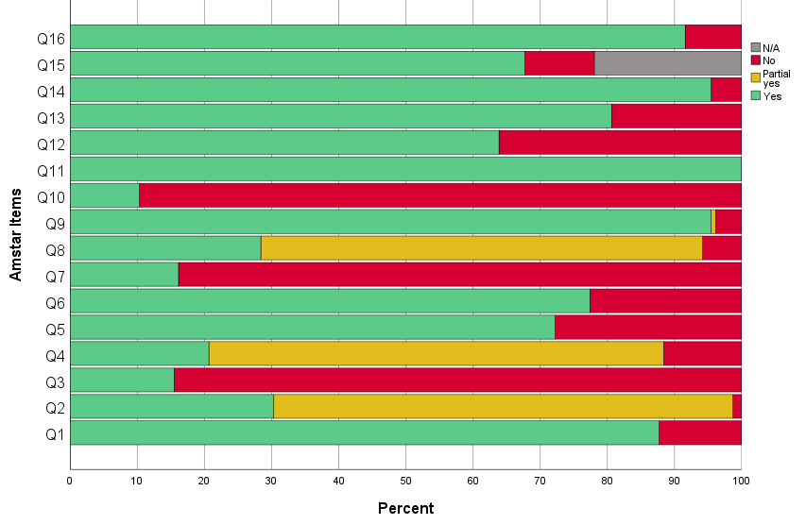

AMSTAR-2 ratings for each review
Author | 1 | 2* | 3 | 4* | 5 | 6 | 7 | 8 | 9* | 10 | 11* | 12 | 13* | 14 | 15* | 16 | Overall
Aalbers 2017⁸⁰ | Y | Y | N | Y | Y | Y | Y | Y | Y | Y | Y | Y | Y | Y | Y | Y | High
Abbing 2023⁸¹ | Y | Y | N | P Y | Y | Y | Y | Y | Y | N | Y | Y | Y | Y | Y | Y | Moderate
Álvarez-Bueno 2023¹¹⁰ | Y | P Y | N | P Y | Y | Y | N | N | Y | N | Y | Y | Y | Y | Y | Y | Low
Atchison 2022⁸² | Y | P Y | N | Y | Y | Y | N | Y | Y | Y | Y | N | Y | Y | N | Y | Moderate
Barnish 2020¹¹¹ | N | P Y | N | P Y | Y | Y | N | Y | Y | Y | Y | Y | Y | Y | N | Y | Critically low
Batubara 2023¹¹² | Y | P Y | N | P Y | N | Y | N | Y | Y | N | Y | Y | Y | Y | Y | Y | Low
Bian 2021¹¹³ | Y | P Y | N | P Y | Y | Y | N | P Y | Y | N | Y | N | Y | Y | N/A | Y | Low
Bighelli 2023⁸³ | Y | P Y | N | P Y | Y | Y | N | P Y | Y | N | Y | Y | Y | Y | Y | Y | Low
Bradt 2013⁵⁷ | Y | Y | N | Y | Y | Y | Y | Y | Y | Y | Y | Y | Y | Y | N/A | Y | High
Bradt 2015²⁹ | Y | Y | N | Y | Y | Y | Y | Y | Y | Y | Y | Y | Y | Y | Y | Y | High
Bradt 2021²⁸ | Y | Y | N | Y | Y | Y | Y | Y | Y | Y | Y | Y | Y | Y | Y | Y | High
Bro 2018³⁰ | Y | P Y | N | P Y | Y | N | N | P Y | Y | N | Y | N | Y | Y | Y | N | Low
Burley 2022¹¹⁴ | Y | P Y | N | P Y | N | N | N | P Y | N | N | Y | Y | Y | Y | Y | Y | Critically low
Cao 2023⁵⁸ | Y | P Y | N | P Y | Y | Y | N | P Y | Y | N | Y | Y | Y | Y | Y | Y | Low
Carapellotti 2020¹¹⁵ | Y | P Y | Y | P Y | Y | N | Y | P Y | Y | N | Y | Y | Y | Y | Y | Y | Low
Chan 2020¹¹⁶ | Y | Y | N | P Y | Y | Y | N | P Y | Y | N | Y | Y | Y | Y | Y | Y | Moderate
Chan 2023⁵⁹ | Y | Y | N | Y | Y | Y | N | Y | Y | N | Y | Y | Y | Y | Y | Y | High
Chandrababu 2021⁶⁰ | Y | P Y | N | P Y | N | Y | N | P Y | Y | N | Y | Y | Y | Y | Y | Y | Low
Chang 2015¹¹⁷ | Y | P Y | Y | N | N | Y | N | P Y | Y | N | Y | Y | Y | Y | Y | Y | Low
Chen 2021⁸⁴ | Y | Y | N | P Y | Y | Y | N | Y | Y | N | Y | Y | Y | Y | N | Y | Low
Chen 2022¹¹⁸ | Y | P Y | N | P Y | Y | Y | N | P Y | Y | N | Y | Y | Y | Y | N | Y | Critically low
Cheng 2021³¹ | N | P Y | N | P Y | N | N | N | N | Y | N | Y | Y | Y | Y | Y | Y | Low
Conceição 2016⁶¹ | Y | P Y | N | P Y | Y | Y | Y | P Y | Y | N | Y | N | N | Y | N/A | Y | Critically low
da Silva Santa 2021³² | Y | P Y | N | Y | Y | Y | N | P Y | Y | N | Y | N | N | Y | N/A | Y | Moderate
Dayuan 2022⁶² | Y | P Y | N | P Y | Y | Y | N | P Y | Y | N | Y | N | N | Y | Y | Y | Critically low
de Almeida 2021¹¹⁹ | Y | P Y | N | P Y | Y | Y | N | P Y | Y | N | Y | Y | Y | Y | N | Y | Critically low
de Dreu 2012¹²⁰ | Y | P Y | N | P Y | Y | N | N | P Y | Y | N | Y | N | N | Y | N/A | Y | Critically low
de Witte 2022⁸⁵ | Y | Y | Y | Y | Y | Y | N | P Y | Y | N | Y | Y | Y | Y | Y | Y | High
do Amaral 2016⁶³ | N | P Y | N | P Y | Y | Y | Y | P Y | Y | N | Y | N | Y | N | N/A | Y | Low
Dorris 2021¹²¹ | Y | P Y | N | N | Y | N | N | P Y | Y | N | Y | Y | Y | Y | Y | Y | Low
dos Santos Delabary 2018¹²² | Y | P Y | N | P Y | Y | Y | N | P Y | Y | N | Y | N | N | Y | N/A |  | Critically low
Ernst 2024¹²³ | Y | Y | Y | Y | Y | Y | Y | Y | Y | Y | Y | Y | Y | Y | Y | Y | High
Fusar-Poli 2018¹²⁴ | Y | Y | Y | P Y | N | N | N | P Y | Y | N | Y | N | N | Y | N/A | Y | Moderate
Geipel 2018⁸⁶ | Y | P Y | N | P Y | Y | N | Y | P Y | Y | N | Y | N | Y | Y | Y | Y | Low
Geng 2023³³ | Y | Y | Y | Y | Y | Y | N | P Y | Y | N | Y | N | Y | Y | Y | Y | High
Geretsegger 2017⁸⁷ | Y | Y | N | Y | Y | Y | Y | Y | Y | Y | Y | Y | Y | Y | Y | Y | High
Geretsegger 2022¹²⁵ | Y | Y | N | Y | Y | Y | Y | Y | Y | Y | Y | Y | Y | Y | Y | Y | High
Gerger 2022⁸⁸ | Y | Y | N | Y | Y | Y | N | P Y | Y | N | Y | N | Y | N | N/A | Y | High
Ghai 2018¹²⁶ | N | P Y | N | P Y | N | N | N | P Y | Y | N | Y | Y | Y | Y | Y | Y | Low
Ghai 2022¹²⁷ | Y | P Y | N | P Y | Y | N | N | P Y | Y | N | Y | Y | Y | Y | Y | Y | Low
Ghetti 2022⁸⁹ | Y | Y | N | Y | Y | Y | Y | Y | Y | Y | Y | Y | Y | Y | Y | Y | High
Goh 2023¹²⁸ | Y | Y | N | P Y | Y | Y | N | Y | Y | N | Y | N | Y | Y | Y | Y | Moderate
Gold 2009⁹⁰ | Y | P Y | Y | P Y | Y | Y | N | Y | Y | N | Y | Y | Y | Y | N/A | Y | Low
Gomes Neto 2014⁶⁴ | N | P Y | N | P Y | Y | Y | N | P Y | Y | N | Y | N | N | N | N/A | Y | Critically low
Guo 2020⁹¹ | Y | P Y | N | P Y | N | N | N | P Y | Y | N | Y | N | N | Y | Y | Y | Critically low
Hao 2022¹²⁹ | Y | P Y | N | P Y | Y | N | N | P Y | Y | N | Y | N | N | Y | Y |  | Critically low
Hasan 2022¹³⁰ | Y | P Y | N | P Y | Y | N | N | Y | Y | N | Y | N | Y | Y | N/A | Y | Low
Hidalgo-Agudo 2020¹³¹ | Y | P Y | N | N | Y | Y | N | P Y | Y | N | Y | N | Y | Y | N/A | Y | low
Huang 2021¹⁷⁸ | N | P Y | N | P Y | Y | Y | N | P Y | Y | N | Y | Y | Y | Y | Y | Y | Low
Hung 2018³⁴ | Y | P Y | N | P Y | N | N | N | P Y | Y | N | Y | Y | Y | Y | Y | N | Low
Ismail 2021¹³² | Y | P Y | N | Y | Y | Y | Y | Y | Y | N | Y | Y | Y | Y | N | Y | low
Ito 2022¹³³ | Y | P Y | N | P Y | Y | Y | N | P Y | Y | N | Y | Y | Y | Y | N/A | Y | Low
Jayakar 2017⁶⁵ | Y | P Y | N | P Y | N | Y | Y | Y | Y | N | Y | Y | Y | Y | Y | N | Low
Jenabi 2023⁹² | N | P Y | N | P Y | Y | Y | N | P Y | Y | N | Y | N | N | Y | Y | Y | Critically low
Jia 2020⁹³ | Y | P Y | N | P Y | Y | Y | N | P Y | Y | N | Y | Y | Y | Y | Y | Y | Low
Jiang 2020³⁵ | Y | P Y | N | P Y | Y | Y | N | P Y | Y | N | Y | Y | Y | Y | Y | Y | Low
Jiang 2023⁹⁴ | Y | Y | N | P Y | Y | N | N | P Y | Y | N | Y | Y | N | Y | Y | Y | Moderate
Jiang 2023³⁶ | Y | P Y | N | P Y | Y | N | N | P Y | Y | N | Y | N | N | Y | Y | N | Critically low
Jin 2022¹³⁴ | Y | P Y | N | Y | Y | N | N | P Y | Y | N | Y | Y | Y | Y | Y | Y | Moderate
Kakar 2021⁶⁶ | Y | Y | N | P Y | Y | Y | N | Y | Y | N | Y | Y | Y | Y | Y | Y | Moderate
Kalyani 2019¹³⁵ | Y | P Y | N | P Y | Y | Y | Y | P Y | Y | N | Y | Y | Y | Y | N/A | Y | Low
Karkou 2019⁹⁵ | Y | P Y | Y | P Y | Y | Y | N | Y | Y | Y | Y | Y | Y | Y | Y | Y | Low
Ke 2022¹³⁶ | Y | P Y | N | P Y | N | Y | N | P Y | Y | N | Y | Y | Y | Y | Y | Y | Low
Kim 2016¹³⁷ | Y | Y | Y | P Y | Y | Y | Y | P Y | N | N | Y | N | N | Y | Y | Y | Critically low
Kim 2021¹⁷⁹ | Y | P Y | N | P Y | N | N | N | P Y | Y | N | Y | N | Y | Y | N/A | N | Low
Koch 2019⁹⁶ | N | P Y | Y | Y | N | N | Y | N | Y | N | Y | Y | Y | Y | Y | Y | Moderate
Köhler 2020³⁷ | Y | Y | N | P Y | Y | Y | N | Y | Y | N | Y | Y | Y | Y | Y | Y | Moderate
Kong 2015¹³⁸ | Y | P Y | N | Y | Y | Y | N | P Y | Y | N | Y | N | Y | N | Y | Y | Moderate
Kwok 2016¹³⁹ | Y | P Y | Y | N | N | N | N | P Y | Y | N | Y | N | Y | Y | N | Y | Critically low
Laws 2019⁹⁷ | Y | P Y | Y | P Y | N | N | N | N | Y | N | Y | Y | Y | Y | Y | Y | Moderate
Lee 2015¹⁸⁰ | Y | Y | N | P Y | Y | N | N | P Y | Y | N | Y | Y | Y | Y | Y | Y | Moderate
Lee 2021⁶⁷ | Y | P Y | N | P Y | Y | Y | N | P Y | Y | N | Y | Y | Y | Y | Y | Y | Low
Lee 2023¹⁴⁰ | Y | Y | N | P Y | Y | Y | N | P Y | Y | N | Y | N | Y | Y | N/A | Y | Moderate
Li 2020³⁸ | Y | P Y | N | P Y | Y | Y | N | P Y | Y | N | Y | Y | Y | Y | Y | Y | Low
Li 2022¹⁴¹ | Y | P Y | N | P Y | N | Y | N | P Y | Y | N | Y | N | N | Y | N | Y | Critically low
Liang 2018¹⁴³ | Y | P Y | Y | P Y | Y | Y | N | P Y | Y | N | Y | Y | Y | Y | Y | Y | Low
Liang 2019¹⁴² | Y | P Y | N | Y | Y | Y | N | P Y | Y | N | Y | Y | Y | Y | Y | Y | Moderate
Liu 2022⁶⁸ | Y | Y | N | P Y | Y | Y | N | P Y | Y | N | Y | N | Y | Y | N/A | Y | Moderate
Liu 2023⁶⁹ | Y | P Y | N | P Y | Y | Y | N | P Y | Y | N | Y | N | Y | Y | Y | Y | Low
Lorenzo-García 2023¹⁴⁴ | Y | P Y | N | P Y | Y | Y | N | P Y | Y | N | Y | Y | Y | Y | Y | Y | low
Lötzke 2015¹⁴⁵ | N | P Y | N | N | N | N | N | Y | N | N | Y | N | N | Y | N | Y | critically low
Lutgens 2017⁹⁸ | Y | P Y | N | P Y | N | N | N | P Y | N | N | Y | Y | Y | Y | Y | Y | Critically low
Magee 2017⁷⁰ | Y | Y | N | Y | Y | Y | Y | Y | Y | Y | Y | Y | Y | Y | Y | Y | High
Masika 2020¹⁴⁶ | Y | Y | N | P Y | Y | Y | N | Y | Y | N | Y | Y | Y | Y | N | Y | Low
May 2021¹⁴⁷ | Y | Y | N | Y | Y | Y | N | P Y | Y | N | Y | N | Y | Y | Y | Y | High
Mazzarin 2017¹⁴⁸ | Y | P Y | N | P Y | Y | Y | N | Y | Y | N | Y | N | Y | Y | N/A | Y | Low
McNamara 2017¹⁸¹ | Y | Y | Y | Y | Y | Y | Y | Y | Y | Y | Y | Y | Y | Y | Y | Y | High
Meekums 2015⁹⁹ | Y | Y | Y | Y | Y | Y | Y | Y | Y | N | Y | Y | Y | Y | Y | Y | High
Mishra 2021¹⁴⁹ | N | P Y | N | P Y | N | Y | N | N | Y | N | Y | Y | Y | Y | N/A | Y | Low
Moreno-Morales 2020¹⁵⁰ | Y | P Y | N | P Y | Y | Y | N | P Y | Y | N | Y | Y | Y | Y | Y | Y | Low
Mustafaoglu 2022¹⁵¹ | Y | Y | N | P Y | Y | Y | N | P Y | Y | N | Y | N | Y | Y | Y | Y | Moderate
Na 2019¹⁵² | Y | Y | N | P Y | Y | Y | N | P Y | Y | N | Y | Y | Y | Y | N/A | Y | Moderate
Nelson 2023³⁹ | Y | P Y | Y | P Y | Y | N | N | Y | Y | N | Y | N | N | Y | N | Y | Critically low
Nguyen 2022⁴⁰ | Y | Y | N | P Y | Y | Y | N | Y | Y | N | Y | Y | Y | Y | N/A | Y | Moderate
Nightingale 2013⁴¹ | N | P Y | Y | P Y | N | N | N | P Y | Y | N | Y | Y | Y | Y | Y | Y | Low
Nyssen 2016¹⁸² | Y | Y | Y | Y | Y | Y | Y | Y | Y | Y | Y | Y | Y | Y | N | Y | Low
Orkibi 2023¹⁰⁰ | Y | P Y | Y | P Y | Y | Y | N | P Y | Y | N | Y | Y | Y | Y | Y | Y | Low
Park 2022⁴² | Y | P Y | N | N | Y | Y | N | Y | Y | N | Y | N | Y | Y | Y | Y | Low
Pedersen 2017¹⁵³ | N | N | Y | P Y | N | N | N | P Y | N | N | Y | N | N | Y | Y | N | Critically low
Peng 2021⁷¹ | N | P Y | N | Y | N | Y | Y | P Y | Y | N | Y | Y | Y | Y | Y | Y | Moderate
Puetz 2013⁴³ | Y | P Y | N | P Y | N | Y | N | P Y | P Y | N | Y | N | N | Y | Y | N | Critically low
Qi 2021⁴⁴ | Y | P Y | N | Y | Y | Y | N | P Y | Y | N | Y | Y | Y | Y | Y | Y | Moderate
Radder 2020¹⁵⁴ | Y | P Y | N | P Y | N | N | N | P Y | N | N | Y | Y | Y | Y | Y | Y | Critically low
Reinhold 2018¹⁰¹ | Y | P Y | N | P Y | N | N | N | P Y | Y | N | Y | Y | Y | Y | Y | Y | Low
Roche Bueno 2019⁷² | Y | Y | N | P Y | Y | Y | N | P Y | Y | N | Y | N | N | Y | N/A | Y | Low
Sabeena 2022¹⁰² | Y | P Y | N | N | N | N | N | N | Y | N | Y | N | N | Y | Y | Y | Critically low
Sezgin 2022⁴⁵ | Y | Y | N | N | Y | Y | N | Y | Y | N | Y | N | Y | Y | Y | Y | Low
Sharp 2014¹⁵⁵ | Y | P Y | N | Y | Y | Y | Y | P Y | Y | N | Y | N | Y | Y | N/A | N | Moderate
Shi 2016¹⁵⁶ | Y | P Y | N | P Y | N | Y | N | P Y | Y | N | Y | N | Y | N | N | Y | Critically low
Simpkins 2023¹⁵⁷ | Y | P Y | N | P Y | N | Y | N | P Y | Y | N | Y | Y | Y | Y | Y | Y | low
Steenhuis 2015¹⁰³ | Y | P Y | N | P Y | Y | N | N | Y | Y | N | Y | Y | Y | Y | Y | Y | Low
Su 2021⁷³ | Y | P Y | N | N | Y | Y | N | Y | Y | N | Y | Y | Y | Y | Y | Y | Low
Tang 2019¹⁵⁸ | N | P Y | N | N | N | Y | N | P Y | Y | N | Y | N | Y | Y | N | Y | Critically low
Tang 2019⁴⁶ | N | P Y | N | N | Y | Y | N | P Y | Y | N | Y | Y | Y | Y | N | Y | Critically low
Tang 2020¹⁰⁴ | Y | P Y | N | P Y | Y | Y | N | P Y | Y | N | Y | Y | Y | Y | Y | Y | Low
Tsai 2014⁴⁷ | Y | P Y | Y | P Y | Y | Y | N | P Y | Y | N | Y | Y | Y | Y | Y | Y | Low
Tseng 2016¹⁰⁵ | Y | P Y | N | N | N | N | N | P Y | Y | N | Y | Y | N | Y | Y | Y | Critically low
Tsoi 2018¹⁵⁹ | Y | P Y | N | Y | Y | Y | N | P Y | Y | N | Y | Y | N | Y | Y | Y | Low
Ueda 2013¹⁶⁰ | Y | P Y | Y | P Y | Y | Y | N | N | Y | N | Y | Y | Y | Y | Y | N | Low
van der Steen 2018¹⁶¹ | Y | Y | N | Y | Y | Y | Y | Y | Y | Y | Y | Y | Y | Y | Y | Y | High
Wang 2018⁴⁸ | Y | P Y | N | P Y | N | Y | N | P Y | Y | N | Y | Y | Y | Y | Y | Y | Low
Wang 2020¹⁶² | Y | Y | N | P Y | Y | Y | N | P Y | Y | N | Y | Y | Y | Y | Y | Y | Moderate
Wang 2020¹⁶⁶ | N | P Y | N | N | N | N | N | P Y | Y | N | Y | Y | Y | Y | Y | Y | Low
Wang 2020⁷⁴ | Y | P Y | N | P Y | Y | Y | N | Y | Y | N | Y | Y | Y | Y | Y | Y | Low
Wang 2021¹⁶³ | Y | P Y | N | P Y | N | Y | N | P Y | Y | N | Y | N | N | Y | Y | Y | Critically low
Wang 2022¹⁶⁴ | Y | P Y | N | Y | Y | Y | N | Y | Y | Y | Y | Y | Y | Y | N/A |  | Moderate
Wang 2022¹⁶⁵ | Y | P Y | N | P Y | Y | Y | N | Y | Y | N | Y | N | Y | Y | Y | Y | Low
Wang 2022⁷⁵ | Y | Y | N | P Y | Y | Y | N | Y | Y | N | Y | Y | Y | Y | Y | Y | Moderate
Wang 2023¹⁶⁷ | N | P Y | N | P Y | N | Y | N | P Y | Y | N | Y | N | Y | Y | Y | Y | Low
Wei 2020¹⁶⁸ | Y | N | N | N | N | Y | N | P Y | Y | N | Y | Y | Y | Y | N/A | Y | Critically low
Wei 2020⁴⁹ | Y | P Y | Y | P Y | Y | Y | N | P Y | Y | N | Y | N | Y | Y | N/A | N | Low
Wong 2022¹⁶⁹ | Y | P Y | N | P Y | N | N | N | P Y | Y | N | Y | Y | Y | Y | N | Y | Critically low
Wu 2021¹⁷⁰ | Y | Y | N | P Y | N | Y | N | P Y | Y | N | Y | N | Y | Y | Y | Y | Moderate
Xia 2023⁵⁰ | Y | Y | N | P Y | Y | Y | N | P Y | Y | N | Y | N | N | Y | Y | Y | Moderate
Xu 2020⁵¹ | N | P Y | N | P Y | Y | Y | N | N | Y | N | Y | N | N | N | Y | Y | Critically low
Yan 2019¹⁰⁶ | Y | Y | N | P Y | Y | Y | N | P Y | Y | N | Y | N | Y | Y | Y | N | Moderate
Yang 2019⁷⁶ | Y | Y | N | Y | Y | Y | N | Y | Y | N | Y | Y | Y | Y | Y | Y | high
Yang 2019¹⁷¹ | Y | P Y | N | P Y | N | Y | N | P Y | Y | N | Y | N | N | N | Y | N | Critically low
Yang 2019¹⁰⁷ | Y | Y | N | P Y | Y | Y | N | P Y | Y | N | Y | Y | Y | Y | N/A | Y | Moderate
Yang 2021⁷⁹ | Y | P Y | N | Y | Y | Y | N | P Y | Y | N | Y | N | N | Y | N/A | Y | Low
Yang 2021⁵² | Y | P Y | N | P Y | Y | Y | N | P Y | Y | N | Y | N | Y | Y | Y | Y | Low
Yang 2022¹⁷² | Y | Y | N | P Y | Y | Y | N | P Y | Y | N | Y | Y | Y | Y | Y | Y | Moderate
Yangöz 2019⁵³ | Y | P Y | N | P Y | N | Y | N | P Y | Y | N | Y | Y | Y | Y | Y | Y | Low
Ye 2022¹⁷³ | Y | P Y | N | N | N | Y | N | P Y | Y | N | Y | Y | Y | Y | Y | Y | Low
Yijing 2018¹⁰⁸ | N | P Y | N | N | Y | Y | N | P Y | Y | N | Y | N | N | Y | N/A | N | Critically low
Yoo 2016⁷⁷ | Y | P Y | N | P Y | N | N | N | P Y | Y | N | Y | Y | N | Y | Y | Y | Critically low
Zhang 2012⁵⁴ | Y | P Y | Y | P Y | N | Y | N | Y | Y | N | Y | Y | Y | Y | N/A | Y | Low
Zhang 2015⁵⁵ | Y | P Y | N | N | Y | Y | N | P Y | Y | N | Y | Y | Y | Y | Y | Y | Low
Zhang 2016⁷⁸ | Y | Y | N | N | Y | Y | N | Y | Y | N | Y | Y | Y | Y | N/A | Y | Low
Zhang 2017¹⁷⁵ | Y | Y | N | P Y | Y | Y | N | Y | Y | N | Y | Y | Y | Y | Y | Y | Moderate
Zhang 2019¹⁷⁴ | Y | P Y | N | P Y | Y | Y | N | P Y | Y | N | Y | Y | Y | Y | N/A | Y | Low
Zhang 2023⁵⁶ | Y | Y | N | P Y | Y | Y | N | N | Y | N | Y | Y | Y | Y | Y | Y | Moderate
Zhao 2016¹⁰⁹ | Y | P Y | N | P Y | N | Y | N | P Y | Y | N | Y | N | N | Y | Y | Y | Critically low
Zhou 2021¹⁷⁶ | Y | P Y | N | P Y | Y | Y | N | P Y | Y | N | Y | Y | Y | Y | Y | Y | Low
Zhu 2020¹⁷⁷ | Y | P Y | N | P Y | Y | Y | N | P Y | Y | N | Y | Y | Y | Y | N/A | Y | Low
1-Question and inclusion; 2-Protocol; 3-Study design; 4-Comprehensive search; 5-Study selection; 6-Data extraction; 7-Excluded studies justification; 8-Included studied details; 9-Risk of Bias; 10-Source of funding of included studies; 11-Appropriate statistical methods for analysis; 12-RoB impact on meta-analyses; 13-RoB interpretation; 14-Explanation for heterogeneity; 15-Publication bias; 16-Conflict of interest. Items 2-4-9-11-13-15 were considered critical.
Legend: Y: yes; N: no; PY: partial yes
Note: We did not consider item 7 a critical item, as suggested in the AMSTAR-2 guidelines. Only 17% of included SR provided a list of excluded studies with reason for exclusion. It is only in recent years that online supplementary materials are common amongst journals. We suspect that prior to that, journals may have not allowed for or may have discouraged lengthy tables in the Appendix.

Supplementary material 7: Forest Plots

Cancer
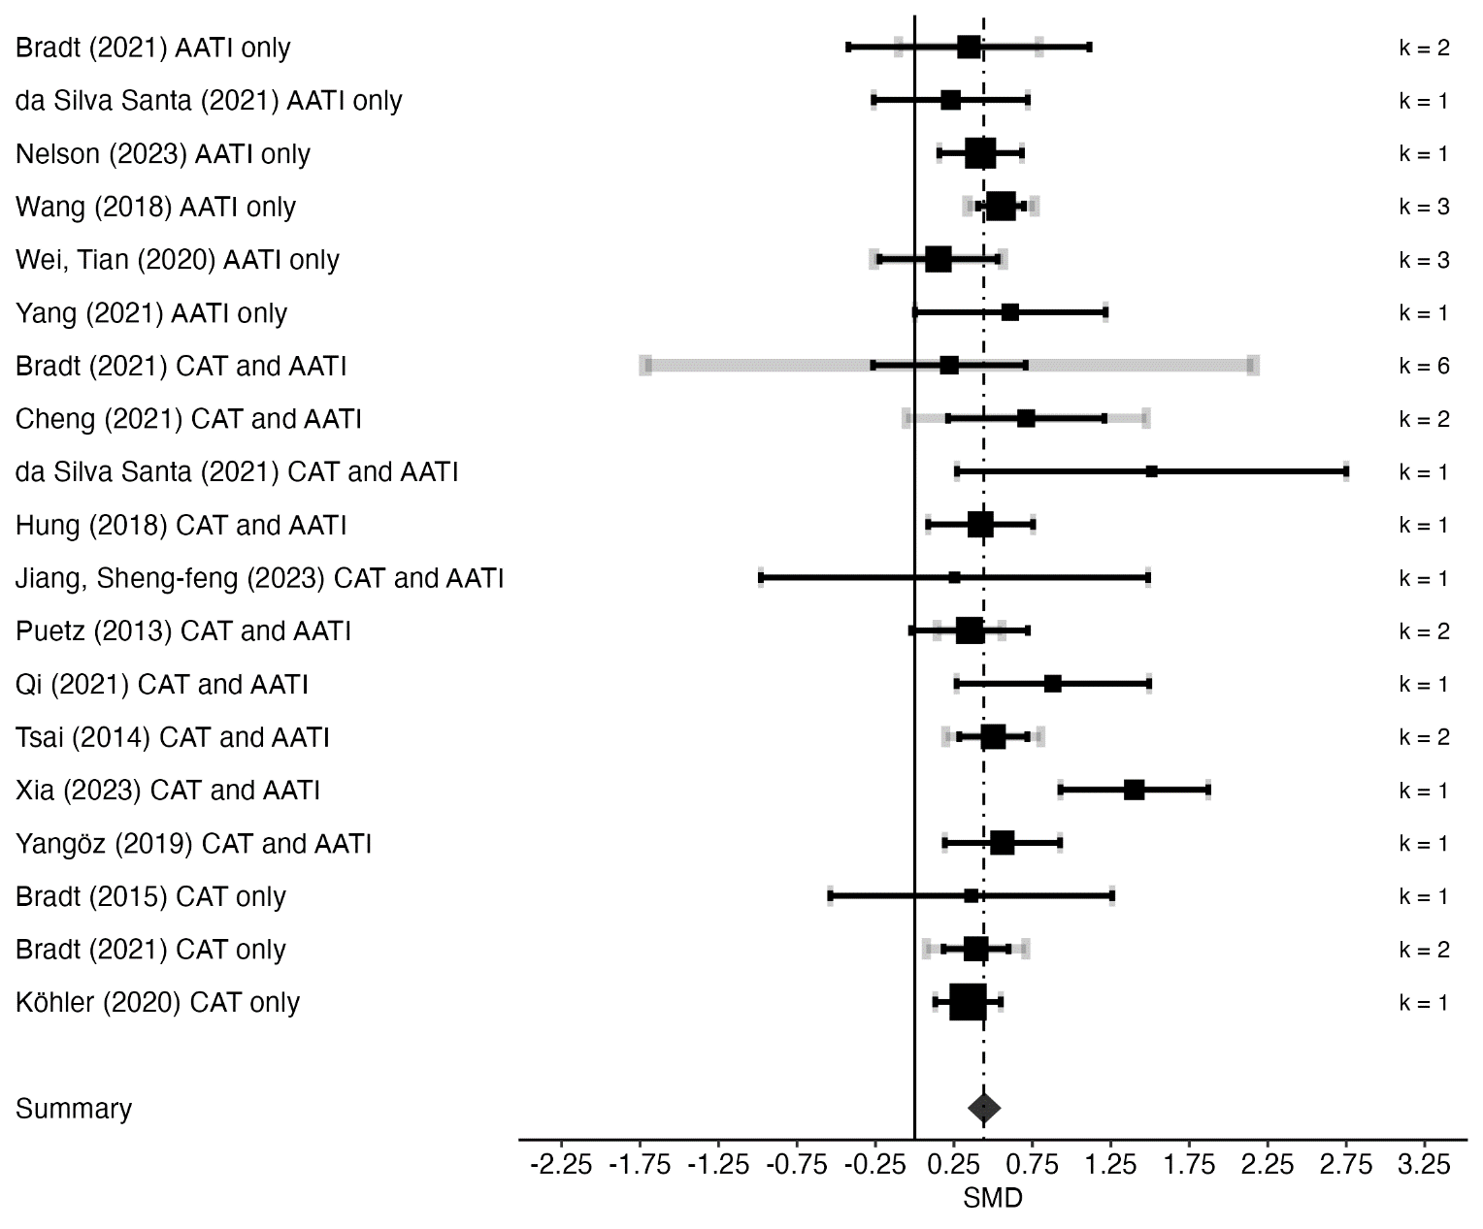
Physical Outcomes

Psychological Outcomes
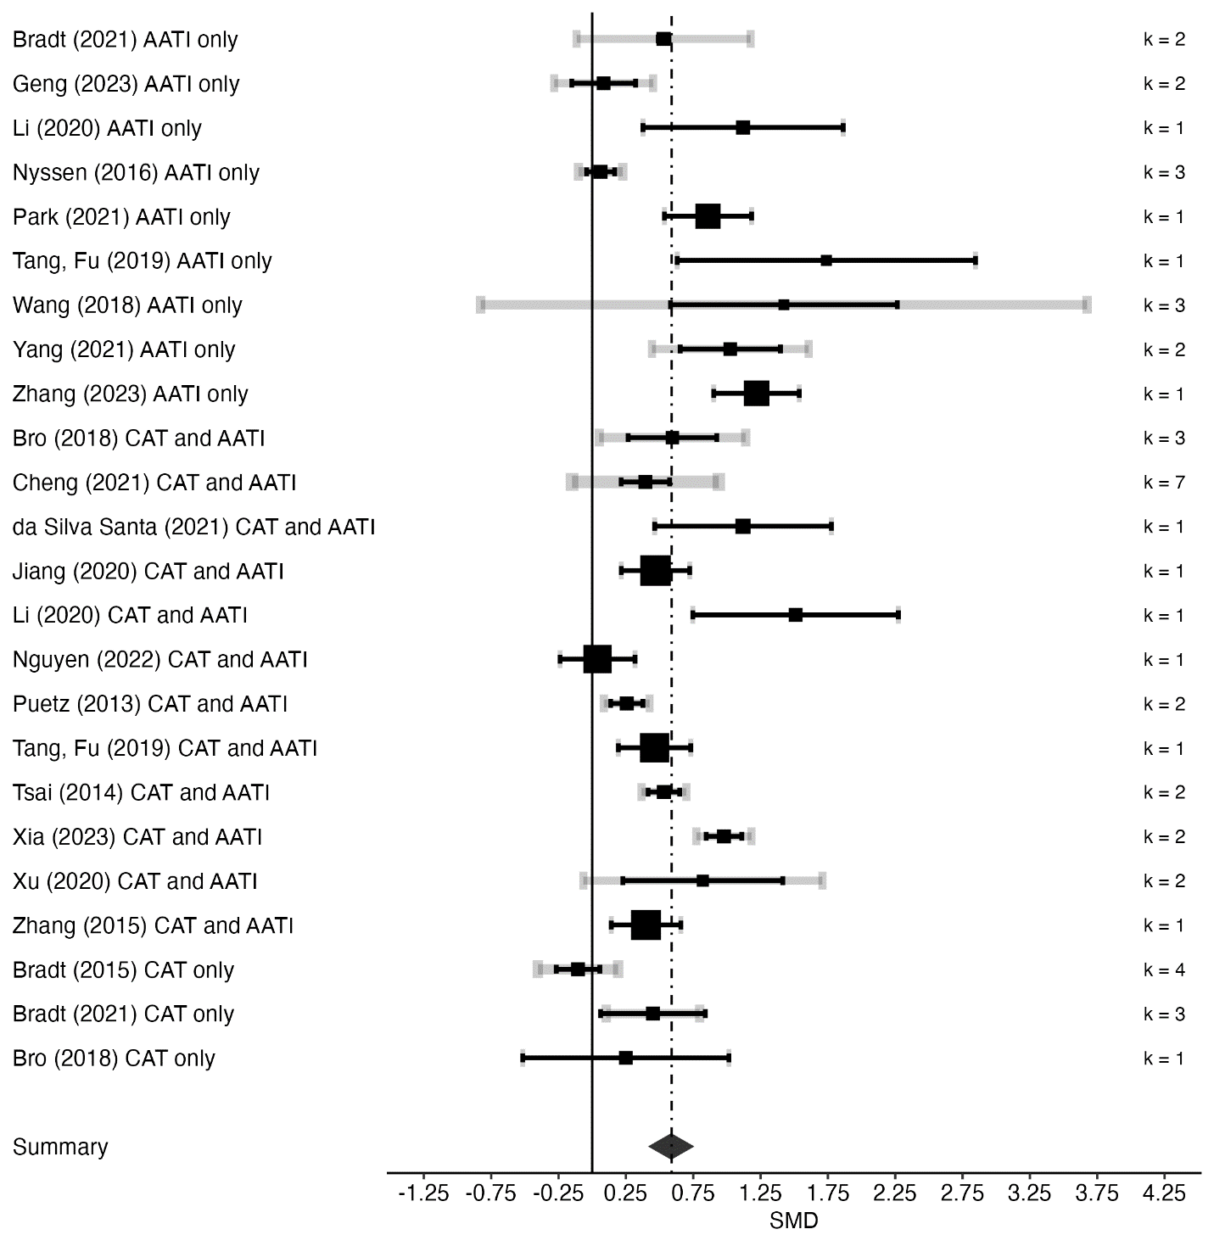

Quality of Life Outcomes
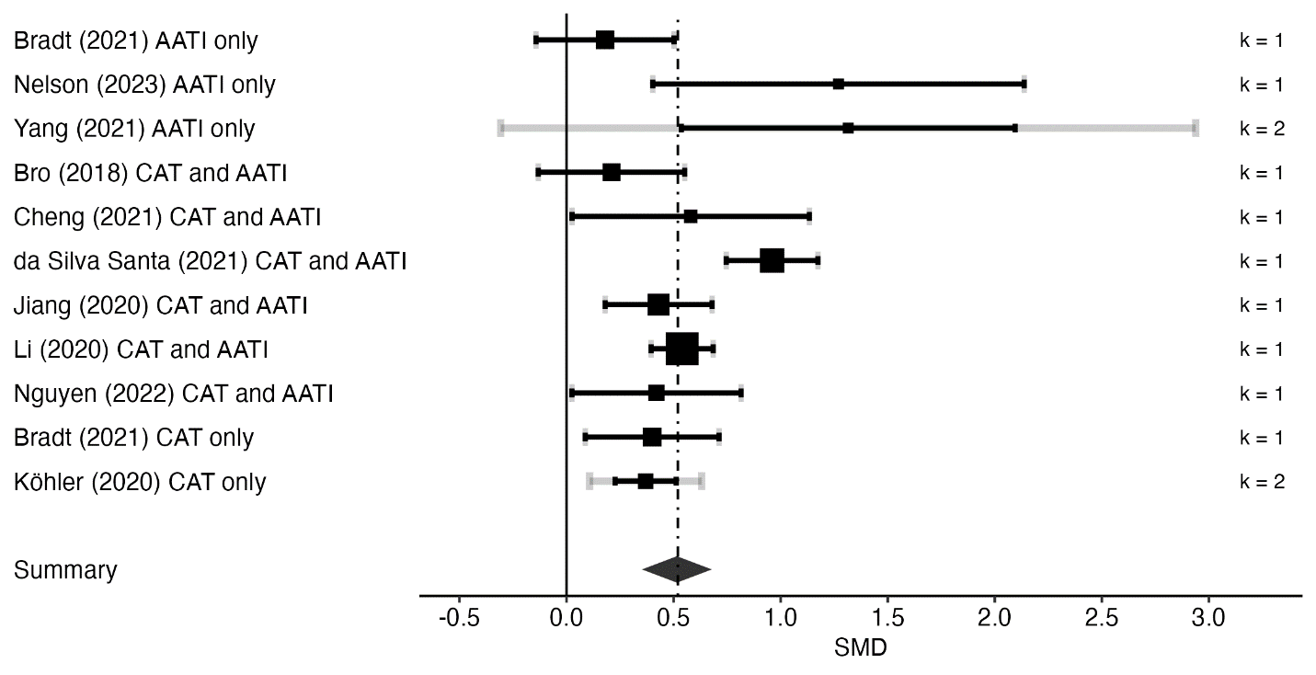

Cardiovascular Diseases
Physical outcomes
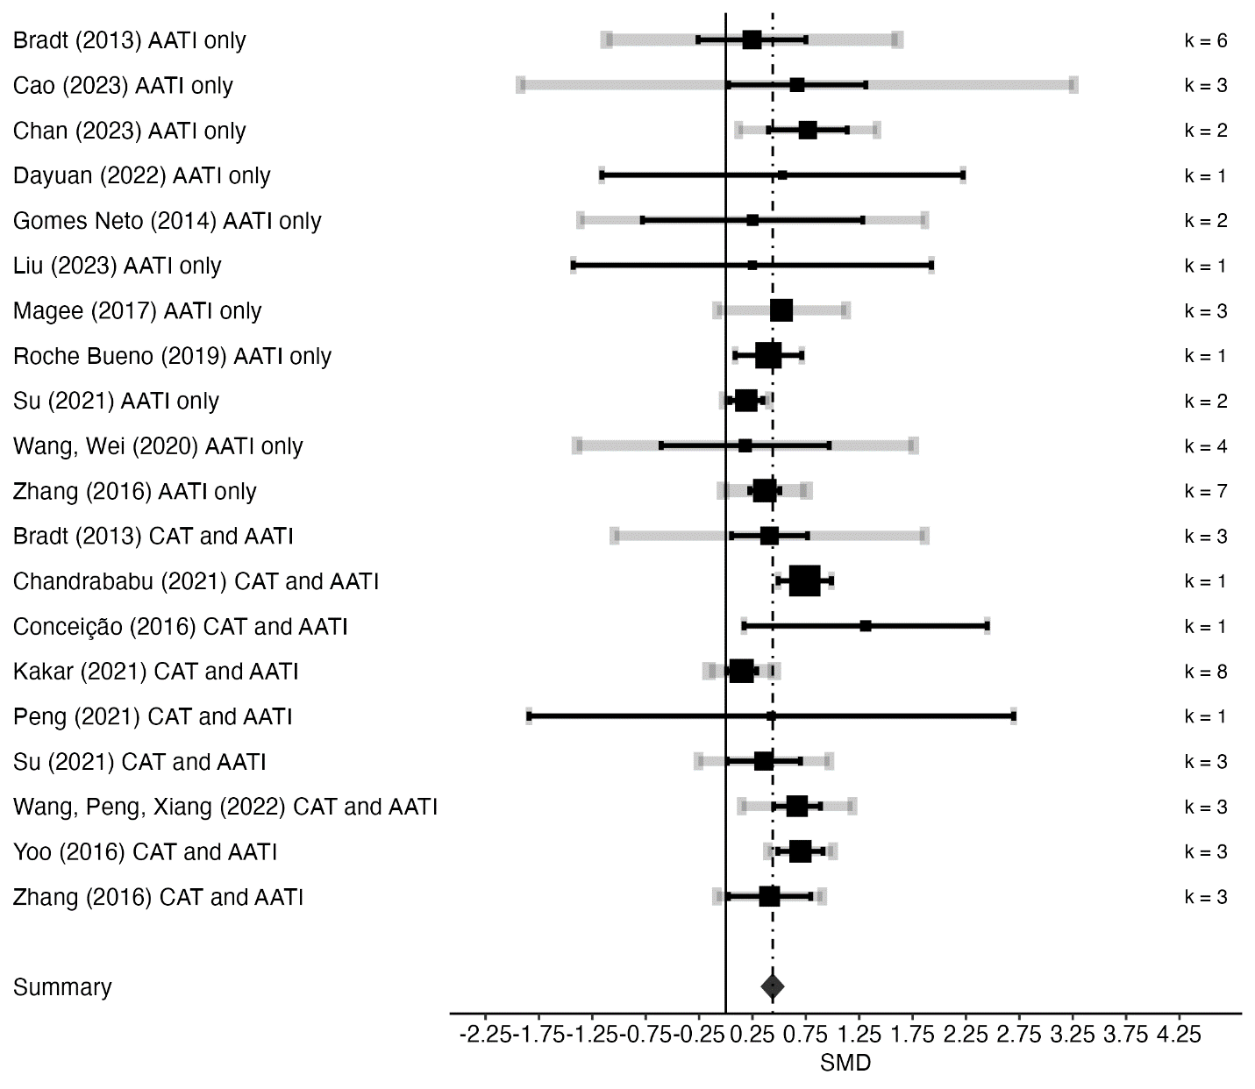

Psychological Outcomes
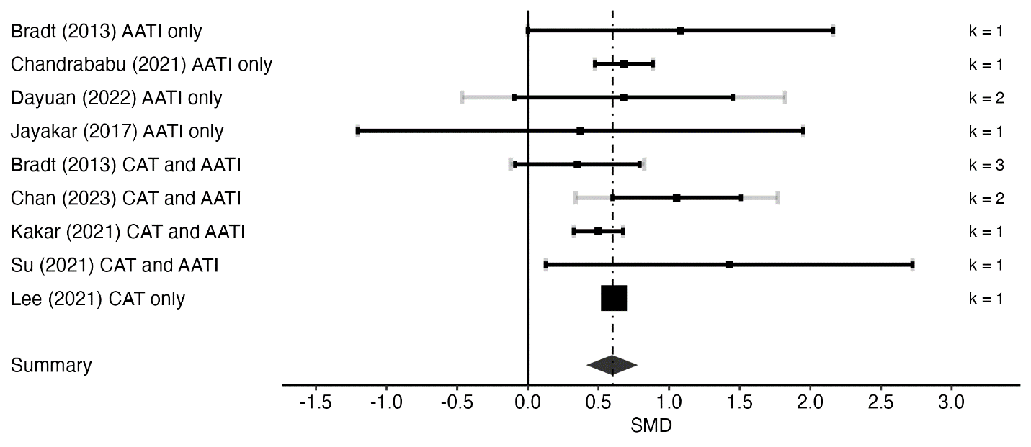
Cognitive Outcomes
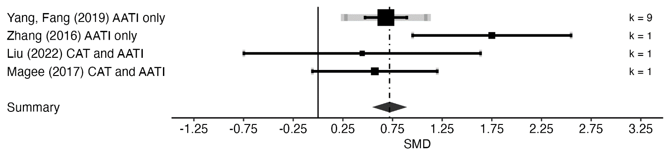
Quality of Life Outcomes

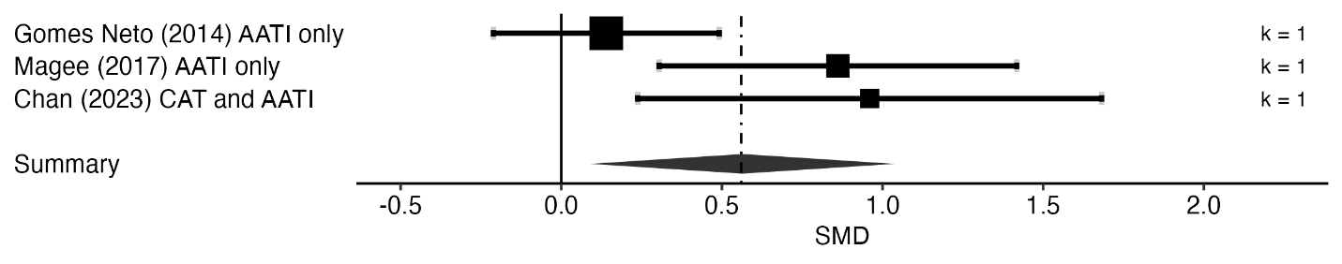

Chronic Respiratory Diseases
Physical Outcomes
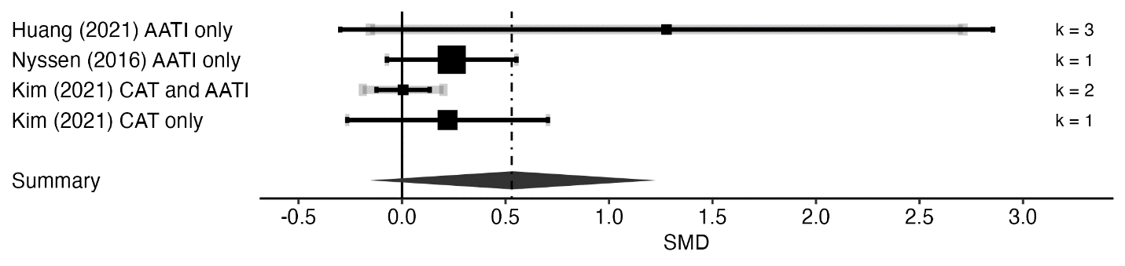
Psychological Outcomes
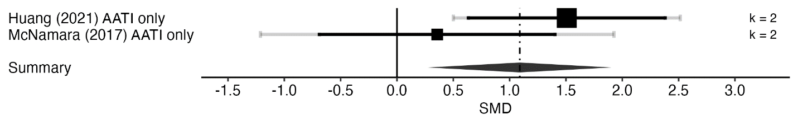
Quality of Life Outcomes
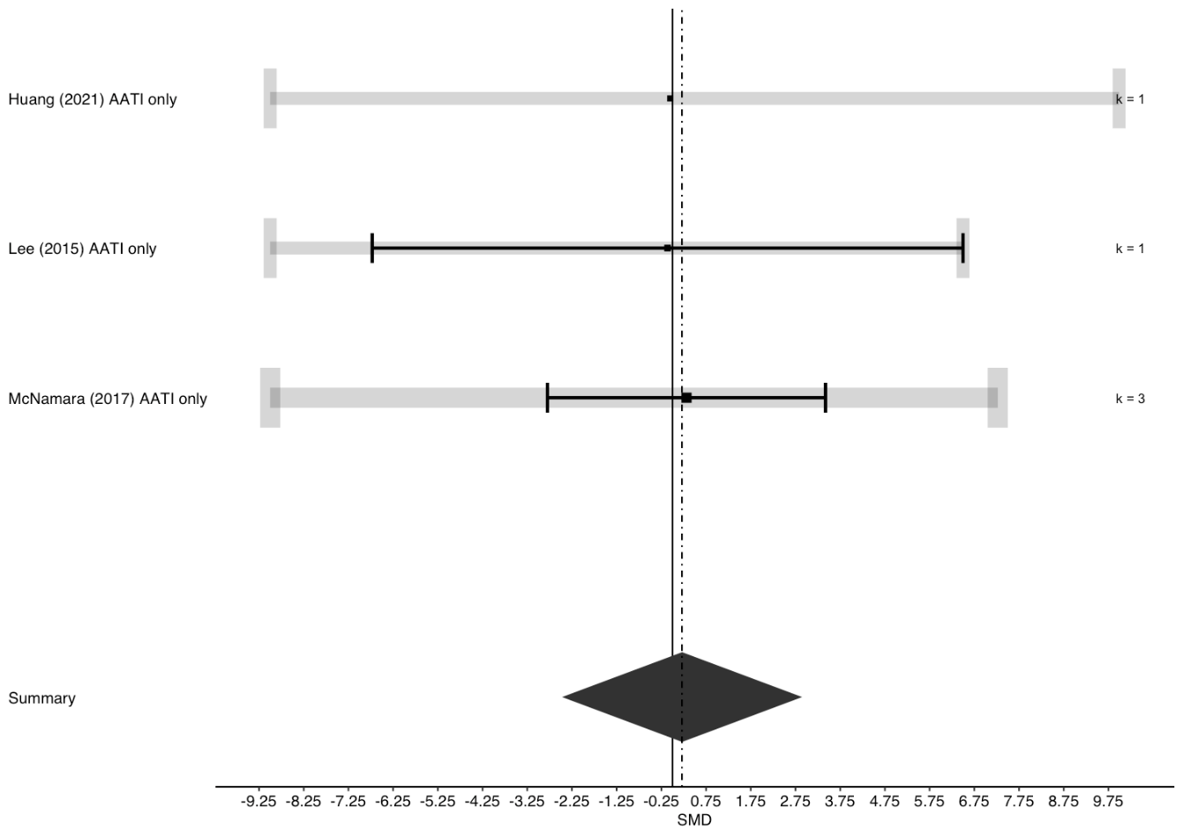

Mental Health Conditions
Psychological Outcomes
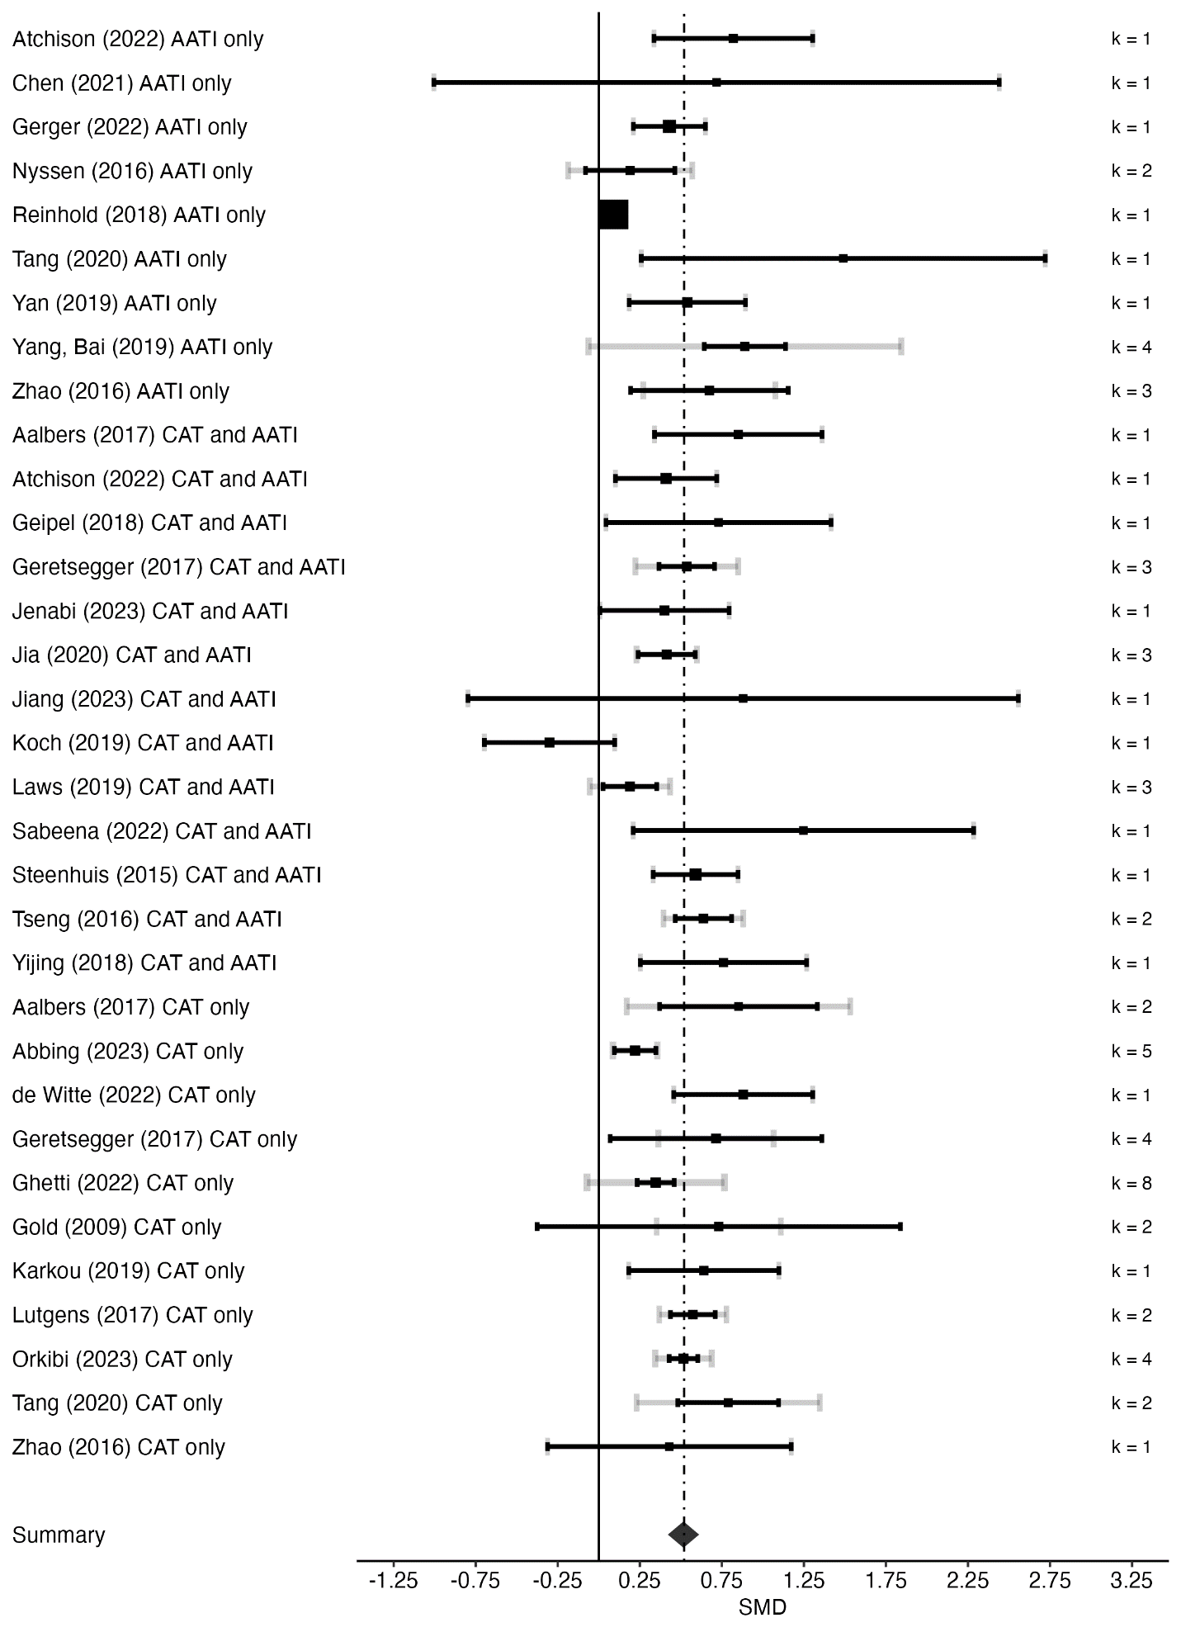
Cognitive Outcomes
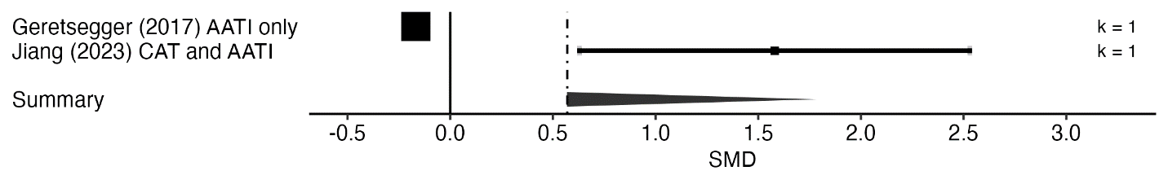
Quality of Life Outcomes
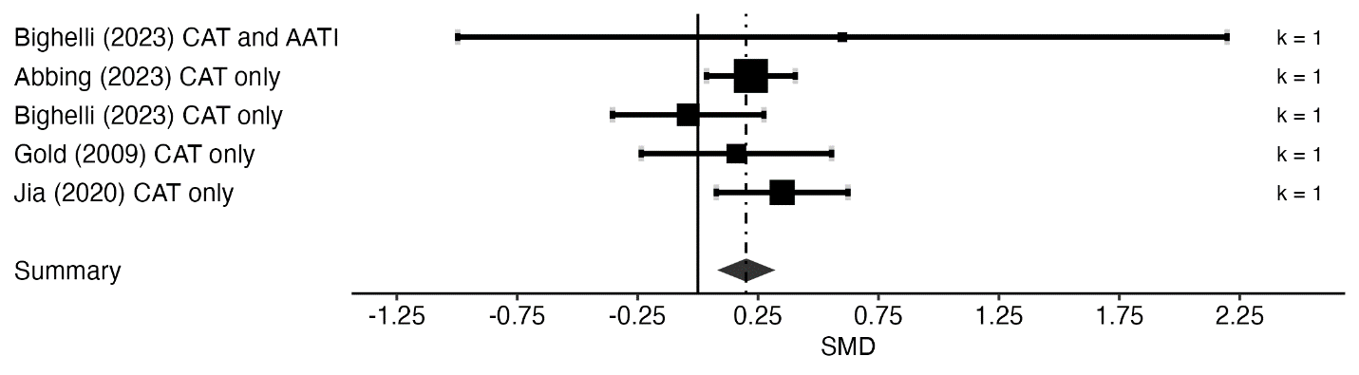

Neurological conditions
Physical Outcomes
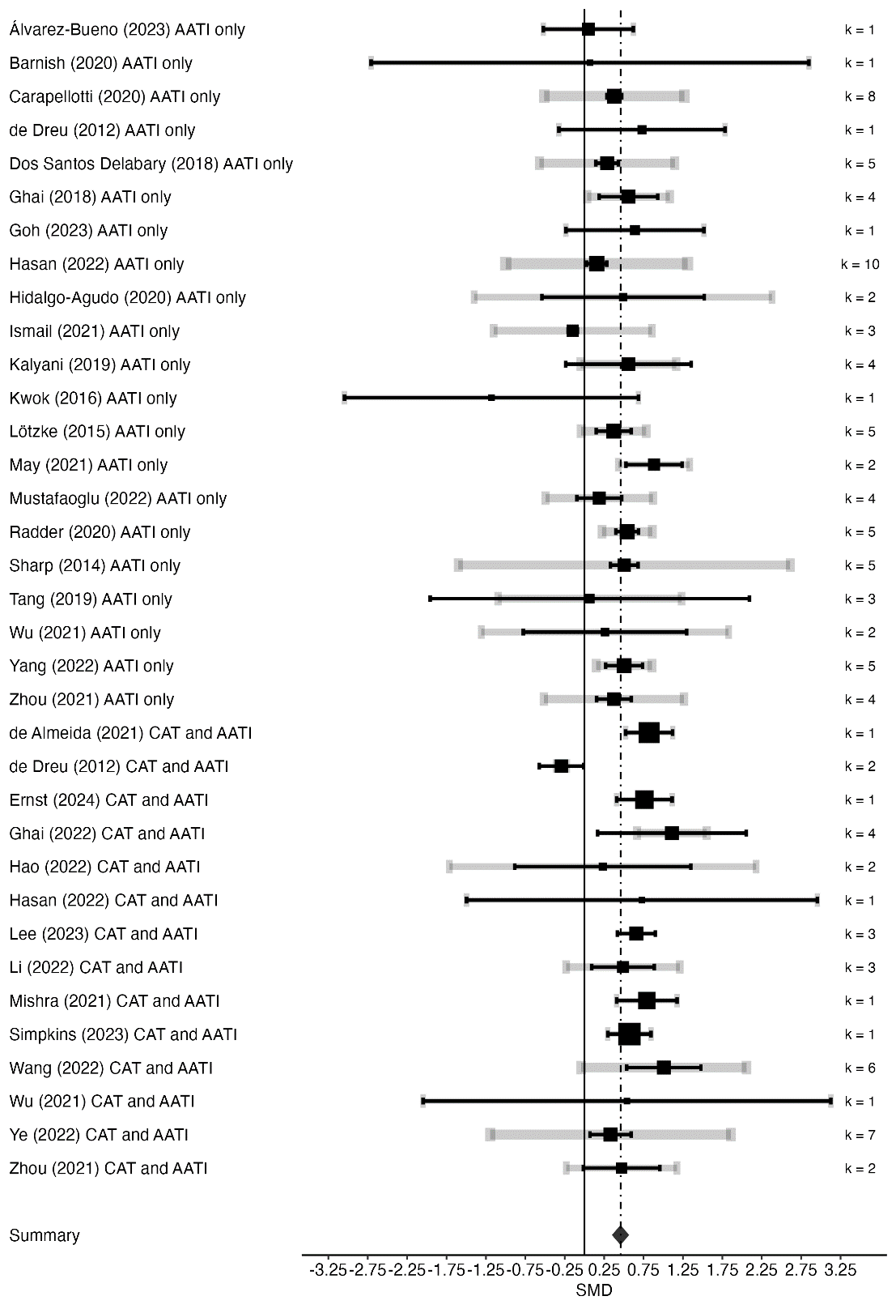

Psychological Outcomes
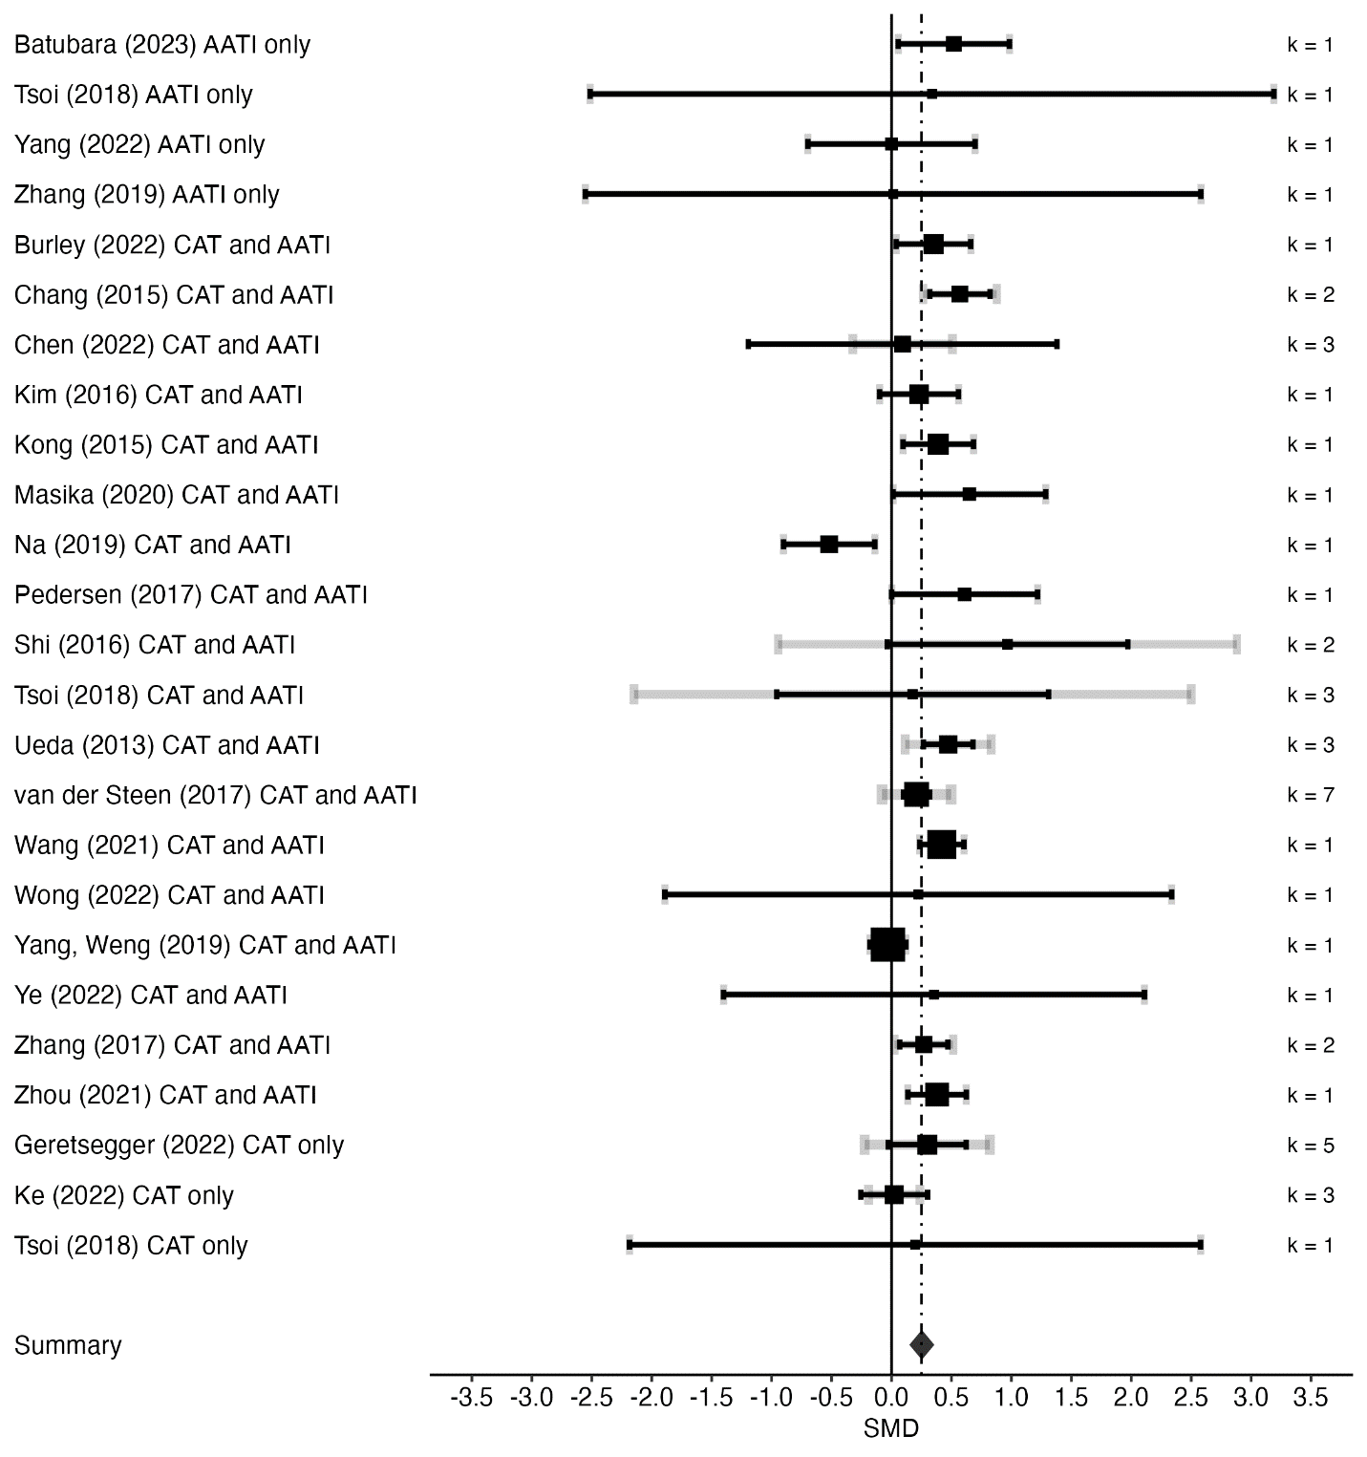

Cognitive Outcomes
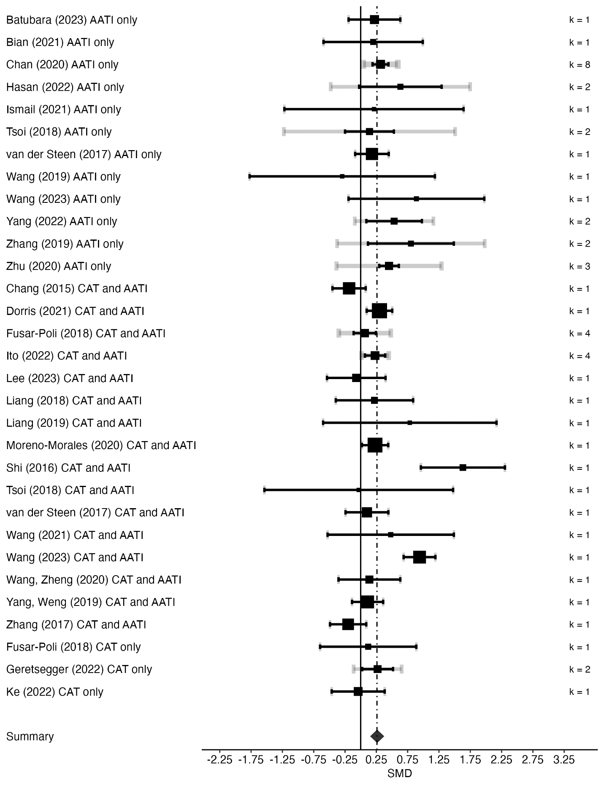
Quality of Life Outcomes
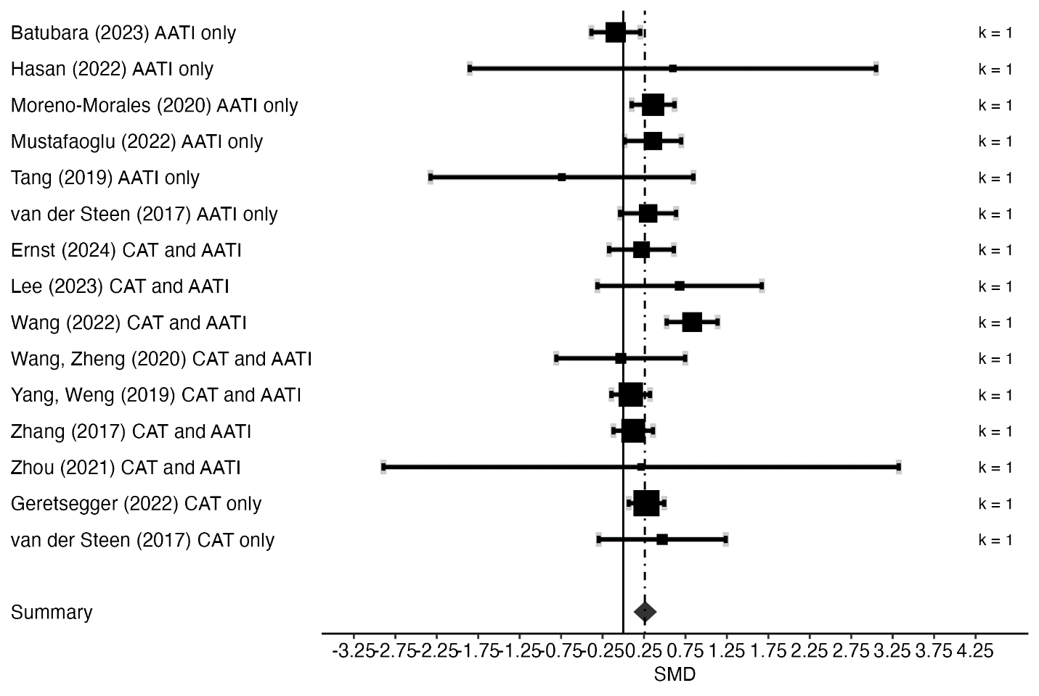

Supplementary material 8: Moderation analyses

Cancer
Variables | S | k | SMD | 95% CI | Q(df) | P
Outcome characteristics
Psychological outcomes |  |  |  |  | Q(2) = 0.244 | 0.885
Anxiety/Stress | 15 | 21 | 0.57 | 0.37, 0.77
Depression | 16 | 18 | 0.56 | 0.36, 0.76
Mood | 3 | 5 | 0.52 | 0.26, 0.78
Physical outcomes |  |  |  |  | Q(2) = 0.485 | 0.785
Physiological responses | 3 | 9 | 0.42 | 0.07, 0.76
Physical symptoms | 12 | 16 | 0.43 | 0.24, 0.62
Review characteristics
Design |  |  |  |  | Q(1) = 0.06 | 0.806
RCT only | 19 | 61 | 0.49 | 0.35, 0.64
RCT/CCT | 8 | 36 | 0.53 | 0.29, 0.76
Study quality (AMSTAR-2) |  |  |  |  | Q(3) = 6.247 | 0.1
High | 3 | 24 | 0.14 | -0.18, 0.46
Moderate | 5 | 13 | 0.65 | 0.38, 0.91
Low | 14 | 48 | 0.54 | 0.38, 0.7
Critically low | 5 | 12 | 0.5 | 0.19, 0.8
Type of control condition |  |  |  |  | Q(2) = 0.014 | 0.993
Active controls | 1 | 1 | 0.5 | -0.12, 1.11
CAU/TAU/waitlist | 17 | 73 | 0.5 | 0.35, 0.65
Mixed controls | 11 | 23 | 0.51 | 0.31, 0.71
Intervention characteristics
Type of intervention (phys outc) |  |  |  |  | Q(2) = 2.869 | 0.238
AATI only | 6 | 13 | 0.35 | 0.16, 0.54
CAT/AATI combined | 10 | 18 | 0.57 | 0.39, 0.75
CAT only | 3 | 4 | 0.43 | 0.15, 0.72
Type of intervention (Psych outc) |  |  |  |  | Q(2) = 3.328 | 0.189
AATI only | 9 | 17 | 0.64 | 0.38, 0.89
CAT/AATI combined | 12 | 24 | 0.55 | 0.32, 0.77
CAT only | 3 | 8 | 0.46 | 0.17, 0.76
Type of intervention (QoL outc) |  |  |  |  | Q(2) = 0.35 | 0.84
AATI only | 3 | 4 | 0.64 | 0.2, 1.07
CAT/AATI combined | 6 | 6 | 0.54 | 0.29, 0.78
CAT only | 2 | 3 | 0.48 | 0.11, 0.85
Arts modality (phys outcomes) |  |  |  |  | Q(3) = 10.757 | 0.013
Music | 11 | 27 | 0.41 | 0.29, 0.53
Dance | 2 | 3 | 0.41 | 0.02, 0.8
Art | 1 | 1 | 1.4 | 0.82, 1.98
Mixed arts | 2 | 4 | 0.43 | 0.16, 0.7
Arts modality (psych outcomes) |  |  |  |  | Q(4) = 8.857 | 0.065
Music | 10 | 23 | 0.8 | 0.53, 1.07
Dance | 2 | 6 | -0.01 | -0.55, 0.52
Art | 3 | 4 | 0.63 | 0.19, 1.07
Poetry/Expressive writing | 2 | 4 | 0.6 | 0.06, 1.14
Mixed arts | 4 | 12 | 0.36 | -0.02, 0.74
Arts modality (QoL outcomes) |  |  |  |  | Q(3) = 2.163 | 0.539
Music | 7 | 10 | 0.53 | 0.3, 0.75
Dance | 1 | 1 | 1.27 | 0.26, 2.28
Art | 1 | 1 | 0.43 | -0.15, 1.01
Mixed arts | 1 | 1 | 0.58 | -0.18, 1.34

Cardiovascular Diseases
Variables | S | k | SMD | 95% CI | Q(df) | P
Outcome characteristics
Psychological outcomes |  |  |  |  | Q(2) = 1.062 | 0.588
Anxiety/Stress | 6 | 7 | 0.65 | 0.37, 0.93
Depression | 5 | 6 | 0.56 | 0.26, 0.85
Mood | 1 | 1 | 1.16 | -0.01, 2.33
Physical outcomes |  |  |  |  | Q(2) = 15.273 | 0
Physiological responses | 7 | 29 | 0.14 | -0.03, 0.31
Physical rehabilitation | 9 | 30 | 0.55 | 0.44, 0.66
Physical symptoms | 3 | 3 | 0.34 | 0.09, 0.6
Review characteristics
Design |  |  |  |  | Q(1) = 4.061 | 0.044
RCT only | 17 | 71 | 0.59 | 0.46, 0.72
RCT/CCT | 5 | 31 | 0.38 | 0.22, 0.54
Study quality (AMSTAR-2) |  |  |  |  | Q(3) = 1.694 | 0.638
High | 4 | 35 | 0.61 | 0.39, 0.82
Moderate | 5 | 31 | 0.41 | 0.18, 0.64
Low | 9 | 25 | 0.49 | 0.28, 0.7
Critically low | 4 | 11 | 0.56 | 0.26, 0.87
Type of control condition |  |  |  |  | Q(2) = 5.059 | 0.08
Active controls | 3 | 9 | 0.28 | 0.05, 0.52
CAU/TAU/waitlist | 16 | 68 | 0.53 | 0.39, 0.67
Mixed controls | 7 | 25 | 0.56 | 0.38, 0.73
Intervention characteristics
Type of intervention (phys outc) |  |  |  |  | Q(1) = 1.202 | 0.273
AATI only | 12 | 39 | 0.42 | 0.26, 0.58
CAT/AATI combined | 10 | 29 | 0.52 | 0.36, 0.68
Type of intervention (psych outc) |  |  |  |  | Q(2) = 0.232 | 0.89
AATI only | 5 | 6 | 0.71 | 0.29, 1.13
CAT/AATI combined | 4 | 7 | 0.58 | 0.3, 0.87
CAT only | 1 | 1 | 0.61 | 0.09, 1.13
Type of intervention (cogn outc) |  |  |  |  | Q(1) = 0.739 | 0.39
AATI only | 3 | 12 | 1.06 | 0.29, 1.82
CAT/AATI combined | 2 | 3 | 0.53 | -0.41, 1.47
Type of intervention (Qol outc) |  |  |  |  | Q(1) = 0.529 | 0.467
AATI only | 3 | 3 | 0.47 | -0.23, 1.16
CAT/AATI combined | 1 | 1 | 0.96 | -0.17, 2.09
Arts modality (phys outc) |  |  |  |  | Q(2) = 1.698 | 0.428
Music | 14 | 61 | 0.44 | 0.3, 0.58
Dance | 3 | 5 | 0.71 | -0.04, 1.46
Art | 1 | 2 | 0.76 | 0.22, 1.3
Arts modality (psych outc) |  |  |  |  | Q(1) = 3.128 | 0.077
Music | 8 | 12 | 0.55 | 0.38, 0.71
Mixed arts | 1 | 2 | 1.04 | 0.52, 1.56
Type of CVD population (phys) |  |  |  |  | Q(2) = 4.46 | 0.108
Heart diseases | 2 | 11 | 0.27 | -0.12, 0.65
Stroke | 7 | 27 | 0.56 | 0.4, 0.72
Cardiovascular procedures | 5 | 21 | 0.31 | 0.1, 0.51
Type of CVD population (psych) |  |  |  |  | Q(2) = 2.333 | 0.311
Heart diseases | 1 | 4 | 0.4 | 0.05, 0.74
Stroke | 3 | 5 | 0.75 | 0.45, 1.04
Cardiovascular procedures | 4 | 4 | 0.62 | 0.32, 0.92

Chronic Respiratory Diseases
Variables | S | k | SMD | 95% CI | Q(df) | P
Outcome characteristics
Psychological outcomes |  |  |  |  | Q(1) = 1.594 | 0.207
Anxiety/Stress | 2 | 2 | 1.43 | 0.34, 2.53
Depression | 2 | 2 | 0.67 | -0.44, 1.78
Review characteristics
Design |  |  |  |  | Q(1) = 0.041 | 0.839
RCT only | 4 | 17 | 0.61 | -0.17, 1.38
RCT/CCT | 1 | 2 | -0.1 | -6.85, 6.65
Study quality (AMSTAR-2) |  |  |  |  | Q(2) = 0.119 | 0.942
High | 1 | 5 | 0.35 | -1.61, 2.31
Moderate | 1 | 2 | -0.1 | -6.9, 6.7
Low | 3 | 12 | 0.66 | -0.34, 1.66
Type of control condition |  |  |  |  | Q(2) = 27.478 | 0
Active controls | 2 | 5 | 0.11 | -0.27, 0.48
CAU/TAU/waitlist | 2 | 9 | 1.75 | 1.26, 2.25
Mixed controls | 1 | 5 | 0.35 | -0.74, 1.44
Intervention characteristics
Type of intervention (all outcomes) |  |  |  |  | Q(2) = 0.874 | 0.646
AATI only | 3 | 15 | 0.81 | -0.08, 1.71
CAT/AATI combined | 1 | 2 | 0.01 | -1.43, 1.45
CAT only | 1 | 2 | 0.22 | -1.49, 1.93
Arts modality (all outcomes) |  |  |  |  | Q(1) = 0.182 | 0.67
Music | 4 | 18 | 0.69 | -0.28, 1.66
Poetry/expressive writing | 1 | 1 | 0.24 | -1.58, 2.06

Mental Health
Variables | S | k | SMD | 95% CI | Q(df) | P
Outcome characteristics
Psychological outcomes |  |  |  |  | Q(2) = 0.965 | 0.617
Anxiety/Stress | 8 | 11 | 0.71 | 0.46, 0.97
Depression | 17 | 24 | 0.57 | 0.42, 0.73
Mood | 1 | 1 | 0.68 | 0.09, 1.26
Physical outcomes |  |  |  |  | Q(2) = 0.485 | 0.785
Physiological responses | 3 | 9 | 0.42 | 0.07, 0.76
Physical symptoms | 12 | 16 | 0.43 | 0.24, 0.62
Review characteristics
Design |  |  |  |  | Q(1) = 0.48 | 0.489
RCT only | 19 | 48 | 0.46 | 0.33, 0.59
RCT/CCT | 11 | 30 | 0.54 | 0.37, 0.7
Study quality (AMSTAR-2) |  |  |  |  | Q(3) = 5.144 | 0.162
High | 5 | 22 | 0.52 | 0.33, 0.72
Moderate | 7 | 20 | 0.42 | 0.23, 0.6
Low | 10 | 21 | 0.39 | 0.23, 0.56
Critically low | 8 | 15 | 0.67 | 0.47, 0.88
Type of control condition |  |  |  |  | Q(2) = 4.371 | 0.112
Active controls | 5 | 7 | 0.36 | 0.08, 0.65
CAU/TAU/waitlist | 18 | 40 | 0.58 | 0.45, 0.71
Mixed controls | 15 | 31 | 0.41 | 0.28, 0.54
Intervention characteristics
Type of intervention (psych outc) |  |  |  |  | Q(2) = 1.005 | 0.605
AATI only | 10 | 16 | 0.56 | 0.36, 0.76
CAT/AATI combined | 13 | 21 | 0.45 | 0.29, 0.61
CAT only | 11 | 32 | 0.54 | 0.38, 0.69
Type of intervention (Qol outc) |  |  |  |  | Q(1) = 0.245 | 0.621
CAT/AATI combined | 1 | 1 | 0.6 | -1, 2.2
CAT only | 4 | 4 | 0.2 | 0.07, 0.33
Arts modality (psych outcomes) |  |  |  |  | Q(5) = 13.745 | 0.017
Music | 16 | 45 | 0.6 | 0.49, 0.7
Dance | 4 | 4 | 0.32 | -0.05, 0.69
Drama/psychodrama | 2 | 5 | 0.54 | 0.23, 0.85
Art | 4 | 5 | 0.55 | 0.29, 0.8
Poetry/expressive writing | 3 | 4 | 0.23 | -0.04, 0.5
Mixed arts | 2 | 6 | 0.24 | 0.01, 0.47
Arts modality (QoL outcomes) |  |  |  |  | Q(2) = 2.977 | 0.226
Music | 3 | 3 | 0.29 | 0.07, 0.52
Art | 1 | 1 | -0.04 | -0.35, 0.27
Mixed arts | 1 | 1 | 0.22 | 0.04, 0.4
Population characteristics
Mental health disorder |  |  |  |  | Q(1) = 0.811 | 0.368
Yes | 22 | 65 | 0.47 | 0.36, 0.58
No | 8 | 13 | 0.59 | 0.35, 0.83
Type of disorder |  |  |  |  | Q(3) = 15.121 | 0.002
Depressive disorder | 8 | 20 | 0.75 | 0.58, 0.93
PTSD | 1 | 1 | 0.43 | -0.14, 1
Schizophrenia/psychosis | 8 | 23 | 0.41 | 0.28, 0.53
Mixed diagnosis | 4 | 13 | 0.29 | 0.12, 0.46

Neurological Conditions
Variables | S | k | SMD | 95% CI | Q(df) | P
Outcome characteristics
Psychological outcomes |  |  |  |  | Q(2) = 2.335 | 0.311
Anxiety/Stress | 3 | 4 | 0.28 | 0.15, 0.41
Depression | 10 | 11 | 0.34 | 0.24, 0.45
mood | 1 | 1 | 1.06 | -0.02, 2.13
Physical outcomes |  |  |  |  | Q(1) = 0.003 | 0.953
Physical rehabilitation | 32 | 137 | 0.54 | 0.35, 0.72
Physical symptoms | 1 | 1 | 0.22 | -10.24, 10.69
Review characteristics
Design |  |  |  |  | Q(1) = 1.717 | 0.19
RCT only | 50 | 200 | 0.36 | 0.23, 0.49
RCT/CCT | 17 | 76 | 0.52 | 0.32, 0.72
Study quality (AMSTAR-2) |  |  |  |  | Q(3) = 0.931 | 0.818
High | 4 | 23 | 0.44 | 0.06, 0.82
Moderate | 15 | 53 | 0.3 | 0.07, 0.54
Low | 29 | 140 | 0.44 | 0.28, 0.6
Critically low | 19 | 60 | 0.42 | 0.19, 0.64
Type of control condition |  |  |  |  | Q(2) = 3.161 | 0.206
Active controls | 16 | 47 | 0.59 | 0.36, 0.82
CAU/TAU/waitlist | 28 | 115 | 0.38 | 0.23, 0.54
Mixed controls | 34 | 114 | 0.37 | 0.23, 0.51
Intervention characteristics
Type of intervention (phys outc) |  |  |  |  | Q(1) = 2.067 | 0.151
AATI only | 22 | 94 | 0.46 | 0.26, 0.66
AATI/CAT combined | 14 | 46 | 0.71 | 0.43, 1
Type of intervention (Psych outc) |  |  |  |  | Q(2) = 0.583 | 0.747
AATI only | 6 | 8 | 0.32 | -0.19, 0.83
AATI/CAT combined | 18 | 36 | 0.27 | 0.13, 0.41
CAT only | 4 | 10 | 0.15 | -0.13, 0.44
Type of intervention (Cogn outc) |  |  |  |  | Q(2) = 1.143 | 0.565
AATI only | 13 | 28 | 0.35 | 0.15, 0.55
AATI/CAT combined | 17 | 26 | 0.23 | 0.08, 0.39
CAT only | 3 | 4 | 0.17 | -0.21, 0.55
Type of intervention (QoL outc) |  |  |  |  | Q(2) = 0.332 | 0.847
AATI only | 10 | 14 | 0.21 | -0.05, 0.47
AATI/CAT combined | 8 | 8 | 0.3 | 0.05, 0.54
CAT only | 2 | 2 | 0.32 | -0.11, 0.74
Arts modality (phys outcomes) |  |  |  |  | Q(3) = 6.75 | 0.08
Music | 6 | 32 | 0.89 | 0.56, 1.22
Dance | 25 | 96 | 0.47 | 0.28, 0.67
Drama/psychodrama | 1 | 1 | -0.16 | -3.22, 2.9
Mixed art | 2 | 11 | 0.16 | -0.41, 0.73
Arts modality (psych outcomes) |  |  |  |  | Q(3) = 3.557 | 0.313
Music | 17 | 42 | 0.27 | 0.15, 0.38
Dance | 6 | 9 | 0.04 | -0.27, 0.34
Art | 2 | 2 | 0.57 | 0.04, 1.11
Mixed art | 1 | 1 | 0.38 | -0.2, 0.96
Arts modality (cogn outc) |  |  |  |  | Q(2) = 11.733 | 0.003
Music | 21 | 35 | 0.16 | 0.05, 0.27
Dance | 7 | 21 | 0.43 | 0.24, 0.62
Art | 2 | 2 | 0.64 | 0.31, 0.97
Arts modality (QoL outcomes) |  |  |  |  | Q(3) = 2.524 | 0.471
Music | 9 | 10 | 0.31 | 0.14, 0.49
Dance | 8 | 12 | 0.26 | -0.09, 0.6
Art | 1 | 1 | -0.09 | -0.56, 0.38
Mixed art | 1 | 1 | 0.22 | -2.91, 3.34
Population characteristics
Type of neurological population |  |  |  |  | Q(2) = 0.82 | 0.664
Neurodegenerative | 60 | 244 | 0.39 | 0.27, 0.5
Neurodevelopmental | 6 | 27 | 0.49 | 0.17, 0.81
Brain injuries | 1 | 5 | 0.76 | -0.24, 1.76
Neurodegenerative population |  |  |  |  | Q(1) = 2.223 | 0.136
Dementia/Alzheimer’s | 28 | 80 | 0.29 | 0.13, 0.46
Parkinson’s Disease | 31 | 160 | 0.46 | 0.31, 0.61

Supplementary material 9: Publication bias funnel plot

Overall
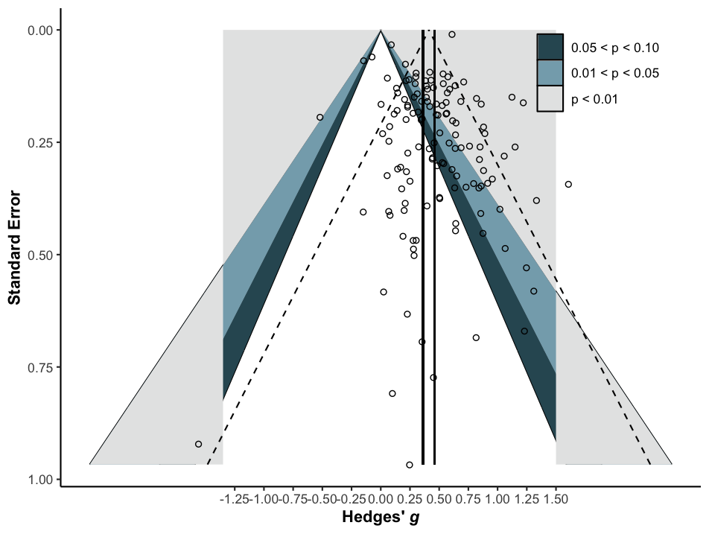

Cancer
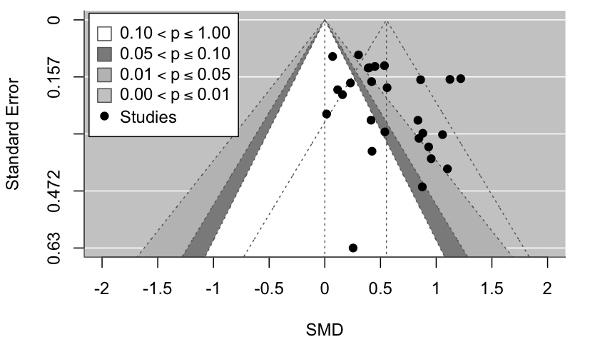

Cardiovascular Diseases
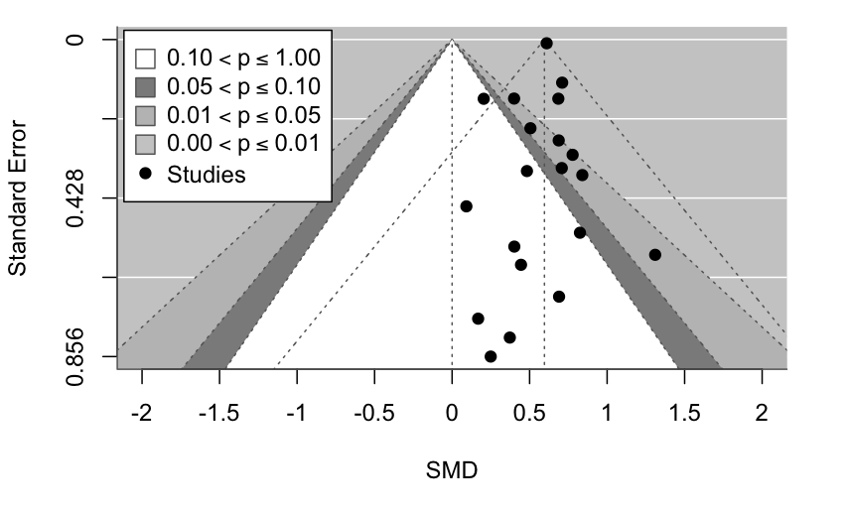

Mental Health Conditions
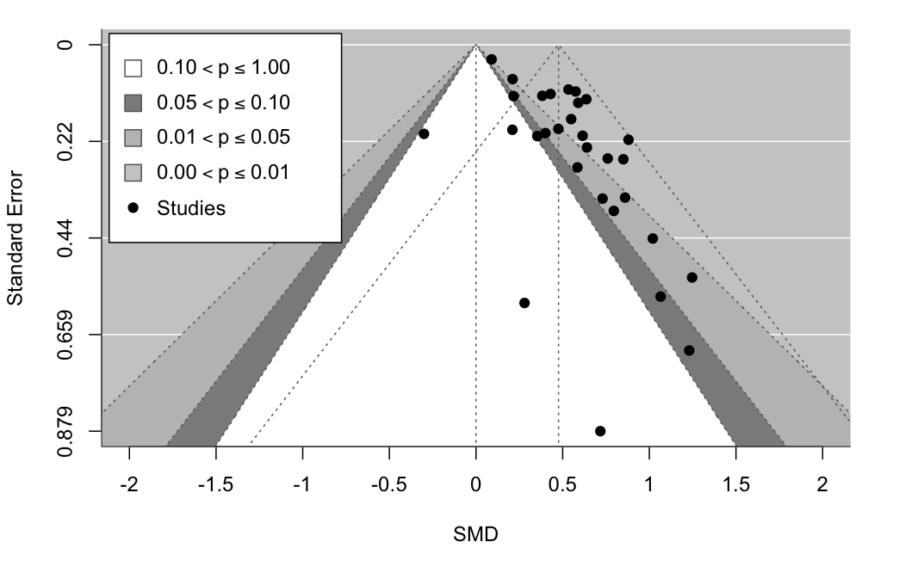

Neurological Conditions
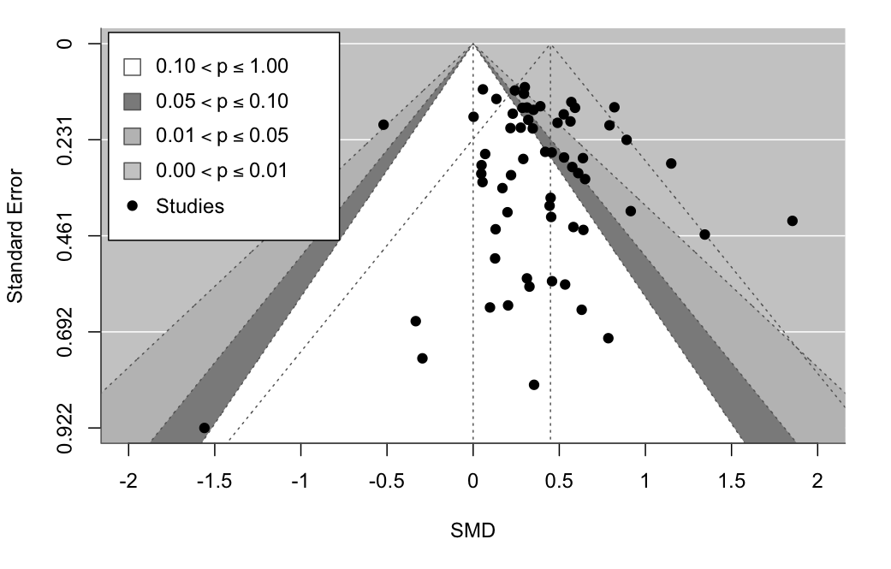

References
1. NCD Alliance. Cancer [Internet]. Geneva, Switzerland: NCD Alliance; 2017 [cited 2024 Aug 2]. Available from: https://ncdalliance.org/why-ncds/ncds/cancer.
2. NCD Alliance. Cardiovascular diseases [Internet]. Geneva, Switzerland: NCD Alliance; 2017 [cited 2024 Aug 2]. Available from: https://ncdalliance.org/why-ncds/ncds/cardiovascular-diseases.
3. NCD Alliance. Chronic respiratory diseases [Internet]. Geneva, Switzerland: NCD Alliance; 2017 [cited 2024 Aug 2]. Available from: https://ncdalliance.org/why-ncds/ncds/chronic-respiratory-diseases-0.
4. NCD Alliance. Diabetes [Internet]. Geneva, Switzerland: NCD Alliance; 2017 [cited 2024 Aug 2]. Available from: https://ncdalliance.org/why-ncds/ncds/diabetes.
5. NCD Alliance. Mental health and neurological disorders [Internet]. Geneva, Switzerland: NCD Alliance; 2017 [cited 2024 Aug 2]. Available from: https://ncdalliance.org/why-ncds/ncds/mental-health-and-neurological-disorders.
6. Karkou V, Sanderson P. Arts therapies: a research-based map of the field: Elsevier Churchill Livingstone; 2006.
7. American Art Therapy Association (AATA). What is art therapy? [Internet]. Alexandria, Virginia: American Art Therapy Association; 2022 [cited 2024 Aug 1]. Available from: https://arttherapy.org/what-is-art-therapy/.
8. British Association of Art Therapists (BAAT). What is art therapy? [Internet]. London, UK: British Association of Art Therapists; 2024 [cited 2024 Aug 1]. Available from: https://baat.org/art-therapy/what-is-art-therapy/.
9. Canadian Art Therapy Association/l’Association canadienne d’art-thérapie (CATA). What is art therapy? [Internet]. Parksville, BC: Canadian Art Therapy Association/l’Association canadienne d’art-thérapie; 2020 [cited 2024 Aug 1]. Available from: https://www.canadianarttherapy.org/what-is-art-therapy.
10. European Federation of Art Therapy (EFAT). What is art therapy? [Internet]. Hoeilaart, Belgium: European Federation of Art Therapy; 2018 [cited 2024 Aug 1]. Available from: https://www.arttherapyfederation.eu/art-therapy.html.
11. Scarth S. What is dance movement therapy (DMT)? [Internet]. European Association Dance Movement Therapy (EADMT); 2021 [cited 2024 Aug 1]. Available from: https://eadmt.com/what-is-dance-movement-therapy-dmt.
12. American Dance Therapy Association (ADTA). What is dance/movement therapy? [Internet]. Albany, NY: American Dance Therapy Association (ADTA); 2020 [cited 2024 Aug 1]. Available from: https://adta.memberclicks.net/what-is-dancemovement-therapy.
13. Dance Movement Therapy Association of Australasia (DTAA). What is dance movement therapy? [Internet]. Neutral Bay Junction, AU: Dance Movement Therapy Association of Australasia; 2014-2024 [updated Dec 2017; cited 2024 Aug 1]. Available from: https://dtaa.org.au/therapy/.
14. The Association for Dance Movement Psychotherapy UK (ADMP UK). What is dance movement psychotherapy? [Internet]. Dorset, UK: The Association for Dance Movement Psychotherapy UK (ADMP UK); 2024 [cited 2024 Aug 1]. Available from: https://admp.org.uk/what-is-dance-movement-psychotherapy/.
15. North American Drama Therapy Association (NADTA). What is drama therapy? [Internet]. Albany, NY: North American Drama Therapy Association (NADTA); 2021 [cited 2024 Aug 1]. Available from: https://www.nadta.org/what-is-drama-therapy.
16. The British Association of Dramatherapists (BADth). What is dramatherapy? [Internet]. Kent, UK: The British Association of Dramatherapists (BADth); 2024 [cited 2024 Aug 1]. Available from: https://www.badth.org.uk/dramatherapy/what-is-dramatherapy.
17. American Society of Group Psychotherapy and Psychodrama (ASGPP). What is psychodrama? [Internet]. Amherst, MA: American Society of Group Psychotherapy and Psychodrama (ASGPP); n.d. [cited 2024 Aug 1]. Available from: https://asgpp.org/what-is-psychodrama/.
18. Karp M. What is psychodrama? [Internet]. Dave, Belgium: The Federation of European Psychodrama Training Organisations (FEPTO); n.d. [cited 2024 Aug 1]. Available from: https://www.fepto.com/about-fepto/what-is-psychodrama.
19. American Music Therapy Association (AMTA). What is music therapy? [Internet]. Silver Spring, MD: American Music Therapy Association (AMTA); 2005 [cited 2024 Aug 2]. Available from: https://www.musictherapy.org/about/musictherapy/.
20. Australian Music Therapy Association (AMTA). What is music therapy? [Internet]. Victoria, AU: Australian Music Therapy Association (AMTA); 2024 [cited 2024 Aug 1]. Available from: https://www.austmta.org.au/about-us/what-is-mt/.
21. British Association for Music Therapy (BAMT). What is music therapy? [Internet]. London, UK: British Association for Music Therapy (BAMT); n.d. [cited 2024 Aug 2]. Available from: https://www.bamt.org/music-therapy/what-is-music-therapy.
22. Canadian Association of Music Therapists/Association canadienne des musicothérapeutes (CAMT). About music therapy [Internet]. Ottawa, ON: Canadian Association of Music Therapists/Association canadienne des musicothérapeutes (CAMT); 2024 [cited 2024 Aug 2]. Available from: https://www.musictherapy.ca/about-camt-music-therapy/about-music-therapy/.
23. World Federation of Music Therapy (WFMT). About WFMT [Internet]. North Carolina, US: World Federation of Music Therapy (WFMT); 2023 [cited 2024 Aug 2]. Available from: https://www.wfmt.info/about.
24. National Association for Poetry Therapy (NAPT). What is poetry therapy? [Internet]. Green Valley, AZ: National Association for Poetry Therapy (NAPT); n.d. [cited 2024 Aug 1]. Available from: https://poetrytherapy.org.
25. Fancourt D, Finn S. What is the evidence on the role of the arts in improving health and well-being? A scoping review. Copenhagen: WHO Regional Office for Europe. 2019 (Health Evidence Network (HEN) synthesis report 67)
26. Pesata V, Colverson A, Sonke J, Morgan-Daniel J, Schaefer N, Sams K, et al. Engaging the arts for wellbeing in the United States of America: a scoping review. Front Psychol. 2022;12:791773-.doi:10.3389/fpsyg.2021.791773
27. Sajnani N, Fietje N. The Jameel Arts & Health Lab in collaboration with the WHO–Lancet Global Series on the Health Benefits of the Arts. Lancet. 2023;402(10414):1732.doi:10.1016/S0140-6736(23)01959-1
28. Bradt J, Dileo C, Myers-Coffman K, Biondo J. Music interventions for improving psychological and physical outcomes in people with cancer. Cochrane Database Syst Rev. 2021;10(10):CD006911.doi:10.1002/14651858.CD006911.pub4
29. Bradt J, Shim M, Goodill SW. Dance/movement therapy for improving psychological and physical outcomes in cancer patients. Cochrane Database Syst Rev. 2015;1(1):Cd007103.doi:10.1002/14651858.CD007103.pub3
30. Bro ML, Jespersen KV, Hansen JB, Vuust P, Abildgaard N, Gram J, et al. Kind of blue: a systematic review and meta-analysis of music interventions in cancer treatment. Psychooncology. 2018;27(2):386-400.doi:10.1002/pon.4470
31. Cheng P, Xu L, Zhang J, Liu W, Zhu J. Role of arts therapy in patients with breast and gynecological cancers: a systematic review and meta-analysis. J Palliat Med. 2021;24(3):443-52.doi:10.1089/jpm.2020.0468
32. da Silva Santa IN, Schveitzer MC, dos Santos M, Ghelman R, Filho VO. Music interventions in pediatric oncology: systematic review and meta-analysis. Complement Ther Med. 2021;59:102725.doi:10.1016/j.ctim.2021.102725
33. Geng L, Duan Y, Li X, Yue S, Li R, Liu H, et al. Comparative efficacy of mind-body exercise for depression in breast cancer survivors: a systematic review and network meta-analysis. Worldviews Evid Based Nurs. 2023;20(6):593-609.doi:10.1111/wvn.12669
34. Hung TT, Liu YC, Tsai PC, Lin MF. The pain-relief efficacy of passive music-based interventions in cancer patients undergoing diagnostic biopsies and surgery: a systematic review and meta-analysis. Hu Li Za Zhi. 2018;65(1):70-82.doi:10.6224/jn.201802_65(1).10
35. Jiang XH, Chen XJ, Xie QQ, Feng YS, Chen S, Peng JS. Effects of art therapy in cancer care: a systematic review and meta-analysis. Eur J Cancer Care (Engl). 2020;29(5):e13277.doi:10.1111/ecc.13277
36. Jiang S-f, Yao Q, Sun H-q, Ding L. Effect of music therapy on sleep quality in lung cancer patients: a meta-analysis. Chin J Convalescent Med. 2023;32(9):909-14.doi:10.13517/j.cnki.ccm.2023.09.004
37. Köhler F, Martin ZS, Hertrampf RS, Gäbel C, Kessler J, Ditzen B, et al. Music therapy in the psychosocial treatment of adult cancer patients: a systematic review and meta-analysis. Front Psychol. 2020;11:651.doi:10.3389/fpsyg.2020.00651
38. Li Y, Xing X, Shi X, Yan P, Chen Y, Li M, et al. The effectiveness of music therapy for patients with cancer: a systematic review and meta-analysis. J Adv Nurs. 2020;76(5):1111-23.doi:10.1111/jan.14313
39. Nelson E, Kelly D, Ni Bhriain O, Garry F, Clifford AM, Allardyce JM. The effectiveness of community dance in people with cancer: a mixed-methods systematic review and meta-analysis. Health Promot Int. 2023;38(4).doi:10.1093/heapro/daad077
40. Nguyen KT, Xiao J, Chan DNS, Zhang M, Chan CWH. Effects of music intervention on anxiety, depression, and quality of life of cancer patients receiving chemotherapy: a systematic review and meta-analysis. Support Care Cancer. 2022;30(7):5615-26.doi:10.1007/s00520-022-06881-2
41. Nightingale CL, Rodriguez C, Carnaby G. The impact of music interventions on anxiety for adult cancer patients: a meta-analysis and systematic review. Integr Cancer Ther. 2013;12(5):393-403.doi:10.1177/1534735413485817
42. Park YJ, Lee MK. Effects of nurse-led nonpharmacological pain interventions for patients with cancer: a systematic review and meta-analysis. J Nurs Scholarsh. 2022;54(4):422-33.doi:10.1111/jnu.12750
43. Puetz TW, Morley CA, Herring MP. Effects of creative arts therapies on psychological symptoms and quality of life in patients with cancer. JAMA Intern Med. 2013;173(11):960-9.doi:10.1001/jamainternmed.2013.836
44. Qi Y, Lin L, Dong B, Xu E, Bao Z, Qi J, et al. Music interventions can alleviate cancer-related fatigue: a metaanalysis. Support Care Cancer. 2021;29(7):3461-70.doi:10.1007/s00520-021-05986-4
45. Sezgin MG, Bektas H. The effect of music therapy interventions on fatigue in patients with hematological cancers: a systematic review and meta-analysis of randomized controlled trials. Support Care Cancer. 2022;30(11):8733-44.doi:10.1007/s00520-022-07198-w
46. Tang Y, Fu F, Gao H, Shen L, Chi I, Bai Z. Art therapy for anxiety, depression, and fatigue in females with breast cancer: a systematic review. J Psychosoc Oncol. 2019;37(1):79-95.doi:10.1080/07347332.2018.1506855
47. Tsai HF, Chen YR, Chung MH, Liao YM, Chi MJ, Chang CC, et al. Effectiveness of music intervention in ameliorating cancer patients' anxiety, depression, pain, and fatigue: a meta-analysis. Cancer Nurs. 2014;37(6):E35-50.doi:10.1097/NCC.0000000000000116
48. Wang X, Zhang Y, Fan Y, Tan XS, Lei X. Effects of music intervention on the physical and mental status of patients with breast cancer: a systematic review and meta-analysis. Breast Care (Basel). 2018;13(3):183-90.doi:10.1159/000487073
49. Wei TT, Tian X, Zhang FY, Qiang WM, Bai AL. Music interventions for chemotherapy-induced nausea and vomiting: a systematic review and meta-analysis. Support Care Cancer. 2020;28(9):4031-41.doi:10.1007/s00520-020-05409-w
50. Xia Y, An X, Xue Y, Wang H. Effect of painting therapy on adult malignant tumor patients: A systematic review <绘画疗法对成年恶性肿瘤病人干预效果的系统评价-循证护理>. Chinese Evidence-based Nursing. 2023;9(10):1738-44.doi:10.12102/j.issn.2095-8668.2023.10.005
51. Xu L, Cheng P, Wu Y, Zhang J, Zhu J, Cui J, et al. The effects of art therapy on anxiety and depression in breast cancer patients: an updated meta-analysis. Eur J Cancer Care (Engl). 2020;29(5):e13266.doi:10.1111/ecc.13266
52. Yang T, Wang S, Wang R, Wei Y, Kang Y, Liu Y, et al. Effectiveness of five-element music therapy in cancer patients: a systematic review and meta-analysis. Complement Ther Clin Pract. 2021;44:101416.doi:10.1016/j.ctcp.2021.101416
53. Yangöz ST, Özer Z. The effect of music intervention on patients with cancer-related pain: a systematic review and meta-analysis of randomized controlled trials. J Adv Nurs. 2019;75(12):3362-73.doi:10.1111/jan.14184
54. Zhang JM, Wang P, Yao JX, Zhao L, Davis MP, Walsh D, et al. Music interventions for psychological and physical outcomes in cancer: a systematic review and meta-analysis. Support Care Cancer. 2012;20(12):3043-53.doi:10.1007/s00520-012-1606-5
55. Zhang MF, Wen YS, Liu WY, Peng LF, Wu XD, Liu QW. Effectiveness of mindfulness-based therapy for reducing anxiety and depression in patients with cancer: a meta-analysis. Medicine (Baltimore). 2015;94(45):e0897-0.doi:10.1097/MD.0000000000000897
56. Zhang C, Xu S, Wen X, Liu M. The effect of expressive writing on Chinese cancer patients: a systematic review and meta‐analysis of randomized control trails. Clin Psychol Psychother. 2023;30(6):1357-68.doi:10.1002/cpp.2878
57. Bradt J, Dileo C, Potvin N. Music for stress and anxiety reduction in coronary heart disease patients. Cochrane Database Syst Rev. 2013;2013(12):Cd006577.doi:10.1002/14651858.CD006577.pub3
58. Cao M, Zhang Z. Adjuvant music therapy for patients with hypertension: a meta-analysis and systematic review. BMC Complement Med Ther. 2023;23(1):110.doi:10.1186/s12906-023-03929-6
59. Chan MWM, Lo SHS, Sit JWH, Choi KC, Tao A. Effects of visual arts-based interventions on physical and psychosocial outcomes of people with stroke: a systematic review and meta-analysis. Int J Nurs Stud Adv. 2023;5:100126.doi:10.1016/j.ijnsa.2023.100126
60. Chandrababu R, Ramesh J, Devi ES, Nayak BS, George A. Effectiveness of music on anxiety and pain among cardiac surgery patients: a quantitative systematic review and meta-analysis of randomized controlled trials. Int J Nurs Pract. 2021;27(4):e12928.doi:10.1111/ijn.12928
61. Conceição LSR, Neto MG, do Amaral MAS, Martins-Filho PRS, Carvalho VO. Effect of dance therapy on blood pressure and exercise capacity of individuals with hypertension: a systematic review and meta-analysis. Int J Cardiol. 2016;220:553-7.doi:10.1016/j.ijcard.2016.06.182
62. Dayuan Z, Lan L, Hui C, Huanjie L, Deliang L, Yihui D. The effect of music as an intervention for post-stroke depression: a systematic review and meta-analysis. Complement Ther Med. 2022;71:102901.doi:10.1016/j.ctim.2022.102901
63. do Amaral MA, Neto MG, de Queiroz JG, Martins-Filho PR, Saquetto MB, Oliveira Carvalho V. Effect of music therapy on blood pressure of individuals with hypertension: a systematic review and meta-analysis. Int J Cardiol. 2016;214:461-4.doi:10.1016/j.ijcard.2016.03.197
64. Gomes Neto M, Menezes MA, Oliveira Carvalho V. Dance therapy in patients with chronic heart failure: a systematic review and a meta-analysis. Clin Rehabil. 2014;28(12):1172-9.doi:10.1177/0269215514534089
65. Jayakar JP, Alter DA. Music for anxiety reduction in patients undergoing cardiac catheterization: a systematic review and meta-analysis of randomized controlled trials. Complement Ther Clin Pract. 2017;28:122-30.doi:10.1016/j.ctcp.2017.05.011
66. Kakar E, Billar RJ, van Rosmalen J, Klimek M, Takkenberg JJM, Jeekel J. Music intervention to relieve anxiety and pain in adults undergoing cardiac surgery: a systematic review and meta-analysis. Open Heart. 2021;8(1).doi:10.1136/openhrt-2020-001474
67. Lee Y, Chen B, Fong MWM, Lee JM, Nicol GE, Lenze EJ, et al. Effectiveness of non-pharmacological interventions for treating post-stroke depressive symptoms: systematic review and meta-analysis of randomized controlled trials. Top Stroke Rehabil. 2021;28(4):289-320.doi:10.1080/10749357.2020.1803583
68. Liu Q, Li W, Yin Y, Zhao Z, Yang Y, Zhao Y, et al. The effect of music therapy on language recovery in patients with aphasia after stroke: a systematic review and meta-analysis. Neurol Sci. 2022;43(2):863-72.doi:10.1007/s10072-021-05743-9
69. Liu M, Ni R, Huang S, Yang X, Lin Q, Lin P, et al. Efficacy of non-pharmacological interventions in pain relief and opioid consumption after cardiac surgery: a systematic review and Bayesian network meta-analysis. J Clin Nurs. 2023;32(15-16):4626-37.doi:10.1111/jocn.16482
70. Magee WL, Clark I, Tamplin J, Bradt J. Music interventions for acquired brain injury. Cochrane Database Syst Rev. 2017;1(1):CD006787.doi:10.1002/14651858.CD006787.pub3
71. Peng Y, Su Y, Wang YD, Yuan LR, Wang R, Dai JS. Effects of regular dance therapy intervention on blood pressure in hypertension individuals: a systematic review and meta-analysis. J Sports Med Phys Fitness. 2021;61(2):301-9.doi:10.23736/s0022-4707.20.11088-0
72. Roche Bueno JC, Mincholé Lapuente E. Efficacy of music therapy in functional recovery of the upper limb after a stroke: a systematic review and meta-analysis. Rehabilitacion (Madr). 2019;53(3):181-8.doi:10.1016/j.rh.2019.02.002
73. Su SF, Yeh WT. Music interventions in percutaneous coronary procedures: a meta-analysis. Clin Nurs Res. 2021;30(2):135-45.doi:10.1177/1054773819883171
74. Wang Y, Wei J, Guan X, Zhang Y, Zhang Y, Zhang N, et al. Music intervention in pain relief of cardiovascular patients in cardiac procedures: a systematic review and meta-analysis. Pain Med. 2020;21(11):3055-65.doi:10.1093/pm/pnaa148
75. Wang L, Peng JL, Xiang W, Huang YJ, Chen AL. Effects of rhythmic auditory stimulation on motor function and balance ability in stroke: a systematic review and meta-analysis of clinical randomized controlled studies. Front Neurosci. 2022;16:1043575.doi:10.3389/fnins.2022.1043575
76. Yang Y, Fang YY, Gao J, Geng GL. Effects of five-element music on language recovery in patients with poststroke aphasia: a systematic review and meta-analysis. J Altern Complement Med. 2019;25(10):993-1004.doi:10.1089/acm.2018.0479
77. Yoo GE, Kim SJ. Rhythmic auditory cueing in motor rehabilitation for stroke patients: systematic review and meta-analysis. J Music Ther. 2016;53(2):149-77.doi:10.1093/jmt/thw003
78. Zhang Y, Cai J, Zhang Y, Ren T, Zhao M, Zhao Q. Improvement in stroke-induced motor dysfunction by music-supported therapy: a systematic review and meta-analysis. Sci Rep. 2016;6:38521.doi:10.1038/srep38521
79. Yang Q, Shao Q, Xu Q, Shi H, Li L. Art therapy alleviates the levels of depression and blood glucose in diabetic patients: a systematic review and meta-analysis. Front Psychol. 2021;12:639626.doi:10.3389/fpsyg.2021.639626
80. Aalbers S, Fusar‐Poli L, Freeman RE, Spreen M, Ket JCF, Vink AC, et al. Music therapy for depression. Cochrane Database Syst Rev. 2017;2017(11):CD004517-CD.doi:10.1002/14651858.CD004517.pub3
81. Abbing A, Haeyen S, Nyapati S, Verboon P, van Hooren S. Effectiveness and mechanisms of the arts therapies in forensic care. A systematic review, narrative synthesis, and meta analysis. Front Psychiatry. 2023;14:1128252.doi:10.3389/fpsyt.2023.1128252
82. Atchison K, Watt JA, Ewert D, Toohey AM, Ismail Z, Goodarzi Z. Non-pharmacologic and pharmacologic treatments for anxiety in long-term care: a systematic review and meta-analysis. Age Ageing. 2022;51(9).doi:10.1093/ageing/afac195
83. Bighelli I, Wallis S, Reitmeir C, Schwermann F, Salahuddin NH, Leucht S. Effects of psychological treatments on functioning in people with Schizophrenia: a systematic review and meta-analysis of randomized controlled trials. Eur Arch Psychiatry Clin Neurosci. 2023;273(4):779-810.doi:10.1007/s00406-022-01526-1
84. Chen YJ, Li XX, Pan B, Wang B, Jing GZ, Liu QQ, et al. Non-pharmacological interventions for older adults with depressive symptoms: a network meta-analysis of 35 randomized controlled trials. Aging Ment Health. 2021;25(5):773-86.doi:10.1080/13607863.2019.1704219
85. de Witte M, Pinho ADS, Stams GJ, Moonen X, Bos AER, van Hooren S. Music therapy for stress reduction: a systematic review and meta-analysis. Health Psychol Rev. 2022;16(1):134-59.doi:10.1080/17437199.2020.1846580
86. Geipel J, Koenig J, Hillecke TK, Resch F, Kaess M. Music-based interventions to reduce internalizing symptoms in children and adolescents: a meta-analysis. J Affect Disord. 2018;225:647-56.doi:10.1016/j.jad.2017.08.035
87. Geretsegger M, Mössler KA, Bieleninik L, Chen XJ, Heldal TO, Gold C. Music therapy for people with schizophrenia and schizophrenia-like disorders. Cochrane Database Syst Rev. 2017;5(5):CD004025.doi:10.1002/14651858.CD004025.pub4
88. Gerger H, Werner CP, Gaab J, Cuijpers P. Comparative efficacy and acceptability of expressive writing treatments compared with psychotherapy, other writing treatments, and waiting list control for adult trauma survivors: a systematic review and network meta-analysis. Psychol Med. 2022;52(15):1-13.doi:10.1017/S0033291721000143
89. Ghetti C, Chen XJ, Brenner AK, Hakvoort LG, Lien L, Fachner J, et al. Music therapy for people with substance use disorders. Cochrane Database Syst Rev. 2022;5(5):CD012576.doi:10.1002/14651858.CD012576.pub3
90. Gold C, Solli HP, Krüger V, Lie SA. Dose-response relationship in music therapy for people with serious mental disorders: systematic review and meta-analysis. Clin Psychol Rev. 2009;29(3):193-207.doi:10.1016/j.cpr.2009.01.001
91. Guo S, Liu F, Shen J, Wei M, Yang Y. Comparative efficacy of seven exercise interventions for symptoms of depression in college students: a network of meta-analysis. Medicine (Baltimore). 2020;99(47):e23058.doi:10.1097/MD.0000000000023058
92. Jenabi E, Bashirian S, Ayubi E, Rafiee M, Bashirian M. The effect of the art therapy interventions on depression symptoms among older adults: a meta-analysis of controlled clinical trials. J Geriatr Psychiatry Neurol. 2023;36(3):185-92.doi:10.1177/08919887221130264
93. Jia R, Liang D, Yu J, Lu G, Wang Z, Wu Z, et al. The effectiveness of adjunct music therapy for patients with schizophrenia: a meta-analysis. Psychiatry Res. 2020;293:113464.doi:10.1016/j.psychres.2020.113464
94. Jiang L, Alizadeh F, Cui W. Effectiveness of drama-based intervention in improving mental health and well-being: a systematic review and meta-analysis during the COVID-19 pandemic and post-pandemic period. Healthcare (Basel). 2023;11(6).doi:10.3390/healthcare11060839
95. Karkou V, Aithal S, Zubala A, Meekums B. Effectiveness of dance movement therapy in the treatment of adults with depression: a systematic review with meta-analyses. Front Psychol. 2019;10:936.doi:10.3389/fpsyg.2019.00936
96. Koch SC, Riege RFF, Tisborn K, Biondo J, Martin L, Beelmann A. Effects of dance movement therapy and dance on health-related psychological outcomes. A meta-analysis update. Front Psychol. 2019;10:1806.doi:10.3389/fpsyg.2019.01806
97. Laws KR, Conway W. Do adjunctive art therapies reduce symptomatology in schizophrenia? A meta-analysis. World J Psychiatry. 2019;9(8):107-20.doi:10.5498/wjp.v9.i8.107
98. Lutgens D, Gariepy G, Malla A. Psychological and psychosocial interventions for negative symptoms in psychosis: systematic review and meta-analysis. Br J Psychiatry. 2017;210(5):324-32.doi:10.1192/bjp.bp.116.197103
99. Meekums B, Karkou V, Nelson EA. Dance movement therapy for depression. Cochrane Database Syst Rev. 2015;2016(6).doi:10.1002/14651858.CD009895.pub2
100. Orkibi H, Keisari S, Sajnani NL, de Witte M. Effectiveness of drama-based therapies on mental health outcomes: a systematic review and meta-analysis of controlled studies. Psychol Aesthet Creat Arts. 2023.doi:10.1037/aca0000582
101. Reinhold M, Bürkner P-C, Holling H. Effects of expressive writing on depressive symptoms—a meta-analysis. Clin Psychol (New York). 2018;25(1).doi:10.1111/cpsp.12224
102. Sabeena PK, Kumar VS. Psycho-social intervention for managing depression among older adults—a meta-analysis. J Evid Based Psychother. 2022;22(2):1-30.doi:10.24193/jebp.2022.2.10
103. Steenhuis LA, Nauta MH, Bocking CL, Pijnenborg GH. Treating depressive symptoms in psychosis: a network meta-analysis on the effects of non-verbal therapies. PLoS One. 2015;10(10):e0140637.doi:10.1371/journal.pone.0140637
104. Tang Q, Huang Z, Zhou H, Ye P. Effects of music therapy on depression: a meta-analysis of randomized controlled trials. PLoS One. 2020;15(11):e0240862.doi:10.1371/journal.pone.0240862
105. Tseng PT, Chen YW, Lin PY, Tu KY, Wang HY, Cheng YS, et al. Significant treatment effect of adjunct music therapy to standard treatment on the positive, negative, and mood symptoms of schizophrenic patients: a meta-analysis. BMC Psychiatry. 2016;16:16.doi:10.1186/s12888-016-0718-8
106. Yan X, Chen T, Peng S, Liu Q, Xu X. Intervention effect of five-element music therapy for patients with depression: a meta-analysis. Nursing of Integrated Traditional Chinese and Western Medicine. 2019;5(10):1-5.doi:10.11997/nitcwm.201910001
107. Yang WJ, Bai YM, Qin L, Xu XL, Bao KF, Xiao JL, et al. The effectiveness of music therapy for postpartum depression: A systematic review and meta-analysis. Complement Ther Clin Pract. 2019;37:93-101.10.1016/j.ctcp.2019.09.002
108. Yijing C, Jie C, Bingxiang Y. Systematic review of dance movement therapy effect on depression patients. Chinese Nursing Research. 2018;32(10):1543-50.doi:10.12102/j.issn.1009-6493.2018.10.014
109. Zhao K, Bai ZG, Bo A, Chi I. A systematic review and meta-analysis of music therapy for the older adults with depression. Int J Geriatr Psychiatry. 2016;31(11):1188-98.doi:10.1002/gps.4494
110. Álvarez-Bueno C, Deeks JJ, Cavero-Redondo I, Jolly K, Torres-Costoso AI, Price M, et al. Effect of exercise on motor symptoms in patients with Parkinson's disease: a network meta-analysis. J Geriatr Phys Ther. 2023;46(2):E87-E105.doi:10.1519/JPT.0000000000000322
111. Barnish MS, Barran SM. A systematic review of active group-based dance, singing, music therapy and theatrical interventions for quality of life, functional communication, speech, motor function and cognitive status in people with Parkinson's disease. BMC Neurol. 2020;20(1):371.doi:10.1186/s12883-020-01938-3
112. Batubara SO, Saragih ID, Mulyadi M, Lee BO. Effects of art therapy for people with mild or major neurocognitive disorders: a systematic review and meta-analysis. Arch Psychiatr Nurs. 2023;45:61-71.doi:10.1016/j.apnu.2023.04.011
113. Bian X, Wang Y, Zhao X, Zhang Z, Ding C. Does music therapy affect the global cognitive function of patients with dementia? A meta-analysis. NeuroRehabilitation. 2021;48(4):553-62.doi:10.3233/NRE-210018
114. Burley CV, Burns K, Lam BCP, Brodaty H. Nonpharmacological approaches reduce symptoms of depression in dementia: a systematic review and meta-analysis. Ageing Res Rev. 2022;79:101669.doi:10.1016/j.arr.2022.101669
115. Carapellotti AM, Stevenson R, Doumas M. The efficacy of dance for improving motor impairments, non-motor symptoms, and quality of life in Parkinson's disease: a systematic review and meta-analysis. PLoS One. 2020;15(8):e0236820.doi:10.1371/journal.pone.0236820
116. Chan JSY, Wu J, Deng K, Yan JH. The effectiveness of dance interventions on cognition in patients with mild cognitive impairment: a meta-analysis of randomized controlled trials. Neurosci Biobehav Rev. 2020;118:80-8.doi:10.1016/j.neubiorev.2020.07.017
117. Chang YS, Chu H, Yang CY, Tsai JC, Chung MH, Liao YM, et al. The efficacy of music therapy for people with dementia: a meta-analysis of randomised controlled trials. J Clin Nurs. 2015;24(23-24):3425-40.doi:10.1111/jocn.12976
118. Chen T, Wen R, Liu H, Zhong X, Jiang C. Dance intervention for negative symptoms in individuals with autism spectrum disorder: a systematic review and meta-analysis. Complement Ther Clin Pract. 2022;47:101565.doi:10.1016/j.ctcp.2022.101565
119. de Almeida HS, Porto F, Porretti M, Lopes G, Fiorot D, Bunn PDS, et al. Effect of dance on postural control in people with Parkinson's disease: a meta-analysis review. J Aging Phys Act. 2021;29(1):130-41.doi:10.1123/japa.2019-0255
120. de Dreu MJ, van der Wilk AS, Poppe E, Kwakkel G, van Wegen EE. Rehabilitation, exercise therapy and music in patients with Parkinson's disease: a meta-analysis of the effects of music-based movement therapy on walking ability, balance and quality of life. Parkinsonism Relat Disord. 2012;18 Suppl 1:S114-9.doi:10.1016/S1353-8020(11)70036-0
121. Dorris JL, Neely S, Terhorst L, VonVille HM, Rodakowski J. Effects of music participation for mild cognitive impairment and dementia: a systematic review and meta-analysis. J Am Geriatr Soc. 2021;69(9):2659-67.doi:10.1111/jgs.17208
122. dos Santos Delabary M, Komeroski IG, Monteiro EP, Costa RR, Haas AN. Effects of dance practice on functional mobility, motor symptoms and quality of life in people with Parkinson's disease: a systematic review with meta-analysis. Aging Clin Exp Res. 2018;30(7):727-35.doi:10.1007/s40520-017-0836-2
123. Ernst M, Folkerts AK, Gollan R, Lieker E, Caro-Valenzuela J, Adams A, et al. Physical exercise for people with Parkinson's disease: a systematic review and network meta-analysis. Cochrane Database Syst Rev. 2024;4(4):CD013856.doi:10.1002/14651858.CD013856.pub3
124. Fusar-Poli L, Bieleninik L, Brondino N, Chen XJ, Gold C. The effect of music therapy on cognitive functions in patients with dementia: a systematic review and meta-analysis. Aging Ment Health. 2018;22(9):1097-106.doi:10.1080/13607863.2017.1348474
125. Geretsegger M, Fusar-Poli L, Elefant C, Mössler KA, Vitale G, Gold C. Music therapy for autistic people. Cochrane Database Syst Rev. 2022;5(5):CD004381.doi:10.1002/14651858.CD004381.pub4
126. Ghai S, Ghai I. Effects of rhythmic auditory cueing in gait rehabilitation for multiple sclerosis: a mini systematic review and meta-analysis. Front Neurol. 2018;9:386.doi:10.3389/fneur.2018.00386
127. Ghai S, Ghai I, Narciss S. Auditory stimulation improves gait and posture in cerebral palsy: a systematic review with between- and within-group meta-analysis. Children (Basel). 2022;9(11).doi:10.3390/children9111752
128. Goh L, Canning CG, Song J, Clemson L, Allen NE. The effect of rehabilitation interventions on freezing of gait in people with Parkinson's disease is unclear: a systematic review and meta-analyses. Disabil Rehabil. 2023;45(19):3199-218.doi:10.1080/09638288.2022.2120099
129. Hao Z, Zhang X, Chen P. Effects of ten different exercise interventions on motor function in Parkinson's disease patients—a network meta-analysis of randomized controlled trials. Brain Sci. 2022;12(6).doi:10.3390/brainsci12060698
130. Hasan SM, Alshafie S, Hasabo EA, Saleh M, Elnaiem W, Qasem A, et al. Efficacy of dance for Parkinson's disease: a pooled analysis of 372 patients. J Neurol. 2022;269(3):1195-208.doi:10.1007/s00415-021-10589-4
131. Hidalgo-Agudo RD, Lucena-Anton D, Luque-Moreno C, Heredia-Rizo AM, Moral-Munoz JA. Additional physical interventions to conventional physical therapy in Parkinson's disease: a systematic review and meta-analysis of randomized clinical trials. J Clin Med. 2020;9(4).doi:10.3390/jcm9041038
132. Ismail SR, Lee SWH, Merom D, Megat Kamaruddin PSN, Chong MS, Ong T, et al. Evidence of disease severity, cognitive and physical outcomes of dance interventions for persons with Parkinson's disease: a systematic review and meta-analysis. BMC Geriatr. 2021;21(1):503.doi:10.1186/s12877-021-02446-w
133. Ito E, Nouchi R, Dinet J, Cheng CH, Husebø BS. The effect of music-based intervention on general cognitive and executive functions, and episodic memory in people with mild cognitive impairment and dementia: a systematic review and meta-analysis of recent randomized controlled trials. Healthcare (Basel). 2022;10(8).doi:10.3390/healthcare10081462
134. Jin B, Xv Y, Zhang B, Qiao L, Liu H. Comparative efficacy and acceptability of treatments for depressive symptoms in cognitive impairment: a systematic review and Bayesian network meta-analysis. Front Aging Neurosci. 2022;14:1037414.doi:10.3389/fnagi.2022.1037414
135. Kalyani HHN, Sullivan K, Moyle G, Brauer S, Jeffrey ER, Roeder L, et al. Effects of dance on gait, cognition, and dual-tasking in Parkinson’s disease: a systematic review and meta-analysis. J Parkinsons Dis. 2019;9:335-49.doi:10.3233/JPD-181516
136. Ke X, Song W, Yang M, Li J, Liu W. Effectiveness of music therapy in children with autism spectrum disorder: a systematic review and meta-analysis. Front Psychiatry. 2022;13:905113.doi:10.3389/fpsyt.2022.905113
137. Kim EY, Hwang SD, Kim EJ. Stimulation-oriented interventions for behavioral problems among people with dementia: a systematic review and meta-analysis. J Korean Acad Nurs. 2016;46(4):475-89.doi:10.4040/jkan.2016.46.4.475
138. Kong E-H, Park M. Effects of music therapy on agitation in dementia: systematic review and meta-analysis. Korean J Adult Nurs. 2015;27(1)
139. Kwok JY, Choi KC, Chan HY. Effects of mind-body exercises on the physiological and psychosocial well-being of individuals with Parkinson's disease: a systematic review and meta-analysis. Complement Ther Med. 2016;29:121-31.doi:10.1016/j.ctim.2016.09.016
140. Lee H, Ko B. Effects of music-based interventions on motor and non-motor symptoms in patients with Parkinson's disease: a systematic review and meta-analysis. Int J Environ Res Public Health. 2023;20(2).doi:10.3390/ijerph20021046
141. Li X, Gao Z, Yu H, Gu Y, Yang G. Effect of long-term exercise therapy on motor symptoms in Parkinson disease patients: a systematic review and meta-analysis of randomized controlled trials. Am J Phys Med Rehabil. 2022;101(10):905-12.doi:10.1097/PHM.0000000000002052
142. Liang JH, Lin L, Wang YQ, Jia RX, Qu XY, Li J, et al. Non-pharmacological therapeutic strategy options for patients with dementia based on cognitive function—a Bayesian network meta-analysis of randomized controlled trials. Ageing Res Rev. 2019;56:100965.doi:10.1016/j.arr.2019.100965
143. Liang JH, Xu Y, Lin L, Jia RX, Zhang HB, Hang L. Comparison of multiple interventions for older adults with Alzheimer disease or mild cognitive impairment: a PRISMA-compliant network meta-analysis. Medicine (Baltimore). 2018;97(20):e10744.doi:10.1097/MD.0000000000010744
144. Lorenzo-García P, Nuñez de Arenas-Arroyo S, Cavero-Redondo I, Guzmán-Pavón MJ, Priego-Jiménez S, Álvarez-Bueno C. Physical exercise interventions on quality of life in Parkinson disease: a network meta-analysis. J Neurol Phys Ther. 2023;47(2):64-74.doi:10.1097/NPT.0000000000000414
145. Lötzke D, Ostermann T, Büssing A. Argentine tango in Parkinson disease—a systematic review and meta-analysis. BMC Neurol. 2015;15:226.doi:10.1186/s12883-015-0484-0
146. Masika GM, Yu DSF, Li PWC. Visual art therapy as a treatment option for cognitive decline among older adults. A systematic review and meta-analysis. J Adv Nurs. 2020;76(8):1892-910.doi:10.1111/jan.14362
147. May T, Chan ES, Lindor E, McGinley J, Skouteris H, Austin D, et al. Physical, cognitive, psychological and social effects of dance in children with disabilities: systematic review and meta-analysis. Disabil Rehabil. 2021;43(1):13-26.doi:10.1080/09638288.2019.1615139
148. Mazzarin CM, Valderramas SR, de Paula Ferreira M, Tiepolo E, Guérios L, Parisotto D, et al. Effects of dance and of tai chi on functional mobility, balance, and agility in Parkinson disease. Top Geriatr Rehabil. 2017;33(4):262-72.doi:10.1097/tgr.0000000000000163
149. Mishra R, Florez-Perdomo WA, Shrivatava A, Chouksey P, Raj S, Moscote-Salazar LR, et al. Role of music therapy in traumatic brain injury: a systematic review and meta-analysis. World Neurosurg. 2021;146:197-204.doi:10.1016/j.wneu.2020.10.130
150. Moreno-Morales C, Calero R, Moreno-Morales P, Pintado C. Music therapy in the treatment of dementia: a systematic review and meta-analysis. Front Med (Lausanne). 2020;7:160.doi:10.3389/fmed.2020.00160
151. Mustafaoglu R, Ahmed I, Pang MYC. Which type of mind-body exercise is most effective in improving functional performance and quality of life in patients with Parkinson's disease? A systematic review with network meta-analysis. Acta Neurol Belg. 2022;122(6):1433-46.doi:10.1007/s13760-022-02070-4
152. Na R, Yang JH, Yeom Y, Kim YJ, Byun S, Kim K, et al. A systematic review and meta-analysis of nonpharmacological interventions for moderate to severe dementia. Psychiatry Investig. 2019;16(5):325-35.doi:10.30773/pi.2019.02.11.2
153. Pedersen SKA, Andersen PN, Lugo RG, Andreassen M, Sütterlin S. Effects of music on agitation in dementia: a meta-analysis. Front Psychol. 2017;8:742.doi:10.3389/fpsyg.2017.00742
154. Radder DLM, Ligia Silva de Lima A, Domingos J, Keus SHJ, van Nimwegen M, Bloem BR, et al. Physiotherapy in Parkinson's disease: A meta-analysis of present treatment modalities. Neurorehabil Neural Repair. 2020;34(10):871-80.doi:10.1177/1545968320952799
155. Sharp K, Hewitt J. Dance as an intervention for people with Parkinson's disease: a systematic review and meta-analysis. Neurosci Biobehav Rev. 2014;47:445-56.doi:10.1016/j.neubiorev.2014.09.009
156. Shi Z-M, Lin G-H, Xie Q. Effects of music therapy on mood, language, behavior, and social skills in children with autism: a meta-analysis. Chinese Nursing Research. 2016;3(3):137-41.doi:10.1016/j.cnre.2016.06.018
157. Simpkins C, Yang F. Do dance style and intervention duration matter in improving balance among people with Parkinson's disease? A systematic review with meta-analysis. Parkinsonism Relat Disord. 2023;106:105231.doi:10.1016/j.parkreldis.2022.105231
158. Tang L, Fang Y, Yin J. The effects of exercise interventions on Parkinson's disease: a Bayesian network meta-analysis. J Clin Neurosci. 2019;70:47-54.doi:10.1016/j.jocn.2019.08.092
159. Tsoi KKF, Chan JYC, Ng YM, Lee MMY, Kwok TCY, Wong SYS. Receptive music therapy is more effective than interactive music therapy to relieve behavioral and psychological symptoms of dementia: a systematic review and meta-analysis. J Am Med Dir Assoc. 2018;19(7):568-76.e3.doi:10.1016/j.jamda.2017.12.009
160. Ueda T, Suzukamo Y, Sato M, Izumi S. Effects of music therapy on behavioral and psychological symptoms of dementia: a systematic review and meta-analysis. Ageing Res Rev. 2013;12(2):628-41.doi:10.1016/j.arr.2013.02.003
161. van der Steen JT, van Soest-Poortvliet MC, van der Wouden JC, Bruinsma MS, Scholten RJ, Vink AC. Music-based therapeutic interventions for people with dementia. Cochrane Database Syst Rev. 2017;5(5):CD003477.doi:10.1002/14651858.CD003477.pub3
162. Wang YQ, Jia RX, Liang JH, Li J, Qian S, Li JY, et al. Effects of non-pharmacological therapies for people with mild cognitive impairment. A Bayesian network meta-analysis. Int J Geriatr Psychiatry. 2020;35(6):591-600.doi:10.1002/gps.5289
163. Wang K, Li K, Zhang P, Ge S, Wen X, Wu Z, et al. Mind–body exercises for non-motor symptoms of patients with Parkinson’s disease: a systematic review and meta-analysis. Front Aging Neurosci. 2021;13:770920-.doi:10.3389/fnagi.2021.770920
164. Wang Y, Liu M, Tan Y, Dong Z, Wu J, Cui H, et al. Effectiveness of dance-based interventions on depression for persons with MCI and dementia: a systematic review and meta-analysis. Front Psychol. 2022;12:709208.doi:10.3389/fpsyg.2021.709208
165. Wang L, Peng JL, Ou-Yang JB, Gan L, Zeng S, Wang HY, et al. Effects of rhythmic auditory stimulation on gait and motor function in Parkinson's disease: a systematic review and meta-analysis of clinical randomized controlled studies. Front Neurol. 2022;13:818559.doi:10.3389/fneur.2022.818559
166. Wang Y, Zheng T, Liao Y-T, Li L, Zhang Y. A meta-analysis of the effect of music therapy on Alzheimer’s disease. Int J Clin Exp Med. 2020;13(2):317-29
167. Wang YY, Wang XX, Chen L, Liu Y, Li YR. A systematic review and network meta-analysis comparing various non-pharmacological treatments for older people with mild cognitive impairment. Asian J Psychiatr. 2023;86:103635.doi:10.1016/j.ajp.2023.103635
168. Wei S, Mai Y, Peng W, Ma J, Sun C, Li G, et al. The effect of nonpharmacologic therapy on global cognitive functions in patients with Alzheimer's disease: an updated meta-analysis of randomized controlled trials. Int J Neurosci. 2020;130(1):28-44.doi:10.1080/00207454.2019.1638377
169. Wong C. Effectiveness of music intervention on cognitive function and neuropsychiatric symptoms in the elderly with dementia: a meta-analysis. Front Nurs. 2022;9(2):143-53.doi:10.2478/fon-2022-0020
170. Wu C, Xu Y, Guo H, Tang C, Chen D, Zhu M. Effects of aerobic exercise and mind-body exercise in Parkinson’s disease: a mixed-treatment comparison analysis. Front Aging Neurosci. 2021;13:739115-.doi:10.3389/fnagi.2021.739115
171. Yang Y, Weng Y, Song Y, Bo Y. Meta-analysis of intervention effect of music therapy on dementia patients Chinese Nursing Research 2019;33(8):1275-82.doi:10.12102/j.issn.1009-6493.2019.08.001
172. Yang Y, Wang G, Zhang S, Wang H, Zhou W, Ren F, et al. Efficacy and evaluation of therapeutic exercises on adults with Parkinson's disease: a systematic review and network meta-analysis. BMC Geriatr. 2022;22(1):813.doi:10.1186/s12877-022-03510-9
173. Ye X, Li L, He R, Jia Y, Poon W. Rhythmic auditory stimulation promotes gait recovery in Parkinson's patients: a systematic review and meta-analysis. Front Neurol. 2022;13:940419.doi:10.3389/fneur.2022.940419
174. Zhang Q, Hu J, Wei L, Jia Y, Jin Y. Effects of dance therapy on cognitive and mood symptoms in people with Parkinson's disease: a systematic review and meta-analysis. Complement Ther Clin Pract. 2019;36:12-7.doi:10.1016/j.ctcp.2019.04.005
175. Zhang Y, Cai J, An L, Hui F, Ren T, Ma H, et al. Does music therapy enhance behavioral and cognitive function in elderly dementia patients? A systematic review and meta-analysis. Ageing Res Rev. 2017;35:1-11.doi:10.1016/j.arr.2016.12.003
176. Zhou Z, Zhou R, Wei W, Luan R, Li K. Effects of music-based movement therapy on motor function, balance, gait, mental health, and quality of life for patients with Parkinson's disease: a systematic review and meta-analysis. Clin Rehabil. 2021;35(7):937-51.doi:10.1177/0269215521990526
177. Zhu Y, Zhong Q, Ji J, Ma J, Wu H, Gao Y, et al. Effects of aerobic dance on cognition in older adults with mild cognitive impairment: a systematic review and meta-analysis. J Alzheimers Dis. 2020;74(2):679-90.doi:10.3233/JAD-190681
178. Huang J, Yuan X, Zhang N, Qiu H, Chen X. Music therapy in adults with COPD. Respir Care. 2021;66(3):501-9.doi:10.4187/respcare.07489
179. Kim S-A, Kim Y-S. Singing improves lung function in chronic lung disease: systematic review and meta-analysis. Journal of Special Education & Rehabilitation Science. 2021;60(4):253-71.doi:10.23944/Jsers.2021.12.60.4.12
180. Lee AL, Desveaux L, Goldstein RS, Brooks D. Distractive auditory stimuli in the form of music in individuals with COPD: a systematic review. Chest. 2015;148(2):417-29.doi:10.1378/chest.14-2168
181. McNamara RJ, Epsley C, Coren E, McKeough ZJ. Singing for adults with chronic obstructive pulmonary disease (COPD). Cochrane Database Syst Rev. 2017;12(12):CD012296.doi:10.1002/14651858.CD012296.pub2
182. Nyssen OP, Taylor SJ, Wong G, Steed E, Bourke L, Lord J, et al. Does therapeutic writing help people with long-term conditions? Systematic review, realist synthesis and economic considerations. Health Technol Assess. 2016;20(27):vii-xxxvii, 1-367.doi:10.3310/hta20270
183. Ab Shukor NF, Han W, Lee J, Seo YJ. Crucial music components needed for speech perception enhancement of pediatric cochlear implant users: a systematic review and meta-analysis. Audiol Neurootol. 2021;26(6):389-413.doi:10.1159/000515136
184. Abdelhakim AM, Samy A, Abbas AM. Effect of music in reducing patient anxiety during colposcopy: a systematic review and meta-analysis of randomized controlled trials. Fertil Steril. 2019;112(3).doi:10.1016/j.fertnstert.2019.07.664
185. Apodaca TR, Miller WR. A meta-analysis of the effectiveness of bibliotherapy for alcohol problems. J Clin Psychol. 2003;59(3):289-304.doi:10.1002/jclp.10130
186. Auliya EP, Yudiarso A. Application of dance movement therapy to stress levels: a meta-analysis study. J Psiko Studia. 2022;11(1).doi:10.30872/psikostudia.v11i1.7273
187. Bai Z, Li Y, Yang Y, Xie C, Zhu Z, Xu Y, et al. The effectiveness of plaza dancing on psychological well-being and ill-being: a systematic review and meta-analysis. Front Psychol. 2022;13:864327.doi:10.3389/fpsyg.2022.864327
188. Bausewein C, Booth S, Gysels M, Higginson IJ. Non-pharmacological interventions for breathlessness in advanced stages of malignant and non-malignant diseases. Cochrane Database Syst Rev. 2013;2013(11):CD005623.doi:10.1002/14651858.CD005623.pub3
189. Bechtold ML, Puli SR, Othman MO, Bartalos CR, Marshall JB, Roy PK. Effect of music on patients undergoing colonoscopy: a meta-analysis of randomized controlled trials. Dig Dis Sci. 2009;54(1):19-24.doi:10.1007/s10620-008-0312-0
190. Bieleninik Ł, Ghetti C, Gold C. Music therapy for preterm infants and their parents: a meta-analysis. Pediatrics. 2016;138(3).doi:10.1542/peds.2016-0971
191. Boehm K, Cramer H, Staroszynski T, Ostermann T. Arts therapies for anxiety, depression, and quality of life in breast cancer patients: a systematic review and meta-analysis. Evid Based Complement Alternat Med. 2014;2014:103297.doi:10.1155/2014/103297
192. Bradt J, Dileo C, Shim M. Music interventions for preoperative anxiety. Cochrane Database Syst Rev. 2013;2013(6):CD006908.doi:10.1002/14651858.CD006908.pub2
193. Bradt J, Dileo C. Music therapy for end-of-life care. Cochrane Database Syst Rev. 2014(1):CD007169.10.1002/14651858.CD007169.pub2
194. Bradt J, Dileo C. Music interventions for mechanically ventilated patients. Cochrane Database Syst Rev. 2014;2014(12):CD006902.doi:10.1002/14651858.CD006902.pub3
195. Burrai F, Forton Magavern E, Micheluzzi V, Magnaghi C, Apuzzo L, Brioni E. Effectiveness of music to improve anxiety in hemodialysis patients: a systematic review and meta-analysis. Holist Nurs Pract. 2020;34(6):324-33.doi:10.1097/HNP.0000000000000411
196. Campbell ER. The effectiveness of art therapy in reducing symptoms of trauma, anxiety, and stress: a meta-analysis [dissertation]. Illinois, US: Wheaton College Graduate School; 2010.
197. Castañeda-Babarro A, Marqués-Jiménez D, Calleja-González J, Viribay A, León-Guereño P, Mielgo-Ayuso J. Effect of listening to music on Wingate Anaerobic Test performance. A systematic review and meta-analysis. Int J Environ Res Public Health. 2020;17(12).doi:10.3390/ijerph17124564
198. Castro LY. Art therapy and the effect it has on levels of aggression and hostility with inpatient psychiatric settings: a meta-analysis [thesis]. Indiana, US: Saint Mary-of-the-Woods College; 2015.
199. Chae JH, Kim YS, Han MY. Effects of non-pharmacological interventions on cancer patients with sleep disorder: a meta-analysis. Asian Oncol Nurs. 2021;21(1).doi:10.5388/aon.2021.21.1.1
200. Chan MF, Wong ZY, Thayala NV. A systematic review on the effectiveness of music listening in reducing depressive symptoms in adults. JBI Libr Syst Rev. 2010;8(31):1242-87.doi:10.11124/jbisrir-2010-163
201. Chen XJ, Leith H, Aarø LE, Manger T, Gold C. Music therapy for improving mental health problems of offenders in correctional settings: systematic review and meta-analysis. J Exp Criminol. 2016;12(2):209-28.doi:10.1007/s11292-015-9250-y
202. Chen K, Tan Y, Lu Y, Wu J, Liu X, Zhao Y. Effect of exercise on quality of life in Parkinson's disease: a systematic review and meta-analysis. Parkinsons Dis. 2020;2020:3257623.doi:10.1155/2020/3257623
203. Chen CT, Tung HH, Fang CJ, Wang JL, Ko NY, Chang YJ, et al. Effect of music therapy on improving sleep quality in older adults: a systematic review and meta-analysis. J Am Geriatr Soc. 2021;69(7):1925-32.doi:10.1111/jgs.17149
204. Cheng J, Zhang H, Bao H, Hong H. Music-based interventions for pain relief in patients undergoing hemodialysis: a PRISMA-compliant systematic review and meta-analysis. Medicine (Baltimore). 2021;100(2):e24102.doi:10.1097/MD.0000000000024102
205. Chow R, Bergner R, Prsic E. Music therapy effectiveness by duration in patients with cancer: a meta-regression. BMJ Support Palliat Care. 2023;13(1):117-20.doi:10.1136/bmjspcare-2021-003163
206. Chuang CH, Chen PC, Lee CS, Chen CH, Tu YK, Wu SC. Music intervention for pain and anxiety management of the primiparous women during labour: a systematic review and meta-analysis. J Adv Nurs. 2019;75(4):723-33.doi:10.1111/jan.13871
207. Clark IN, Taylor NF, Baker F. Music interventions and physical activity in older adults: a systematic literature review and meta-analysis. J Rehabil Med. 2012;44(9):710-9.doi:10.2340/16501977-1025
208. Cooper PK. It’s all in your head: a meta-analysis on the effects of music training on cognitive measures in schoolchildren. Int J Music Educ. 2020;38(3):321-36.doi:10.1177/0255761419881495
209. Corbijn van Willenswaard K, Lynn F, McNeill J, McQueen K, Dennis CL, Lobel M, et al. Music interventions to reduce stress and anxiety in pregnancy: a systematic review and meta-analysis. BMC Psychiatry. 2017;17(1):271.doi:10.1186/s12888-017-1432-x
210. Cuijpers P. Bibliotherapy in unipolar depression: a meta-analysis. J Behav Ther Exp Psychiatry. 1997;28(2):139-47.doi:10.1016/s0005-7916(97)00005-0
211. Dale VH. The impact of perioperative music on abdominal surgery patients' experience of postoperative pain: a systematic review and meta-analysis. J Perioper Pract. 2021;31(1-2):31-43.doi:10.1177/1750458920943375
212. Dastgheib SS, Layegh P, Sadeghi R, Foroughipur M, Shoeibi A, Gorji A. The effects of Mozart's music on interictal activity in epileptic patients: systematic review and meta-analysis of the literature. Curr Neurol Neurosci Rep. 2014;14(1):420.doi:10.1007/s11910-013-0420-x
213. de Niet G, Tiemens B, Lendemeijer B, Hutschemaekers G. Music-assisted relaxation to improve sleep quality: meta-analysis. J Adv Nurs. 2009;65(7):1356-64.doi:10.1111/j.1365-2648.2009.04982.x
214. De Silva MJ, Cooper S, Li HL, Lund C, Patel V. Effect of psychosocial interventions on social functioning in depression and schizophrenia: meta-analysis. Br J Psychiatry. 2013;202(4):253-60.doi:10.1192/bjp.bp.112.118018
215. de Witte M, Spruit A, van Hooren S, Moonen X, Stams GJ. Effects of music interventions on stress-related outcomes: a systematic review and two meta-analyses. Health Psychol Rev. 2020;14(2):294-324.doi:10.1080/17437199.2019.1627897
216. Delfa-Lobato L, Guàrdia-Olmos J, Feliu-Torruella M. Benefits of cultural activities on people with cognitive impairment: a systematic review. Front Psychol. 2021;12:762392.doi:10.3389/fpsyg.2021.762392
217. Deshmukh SR, Holmes J, Cardno A. Art therapy for people with dementia. Cochrane Database Syst Rev. 2018;9(9):CD011073.doi:10.1002/14651858.CD011073.pub2
218. Diaz A. The effectiveness of dance therapy in improving balance and gait in individuals with Parkinson’s disease: a meta-analysis [dissertation]. California, US: California State University, Fresno; 2022.
219. Dileo C. Effects of music and music therapy on medical patients: a meta-analysis of the research and implications for the future. J Soc Integr Oncol. 2006;4(2):67-70.doi:10.2310/7200.2006.002
220. Drahota A, Ward D, Mackenzie H, Stores R, Higgins B, Gal D, et al. Sensory environment on health-related outcomes of hospital patients. Cochrane Database Syst Rev. 2012;2012(3):CD005315.doi:10.1002/14651858.CD005315.pub2
221. Duarte Machado E, Cole MH, Miller L, McGuckian TB, Wilson PH. The efficacy of dance interventions for the activity and participation of individuals with cerebral palsy—a systematic review and meta-analysis. Disabil Rehabil. 2024;46(8):1485-501.doi:10.1080/09638288.2023.2200259
222. Düzgün MV, Özer Z. The effects of music intervention on breast milk production in breastfeeding mothers: a systematic review and meta-analysis of randomized controlled trials. J Adv Nurs. 2020;76(12):3307-16.doi:10.1111/jan.14589
223. Evans D. Music as an intervention for hospital patients: a systematic review. Int J Evid Based Healthc. 2001;4:218-79
224. Evans D. The effectiveness of music as an intervention for hospital patients: a systematic review. J Adv Nurs. 2002;37(1):8-18.doi:10.1046/j.1365-2648.2002.02052.x
225. Feng F, Zhang Y, Hou J, Cai J, Jiang Q, Li X, et al. Can music improve sleep quality in adults with primary insomnia? A systematic review and network meta-analysis. Int J Nurs Stud. 2018;77:189-96.doi:10.1016/j.ijnurstu.2017.10.011
226. Fernández-García D, Campa Menéndez E, Gómez Salgado J, Navarro Abal Y. Efectos de la musicoterapia en las habilidades de comunicación de niños con autismo/The effects of music therapy on communication skills in children with autism. Revista ROL de enfermería. 2018;41(5):54-63
227. Fleming PS, Strydom H, Katsaros C, MacDonald L, Curatolo M, Fudalej P, et al. Non-pharmacological interventions for alleviating pain during orthodontic treatment. Cochrane Database Syst Rev. 2016;12(12):CD010263.doi:10.1002/14651858.CD010263.pub2
228. Fong Yan A, Cobley S, Chan C, Pappas E, Nicholson LL, Ward RE, et al. The effectiveness of dance interventions on physical health outcomes compared to other forms of physical activity: a systematic review and meta-analysis. Sports Med. 2018;48(4):933-51.doi:10.1007/s40279-017-0853-5
229. Frank HE, Munro PE, Clark I, Lee AL. The effect of music listening during pulmonary or cardiac rehabilitation on clinical outcomes: a systematic review and meta-analysis. Cardiopulm Phys Ther J. 2023;34(1):13-29.doi:10.1097/cpt.0000000000000204
230. Fu VX, Oomens P, Sneiders D, van den Berg SAA, Feelders RA, Wijnhoven BPL, et al. The effect of perioperative music on the stress response to surgery: a meta-analysis. J Surg Res. 2019;244:444-55.doi:10.1016/j.jss.2019.06.052
231. Fu VX, Oomens P, Klimek M, Verhofstad MHJ, Jeekel J. The effect of perioperative music on medication requirement and hospital length of stay: a meta-analysis. Ann Surg. 2020;272(6):961-72.doi:10.1097/SLA.0000000000003506
232. Gao Y, Wei Y, Yang W, Jiang L, Li X, Ding J, et al. The effectiveness of music therapy for terminally ill patients: a meta-analysis and systematic review. J Pain Symptom Manage. 2019;57(2):319-29.doi:10.1016/j.jpainsymman.2018.10.504
233. García-Perdomo HA, Montealegre Cardona LM, Cordoba-Wagner MJ, Zapata-Copete JA. Music to reduce pain and anxiety in cystoscopy: a systematic review and meta-analysis. J Complement Integr Med. 2019;16(3).doi:10.1515/jcim-2018-0095
234. Garza-Villarreal EA, Pando V, Vuust P, Parsons C. Music-induced analgesia in chronic pain conditions: a systematic review and meta-analysis. Pain Physician. 2017;20(7):597-610
235. Gold C, Voracek M, Wigram T. Effects of music therapy for children and adolescents with psychopathology: a meta-analysis. J Child Psychol Psychiatry. 2004;45(6):1054-63.doi:10.1111/j.1469-7610.2004.t01-1-00298.x
236. Gordon RL, Fehd HM, McCandliss BD. Does music training enhance literacy skills? A meta-analysis. Front Psychol. 2015;6:1777.doi:10.3389/fpsyg.2015.01777
237. Gregory RJ, Schwer Canning S, Lee TW, Wise JC. Cognitive bibliotherapy for depression: a meta-analysis. Prof Psychol Res Pr. 2004;35(3):275-80.doi:10.1037/0735-7028.35.3.275
238. Grossman NJ. Effectiveness of dance compared to exercise training as an intervention for improving motor function and mobility in Parkinson’s disease: a meta analysis [dissertation]. California, US: California State University, Fresno; 2022.
239. Gurbuz-Dogan RN, Ali A, Candy B, King M. The effectiveness of Sufi music for mental health outcomes. a systematic review and meta-analysis of 21 randomised trials. Complement Ther Med. 2021;57:102664.doi:10.1016/j.ctim.2021.102664
240. Haslbeck FB, Mueller K, Karen T, Loewy J, Meerpohl JJ, Bassler D. Musical and vocal interventions to improve neurodevelopmental outcomes for preterm infants. Cochrane Database Syst Rev. 2023;9(9):CD013472.doi:10.1002/14651858.CD013472.pub2
241. Hewston P, Kennedy CC, Borhan S, Merom D, Santaguida P, Ioannidis G, et al. Effects of dance on cognitive function in older adults: a systematic review and meta-analysis. Age Ageing. 2021;50(4):1084-92.doi:10.1093/ageing/afaa270
242. Hole J, Hirsch M, Ball E, Meads C. Music as an aid for postoperative recovery in adults: a systematic review and meta-analysis. Lancet. 2015;386(10004):1659-71.doi:10.1016/S0140-6736(15)60169-6
243. Hu W, Yang K, Zhang L, Lu X. Effect of media distraction (audio-visual and music) for pain and anxiety control in patients undergoing shock-wave lithotripsy: a systematic review and meta-analysis. Exp Ther Med. 2021;21(6):623.doi:10.3892/etm.2021.10055
244. Huda N, Banda KJ, Liu AI, Huang TW. Effects of music therapy on spiritual well-being among patients with advanced cancer in palliative care: a meta-analysis of randomized controlled trials. Semin Oncol Nurs. 2023;39(6):151481.doi:10.1016/j.soncn.2023.151481
245. Jespersen KV, Koenig J, Jennum P, Vuust P. Music for insomnia in adults. Cochrane Database Syst Rev. 2015;2015(8):CD010459.doi:10.1002/14651858.CD010459.pub2
246. Karkou V, Aithal S, Richards M, Hiley E, Meekums B. Dance movement therapy for dementia. Cochrane Database Syst Rev. 2023;8(8):CD011022.doi:10.1002/14651858.CD011022.pub3
247. Kim Y, Evangelista LS, Park YG. Anxiolytic effects of music interventions in patients receiving incenter hemodialysis: a systematic review and meta-analysis. Nephrol Nurs J. 2015;42(4):339-47; quiz 48
248. Kim SJ, Yoo GE. Instrument playing as a cognitive intervention task for older adults: a systematic review and meta-analysis. Front Psychol. 2019;10:151.doi:10.3389/fpsyg.2019.00151
249. Kim H-Y, Lee M-N. Effects of non-pharmacological interventions for preoperative anxiety in surgical patient: a systematic review and meta-analysis. J Korean Acad Fundam Nurs. 2019;26(4):248-59.doi:10.7739/jkafn.2019.26.4.248
250. Kim M, Song Y. A systematic review and meta-analysis of music therapy on depression for stroke patients. J Korean Acad Fundam Nurs. 2022;29(4):416-29.doi:10.7739/jkafn.2022.29.4.416
251. Klassen JA, Liang Y, Tjosvold L, Klassen TP, Hartling L. Music for pain and anxiety in children undergoing medical procedures: a systematic review of randomized controlled trials. Ambul Pediatr. 2008;8(2):117-28.doi:10.1016/j.ambp.2007.12.005
252. Kühlmann AY, Etnel JR, Roos-Hesselink JW, Jeekel J, Bogers AJ, Takkenberg JJ. Systematic review and meta-analysis of music interventions in hypertension treatment: a quest for answers. BMC Cardiovasc Disord. 2016;16:69.doi:10.1186/s12872-016-0244-0
253. Kühlmann AYR, de Rooij A, Kroese LF, van Dijk M, Hunink MGM, Jeekel J. Meta-analysis evaluating music interventions for anxiety and pain in surgery. Br J Surg. 2018;105(7):773-83.doi:10.1002/bjs.10853
254. Kyriakides R, Jones P, Geraghty R, Skolarikos A, Liatsikos E, Traxer O, et al. Effect of music on outpatient urological procedures: a systematic review and meta-analysis from the European Association of Urology Section of Uro-Technology. J Urol. 2018;199(5):1319-27.doi:10.1016/j.juro.2017.11.117
255. Lai X, Wen H, Li Y, Lu L, Tang C. The comparative efficacy of multiple interventions for mild cognitive impairment in Alzheimer's disease: a Bayesian network meta-analysis. Front Aging Neurosci. 2020;12:121.doi:10.3389/fnagi.2020.00121
256. Lang D, Lim LC. Effects of art therapy for family caregivers of cancer patients: a systematic review protocol. JBI Database System Rev Implement Rep. 2013;11(8):64-72.doi:10.11124/jbisrir-2013-573
257. Laopaiboon M, Lumbiganon P, Martis R, Vatanasapt P, Somjaivong B. Music during caesarean section under regional anaesthesia for improving maternal and infant outcomes. Cochrane Database Syst Rev. 2009(2):CD006914.doi:10.1002/14651858.CD006914.pub2
258. Lee BK, Patall EA, Cawthon SW, Steingut RR. The effect of drama-based pedagogy on prek–16 outcomes: a meta-analysis of research from 1985 to 2012. Rev Educ Res. 2015;85(1):3-49.doi:10.3102/0034654314540477
259. Lee JH. The effects of music on pain: a meta-analysis. J Music Ther. 2016;53(4):430-77.doi:10.1093/jmt/thw012
260. Lewandowska K, Węziak-Białowolska D. The impact of theatre on empathy and self-esteem: a meta-analysis. Creat Res J. 2020;32(3):237-45.doi:10.1080/10400419.2020.1821553
261. Li HC, Wang HH, Chou FH, Chen KM. The effect of music therapy on cognitive functioning among older adults: a systematic review and meta-analysis. J Am Med Dir Assoc. 2015;16(1):71-7.doi:10.1016/j.jamda.2014.10.004
262. Li J, Zhou L, Wang Y. The effects of music intervention on burn patients during treatment procedures: a systematic review and meta-analysis of randomized controlled trials. BMC Complement Altern Med. 2017;17(1):158.doi:10.1186/s12906-017-1669-4
263. Li X, Li C, Hu N, Wang T. Music interventions for disorders of consciousness: a systematic review and meta-analysis. J Neurosci Nurs. 2020;52(4):146-51.doi:10.1097/JNN.0000000000000511
264. Li M, Jiang X, Ren Y. Public square dancing intervention on subjective well-being of middle-aged and elderly people: a meta-analysis. Int J Ment Health Promot. 2022;24(1):129-42.doi:10.32604/ijmhp.2022.016671
265. Li H, Jiang H, Wang J, Zhou J, Liang H, Chen G, et al. Effects of mind-body exercises for osteoporosis in older adults: a systematic review and meta-analysis of randomized controlled trials. Geriatr Orthop Surg Rehabil. 2023;14:21514593231195237.doi:10.1177/21514593231195237
266. Lieber AC, Bose J, Zhang X, Seltzberg H, Loewy J, Rossetti A, et al. Effects of music therapy on anxiety and physiologic parameters in angiography: a systematic review and meta-analysis. J Neurointerv Surg. 2019;11(4):416-23.doi:10.1136/neurintsurg-2018-014313
267. Lin HH, Chang YC, Chou HH, Chang CP, Huang MY, Liu SJ, et al. Effect of music interventions on anxiety during labor: a systematic review and meta-analysis of randomized controlled trials. PeerJ. 2019;7:e6945.doi:10.7717/peerj.6945
268. Lin CJ, Chang YC, Chang YH, Hsiao YH, Lin HH, Liu SJ, et al. Music interventions for anxiety in pregnant women: a systematic review and meta-analysis of randomized controlled trials. J Clin Med. 2019;8(11).doi:10.3390/jcm8111884
269. Lin CL, Hwang SL, Jiang P, Hsiung NH. Effect of music therapy on pain after orthopedic surgery—a systematic review and meta-analysis. Pain Pract. 2020;20(4):422-36.doi:10.1111/papr.12864
270. Liu X, Shen PL, Tsai YS. Dance intervention effects on physical function in healthy older adults: a systematic review and meta-analysis. Aging Clin Exp Res. 2021;33(2):253-63.doi:10.1007/s40520-019-01440-y
271. Liu C, Su M, Jiao Y, Ji Y, Zhu S. Effects of dance interventions on cognition, psycho-behavioral symptoms, motor functions, and quality of life in older adult patients with mild cognitive impairment: a meta-analysis and systematic review. Front Aging Neurosci. 2021;13:706609.doi:10.3389/fnagi.2021.706609
272. Liu X, Wang G, Cao Y. Association of nonpharmacological interventions for cognitive function in older adults with mild cognitive impairment: a systematic review and network meta-analysis. Aging Clin Exp Res. 2023;35(3):463-78.doi:10.1007/s40520-022-02333-3
273. Llovet AK. Meta-analysis of specific music therapy measures and their implications for the health care system. Health Care Manag (Frederick). 2017;36(1):60-8.doi:10.1097/HCM.0000000000000135
274. Loomba RS, Arora R, Shah PH, Chandrasekar S, Molnar J. Effects of music on systolic blood pressure, diastolic blood pressure, and heart rate: a meta-analysis. Indian Heart J. 2012;64(3):309-13.doi:10.1016/S0019-4832(12)60094-7
275. Lourida I, Gwernan-Jones R, Abbott R, Rogers M, Green C, Ball S, et al. Activity interventions to improve the experience of care in hospital for people living with dementia: a systematic review. BMC Geriatr. 2020;20(1):131.doi:10.1186/s12877-020-01534-7
276. Lu G, Jia R, Liang D, Yu J, Wu Z, Chen C. Effects of music therapy on anxiety: a meta-analysis of randomized controlled trials. Psychiatry Res. 2021;304:114137.doi:10.1016/j.psychres.2021.114137
277. Manyande A, Cyna AM, Yip P, Chooi C, Middleton P. Non-pharmacological interventions for assisting the induction of anaesthesia in children. Cochrane Database Syst Rev. 2015;2015(7):CD006447.doi:10.1002/14651858.CD006447.pub3
278. Marrs RW. A meta-analysis of bibliotherapy studies. Am J Community Psychol. 1995;23(6):843-70.doi:10.1007/BF02507018
279. Martin-Saavedra JS, Vergara-Mendez LD, Pradilla I, Vélez-van-Meerbeke A, Talero-Gutiérrez C. Standardizing music characteristics for the management of pain: a systematic review and meta-analysis of clinical trials. Complement Ther Med. 2018;41:81-9.doi:10.1016/j.ctim.2018.07.008
280. Mattle M, Chocano-Bedoya PO, Fischbacher M, Meyer U, Abderhalden LA, Lang W, et al. Association of dance-based mind-motor activities with falls and physical function among healthy older adults: a systematic review and meta-analysis. JAMA Netw Open. 2020;3(9):e2017688.doi:10.1001/jamanetworkopen.2020.17688
281. Maw SS, Haga C. Effectiveness of cognitive, developmental, and behavioural interventions for autism spectrum disorder in preschool-aged children: a systematic review and meta-analysis. Heliyon. 2018;4(9):e00763.doi:10.1016/j.heliyon.2018.e00763
282. McConnell T, Scott D, Porter S. Music therapy for end-of-life care: an updated systematic review. Palliat Med. 2016;30(9):877-83.doi:10.1177/0269216316635387
283. Meng X, Li G, Jia Y, Liu Y, Shang B, Liu P, et al. Effects of dance intervention on global cognition, executive function and memory of older adults: a meta-analysis and systematic review. Aging Clin Exp Res. 2020;32(1):7-19.doi:10.1007/s40520-019-01159-w
284. Montgomery P, Bjornstad G, Dennis J. Media-based behavioural treatments for behavioural problems in children. Cochrane Database Syst Rev. 2006;2006(1):CD002206.doi:10.1002/14651858.CD002206.pub3
285. Morison L, Simonds L, Stewart SF. Effectiveness of creative arts-based interventions for treating children and adolescents exposed to traumatic events: a systematic review of the quantitative evidence and meta-analysis. Arts Health. 2022;14(3):237-62.doi:10.1080/17533015.2021.2009529
286. Murillo-Garcia A, Villafaina S, Adsuar JC, Gusi N, Collado-Mateo D. Effects of dance on pain in patients with fibromyalgia: a systematic review and meta-analysis. Evid Based Complement Alternat Med. 2018;2018:8709748.doi:10.1155/2018/8709748
287. Murillo-Garcia A, Villafaina S, Collado-Mateo D, Leon-Llamas JL, Gusi N. Effect of dance therapies on motor-cognitive dual-task performance in middle-aged and older adults: a systematic review and meta-analysis. Disabil Rehabil. 2021;43(22):3147-58.doi:10.1080/09638288.2020.1735537
288. Murillo-Garcia A, Adsuar JC, Villafaina S, Collado-Mateo D, Gusi N. Creative versus repetitive dance therapies to reduce the impact of fibromyalgia and pain: a systematic review and meta-analysis. Complement Ther Clin Pract. 2022;47:101577.doi:10.1016/j.ctcp.2022.101577
289. Newland P, Bettencourt BA. Effectiveness of mindfulness-based art therapy for symptoms of anxiety, depression, and fatigue: a systematic review and meta-analysis. Complement Ther Clin Pract. 2020;41:101246.doi:10.1016/j.ctcp.2020.101246
290. O'Connell MA, Khashan AS, Leahy-Warren P, Stewart F, O'Neill SM. Interventions for fear of childbirth including tocophobia. Cochrane Database Syst Rev. 2021;7(7):CD013321.doi:10.1002/14651858.CD013321.pub2
291. Oberoi S, Yang J, Woodgate RL, Niraula S, Banerji S, Israels SJ, et al. Association of mindfulness-based interventions with anxiety severity in adults with cancer: a systematic review and meta-analysis. JAMA Netw Open. 2020;3(8):e2012598.doi:10.1001/jamanetworkopen.2020.12598
292. Panteleeva Y, Ceschi G, Glowinski D, Courvoisier DS, Grandjean D. Music for anxiety? Meta-analysis of anxiety reduction in non-clinical samples. Psychol Music. 2018;46(4):473-87.doi:10.1177/0305735617712424
293. Pelletier CL. The effect of music on decreasing arousal due to stress: a meta-analysis. J Music Ther. 2004;41(3):192-214
294. Peters H. Dance/dance movement therapy and general wellbeing, depression, and anxiety: a meta-analysis [thesis]. Tasmania, AU: University of Tasmania; 2012.
295. Pietschnig J, Voracek M, Formann AK. Mozart effect–Shmozart effect: a meta-analysis. Intelligence. 2010;38(3):314-23.doi:10.1016/j.intell.2010.03.001
296. Podolski OS, Whitfield T, Schaaf L, Cornaro C, Köbe T, Koch S, et al. The impact of dance movement interventions on psychological health in older adults without dementia: a systematic review and meta-analysis. Brain Sci. 2023;13(7).doi:10.3390/brainsci13070981
297. Popa D, Porumbu D. Bibliotherapy in clinical context: an umbrella review. Bull Transilvania Univ Braşov, Series VII: Social sciences, Law. 2017;10 (59)(2 Special Issue):165-74
298. Qian J, Zhou X, Sun X, Wu M, Sun S, Yu X. Effects of expressive writing intervention for women's PTSD, depression, anxiety and stress related to pregnancy: a meta-analysis of randomized controlled trials. Psychiatry Res. 2020;288:112933.doi:10.1016/j.psychres.2020.112933
299. Qian J, Sun S, Wang M, Sun X, Yu X. Art-based interventions for women's mental health in pregnancy and postpartum: a meta-analysis of randomised controlled trials. Front Psychiatry. 2023;14:1112951.doi:10.3389/fpsyt.2023.1112951
300. Ren J, Xia J. Dance therapy for schizophrenia. Cochrane Database Syst Rev. 2013(10):CD006868.doi:10.1002/14651858.CD006868.pub3
301. Richard-Lalonde M, Gélinas C, Boitor M, Gosselin E, Feeley N, Cossette S, et al. The effect of music on pain in the adult intensive care unit: a systematic review of randomized controlled trials. J Pain Symptom Manage. 2020;59(6):1304-19 e6.doi:10.1016/j.jpainsymman.2019.12.359
302. Ritter M, Low KG. Effects of dance/movement therapy: a meta-analysis. Arts Psychother. 1996;23(3):249-60.doi:10.1016/0197-4556(96)00027-5
303. Rittiwong T. Health promoting interventions in older adults [dissertation]. Missouri, US: Saint Louis University; 2022.
304. Rittiwong T, Reangsing C, Schneider JK. The effects of dance interventions on depression in older adults: a meta-analysis. J Appl Gerontol. 2023;42(9):2009-24.doi:10.1177/07334648231172357
305. Rodrigues-Krause J, Farinha JB, Krause M, Reischak-Oliveira A. Effects of dance interventions on cardiovascular risk with ageing: systematic review and meta-analysis. Complement Ther Med. 2016;29:16-28.doi:10.1016/j.ctim.2016.09.004
306. Román-Caballero R, Arnedo M, Triviño M, Lupiáñez J. Musical practice as an enhancer of cognitive function in healthy aging—a systematic review and meta-analysis. PLoS One. 2018;13(11):e0207957.doi:10.1371/journal.pone.0207957
307. Ruddy R, Milnes D. Art therapy for schizophrenia or schizophrenia-like illnesses. Cochrane Database Syst Rev. 2005(4):CD003728.doi:10.1002/14651858.CD003728.pub2
308. Ruddy RA, Dent-Brown K. Drama therapy for schizophrenia or schizophrenia-like illnesses. Cochrane Database Syst Rev. 2007(1):CD005378.doi:10.1002/14651858.CD005378.pub2
309. Rudin D, Kiss A, Wetz RV, Sottile VM. Music in the endoscopy suite: a meta-analysis of randomized controlled studies. Endoscopy. 2007;39(6):507-10.doi:10.1055/s-2007-966362
310. Sala G, Gobet F. Cognitive and academic benefits of music training with children: a multilevel meta-analysis. Mem Cognit. 2020;48(8):1429-41.doi:10.3758/s13421-020-01060-2
311. Salihu D, Kwan RYC, Wong EML. The effect of dancing interventions on depression symptoms, anxiety, and stress in adults without musculoskeletal disorders: an integrative review and meta-analysis. Complement Ther Clin Pract. 2021;45:101467.doi:10.1016/j.ctcp.2021.101467
312. Santiváñez-Acosta R, Tapia-López ELN, Santero M. Music therapy in pain and anxiety management during labor: a systematic review and meta-analysis. Medicina (Kaunas). 2020;56(10).doi:10.3390/medicina56100526
313. Sesso G, Sicca F. Safe and sound: meta-analyzing the Mozart effect on epilepsy. Clin Neurophysiol. 2020;131(7):1610-20.doi:10.1016/j.clinph.2020.03.039
314. Shanahan J, Morris ME, Bhriain ON, Saunders J, Clifford AM. Dance for people with Parkinson disease: what is the evidence telling us? Arch Phys Med Rehabil. 2015;96(1):141-53.doi:10.1016/j.apmr.2014.08.017
315. Shanmuganandan AP, Siddiqui MRS, Farkas N, Sran K, Thomas R, Mohamed S, et al. Does music reduce anxiety and discomfort during flexible sigmoidoscopy? A systematic review and meta-analysis. World J Gastrointest Endosc. 2017;9(5):228-37.doi:10.4253/wjge.v9.i5.228
316. Sheikh-Wu SF, Kauffman MA, Anglade D, Shamsaldeen F, Ahn S, Downs CA. Effectiveness of different music interventions on managing symptoms in cancer survivors: a meta-analysis. Eur J Oncol Nurs. 2021;52:101968.doi:10.1016/j.ejon.2021.101968
317. Shen F, Han J. Effectiveness of entertainment education in communicating health information: a systematic review. Asian J Commun. 2014;24(6):605-16.doi:10.1080/01292986.2014.927895
318. Sherrington C, Fairhall NJ, Wallbank GK, Tiedemann A, Michaleff ZA, Howard K, et al. Exercise for preventing falls in older people living in the community. Cochrane Database Syst Rev. 2019;1(1):CD012424.doi:10.1002/14651858.CD012424.pub2
319. Silva PA, Cochrane A, Farrell H. The effectiveness of technology-mediated dance interventions and their impact on psychosocial factors in older adults: a systematic review and meta-analysis. Games Health J. 2018;7(6):347-61.doi:10.1089/g4h.2017.0197
320. Silverman MJ. The influence of music on the symptoms of psychosis: a meta-analysis. J Music Ther. 2003;40(1):27-40.doi:10.1093/jmt/40.1.27
321. Smith CA, Levett KM, Collins CT, Armour M, Dahlen HG, Suganuma M. Relaxation techniques for pain management in labour. Cochrane Database Syst Rev. 2018;3(3):CD009514.doi:10.1002/14651858.CD009514.pub2
322. Song M, Li N, Zhang X, Shang Y, Yan L, Chu J, et al. Music for reducing the anxiety and pain of patients undergoing a biopsy: a meta-analysis. J Adv Nurs. 2018;74(5):1016-29.doi:10.1111/jan.13509
323. Standley JM. Music research in medical/dental treatment: meta-analysis and clinical applications. J Music Ther. 1986;23(2):56-122.doi:10.1093/jmt/23.2.56
324. Standley JM. A meta-analysis on the effects of music as reinforcement for education/therapy objectives. J Res Mus Educ. 1996;44(2):105-33.doi:10.2307/3345665
325. Standley JM. A meta-analysis of the efficacy of music therapy for premature infants. J Pediatr Nurs. 2002;17(2):107-13.doi:10.1053/jpdn.2002.124128
326. Standley J. Music therapy research in the NICU: an updated meta-analysis. Neonatal Netw. 2012;31(5):311-6.doi:10.1891/0730-0832.31.5.311
327. Tam WW, Wong EL, Twinn SF. Effect of music on procedure time and sedation during colonoscopy: a meta-analysis. World J Gastroenterol. 2008;14(34):5336-43.doi:10.3748/wjg.14.5336
328. Tam WW, Lo KK, Hui DS. The effect of music during bronchoscopy: a meta-analysis. Heart Lung. 2016;45(2):86-94.doi:10.1016/j.hrtlng.2015.12.004
329. Tang YW, Teoh SL, Yeo JHH, Ngim CF, Lai NM, Durrant SJ, et al. Music-based intervention for improving sleep quality of adults without sleep disorder: a systematic review and meta-analysis. Behav Sleep Med. 2021;20(2):241-59.doi:10.1080/15402002.2021.1915787
330. Tao WW, Jiang H, Tao XM, Jiang P, Sha LY, Sun XC. Effects of acupuncture, tuina, tai chi, qigong, and traditional Chinese medicine five-element music therapy on symptom management and quality of life for cancer patients: a meta-analysis. J Pain Symptom Manage. 2016;51(4):728-47.doi:10.1016/j.jpainsymman.2015.11.027
331. Terry PC, Karageorghis CI, Curran ML, Martin OV, Parsons-Smith RL. Effects of music in exercise and sport: a meta-analytic review. Psychol Bull. 2020;146(2):91-117.doi:10.1037/bul0000216
332. Tjasink M, Keiller E, Stephens M, Carr CE, Priebe S. Art therapy-based interventions to address burnout and psychosocial distress in healthcare workers—a systematic review. BMC Health Serv Res. 2023;23(1):1059.doi:10.1186/s12913-023-09958-8
333. Tonkin PG, Miller TD, Hartmann TE, Skein M. The effects of exercise on non-motor experiences of daily living experienced in Parkinson's disease: a systematic review and network meta-analysis. Clin Park Relat Disord. 2023;9:100203.doi:10.1016/j.prdoa.2023.100203
334. Van Criekinge T, D'Août K, O'Brien J, Coutinho E. Effect of music listening on hypertonia in neurologically impaired patients—systematic review. PeerJ. 2019;7:e8228.doi:10.7717/peerj.8228
335. van der Heijden MJ, Oliai Araghi S, van Dijk M, Jeekel J, Hunink MG. The effects of perioperative music interventions in pediatric surgery: a systematic review and meta-analysis of randomized controlled trials. PLoS One. 2015;10(8):e0133608.doi:10.1371/journal.pone.0133608
336. van Lankveld JJDM, van de Wetering FT, Wylie K, Scholten RJPM. Bibliotherapy for sexual dysfunctions: a systematic review and meta-analysis. J Sex Med. 2021;18(3):582-614.doi:10.1016/j.jsxm.2020.12.009
337. Vasileios P, Styliani P, Nifon G, Pavlos S, Aris F, Ioannis P. Managing fibromyalgia with complementary and alternative medical exercise: a systematic review and meta-analysis of clinical trials. Rheumatol Int. 2022;42(11):1909-23.doi:10.1007/s00296-022-05151-y
338. Vasionytė I, Madison G. Musical intervention for patients with dementia: a meta-analysis. J Clin Nurs. 2013;22(9-10):1203-16.doi:10.1111/jocn.12166
339. Vetter D, Barth J, Uyulmaz S, Uyulmaz S, Vonlanthen R, Belli G, et al. Effects of art on surgical patients: a systematic review and meta-analysis. Ann Surg. 2015;262(5):704-13.doi:10.1097/SLA.0000000000001480
340. Wang MC, Zhang LY, Zhang YL, Zhang YW, Xu XD, Zhang YC. Effect of music in endoscopy procedures: systematic review and meta-analysis of randomized controlled trials. Pain Med. 2014;15(10):1786-94.doi:10.1111/pme.12514
341. Wang CF, Sun YL, Zang HX. Music therapy improves sleep quality in acute and chronic sleep disorders: a meta-analysis of 10 randomized studies. Int J Nurs Stud. 2014;51(1):51-62.doi:10.1016/j.ijnurstu.2013.03.008
342. Wang M, Yi G, Gao H, Wu B, Zhou Y. Music-based interventions to improve fibromyalgia syndrome: a meta-analysis. Explore (NY). 2020;16(6):357-62.doi:10.1016/j.explore.2020.05.012
343. Wang Q, Ding F, Chen D, Zhang X, Shen K, Fan Y, et al. Intervention effect of psychodrama on depression and anxiety: a meta-analysis based on Chinese samples. Arts Psychother. 2020;69.doi:10.1016/j.aip.2020.101661
344. Wang Z, Feng D, Wei W. Impact of music on anxiety and pain control during extracorporeal shockwave lithotripsy: a protocol for systematic review and meta-analysis. Medicine (Baltimore). 2021;100(4):e23684.doi:10.1097/MD.0000000000023684
345. Wang C, Li G, Zheng L, Meng X, Meng Q, Wang S, et al. Effects of music intervention on sleep quality of older adults: a systematic review and meta-analysis. Complement Ther Med. 2021;59:102719.doi:10.1016/j.ctim.2021.102719
346. Wang X, Shen H, Wang Y, Ma H, Liang Y. Effect of tango on motor symptoms in patients with Parkinson's disease: a systematic review and meta-analysis. Research Square [Preprint]. 2022.doi:10.21203/rs.3.rs-1086569/v1 [cited 6 Aug 2024]
347. Wang Y, Sun X, Li F, Li Q, Jin Y. Efficacy of non-pharmacological interventions for depression in individuals with Parkinson's disease: a systematic review and network meta-analysis. Front Aging Neurosci. 2022;14:1050715.doi:10.3389/fnagi.2022.1050715
348. Wang D, Cui WJ, Hou ZH, Gao Y. Effectiveness of different exercises in improving postural balance among Parkinson's disease patients: a systematic review and network meta-analysis. Front Aging Neurosci. 2023;15:1215495.doi:10.3389/fnagi.2023.1215495
349. Whipple J. Music in intervention for children and adolescents with autism: a meta-analysis. J Music Ther. 2004;41(2):90-106.doi:10.1093/jmt/41.2.90
350. Wu Q, Liu Z, Pang X, Cheng L. Efficacy of five-element music interventions in perinatal mental health and labor pain: a meta-analysis. Complement Ther Clin Pract. 2020;40:101217.doi:10.1016/j.ctcp.2020.101217
351. Wu VX, Chi Y, Lee JK, Goh HS, Chen DYM, Haugan G, et al. The effect of dance interventions on cognition, neuroplasticity, physical function, depression, and quality of life for older adults with mild cognitive impairment: a systematic review and meta-analysis. Int J Nurs Stud. 2021;122:104025.doi:10.1016/j.ijnurstu.2021.104025
352. Wu XL, Ji B, Yao SD, Wang LL, Jiang ZY. Effect of music intervention during hemodialysis: a comprehensive meta-analysis. Eur Rev Med Pharmacol Sci. 2021;25(10):3822-34.doi:10.26355/eurrev_202105_25950
353. Xu B, Sui Y, Zhu C, Yang X, Zhou J, Li L, et al. Music intervention on cognitive dysfunction in healthy older adults: a systematic review and meta-analysis. Neurol Sci. 2017;38(6):983-92.doi:10.1007/s10072-017-2878-9
354. Yangöz ST, Özer Z. Effects of music intervention on physical and psychological problems in adults receiving haemodialysis treatment: a systematic review and meta-analysis. J Clin Nurs. 2022;31(23-24):3305-26.doi:10.1111/jocn.16199
355. Ye P, Huang Z, Zhou H, Tang Q. Music-based intervention to reduce aggressive behavior in children and adolescents: a meta-analysis. Medicine (Baltimore). 2021;100(4):e23894.doi:10.1097/MD.0000000000023894
356. Yin Z, Dong X, Zhang M. Effects of visual-art therapy on depression in patients: a systematic review and meta-analysis. Asian J Surg. 2023;46(5):2259-60.doi:10.1016/j.asjsur.2022.12.005
357. You Z-y, Wang J-z. Meta-analysis of assisted music therapy for chronic schizophrenia. Zhongguo Yi Xue Ke Xue Yuan Xue Bao. 2002;24(6):564-7
358. Yu R, Zhuo Y, Feng E, Wang W, Lin W, Lin F, et al. The effect of musical interventions in improving short-term pain outcomes following total knee replacement: a meta-analysis and systematic review. J Orthop Surg Res. 2020;15(1):465.doi:10.1186/s13018-020-01995-x
359. Yuan S, Zhou X, Zhang Y, Zhang H, Pu J, Yang L, et al. Comparative efficacy and acceptability of bibliotherapy for depression and anxiety disorders in children and adolescents: a meta-analysis of randomized clinical trials. Neuropsychiatr Dis Treat. 2018;14:353-65.doi:10.2147/NDT.S152747
360. Yuan Z, Li B, Ye X, Zhu X. Systematic review and meta-analysis of the effects of group painting therapy on the negative emotions of depressed adolescent patients. Ann Palliat Med. 2021;10(10):10744-55.doi:10.21037/apm-21-2474
361. Yuan Y, Li X, Liu W. Dance activity interventions targeting cognitive functioning in older adults with mild cognitive impairment: a meta-analysis. Front Psychol. 2022;13:966675.doi:10.3389/fpsyg.2022.966675
362. Yue W, Han X, Luo J, Zeng Z, Yang M. Effect of music therapy on preterm infants in neonatal intensive care unit: systematic review and meta-analysis of randomized controlled trials. J Adv Nurs. 2021;77(2):635-52.doi:10.1111/jan.14630
363. Zang L, Cheng C, Zhou Y, Liu X. Music therapy effect on anxiety reduction among patients with cancer: a meta-analysis. Front Psychol. 2023;13:1028934.doi:10.3389/fpsyg.2022.1028934
364. Zapata-Copete JA, Cordoba-Wagner MJ, García-Perdomo HA. Role of music in a plastic surgery setting: a systematic review and meta-analysis. Indian J Plast Surg. 2019;52(2):160-5.doi:10.1055/s-0039-1696792
365. Zhang S, Liu D, Ye D, Li H, Chen F. Can music-based movement therapy improve motor dysfunction in patients with Parkinson's disease? Systematic review and meta-analysis. Neurol Sci. 2017;38(9):1629-36.doi:10.1007/s10072-017-3020-8
366. Zhang M, Li F, Wang D, Ba X, Liu Z. Exercise sustains motor function in Parkinson's disease: evidence from 109 randomized controlled trials on over 4,600 patients. Front Aging Neurosci. 2023;15:1071803.doi:10.3389/fnagi.2023.1071803
367. Zhang J, Yu Z, Zhang N, Zhao W, Wei B, He R, et al. Does music intervention relieve depression or anxiety in people living with dementia? A systematic review and meta-analysis. Aging Ment Health. 2023;27(10):1864-75.doi:10.1080/13607863.2023.2214091
368. Zhu Y, Wang R, Tang X, Li Q, Xu G, Zhang A. The effect of music, massage, yoga and exercise on antenatal depression: a meta-analysis. J Affect Disord. 2021;292:592-602.doi:10.1016/j.jad.2021.05.122
369. Zimpel SA, Torloni MR, Porfírio GJ, Flumignan RL, da Silva EM. Complementary and alternative therapies for post-caesarean pain. Cochrane Database Syst Rev. 2020;9(9):CD011216.doi:10.1002/14651858.CD011216.pub2

