SUPPLEMENTAL FIGURE CAPTIONS

Figure S1, related to Figure 1. Unfavorable chromosomal 17 q gain is common in neuroblastoma. Gain of 17q correlates with poor survival in neuroblastoma. Neuroblastoma survival probability according to Kaplan-Meier analysis in a Swedish population-based patient material in relation to chromosome 17 status in the tumor tissue, shows significantly worse overall survival (OS) for children with 17q segmental gain (50.2%). Abbreviations; MNA, MYCN amplification; 11q-del, 11q-deletion; NumOnly, numerical only (whole chromosome loss or gain); OS, Other segmental (no MNA, no 11q-del, no 17q-gain).

Figure S2, related to Figure 2. Chromosome 17 gain is an early event in neuroblastoma development. A. Copy number profiling based on normalized sequencing coverage from two different metastatic sites, at diagnosis (Met 1) and relapse (Met 2), respectively, display different segmental aberrations except for the common 17q-gain and 11q-deletion resulting for one single unbalanced translocation being the first genetic event in neuroblastoma tumor development. B. Beside the primary unbalanced translocation t(11;17), all other mutations and structural aberrations showed sequence and/or breakpoint differences although multiple genomic alterations have emerged in parallel in the two different clones (same high-risk neuroblastoma patient as in Fig 2B and Fig S2A).

Figure S3, related to Figure 3. The PPM1D gene located on chromosome 17q is altered in neuroblastoma.
A. Genetic landscape of sequenced Swedish neuroblastomas. Diagram of detected genetic defects of specific targets/pathways and clinical parameters (rows) in 73 whole-exome and/or whole-genome sequenced neuroblastoma samples (columns) including one with PPM1D mutation as described in detail in Fig 2B and three with TP53 mutations. B. t-SNE Plot of facial dysmorphic features showing the distribution of 12 individuals with germline variants in PPM1D (n=12, circles) eleven of which previously described (open circles) (Jansen et al., 2017). and including the patient with neuroblastoma (filled circle) versus controls with intellectual disability (ID, red crosses, p=0.0164).

Figure S4, related to Figure 4. PPM1D expression correlates with unfavorable neuroblastoma and medulloblastoma biological subgroups and is highly expressed in unfavorable chromosome 17q+ tumors.
A. PPM1D as a prognostic marker for neuroblastoma. Principal Components Analysis (PCA) of the pre-processed McArdle/Wilzén microarray data sets (716 variables, 30 tumor samples/cases). PCA subgroups corresponding to molecular subtypes of NB; Type 1 (white), Type 2A (orange), Type 2B (red) and ganglioneuroma/ganglioneuroblastoma (GN/GNB; blue), and the expression of PPM1D in the four subgroups (Red = High expression; Green = Low expression). Samples/cases are represented as spheres joined by nearest Euclidean neighbor. The color scale of expression is based on standard deviations (SD) ranging from +2 SD (red) to -2 SD (green). Differential expression by fold change and significance (Student’s t-test) was calculated between neuroblastoma subtypes; Type 1(n=10), Type 2A (=10), Type 2B (n=5). B. Representative images of H/E and Wip1 staining in neuroblastic tumors. Upper images from three neuroblastomas with normal chromosome 17 status (17N), whole chromosome 17 gain (17+), and chromosome 17q gain (17q+).

SUPPLEMENTAL FIGURES
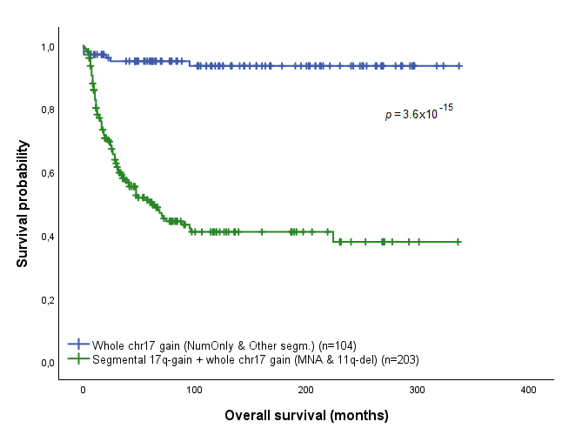
Figure S1
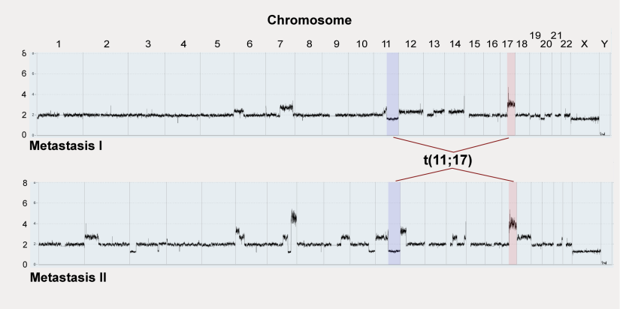
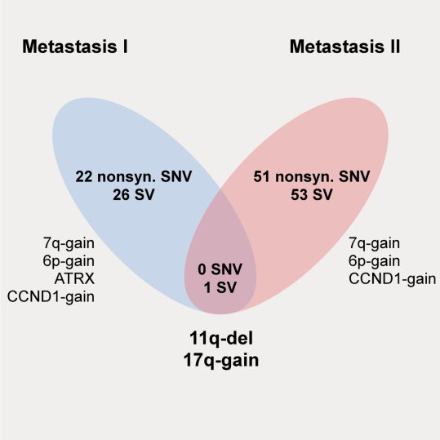
B
A
Figure S2
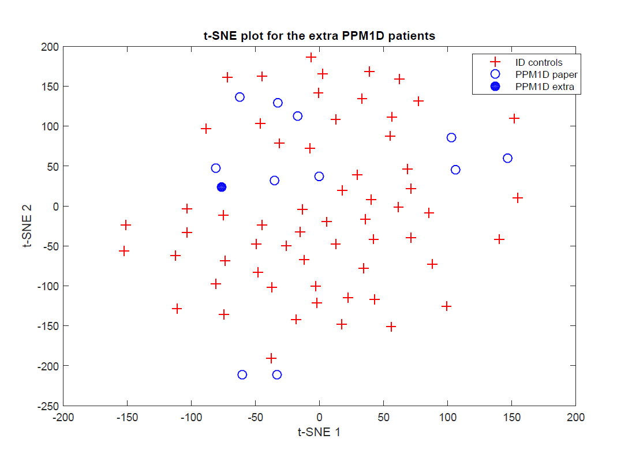
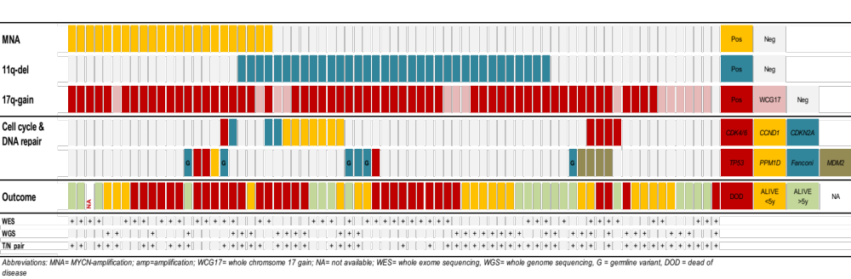
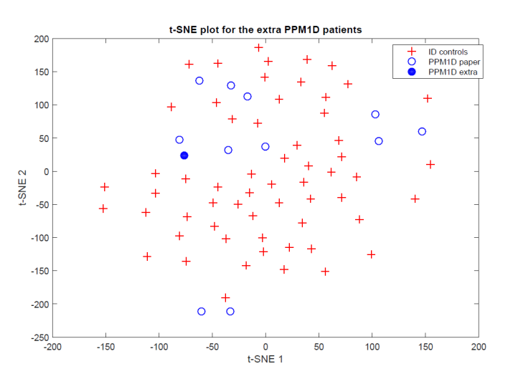
Controls, Intellectual Disability
Germline PPM1D-mut with Intellectual Disability
Germline PPM1D-mut with Neuroblastoma
B
A
Figure S3
t-SNE plot for the extra PPM1D patients
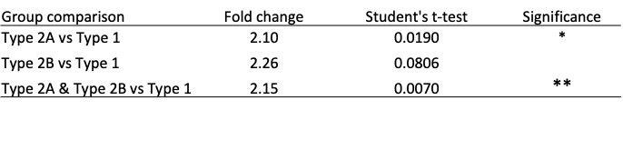
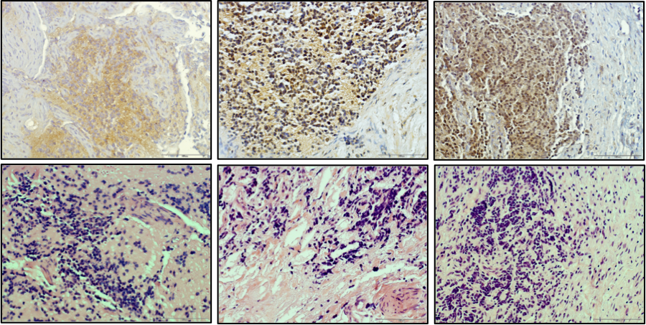
A
B
17+
17q+
17N
WIP1
H/E
Figure S4

Supp. Table S1A, Summary of 17q variation. Evolutionary analysis of PPM1D/17q copy number yielded three categories of tumors, those with PPM1D/17q gain present only in the stem with no further evolution, those with intratumoral accumulation of PPM1D/17q through clonal evolution and those where PPM1D/17q copy number fluctuated to an extent that precluded analysis. Patient IDs refer to those in Karlsson et al., 2018. Each category is the further subdivided into low-risk patients (numerical only) or high-risk patients, either MYCN amplified or dominated by structural changes (STR).

Tumor ID | Sample ID | Chr |  | Start |  | End |  | Med LogR |  | Type |  | Method |  | Cytoband/ Gene |  | Clone size (%)
NO INTRATUMORAL COPY NUMBER VARIATION: 17q GAIN IN STEM
NB1 | ALL SAMPLES (3) |  | 17 |  | 0 |  | 83257441 |  | NA |  | GAIN x2 |  | SNP Array |  | WHOLE | 100
NB2 | ALL SAMPLES (3) |  | 17 |  | 0 |  | 81041938 |  | NA |  | GAIN x3 |  | SNP Array |  | WHOLE | 100
NB3 | ALL SAMPLES (2) |  | 17 |  | 0 |  | 81041938 |  | 0,47 |  | GAIN x2 |  | SNP array |  | WHOLE | 100
NB5 | ALL SAMPLES (6) |  | 17 |  | 400959 |  | 80263427 |  | NA |  | GAIN x2 |  | SNP array |  | WHOLE | 100
NB6 | ALL SAMPLES (4) |  | 17 |  | 400959 |  | 80263427 |  | NA |  | GAIN x2 |  | SNP array |  | WHOLE | 100
NB7 | ALL SAMPLES (6) |  | 17 |  | 400959 |  | 80263427 |  | NA |  | GAIN x2 |  | SNP array |  | WHOLE | 100
NB8 | ALL SAMPLES (3) |  | 17 |  | 400959 |  | 80263427 |  | 0,70 |  | GAIN x2 |  | SNP array |  | WHOLE | 100
NB9 | ALL SAMPLES (2) |  | 17 |  | 28183784 |  | 81041938 |  | NA |  | GAIN |  | SNP array |  | 17q11q25 | 100
NB12 | ALL SAMPLES (3) |  | 17 |  | 19143975 |  | 81041938 |  | 0,70 |  | GAIN x2 |  | SNP array |  | 17q11q25 | 100
NB13 | ALL SAMPLES (4) |  | 17 |  | 35914854 |  | 80956017 |  | NA |  | GAIN x3 |  | SNP array |  | 17q12q25 | 100
NB17 | ALL SAMPLES (4) |  | 17 |  | 36412891 |  | 80652682,5 |  | NA |  | GAIN |  | SNP array |  | 17q12q25 | 100
NB19 | ALL SAMPLES (10) |  | 17 |  | 43766497 |  | 80263427 |  | NA |  | GAIN x2 |  | SNP array |  | 17q21q25 | 100
NB22 | ALL SAMPLES (12) |  | 17 |  | 45836832 |  | 80263427 |  | NA |  | GAIN |  | SNP array |  | 17q21q25 | 100
REGIONAL ACCUMULATION OF 17q COPIES COMPARED TO STEM LINE
17q+ IN STEM FOLLOWED BY ADDITIONAL GAINS IN BRANCHES
NB11 | ALL SAMPLES (4) |  | 17 |  | 0 |  | 81027137 |  | NA |  | CNNI GAIN |  | SNP array |  | WHOLE | 100
NB11 | B2 |  | 17 |  | 0 |  | 81027137 |  | 0,05 |  | GAIN |  | SNP array |  | WHOLE | 30
NB11 | B3 |  | 17 |  | 400959 |  | 80263427 |  | 0,11 |  | GAIN |  | SNP array |  | WHOLE | 55
NB11 | B4 |  | 17 |  | 400959 |  | 80263427 |  | 0,21 |  | GAIN |  | SNP array |  | WHOLE | 100
NB14 | ALL SAMPLES (4) |  | 17 |  | 400959 |  | 80263427 |  | NA |  | GAIN |  | SNP array |  | WHOLE | 100
NB14 | B3 |  | 17 |  | 0 |  | 81027137 |  | 0,18 |  | GAIN x2 |  | SNP array |  | WHOLE | 60
NB14 | M |  | 17 |  | 0 |  | 81027137 |  | 0,08 |  | GAIN x2 |  | SNP array |  | WHOLE | 100
NB18 | ALL SAMPLES (7) |  | 17 |  | 44788545 |  | 81041937 |  | NA |  | GAIN |  | SNP array |  | 17q21q25 | 100
NB18 | B |  | 17 |  | 33225118 |  | 81041937 |  | 0,38 |  | GAIN x2 |  | SNP array |  | 17q12q21 | 100
NB18 | P2 |  | 17 |  | 33339133 |  | 44165802 |  | 0,13 |  | GAIN |  | SNP array |  | 17q12q21 | 100
NB18 | P2 |  | 17 |  | 0 |  | 33339133 |  | -0,16 |  | LOSS |  | SNP array |  | 17p13q12 | 100
NB18 | P3 |  | 17 |  | 33339133 |  | 44165802 |  | 0,22 |  | GAIN |  | SNP array |  | 17q12q21 | 100
NB18 | P4 |  | 17 |  | 33339133 |  | 81195210 |  | 0,16 |  | GAIN x2-3 |  | SNP array |  | 17q12q21 | 30
NB18 | M1 |  | 17 |  | 33339133 |  | 81041937 |  | 0,52 |  | GAIN x2 |  | SNP array |  | 17q12q21 | 100
NB18 | M2 |  | 17 |  | 33339133 |  | 81041937 |  | 0,45 |  | GAIN x2 |  | SNP array |  | 17q12q21 | 100
NB21 | ALL SAMPLES (2) |  | 17 |  | 39613689 |  | 81041937 |  | NA |  | GAIN |  | SNP array |  | 17q21q25 | 100
NB21 | B1 |  | 17 |  | 39488988 |  | 80263427 |  | 0,49 |  | GAIN x2 |  | SNP array |  | 17q21q25 | 60
17q+ IN BRANCHES ONLY, BUT BECOMES FIXED REGIONALLY THROUGH CLONAL SWEEP
NB16 | ALL SAMPLES (2) |  | 17q normal copy number
NB16 | B1 |  | 17 |  | 54967528 |  | 80263427 |  | 0,41 |  | GAIN |  | SNP array |  | 17q22q25 | 80
NB16 | B2 |  | 17 |  | 54900876 |  | 81195210 |  | 0,41 |  | GAIN |  | SNP array |  | 17q22q25 | 100
NB16 | B3 |  | 17 |  | 54967528 |  | 80263427 |  | 0,48 |  | GAIN |  | SNP array |  | 17q22q25 | 100
NB20 | ALL SAMPLES (4) |  | 17q normal copy number
NB20 | B2 |  | 17 |  | 0 |  | 83257441 |  | NA |  | GAIN |  | SNP array |  | WHOLE | 100
NB20 | B2 |  | 17 |  | 0 |  | 83257441 |  | 0,37 |  | GAINx2 |  | SNP array |  | WHOLE | 30
NB20 | B4 |  | 17 |  | 0 |  | 83257441 |  | 0,24 |  | GAIN |  | SNP array |  | WHOLE | 100
NB20 | B1 |  | 17 |  | 38866764 |  | 83257441 |  | 0,30 |  | GAIN |  | SNP array |  | 17q21q25 | 60
NB20 | B3 |  | 17 |  | 38866764 |  | 83257441 |  | 0,31 |  | GAIN |  | SNP array |  | 17q21q25 | 75
NB23 | ALL SAMPLES (8) |  | 17q normal copy number
NB23 | P1 |  | 17 |  | 38195495 |  | 63495631 |  | 0,15 |  | GAIN |  | SNP array |  | 17q21q24 | 100
NB23 | P2 |  | 17 |  | 38195495 |  | 63495631 |  | 0,13 |  | GAIN |  | SNP array |  | 17q21q24 | 100
NB23 | M1 |  | 17 |  | 43262179 |  | 81041938 |  | 0,34 |  | GAIN |  | SNP array |  | 17q21q25 | 100
NB23 | M2 |  | 17 |  | 43352049 |  | 80263427 |  | 0,37 |  | GAIN |  | SNP array |  | 17q21q25 | 100
NB23 | M3 |  | 17 |  | 43268712 |  | 80263427 |  | 0,40 |  | GAIN |  | SNP array |  | 17q21q25 | 100
NB23 | R1 |  | 17 |  | 43266347 |  | 80263427 |  | 0,31 |  | GAIN |  | SNP array |  | 17q21q25 | 100
NB23 | R2A |  | 17 |  | 43266347 |  | 80263427 |  | 0,32 |  | GAIN |  | SNP array |  | 17q21q25 | 100
NB23 | R2B |  | 17 |  | 43266347 |  | 80263427 |  | 0,31 |  | GAIN |  | SNP array |  | 17q21q25 | 100
GAIN OF 17q FLUCTUATES IN SUBCLONES
NB4 | ALL SAMPLES (3) |  | 17q normal copy number
NB4 | B1 |  | 17 |  | 40086266 |  | 81021494 |  | 0,33 |  | GAIN x2 |  | SNP array |  | 17q21q25 | 40
NB4 | B2 |  | 17 |  | 38074518 |  | 80263427 |  | 0,41 |  | GAIN x2 |  | SNP array |  | 17q12q25 | 50
NB4 | B3 |  | 17 |  | 38074518 |  | 80263427 |  | 0,36 |  | GAIN x2 |  | SNP array |  | 17q12q25 | 40
NB10 | ALL SAMPLES (2) |  | 17q normal copy number
NB10 | B2 |  | 17 |  | 400959 |  | 80263427 |  | 0,27 |  | GAIN |  | SNP array |  | WHOLE | 100
NB15 | ALL SAMPLES (2) |  | 17q normal copy number
NB15 | B1 |  | 17 |  | 38299547 |  | 81041937 |  | 0,57 |  | GAIN x4 |  | SNP array |  | 17q22q25 | 50
NB15 | B2 |  | 17 |  | 38299547 |  | 81041937 |  | 0,53 |  | GAIN x2 |  | SNP array |  | 17q22q25 | 65

