Supporting information: Conformation and dynamics of the kinase domain drive subcellular location and activation of LRRK2.
Sven H. Schmidt^{1*}, Jui-Hung Weng^{2,3*}, Phillip C. Aoto^{2,3*}, Daniela Boassa^{4,5}, Sebastian Mathea⁶, Steven Silletti³, Junru Hu^{4,5}, Maximilian Wallbott¹, Elizabeth A. Komives³, Stefan Knapp⁶, Friedrich W. Herberg^{1a}, Susan S. Taylor^{2,3a}
¹ Department of Biochemistry, University of Kassel, 34132 Kassel, Germany
² Department of Pharmacology, University of California, San Diego, La Jolla, California 92093, USA
³ Department of Chemistry and Biochemistry, University of California, San Diego, La Jolla, California 92093,
USA
⁴ National Center for Microscopy and Imaging Research, University of California, San Diego, La Jolla,
California 92093, USA
⁵ Department of Neurosciences, University of California, San Diego, La Jolla, California 92093, USA
⁶ Institute for Pharmaceutical Chemistry, Goethe University Frankfurt, 60438 Frankfurt am Main, Germany
* Authors contributed equally

ª Co-corresponding authors
Figure S1. The type-2 kinase inhibitor rebastinib binds to the LRRK2 kinase domain. Shown are the 1st derivatives of the LRRK2 melting curves with or without rebastinib. The LRRK2 protein comprised two domains (kinase and WD40). Accordingly, there were two minima in the control curve. The addition of rebastinib stabilized the LRRK2 kinase domain and shifted its melting temperature by 14 K, indicating a binding constant <1 uM.

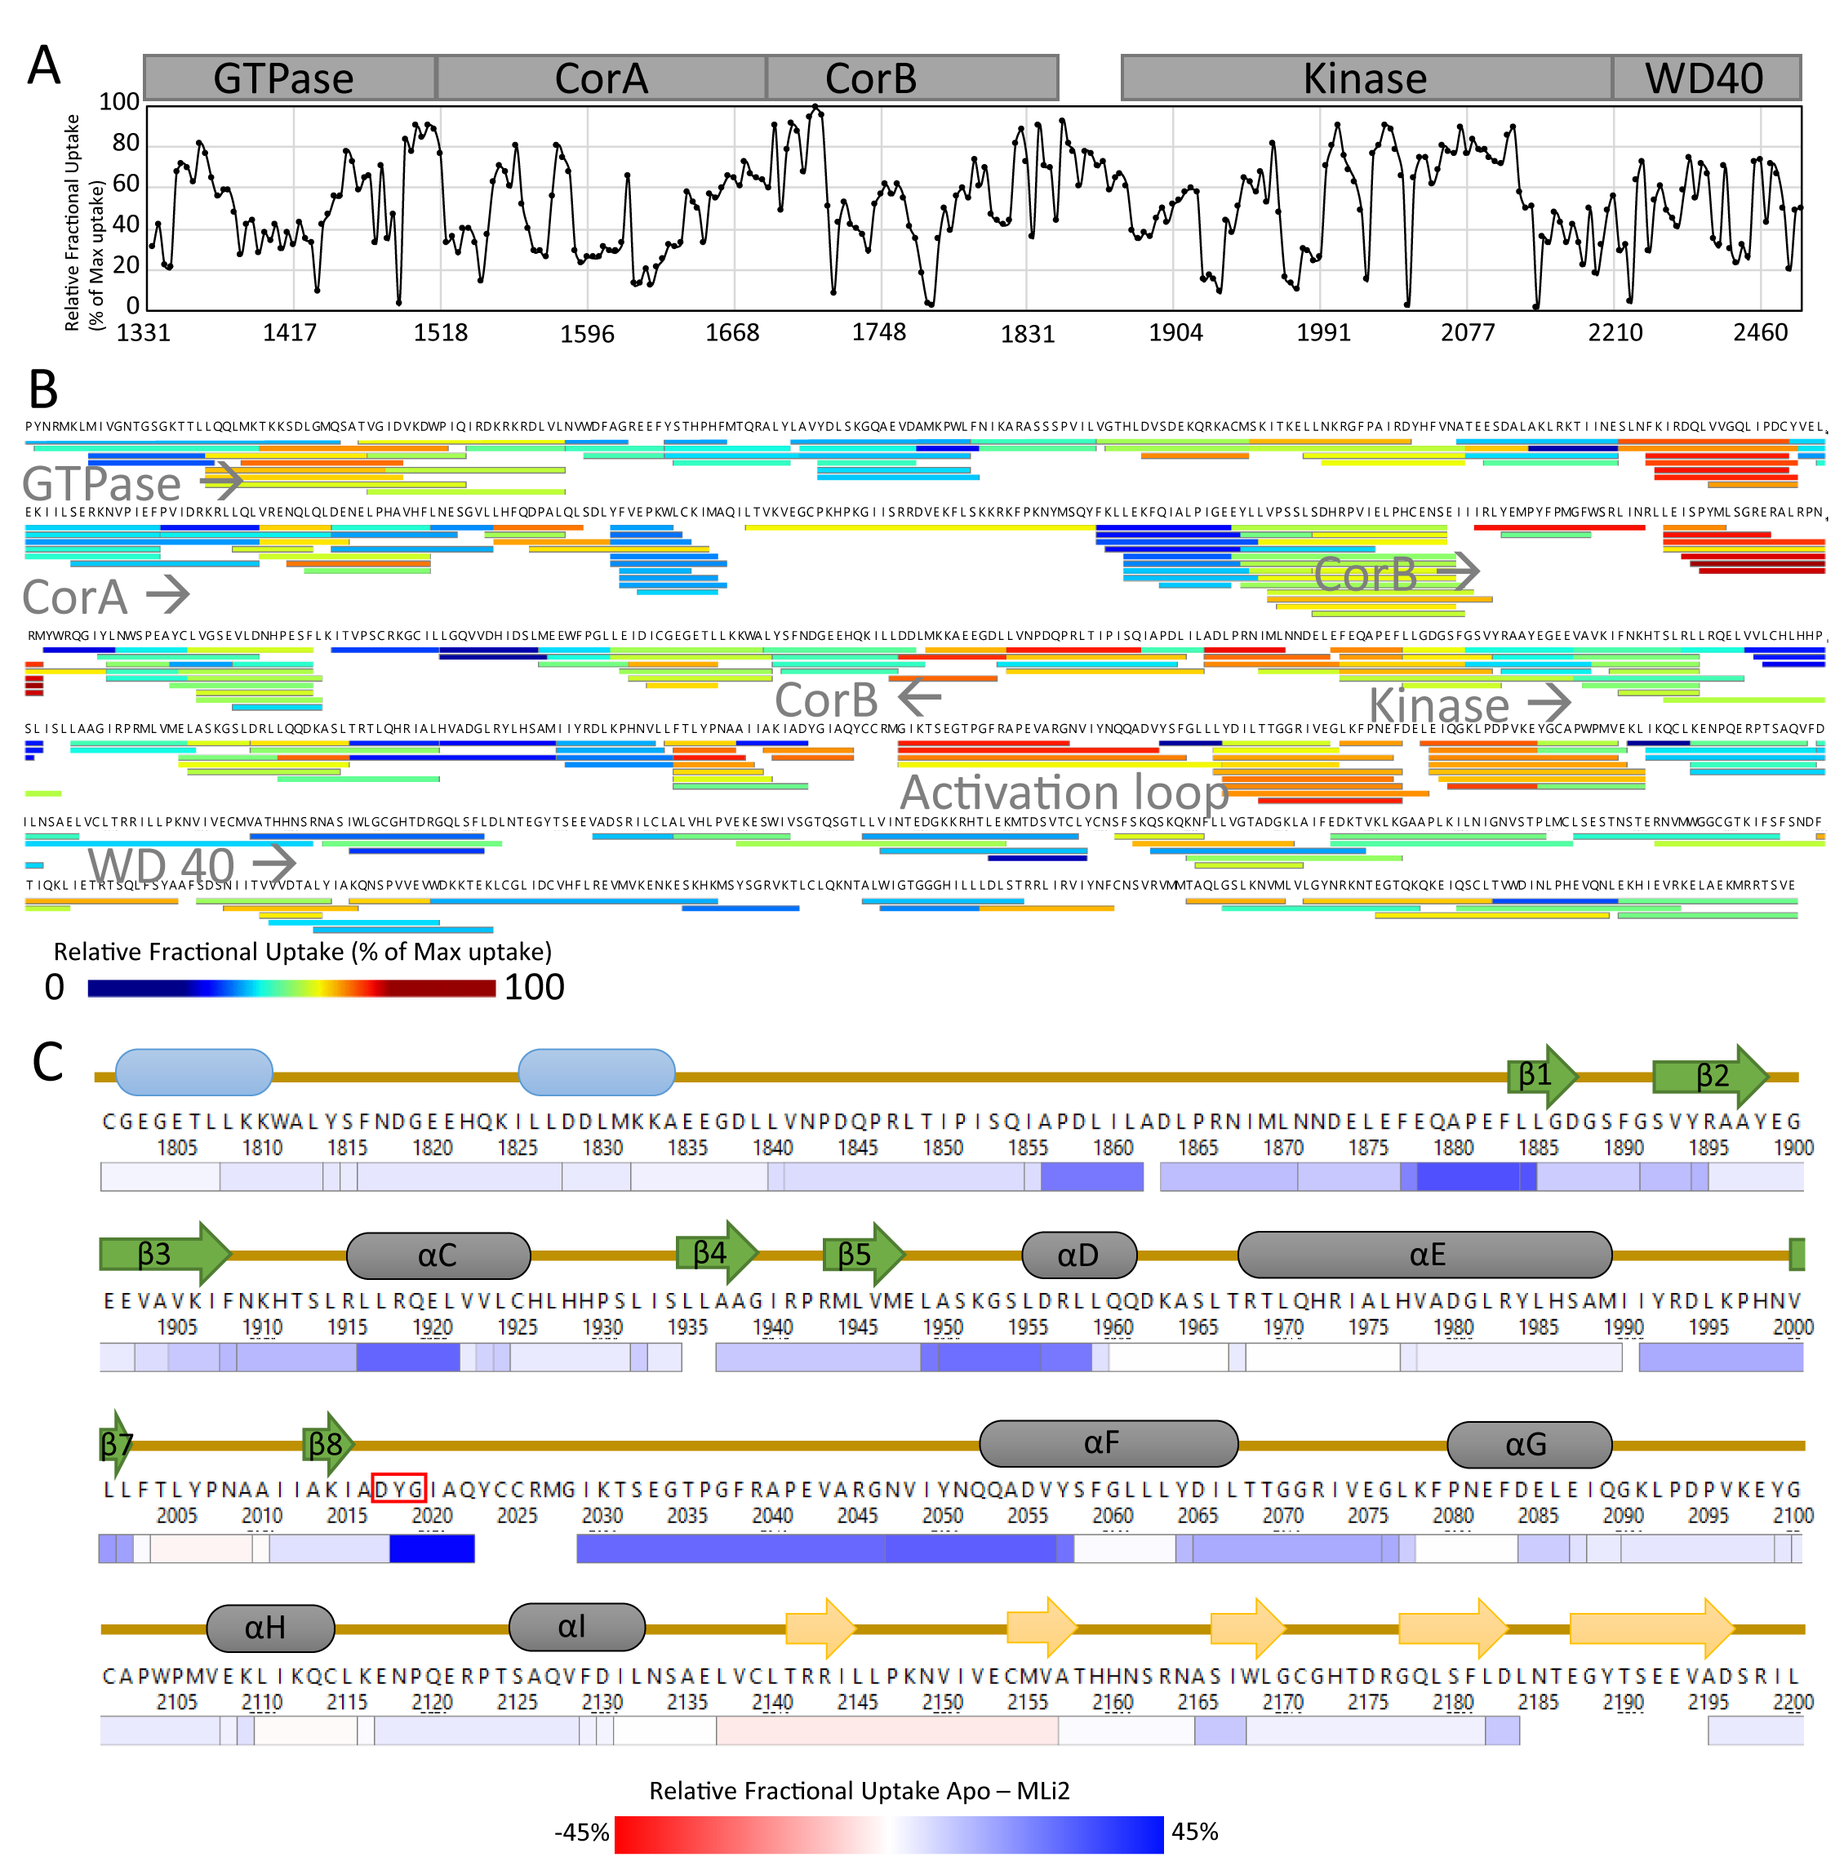
Figure S2. The identified HDX-MS peptides of LRRK2_{RCKW} . (A) The relative deuterium exchange for each peptide detected from the N to C terminus of LRRK2 at 2 min, apo condition. (B) Each line in the coverage map represents an identified peptide (exchanged 2 min) and the color indicates the relative deuterium uptake. Location of each domain is indicated. The map identifies folded regions as well as solvent exposed regions such as the activation loop in the kinase domain. The coverage is 96.3% and the redundancy is 3.72, which is successful for a protein this large. (C) The heat shows the relative fractional uptake by color at 2 min. It is colored based on the difference of relative deuterium uptake between apo and MLi-2 states.

Figure S3. Y2018 has a non-ideal sidechain torsion angle that introduces disorder to the DYG loop. (A) Ideal Tyr χ1/ χ2 gauche(-) torsions from the Dunbrack database is shown with blue-to-red color indicating increasing torsion angle preference (88). The average torsion angles for wt Y2018 (magenta circle) and Y2018F (white circle) from the simulation are overlaid, showing that wt Y2018’s sidechain is in a non-preferred conformation. The χ1 / χ2 sidechain torsion angle distribution for Y2018 and Y2018F during the simulations are shown (right panels). Y2018F breaks the hydrogen bonds that lock the sidechain of Y2018 in wt and leads to a more ideal side-chain conformation in the mutant. The white dashed line indicates the preferred χ1 for Tyr from the Dunbrack dataset. (B) The ideal backbone dependent conformation for the gauche(-) rotamer of Tyr, derived from rotamer libraries (88), is depicted as the probability of the backbone ψ-dihedral angle (_{i}N- _{i}Cα- _{i}C- _{i+1}N) in blue. The non-ideal Y2018 rotamer in wt adds strain to the backbone: the Tyr backbone explores non-preferred conformations (black area, arrows indicate a non-ideal backbone ψ-angle). The backbone conformation of Y2018F populates ideal dihedral space (red area). The φ/ψ distribution of the backbone of Y/F2018 during the simulation is shown (right panels). The wt Y2018 backbone is more dynamic than Y2018F. In Y2018F the sidechain is free to access the preferred rotamer torsions and the backbone conformation is stabilized in the preferred active backbone conformation. The mutation stabilizes the entire DYGI backbone as seen in the conformational ensemble from MD (upper right).

Figure S4. DYGI backbone dihedrals from MD simulations. DYGψ dihedral space that is associated with an activated kinase are circled in cyan (62). The wt kinase and D2017A mutant have a dynamic DYG loop that samples conformations associated with inactive kinases. The DYG loop of the mutants converge to a φ/ψ space that is typical of active / closed kinases. Asterisks indicate sites of mutation.

Figure S5. Activation loop stability from MD simulations. (A/B) The stability of the activation loop is represented as the distance between the YRD loop (R1993) and activation loop (pS2032). The salt-bridge between YRD and activation loop couples the catalytic loop with the N- and C-lobes. The activation loop of wt is the least stable, while activating DYGψ mutants increase stability. (C) The wt activation loop conformational ensemble is more widely distributed and more solvent accessible than (D) the I2020T activation loop. The DYGI motif is shown in blue, YRD motif in green, and activation loop in orange.

Supplementary videos:
Movie 1. Time-lapse imaging of HEK293T cells transiently expressing YFP-LRRK2-G2019S. The time interval is 5 minutes. MLi-2 was added right after the second frame. Images (640x640 pixels) of YFP fluorescence (515 nm excitation/530-630 nm emission) represent 3D volume reconstructions from confocal image stacks over time.
Movie 2. Time-lapse imaging of HEK293T cells transiently expressing YFP-LRRK2-G2019S following wash-out of MLi-2. The time interval is 11 minutes. Images (640x640 pixels) of YFP fluorescence (515 nm excitation/530-630 nm emission) represent 3D volume reconstructions from confocal image stacks over time.
Movie 3. Time-lapse imaging of HEK293T cells transiently expressing YFP-LRRK2-WT. The time interval is 5 minutes. MLi-2 was added right after the second frame. Images (640x640 pixels) of YFP fluorescence (515 nm excitation/530-630 nm emission) represent 3D volume reconstructions from confocal image stacks over time.
Movie 4. Time-lapse imaging of HEK293T cells transiently expressing YFP-LRRK2-WT following wash-out of MLi-2. The time interval is 11 minutes. Images (640x640 pixels) of YFP fluorescence (515 nm excitation/530-630 nm emission) represent 3D volume reconstructions from confocal image stacks over time.

