Supplementary Information for

Local and global energy barriers for chiral domain walls in synthetic antiferromagnet-ferromagnet lateral junctions
Jiho Yoon^{1,2}, See-Hun Yang^{1†}, Jae-chun Jeon¹, Andrea Migliorini¹, Ilya Kostanovskiy¹, Stuart. S. P. Parkin^{1,2†}
¹Max Planck Institute of Microstructure Physics, 06120, Halle, Germany
²Institute of Physics, Martin Luther University, Halle-Wittenberg, 06120, Halle, Germany
†Email: sehuyang@mpi-halle.mpg.de, stuart.parkin@mpi-halle.mpg.de

Supplementary Discussion 1. SAF to FM transition as a function of oxidation process time
Fig. S1. Influence of oxidation upon the SAF to FM transition. a, M-H hysteresis loops of SAF film measured along the magnetic easy-axis as a function of oxidation process time. b,c, Comparison of oxidized SAF (60 sec processed) and as-grown reference FM film measured along the magnetic easy-axis (b) and hard-axis (c).

The plasma oxidation to transform SAF into FM is optimized by monitoring the magnetic hysteresis loop measured on unpatterned films using vibrating sample magnetometry. The magnetic easy axis hysteresis loops of SAF films that are treated with different oxidation times are shown in Fig. S1a. Here, the plasma oxidation is carried out using reactive ion etching (RIE) at an oxygen pressure of 50 mTorr and an RF bias power of 100 W.
The pristine SAF film exhibits a typical spin-flop transition with AF coupling and nearly zero remnant magnetization at $H_{z}=0$ thus showing that the SAF film is nearly compensated. The film structure is composed of the underlayer (20 TaN | 30 Pt), lower FM layer (LM : 3 Co | 7 Ni | 1.5 Co), spacer layer (9.5 Ru), upper FM layer (UM : 3.5 Co | 7 Ni | 3 Co), and capping layer (30 TaN) (all thicknesses are in Å). By increasing the oxidation time, the remnant magnetization of SAF gradually increases while the exchange field $H_{ex}$ still remains ~ 1 T up to 50 sec of process time (orange line). This shows that the oxidation affects the compensated moment by reducing the magnetic moment of UM. As for 60 sec oxidation time (yellow line), the hysteresis loops shows a clear transition from SAF to FM that is evidenced by the disappearance of any AF coupling. It is found that the magnetic moment of LM remains constant over the oxidation time up to 240 sec (red line). The Ru spacer layer prevents the LM layer from further oxidation¹. For reference, a control FM film (20 TaN | 30 Pt | 3 Co | 7 Ni | 1.5 Co | 9.5 Ru | 30 TaN) is prepared. As shown in Fig. S1b and c, the magnetic properties of the oxidized SAF (process time of 60 sec) are identical to the FM control film, thereby showing that our oxidation process affects only the upper FM layer.

Supplementary Discussion 2. AFM imaging and topography of FM-SAF junction
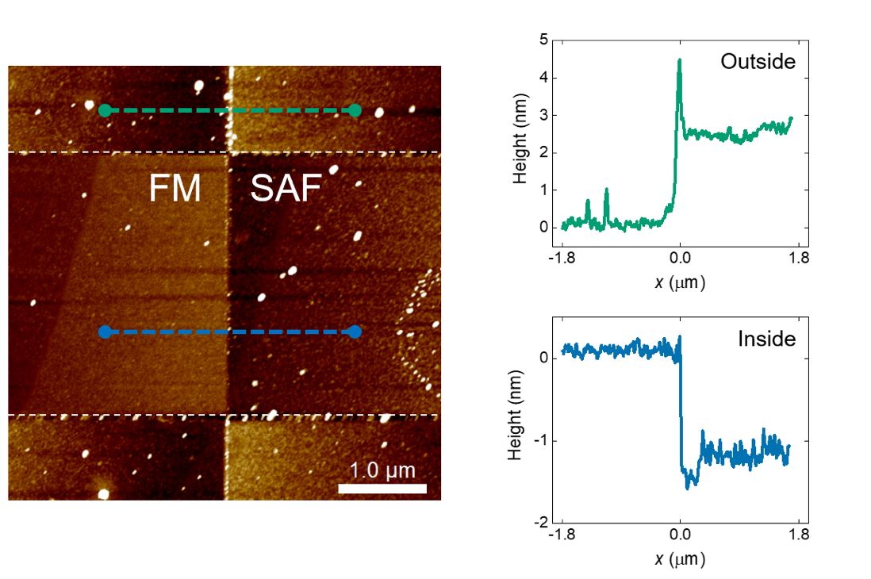
Fig. S2. Atomic force microscopy (AFM) images of FM-SAF junction ($θ_{J}=0°)$ in a racetrack. The edges of the Racetrack are shown by the white dashed lines. The FM-SAF junction boundary is clearly seen from the color contrast within the nanowire. Step heights are measured on the racetrack across the junction (blue dashed line) and off the racetrack that is capsulated with alumina (green dashed line).

AFM imaging shows that the oxidation process results in a local increase in the thickness of the racetrack by ~1-2 nm as discussed in main text, which allows us to measure the width of the FM-SAF junction boundary. On the other hand, the alumina encapsulation region outside the nanowire is found to become thinner due to chemical etching of the alumina by the developer, diluted tetramethylammonium hydroxide (TMAH), as shown in Fig. S2. The etching rate of alumina is estimated to be ~ 5 nm/min at room temperature. This leads to the distinct color contrast in the optical microscopy image, as can be seen in Fig. 1a.

Supplementary Discussion 3. XPS depth-profile analysis of the pristine and oxidized SAF

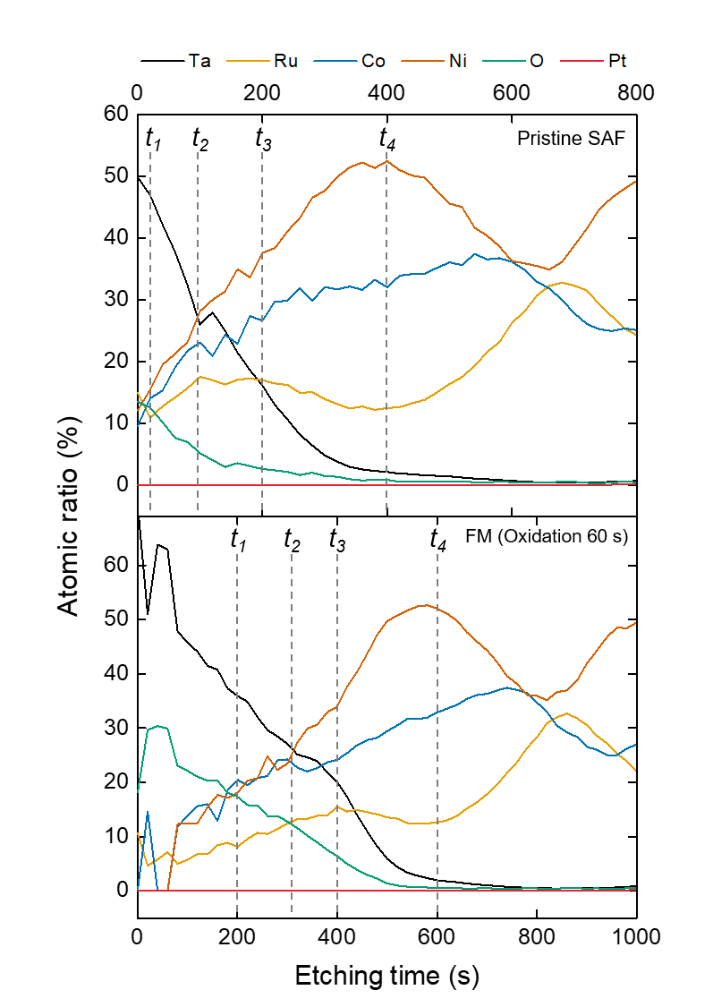

Fig. S3. XPS profile of atomic concentrations with etching time. Depth profile spectra of pristine (upper panel) and oxidized SAF (lower panel). The four times t₁, t₂, t₃, and t₄ that are shown in the figure refer to the points where the Co and Ni 2p spectra are investigated, as shown in Fig. S4.

To investigate the effect of plasma oxidation on the SAF, XPS depth profile measurements are carried out, using Ar ion etching, on the unpatterned pristine SAF film and a FM film that had been obtained by oxidization for 60 sec of a SAF film. The etching conditions are: Ar+ energy 500 eV, 0.5 µA beam current, 5 x 2 mm² etching area, 20 sec per cycle.
As shown in Fig. S3, it takes longer to etch the TaN capping layer for the oxidized SAF than for the pristine case, thus showing that TaN becomes thicker on oxidation by forming TaON. The depth profiles show that the oxygen level is significantly increased in the TaN, and the Co and Ni upper layers in the oxidized SAF film.

Supplementary Discussion 4. XPS spectra analysis of the chemical shifts in upper FM layer
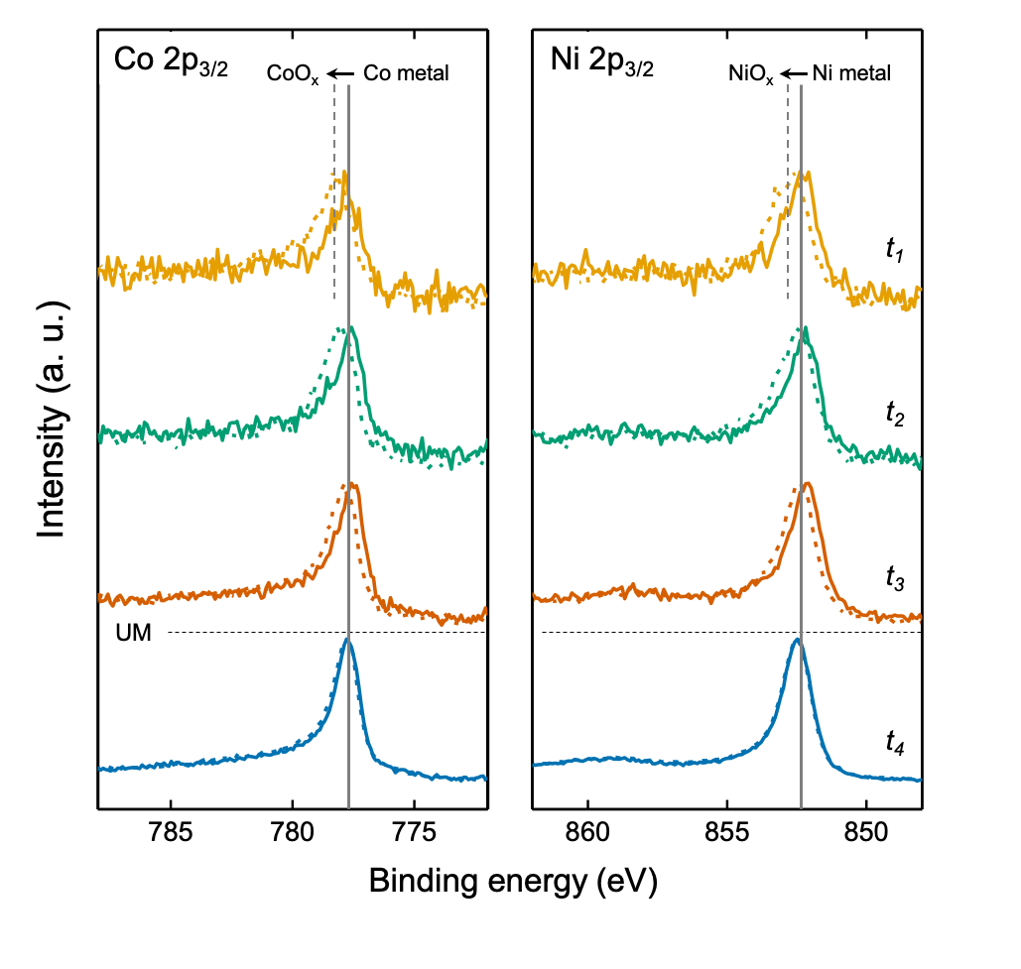
Fig. S4. XPS spectra of Co and Ni at different etching times. 2p_{3/2} spectra of Co (left panel) and Ni (right panel) in pristine SAF (solid line) and oxidized SAF (dashed line) are plotted at t₁, t₂, t₃ and t₄ as designated in Fig. S3. Peak positions for metallic Co and Ni are indicated, as a guide, by grey solid lines, while those from the oxidized film are displayed by grey dashed lines.

Metallic Co 2p_{3/2} (~778.2 eV) and Ni 2p_{3/2} (~852.6 eV) spectra are observed in the pristine SAF (solid line) film, thus showing that the 30 Å TaN capping layer effectively protects Co and Ni in the upper layer against natural oxidation. On the other hand, the oxidized SAF shows chemical shifts of ~ 0.5 eV of spectral peaks towards higher binding energies, thereby confirming the oxidation of Co and Ni in the upper layer. As the film is further etched away, thus allowing analysis of the lower FM layer, Co and Ni are clearly seen to be metallic (unoxidized) (t₄).
Supplementary Discussion 5. Current- and field-driven DW depinning probability in FM and SAF regions

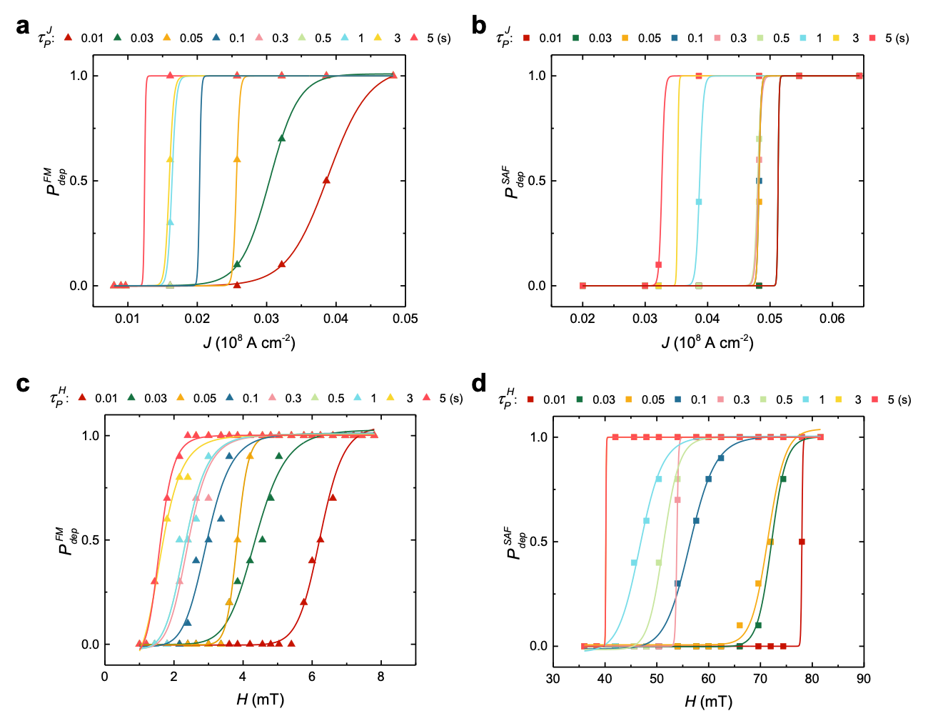
Fig. S5. Domain wall depinning probability versus current density and applied field in the creep regime. a,b, Current-driven domain wall depinning probability as a function of current density in FM (a), and SAF region (b) for various current pulse lengths $τ_{P}^{J}$ (10 to 10⁴ ms). c,d, Field-driven domain wall depinning probability as a function of easy axis magnetic field in FM (c), and SAF region (d) for various field pulse lengths $τ_{P}^{H}$ (10 to 10⁴ ms).

To understand the domain wall (DW) dynamics in the creep regime in which DW motion is dominated by thermal fluctuations, the depinning probabilities for current- and field-driven DW motion are measured inside the FM and SAF regions. Single current or magnetic easy axis field pulses are applied. The DW depinning is monitored by magneto-optical Kerr microscopy. Each depinning process is repeated 10 times. Solid lines represent fits to the depinning probability curves. Here, the depinning threshold current density $J_{th}^{i}$, and field $H_{th}^{i} (i=FM$ and$SAF)$ correspond to $P_{dep}^{i}=0.5$ at $τ_{P}^{J}$, and $τ_{P}^{H}$, respectively^{2,3}.

Supplementary Discussion 6. Current-driven DW injection (FM SAF) probability at FM-SAF junction

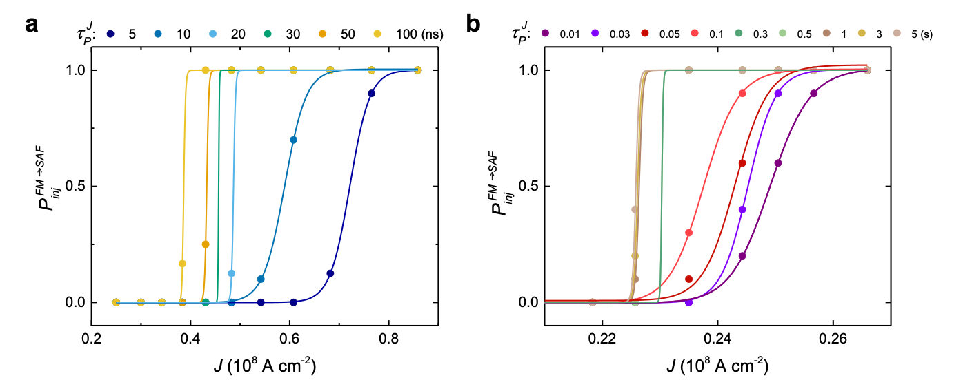
Fig. S6. DW injection (FMSAF) probability versus current density. a,b, Current-driven DW injection probability versus current density in the flow regime (a), and creep regime (b). Current pulse lengths $τ_{P}^{J}$ are varied from 5 to 100 ns (flow regime) and 10 to 10⁴ ms (creep regime) for the DW injection from FM to SAF region across the junction $θ_{J}=$ $0°$.
Supplementary Discussion 7. Extraction of energy barrier in DW creep regime
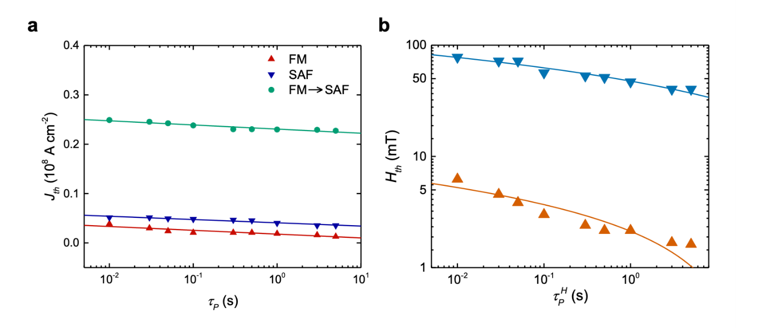
Fig. S7. Threshold current density and threshold field versus pulse length in the creep regime. a, Threshold current density for DW depinning $J_{dep}^{i} (i=$ FM and SAF) and DW injection $J_{inj}^{FM→SAF}$ (green circle) in the creep regime. $J_{dep}^{i}$ are measured from the FM (red triangle) and SAF region (blue triangle), respectively. DW injection from the FM region into the SAF region is carried out for the junction with $θ_{J}=0°$. b, DW depinning threshold fields in the FM and SAF regions. $H_{th}^{i} (i=$ FM and SAF) are measured by applying magnetic easy-axis fields for the FM (orange triangle) and SAF (blue triangle) regions. Current and field pulse lengths are varied from 10 to 10⁴ ms.

To determine the energy barriers for DW depinning and injection, we carry out the current- and field-driven DW depinning measurements in the creep regime and determine the corresponding $J_{dep}^{i}$, $J_{inj}^{FM→SAF}$, and $H_{dep}^{i} (i=$ FM, SAF and FMSAF ) as discussed in Supplementary Discussion 5 and 6. According to ref. 2, 4, and 5, $τ_{P}^{J}=τ_{0}exp⁡({E_{J}^{eff}}/{k_{B}T)}$ based on the Arrhenius relation, where $τ_{P}^{J}$ is applied current pulse length, and $τ_{0}$ is thermal attempt time. The effective energy barrier $E_{J}^{eff}$ is given by $E_{J}^{eff}=E_{J}(1-{J_{th}}/{J_{th0})^{α}}$ with threshold current density $J_{th0}$ to depin DW within infinitely long time and at zero temperature. In this work, we define $E_{J}$ as the energy barrier at room temperature by assuming a finite thermal attempt time $τ_{0}=1$ ns. The exponent $α$ corresponds to the reversal mechanism which is either $α=1$ (DW propagation dominant), or $α=2$ (DW nucleation dominant)⁶. Here, we used $α=1$ since DW depinning and injection is mainly governed by propagation mechanism. By plotting an exponential fit (solid lines in Fig. S7a) with the equation $J_{th}=J_{th0}(1-\frac{k_{B}T}{E_{J}}\ln{(\frac{τ_{P}^{J}}{τ_{0}}))}(T=300 K)$, $E_{J}$can be determined. Similar to the current case, $E_{H}$ can be obtained from the fits to the equation $H_{th}=H_{th0}(1-\frac{k_{B}T}{E_{H}}\ln{(\frac{τ_{P}^{H}}{τ_{0}}))}(T=300 K)$ (solid lines in Fig. S7b). $H_{th}$ corresponds to collected threshold field $H_{dep}^{i} (i=$ FM, and SAF) from DW depinning in each region, and $H_{th0}$ refers to the field to depin DW within infinitely long time at zero temperature. $τ_{P}^{H}$ is applied field pulse length, and $τ_{0}$ is thermal attempt time ($τ_{0}=1$ ns).

Supplementary Discussion 8. Sequential DW initialization and injection in FM-SAF junction
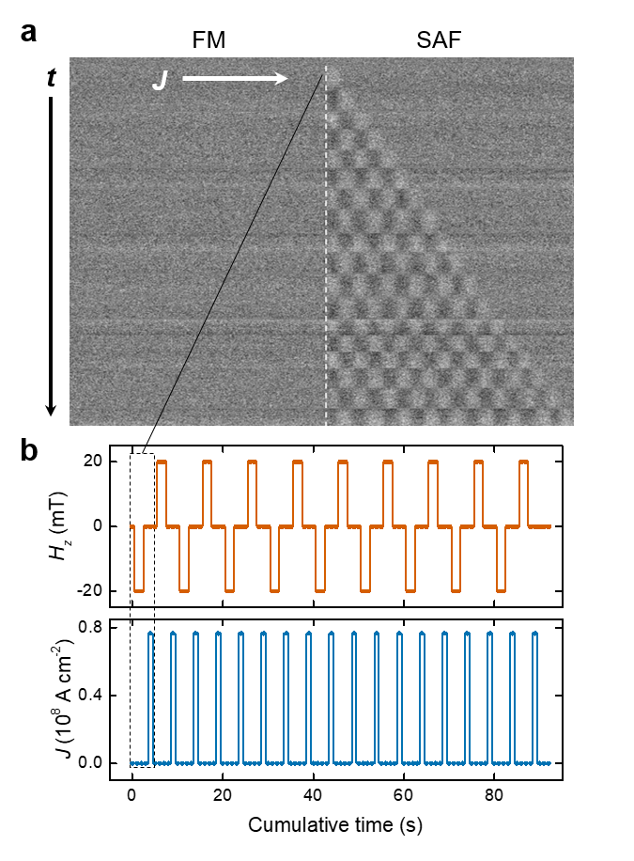
Fig. S8. Sequential DW initialization and multi-bit injection from the FM into the SAF region in a racetrack. a, Sequential Kerr microscopy images of injection of eighteen DWs from the FM region into the SAF region. The racetrack is 3 µm wide and 40 µm long. The FM-SAF junction with $θ_{J}=0°$ is designated by the white dashed line. Each Kerr image is taken after a combination of field and current pulse applications. Bright and dark contrast correspond to down ($↓)$ and up ($↑)$ domains, respectively. b, Cycles of field and current pulses versus cumulative time corresponding to Kerr images in (a). Each cycle is denoted by the black dashed line, which is repeated eighteen times.

By taking advantage of large difference in coercivities between the FM and SAF regions, DWs can be readily and reliably created by applying an external field. The field ${|H}_{z}|$ is chosen to be ${|H}_{c}^{FM}|(≈10 mT{)<|H}_{z}|<{|H}_{c}^{SAF}|(≈300 mT)$ such that a DW is nucleated in the FM region. The created DW is injected into the SAF region by current pulses. By repeating the DW nucleation and injection cycle, we demonstrated multi-DW injection, as shown in Fig. S8a. Each cycle for DW injection consists of a field pulse of $±$ 20 mT for 2 sec and a current pulse of $0.76 × {10}^{8} A cm^{-2}$ for 10 ns (see Fig. S8b). An external field is set to zero when the current pulse is applied. Consequently, eighteen DWs can be successfully injected with wall-to-wall distances of ~1.4 µm. The domain bit sizes can be modulated by the amplitude and length of the current pulse.

References

- Balcerzak, J., et al., In-situ XPS analysis of oxidized and reduced plasma deposited ruthenium-based thin catalytic films. Applied Surface Science 426, 852-855 (2017).
- Kim, K.-J. et al. Two-barrier stability that allows low-power operation in current-induced domain-wall motion. Nature Communications 4, 2011 (2013).
- Fukami, S., Yamanouchi, M., Ikeda, S. & Ohno, H., Depinning probability of a magnetic domain wall in nanowires by spin-polarized currents. Nature Communications 4, 2293 (2013).
- Khvalkovskiy, A.V., et al., Basic principles of STT-MRAM cell operation in memory arrays. J. Phys. D: Appl. Phys. 46, 074001 (2013).
- Koch, R.H., Katine, J.A., and Sun, J.Z., Time-resolved reversal of spin-transfer switching in a nanomagnet. Phys. Rev. Lett. 92, 088302 (2004).
- Raquet, B. et al., Dynamical properties of magnetization reversal in an ultrathin Au/Co film. J. Magn. Magn. Mater. 150, L5-L12 (1995).

