Supplemental information: PFHpA alters lipid metabolism and increases the risk of metabolic dysfunction-associated steatotic liver disease in youth—a translational research framework

Table of Contents
Figure S1. Association between plasma-PFAS and MASLD in Teen-LABS

Table S1. Association between plasma-PFAS and MASLD in Teen-LABS

Table S2. PFHpA exposure, histopathological determined outcomes of MASLD in the Teen-LABS study

Table S3. Metabolome-Wide Association Study (MWAS) between plasma-PFHpA and metabolites in Teen-LABS

Table S4. Proteome-Wide Association Study (PWAS) between plasma-PFHpA and proteins in Teen-LABS

Figure S2. Lipid Metabolism Pathways Upregulated in T cells

Table S1. Association between plasma-PFAS and MASLD in Teen-LABS
 | OR | 95% CI |  | P Value
PFUnDA | 0.66 | 0.41 | 1.06 | 0.34
PFDA | 0.82 | 0.42 | 1.58 | 0.73
PFNA | 0.63 | 0.34 | 1.17 | 0.38
PFOS | 0.78 | 0.46 | 1.33 | 0.58
PFOA | 1.34 | 0.79 | 2.29 | 0.56
PFHpS | 1.01 | 0.60 | 1.69 | 0.97
PFHpA | 1.80 | 1.30 | 2.50 | 0.003
PFHxS | 0.92 | 0.65 | 1.31 | 0.74
Logistic regression controlling for race, age, sex, parent's income, clinical site

Figure S1. Association between plasma-PFAS and MASLD in Teen-LABS controlling
for race, sex, parent’s income, clinical site

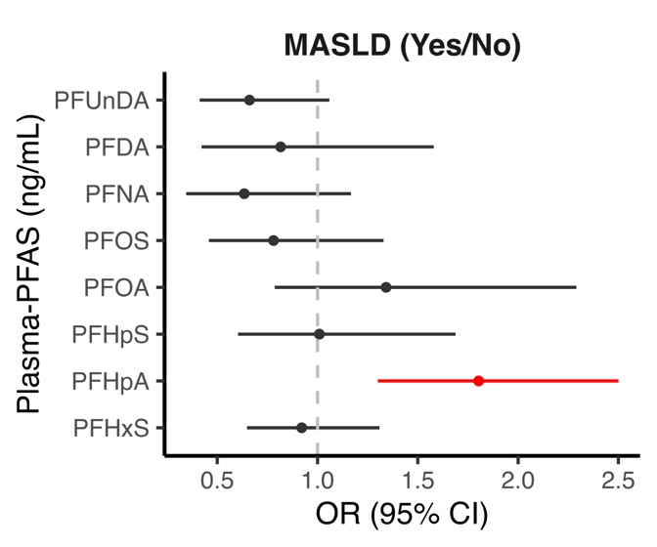

Table S2. PFHpA exposure, histopathological determined outcomes of MASLD in the Teen-LABS study

 | OR | 95% CI |  | P value | P trend
MASLD
No MASLD/MASH | ref | ref | ref | ref
MASLD not MASH | 1.68 | 1.19 | 2.37 | 0.003
MASH | 2.10 | 1.37 | 3.23 | 0.001
Steatosis
No steatosis | ref | ref | ref | ref
Possible | 1.52 | 1.01 | 2.26 | 0.04
Definite | 1.61 | 0.84 | 3.05 | 0.15
Steatosis grade
0-5% | ref | ref | ref | ref
5-33% | 1.61 | 1.16 | 2.24 | 0.004
33-67% and >67% | 1.88 | 1.22 | 2.89 | 0.004
Hepatocellular Ballooning
None | ref | ref | ref | ref
Few | 1.56 | 0.98 | 2.50 | 0.06
Many | 2.45 | 0.99 | 6.05 | 0.05
MASH stage
0 | ref | ref | ref | ref
1 | 2.28 | 1.40 | 3.73 | 0.001
2 | 2.38 | 1.44 | 3.91 | 0.001
>=3 | 3.04 | 1.78 | 5.21 | 0.000
Fibrosis
No | ref | ref | ref | ref
Yes | 1.49 | 1.04 | 2.14 | 0.03
PFHpA Quantiles & MASLD (n/y)
(0.015,0.049] | ref | ref | ref | ref | < 0.0001
(0.049,0.0865] | 1.63 | 0.47 | 5.86 | 0.44 | < 0.0001
(0.0865,0.176] | 2.29 | 0.67 | 8.31 | 0.19 | < 0.0001
(0.176,2.81] | 6.88 | 1.88 | 28.00 | 0.005 | < 0.0001
Models control for race, study site, age, sex, parental income

Table S3. Metabolome-Wide Association Study (MWAS) between plasma-PFHpA and metabolites in Teen-LABS
Metabolite | estimate | se | test statistic | p value | mz | retention time | mode
Isobutyryl-L-carnitine | 0.24 | 0.06 | 4.03 | 0.00 | 232.15 | 26.40 | c18pos
Cholate | 0.28 | 0.08 | 3.60 | 0.00 | 407.28 | 220.30 | c18neg
Trans-4-Hydroxy-L-Proline | 0.18 | 0.05 | 3.56 | 0.00 | 132.07 | 265.60 | hilicpos
Glycine | 0.20 | 0.06 | 3.50 | 0.00 | 464.30 | 257.80 | hilicneg
Glycocholic acid | 0.18 | 0.05 | 3.46 | 0.00 | 464.30 | 210.30 | c18neg
Aminolevulinic acid | 0.17 | 0.05 | 3.14 | 0.00 | 130.05 | 336.40 | hilicneg
Murideoxycholic acid | 0.20 | 0.07 | 3.10 | 0.00 | 451.31 | 233.40 | c18neg
Indole-3-Acetate | 0.17 | 0.06 | 3.04 | 0.00 | 174.06 | 32.00 | c18neg
Glycoursodeoxycholic acid | 0.16 | 0.05 | 3.04 | 0.00 | 448.31 | 222.10 | c18neg
Deoxycarnitine | 0.17 | 0.06 | 2.99 | 0.00 | 146.12 | 22.10 | c18pos
Glucuronate | 0.23 | 0.08 | 2.98 | 0.00 | 193.04 | 334.90 | hilicneg
Beta-Alanine | 0.16 | 0.06 | 2.93 | 0.00 | 88.04 | 336.10 | hilicneg
Tryptophan | 0.16 | 0.06 | 2.76 | 0.01 | 203.08 | 282.70 | hilicneg
Indolelactic acid | 0.16 | 0.06 | 2.75 | 0.01 | 204.07 | 34.00 | c18neg
Chenodeoxycholate | 0.15 | 0.06 | 2.73 | 0.01 | 391.29 | 241.50 | c18neg
Phenylpyruvic acid | 0.13 | 0.05 | 2.72 | 0.01 | 163.04 | 41.30 | c18neg
5-Aminovaleric acid | 0.13 | 0.05 | 2.72 | 0.01 | 116.07 | 22.20 | c18neg
Tauroursodeoxycholic acid | 0.14 | 0.05 | 2.68 | 0.01 | 498.29 | 224.50 | c18neg
Uric Acid | 0.14 | 0.05 | 2.65 | 0.01 | 167.02 | 19.70 | c18neg
3-Methylglutaric acid | 0.19 | 0.07 | 2.64 | 0.01 | 147.06 | 35.40 | c18pos
Proline | 0.15 | 0.06 | 2.56 | 0.01 | 114.06 | 315.30 | hilicneg
Indoxyl Sulfate | 0.16 | 0.06 | 2.55 | 0.01 | 212.00 | 41.00 | hilicneg
Homocysteine | 0.17 | 0.07 | 2.55 | 0.01 | 134.03 | 305.00 | hilicneg
Adipic acid | -0.14 | 0.06 | -2.50 | 0.01 | 145.05 | 18.50 | c18neg
Hypoxanthine | 0.16 | 0.06 | 2.47 | 0.01 | 135.03 | 213.80 | hilicneg
2-Ethyl2-OH-40-2-Ethyl-2-hydroxybutyric acid | -0.15 | 0.06 | -2.44 | 0.02 | 131.07 | 71.70 | hilicneg
C111-Undecylenic acid | 0.18 | 0.08 | 2.40 | 0.02 | 183.14 | 54.60 | c18neg
12-Ketochenodeoxycholic acid | 0.15 | 0.06 | 2.39 | 0.02 | 465.29 | 178.80 | hilicneg
2-Methylbutyroylcarnitine | 0.13 | 0.05 | 2.36 | 0.02 | 246.17 | 42.50 | c18pos
Hippuric acid | -0.16 | 0.07 | -2.36 | 0.02 | 178.05 | 26.90 | c18neg
2-Aminoisobutyrate | -0.13 | 0.05 | -2.35 | 0.02 | 102.06 | 326.50 | hilicneg
Erucate | 0.15 | 0.07 | 2.33 | 0.02 | 337.31 | 55.60 | hilicneg
Phenylalanine | 0.09 | 0.04 | 2.32 | 0.02 | 166.09 | 221.90 | hilicpos
Eicosapentaenoate | -0.14 | 0.06 | -2.32 | 0.02 | 301.22 | 58.30 | hilicneg
Ursocholic acid | 0.21 | 0.09 | 2.31 | 0.02 | 407.28 | 222.10 | hilicneg
N-Formyl-L-Methionine | 0.16 | 0.07 | 2.31 | 0.02 | 176.04 | 211.60 | hilicneg
Hexanoylcarnitine | 0.10 | 0.05 | 2.27 | 0.03 | 260.19 | 107.20 | c18pos
Theophylline | 0.15 | 0.07 | 2.25 | 0.03 | 181.07 | 80.70 | hilicpos
3,4-Dihydroxymandelic acid | 0.12 | 0.06 | 2.13 | 0.03 | 183.03 | 272.50 | hilicneg
L-Carnitine | 0.12 | 0.06 | 2.12 | 0.04 | 162.11 | 21.20 | c18pos
Norvaline | 0.10 | 0.05 | 2.11 | 0.04 | 116.07 | 307.20 | hilicneg
Normetanephrine | 0.13 | 0.06 | 2.09 | 0.04 | 184.10 | 20.40 | c18pos
Glycochenodeoxycholic acid | 0.13 | 0.06 | 2.09 | 0.04 | 450.32 | 254.20 | c18pos
Cinnamoylglycine-trans | 0.12 | 0.06 | 2.08 | 0.04 | 204.07 | 176.30 | hilicneg
Sarcosine | 0.12 | 0.06 | 2.05 | 0.04 | 131.08 | 273.60 | hilicpos
Oxoglutarate | 0.12 | 0.06 | 2.04 | 0.04 | 145.01 | 320.10 | hilicneg
Adenine | 0.09 | 0.04 | 2.01 | 0.05 | 177.09 | 278.80 | hilicpos
Phytanic acid | -0.11 | 0.06 | -1.99 | 0.05 | 376.32 | 270.90 | c18pos
MWAS between plasma-PFHpA and metabolites measured in Teen-LABS participants controlling for race, age, sex, parent's income, clinical site.

Table S4. Proteome-Wide Association Study (PWAS) between plasma-PFHpA and metabolites in Teen-LABS
Protein | estimate | se | test statistic | p value
ccl25 | 0.14 | 0.05 | 3.09 | 0.00
adamts16 | 0.09 | 0.03 | 3.07 | 0.00
vcam1 | 0.05 | 0.02 | 2.80 | 0.01
ikbkg | -0.20 | 0.07 | -2.71 | 0.01
smpdl3a | 0.12 | 0.04 | 2.70 | 0.01
ctsz | 0.06 | 0.03 | 2.58 | 0.01
scgb3a2 | -0.15 | 0.06 | -2.56 | 0.01
ccl20 | 0.17 | 0.07 | 2.54 | 0.01
prss2 | 0.09 | 0.03 | 2.51 | 0.01
prok1 | -0.12 | 0.05 | -2.47 | 0.02
n tpro bnp | -0.20 | 0.08 | -2.43 | 0.02
bank1 | -0.22 | 0.09 | -2.40 | 0.02
igfbpl1 | 0.10 | 0.04 | 2.39 | 0.02
gdf2 | 0.10 | 0.04 | 2.39 | 0.02
adamts13 | 0.06 | 0.03 | 2.39 | 0.02
hyal1 | 0.05 | 0.02 | 2.38 | 0.02
sh2d1a | -0.12 | 0.05 | -2.36 | 0.02
irak1 | -0.15 | 0.06 | -2.35 | 0.02
map2k6 | -0.21 | 0.09 | -2.34 | 0.02
ca5a | 0.19 | 0.08 | 2.31 | 0.02
slamf7 | -0.08 | 0.04 | -2.30 | 0.02
il18r1 | 0.06 | 0.03 | 2.29 | 0.02
nub1 | -0.18 | 0.08 | -2.24 | 0.03
adh4 | 0.15 | 0.07 | 2.23 | 0.03
axl | 0.04 | 0.02 | 2.22 | 0.03
hexim1 | -0.17 | 0.08 | -2.19 | 0.03
ccl24 | 0.14 | 0.06 | 2.19 | 0.03
ace2 | 0.10 | 0.04 | 2.18 | 0.03
c2 | 0.04 | 0.02 | 2.18 | 0.03
plxna4 | -0.14 | 0.07 | -2.17 | 0.03
arhgef12 | -0.18 | 0.09 | -2.14 | 0.03
tbc1d5 | -0.16 | 0.07 | -2.14 | 0.03
stx8 | -0.13 | 0.06 | -2.14 | 0.03
bcl2l11 | -0.12 | 0.06 | -2.12 | 0.04
il6st | 0.03 | 0.01 | 2.12 | 0.04
il1rn | 0.14 | 0.07 | 2.11 | 0.04
robo1 | 0.06 | 0.03 | 2.10 | 0.04
hpcal1 | -0.13 | 0.06 | -2.10 | 0.04
hla_e | 0.06 | 0.03 | 2.10 | 0.04
fxyd5 | -0.15 | 0.07 | -2.10 | 0.04
trem2 | 0.12 | 0.06 | 2.10 | 0.04
f7 | 0.05 | 0.02 | 2.10 | 0.04
osmr | 0.04 | 0.02 | 2.08 | 0.04
pm20d1 | -0.33 | 0.16 | -2.06 | 0.04
snx9 | -0.11 | 0.05 | -2.05 | 0.04
milr1 | -0.09 | 0.04 | -2.04 | 0.04
col1a1 | 0.06 | 0.03 | 2.04 | 0.04
ccl27 | 0.09 | 0.04 | 2.03 | 0.04
vsir | -0.11 | 0.05 | -2.03 | 0.04
susd1 | -0.12 | 0.06 | -2.02 | 0.05
ghrl | -0.11 | 0.06 | -2.01 | 0.05
trim21 | -0.18 | 0.09 | -2.01 | 0.05
acy1 | 0.10 | 0.05 | 1.99 | 0.05
bach1 | -0.10 | 0.05 | -1.99 | 0.05
ppp1r9b | -0.17 | 0.09 | -1.98 | 0.05
PWAS between plasma-PFHpA and proteins measured in Teen-LABS participants controlling for race, age, sex, parent's income, clinical site.

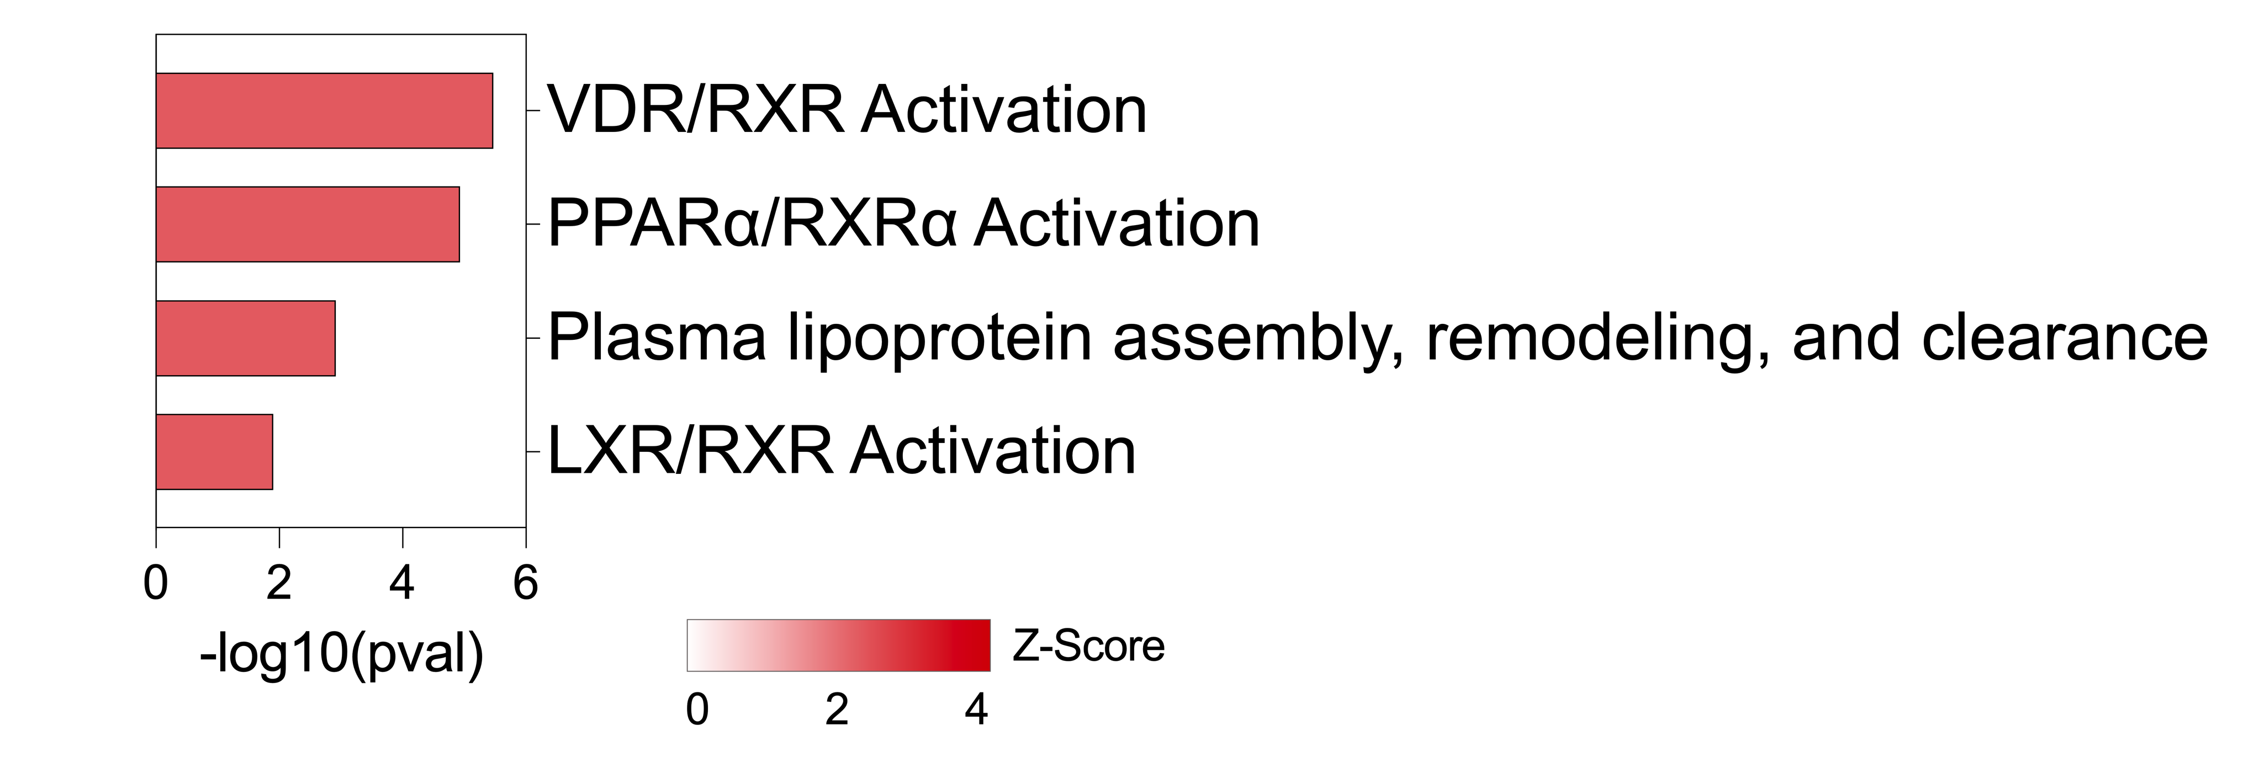

Figure S2. Lipid metabolism pathways upregulated in T cells from 3D liver spheroids exposed to PFHpA for 7 days.

